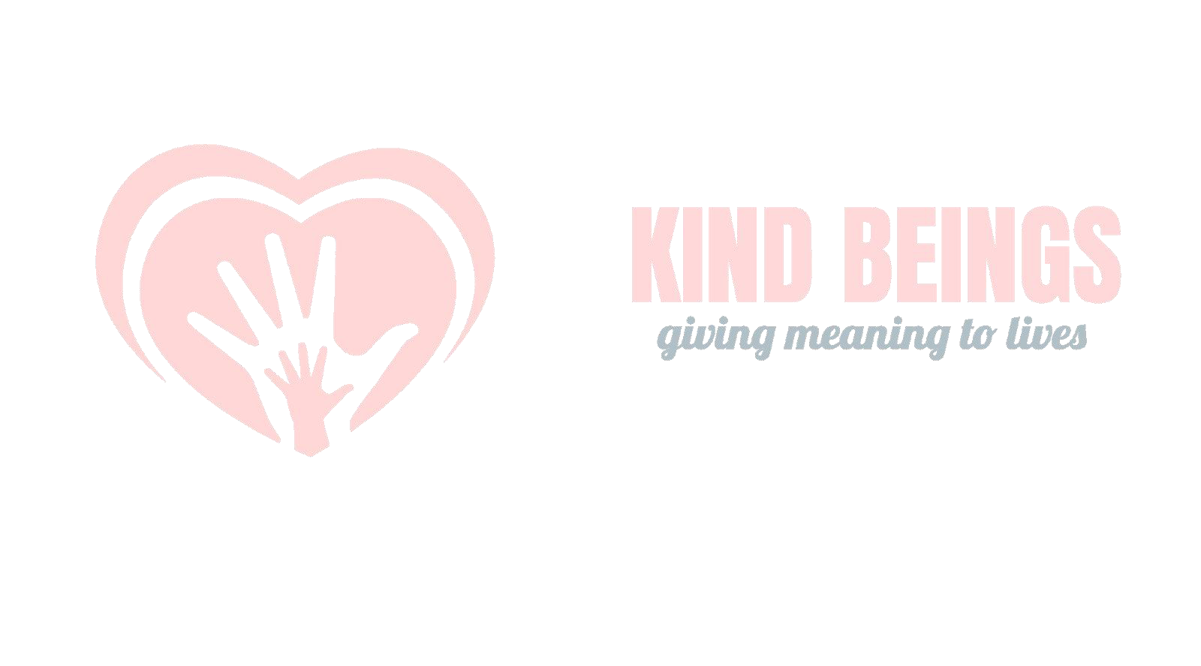

|  |
| --- |
| **Letter of Appointment Name: Raman Verma**  **Designation: Social Media Intern**  **DOJ: 9 June 2023**  **Date: 9 June 2023**  Dear **Raman**,  We are pleased to inform you that we are appointing you as a **Social Media Intern** in our organization. We all are very much excited about the talent and insights that you will contribute to our organization.  Your internship period will be for **1 month** and shall commence on **9 June 2023**, your work hours will be 4 hours per day, totalling 28 hours per week. Your department manager will assign your task and assignments.  As an intern, either party may discontinue the internship relationship at any time due to any reason not prohibited by law. If the intern discontinues the internship before the completion of a stated period of internship, then the intern will not be provided with any certificate and rewards.  Since you are not the organization’s employee, and your internship is unpaid. Therefore, you will not be provided with any health and compensatory benefits and support during the internship. After internship completion, you will get the completion letter from the organization and an appreciation certificate based on your performance, along with a recommendation letter stating your performance report during the internship period.  We expect you to bring about the following responsibilities during your association with the organization: • Spread awareness about the initiatives of Kind Beings.  Motivate people to join this organization and join hands with us to support the causes we work on.• • Organize regular activities for the welfare of the needy and promote kindness.  • Reach out for collaborations and sponsorships.  • Promote the social media handles of this organization.  We are gratified to have you as a member and look forward to working with you as an Intern. We are confident that you will play a key role in the development of our organization.  Kindly feel free to contact us, In case of any discrepancies.  Sincerely,    Sanya Bajaj  Team Kind Beings  KIND BEINGS, D-1/234,235 NEW KONDU, MAYUR VIHAR PHASE-III, NEW DELHI – 110096, INDIA  Mobile: +91- 7834854514, Email ID: humanresources@thekindbeings.com |