CISC SIMULATOR
USER GUIDE DOCUMENT

Nikhil Reddy Kodumuru
Poojasri Mothukuri
Prudhvi Lakshmi Sesha Sai Cheedella
Sai Nikhil Varada

- Preparation Instructions: Install Java JDK 18

- Download the below file from Blackboard: CSCI-Simulator-T7.zip

- Execution Instructions:
  - Extract the zip file and make sure all the files indicated below are present before you run the jar file.
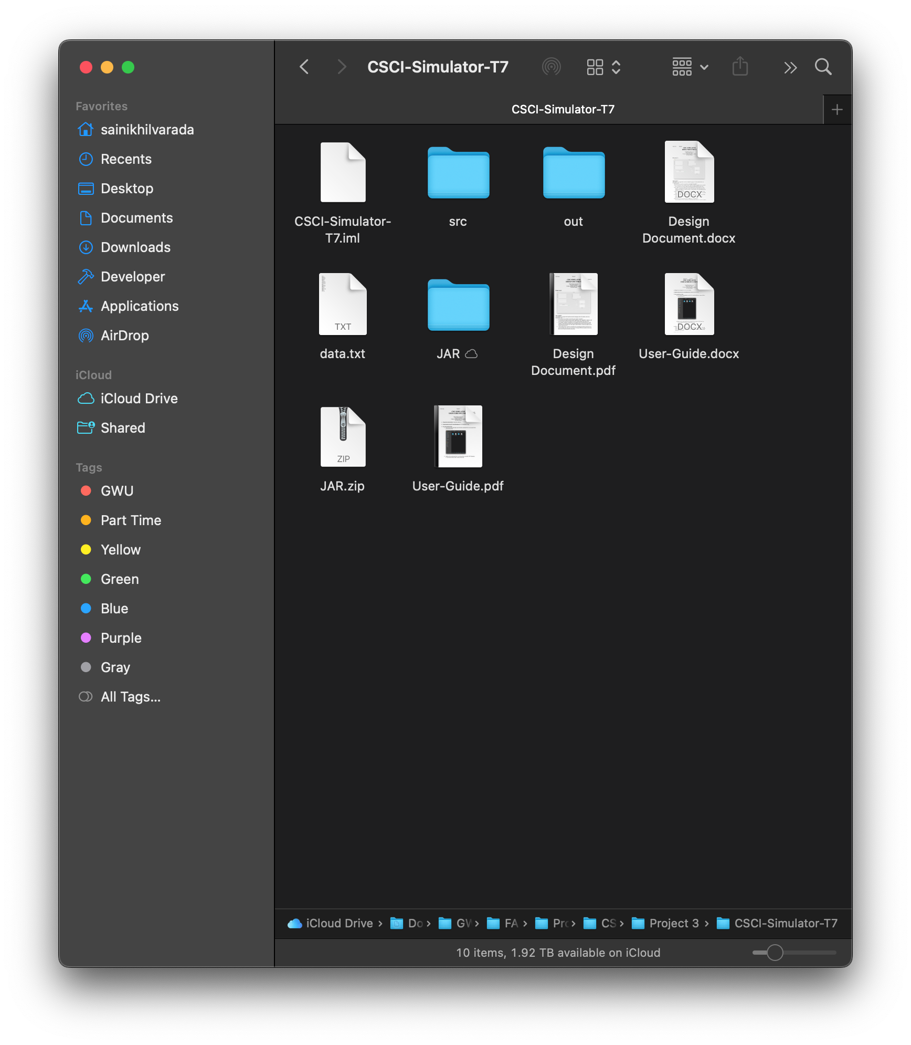
  - Double-click on the team12.jar to run the jar file or open the CISC-Simulator-T7.jar from the folder where you have these files.

- Project Phase 3:
As a continuation from part 2, in this phase, we have implemented all instructions and added the keyboard and printer to the consoles to the UI. Now the assembler will take a file with instructions from the user convert its content to hexadecimal format and then decode those instructions.

- Using the simulator:


NOTE:
The memory values from 0 to 5 are reserved, accessing them will raise an error.

  - Inside the JAR folder, we can see that there are 2 files called CSCI-Simulator-T7.jar and data.txt. The CSCI-Simulator-T7.jar is the main application and the data.txt file is the input to the assembler, the content of the data.txt file will be converted to a hexadecimal format and will be written to a file called instructions.txt. The instructions.txt will be only when we run the application.
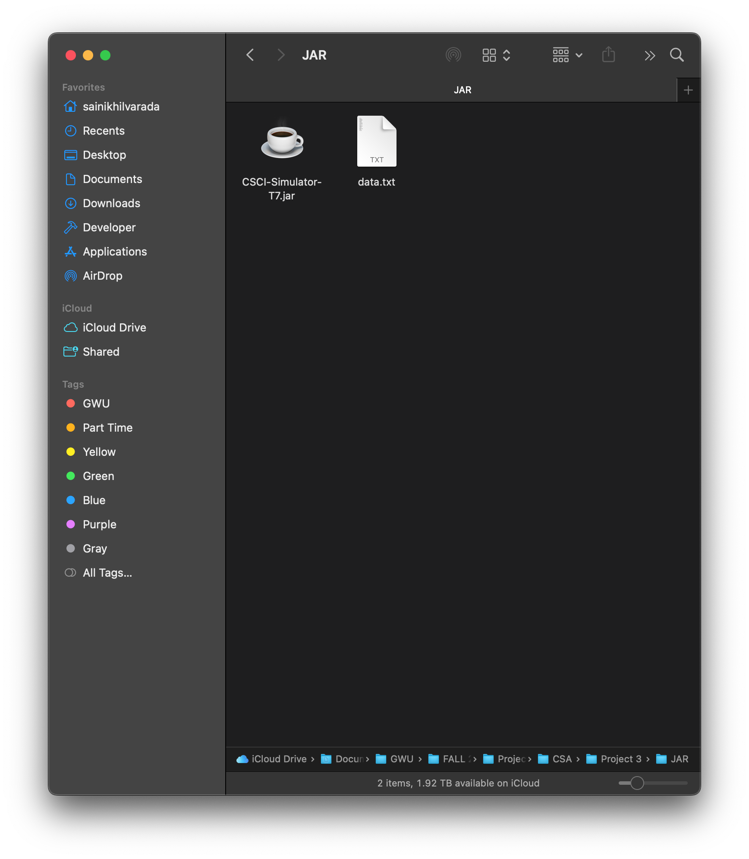

  - This instructions.txt file is fed as input into the simulator.
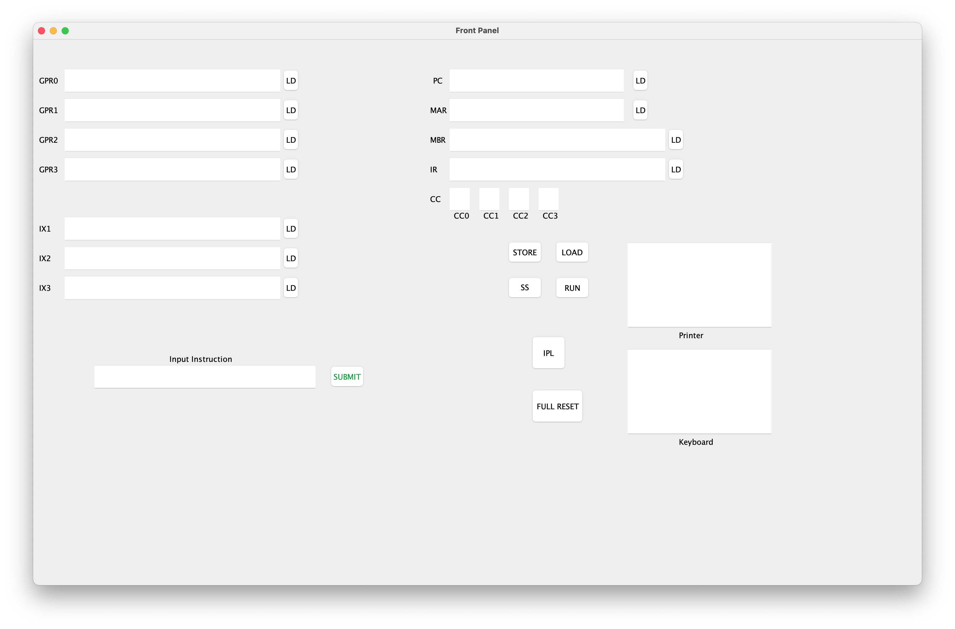
  - To load the data from the data.txt, we must press the IPL button.
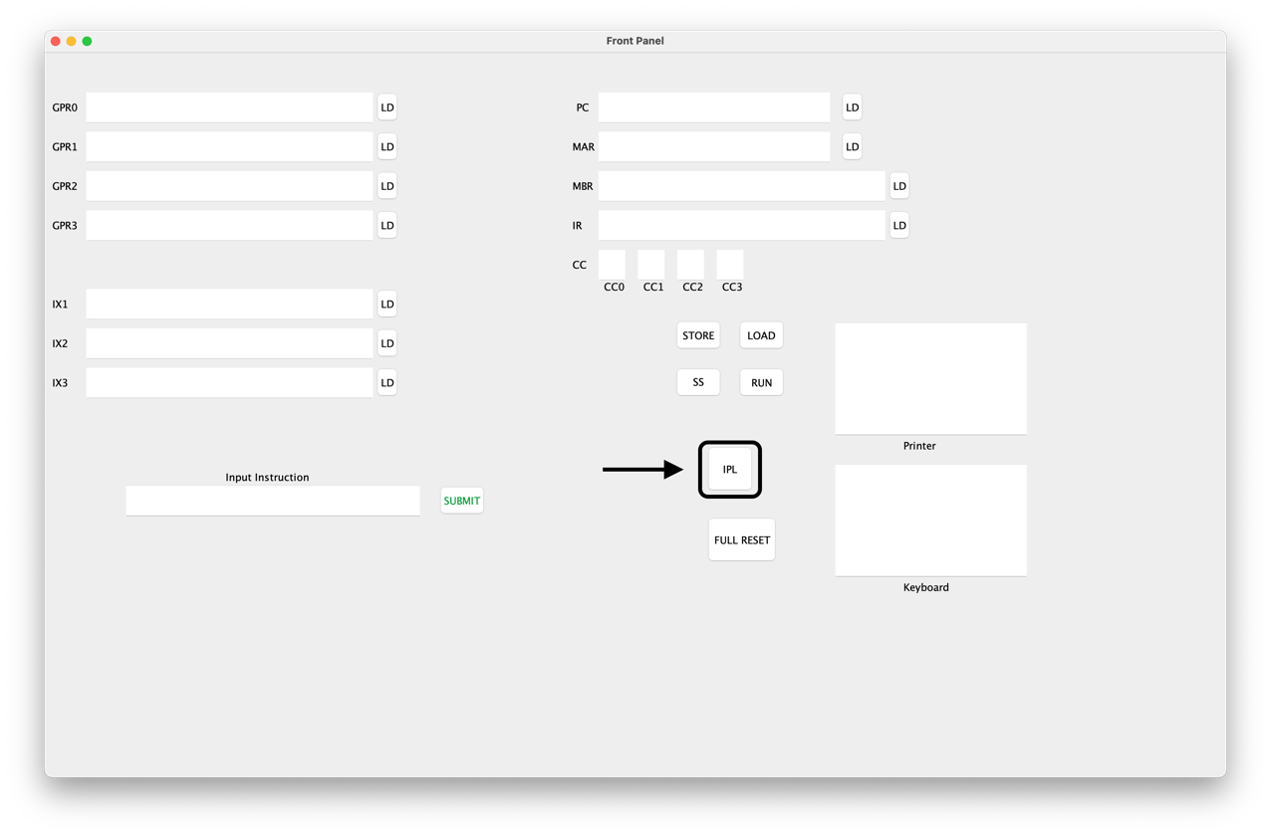

  - To run the application, enter a value into the “keyboard” so that it will smoothly without an error and then we must press the “RUN” button, this will generate the instruction.txt and take it as an input for the simulator.
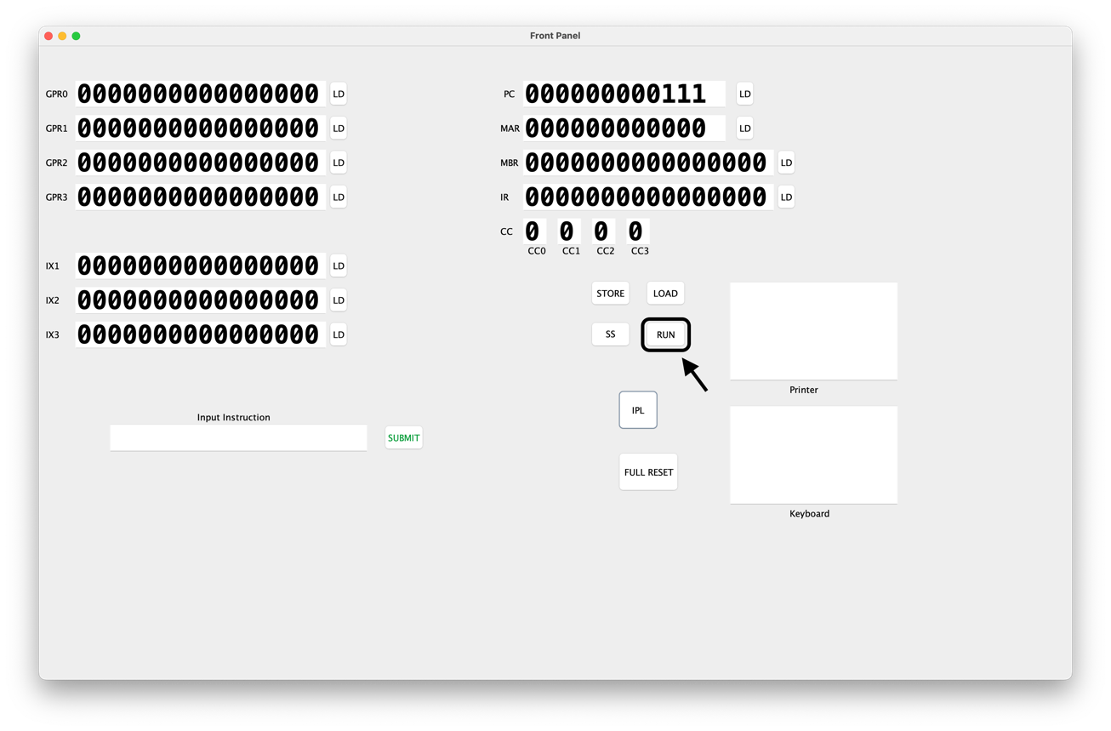
  - Click on “SS” to execute the instructions single step at a time.
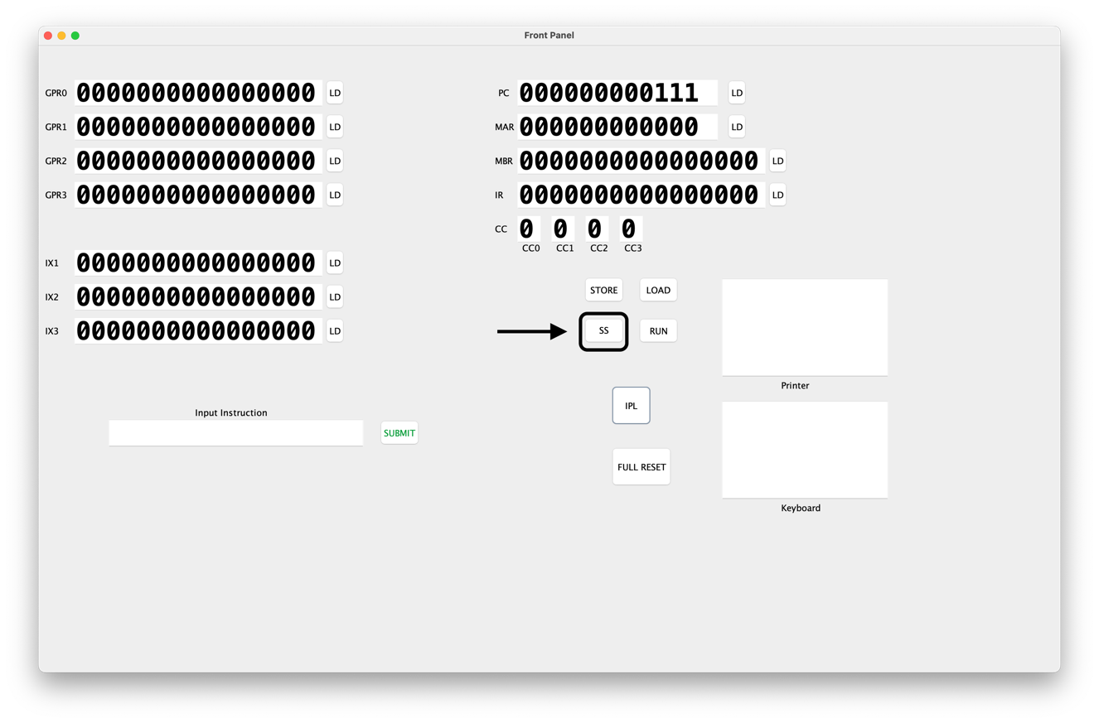

  - To execute “IN” and “OUT” instructions use the “Keyboard Console” and “Printer Display”.
While executing “IN”, we must enter a number into the “Keyboard Console”. This number will be stored in the register mentioned in the instruction.
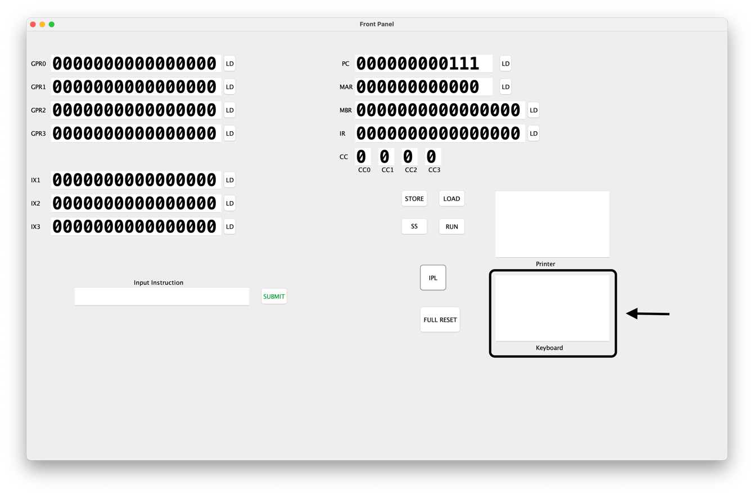

  - The “OUT” instruction will read the value from the register specified in the instruction and displays it in the “Printer Display”.
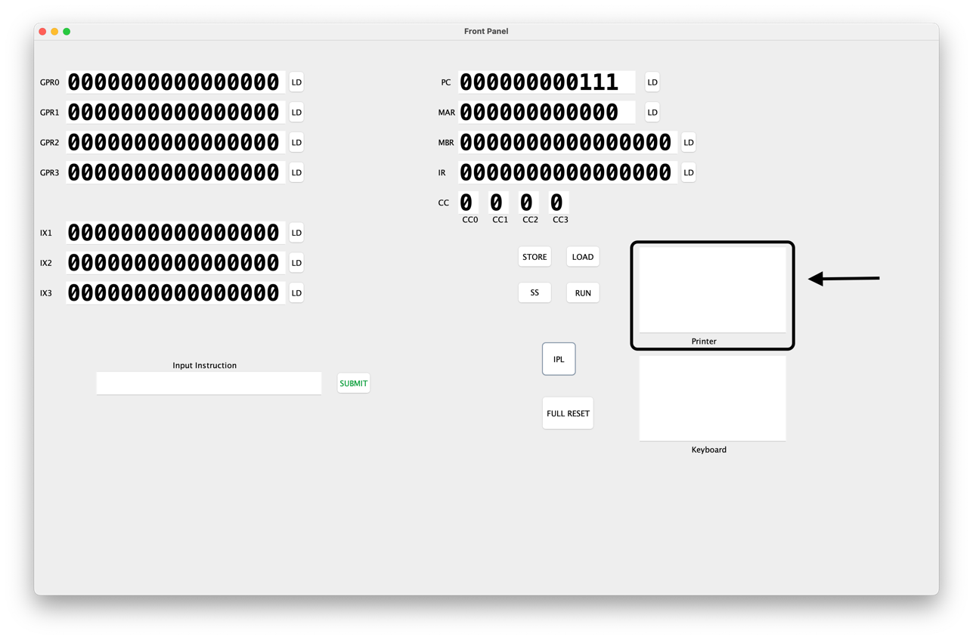

- Data.txt file :
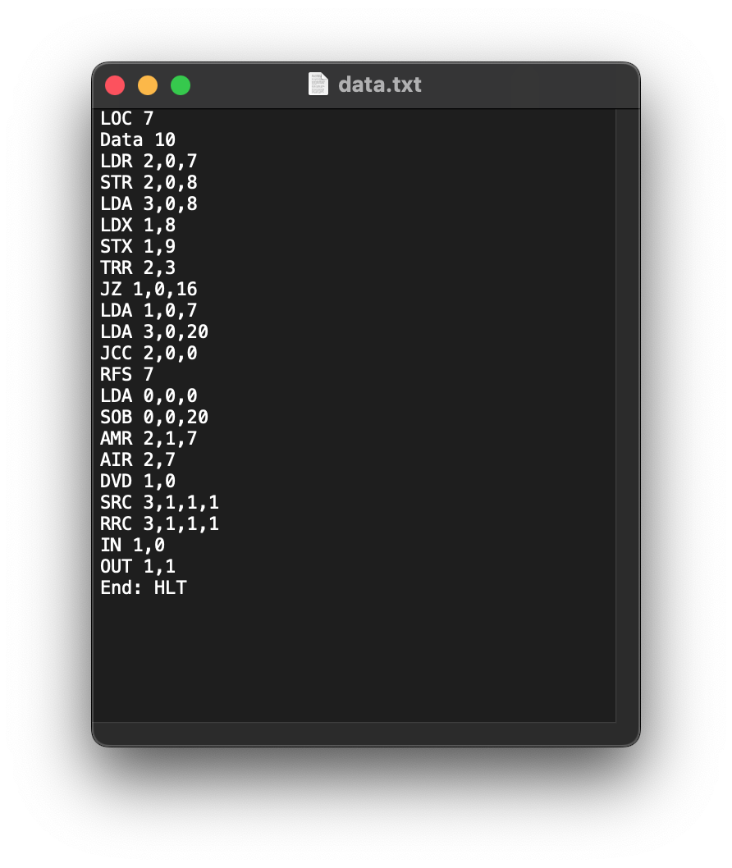

- Instructions.txt file :
