Jenkins Pipelines Implementation
- Create one Declarative pipeline job
  - Source Code: https://github.com/betawins/spring3-mvc-maven-xml-hello-world-1.git
- Create one Scripted pipeline job
  - Source Code: https://github.com/betawins/spring3-mvc-maven-xml-hello-world-1.git
- Create one Parameterized job
  - Source Code: https://github.com/betawins/spring3-mvc-maven-xml-hello-world-1.git
- Write sample skeleton for Declarative and Scripted pipelines
- Create one Declarative job
  - Source Code: https://github.com/betawins/sabear_simplecutomerapp/tree/feature-1.1
- Create one Declarative job
  - Source Code: https://github.com/betawins/Trading-UI.git
- Execute parallel stages using Jenkins pipeline for any sample job
- Execute Jenkins pipeline stages using shared libraries
  - Reference: https://phoenixnap.com/kb/jenkins-shared-library

Task 1 — Declarative Pipeline
Source repository: spring3-mvc-maven-xml-hello-world-1

Objective
Create a Jenkins Declarative Pipeline that:
Developer Code
|
v
GitHub Repository
|
v
Jenkins Pipeline
|
+----> Checkout
|
+----> Maven Compile
|
+----> Maven Test
|
+----> Maven Package
|
v
Success

1. Create the Jenkins job
In Jenkins:
Dashboard
↓
New Item
↓
Name: declarative-maven-demo
↓
Pipeline
↓
OK
Scroll to Pipeline.
Set:
Definition: Pipeline script
For this first task, we'll put the pipeline directly into Jenkins rather than changing the GitHub repository.

2. Declarative Jenkinsfile
Use this complete pipeline:
pipeline {
agent any

stages {
stage('Checkout') {
steps {
git 'https://github.com/betawins/spring3-mvc-maven-xml-hello-world-1.git'
}
}

stage('Compile') {
steps {
sh '''
set -e

echo "Cleaning previous build..."
mvn -B clean

echo "Copying application resources..."
mvn -B org.apache.maven.plugins:maven-resources-plugin:3.3.1:resources

echo "Compiling Java source with Java 8 compatibility..."
mvn -B org.apache.maven.plugins:maven-compiler-plugin:3.13.0:compile \
-Dmaven.compiler.release=8
'''
}
}

stage('Test') {
steps {
sh '''
set -e

echo "Preparing test resources..."
mvn -B org.apache.maven.plugins:maven-resources-plugin:3.3.1:testResources

echo "Compiling test source with the updated compiler plugin..."
mvn -B org.apache.maven.plugins:maven-compiler-plugin:3.13.0:testCompile \
-Dmaven.compiler.release=8

echo "Running tests..."
mvn -B org.apache.maven.plugins:maven-surefire-plugin:3.2.5:test
'''
}
}

stage('Package') {
steps {
sh '''
set -e

echo "Packaging the application as a WAR..."
mvn -B org.apache.maven.plugins:maven-war-plugin:3.4.0:war \
-DskipTests
'''
}
}

stage('Verify Artifact') {
steps {
sh '''
set -e

echo "Checking generated WAR file..."
find target -maxdepth 1 -type f -name '*.war' -print

WAR_FILE="$(find target -maxdepth 1 -type f -name '*.war' -print -quit)"

if [ -z "$WAR_FILE" ]; then
echo "ERROR: No WAR artifact was generated."
exit 1
fi

ls -lh "$WAR_FILE"
echo "Artifact verification successful."
'''
}
}
}

post {
success {
echo 'Pipeline completed successfully.'
}

failure {
echo 'Pipeline failed. Check the stage logs.'
}

always {
echo 'Pipeline execution completed.'
}
}
}
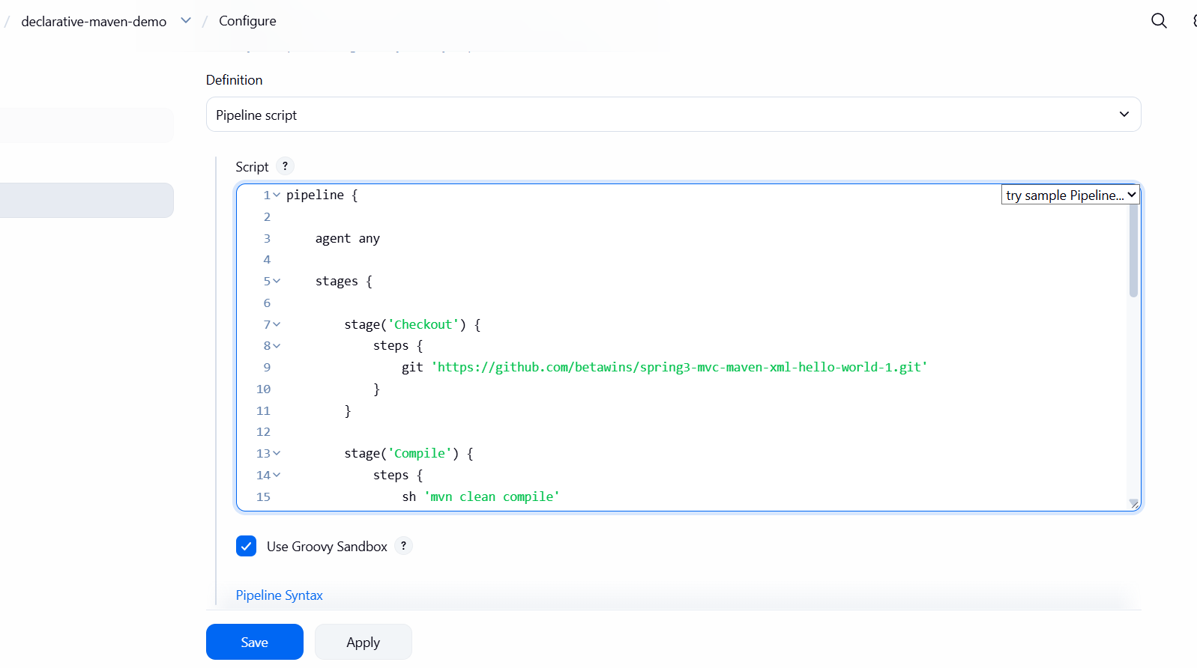

3. Save and Build
Click:
Save
Then:
Build Now

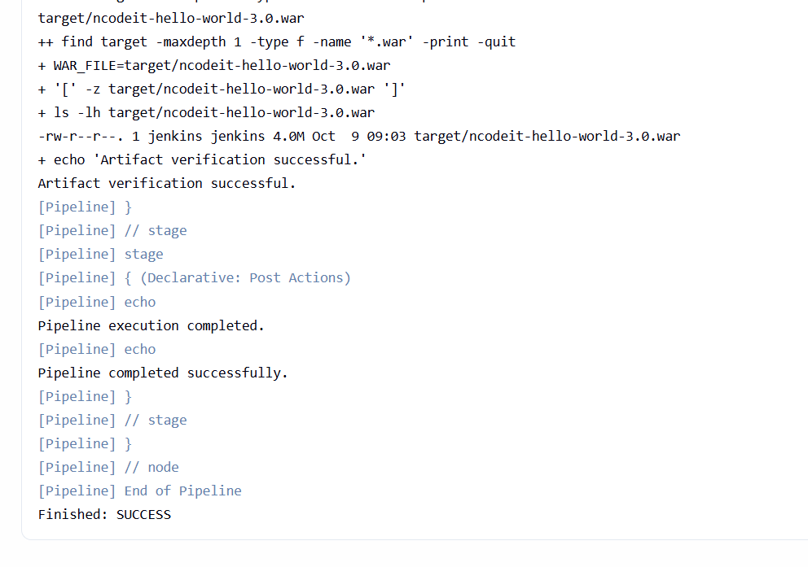
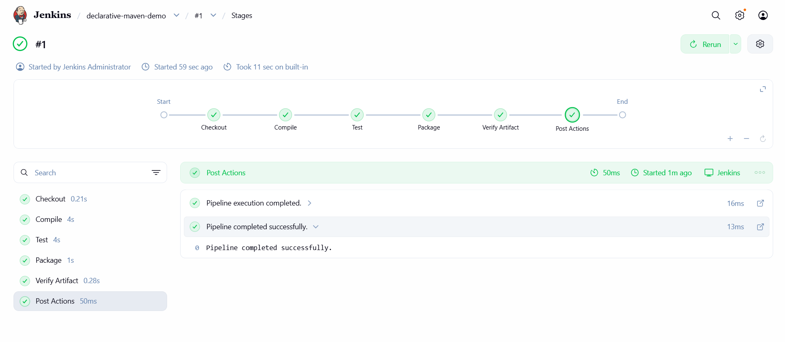
Jenkins should execute:
Checkout
↓
Compile
↓
Test
↓
Package
↓
Post

4. Expected result
In Console Output, you should see commands similar to:
[Pipeline] stage
[Pipeline] { (Checkout)
...
[Pipeline] { (Compile)
...
mvn clean compile
...
[Pipeline] { (Test)
...
mvn test
...
[Pipeline] { (Package)
...
mvn package -DskipTests
...
Pipeline completed successfully
The final result should be:
Finished: SUCCESS

Important Jenkins concept
This is Declarative Pipeline because it follows the predefined Jenkins structure:
pipeline {
agent
stages {
stage {
steps {
}
}
}
post {
}
}
The structure is intentionally strict.

Pipeline flow
pipeline
|
+-- agent
|
+-- stages
| |
| +-- Checkout
| |
| +-- Compile
| |
| +-- Test
| |
| +-- Package
|
+-- post
|
+-- success
+-- failure
+-- always

Outcome
You have created a Declarative Jenkins Pipeline that:
- Clones the GitHub repository
- Compiles the Maven application
- Runs tests
- Creates the Maven package
- Handles success/failure using post

Task 2 — Create a Scripted Pipeline Job in Jenkins
Objective: Create a Jenkins Scripted Pipeline that clones the same GitHub repository used in Task 1, compiles the Maven project, runs tests, and packages the application.
Source code: betawins/spring3-mvc-maven-xml-hello-world-1

1. Create a new Jenkins job
Open your Jenkins dashboard and follow these steps:
- Click New Item.
- Enter the job name: scripted-maven-demo
- Select Pipeline.
- Click OK.
- Scroll down to the Pipeline section.
- Set Definition to Pipeline script.
Keep Task 1's Declarative job unchanged.

2. Write the Scripted Pipeline

node {
stage('Checkout') {
git 'https://github.com/betawins/spring3-mvc-maven-xml-hello-world-1.git'
}

stage('Inspect Maven Configuration') {
sh '''
echo "Java version:"
java -version

echo "Maven version:"
mvn -version

echo "Compiler settings in pom.xml:"
grep -n -B 5 -A 10 -E \
'maven.compiler|<source>|<target>|maven-compiler-plugin' pom.xml
'''
}
}

3. Execute the pipeline
- Click Save.
- Click Build Now.
- Open Build History.
- Select the latest build.
- Click Console Output.
Expected execution flow:
node
Allocate an executor and workspace
Stage 1 — Checkout GitHub
Stage 2 — Maven Compile
Stage 3 — Maven Test
Stage 4 — Maven Package
Finally — Print completion message
If every stage succeeds, the build should finish with:
Pipeline execution completed
Finished: SUCCESS
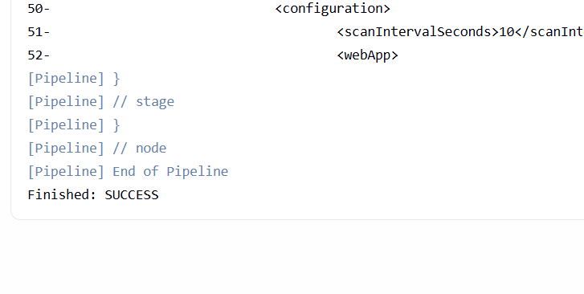
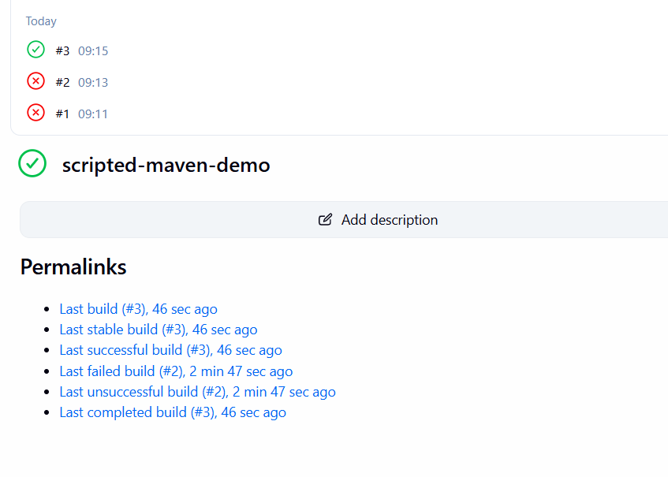
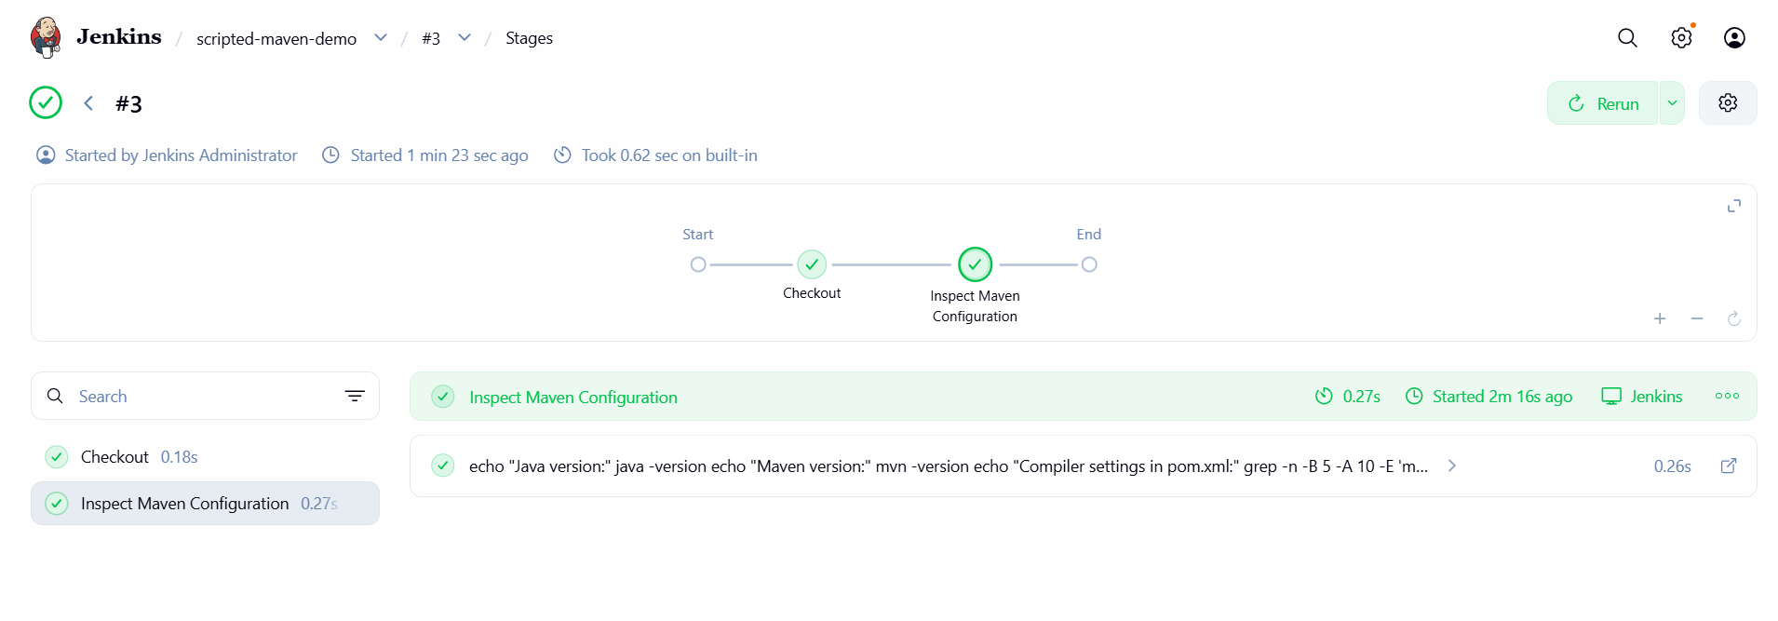

Task 3 — Create a Parameterized Jenkins Job
Objective: Create a Jenkins Pipeline job that accepts user-defined parameters when the job is started and uses those values during the Maven build.
Source code: betawins/spring3-mvc-maven-xml-hello-world-1
We'll create a Declarative Pipeline with three parameters:
- BUILD_ACTION — choose whether to compile, test, or package.
- RUN_TESTS — choose whether to run tests.
- APP_ENV — select the target environment.

1. Create the Jenkins job
- Open Jenkins Dashboard.
- Click New Item.
- Enter parameterized-maven-demo.
- Select Pipeline, then click OK.
- Scroll down to Pipeline and select Pipeline script.

2. Add the complete Jenkinsfile
Paste this script into the Pipeline script box.
pipeline {
agent any

parameters {
choice(
name: 'BUILD_ACTION',
choices: ['compile', 'test', 'package'],
description: 'Select the Maven build action'
)

booleanParam(
name: 'RUN_TESTS',
defaultValue: true,
description: 'Run unit tests during the build'
)

choice(
name: 'APP_ENV',
choices: ['dev', 'qa', 'prod'],
description: 'Select the application environment'
)
}

stages {

stage('Checkout') {
steps {
echo 'Checking out source code from GitHub'

git(
url: 'https://github.com/betawins/spring3-mvc-maven-xml-hello-world-1.git',
branch: 'master'
)
}
}

stage('Java and Maven Version') {
steps {
echo 'Checking Java and Maven versions'

sh '''
java -version
mvn -version
'''
}
}

stage('Fix Workspace Maven Configuration') {
steps {
echo 'Configuring a compatible Maven WAR plugin in the workspace'

sh '''
set -eu

python3 - <<'PY'
import xml.etree.ElementTree as ET
from pathlib import Path

pom = Path("pom.xml")

if not pom.exists():
raise SystemExit("ERROR: pom.xml was not found in the workspace")

tree = ET.parse(pom)
root = tree.getroot()

# Support Maven POMs with or without the standard XML namespace.
if root.tag.startswith("{"):
namespace = root.tag.split("}")[0][1:]
else:
namespace = ""

def tag(name):
if namespace:
return "{" + namespace + "}" + name
return name

if namespace:
ET.register_namespace("", namespace)

build = root.find(tag("build"))

if build is None:
build = ET.SubElement(root, tag("build"))

plugins = build.find(tag("plugins"))

if plugins is None:
plugins = ET.SubElement(build, tag("plugins"))

war_plugin = None

for plugin in plugins.findall(tag("plugin")):
artifact_id = plugin.find(tag("artifactId"))

if artifact_id is not None and artifact_id.text == "maven-war-plugin":
war_plugin = plugin
break

if war_plugin is None:
war_plugin = ET.SubElement(plugins, tag("plugin"))
group_id = ET.SubElement(war_plugin, tag("groupId"))
group_id.text = "org.apache.maven.plugins"

artifact_id = ET.SubElement(war_plugin, tag("artifactId"))
artifact_id.text = "maven-war-plugin"

version = war_plugin.find(tag("version"))

if version is None:
version = ET.SubElement(war_plugin, tag("version"))

version.text = "3.4.0"

ET.indent(tree, space=" ")
tree.write(pom, encoding="UTF-8", xml_declaration=True)

print("Workspace pom.xml configured with maven-war-plugin 3.4.0")
PY

echo 'Checking the configured WAR plugin version'
mvn help:evaluate \
-Dexpression=project.build.plugins \
-q \
-DforceStdout || true
'''
}
}

stage('Verify Compiler Property') {
steps {
echo 'Verifying the Java compiler property'

sh '''
set -eu
mvn help:evaluate \
-Dexpression=jdk.version \
-Djdk.version=1.8 \
-q \
-DforceStdout

echo
'''
}
}

stage('Display Parameters') {
steps {
echo "Selected build action: ${params.BUILD_ACTION}"
echo "Run tests: ${params.RUN_TESTS}"
echo "Application environment: ${params.APP_ENV}"
}
}

stage('Compile') {
when {
expression {
params.BUILD_ACTION in ['compile', 'test', 'package']
}
}

steps {
echo 'Compiling the application'

sh '''
set -eu
mvn clean compile -Djdk.version=1.8
'''
}
}

stage('Test') {
when {
expression {
params.BUILD_ACTION in ['test', 'package']
}
}

steps {
script {
if (params.RUN_TESTS) {
echo 'Running Maven tests'

sh '''
set -eu
mvn test -Djdk.version=1.8
'''
} else {
echo 'Tests skipped because RUN_TESTS is false'
}
}
}
}

stage('Package') {
when {
expression {
params.BUILD_ACTION == 'package'
}
}

steps {
script {
if (params.RUN_TESTS) {
echo 'Packaging the application with tests enabled'

sh '''
set -eu
mvn package -Djdk.version=1.8
'''
} else {
echo 'Packaging the application without running tests'

sh '''
set -eu
mvn package -DskipTests -Djdk.version=1.8
'''
}
}
}
}

stage('Verify Artifact') {
when {
expression {
params.BUILD_ACTION == 'package'
}
}

steps {
echo 'Verifying the generated WAR artifact'

sh '''
set -eu

echo "Contents of target directory:"
ls -lh target/

echo "Checking for WAR files:"
ls -lh target/*.war
'''
}
}
}

post {
success {
echo "Build completed successfully for environment: ${params.APP_ENV}"
}

failure {
echo 'Build failed. Review the console output for the failing stage.'
}

always {
echo 'Build execution finished.'
}
}
}
Click Save.

3. Execute the parameterized job
Open the job parameterized-maven-demo.
Instead of the usual Build Now button, Jenkins should display Build with Parameters.
Click it.

Example build parameters
BUILD_ACTION
compile — compile the application
test — compile and run tests
package — compile, test (if enabled), and package
RUN_TESTS — run unit tests
APP_ENV
dev
qa
prod
Selected configuration
Action: {action}
Run tests: {String(tests)}
Environment: {env}
This is a preview only; it does not trigger a Jenkins build.
Copy selected values
Use these values in the actual Jenkins Build with Parameters form. The interactive preview above does not submit a build.

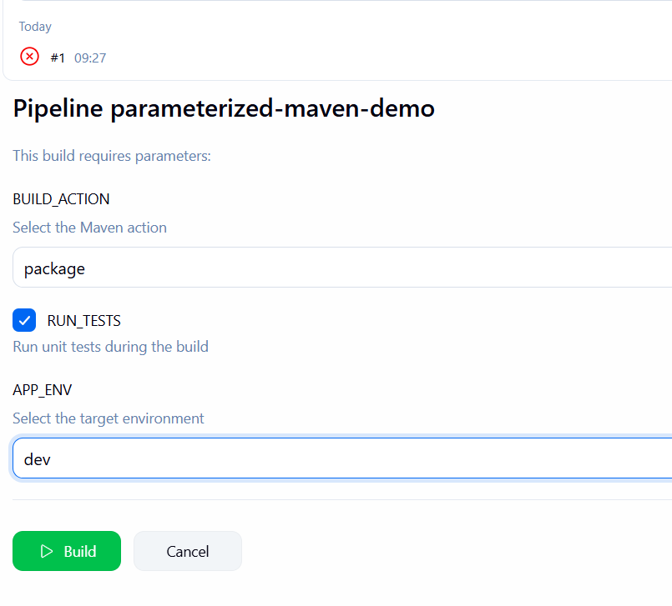

4. Understand the execution flow
User selects parameters
Jenkins checks out GitHub source
Pipeline evaluates when conditions
Selected Maven stages execute
Build result appears in Jenkins
For example, if you select BUILD_ACTION=package, RUN_TESTS=true, and APP_ENV=qa, Jenkins checks out the repository, compiles the project, runs tests, and packages it. The log identifies qa as the selected environment.
Important: APP_ENV only labels the build in this example. It does not deploy the application to QA or production. Actual deployment requires additional stages and environment-specific configuration.

5. Verify success
Open Console Output and look for messages similar to:
Build action: package
Run tests: true
Target environment: qa
...
Build completed successfully for qa
Parameterized pipeline execution finished
Finished: SUCCESS

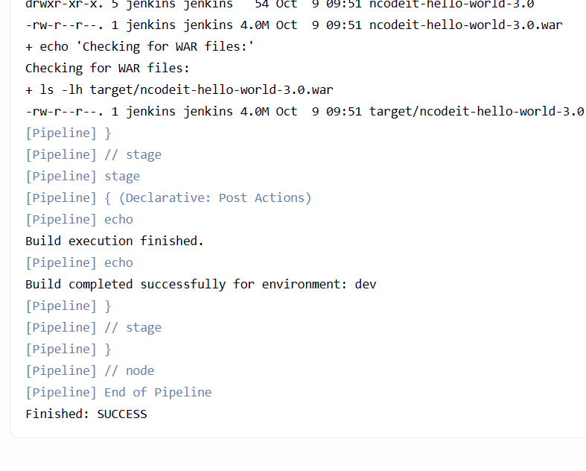
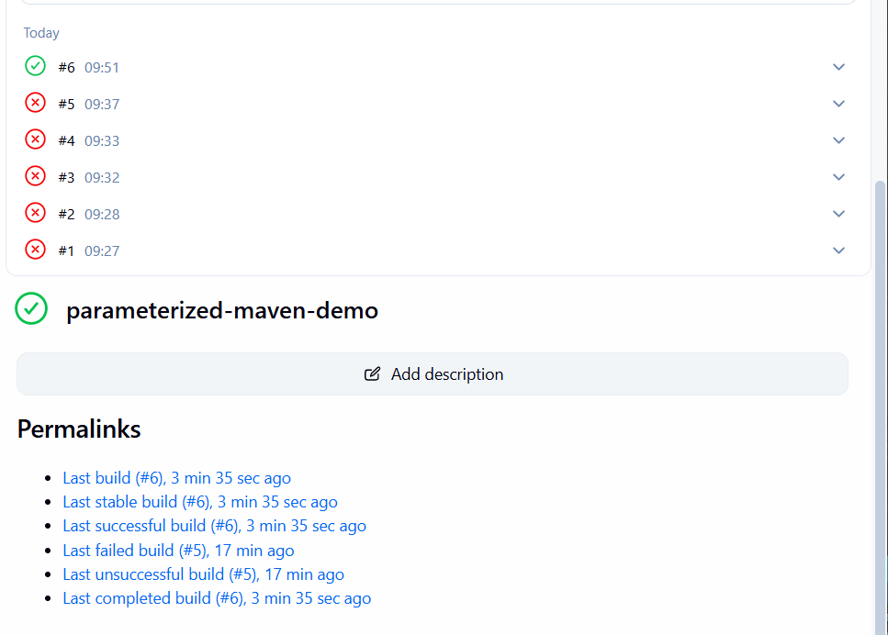
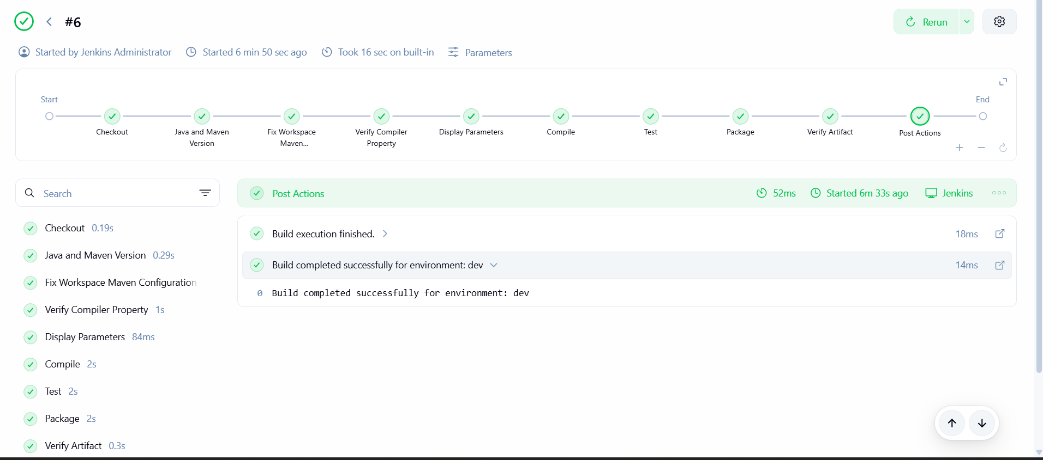

Task 4 — Sample Skeletons for Declarative and Scripted Pipelines
Objective: Understand the basic structure of both Jenkins pipeline types, learn what each block does, and prepare reusable skeletons for future CI/CD projects.

1. Declarative Pipeline skeleton
Declarative Pipeline uses a predefined structure starting with pipeline {}.

pipeline {

agent any

environment {
APP_NAME = 'myapp'
}

parameters {
string(
name: 'BUILD_VERSION',
defaultValue: '1.0',
description: 'Application version'
)
}

stages {

stage('Checkout') {
steps {
echo 'Checking out source code'
}
}

stage('Build') {
steps {
echo "Building ${APP_NAME}"
echo "Version: ${params.BUILD_VERSION}"
}
}

stage('Test') {
steps {
echo 'Running tests'
}
}

stage('Deploy') {
steps {
echo 'Deploying application'
}
}
}

post {
success {
echo 'Pipeline succeeded'
}

failure {
echo 'Pipeline failed'
}

always {
echo 'Pipeline execution finished'
}
}
}
This is a skeleton for learning pipeline syntax. It prints messages rather than actually checking out, building, testing, or deploying an application.

Explanation of each block
Block | Purpose
pipeline {} | Root block of a Declarative Pipeline
agent any | Allows Jenkins to choose any available eligible agent
environment {} | Defines environment variables
parameters {} | Defines user inputs for a build
stages {} | Contains the pipeline's stages
stage('Build') | Names a stage in the pipeline
steps {} | Contains the commands or steps for that stage
post {} | Defines actions based on the final build result

Declarative execution flow
pipeline {}
agent — allocate execution environment
environment and parameters — configure the build
stages — execute tasks in order
post — handle the build outcome

2. Scripted Pipeline skeleton
Scripted Pipeline uses Groovy-based procedural logic. A common starting point is node {}.

node {

try {

stage('Checkout') {
echo 'Checking out source code'
}

stage('Build') {
def appName = 'myapp'
def buildVersion = '1.0'

echo "Building ${appName}"
echo "Version: ${buildVersion}"
}

stage('Test') {
echo 'Running tests'
}

stage('Deploy') {
echo 'Deploying application'
}

} catch (Exception e) {

echo "Pipeline failed: ${e.getMessage()}"
throw e

} finally {

echo 'Pipeline execution finished'
}
}
This is also a learning skeleton. It demonstrates the structure without performing actual application build or deployment operations.

Explanation of each block
Syntax | Purpose
node {} | Allocates a Jenkins executor and workspace
try {} | Runs the main pipeline logic
stage('Build') | Groups steps under a named stage
def appName | Declares a Groovy local variable
echo | Prints a message in the build log
catch (Exception e) | Handles an exception
throw e | Rethrows the exception so the build remains failed
finally {} | Runs the cleanup or completion logic regardless of success or failure

3. Declarative vs. Scripted — key differences
Feature | Declarative | Scripted
Entry point | pipeline {} | Usually node {}
Structure | Predefined and strict | More flexible and procedural
Stage steps | Inside steps {} | Can be called directly inside stage {}
Variables | Supports environment and Groovy variables | Commonly uses Groovy variables
Conditions | Often uses when {} | Often uses if/else
Error handling | Supports post conditions | Supports try/catch/finally
Best suited for | Standard CI/CD pipelines | Complex custom control flow

Task 5 — Declarative Pipeline for sabear_simplecutomerapp
Objective: Create a Jenkins Declarative Pipeline that checks out the feature-1.1 branch of the application, identifies its build technology, and executes the appropriate build and test commands.
Repository: betawins/sabear_simplecutomerapp
We'll create a new Jenkins job without modifying the GitHub repository.

1. Create the Jenkins job
- Open the Jenkins Dashboard.
- Click New Item.
- Enter the job name sabear-customerapp-declarative.
- Select Pipeline, then click OK.
- Scroll to the Pipeline section.
- Set Definition to Pipeline script.

2. Add the Jenkinsfile
pipeline {
agent any

options {
timestamps()
}

stages {
stage('Checkout') {
steps {
git branch: 'feature-1.1',
url: 'https://github.com/betawins/sabear_simplecutomerapp.git'
}
}

stage('Inspect Project') {
steps {
sh '''
echo "Current branch:"
git branch --show-current

echo "Project files:"
ls -la

echo "Build files:"
find . -maxdepth 2 -type f \\( -name 'pom.xml' -o -name 'build.xml' -o -name 'README*' \\) -print
'''
}
}

stage('Validate Maven') {
steps {
sh '''
if [ -f pom.xml ]; then
echo "Maven project detected"
mvn -version
else
echo "pom.xml not found"
exit 1
fi
'''
}
}

stage('Build') {
steps {
sh 'mvn clean package'
}
}
}

post {
success {
echo 'Customer application build completed successfully'
}

failure {
echo 'Pipeline failed. Check the first failing stage.'
}

always {
echo 'Task 5 pipeline execution finished'
}
}
}
Click Save, then Build Now.

3. Run the job
- Click Save.
- Click Build Now.
- Open Console Output.
Expected stage sequence:
Checkout
Inspect Project
Validate Maven
Build
Declarative: Post Actions
Finished: SUCCESS
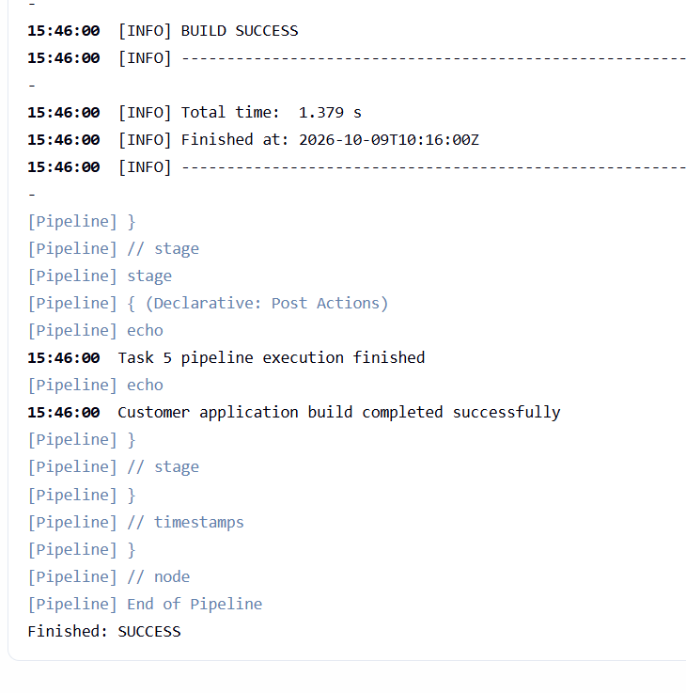
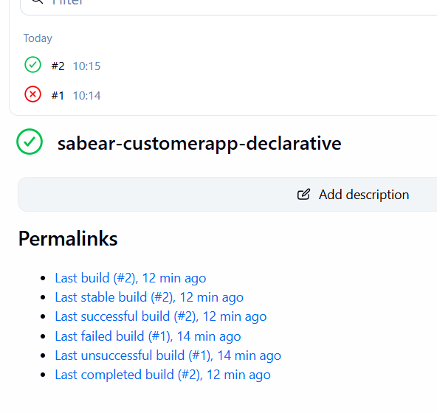
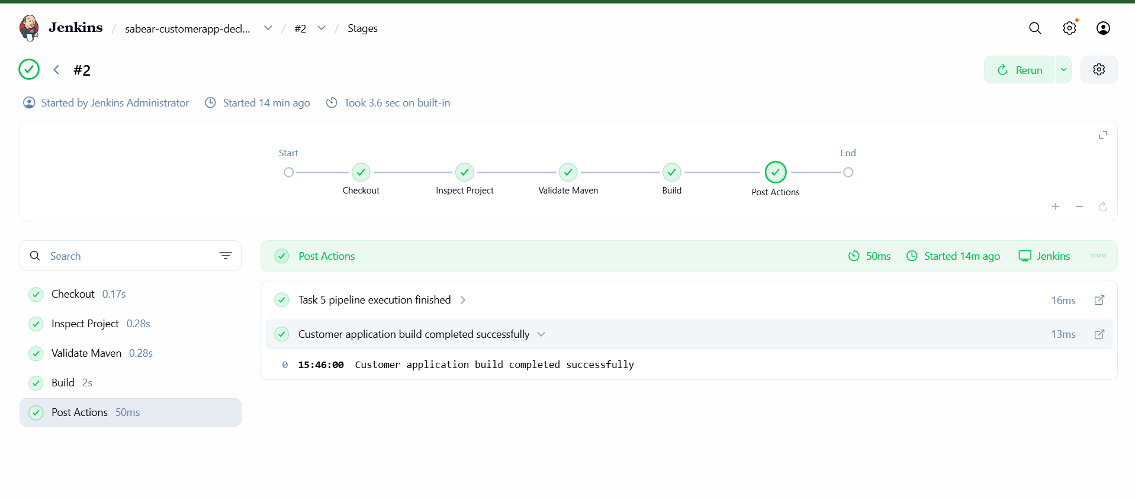

Task 6 — Create a Declarative Pipeline for Trading-UI
Objective: Create a Jenkins Declarative Pipeline to build and test the Node.js frontend application from GitHub.
Source repository: betawins/Trading-UI
We'll create a separate job so your successful Task 5 job remains unchanged.

1. Create the Jenkins job
- Open Jenkins Dashboard.
- Click New Item.
- Enter the name trading-ui-declarative.
- Select Pipeline and click OK.
- Scroll down to the Pipeline section.
- Set Definition to Pipeline script.

2. Add the complete Jenkinsfile
Paste the following into the Script box.

pipeline {
agent any

options {
timestamps()
skipDefaultCheckout(true)
}

environment {
NODE_OPTIONS = '--openssl-legacy-provider'
CI = 'false'
}

stages {
stage('Checkout') {
steps {
git branch: 'master',
url: 'https://github.com/betawins/Trading-UI.git'
}
}

stage('Check Node and npm') {
steps {
sh '''
node --version
npm --version
'''
}
}

stage('Install Dependencies') {
steps {
sh 'npm install --legacy-peer-deps'
}
}

stage('Build React Application') {
steps {
sh 'npm run build'
}
}
}

post {
success {
echo 'React production build completed successfully.'
}

failure {
echo 'Pipeline failed. Check the console output.'
}

always {
echo 'Task 6 pipeline execution finished.'
}
}
}
This pipeline assumes the repository's branch is main and its package.json supports the test and build commands shown. If the repository uses a different default branch or test runner, we'll adjust based on the console output.

3. Check prerequisites on your Jenkins agent
Your Jenkins agent needs Node.js and npm installed. In your earlier Trading-UI practice, you used Node.js 18.20.8 and npm 10.8.2.
Run these commands on the machine executing the pipeline, if you need to verify the installation:
node --version
npm --version
Expected versions:
v18.20.8
10.8.2
If Jenkins reports node: command not found, Node.js may be installed only for your login user rather than being available to the Jenkins service.

4. Run the pipeline
- Click Save.
- Click Build Now.
- Open Console Output.
The stages execute in this order:
1. Checkout — clone Trading-UI
2. Check Node.js and npm
3. Install dependencies
4. Run automated tests
5. Build the frontend
Important: Your earlier Trading-UI practice encountered a failure in Purchase.test involving #submit. If that test fails again, Jenkins should correctly mark the build as failed and skip the build stage. Don't disable or ignore the failing test just to obtain a successful pipeline.

5. Verify the result
A successful run should end with:
Trading-UI pipeline completed successfully
Trading-UI pipeline execution finished
Finished: SUCCESS
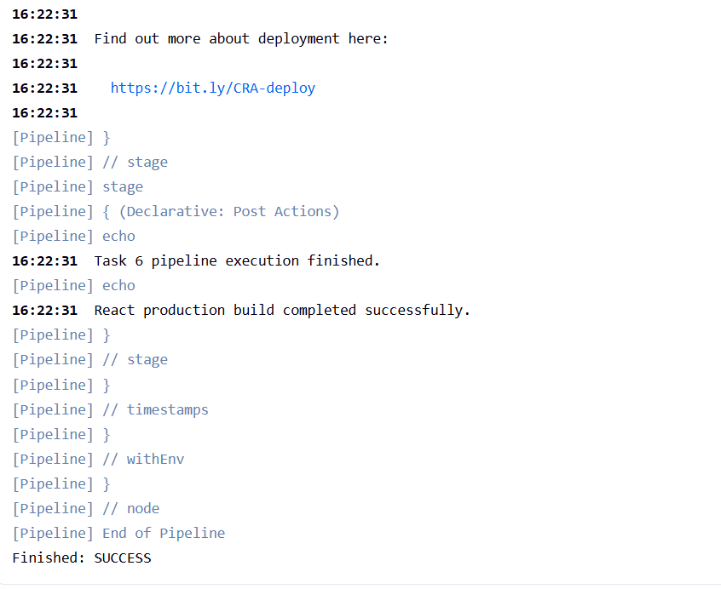
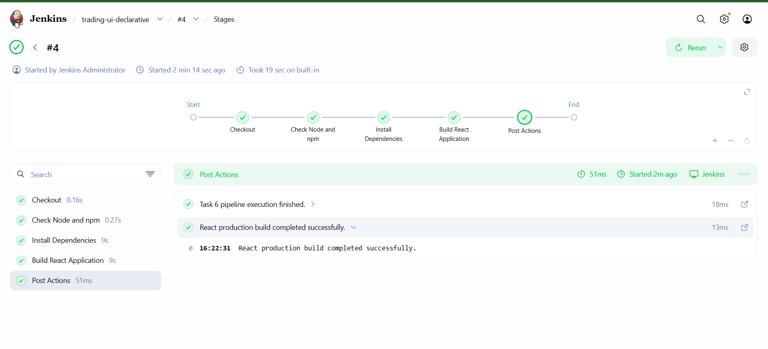
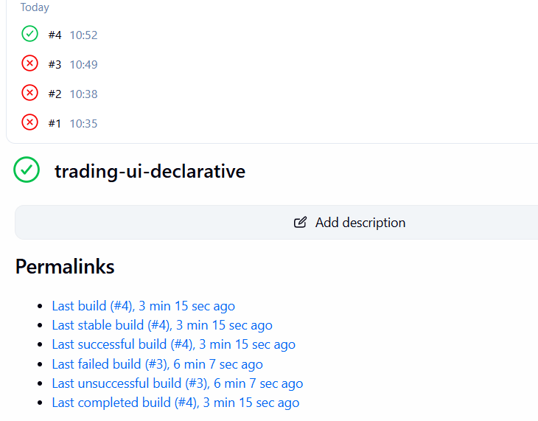

Task 7: Jenkins Pipeline with Parallel Stages
Objective: Create a Jenkins Declarative Pipeline that runs multiple stages simultaneously to reduce the overall pipeline execution time.

7.1 Understand parallel stages
Normally, Jenkins executes stages sequentially, one after another. With parallel, Jenkins can execute independent stages at the same time.
Jenkins Pipeline
Starts the parallel execution
Build
Compile application
Security Check
Check dependencies
Unit Tests
Run tests
Code Analysis
Analyze code
Pipeline continues
After all parallel branches finish successfully
In a real pipeline, the tasks should be independent and the required tools must be available on the Jenkins agents.

7.2 Create the Jenkins job
- Open Jenkins at http://<your-jenkins-server>:8081.
- Click New Item.
- Enter the job name jenkins-parallel-stages.
- Select Pipeline, then click OK.
- Scroll to the Pipeline section.
- Set Definition to Pipeline script.

7.3 Complete Jenkinsfile
Paste this complete Declarative Pipeline into the Script box.

pipeline {
agent any

options {
timestamps()
}

stages {
stage('Initialize') {
steps {
echo 'Pipeline started.'
echo "Build number: ${BUILD_NUMBER}"
echo "Workspace: ${WORKSPACE}"
}
}

stage('Parallel Execution') {
parallel {
stage('Build Application') {
steps {
echo 'Building application...'
sh '''
echo "Build started"
sleep 10
echo "Build completed"
'''
}
}

stage('Run Unit Tests') {
steps {
echo 'Running unit tests...'
sh '''
echo "Tests started"
sleep 10
echo "Tests completed"
'''
}
}

stage('Security Scan') {
steps {
echo 'Running security checks...'
sh '''
echo "Security scan started"
sleep 10
echo "Security scan completed"
'''
}
}
}
}

stage('Post Parallel Execution') {
steps {
echo 'All parallel branches completed successfully.'
}
}
}

post {
success {
echo 'Pipeline completed successfully.'
}

failure {
echo 'Pipeline failed. Check the Console Output.'
}

always {
echo 'Pipeline execution finished.'
}
}
}
This is a demonstration pipeline: sleep 10 simulates work, rather than performing a real build, test, or security scan. It does not require modifying any GitHub repository.

7.4 Execute and verify
- Click Save.
- Click Build Now.
- Open the build's Console Output.
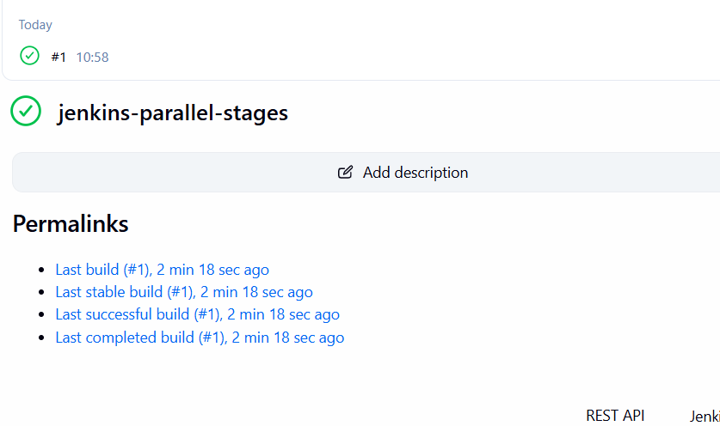
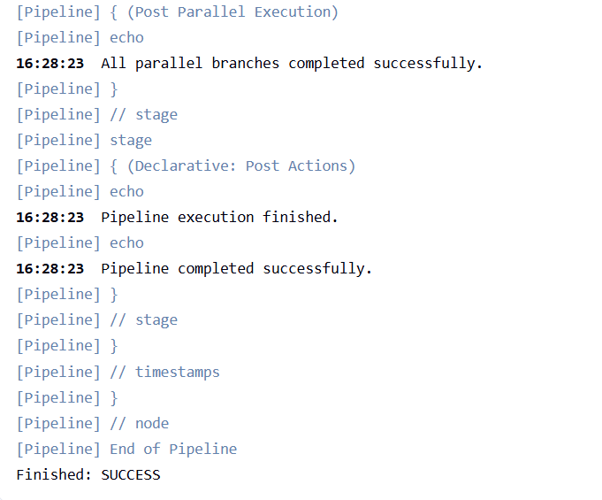

You should see the three parallel branches begin around the same time:
- Build Application
- Run Unit Tests
- Security Scan
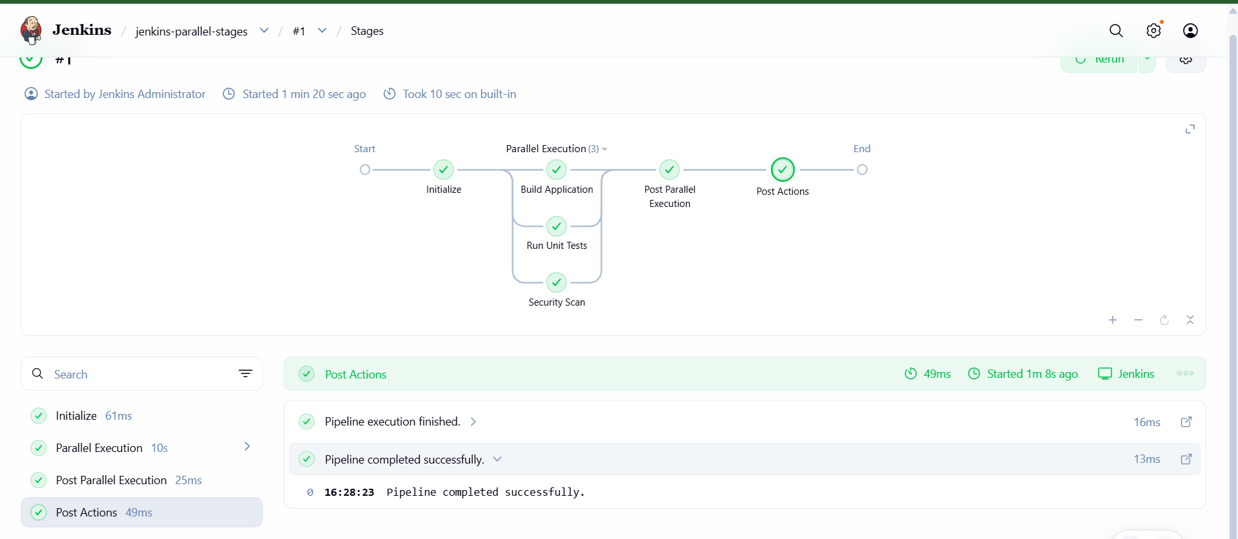
Each waits approximately 10 seconds. If Jenkins has enough executor capacity, the parallel stage should take roughly 10 seconds plus startup overhead, instead of roughly 30 seconds if all three ran sequentially.

7.5 Understand the execution flow
- Initialize: Prints the build number and workspace.
- Parallel Execution: Jenkins launches the three independent branches.
- Build Application: Simulates a build operation.
- Run Unit Tests: Simulates testing independently of the build.
- Security Scan: Simulates a security check.
- Post Parallel Execution: Runs after all parallel branches succeed.
- Post actions: Reports overall success or failure.

Task 8: Jenkins Shared Libraries
Objective: Create a reusable Jenkins Shared Library and use it from a Jenkins Pipeline so common steps—such as building an application, running SonarQube analysis, and building a Docker image—can be maintained separately from individual Jenkinsfiles.

8.1 What is a Jenkins Shared Library?
A Jenkins Shared Library is a collection of reusable Groovy code that multiple Jenkins pipelines can call.
Without a shared library, you might copy the same build and scan stages into several Jenkinsfiles. With a shared library, you define those operations once and reuse them.
Application A — Jenkinsfile
Application B — Jenkinsfile
Application C — Jenkinsfile
Jenkins Shared Library
Common build, test, scan and deployment functions
For example, if three applications use the same Maven build procedure, you can define buildApp() once and call it from all three pipelines.

8.2 Understand the directory structure
A typical Shared Library repository looks like this:
jenkins-shared-library/
vars/
Contains globally accessible pipeline steps, such as buildApp.groovy and sonarScan.groovy.
src/
Contains reusable Groovy classes organized using package directories.
resources/
Contains non-code resources such as templates and configuration files.
The most important directory for this lab is vars/, because we'll define functions that the Jenkinsfile can call directly.

8.3 Create a separate GitHub repository
To keep your existing application repositories unchanged, create a new repository dedicated to the Shared Library.
- Open GitHub and click New repository.
- Name it jenkins-shared-library.
- Set it to Public for this practice lab.
- Initialize it with a README, then clone it to your computer or create the files directly on GitHub.
Create this structure:
jenkins-shared-library/
├── vars/
│ ├── buildApp.groovy
│ ├── sonarScan.groovy
│ └── dockerBuild.groovy
├── src/
│ └── org/
│ └── demo/
│ └── AppUtils.groovy
└── README.md

8.4 Create the Shared Library functions

File 1: vars/buildApp.groovy
This function runs a Maven build.

def call() {
echo 'Building the application with Maven'

sh 'mvn -B clean package'
}

File 2: vars/sonarScan.groovy
This example runs Maven with the SonarQube scanner goal. It assumes the project has a configured SonarQube server and valid scanner configuration.

def call() {
echo 'Running SonarQube analysis'

withSonarQubeEnv('SonarQube') {
sh 'mvn -B sonar:sonar'
}
}
SonarQube must match the SonarQube installation name configured in Jenkins under Manage Jenkins → System. The project may also require a configured SonarQube token and project properties.

File 3: vars/dockerBuild.groovy
This function builds a Docker image from a Dockerfile in the current workspace.

def call(String imageName = 'myapp:latest') {
echo "Building Docker image: ${imageName}"

sh "docker build -t ${imageName} ."
}
The Jenkins agent needs Docker installed and permission to use the Docker daemon.

File 4: src/org/demo/AppUtils.groovy
This demonstrates a reusable Groovy class. It is not required for the three functions above, but shows what belongs in src/.

package org.demo

class AppUtils implements Serializable {

String applicationName

AppUtils(String applicationName) {
this.applicationName = applicationName
}

String getMessage() {
return "Application: ${applicationName}"
}
}
Commit and push the files to the new repository.

8.5 Configure the Shared Library in Jenkins
Step 1 — Open Jenkins configuration
Navigate to Manage Jenkins → System and locate Global Pipeline Libraries.
Step 2 — Add a library
Click Add and enter these settings:
Setting | Value
Name | my-shared-library
Default version | main
Load implicitly | Unchecked
Allow default version to be overridden | Checked
Retrieval method | Modern SCM
SCM | Git
Project Repository | Your new Shared Library repository URL
If your repository's default branch is master, use master instead of main.
Step 3 — Save
Save the Jenkins configuration. For a public repository, credentials are generally unnecessary. For a private repository, configure appropriate Git credentials.

8.6 Create a pipeline that uses the library
Create a new Jenkins Pipeline job named jenkins-shared-library-demo. Select Pipeline script and paste this complete Jenkinsfile.
For the first run, we'll use a lightweight demonstration function instead of executing Maven, SonarQube, or Docker. This verifies library loading without requiring those tools for the test.
First, add vars/helloLibrary.groovy to your Shared Library repository:

def call(String name = 'Jenkins') {
echo "Hello, ${name}! Shared Library is working."
}
Then use this Jenkinsfile:

@Library('my-shared-library') _

pipeline {
agent any

stages {
stage('Test Shared Library') {
steps {
helloLibrary('DevOps Engineer')
}
}

stage('Show Reusable Functions') {
steps {
echo 'Available library steps:'
echo 'buildApp()'
echo 'sonarScan()'
echo "dockerBuild('myapp:latest')"
}
}
}

post {
success {
echo 'Shared Library loaded successfully.'
}

failure {
echo 'Shared Library test failed. Check the console output.'
}
}
}
Save and click Build Now.
Expected output includes:
Hello, DevOps Engineer! Shared Library is working.
Shared Library loaded successfully.
Finished: SUCCESS
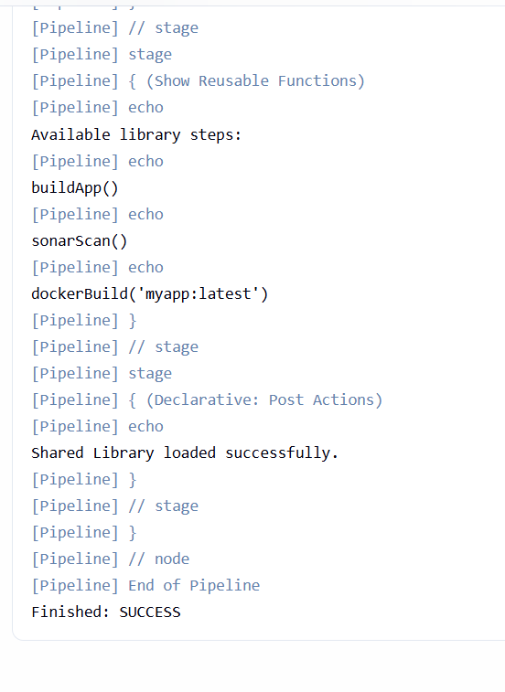
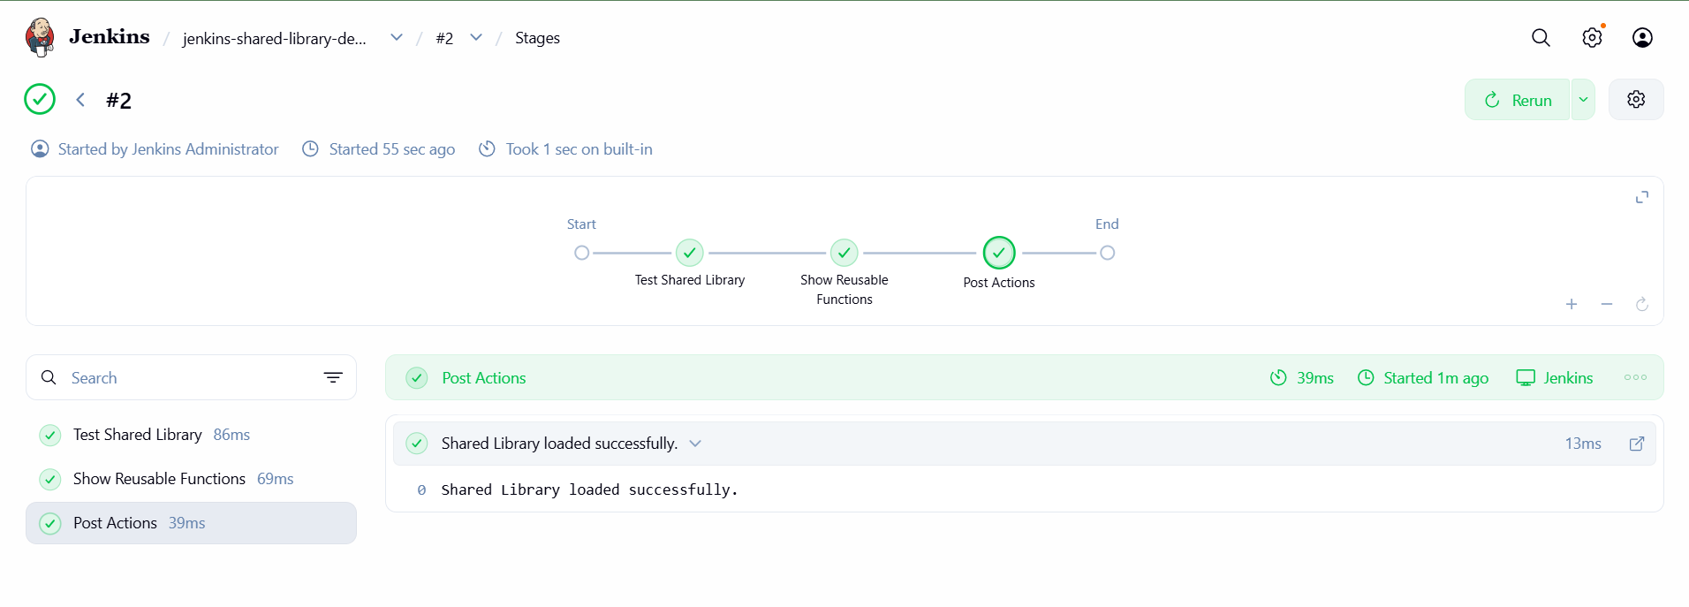

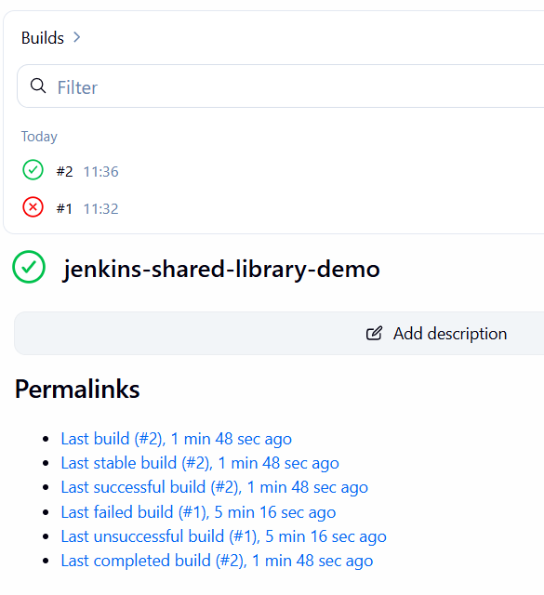
Once this test passes, you can use the actual functions in a real application pipeline. For example, call buildApp() in a Maven project after checking out its source code. Only call sonarScan() when SonarQube is configured, and dockerBuild() when the workspace contains a Dockerfile and the agent can access Docker.

8.7 Understand how buildApp() and .groovy work
The filename and function call are connected by Jenkins' Shared Library convention.
Jenkinsfile
Calls buildApp()
vars/buildApp.groovy
Defines def call() { ... }
Maven
Executes mvn -B clean package
- vars/ contains globally callable pipeline steps.
- buildApp.groovy defines the step named buildApp.
- def call() allows you to invoke that step as buildApp() rather than writing buildApp.call().
- The .groovy extension identifies a Groovy source file.
- @Library('my-shared-library') _ loads the configured library before the pipeline runs.

