**Question 1:** Create ASG with UserData in Launch Template to install nginx and setup min, Desired as 1 and max as 2 with Avg CPU 60

**Ans:**

1. In the first point we are creating launch templates and with the help of launch templates we are creating new ASG .

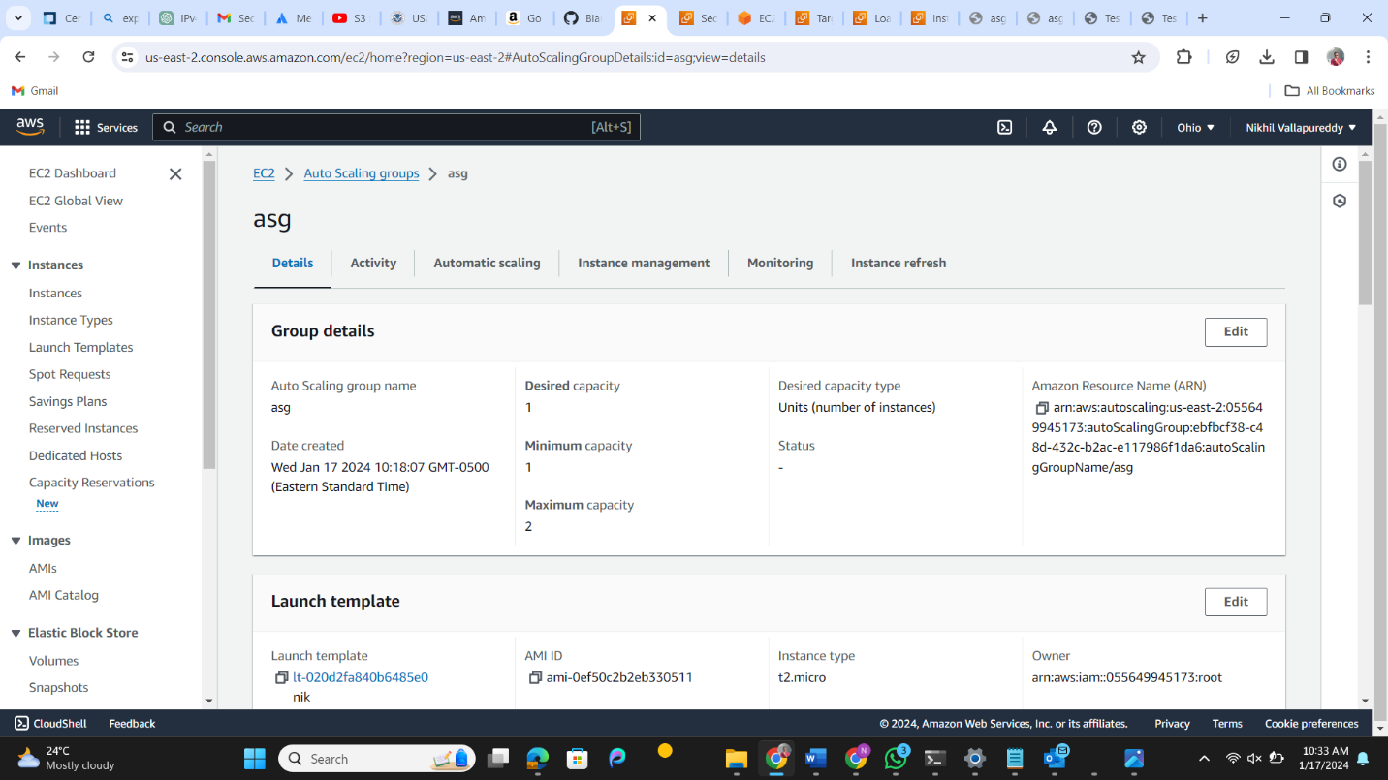

1. Then we are creating Load balancers and target groups and attaching it to auto scaling groups.
2. Now the ec2-instance has been created now we are checking the security groups inbound rules for the flow traffic
3. The rules should be HTTP and SSH
4. Now that everything is done and we are checking DNS name in loadbalancers we hit the webpage will get the final output nginx running on webpage.

**Result:**

**Question3:** Download and Install GIT

**Question4:**Create github account with personal gmail

