SIMATS ENGINEERING
ASSESSMENT TOOL 2

COURSE NAME: Database Management Systems
COURSE CODE: CSA0501

COURSE OUTCOME COVERED

CO1: Analyze DBMS architecture, different data models, schema types, and design ER/EER diagrams, relational schemas for case-based scenarios by identifying entities and relationships. (BL1, BL2)

Activity Tool : Concept Mapping (Medium)
Assessment Tool Weightage: 35%

Dr. A JAYA MABEL RANI

QUESTIONS Total Marks: 50
Q.No | Question | Bloom's Level | Marks
1 | Construct a concept map linking the following terms: DBMS, Schema, Instance, Data Model, ER Diagram, Entity, Attribute, Relationship. | BL2 – Understand | 5
2 | Create a concept map for the three-level ANSI/SPARC architecture showing data independence at each level. | BL2 – Understand | 5
3 | Map the relationship between file-based systems and database systems, highlighting the problems solved by DBMS. | BL2 – Understand | 5
4 | Design a concept map for ER diagram components: entity, weak entity, attribute types, relationship types, and participation constraints. | BL2 – Understand | 5
5 | Construct a concept map comparing Hierarchical, Network, and Relational data models with their key properties. | BL2 – Understand | 5
6 | Develop a concept map for the EER model showing how it extends the basic ER model with generalization, specialization, and aggregation. | BL2 – Understand | 5
7 | Create a visual concept map for the DBMS software architecture, illustrating the flow from user request to data retrieval. | BL2 – Understand | 5
8 | Map the data models discussed in CO1 to real-world applications and explain the suitability of each model. | BL2 – Understand | 5
9 | Construct a concept map for schemas and instances, showing how they relate to physical and logical data independence. | BL2 – Understand | 5
10 | Design a concept map for the roles and responsibilities in a DBMS environment: DBA, End User, Application Developer. | BL1 – Remember | 5

Code of Conduct:

I K.Nikhil / 192424366 (Name / Reg No) certify that this submission is my original work and that I have adhered to the guidelines specified for this assessment.
I understand that any violation of academic integrity rules will result in disciplinary action.

Signature of the student: K.NIKHIL

RUBRICS FOR CALCULATION:

Criteria | Weightage | Level 4 (Exemplary) | Level 3 (Proficient) | Level 2 (Developing) | Level 1 (Beginning)
Concept Identification | 25% | Identifies all key concepts from literature accurately and comprehensively | Identifies most key concepts with minor omissions | Identifies limited concepts; some are irrelevant or missing | Fails to identify essential concepts
Linkages | 25% | Establishes clear, meaningful, and accurate relationships between concepts | Shows correct relationships with minor gaps | Relationships are weak, unclear, or partially incorrect | No meaningful relationships established
Organization | 20% | Concepts are well-structured hierarchically with logical flow and grouping | Mostly organized with minor structural issues | Some organization but lacks clear hierarchy | No logical organization or structure
Integration of Literature | 20% | Integrates multiple studies effectively to show connections and comparisons | Shows some integration of literature | Limited integration; mostly isolated concepts | No integration of literature evidence
Clarity | 10% | Concept map is clear, neat, visually structured, and easy to interpret | Generally clear with minor readability issues | Clarity is reduced; difficult to interpret in parts | Poorly presented and hard to understand

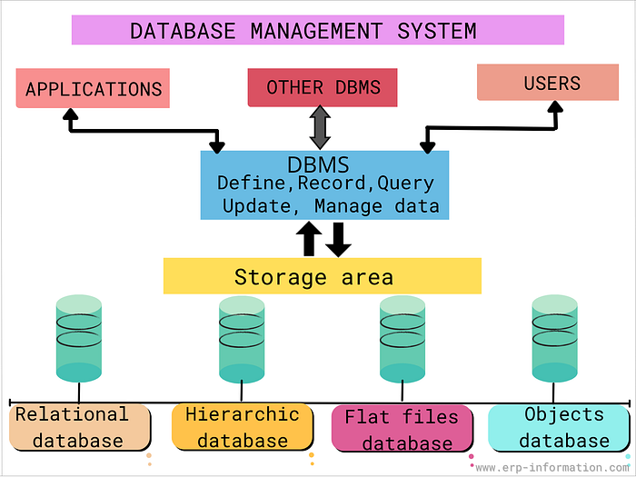

ANSWERS

NAME: K.NIKHIL LAKSHMI SAI
REG No. 192424366
COURSE : CSA0501

1.A Database Management System (DBMS) is software used to store, organize, retrieve, and manage data efficiently. Before creating a database, a Data Model is selected to define how data is structured. The most commonly used model is the Relational Data Model.
An ER (Entity-Relationship) Diagram is created during database design. It represents real-world objects called Entities, their Attributes, and the Relationships between entities.
The ER diagram is converted into a Database Schema, which defines the logical structure of the database including tables, columns, and constraints. The actual data stored in the database at a particular moment is called an Instance.
Concept Map:
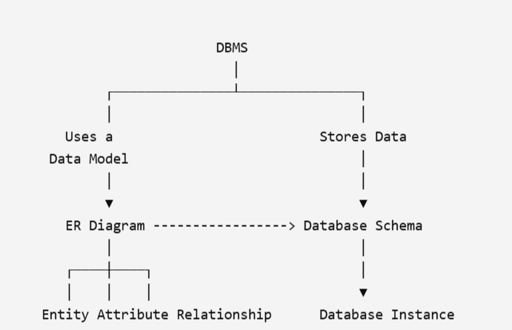

Term | Description
DBMS | Software used to manage databases
Data Model | Defines database structure
ER Diagram | Graphical representation of database design
Entity | Real-world object
Attribute | Property of an entity
Relationship | Association between entities
Schema | Logical design of database
Instance | Actual data stored at a specific time

Conclusion
The DBMS uses a data model to design an ER diagram, which is converted into a schema. The schema stores database instances containing actual data.

2.The ANSI/SPARC three-level architecture separates the database into three levels to provide data independence.
- External Level
  - User views
  - Different users see different parts of the database.
- Conceptual Level
  - Overall logical database structure.
  - Defines entities, relationships, and constraints.
- Internal Level
  - Physical storage of data.
  - Includes files, indexes, and storage techniques.
Data Independence
- Physical Data Independence
  - Changes in the internal level do not affect the conceptual level.
- Logical Data Independence
  - Changes in the conceptual level do not affect external user views.

Concept Map
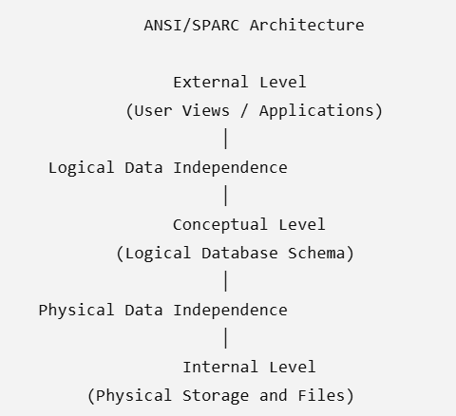
Table
Level | Description | Example
External | User-specific view | Student Portal
Conceptual | Overall logical database | Tables & Relationships
Internal | Physical storage | Disk files, Indexes
Conclusion
The ANSI/SPARC architecture improves security, flexibility, and database maintenance by separating user views, logical design, and physical storage.

3.A File-Based System stores data in separate files managed by individual applications. This often leads to duplicate data, inconsistency, and poor security.
A Database Management System (DBMS) centralizes data storage and provides efficient data management, security, concurrency control, and backup facilities.

Concept Map
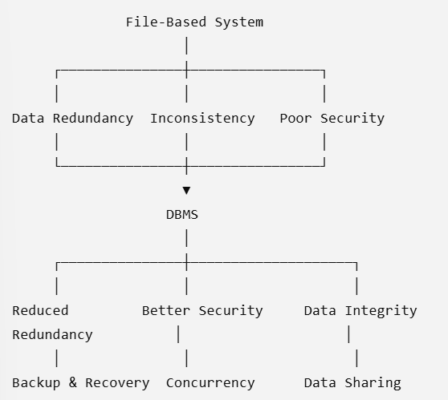

Comparison Table
File-Based System | DBMS
Data redundancy | Reduced redundancy
Poor security | Strong security
Difficult sharing | Easy data sharing
No concurrency control | Supports concurrency
Difficult backup | Automatic backup and recovery
Data inconsistency | Improved consistency

Problems Solved by DBMS
- Reduces data redundancy
- Eliminates data inconsistency
- Improves security
- Enables data sharing
- Provides concurrency control
- Supports backup and recovery
- Maintains data integrity

Conclusion
A DBMS overcomes the limitations of file-based systems by providing secure, consistent, and efficient data management.

4.An Entity-Relationship (ER) Diagram is a graphical representation of a database. It helps identify entities, their attributes, relationships, and constraints before implementing the database.

ER Diagram Components
1. Entity
- A real-world object that can be identified uniquely.
- Example: Student, Employee, Product.
2. Weak Entity
- An entity that cannot be uniquely identified by its own attributes.
- Depends on a strong entity.
- Example: Dependent of an Employee.
3. Attribute Types
- Simple Attribute: Cannot be divided further (Age).
- Composite Attribute: Can be divided into sub-parts (Address → City, State, PIN).
- Single-valued Attribute: One value per entity (Roll Number).
- Multi-valued Attribute: Multiple values (Phone Numbers).
- Derived Attribute: Calculated from another attribute (Age from Date of Birth).
4. Relationship Types
- One-to-One (1:1)
- One-to-Many (1:M)
- Many-to-Many (M:N)
5. Participation Constraints
- Total Participation: Every entity must participate.
- Partial Participation: Participation is optional.

Concept Map

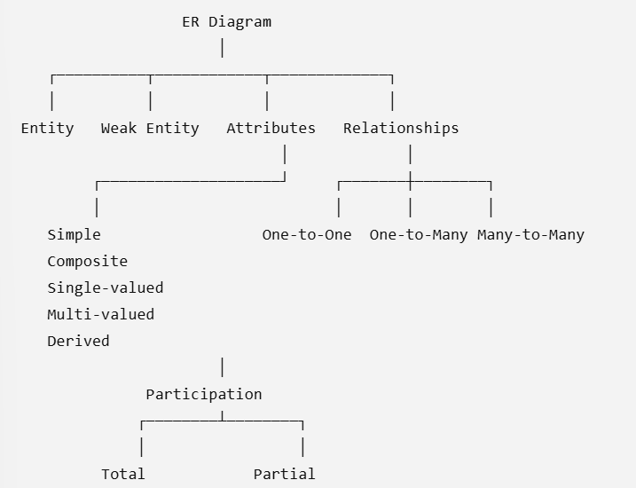

Table

Component | Description | Example
Entity | Independent object | Student
Weak Entity | Depends on another entity | Dependent
Simple Attribute | Cannot be divided | Age
Composite Attribute | Divisible | Address
Multi-valued Attribute | Multiple values | Phone Numbers
Derived Attribute | Computed | Age
Relationship | Connects entities | Student Enrolls Course
Participation | Mandatory/Optional | Total or Partial

Conclusion
ER diagrams provide a clear blueprint for database design by representing entities, relationships, attributes, and constraints.

4.A Data Model defines how data is organized, stored, and accessed in a database. The three major traditional data models are Hierarchical, Network, and Relational.
Hierarchical Model
- Tree structure
- Parent-child relationship
- One parent can have many children
- Supports one-to-many relationships
Network Model
- Graph structure
- Records connected through links
- Supports many-to-many relationships
Relational Model
- Data stored in tables (relations)
- Uses rows and columns
- Relationships established using Primary Key and Foreign Key
- Most widely used model
Concept Map

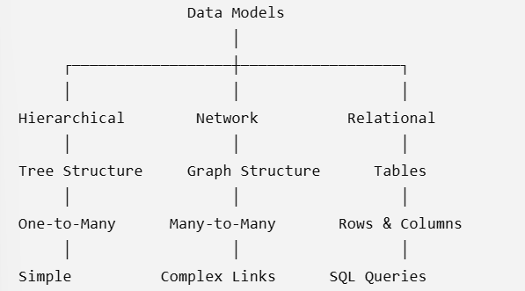

Comparison Table
Feature | Hierarchical | Network | Relational
Structure | Tree | Graph | Tables
Relationship | One-to-Many | Many-to-Many | Keys
Flexibility | Low | Medium | High
Complexity | Low | High | Medium
Query Language | Navigation | Navigation | SQL

Advantages
Hierarchical
- Simple structure
- Fast access
Network
- Flexible relationships
- Reduced redundancy
Relational
- Easy to understand
- Supports SQL
- High data independence
- Most commonly used

Conclusion
Among the three models, the Relational Data Model is the most popular because of its simplicity, flexibility, and SQL support.

6.The Enhanced Entity-Relationship (EER) Model extends the basic ER model by introducing advanced concepts such as Generalization, Specialization, and Aggregation to represent complex real-world scenarios.
EER Concepts
1. Generalization
- Combines similar lower-level entities into a higher-level entity.
- Example:
  - Car
  - Bike
  - Truck
→ Vehicle
2. Specialization
- Divides one entity into multiple specialized entities.
- Example:
  - Employee
→ Manager
→ Engineer
→ Clerk
3. Aggregation
- Represents a relationship as a higher-level entity.
- Used when relationships participate in another relationship.

Concept Map

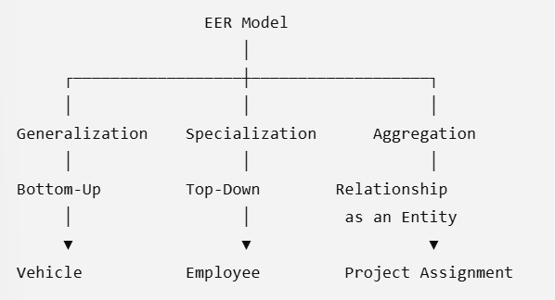

Table
Feature | Purpose | Example
Generalization | Combine entities | Vehicle
Specialization | Divide entity | Employee → Manager
Aggregation | Treat relationship as entity | Project Assignment

Difference Between ER and EER
ER Model | EER Model
Basic entities and relationships | Includes advanced concepts
Simpler design | More expressive design
Limited inheritance | Supports inheritance and abstraction

Conclusion
The EER model extends the ER model by supporting inheritance, abstraction, and complex relationships, making it suitable for large and real-world database applications.

7.The DBMS Software Architecture shows how a user's request is processed, optimized, executed, and finally retrieves data from the database.
Components
1. User
- Sends SQL queries through an application.
2. Application Program
- Accepts user input and forwards SQL commands to the DBMS.
3. Query Processor
- Parses SQL queries.
- Checks syntax and semantics.
- Optimizes the query for efficient execution.
4. Storage Manager
- Manages data files, indexes, and buffers.
- Retrieves the required data.
5. Database
- Stores the actual data permanently.
6. Result
- Retrieved data is returned to the user.
Concept Map
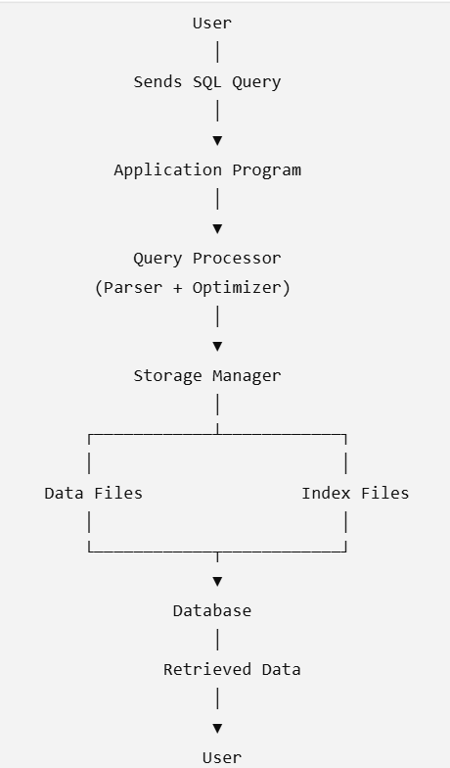

Table
Component | Function
User | Sends request
Application | Accepts user input
Query Processor | Parses and optimizes SQL
Storage Manager | Retrieves required data
Database | Stores data

Conclusion
The DBMS architecture ensures efficient processing of user queries and fast retrieval of data.

8.Different data models are suitable for different real-world applications depending on how data is organized and related.

Concept Map
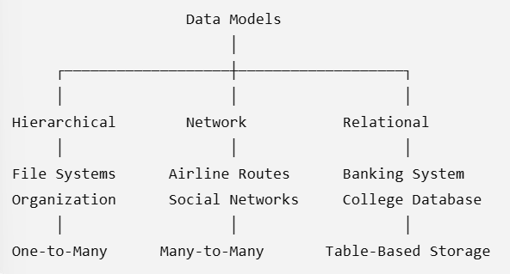
Applications Table
Data Model | Real-World Application | Reason for Suitability
Hierarchical | File System, Organization Chart | Tree structure with parent-child relationship
Network | Airline Route Network, Social Media | Supports many-to-many relationships
Relational | Banking, Hospital, College Management | Easy querying using SQL and reduced redundancy
Advantages
Hierarchical
- Fast access
- Simple navigation
Network
- Flexible connections
- Efficient for complex relationships
Relational
- Easy maintenance
- Supports SQL
- High security
- Data independence
Conclusion
Different data models are used based on application requirements, but the relational model is the most widely used due to its flexibility and SQL support.
9.A Schema defines the structure of a database, while an Instance represents the actual data stored at a particular time. Data independence ensures that changes at one level do not unnecessarily affect other levels.
Types of Schema
- External Schema – User-specific view.
- Conceptual Schema – Overall logical structure.
- Internal Schema – Physical storage details.
Data Independence
Logical Data Independence
- Changes in the conceptual schema do not affect external schemas.
Physical Data Independence
- Changes in the internal schema do not affect the conceptual schema.
Concept Map
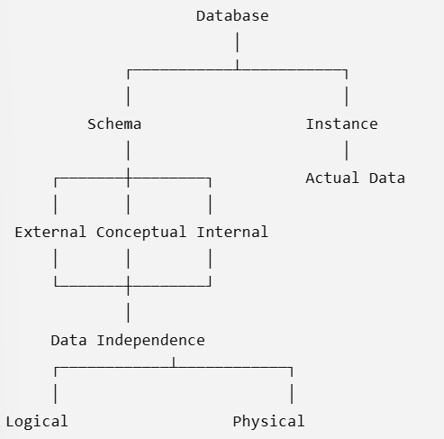
Table
Concept | Description
Schema | Database design
Instance | Current database contents
External Schema | User view
Conceptual Schema | Logical database
Internal Schema | Physical storage
Logical Independence | Protects user views
Physical Independence | Protects logical structure
Conclusion
Schemas define the database structure, instances store actual data, and data independence improves flexibility and maintainability.
10.A DBMS environment includes different users who work together to design, manage, and use the database efficiently.
Roles
1. Database Administrator (DBA)
- Creates and manages databases.
- Controls security and user access.
- Performs backup and recovery.
- Monitors database performance.
2. Application Developer
- Designs and develops database applications.
- Writes SQL queries and programs.
- Creates user interfaces.
3. End User
- Uses the application to insert, update, delete, and retrieve data.
- Does not manage the database directly.

Concept Map

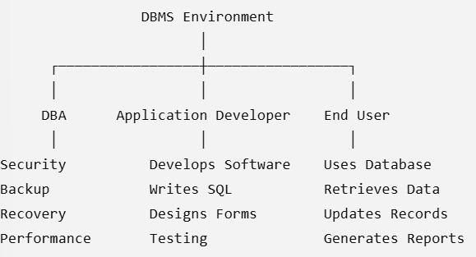

Responsibilities Table
Role | Responsibilities
DBA | Security, backup, recovery, performance tuning
Application Developer | Develop applications, write SQL, testing
End User | Perform daily database operations

Conclusion
Each role has specific responsibilities, and together they ensure that the DBMS operates securely, efficiently, and meets user requirements.

