CO2 – LAB EXPERIMENTS
Neural Networks: Perceptron, Backpropagation, MLP, Regularisation and CNN
NAME: Nikhil.K
ID: 192424366
Experiments 1 – 12
Format of each experiment: AIM • TOOLS • CODE • OUTPUT • RESULT
Index

Exp. No. | Title | Packages
1 | Smart Traffic Signal Classification | NumPy, Matplotlib
2 | Industrial Machine Status Prediction | NumPy, Matplotlib
3 | Electricity Consumption Prediction | NumPy, Matplotlib
4 | Crop Yield Classification | NumPy, Matplotlib
5 | Student Placement Eligibility Prediction | TF, Keras, NumPy, Matplotlib
6 | Manufacturing Product Quality Prediction | TF, Keras, NumPy, Matplotlib
7 | House Price Prediction and Overfitting | TF, Keras, NumPy, Matplotlib
8 | Medical Appointment No-Show Prediction | TF, Keras, NumPy, Matplotlib
9 | Plant Leaf Disease Classification | TF, Keras, NumPy, Matplotlib
10 | Road Sign Image Classification | TF, Keras, NumPy, Matplotlib
11 | Wildlife Image Classification | TF, Keras, NumPy, Matplotlib
12 | Hyperparameter Optimization for Waste Classification | TF, Keras, NumPy, Matplotlib

1. Perceptron and Forward Propagation

Experiment 1: Smart Traffic Signal Classification

AIM
To implement a perceptron using NumPy that computes the weighted sum and applies a step activation to classify traffic as Low (0) or Heavy (1), to study how different weights and bias values affect classification accuracy, and to plot the data with the decision boundary.

TOOLS
Platform: Python 3 notebook (Google Colab compatible), TensorFlow 2.21
Packages: NumPy, Matplotlib
Dataset / settings: Synthetic: 60 samples of vehicle count (10–100) and average waiting time (5–60 s), normalised to [0,1]; label = Heavy if 0.6·vehicles + 0.4·wait > 0.5.

CODE
import numpy as np
import matplotlib.pyplot as plt

# ---- Dataset: vehicle count (0-100) and average waiting time (0-60 s), normalised to [0,1]
rng = np.random.default_rng(42)
n = 60
vehicles = rng.uniform(10, 100, n)
wait = rng.uniform(5, 60, n)
X = np.column_stack([vehicles / 100, wait / 60])
y = ((0.6 * X[:, 0] + 0.4 * X[:, 1]) > 0.5).astype(int) # 0 = Low, 1 = Heavy

# ---- Perceptron: weighted sum + step activation
def perceptron(X, w, b):
z = X @ w + b # weighted sum
return (z >= 0).astype(int) # step activation

def accuracy(X, y, w, b):
return np.mean(perceptron(X, np.array(w), b) == y) * 100

configs = {
"A: w=[1.0,-1.0], b=0.0": ([1.0, -1.0], 0.0),
"B: w=[0.5, 0.5], b=-0.2": ([0.5, 0.5], -0.2),
"C: w=[0.6, 0.4], b=-0.8": ([0.6, 0.4], -0.8),
"D: w=[0.6, 0.4], b=-0.5": ([0.6, 0.4], -0.5),
}
print(f"{'Configuration':28s} Accuracy (%)")
for name, (w, b) in configs.items():
print(f"{name:28s} {accuracy(X, y, w, b):6.1f}")

# ---- Plot data + decision boundary for every configuration
fig, axes = plt.subplots(2, 2, figsize=(10, 8))
for ax, (name, (w, b)) in zip(axes.ravel(), configs.items()):
ax.scatter(X[y == 0, 0], X[y == 0, 1], c="tab:blue", label="Low (0)")
ax.scatter(X[y == 1, 0], X[y == 1, 1], c="tab:red", marker="s", label="Heavy (1)")
xs = np.linspace(0, 1, 100)
if w[1] != 0:
ax.plot(xs, -(w[0] * xs + b) / w[1], "k--", label="Decision boundary")
ax.set_xlim(0, 1); ax.set_ylim(0, 1)
ax.set_xlabel("Vehicle count (normalised)"); ax.set_ylabel("Waiting time (normalised)")
ax.set_title(f"{name}\nAccuracy = {accuracy(X, y, w, b):.1f}%", fontsize=10)
ax.legend(fontsize=8)
plt.tight_layout(); plt.savefig("q1_boundaries.png", dpi=110); plt.show()

# ---- Effect of bias alone (weights fixed at [0.6, 0.4])
biases = np.linspace(-1.2, 0.2, 57)
accs = [accuracy(X, y, [0.6, 0.4], b) for b in biases]
plt.figure(figsize=(6, 4))
plt.plot(biases, accs, "o-", ms=3)
plt.xlabel("Bias"); plt.ylabel("Accuracy (%)"); plt.title("Effect of bias on accuracy (w=[0.6, 0.4])")
plt.grid(alpha=.3); plt.tight_layout(); plt.savefig("q1_bias.png", dpi=110); plt.show()
print("Best bias =", round(biases[int(np.argmax(accs))], 3), "-> accuracy", max(accs))

OUTPUT
Console output:
Configuration Accuracy (%)
A: w=[1.0,-1.0], b=0.0 61.7
B: w=[0.5, 0.5], b=-0.2 60.0
C: w=[0.6, 0.4], b=-0.8 53.3
D: w=[0.6, 0.4], b=-0.5 100.0
Best bias = -0.5 -> accuracy 100.0

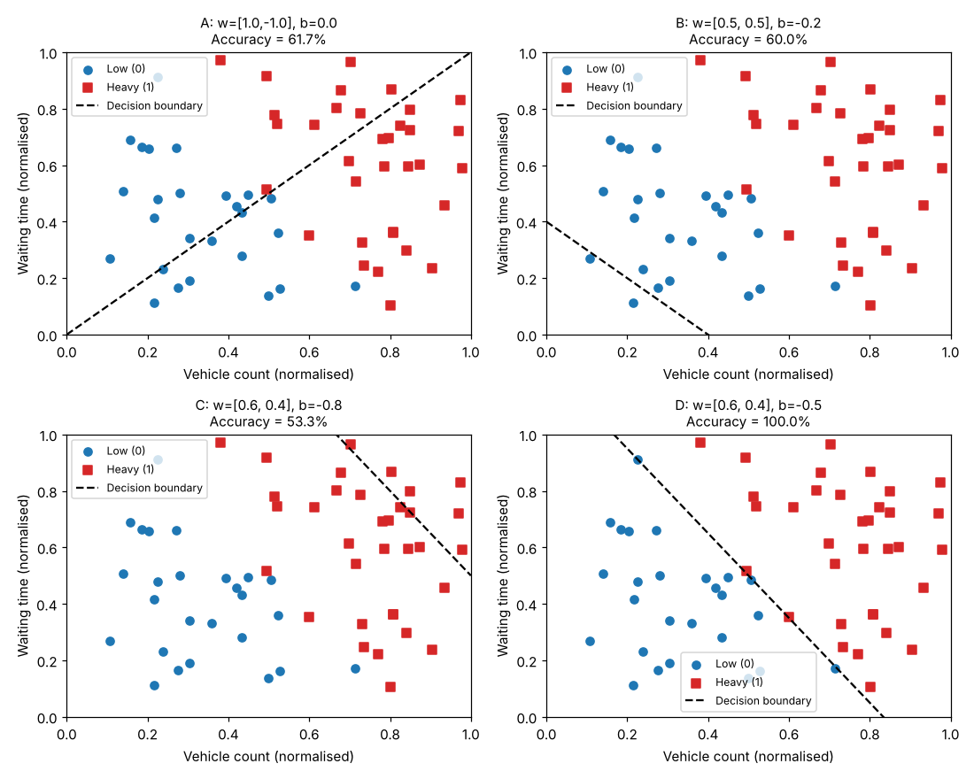
Figure 1.1
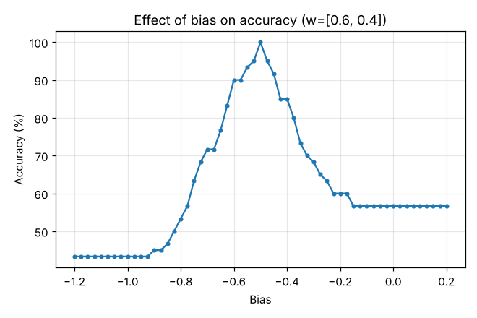
Figure 1.2

RESULT
- Four weight/bias configurations were tested. Configuration A (w = [1.0, −1.0], b = 0) gave 61.7%, B gave 60.0% and C (bias −0.8) gave only 53.3%, while D (w = [0.6, 0.4], b = −0.5) reached 100% accuracy.
- Two parameter changes improved the result: (i) both weights must be positive, because more vehicles and longer waiting both indicate heavy traffic (A used a negative weight for waiting time and inverted that relationship); (ii) the bias must place the boundary correctly. With w = [0.6, 0.4] fixed, the bias sweep showed the best accuracy (100%) at b = −0.5; a bias that is too negative pushed most samples into class 0.
- Hence the weights control the orientation (slope) of the decision boundary and the bias controls its position (shift). The perceptron classified the data perfectly once both were set correctly.

Experiment 2: Industrial Machine Status Prediction

AIM
To implement a perceptron and perform forward propagation on machine temperature and vibration samples, compare predicted outputs with actual labels, modify the weights and bias to correct misclassifications, and analyse the limitations of a perceptron.

TOOLS
Platform: Python 3 notebook (Google Colab compatible), TensorFlow 2.21
Packages: NumPy, Matplotlib
Dataset / settings: Synthetic: 12 machine samples (temperature in °C, normalised by 100; vibration in mm/s); label 1 = inspection required, 0 = continue operating. A second 80-sample XOR-like set is used to show the limitation.

CODE
import numpy as np
import matplotlib.pyplot as plt

# ---- Dataset: temperature (C) and vibration (mm/s); 1 = inspection, 0 = continue
raw = np.array([[55,0.20],[60,0.30],[65,0.25],[70,0.40],[72,0.50],[78,0.30],
[85,0.20],[90,0.40],[60,0.70],[65,0.85],[70,0.90],[75,0.70]])
X = np.column_stack([raw[:, 0] / 100, raw[:, 1]]) # normalise temperature
y = ((0.5 * X[:, 0] + 0.5 * X[:, 1]) > 0.55).astype(int) # actual labels

def forward(X, w, b):
z = X @ w + b # weighted sum
return z, (z >= 0).astype(int) # step activation

def report(title, w, b):
z, pred = forward(X, np.array(w), b)
print(f"\n{title}: w={w}, b={b}")
print("Temp Vib z Pred Actual Result")
for r, zi, p, a in zip(raw, z, pred, y):
print(f"{r[0]:4.0f} {r[1]:5.2f} {zi:7.3f} {p} {a} {'OK' if p == a else 'WRONG'}")
acc = np.mean(pred == y) * 100
print(f"Accuracy = {acc:.1f}%")
return pred, acc

p1, a1 = report("Initial parameters", [0.2, 0.2], -0.1)
p2, a2 = report("Modified parameters (step 1)", [1.0, 1.0], -1.1)
p3, a3 = report("Modified parameters (step 2: bias fine-tuned)", [1.0, 1.0], -1.15)

fig, axes = plt.subplots(1, 3, figsize=(15, 4.5))
for ax, (w, b, p, t) in zip(axes, [([0.2,0.2],-0.1,p1,"Initial"), ([1.0,1.0],-1.1,p2,"Modified (b=-1.10)"), ([1.0,1.0],-1.15,p3,"Fine-tuned (b=-1.15)")]):
ax.scatter(X[y==0,0], X[y==0,1], c="tab:blue", label="Actual 0")
ax.scatter(X[y==1,0], X[y==1,1], c="tab:red", marker="s", label="Actual 1")
wrong = p != y
ax.scatter(X[wrong,0], X[wrong,1], s=180, facecolors="none", edgecolors="k", label="Misclassified")
xs = np.linspace(0.5, 1, 50); ax.plot(xs, -(w[0]*xs+b)/w[1], "k--")
ax.set_ylim(0, 1); ax.set_xlabel("Temperature (normalised)"); ax.set_ylabel("Vibration (mm/s)")
ax.set_title(f"{t}: accuracy {np.mean(p==y)*100:.1f}%"); ax.legend(fontsize=8)
plt.tight_layout(); plt.savefig("q2_results.png", dpi=110); plt.show()

# ---- Limitation: XOR-like data (inspect if temp high XOR vibration high)
rng = np.random.default_rng(1)
T = rng.uniform(0, 1, 80); V = rng.uniform(0, 1, 80)
Xx = np.column_stack([T, V]); yx = ((T > 0.5) ^ (V > 0.5)).astype(int)
best = (0, None)
for w1 in np.linspace(-2, 2, 41):
for w2 in np.linspace(-2, 2, 41):
for b in np.linspace(-2, 2, 41):
acc = np.mean(((Xx @ np.array([w1, w2]) + b) >= 0).astype(int) == yx) * 100
if acc > best[0]: best = (acc, (w1, w2, b))
print(f"\nNon-linearly separable (XOR-like) data: best accuracy over 68,921 weight/bias combinations = {best[0]:.1f}%")
w1, w2, b = best[1]
plt.figure(figsize=(5, 4.5))
plt.scatter(Xx[yx==0,0], Xx[yx==0,1], c="tab:blue", label="Continue (0)")
plt.scatter(Xx[yx==1,0], Xx[yx==1,1], c="tab:red", marker="s", label="Inspect (1)")
xs = np.linspace(0, 1, 50)
if abs(w2) > 1e-9: plt.plot(xs, -(w1*xs+b)/w2, "k--", label="Best single line")
plt.ylim(0, 1); plt.xlabel("Temperature"); plt.ylabel("Vibration"); plt.legend(fontsize=8)
plt.title(f"Perceptron limitation (best {best[0]:.1f}%)"); plt.tight_layout(); plt.savefig("q2_limit.png", dpi=110); plt.show()

OUTPUT
Console output:

Initial parameters: w=[0.2, 0.2], b=-0.1
Temp Vib z Pred Actual Result
55 0.20 0.050 1 0 WRONG
60 0.30 0.080 1 0 WRONG
65 0.25 0.080 1 0 WRONG
70 0.40 0.120 1 0 WRONG
72 0.50 0.144 1 1 OK
78 0.30 0.116 1 0 WRONG
85 0.20 0.110 1 0 WRONG
90 0.40 0.160 1 1 OK
60 0.70 0.160 1 1 OK
65 0.85 0.200 1 1 OK
70 0.90 0.220 1 1 OK
75 0.70 0.190 1 1 OK
Accuracy = 50.0%

Modified parameters (step 1): w=[1.0, 1.0], b=-1.1
Temp Vib z Pred Actual Result
55 0.20 -0.350 0 0 OK
60 0.30 -0.200 0 0 OK
65 0.25 -0.200 0 0 OK
70 0.40 0.000 1 0 WRONG
72 0.50 0.120 1 1 OK
78 0.30 -0.020 0 0 OK
85 0.20 -0.050 0 0 OK
90 0.40 0.200 1 1 OK
60 0.70 0.200 1 1 OK
65 0.85 0.400 1 1 OK
70 0.90 0.500 1 1 OK
75 0.70 0.350 1 1 OK
Accuracy = 91.7%

Modified parameters (step 2: bias fine-tuned): w=[1.0, 1.0], b=-1.15
Temp Vib z Pred Actual Result
55 0.20 -0.400 0 0 OK
60 0.30 -0.250 0 0 OK
65 0.25 -0.250 0 0 OK
70 0.40 -0.050 0 0 OK
72 0.50 0.070 1 1 OK
78 0.30 -0.070 0 0 OK
85 0.20 -0.100 0 0 OK
90 0.40 0.150 1 1 OK
60 0.70 0.150 1 1 OK
65 0.85 0.350 1 1 OK
70 0.90 0.450 1 1 OK
75 0.70 0.300 1 1 OK
Accuracy = 100.0%

Non-linearly separable (XOR-like) data: best accuracy over 68,921 weight/bias combinations = 75.0%

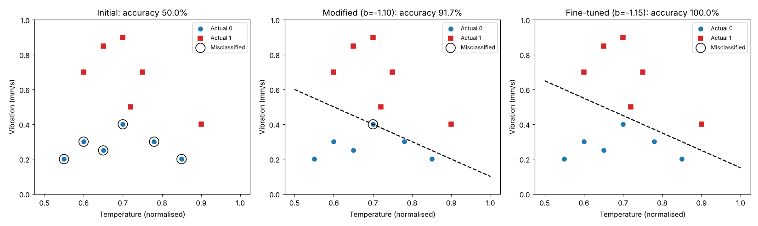
Figure 2.1
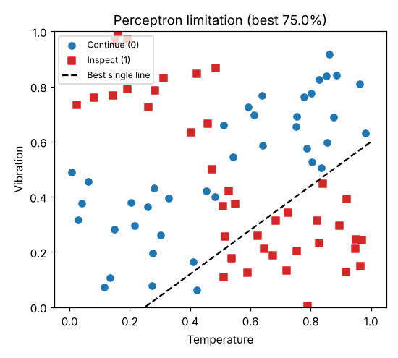
Figure 2.2

RESULT
- With the initial parameters (w = [0.2, 0.2], b = −0.1) every weighted sum was positive, so all 12 machines were predicted as 'inspect' and accuracy was 50.0%.
- After modifying the parameters to w = [1.0, 1.0], b = −1.1 the accuracy rose to 91.7%; one sample lay exactly on the boundary (z = 0) and was wrongly classified because the step function outputs 1 at z ≥ 0. Fine-tuning the bias to −1.15 removed this error and gave 100% accuracy.
- Limitation: when the data is not linearly separable (XOR-like: inspect when temperature is high XOR vibration is high), a search over 68,921 weight/bias combinations achieved at most 75.0% accuracy. A single perceptron can only draw one straight line, so such data needs a multilayer network.

2. Two-Layer Neural Network with Backpropagation

Experiment 3: Electricity Consumption Prediction

AIM
To implement a two-layer neural network (hidden layer + output layer) in NumPy that predicts electricity consumption from temperature and number of occupied rooms, using forward propagation, mean squared error loss and backpropagation, and to analyse how the loss changes over epochs.

TOOLS
Platform: Python 3 notebook (Google Colab compatible), TensorFlow 2.21
Packages: NumPy, Matplotlib
Dataset / settings: Synthetic: 120 samples; consumption (kWh) = 3·temperature + 5·rooms + 20 + noise (σ = 5); inputs and target standardised. Network 2 → 8 (tanh) → 1 (linear), learning rate 0.05, 1000 epochs.

CODE
import numpy as np
import matplotlib.pyplot as plt

rng = np.random.default_rng(0)
n = 120
temp = rng.uniform(15, 40, n); rooms = rng.integers(1, 21, n)
kwh = 3.0 * temp + 5.0 * rooms + 20 + rng.normal(0, 5, n) # electricity consumption (kWh)
X = np.column_stack([temp, rooms]).astype(float); y = kwh.reshape(-1, 1)
Xm, Xs, ym, ys = X.mean(0), X.std(0), y.mean(), y.std()
Xn, yn = (X - Xm) / Xs, (y - ym) / ys

# ---- Two-layer network: 2 -> 8 (tanh) -> 1 (linear)
W1 = rng.normal(0, 1, (2, 8)); b1 = np.zeros((1, 8))
W2 = rng.normal(0, 1, (8, 1)); b2 = np.zeros((1, 1))
lr, epochs, losses = 0.05, 1000, []

def forward(X):
z1 = X @ W1 + b1; a1 = np.tanh(z1); z2 = a1 @ W2 + b2
return a1, z2

for ep in range(epochs):
a1, yhat = forward(Xn)
loss = np.mean((yhat - yn) ** 2) # mean squared error
losses.append(loss)
d2 = 2 * (yhat - yn) / n # dL/dz2
dW2 = a1.T @ d2; db2 = d2.sum(0, keepdims=True)
d1 = (d2 @ W2.T) * (1 - a1 ** 2) # back through tanh
dW1 = Xn.T @ d1; db1 = d1.sum(0, keepdims=True)
W1 -= lr * dW1; b1 -= lr * db1; W2 -= lr * dW2; b2 -= lr * db2
if ep in (0, 9, 49, 99, 249, 499, 999):
print(f"Epoch {ep+1:4d} MSE (normalised) = {loss:.5f}")

_, pred = forward(Xn); pred_kwh = pred * ys + ym
rmse = np.sqrt(np.mean((pred_kwh - y) ** 2))
print(f"\nInitial loss = {losses[0]:.4f}, final loss = {losses[-1]:.5f}")
print(f"Final RMSE = {rmse:.2f} kWh")
print("\nSample predictions (kWh):")
for i in range(5): print(f" Temp={X[i,0]:.1f} Rooms={int(X[i,1]):2d} Actual={y[i,0]:6.1f} Predicted={pred_kwh[i,0]:6.1f}")

fig, ax = plt.subplots(1, 2, figsize=(11, 4))
ax[0].plot(losses); ax[0].set_yscale("log"); ax[0].set_xlabel("Epoch"); ax[0].set_ylabel("MSE (log scale)"); ax[0].set_title("Loss curve")
ax[1].scatter(y, pred_kwh, s=14); ax[1].plot([y.min(), y.max()], [y.min(), y.max()], "r--")
ax[1].set_xlabel("Actual (kWh)"); ax[1].set_ylabel("Predicted (kWh)"); ax[1].set_title("Predicted vs actual")
plt.tight_layout(); plt.savefig("q3_loss.png", dpi=110); plt.show()

OUTPUT
Console output:
Epoch 1 MSE (normalised) = 11.32704
Epoch 10 MSE (normalised) = 0.04236
Epoch 50 MSE (normalised) = 0.03435
Epoch 100 MSE (normalised) = 0.03071
Epoch 250 MSE (normalised) = 0.02578
Epoch 500 MSE (normalised) = 0.02293
Epoch 1000 MSE (normalised) = 0.02101

Initial loss = 11.3270, final loss = 0.02101
Final RMSE = 5.69 kWh

Sample predictions (kWh):
Temp=30.9 Rooms=14 Actual= 187.9 Predicted= 186.6
Temp=21.7 Rooms= 7 Actual= 110.6 Predicted= 114.4
Temp=16.0 Rooms= 5 Actual= 91.9 Predicted= 92.1
Temp=15.4 Rooms= 9 Actual= 110.2 Predicted= 109.7
Temp=35.3 Rooms=18 Actual= 210.8 Predicted= 218.3

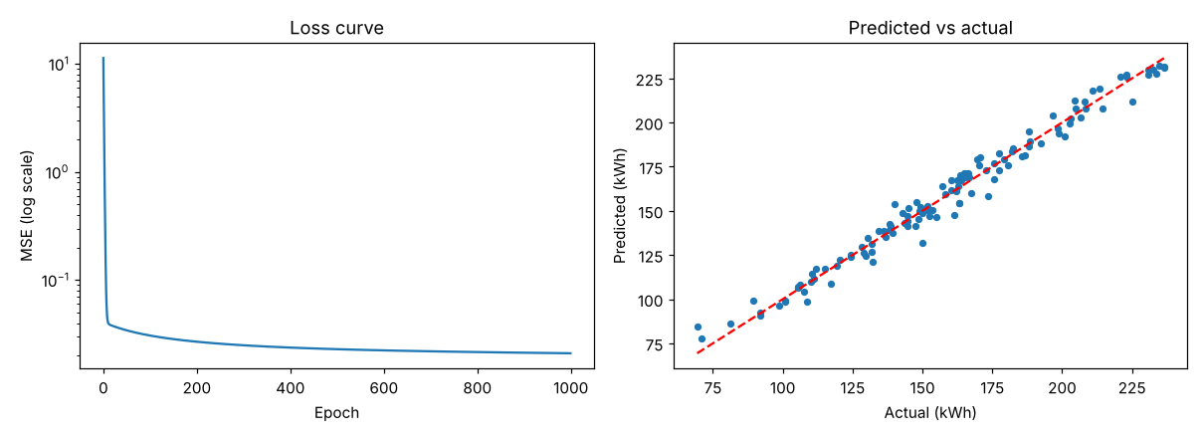
Figure 3.1

RESULT
- The randomly initialised network started with a normalised MSE of 11.327. After only 10 epochs the loss fell to 0.042, and it reached 0.021 after 1000 epochs, corresponding to an RMSE of 5.69 kWh.
- The steep early drop shows that the first gradient updates correct the large errors caused by random weights; later updates only make small refinements. The final RMSE (≈ 5.7 kWh) is close to the noise level added to the data (σ = 5 kWh), so the network has learned the underlying relationship, and the predicted-vs-actual plot lies close to the ideal diagonal.

Experiment 4: Crop Yield Classification

AIM
To implement a two-layer neural network in NumPy for classifying crop yield as high or low from soil moisture and fertiliser quantity, computing forward-pass outputs, binary cross-entropy loss, gradients and weight updates, and to compare the predictions before and after training.

TOOLS
Platform: Python 3 notebook (Google Colab compatible), TensorFlow 2.21
Packages: NumPy, Matplotlib
Dataset / settings: Synthetic: 200 samples (soil moisture 10–60%, fertiliser 20–100 kg/ha, normalised); label from a noisy non-linear rule. Network 2 → 6 (tanh) → 1 (sigmoid), learning rate 0.5, 2000 epochs.

CODE
import numpy as np
import matplotlib.pyplot as plt

rng = np.random.default_rng(3)
n = 200
moisture = rng.uniform(10, 60, n); fert = rng.uniform(20, 100, n)
Xn = np.column_stack([(moisture - 10) / 50, (fert - 20) / 80])
score = 0.6 * Xn[:, 0] + 0.4 * np.sqrt(Xn[:, 1]) + rng.normal(0, 0.05, n)
y = (score > 0.55).astype(int).reshape(-1, 1) # 1 = high yield, 0 = low yield

W1 = rng.normal(0, 1, (2, 6)); b1 = np.zeros((1, 6))
W2 = rng.normal(0, 1, (6, 1)); b2 = np.zeros((1, 1))
sigmoid = lambda z: 1 / (1 + np.exp(-z))

def forward(X):
a1 = np.tanh(X @ W1 + b1); return a1, sigmoid(a1 @ W2 + b2)

def bce(p, y):
p = np.clip(p, 1e-9, 1 - 1e-9); return -np.mean(y * np.log(p) + (1 - y) * np.log(1 - p))

_, p0 = forward(Xn); pred0 = (p0 >= 0.5).astype(int)
print(f"BEFORE training: loss = {bce(p0, y):.4f}, accuracy = {np.mean(pred0 == y)*100:.1f}%")

lr, epochs, losses = 0.5, 2000, []
for ep in range(epochs):
a1, p = forward(Xn); losses.append(bce(p, y))
d2 = (p - y) / n # gradient of BCE wrt z2
dW2 = a1.T @ d2; db2 = d2.sum(0, keepdims=True)
d1 = (d2 @ W2.T) * (1 - a1 ** 2)
dW1 = Xn.T @ d1; db1 = d1.sum(0, keepdims=True)
if ep == 0: print(f"\nGradient norms at epoch 1: |dW1|={np.linalg.norm(dW1):.4f}, |dW2|={np.linalg.norm(dW2):.4f}")
W1 -= lr * dW1; b1 -= lr * db1; W2 -= lr * dW2; b2 -= lr * db2
if ep + 1 in (1, 100, 500, 1000, 2000): print(f"Epoch {ep+1:4d} loss = {losses[-1]:.4f}")

_, p1 = forward(Xn); pred1 = (p1 >= 0.5).astype(int)
print(f"\nAFTER training: loss = {bce(p1, y):.4f}, accuracy = {np.mean(pred1 == y)*100:.1f}%")
print("\nSample Actual Before After")
for i in range(8): print(f"{i+1:4d} {y[i,0]} {pred0[i,0]} {pred1[i,0]}")

fig, ax = plt.subplots(1, 3, figsize=(15, 4))
ax[0].plot(losses); ax[0].set_xlabel("Epoch"); ax[0].set_ylabel("Binary cross-entropy"); ax[0].set_title("Loss vs epochs")
for a, pr, t in [(ax[1], pred0, "Before training"), (ax[2], pred1, "After training")]:
a.scatter(Xn[y[:,0]==0,0], Xn[y[:,0]==0,1], c="tab:blue", s=14, label="Low")
a.scatter(Xn[y[:,0]==1,0], Xn[y[:,0]==1,1], c="tab:red", s=14, label="High")
w = pr[:,0] != y[:,0]; a.scatter(Xn[w,0], Xn[w,1], s=70, facecolors="none", edgecolors="k", label="Misclassified")
a.set_xlabel("Soil moisture (norm.)"); a.set_ylabel("Fertilizer (norm.)")
a.set_title(f"{t}: {np.mean(pr==y)*100:.1f}% correct"); a.legend(fontsize=7)
plt.tight_layout(); plt.savefig("q4_results.png", dpi=110); plt.show()

OUTPUT
Console output:
BEFORE training: loss = 0.6753, accuracy = 50.0%

Gradient norms at epoch 1: |dW1|=0.1752, |dW2|=0.2480
Epoch 1 loss = 0.6753
Epoch 100 loss = 0.1871
Epoch 500 loss = 0.1419
Epoch 1000 loss = 0.1394
Epoch 2000 loss = 0.1369

AFTER training: loss = 0.1369, accuracy = 93.0%

Sample Actual Before After
1 0 0 0
2 0 0 0
3 1 1 1
4 1 0 1
5 0 0 0
6 0 0 1
7 1 0 1
8 0 0 0

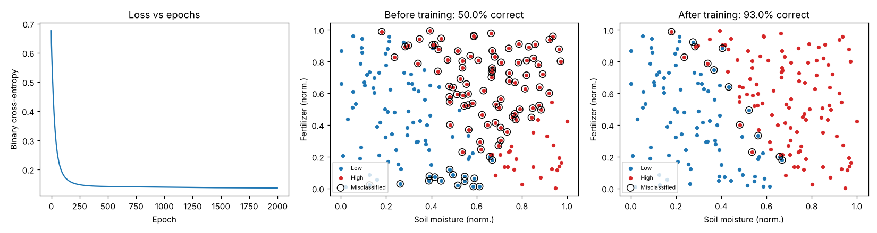
Figure 4.1

RESULT
- Before training the network had a loss of 0.6753 and an accuracy of 50.0% (chance level). After 2000 epochs of backpropagation the loss decreased to 0.1369 and the accuracy rose to 93.0%.
- The loss dropped rapidly in the first 100 epochs (0.1871) and then flattened (0.1419 at epoch 500, 0.1369 at epoch 2000). The remaining ≈ 7% errors lie near the class boundary where noise was added to the labels. The network therefore learns an effective relationship between soil moisture, fertiliser quantity and crop yield.

3. Multilayer Perceptron Implementation

Experiment 5: Student Placement Eligibility Prediction

AIM
To implement an MLP using TensorFlow/Keras that predicts placement-interview eligibility from aptitude, programming and communication scores, to record training and validation accuracy and loss using NumPy, and to analyse whether more hidden neurons improve performance without overfitting.

TOOLS
Platform: Python 3 notebook (Google Colab compatible), TensorFlow 2.21
Packages: TensorFlow, Keras, NumPy, Matplotlib
Dataset / settings: Synthetic: 500 students (350 train / 150 validation), three scores standardised; label from a weighted score with noise. MLP 3 → h (ReLU) → 1 (sigmoid) with h = 2, 8, 32, 128; Adam (0.01), 60 epochs, batch 16.

CODE
import os; os.environ["TF_CPP_MIN_LOG_LEVEL"] = "3"
import numpy as np, tensorflow as tf
import matplotlib.pyplot as plt
from tensorflow import keras
from tensorflow.keras import layers

np.random.seed(7); tf.random.set_seed(7)
n = 500
apt, prog, comm = np.random.uniform(30, 100, (3, n))
score = 0.4 * apt + 0.4 * prog + 0.2 * comm + np.random.normal(0, 7, n)
y = (score > 64).astype("float32") # 1 = qualifies for interview
X = np.column_stack([apt, prog, comm]); X = (X - X.mean(0)) / X.std(0)
idx = np.random.permutation(n); tr, va = idx[:350], idx[350:]
Xtr, ytr, Xva, yva = X[tr], y[tr], X[va], y[va]
print("Train:", Xtr.shape, " Validation:", Xva.shape, " Positive rate:", y.mean().round(2))

def build(h):
m = keras.Sequential([layers.Input(shape=(3,)), layers.Dense(h, activation="relu"),
layers.Dense(1, activation="sigmoid")])
m.compile(optimizer=keras.optimizers.Adam(0.01), loss="binary_crossentropy", metrics=["accuracy"])
return m

results = {}
for h in [2, 8, 32, 128]:
tf.random.set_seed(7)
hist = build(h).fit(Xtr, ytr, validation_data=(Xva, yva), epochs=60, batch_size=16, verbose=0).history
results[h] = {k: np.array(v) for k, v in hist.items()} # stored with NumPy
print(f"\n{'Hidden':>7} {'Train acc':>10} {'Val acc':>8} {'Train loss':>11} {'Val loss':>9} {'Gap (acc)':>10}")
for h, r in results.items():
print(f"{h:7d} {r['accuracy'][-1]:10.3f} {r['val_accuracy'][-1]:8.3f} {r['loss'][-1]:11.3f} {r['val_loss'][-1]:9.3f} {r['accuracy'][-1]-r['val_accuracy'][-1]:10.3f}")

fig, ax = plt.subplots(2, 2, figsize=(12, 8))
for h, r in results.items():
ax[0,0].plot(r["accuracy"], label=f"{h} neurons"); ax[0,1].plot(r["val_accuracy"], label=f"{h} neurons")
ax[1,0].plot(r["loss"], label=f"{h} neurons"); ax[1,1].plot(r["val_loss"], label=f"{h} neurons")
for a, t in zip(ax.ravel(), ["Training accuracy", "Validation accuracy", "Training loss", "Validation loss"]):
a.set_title(t); a.set_xlabel("Epoch"); a.legend(fontsize=8)
plt.tight_layout(); plt.savefig("q5_curves.png", dpi=110); plt.show()

OUTPUT
Console output:
Train: (350, 3) Validation: (150, 3) Positive rate: 0.53

Hidden Train acc Val acc Train loss Val loss Gap (acc)
2 0.860 0.827 0.314 0.394 0.033
8 0.869 0.820 0.290 0.426 0.049
32 0.886 0.800 0.275 0.445 0.086
128 0.883 0.800 0.260 0.471 0.083

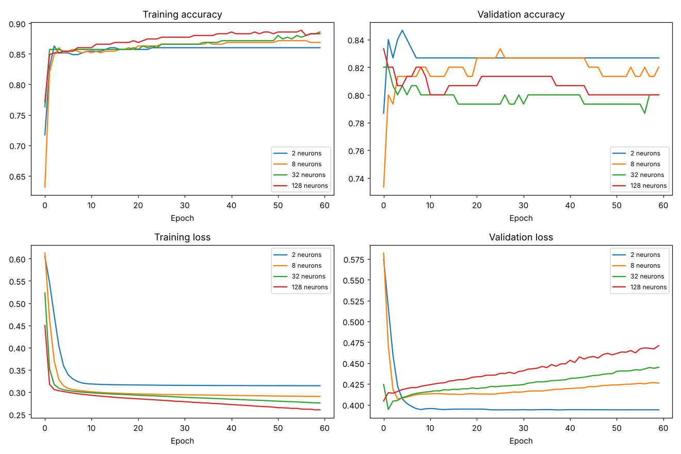
Figure 5.1

RESULT
- Increasing the hidden neurons did not improve validation performance. Training accuracy rose slightly (0.860 → 0.883) from 2 to 128 neurons, but validation accuracy fell (0.827 → 0.800) and validation loss rose (0.394 → 0.471).
- The train–validation accuracy gap widened from 0.033 (2 neurons) to 0.086 (32 neurons) and 0.083 (128 neurons), indicating the larger networks began to overfit the noise in the training data.
- Conclusion: for this small, nearly linear dataset a small hidden layer (2–8 neurons) generalises best; adding neurons gives no benefit and increases overfitting.

Experiment 6: Manufacturing Product Quality Prediction

AIM
To implement and train two MLP architectures (single hidden layer and multiple hidden layers) with TensorFlow/Keras under identical conditions, record metrics using NumPy, compare accuracy, loss and generalisation, and recommend the more suitable architecture.

TOOLS
Platform: Python 3 notebook (Google Colab compatible), TensorFlow 2.21
Packages: TensorFlow, Keras, NumPy, Matplotlib
Dataset / settings: Synthetic: 800 products (560 train / 240 validation) with pressure, temperature and production speed; pass/fail follows a non-linear rule. Adam (0.01), 80 epochs, batch 32, same seed and split for both models.

CODE
import os; os.environ["TF_CPP_MIN_LOG_LEVEL"] = "3"
import numpy as np, tensorflow as tf
import matplotlib.pyplot as plt
from tensorflow import keras
from tensorflow.keras import layers

np.random.seed(11); tf.random.set_seed(11)
n = 800
p = np.random.normal(50, 10, n); t = np.random.normal(200, 20, n); s = np.random.normal(100, 15, n)
passed = ((((p - 50) / 10) ** 2 + ((t - 200) / 20) ** 2) < 1.5) & (s > 85) # non-linear rule
y = passed.astype("float32")
X = np.column_stack([p, t, s]); X = (X - X.mean(0)) / X.std(0)
idx = np.random.permutation(n); tr, va = idx[:560], idx[560:]
Xtr, ytr, Xva, yva = X[tr], y[tr], X[va], y[va]
print("Pass rate:", y.mean().round(2), " Train/Val:", len(tr), len(va))

def build(hidden):
m = keras.Sequential([layers.Input(shape=(3,))] + [layers.Dense(u, activation="relu") for u in hidden]
+ [layers.Dense(1, activation="sigmoid")])
m.compile(optimizer=keras.optimizers.Adam(0.01), loss="binary_crossentropy", metrics=["accuracy"])
return m

archs = {"Single hidden layer (16)": [16], "Multiple hidden layers (32-16-8)": [32, 16, 8]}
res = {}
for name, hl in archs.items():
tf.random.set_seed(11); m = build(hl)
h = m.fit(Xtr, ytr, validation_data=(Xva, yva), epochs=80, batch_size=32, verbose=0).history
res[name] = {k: np.array(v) for k, v in h.items()}; res[name]["params"] = m.count_params()
print(f"\n{'Architecture':34s} {'Params':>7} {'TrainAcc':>9} {'ValAcc':>7} {'TrainLoss':>10} {'ValLoss':>8} {'TrLoss-ValLoss':>15}")
for name, r in res.items():
print(f"{name:34s} {r['params']:7d} {r['accuracy'][-1]:9.3f} {r['val_accuracy'][-1]:7.3f} {r['loss'][-1]:10.3f} {r['val_loss'][-1]:8.3f} {r['loss'][-1]-r['val_loss'][-1]:15.3f}")

fig, ax = plt.subplots(1, 2, figsize=(12, 4.5))
for name, r in res.items():
ax[0].plot(r["val_accuracy"], label=name + " (val)"); ax[0].plot(r["accuracy"], "--", label=name + " (train)")
ax[1].plot(r["val_loss"], label=name + " (val)"); ax[1].plot(r["loss"], "--", label=name + " (train)")
ax[0].set_title("Accuracy"); ax[1].set_title("Loss")
for a in ax: a.set_xlabel("Epoch"); a.legend(fontsize=7)
plt.tight_layout(); plt.savefig("q6_compare.png", dpi=110); plt.show()

OUTPUT
Console output:
Pass rate: 0.43 Train/Val: 560 240

Architecture Params TrainAcc ValAcc TrainLoss ValLoss TrLoss-ValLoss
Single hidden layer (16) 81 0.996 0.983 0.062 0.079 -0.017
Multiple hidden layers (32-16-8) 801 0.996 0.979 0.010 0.080 -0.070

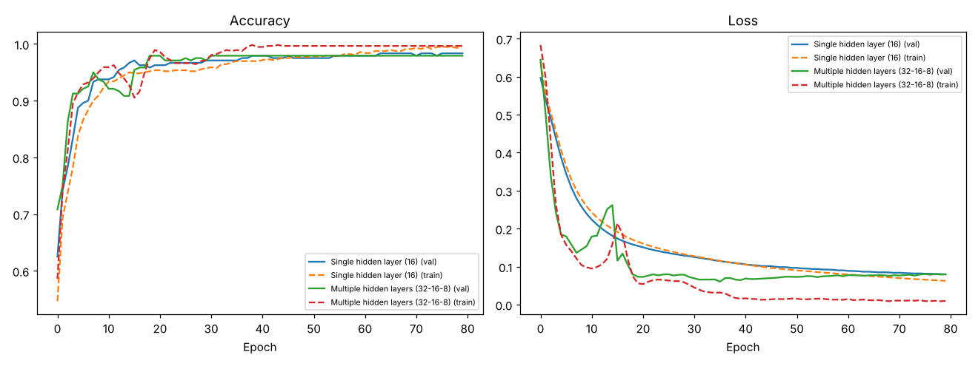
Figure 6.1

RESULT
- Both architectures reached almost the same accuracy: the single-layer network (81 parameters) obtained 0.996 training / 0.983 validation accuracy and validation loss 0.079; the multi-layer network (801 parameters) obtained 0.996 / 0.979 and validation loss 0.080.
- The deeper network, however, drove its training loss to 0.010 versus a validation loss of 0.080 (difference −0.070), whereas the single-layer network had 0.062 versus 0.079 (difference −0.017), i.e. the deeper model generalises slightly worse relative to its training fit.
- Recommendation: the single-hidden-layer MLP is the more suitable architecture because it gives equal validation accuracy with ten times fewer parameters, lower computational cost and less overfitting.

4. L2, Dropout and Early Stopping Comparison

Experiment 7: House Price Prediction and Overfitting

AIM
To build a baseline network, an L2-regularised network and a dropout network in TensorFlow/Keras for house price prediction, train them on the same data, store the loss values using NumPy, plot training and validation loss, and determine which technique generalises better.

TOOLS
Platform: Python 3 notebook (Google Colab compatible), TensorFlow 2.21
Packages: TensorFlow, Keras, NumPy, Matplotlib
Dataset / settings: Synthetic: 120 houses (area, rooms, age, distance); price = linear combination + noise; only 40 training and 80 validation samples to induce overfitting. Two Dense(128) layers; L2 = 0.05; dropout = 0.4; 300 epochs, Adam (0.001), batch 16.

CODE
import os; os.environ["TF_CPP_MIN_LOG_LEVEL"] = "3"
import numpy as np, tensorflow as tf
import matplotlib.pyplot as plt
from tensorflow import keras
from tensorflow.keras import layers, regularizers

np.random.seed(5); tf.random.set_seed(5)
n = 120
area = np.random.uniform(500, 3500, n); rooms = np.random.randint(1, 7, n)
age = np.random.uniform(0, 50, n); dist = np.random.uniform(1, 30, n)
price = 120 * area + 15000 * rooms - 1500 * age - 4000 * dist + 50000 + np.random.normal(0, 60000, n)
X = np.column_stack([area, rooms, age, dist]); y = price.reshape(-1, 1)
tr, va = np.arange(40), np.arange(40, n) # small train set -> overfitting risk
xm, xs, ym, ys = X[tr].mean(0), X[tr].std(0), y[tr].mean(), y[tr].std()
Xtr, Xva = (X[tr] - xm) / xs, (X[va] - xm) / xs; ytr, yva = (y[tr] - ym) / ys, (y[va] - ym) / ys
print("Train samples:", len(tr), " Validation samples:", len(va))

def build(kind):
reg = regularizers.l2(0.05) if kind == "L2" else None
L = [layers.Input(shape=(4,)), layers.Dense(128, activation="relu", kernel_regularizer=reg)]
if kind == "Dropout": L.append(layers.Dropout(0.4))
L.append(layers.Dense(128, activation="relu", kernel_regularizer=reg))
if kind == "Dropout": L.append(layers.Dropout(0.4))
L.append(layers.Dense(1))
m = keras.Sequential(L); m.compile(optimizer=keras.optimizers.Adam(1e-3), loss="mse"); return m

res = {}
for kind in ["Baseline", "L2", "Dropout"]:
tf.random.set_seed(5)
h = build(kind).fit(Xtr, ytr, validation_data=(Xva, yva), epochs=300, batch_size=16, verbose=0).history
res[kind] = {"loss": np.array(h["loss"]), "val_loss": np.array(h["val_loss"])}
print(f"\n{'Model':10s} {'Final train MSE':>16} {'Final val MSE':>14} {'Best val MSE':>13} {'Best epoch':>11} {'Val-Train gap':>14}")
for k, r in res.items():
print(f"{k:10s} {r['loss'][-1]:16.4f} {r['val_loss'][-1]:14.4f} {r['val_loss'].min():13.4f} {r['val_loss'].argmin()+1:11d} {r['val_loss'][-1]-r['loss'][-1]:14.4f}")

fig, ax = plt.subplots(1, 3, figsize=(15, 4), sharey=True)
for a, (k, r) in zip(ax, res.items()):
a.plot(r["loss"], label="Training"); a.plot(r["val_loss"], label="Validation")
a.set_title(k); a.set_xlabel("Epoch"); a.legend()
ax[0].set_ylabel("MSE (standardised price)"); ax[0].set_ylim(0, 1.2)
plt.tight_layout(); plt.savefig("q7_loss.png", dpi=110); plt.show()

OUTPUT
Console output:
Train samples: 40 Validation samples: 80

Model Final train MSE Final val MSE Best val MSE Best epoch Val-Train gap
Baseline 0.0000 0.4326 0.3639 12 0.4326
L2 0.1570 0.4257 0.4252 299 0.2687
Dropout 0.0692 0.3770 0.3454 162 0.3078

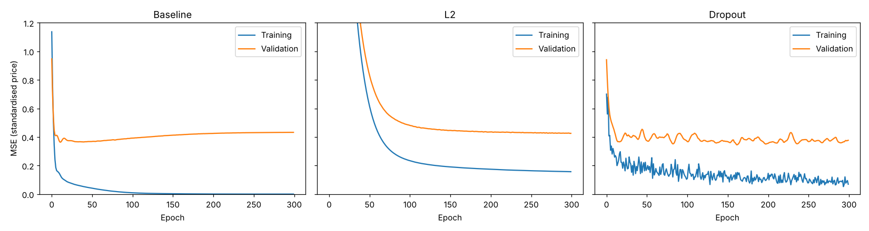
Figure 7.1

RESULT
- The baseline model overfitted strongly: its final training MSE was 0.0000 while the final validation MSE was 0.4326, with the best validation loss (0.3639) reached at epoch 12 and then getting worse.
- L2 regularisation gave a training MSE of 0.1570 and a validation MSE of 0.4257 (gap 0.2687); dropout gave 0.0692 and 0.3770 (gap 0.3078, best validation 0.3454 at epoch 162).
- Dropout produced the lowest final validation loss, so it provided the better generalisation here; L2 produced the smallest train–validation gap and the most stable validation curve. Both were better than the baseline. (Validation error stays well above zero because noise was deliberately added to the prices.)

Experiment 8: Medical Appointment No-Show Prediction

AIM
To implement a baseline neural network, a dropout-based model and an early-stopping model in TensorFlow/Keras for predicting appointment no-shows, record the metrics using NumPy, plot loss curves, and analyse the effect of dropout and early stopping on overfitting, training duration and validation performance.

TOOLS
Platform: Python 3 notebook (Google Colab compatible), TensorFlow 2.21
Packages: TensorFlow, Keras, NumPy, Matplotlib
Dataset / settings: Synthetic: 400 appointments (lead time, previous attendance, reminder status); 120 training and 280 validation samples with stochastic labels. Two Dense(64) layers, Adam (0.001), up to 200 epochs; dropout 0.4; early stopping patience 10 with best weights restored.

CODE
import os; os.environ["TF_CPP_MIN_LOG_LEVEL"] = "3"
import time, numpy as np, tensorflow as tf
import matplotlib.pyplot as plt
from tensorflow import keras
from tensorflow.keras import layers

np.random.seed(9); tf.random.set_seed(9)
n = 400
lead = np.random.uniform(0, 60, n); prev = np.random.uniform(0, 1, n); remind = np.random.randint(0, 2, n)
prob = 1 / (1 + np.exp(-(0.05 * lead - 3 * prev - 1.0 * remind + 0.8)))
y = (np.random.uniform(size=n) < prob).astype("float32") # 1 = no-show
X = np.column_stack([lead, prev, remind]); X = (X - X.mean(0)) / X.std(0)
tr, va = np.arange(120), np.arange(120, n)
Xtr, ytr, Xva, yva = X[tr], y[tr], X[va], y[va]
print("Train:", len(tr), " Validation:", len(va), " No-show rate:", y.mean().round(2))

def build(drop=0.0):
L = [layers.Input(shape=(3,)), layers.Dense(64, activation="relu")]
if drop: L.append(layers.Dropout(drop))
L.append(layers.Dense(64, activation="relu"))
if drop: L.append(layers.Dropout(drop))
L.append(layers.Dense(1, activation="sigmoid"))
m = keras.Sequential(L); m.compile(optimizer=keras.optimizers.Adam(1e-3), loss="binary_crossentropy", metrics=["accuracy"]); return m

setups = {"Baseline": (0.0, []), "Dropout (0.4)": (0.4, []),
"Early stopping": (0.0, [keras.callbacks.EarlyStopping(monitor="val_loss", patience=10, restore_best_weights=True)])}
res = {}
for name, (d, cb) in setups.items():
tf.random.set_seed(9); m = build(d); t0 = time.time()
h = m.fit(Xtr, ytr, validation_data=(Xva, yva), epochs=200, batch_size=16, callbacks=cb, verbose=0).history
res[name] = {k: np.array(v) for k, v in h.items()}; res[name]["time"] = time.time() - t0
print(f"\n{'Model':16s} {'Epochs':>7} {'Time(s)':>8} {'TrainAcc':>9} {'ValAcc':>7} {'Best ValLoss':>13} {'Final ValLoss':>14}")
for k, r in res.items():
print(f"{k:16s} {len(r['loss']):7d} {r['time']:8.1f} {r['accuracy'][-1]:9.3f} {r['val_accuracy'][-1]:7.3f} {r['val_loss'].min():13.3f} {r['val_loss'][-1]:14.3f}")

fig, ax = plt.subplots(1, 3, figsize=(15, 4), sharey=True)
for a, (k, r) in zip(ax, res.items()):
a.plot(r["loss"], label="Training"); a.plot(r["val_loss"], label="Validation"); a.set_title(k); a.set_xlabel("Epoch"); a.legend()
ax[0].set_ylabel("Binary cross-entropy"); plt.tight_layout(); plt.savefig("q8_loss.png", dpi=110); plt.show()

OUTPUT
Console output:
Train: 120 Validation: 280 No-show rate: 0.56

Model Epochs Time(s) TrainAcc ValAcc Best ValLoss Final ValLoss
Baseline 200 30.7 0.842 0.643 0.553 0.732
Dropout (0.4) 200 29.7 0.717 0.664 0.556 0.576
Early stopping 30 5.2 0.700 0.721 0.549 0.551

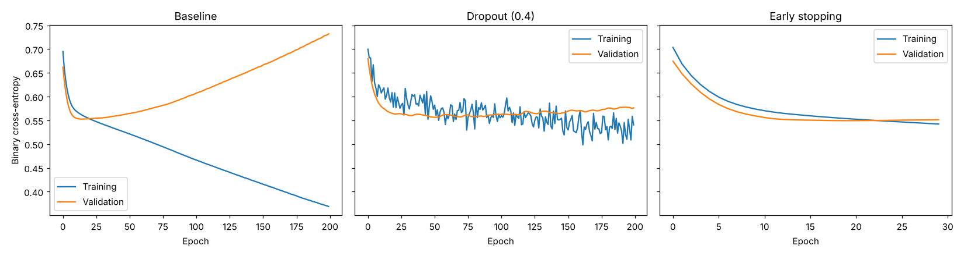
Figure 8.1

RESULT
- The baseline overfitted: after 200 epochs it had training accuracy 0.842 but only 0.643 validation accuracy, and validation loss rose from a best of 0.553 to 0.732.
- Dropout (0.4) reduced overfitting: training accuracy 0.717, validation accuracy 0.664, final validation loss 0.576. Early stopping halted at epoch 30, restored the best weights, and gave the best validation accuracy (0.721) with validation loss 0.551, using 5.2 s instead of about 30 s (≈ 85% less training time).
- Recommendation: use early stopping (optionally together with dropout) for this small dataset, since it prevents overfitting and shortens training.

5. CNN for Image Classification

Experiment 9: Plant Leaf Disease Classification

AIM
To implement a CNN in TensorFlow/Keras with convolution, activation, pooling, flattening and a dense output layer to classify leaf images as healthy or diseased, to illustrate each processing step on a 4×4 grayscale matrix, to record accuracy and loss using NumPy, and to analyse how convolution and pooling affect the classification features.

TOOLS
Platform: Python 3 notebook (Google Colab compatible), TensorFlow 2.21
Packages: TensorFlow, Keras, NumPy, Matplotlib
Dataset / settings: Synthetic: 800 4×4 grayscale images (600 train / 200 validation); diseased leaves contain a bright 2×2 lesion at a random position, with Gaussian noise. CNN: Conv2D(4, 2×2, ReLU) → MaxPool(2, stride 1) → Flatten → Dense(1, sigmoid); 40 epochs.

CODE
import os; os.environ["TF_CPP_MIN_LOG_LEVEL"] = "3"
import numpy as np, tensorflow as tf
import matplotlib.pyplot as plt
from tensorflow import keras
from tensorflow.keras import layers

np.random.seed(21); tf.random.set_seed(21)
# ---- Simplified leaf dataset: 4x4 grayscale. Diseased leaf = bright 2x2 lesion at a random position.
def make(n):
X = np.random.uniform(0.25, 0.45, (n, 4, 4)); y = np.zeros(n)
for i in range(n):
if i % 2 == 0:
r, c = np.random.randint(0, 3, 2); X[i, r:r+2, c:c+2] += np.random.uniform(0.12, 0.25); y[i] = 1
return np.clip(X + np.random.normal(0, 0.12, X.shape), 0, 1)[..., None].astype("float32"), y.astype("float32")
X, y = make(800); idx = np.random.permutation(800); X, y = X[idx], y[idx]
Xtr, ytr, Xva, yva = X[:600], y[:600], X[600:], y[600:]

# ---- Step-by-step illustration on ONE 4x4 matrix with NumPy
img = Xva[np.where(yva == 1)[0][0], :, :, 0]
kernel = np.array([[1, 1], [1, 1]]) / 4.0 # 2x2 averaging (blob) filter
conv = np.array([[np.sum(img[i:i+2, j:j+2] * kernel) for j in range(3)] for i in range(3)])
relu = np.maximum(conv, 0)
pool = np.array([[relu[i:i+2, j:j+2].max() for j in range(2)] for i in range(2)])
np.set_printoptions(precision=2, suppress=True)
print("Input 4x4 image:\n", img); print("\nConvolution 2x2 kernel (3x3 output):\n", conv)
print("\nAfter ReLU:\n", relu); print("\nAfter 2x2 max-pooling, stride 1 (2x2 output):\n", pool)
print("\nFlattened vector:", pool.flatten())

# ---- Keras CNN
def build(pool_size=2, pool_stride=1, use_pool=True):
L = [layers.Input(shape=(4, 4, 1)), layers.Conv2D(4, (2, 2), activation="relu")]
if use_pool: L.append(layers.MaxPooling2D(pool_size, strides=pool_stride))
L += [layers.Flatten(), layers.Dense(1, activation="sigmoid")]
m = keras.Sequential(L); m.compile(optimizer=keras.optimizers.Adam(0.01), loss="binary_crossentropy", metrics=["accuracy"]); return m

def train(m):
h = m.fit(Xtr, ytr, validation_data=(Xva, yva), epochs=40, batch_size=16, verbose=0).history
return {k: np.array(v) for k, v in h.items()}
tf.random.set_seed(21); model = build(); model.summary(print_fn=print); hist = train(model)
print(f"\nFinal: train acc={hist['accuracy'][-1]:.3f}, val acc={hist['val_accuracy'][-1]:.3f}, train loss={hist['loss'][-1]:.3f}, val loss={hist['val_loss'][-1]:.3f}")

variants = {"Conv + Pool(2, stride 1)": dict(), "Conv + Pool(3) -> 1x1 (aggressive)": dict(pool_size=3, pool_stride=3), "Conv only (no pooling)": dict(use_pool=False)}
print(f"\n{'Variant':38s} {'Val acc':>8} {'Val loss':>9}")
for name, kw in variants.items():
tf.random.set_seed(21); h = train(build(**kw)); print(f"{name:38s} {h['val_accuracy'][-1]:8.3f} {h['val_loss'][-1]:9.3f}")

fig, ax = plt.subplots(1, 2, figsize=(11, 4))
ax[0].plot(hist["accuracy"], label="Train"); ax[0].plot(hist["val_accuracy"], label="Validation"); ax[0].set_title("Accuracy"); ax[0].legend()
ax[1].plot(hist["loss"], label="Train"); ax[1].plot(hist["val_loss"], label="Validation"); ax[1].set_title("Loss"); ax[1].legend()
for a in ax: a.set_xlabel("Epoch")
plt.tight_layout(); plt.savefig("q9_curves.png", dpi=110); plt.show()
fig, ax = plt.subplots(1, 4, figsize=(11, 3))
for a, m, t in zip(ax, [img, conv, relu, pool], ["Input 4x4", "Convolution 3x3", "ReLU 3x3", "MaxPool 2x2"]):
a.imshow(m, cmap="gray", vmin=0, vmax=1); a.set_title(t)
for (i, j), v in np.ndenumerate(m): a.text(j, i, f"{v:.2f}", ha="center", va="center", color="red", fontsize=8)
a.set_xticks([]); a.set_yticks([])
plt.tight_layout(); plt.savefig("q9_steps.png", dpi=110); plt.show()

OUTPUT
Console output:
Input 4x4 image:
[[0.32 0.29 0.51 0.2 ]
[0.42 0.4 0.89 0.21]
[0.28 0.68 0.54 0.24]
[0.47 0.55 0.36 0.49]]

Convolution 2x2 kernel (3x3 output):
[[0.36 0.52 0.45]
[0.44 0.63 0.47]
[0.49 0.53 0.41]]

After ReLU:
[[0.36 0.52 0.45]
[0.44 0.63 0.47]
[0.49 0.53 0.41]]

After 2x2 max-pooling, stride 1 (2x2 output):
[[0.63 0.63]
[0.63 0.63]]

Flattened vector: [0.63 0.63 0.63 0.63]
Model: "sequential"
Total params: 37 (148.00 B)
Trainable params: 37 (148.00 B)
Non-trainable params: 0 (0.00 B)

Final: train acc=0.830, val acc=0.810, train loss=0.384, val loss=0.421

Variant Val acc Val loss
Conv + Pool(2, stride 1) 0.820 0.416
Conv + Pool(3) -> 1x1 (aggressive) 0.810 0.396
Conv only (no pooling) 0.825 0.423

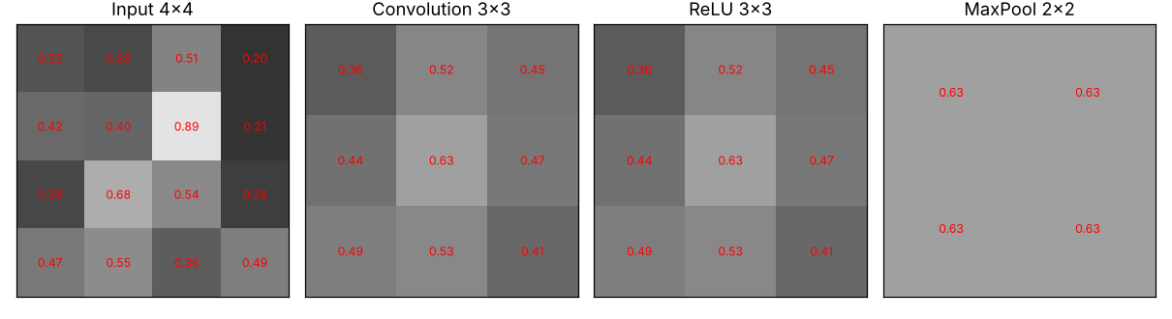
Figure 9.1
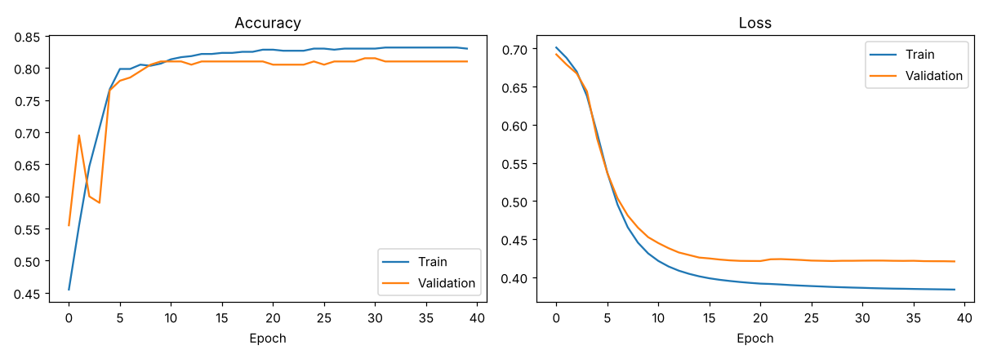
Figure 9.2

RESULT
- The step-by-step example shows a 4×4 input becoming a 3×3 feature map after the 2×2 convolution (the lesion region gives the highest response, 0.63), unchanged by ReLU (all values positive), and a 2×2 map after max-pooling which keeps the strongest activation (0.63) in each window.
- The CNN achieved 0.830 training and 0.810 validation accuracy (validation loss 0.421). Variants gave similar validation accuracy: conv + pool 0.820, conv + aggressive pooling to 1×1 0.810, conv only 0.825. The differences (≤ 1.5%) are within the noise of a 200-image validation set.
- Convolution extracts local lesion features irrespective of position; max-pooling keeps the strongest response and discards its exact location. In this task only the presence of a lesion matters, so pooling did not hurt; with larger images or tasks where position matters, excessive pooling would remove useful spatial information.

Experiment 10: Road Sign Image Classification

AIM
To implement a CNN in TensorFlow/Keras that classifies road signs into speed limit, stop and no entry, evaluate it with accuracy and a confusion matrix, visualise training/validation accuracy and loss, and analyse which classes are misclassified and how the model could be improved.

TOOLS
Platform: Python 3 notebook (Google Colab compatible), TensorFlow 2.21
Packages: TensorFlow, Keras, NumPy, Matplotlib
Dataset / settings: Synthetic: 450 RGB 32×32 sign images (150 per class; 360 train / 90 validation) with heavy noise, random position/size and occlusion; stop and no-entry signs deliberately look similar. CNN: Conv(16)–Pool–Conv(32)–Pool–Dense(64)–Softmax(3); Adam (0.001), 15 epochs, batch 32.

CODE
import os; os.environ["TF_CPP_MIN_LOG_LEVEL"] = "3"
import numpy as np, tensorflow as tf
import matplotlib.pyplot as plt
from tensorflow import keras
from tensorflow.keras import layers

rng = np.random.default_rng(10); tf.random.set_seed(10)
names = ["Speed limit", "Stop", "No entry"]
yy, xx = np.mgrid[0:32, 0:32]
def sign(c): # synthetic 32x32 RGB road sign
img = np.repeat(rng.uniform(0.25, 0.75, (32, 32, 1)), 3, axis=2)
cx, cy, r = 16 + rng.integers(-3, 4), 16 + rng.integers(-3, 4), rng.integers(10, 14)
dx, dy = xx - cx, yy - cy; d = np.hypot(dx, dy); red = np.array([0.85, 0.1, 0.1]); white = np.ones(3)
if c == 0: img[d < r] = white; img[(d < r) & (d > r - rng.integers(2, 5))] = red; img[(np.abs(dx) < 1.5) & (np.abs(dy) < 5) & (rng.random() < 0.6)] = 0.1 # ring (+ bar 60% of time)
elif c == 1: oct_ = np.maximum.reduce([np.abs(dx), np.abs(dy), (np.abs(dx) + np.abs(dy)) / 1.25]) < r; img[oct_] = red; img[(np.abs(dy) < rng.uniform(1.5, 3)) & (np.abs(dx) < r * rng.uniform(0.4, 0.7))] = white # near-circular octagon + bar
else: img[d < r] = red; img[(np.abs(dy) < rng.uniform(1.5, 3.2)) & (np.abs(dx) < r * rng.uniform(0.5, 0.8))] = white # disc + bar
if rng.random() < 0.3: i, j = rng.integers(0, 24, 2); img[i:i+8, j:j+8] = rng.uniform(0.2, 0.8) # random occlusion
return np.clip(img + rng.normal(0, 0.65, img.shape), 0, 1)
n = 150
X = np.array([sign(c) for c in range(3) for _ in range(n)], dtype="float32"); y = np.repeat(np.arange(3), n)
idx = rng.permutation(len(y)); X, y = X[idx], y[idx]; split = int(0.8 * len(y))
Xtr, ytr, Xva, yva = X[:split], y[:split], X[split:], y[split:]
print("Images:", X.shape, " Train:", len(ytr), " Validation:", len(yva))

model = keras.Sequential([layers.Input(shape=(32, 32, 3)),
layers.Conv2D(16, 3, activation="relu"), layers.MaxPooling2D(),
layers.Conv2D(32, 3, activation="relu"), layers.MaxPooling2D(),
layers.Flatten(), layers.Dense(64, activation="relu"), layers.Dense(3, activation="softmax")])
model.compile(optimizer=keras.optimizers.Adam(1e-3), loss="sparse_categorical_crossentropy", metrics=["accuracy"])
model.summary(print_fn=print)
h = model.fit(Xtr, ytr, validation_data=(Xva, yva), epochs=15, batch_size=32, verbose=0).history
h = {k: np.array(v) for k, v in h.items()}
for e in (0, 4, 9, 14): print(f"Epoch {e+1:2d}: train acc={h['accuracy'][e]:.3f} val acc={h['val_accuracy'][e]:.3f} train loss={h['loss'][e]:.3f} val loss={h['val_loss'][e]:.3f}")

pred = model.predict(Xva, verbose=0).argmax(1)
cm = np.zeros((3, 3), int)
for t, p in zip(yva, pred): cm[t, p] += 1
print("\nValidation accuracy =", round(np.mean(pred == yva) * 100, 2), "%")
print("\nConfusion matrix (rows = actual, columns = predicted):"); print(cm)
for i, nm in enumerate(names): print(f" {nm:12s} recall = {cm[i,i]/cm[i].sum():.3f} precision = {cm[i,i]/max(cm[:,i].sum(),1):.3f}")
off = [(names[i], names[j], cm[i, j]) for i in range(3) for j in range(3) if i != j and cm[i, j] > 0]
print("Misclassifications (actual -> predicted : count):", sorted(off, key=lambda t: -t[2]))

fig, ax = plt.subplots(1, 3, figsize=(16, 4.3))
ax[0].plot(h["accuracy"], label="Train"); ax[0].plot(h["val_accuracy"], label="Validation"); ax[0].set_title("Accuracy"); ax[0].legend()
ax[1].plot(h["loss"], label="Train"); ax[1].plot(h["val_loss"], label="Validation"); ax[1].set_title("Loss"); ax[1].legend()
for a in ax[:2]: a.set_xlabel("Epoch")
im = ax[2].imshow(cm, cmap="Blues"); ax[2].set_xticks(range(3)); ax[2].set_xticklabels(names, rotation=20); ax[2].set_yticks(range(3)); ax[2].set_yticklabels(names)
for (i, j), v in np.ndenumerate(cm): ax[2].text(j, i, v, ha="center", va="center", color="red" if v > cm.max()/2 else "black", fontsize=12)
ax[2].set_xlabel("Predicted"); ax[2].set_ylabel("Actual"); ax[2].set_title("Confusion matrix")
plt.tight_layout(); plt.savefig("q10_results.png", dpi=110); plt.show()
fig, ax = plt.subplots(1, 3, figsize=(7, 2.5))
for c in range(3): ax[c].imshow(Xtr[np.where(ytr == c)[0][0]]); ax[c].set_title(names[c], fontsize=9); ax[c].axis("off")
plt.tight_layout(); plt.savefig("q10_samples.png", dpi=110); plt.show()

OUTPUT
Console output:
Images: (450, 32, 32, 3) Train: 360 Validation: 90
Model: "sequential"
Total params: 79,075 (308.89 KB)
Trainable params: 79,075 (308.89 KB)
Non-trainable params: 0 (0.00 B)

Epoch 1: train acc=0.333 val acc=0.467 train loss=1.136 val loss=1.069
Epoch 5: train acc=0.711 val acc=0.700 train loss=0.565 val loss=0.585
Epoch 10: train acc=0.864 val acc=0.778 train loss=0.345 val loss=0.450
Epoch 15: train acc=0.925 val acc=0.756 train loss=0.248 val loss=0.499

Validation accuracy = 75.56 %

Confusion matrix (rows = actual, columns = predicted):
[[24 0 0]
[ 2 29 3]
[ 1 16 15]]
Speed limit recall = 1.000 precision = 0.889
Stop recall = 0.853 precision = 0.644
No entry recall = 0.469 precision = 0.833
Misclassifications (actual -> predicted : count): [('No entry', 'Stop', np.int64(16)), ('Stop', 'No entry', np.int64(3)), ('Stop', 'Speed limit', np.int64(2)), ('No entry', 'Speed limit', np.int64(1))]

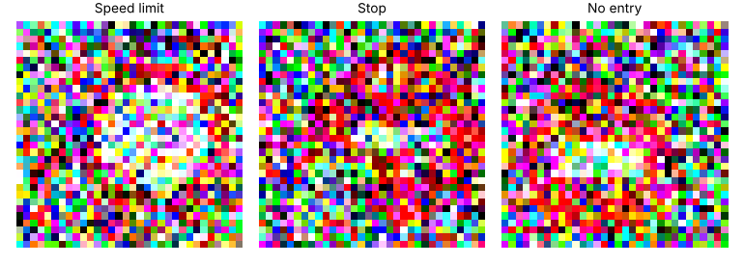
Figure 10.1
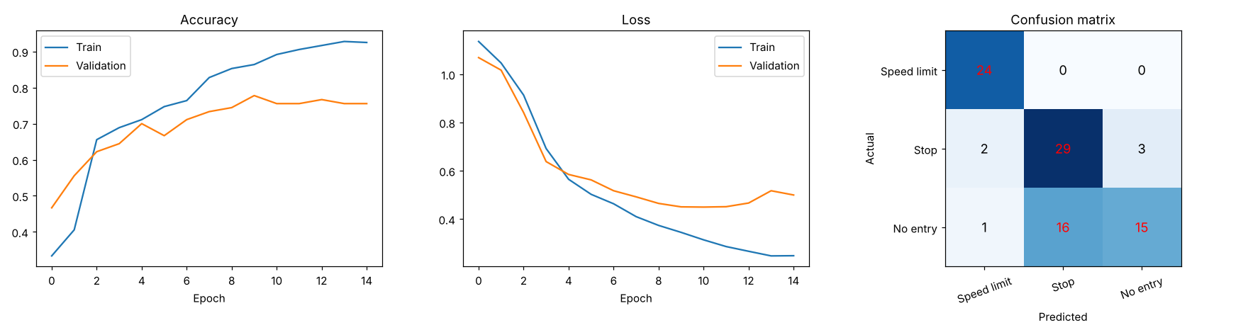
Figure 10.2

RESULT
- The CNN reached 75.56% validation accuracy while training accuracy reached 0.925, so the model overfits (validation loss starts rising after about epoch 10).
- From the confusion matrix: speed-limit signs were recognised perfectly (recall 1.000), stop signs had recall 0.853, but no-entry signs had recall only 0.469 – 16 of 32 no-entry signs were predicted as stop (the most frequent error), and a further 3 stop signs were predicted as no-entry. These two classes overlap visually (red shape with a white horizontal bar).
- Improvements: collect more images and use data augmentation (rotation, brightness, shifts), add dropout/L2 regularisation or early stopping, use a deeper network or higher-resolution input to capture the octagon-versus-circle shape, use class weights/more samples for no-entry, and tune learning rate and batch size.

6. CNN Architecture and Hyperparameter Comparison

Experiment 11: Wildlife Image Classification

AIM
To implement a shallow CNN and a deeper CNN in TensorFlow/Keras for classifying deer, elephant and tiger images, record training time, accuracy and loss using NumPy, plot performance curves, and recommend the architecture that best balances performance and resource requirements.

TOOLS
Platform: Python 3 notebook (Google Colab compatible), TensorFlow 2.21
Packages: TensorFlow, Keras, NumPy, Matplotlib
Dataset / settings: Synthetic: 900 RGB 32×32 texture images (spotted = deer, smooth grey = elephant, striped = tiger), 720 train / 180 validation, noise added. Shallow: 1 conv block; Deeper: 4 conv blocks + Dense(128). Adam (0.001), 15 epochs, batch 32.

CODE
import os; os.environ["TF_CPP_MIN_LOG_LEVEL"] = "3"
import time, numpy as np, tensorflow as tf
import matplotlib.pyplot as plt
from tensorflow import keras
from tensorflow.keras import layers

rng = np.random.default_rng(11); tf.random.set_seed(11)
names = ["Deer", "Elephant", "Tiger"]
yy, xx = np.mgrid[0:32, 0:32]
def animal(c): # synthetic texture images: spots / smooth grey / stripes
jitter = rng.uniform(-0.12, 0.12, 3)
if c == 0:
img = np.ones((32, 32, 3)) * (np.array([0.6, 0.42, 0.25]) + jitter)
for _ in range(rng.integers(8, 14)):
i, j = rng.integers(0, 30, 2); img[i:i+2, j:j+2] = 0.95
elif c == 1:
img = np.ones((32, 32, 3)) * (np.array([0.5, 0.5, 0.52]) + jitter) + 0.15 * np.sin(yy / 6 + rng.uniform(0, 6))[..., None]
else:
img = np.ones((32, 32, 3)) * (np.array([0.9, 0.55, 0.15]) + jitter)
stripes = np.sin((xx + 0.4 * yy) * rng.uniform(0.7, 1.0) + rng.uniform(0, 6)) > 0.55; img[stripes] = 0.05
return np.clip(img + rng.normal(0, 0.45, img.shape), 0, 1)
n = 300
X = np.array([animal(c) for c in range(3) for _ in range(n)], dtype="float32"); y = np.repeat(np.arange(3), n)
idx = rng.permutation(len(y)); X, y = X[idx], y[idx]; s = int(0.8 * len(y))
Xtr, ytr, Xva, yva = X[:s], y[:s], X[s:], y[s:]
print("Train:", len(ytr), " Validation:", len(yva))

def build(deep):
L = [layers.Input(shape=(32, 32, 3)), layers.Conv2D(16, 3, activation="relu", padding="same"), layers.MaxPooling2D()]
if deep:
L += [layers.Conv2D(32, 3, activation="relu", padding="same"), layers.MaxPooling2D(),
layers.Conv2D(64, 3, activation="relu", padding="same"), layers.MaxPooling2D(),
layers.Conv2D(128, 3, activation="relu", padding="same"), layers.MaxPooling2D()]
L += [layers.Flatten()] + ([layers.Dense(128, activation="relu")] if deep else []) + [layers.Dense(3, activation="softmax")]
m = keras.Sequential(L); m.compile(optimizer=keras.optimizers.Adam(1e-3), loss="sparse_categorical_crossentropy", metrics=["accuracy"]); return m

res = {}
for name, deep in [("Shallow CNN (1 conv block)", False), ("Deeper CNN (4 conv blocks)", True)]:
tf.random.set_seed(11); m = build(deep); t0 = time.time()
h = m.fit(Xtr, ytr, validation_data=(Xva, yva), epochs=15, batch_size=32, verbose=0).history
res[name] = {k: np.array(v) for k, v in h.items()}; res[name]["time"] = time.time() - t0; res[name]["params"] = m.count_params()
print(f"\n{'Model':30s} {'Params':>9} {'Time(s)':>8} {'TrainAcc':>9} {'ValAcc':>7} {'TrainLoss':>10} {'ValLoss':>8} {'Epochs to 90% val':>18}")
for k, r in res.items():
ep = np.argmax(r["val_accuracy"] >= 0.9) + 1 if (r["val_accuracy"] >= 0.9).any() else None
print(f"{k:30s} {r['params']:9d} {r['time']:8.1f} {r['accuracy'][-1]:9.3f} {r['val_accuracy'][-1]:7.3f} {r['loss'][-1]:10.3f} {r['val_loss'][-1]:8.3f} {str(ep):>18}")

fig, ax = plt.subplots(1, 3, figsize=(16, 4.3))
for k, r in res.items():
ax[0].plot(r["val_accuracy"], label=k + " val"); ax[0].plot(r["accuracy"], "--", label=k + " train")
ax[1].plot(r["val_loss"], label=k + " val"); ax[1].plot(r["loss"], "--", label=k + " train")
ax[0].set_title("Accuracy"); ax[1].set_title("Loss")
for a in ax[:2]: a.set_xlabel("Epoch"); a.legend(fontsize=7)
ax[2].bar(["Shallow", "Deeper"], [r["time"] for r in res.values()], color=["tab:blue", "tab:orange"]); ax[2].set_title("Training time (s)")
plt.tight_layout(); plt.savefig("q11_compare.png", dpi=110); plt.show()

OUTPUT
Console output:
Train: 720 Validation: 180

Model Params Time(s) TrainAcc ValAcc TrainLoss ValLoss Epochs to 90% val
Shallow CNN (1 conv block) 12739 3.8 1.000 0.989 0.029 0.069 2
Deeper CNN (4 conv blocks) 163491 7.8 0.983 0.989 0.042 0.040 3

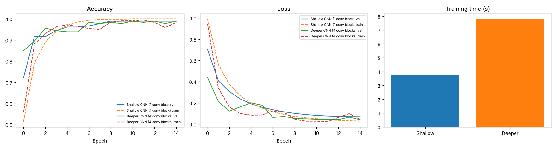
Figure 11.1

RESULT
- Both networks reached the same validation accuracy (0.989). The shallow CNN (12,739 parameters) trained in 3.8 s with training accuracy 1.000 and validation loss 0.069; the deeper CNN (163,491 parameters, ≈ 12.8× more) needed 7.8 s (≈ 2× longer) and had training accuracy 0.983 and a lower validation loss of 0.040.
- The deeper CNN generalised slightly better (smaller gap between training and validation loss) but it converged no faster (90% validation accuracy after 3 epochs vs 2) and cost roughly double the computation.
- Recommendation: for this dataset the shallow CNN gives the best balance of accuracy and resource use; the deeper CNN is worth using only when the images are more complex, where extra convolutional blocks are needed to learn richer features.

Experiment 12: Hyperparameter Optimization for Waste Classification

AIM
To implement several CNN configurations in TensorFlow/Keras for classifying plastic, paper and metal waste images by changing one hyperparameter at a time (learning rate, batch size, number of filters), record validation accuracy, validation loss and training time using NumPy, and identify the best balance of performance, efficiency and generalisation.

TOOLS
Platform: Python 3 notebook (Google Colab compatible), TensorFlow 2.21
Packages: TensorFlow, Keras, NumPy, Matplotlib
Dataset / settings: Synthetic: 900 RGB 32×32 texture images (plastic, paper, metal), 720 train / 180 validation. Baseline: learning rate 0.001, batch 32, 16 filters; each run 10 epochs with the same seed and split.

CODE
import os; os.environ["TF_CPP_MIN_LOG_LEVEL"] = "3"
import time, numpy as np, tensorflow as tf
import matplotlib.pyplot as plt
from tensorflow import keras
from tensorflow.keras import layers

rng = np.random.default_rng(12)
yy, xx = np.mgrid[0:32, 0:32]
def waste(c): # plastic: smooth blue + glare; paper: beige fibres; metal: grey brushed lines
if c == 0:
img = np.ones((32, 32, 3)) * (np.array([0.3, 0.45, 0.8]) + rng.uniform(-0.1, 0.1, 3))
i, j = rng.integers(3, 28, 2); img[max(i-2,0):i+2, max(j-2,0):j+2] = 0.95
elif c == 1:
img = np.ones((32, 32, 3)) * (np.array([0.85, 0.8, 0.65]) + rng.uniform(-0.1, 0.1, 3)) + rng.normal(0, 0.08, (32, 32, 1))
else:
img = np.ones((32, 32, 3)) * (np.array([0.6, 0.6, 0.62]) + rng.uniform(-0.1, 0.1, 3)) + 0.12 * np.sin(xx * rng.uniform(1.5, 3))[..., None]
return np.clip(img + rng.normal(0, 0.45, img.shape), 0, 1)
n = 300
X = np.array([waste(c) for c in range(3) for _ in range(n)], dtype="float32"); y = np.repeat(np.arange(3), n)
idx = rng.permutation(len(y)); X, y = X[idx], y[idx]; s = int(0.8 * len(y))
Xtr, ytr, Xva, yva = X[:s], y[:s], X[s:], y[s:]

def build(lr, filters):
m = keras.Sequential([layers.Input(shape=(32, 32, 3)),
layers.Conv2D(filters, 3, activation="relu"), layers.MaxPooling2D(),
layers.Conv2D(filters * 2, 3, activation="relu"), layers.MaxPooling2D(),
layers.Flatten(), layers.Dense(32, activation="relu"), layers.Dense(3, activation="softmax")])
m.compile(optimizer=keras.optimizers.Adam(lr), loss="sparse_categorical_crossentropy", metrics=["accuracy"]); return m

base = dict(lr=1e-3, batch=32, filters=16)
experiments = [("Baseline", base)]
for lr in [1e-4, 1e-2]: experiments.append((f"lr={lr}", {**base, "lr": lr}))
for b in [16, 64, 128]: experiments.append((f"batch={b}", {**base, "batch": b}))
for f in [8, 32]: experiments.append((f"filters={f}", {**base, "filters": f}))

res = {}
for name, cfg in experiments:
tf.random.set_seed(12); m = build(cfg["lr"], cfg["filters"]); t0 = time.time()
h = m.fit(Xtr, ytr, validation_data=(Xva, yva), epochs=10, batch_size=cfg["batch"], verbose=0).history
res[name] = {k: np.array(v) for k, v in h.items()}; res[name]["time"] = time.time() - t0
print("Baseline: lr=0.001, batch=32, filters=16 (one hyperparameter changed at a time)")
print(f"\n{'Config':12s} {'Val acc':>8} {'Val loss':>9} {'Train acc':>10} {'Gap':>6} {'Time(s)':>8} {'Val-acc std (last 5 ep)':>24}")
for k, r in res.items():
print(f"{k:12s} {r['val_accuracy'][-1]:8.3f} {r['val_loss'][-1]:9.3f} {r['accuracy'][-1]:10.3f} {r['accuracy'][-1]-r['val_accuracy'][-1]:6.3f} {r['time']:8.1f} {r['val_accuracy'][-5:].std():24.4f}")

fig, ax = plt.subplots(2, 2, figsize=(13, 9))
groups = {"Learning rate": ["lr=0.0001", "Baseline", "lr=0.01"], "Batch size": ["batch=16", "Baseline", "batch=64", "batch=128"], "Filters": ["filters=8", "Baseline", "filters=32"]}
for a, (g, ks) in zip(ax.ravel(), groups.items()):
for k in ks: a.plot(res[k]["val_accuracy"], label=k)
a.set_title(f"Validation accuracy - {g}"); a.set_xlabel("Epoch"); a.legend(fontsize=8)
names_ = list(res); a = ax[1, 1]; xs = np.arange(len(names_))
a.bar(xs - 0.2, [res[k]["val_accuracy"][-1] for k in names_], 0.4, label="Val accuracy")
a2 = a.twinx(); a2.bar(xs + 0.2, [res[k]["time"] for k in names_], 0.4, color="tab:orange", label="Time (s)")
a.set_xticks(xs); a.set_xticklabels(names_, rotation=60, fontsize=8); a.set_title("Final val accuracy (blue) & time (orange)")
plt.tight_layout(); plt.savefig("q12_compare.png", dpi=110); plt.show()

OUTPUT
Console output:
Baseline: lr=0.001, batch=32, filters=16 (one hyperparameter changed at a time)

Config Val acc Val loss Train acc Gap Time(s) Val-acc std (last 5 ep)
Baseline 0.994 0.013 0.992 -0.003 4.3 0.0000
lr=0.0001 0.978 0.228 0.985 0.007 4.2 0.0188
lr=0.01 0.961 0.075 0.979 0.018 3.9 0.0198
batch=16 0.944 0.111 0.992 0.047 4.1 0.0147
batch=64 0.972 0.054 0.997 0.025 3.7 0.0075
batch=128 1.000 0.030 0.999 -0.001 3.3 0.0065
filters=8 0.983 0.032 0.997 0.014 3.4 0.0044
filters=32 0.989 0.029 0.997 0.008 5.6 0.0054

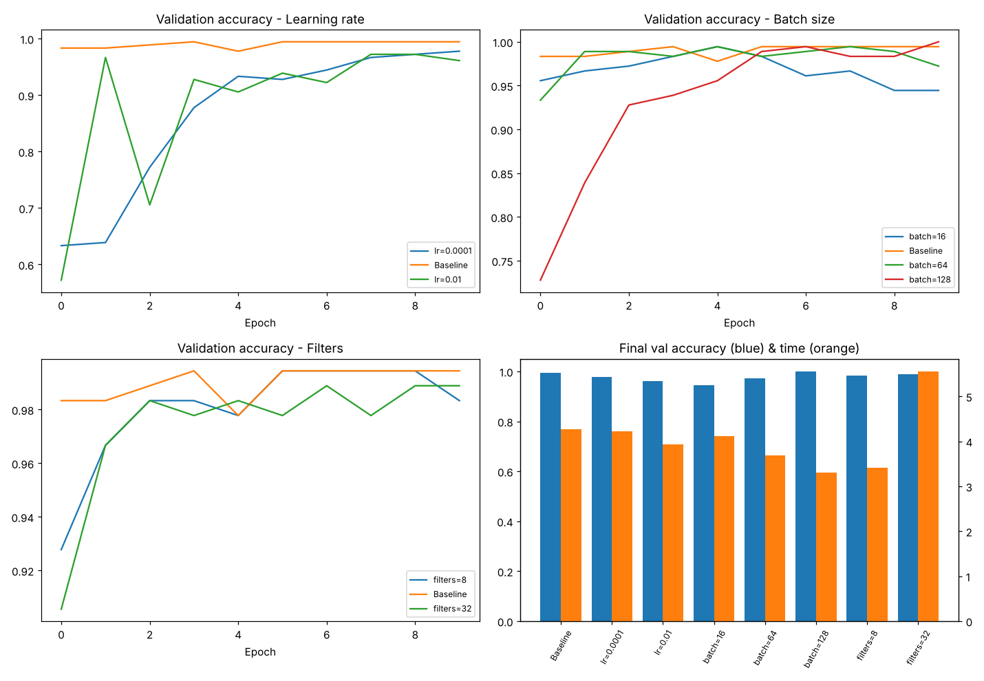
Figure 12.1

RESULT
- Learning rate: 0.0001 converged slowly (validation loss 0.228, validation accuracy 0.978) and 0.01 was unstable (validation accuracy 0.961, standard deviation over the last 5 epochs 0.0198); 0.001 gave the best validation loss (0.013) and accuracy of 0.994.
- Batch size: 16 gave the lowest validation accuracy (0.944) and the largest generalisation gap (0.047); 64 gave 0.972; 128 gave 1.000 accuracy and was the fastest (3.3 s), although its validation loss (0.030) was higher than the baseline's (0.013).
- Filters: 8 filters (0.983, 3.5 s) and 32 filters (0.989, 5.6 s) were not better than 16 filters (0.994, 4.3 s), so more filters increased training time without improving accuracy.
- Best balance: learning rate 0.001, batch size 32 (or 128 for speed) and 16 filters. Note that the validation set has 180 images (one image ≈ 0.56%) and each setting was run once, so differences below about 1% should not be over-interpreted.

