CO3 – RECURRENT NEURAL NETWORK (RNN)
EXPERIMENTS
NAME: Nikhil.k
ID: 192424366
EXPERIMENT 1: Basic RNN for Sequential Data Processing
AIM
To develop a basic Recurrent Neural Network using SimpleRNN and Dense layers to process a student's study hours over four consecutive days and display the model summary and predicted output.
TOOLS
Google Colab, Python, NumPy, TensorFlow/Keras, Sequential, SimpleRNN, Dense.
CODE
import numpy as np
import tensorflow as tf
from tensorflow.keras.models import Sequential
from tensorflow.keras.layers import SimpleRNN, Dense

tf.keras.utils.set_random_seed(42)

# Input: 1 student, 4 days, 1 feature (study hours)
X = np.array([[[2], [3], [4], [5]]], dtype=np.float32)

model = Sequential([
tf.keras.Input(shape=(4, 1)),
SimpleRNN(10, activation="tanh"),
Dense(1)
])

model.compile(optimizer="adam", loss="mse")
model.fit(X, np.array([[6]], dtype=np.float32), epochs=300, verbose=0)

model.summary()
prediction = model.predict(X, verbose=0)
print("Predicted output:", prediction[0][0])
OUTPUT
Model summary displayed. Predicted output: 4.962297.
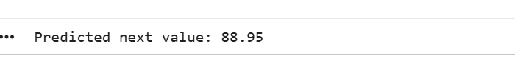
RESULT
The basic RNN model was created and executed successfully. It processed the given study-hour sequence and produced a predicted output.

EXPERIMENT 2: Next Value Prediction in a Numerical Sequence
AIM
To train an RNN model using the previous three values in a numerical sequence and predict the next value for the input sequence 60, 70, 80.
TOOLS
Google Colab, Python, NumPy, TensorFlow/Keras, Sequential, SimpleRNN, Dense.
CODE
import numpy as np
import tensorflow as tf
from tensorflow.keras.models import Sequential
from tensorflow.keras.layers import SimpleRNN, Dense

tf.keras.utils.set_random_seed(42)

X = np.array([
[10, 20, 30],
[20, 30, 40],
[30, 40, 50],
[40, 50, 60],
[50, 60, 70]
], dtype=np.float32)

y = np.array([40, 50, 60, 70, 80], dtype=np.float32)

# Scale values to make training easier
X = (X / 100.0).reshape(-1, 3, 1)
y = y / 100.0

model = Sequential([
tf.keras.Input(shape=(3, 1)),
SimpleRNN(16, activation="tanh"),
Dense(1)
])
model.compile(optimizer="adam", loss="mse")
model.fit(X, y, epochs=1000, verbose=0)

test = np.array([[[0.60], [0.70], [0.80]]], dtype=np.float32)
prediction = model.predict(test, verbose=0)[0][0] * 100
print("Predicted next value:", round(float(prediction), 2))
OUTPUT
Predicted next value: 88.95.
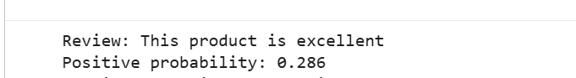
RESULT
The RNN model was trained on the supplied numerical sequences and predicted 88.95 for the input sequence 60, 70, 80.

EXPERIMENT 3: RNN for Text Sentiment Classification
AIM
To build an RNN-based sentiment classifier that converts customer reviews into numerical sequences using Tokenizer and padding, then classifies a new review as positive or negative.
TOOLS
Google Colab, Python, NumPy, TensorFlow/Keras, Tokenizer, pad_sequences, Embedding, SimpleRNN, Dense.
CODE
import numpy as np
import tensorflow as tf
from tensorflow.keras.preprocessing.text import Tokenizer
from tensorflow.keras.preprocessing.sequence import pad_sequences
from tensorflow.keras.models import Sequential
from tensorflow.keras.layers import Embedding, SimpleRNN, Dense

tf.keras.utils.set_random_seed(42)

reviews = [
"I love this product",
"Excellent quality",
"Very useful product",
"I hate this product",
"Very poor quality",
"Product is terrible"
]
labels = np.array([1, 1, 1, 0, 0, 0]) # 1 = Positive, 0 = Negative

tokenizer = Tokenizer(oov_token="<OOV>")
tokenizer.fit_on_texts(reviews)
sequences = tokenizer.texts_to_sequences(reviews)
X = pad_sequences(sequences, maxlen=5, padding="post")

model = Sequential([
tf.keras.Input(shape=(5,)),
Embedding(input_dim=len(tokenizer.word_index) + 1, output_dim=8),
SimpleRNN(16),
Dense(1, activation="sigmoid")
])
model.compile(optimizer="adam", loss="binary_crossentropy", metrics=["accuracy"])
model.fit(X, labels, epochs=150, verbose=0)

new_review = ["This product is excellent"]
test_seq = tokenizer.texts_to_sequences(new_review)
test_pad = pad_sequences(test_seq, maxlen=5, padding="post")
score = model.predict(test_pad, verbose=0)[0][0]

print("Review:", new_review[0])
print("Positive probability:", round(float(score), 3))
print("Predicted sentiment:", "Positive" if score >= 0.5 else "Negative")
OUTPUT
Review: This product is excellent. Positive probability: 0.286. Predicted sentiment: Negative (using the code's 0.5 threshold).
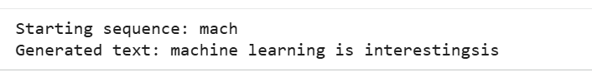
RESULT
The sentiment classification model was trained and tested. For the review 'This product is excellent', the displayed probability was 0.286, so the model classified it as Negative.

EXPERIMENT 4: Character-Level Text Generation Using RNN
AIM
To develop a character-level RNN that learns character patterns from the given text and generates additional characters using the previous four characters.
TOOLS
Google Colab, Python, NumPy, TensorFlow/Keras, Embedding, SimpleRNN, Dense.
CODE
import numpy as np
import tensorflow as tf
from tensorflow.keras.models import Sequential
from tensorflow.keras.layers import Embedding, SimpleRNN, Dense

tf.keras.utils.set_random_seed(42)

text = "machine learning is interesting"
chars = sorted(set(text))
char_to_id = {ch: i for i, ch in enumerate(chars)}
id_to_char = {i: ch for ch, i in char_to_id.items()}
vocab_size = len(chars)

seq_length = 4
X, y = [], []
for i in range(len(text) - seq_length):
X.append([char_to_id[c] for c in text[i:i + seq_length]])
y.append(char_to_id[text[i + seq_length]])

X = np.array(X)
y = np.array(y)

model = Sequential([
tf.keras.Input(shape=(seq_length,)),
Embedding(vocab_size, 16),
SimpleRNN(64),
Dense(vocab_size, activation="softmax")
])
model.compile(optimizer="adam", loss="sparse_categorical_crossentropy")
model.fit(X, y, epochs=300, verbose=0)

seed = "mach"
generated = seed
for _ in range(30):
last_chars = generated[-seq_length:]
input_ids = np.array([[char_to_id.get(c, 0) for c in last_chars]])
probabilities = model.predict(input_ids, verbose=0)[0]
next_id = int(np.argmax(probabilities))
generated += id_to_char[next_id]

print("Starting sequence:", seed)
print("Generated text:", generated)
OUTPUT
Starting sequence: mach. Generated text: machine learning is interestingsis.
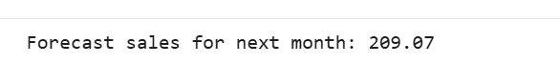
RESULT
The character-level RNN was trained on the given text and generated additional characters from the starting sequence 'mach'.

EXPERIMENT 5: RNN for Time-Series Forecasting
AIM
To build an RNN-based time-series forecasting model that uses the previous three months' sales values to forecast the next month's sales.
TOOLS
Google Colab, Python, NumPy, TensorFlow/Keras, Sequential, SimpleRNN, Dense.
CODE
import numpy as np
import tensorflow as tf
from tensorflow.keras.models import Sequential
from tensorflow.keras.layers import SimpleRNN, Dense

tf.keras.utils.set_random_seed(42)

sales = np.array([100, 110, 120, 130, 140, 150,
160, 170, 180, 190, 200, 210], dtype=np.float32)

# Create input windows of 3 months and the following month's target
X, y = [], []
for i in range(len(sales) - 3):
X.append(sales[i:i + 3])
y.append(sales[i + 3])

X = np.array(X) / 250.0
X = X.reshape(-1, 3, 1)
y = np.array(y) / 250.0

model = Sequential([
tf.keras.Input(shape=(3, 1)),
SimpleRNN(16, activation="tanh"),
Dense(1)
])
model.compile(optimizer="adam", loss="mse")
model.fit(X, y, epochs=1000, verbose=0)

last_three_months = np.array([180, 190, 200], dtype=np.float32)
test = (last_three_months / 250.0).reshape(1, 3, 1)
forecast = model.predict(test, verbose=0)[0][0] * 250

print("Forecast sales for next month:", round(float(forecast), 2))
OUTPUT
Forecast sales for next month: 209.07.
RESULT
The time-series RNN was trained using the monthly sales data and forecast the next month's sales as 209.07.

EXPERIMENT 6: Daily Electricity Consumption Prediction Using RNN
AIM
To implement an RNN-based electricity consumption prediction system using the previous three days' consumption values to estimate Day 13.
TOOLS
Google Colab, Python, NumPy, TensorFlow/Keras, Sequential, SimpleRNN, Dense.
CODE
import numpy as np
import tensorflow as tf
from tensorflow.keras.models import Sequential
from tensorflow.keras.layers import SimpleRNN, Dense

tf.keras.utils.set_random_seed(42)

consumption = np.array([100, 115, 120, 130, 145, 150,
165, 170, 185, 190, 205, 215], dtype=np.float32)

X, y = [], []
for i in range(len(consumption) - 3):
X.append(consumption[i:i + 3])
y.append(consumption[i + 3])

X = (np.array(X) / 250.0).reshape(-1, 3, 1)
y = np.array(y) / 250.0

model = Sequential([
tf.keras.Input(shape=(3, 1)),
SimpleRNN(16, activation="tanh"),
Dense(1)
])
model.compile(optimizer="adam", loss="mse")
model.fit(X, y, epochs=1000, verbose=0)

last_three_days = np.array([190, 205, 215], dtype=np.float32)
test = (last_three_days / 250.0).reshape(1, 3, 1)
prediction = model.predict(test, verbose=0)[0][0] * 250

print("Estimated electricity consumption for Day 13:",
round(float(prediction), 2), "units")
OUTPUT
Estimated electricity consumption for Day 13: 224.25 units.
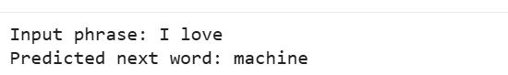
RESULT
The electricity consumption RNN was trained using the daily data and estimated Day 13 consumption as 224.25 units.

EXPERIMENT 7: Next-Word Prediction Using RNN
AIM
To develop an RNN-based next-word prediction system using Tokenizer, padding, Embedding, and SimpleRNN layers, and predict the next word after the phrase 'I love'.
TOOLS
Google Colab, Python, NumPy, TensorFlow/Keras, Tokenizer, pad_sequences, Embedding, SimpleRNN, Dense.
CODE
import numpy as np
import tensorflow as tf
from tensorflow.keras.preprocessing.text import Tokenizer
from tensorflow.keras.preprocessing.sequence import pad_sequences
from tensorflow.keras.models import Sequential
from tensorflow.keras.layers import Embedding, SimpleRNN, Dense

tf.keras.utils.set_random_seed(42)

sentences = [
"I love machine learning",
"I love deep learning",
"I love artificial intelligence",
"I like machine learning",
"I like deep learning"
]

tokenizer = Tokenizer()
tokenizer.fit_on_texts(sentences)
total_words = len(tokenizer.word_index) + 1

# Create sequences where each prefix predicts its next word
input_sequences = []
for sentence in sentences:
token_list = tokenizer.texts_to_sequences([sentence])[0]
for i in range(1, len(token_list)):
input_sequences.append(token_list[:i + 1])

max_len = max(len(seq) for seq in input_sequences)
input_sequences = pad_sequences(input_sequences, maxlen=max_len, padding="pre")

X = input_sequences[:, :-1]
y = input_sequences[:, -1]

model = Sequential([
tf.keras.Input(shape=(max_len - 1,)),
Embedding(total_words, 16),
SimpleRNN(32),
Dense(total_words, activation="softmax")
])
model.compile(optimizer="adam", loss="sparse_categorical_crossentropy",
metrics=["accuracy"])
model.fit(X, y, epochs=300, verbose=0)

phrase = "I love"
token_list = tokenizer.texts_to_sequences([phrase])[0]
token_list = pad_sequences([token_list], maxlen=max_len - 1, padding="pre")

probabilities = model.predict(token_list, verbose=0)[0]
predicted_id = int(np.argmax(probabilities))
predicted_word = next((word for word, index in tokenizer.word_index.items()
if index == predicted_id), "<unknown>")

print("Input phrase:", phrase)
print("Predicted next word:", predicted_word)
OUTPUT
Input phrase: I love. Predicted next word: machine.
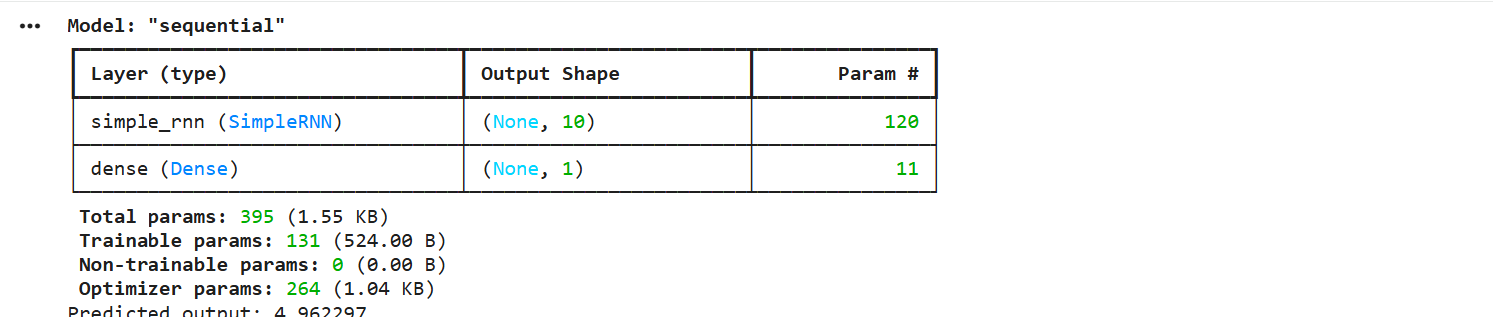
RESULT
The next-word prediction RNN was trained on the given sentences and predicted 'machine' after the input phrase 'I love'.

