**KPI’s Requirement:**

1.) Pizza Sales:

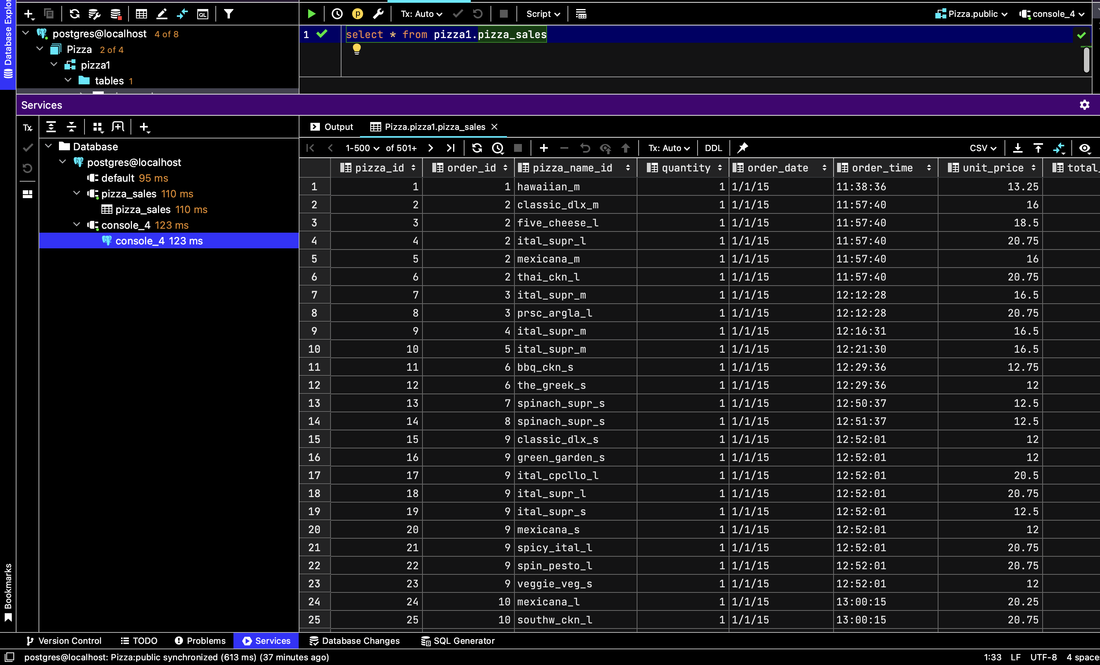

2.) Total Revenue:

/* Total Revenue */  
  
select *sum*(total_price) as Total_Revenue from pizza1.pizza_sales

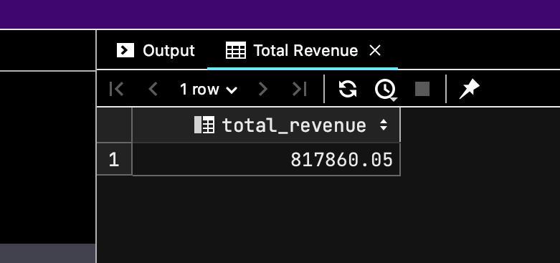

3.) Average Order Value:

select * from pizza1.pizza_sales  
/* Average Order Value */  
  
select *sum*(total_price) / *count*(distinct order_id) as Avg_Order_Value from pizza1.pizza_sales

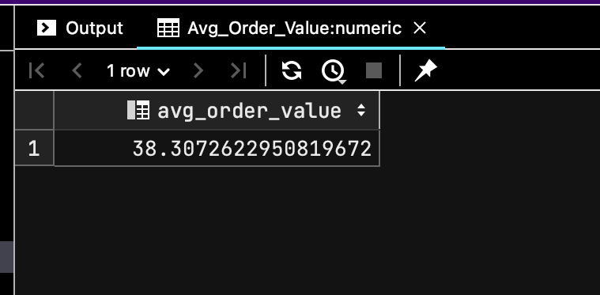

4.) Total Pizzas sold:

select * from pizza1.pizza_sales  
/* Total Pizzas Sold */  
select *sum*(quantity) as Total_Pizza_Sold from pizza1.pizza_sales

5.) Total number of orders place:

select * from pizza1.pizza_sales  
  
/* Total number of orders place */  
select *count*(distinct order_id) as Total_Orders from pizza1.pizza_sales

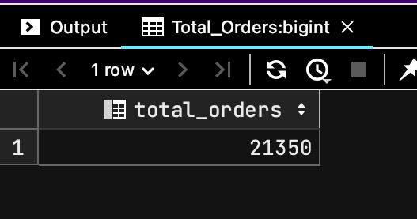

6.) Average Pizzas per order:

select * from pizza1.pizza_sales**;**/* Average Pizzas per order */  
select *cast*(*sum*(quantity) as decimal(**10,2**)) / *cast*(*count*(distinct order_id) as decimal(**10,2**)) as avg_pizza_order  
from pizza1.pizza_sales

**Problem Statement:**

Chart Requirements

1.) Daily Trend for Total Orders:

select * from pizza1.pizza_sales**;**/* Daily Trend for Total Orders */  
  
SELECT *TO_CHAR*(*TO_DATE*(order_date**,** 'DD/MM/YY')**,** 'Dy') AS order_day**,** *COUNT*(DISTINCT order_id) AS total_orders  
FROM pizza1.pizza_sales  
GROUP BY *TO_CHAR*(*TO_DATE*(order_date**,** 'DD/MM/YY')**,** 'Dy')**;**

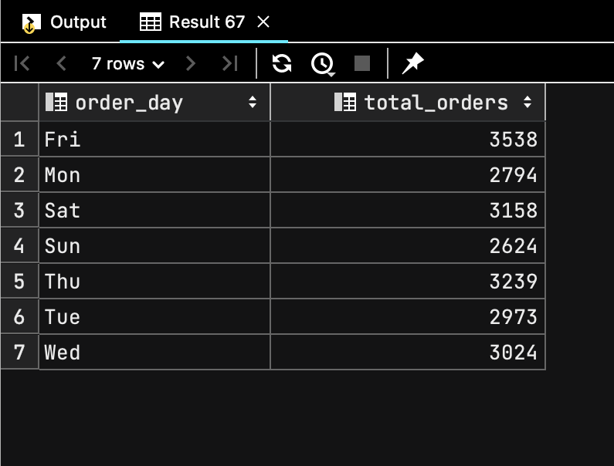

2.) Monthly Trend for Total Orders:

select * from pizza1.pizza_sales**;**/* Monthly Trend for Total Orders */  
  
SELECT *TO_CHAR*(*TO_DATE*(order_date**,** 'DD/MM/YY')**,** 'Mon') AS month**,** *COUNT*(DISTINCT order_id) AS Total_orders  
FROM pizza1.pizza_sales  
GROUP BY *TO_CHAR*(*TO_DATE*(order_date**,** 'DD/MM/YY')**,** 'Mon')  
ORDER BY Total_orders desc**;**

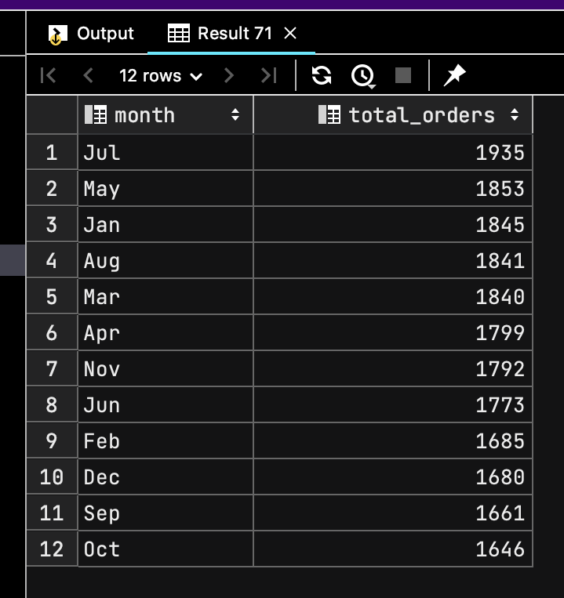

3.) Total revenue in percentage:

select * from pizza1.pizza_sales**;**/* Total revenue in percentage */  
  
select pizza_category**,** *sum*(total_price)* **100** / (select *sum*(total_price) from pizza1.pizza_sales) as PCT  
from pizza1.pizza_sales  
group by pizza_category

4.) Percentage of sales by Pizza Size: *For quarter*

select * from pizza1.pizza_sales**;**/* Percentage of sales by Pizza Size: For quarter*/  
  
SELECT pizza_size**,** *CAST*(*SUM*(total_price) AS decimal(**10, 2**)) AS Total_Sales**,** *CAST*(*SUM*(total_price) * **100** / (SELECT *SUM*(total_price) FROM pizza1.pizza_sales WHERE *EXTRACT*(QUARTER FROM *TO_DATE*(order_date**,** 'DD/MM/YY')) = **1**) AS decimal(**10, 2**)) AS pct  
FROM pizza1.pizza_sales  
WHERE *EXTRACT*(QUARTER FROM *TO_DATE*(order_date**,** 'DD/MM/YY')) = **1**GROUP BY pizza_size  
ORDER BY pct DESC**;**

Top 5 Best revenue pizzas:

select * from pizza1.pizza_sales**;**/* Top 5 Best revenue pizzas */  
  
select pizza_name**,** *sum*(total_price) as total_revenue from pizza1.pizza_sales  
group by pizza_name  
order by total_revenue desc  
limit **5**

Bottom 5 Worst revenue pizzas:

select * from pizza1.pizza_sales**;**/* Bottom 5 Worst revenue pizzas */  
  
select pizza_name**,** *sum*(total_price) as total_revenue from pizza1.pizza_sales  
group by pizza_name  
order by total_revenue  
limit **5**

Top 5 Best Quantity Pizzas:

select * from pizza1.pizza_sales**;**/* Top 5 Best Quantity pizzas */  
  
select pizza_name**,** *sum*(quantity) as total_quantity from pizza1.pizza_sales  
group by pizza_name  
order by total_quantity desc  
limit **5**

Worst 5 Quantity pizzas:

select * from pizza1.pizza_sales**;**/* Worst 5 Quantity pizzas */  
  
select pizza_name**,** *sum*(quantity) as total_quantity from pizza1.pizza_sales  
group by pizza_name  
order by total_quantity  
limit **5**

Top 5 according to Order id:

select * from pizza1.pizza_sales**;**/* Top 5 according to Order id */  
  
SELECT pizza_name**,** *COUNT*(DISTINCT order_id) AS total_orders  
FROM pizza1.pizza_sales  
GROUP BY pizza_name  
ORDER BY total_orders DESC  
LIMIT **5;**

Bottom 5 :

select * from pizza1.pizza_sales**;**/* Bottom 5 according to Order id */  
  
SELECT pizza_name**,** *COUNT*(DISTINCT order_id) AS total_orders  
FROM pizza1.pizza_sales  
GROUP BY pizza_name  
ORDER BY total_orders  
LIMIT **5;**

