Convolutional Neural Network Based Text Steganalysis

In this paper author is proposing concept for Steganalysis on text using Convolution Neural Networks (CNN). Steganalysis is the process of detecting hidden text from text cover. All existing text Steganalysis using manually hand crafted features with SVM algorithm for detection but this technique detection accuracy is very less. To increase Steganalysis accuracy author is using CNN Machine Learning algorithm.

In CNN we will train neural network using word embedding (Converting documents into integer representation vector) features vector from documents. Below is the example to generate vector from document

Example we have 3 documents

Document 1) Apple a day keep doctor away

Document 2) Shipment of gold damaged in a fire

Document 3) Apple good for health

From above 3 documents we will extract all unique words and put in vector column header

**Apple day doctor away shipment gold damaged fire health good**

In above text all bold names are the vector column header and all this column header values will maintain count of each word. In above 3 documents apple appear 1 time in document 1 and we put 1 in vector. See below example

**Apple day doctor away shipment gold damaged fire health good**

1 1 1 1 0 0 0 0 0 0

0 0 0 0 1 1 1 1 0 0

1 0 0 0 0 0 0 0 1 1

In above vector all 3 documents converted to integer representation in vector we put value 1 if word appear in that row document and 0 if not appear. Some time we will put count of each words in that vector. So above vector will be passed to CNN for training purpose and after training CNN model we can give test input values and then CNN apply test input values on trained model to get it predicted class.

In propose work also we will build embedding vector with all non-steg and steg sentences and then build CNN training model. This model later will applied on new sentences to check whether that sentence contain steg or non-steg words. To implement this project we are using some non-steg sentences from GUTENBERG dataset and we got some steg sentences from T-Lex website. Below are the non-steg sentences

‘Kolkata is a nice little city’ is a non-steg sentence and by manipulating main words with synonyms or adjectives or adverbs they will convert non-steg text to steg text. After applying stegnography on above sentence we will get ‘Kolkata is a good miniscule metropolis’. So by using above type of non-steg and steg sentences we will build CNN model.

We are building CNN model with below steg sentences

‘Kolkata is a nice little city’ non-steg

‘Kolkata is a good miniscule metropolis’ steg

‘Hansel and Gretel are the young children of a poor woodcutter’ non-steg

‘Hansel and Gretel are the little children of a unfortunate woodcutter’ steg

Non-steg sentence we are taking from GUTENBERG dataset.

Screen shot

Double click on ‘run.bat’ file to get below screen

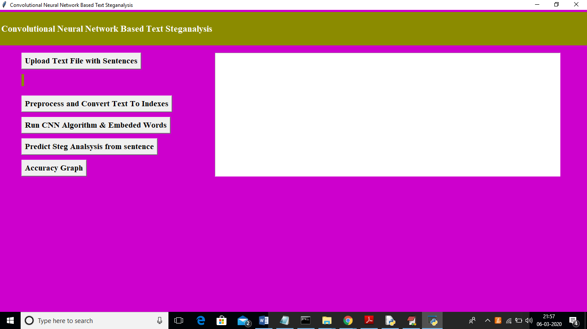

In above screen click on ‘Upload Text File with Sentences’ button to upload dataset

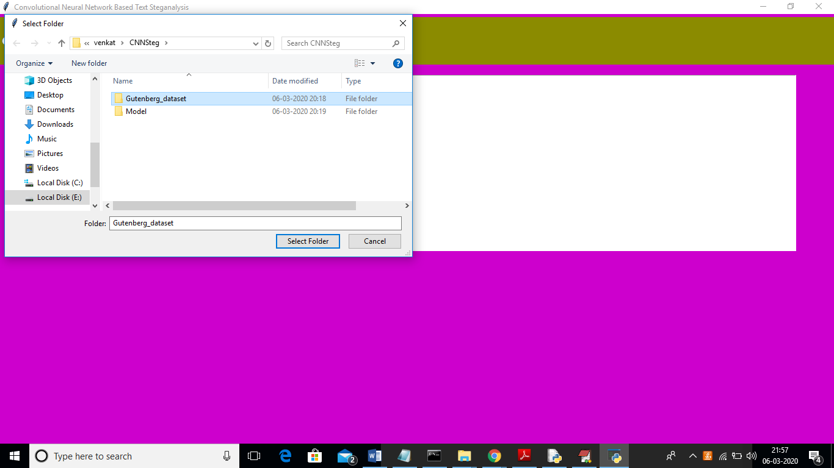

In above screen I am uploading ‘Gutenberg dataset’ and after uploading dataset will get below screen

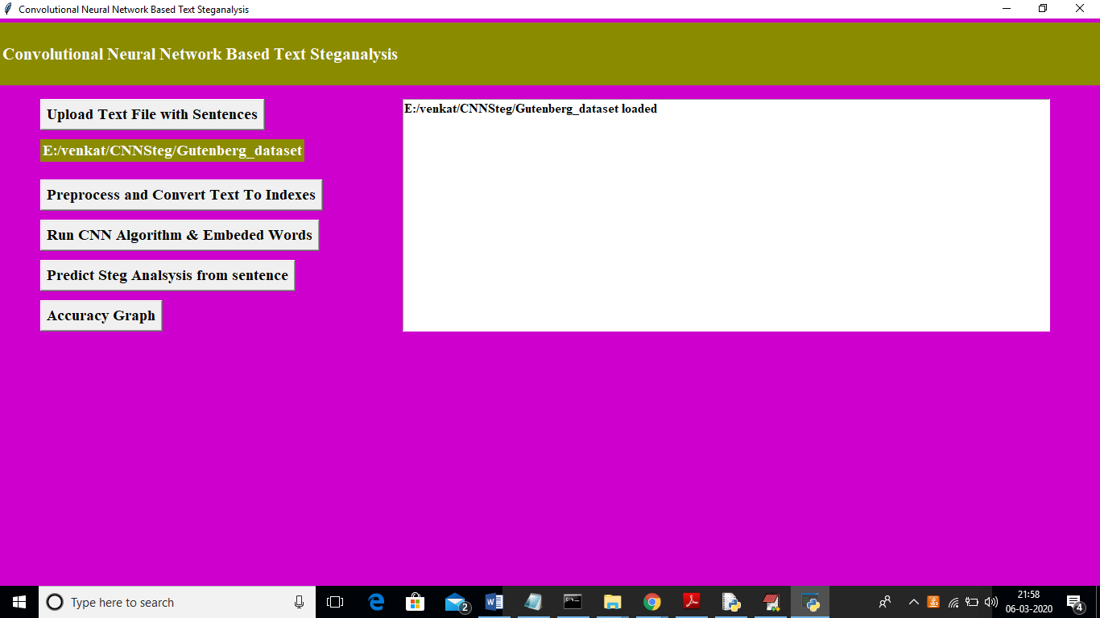

In above screen click on ‘Preprocess and Convert Text To indexes’ button to apply preprocessing such as removing stopwords, special symbols and digits etc. Then build vector from sentences

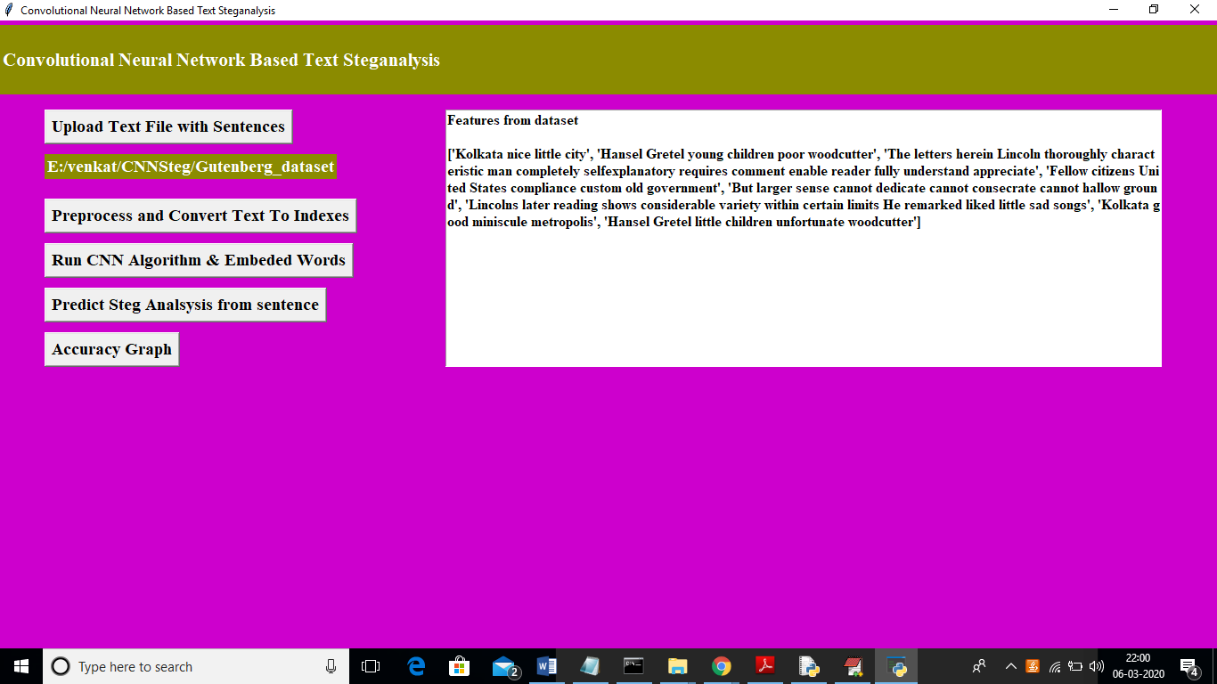

In above screen all sentences from dataset converted to vector. Now click on ‘Run CNN Algorithm Embeded Words’ button to convert above words vector to integer vector and then apply CNN model on that vector to generate train model

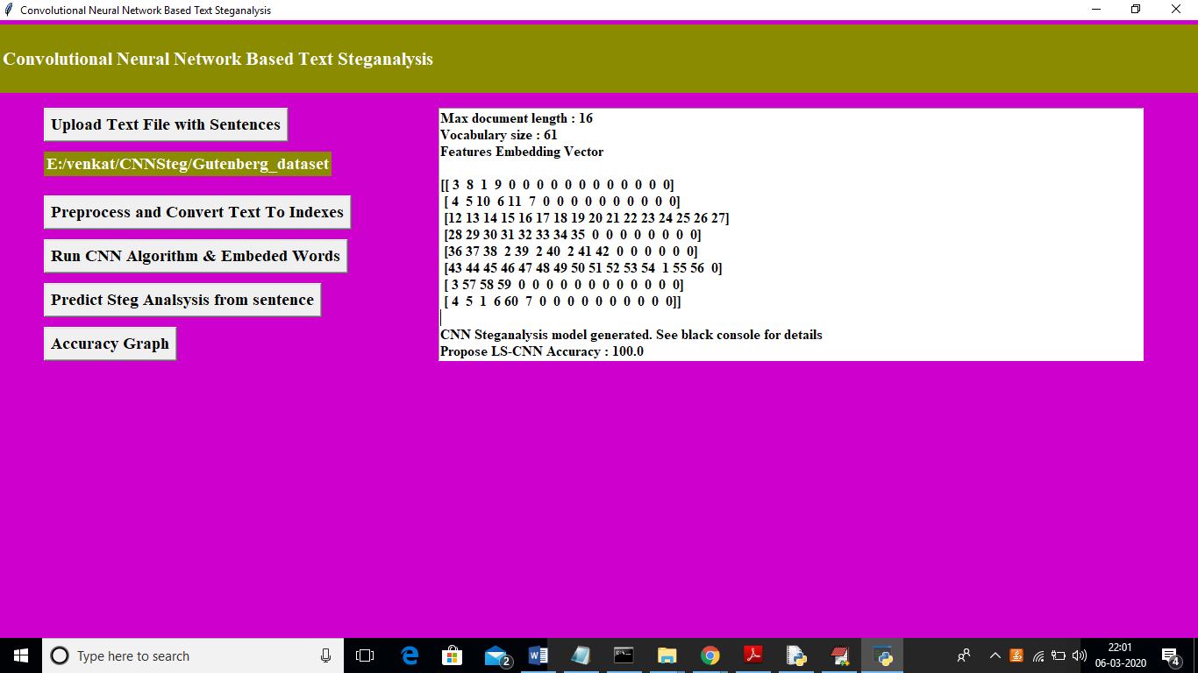

In above screen after applying CNN we got integer vector from text vector and then we are seeing accuracy of propose LC-CNN work as 100%. We can see CNN model details in below screen

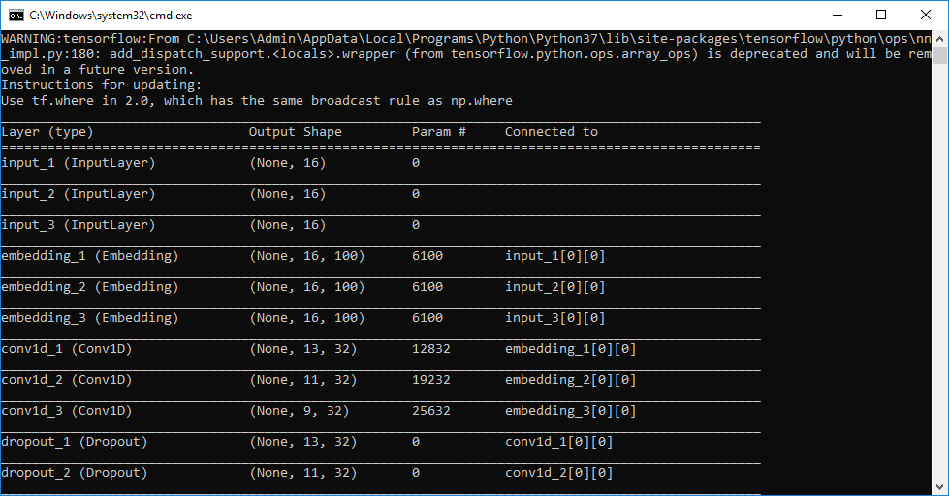

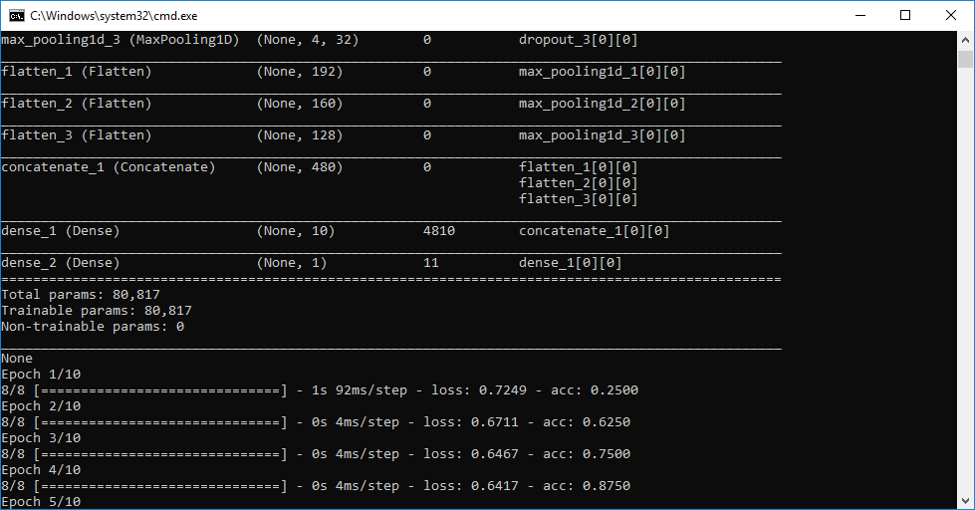

In above console screens we can see we generated CNN model with multiple embedding vectors. After building model click on ‘Predict Steg Analsysis from sentence’ button to enter sentence and then identify whether sentence contains steg or non-steg words

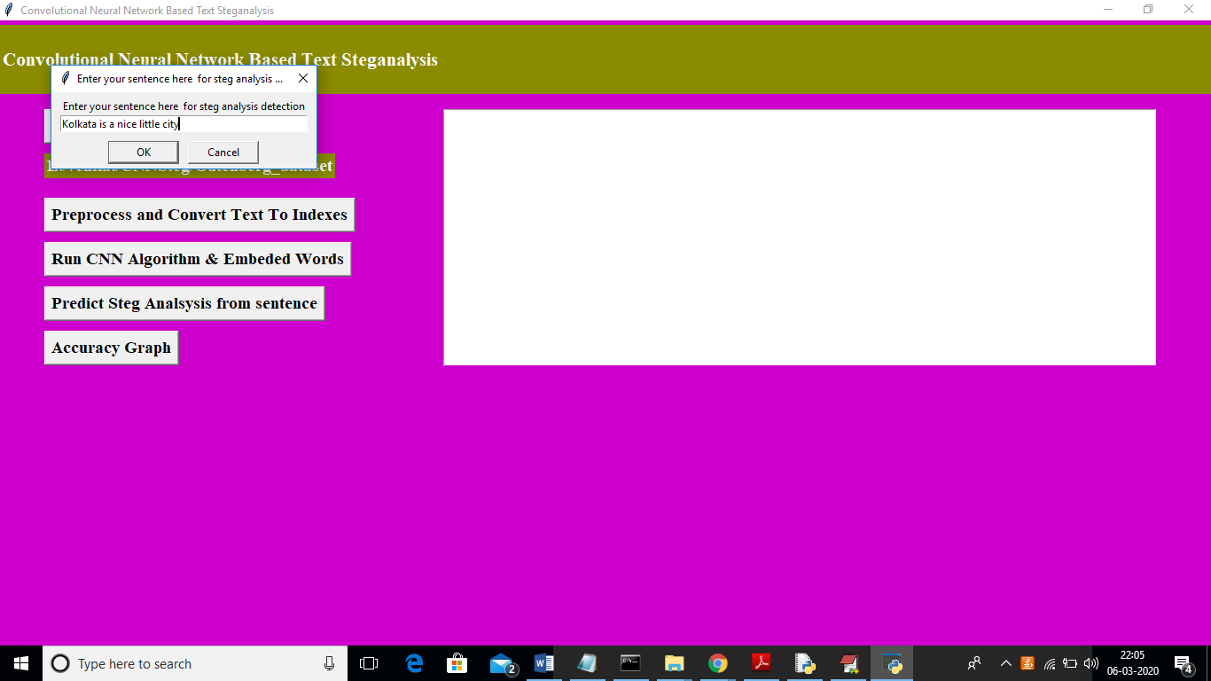

In above screen dialog I entered one sentence and below is the result

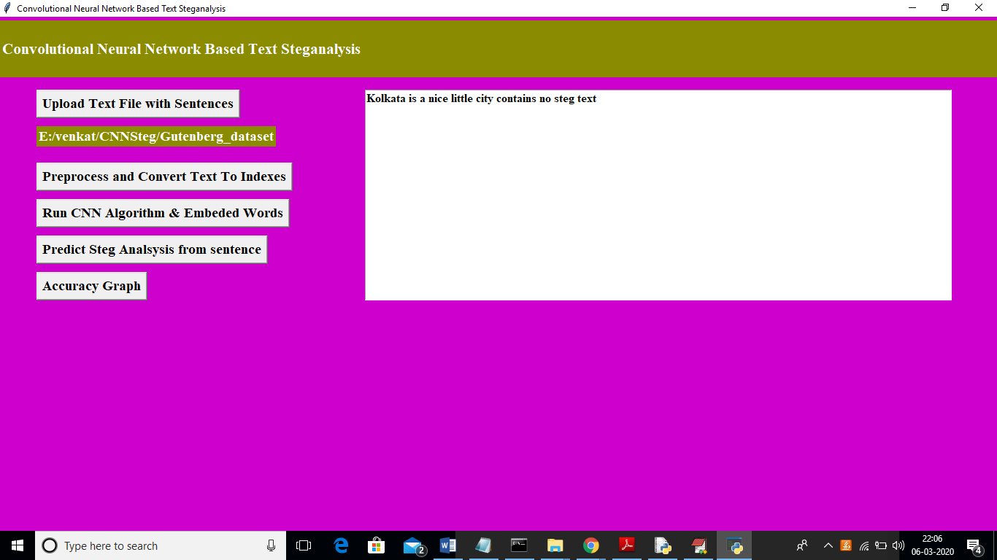

In above screen in text area we can see the sentences result as sentence contains no steg text. Now enter other sentence and test

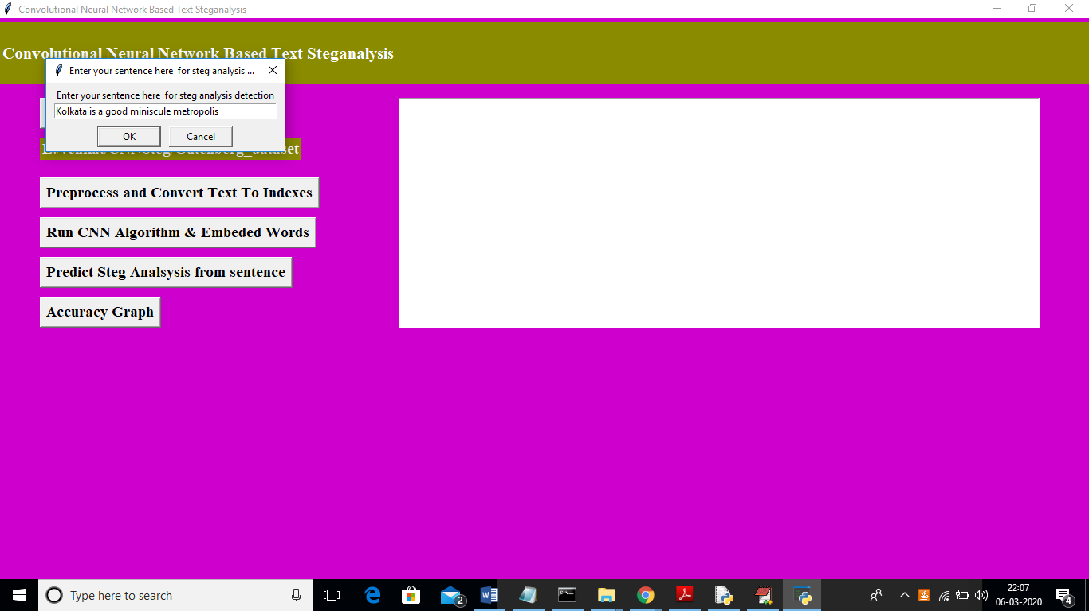in above screen I entered other sentence and below is the result

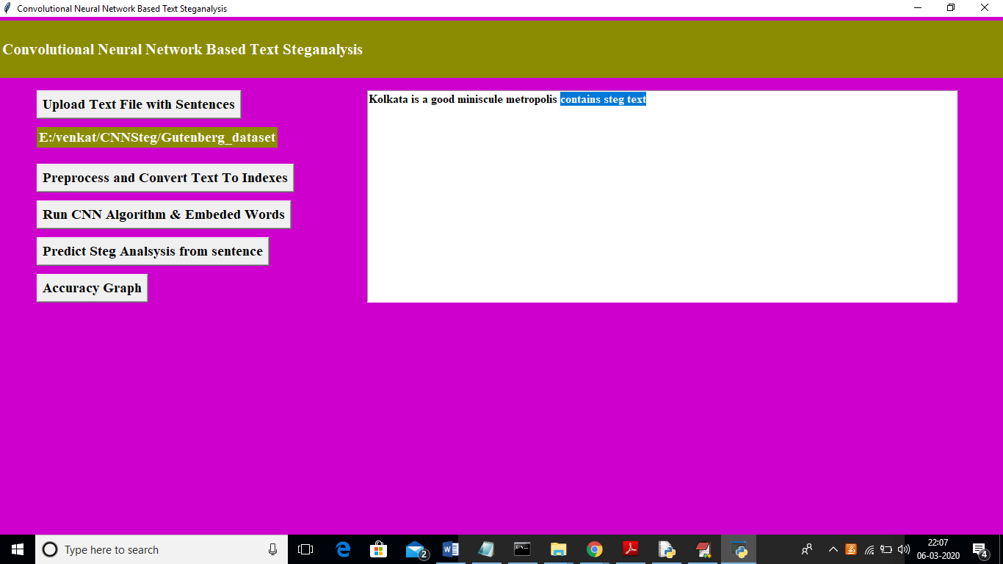

In above screen in selected text we got message as sentence contains ‘steg text’. Now click on ‘Accuracy Graph’ button to see accuracy between propose LC-CNN and existing algorithm

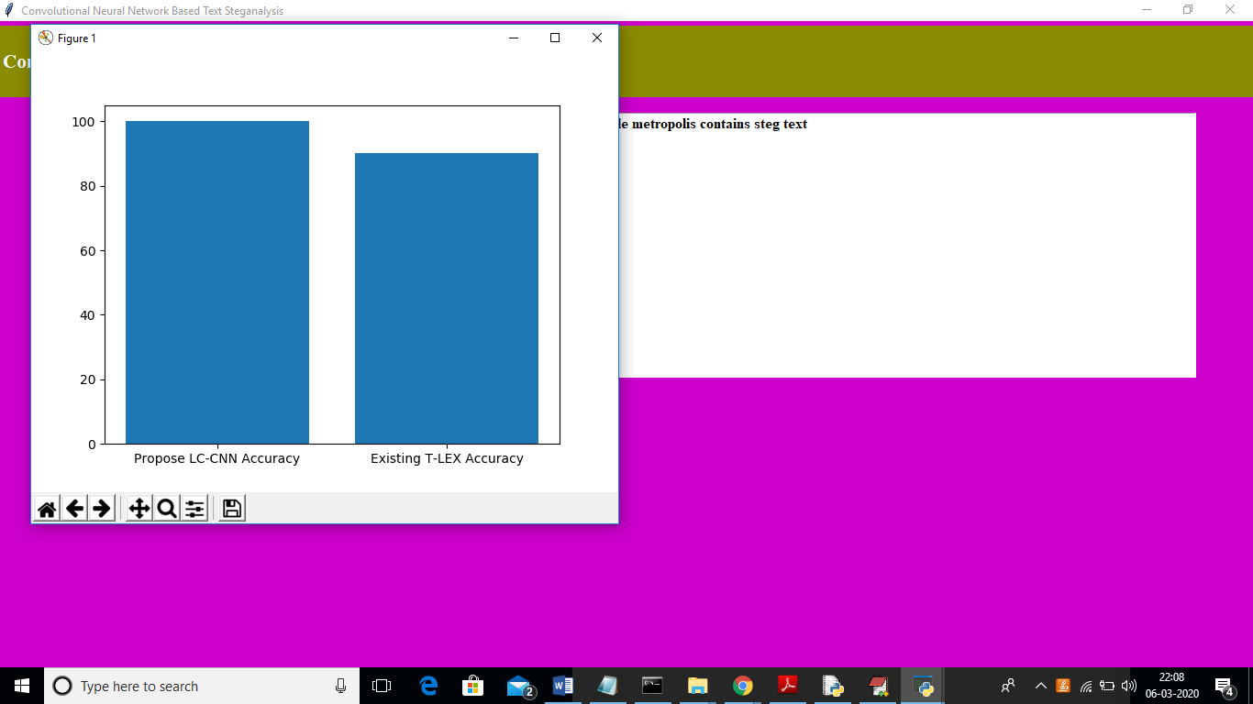

In above graph x-axis represents algorithm name and y-axis represents Accuracy. From above graph we can conclude propose LC-CNN got better accuracy compare to existing L-TEX algorithm.