As partial code we wrote function to design GUI and to allow user to upload files with sentences and then application will apply pre-process technique to remove stopwords.

First screen

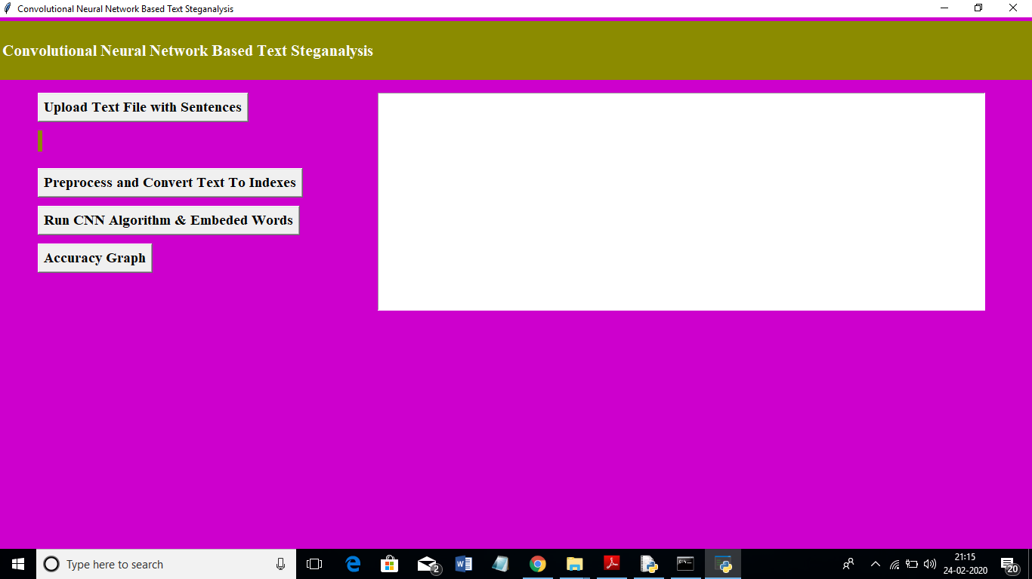

In above screen click on ‘Upload Text File with Sentences’ button and upload file

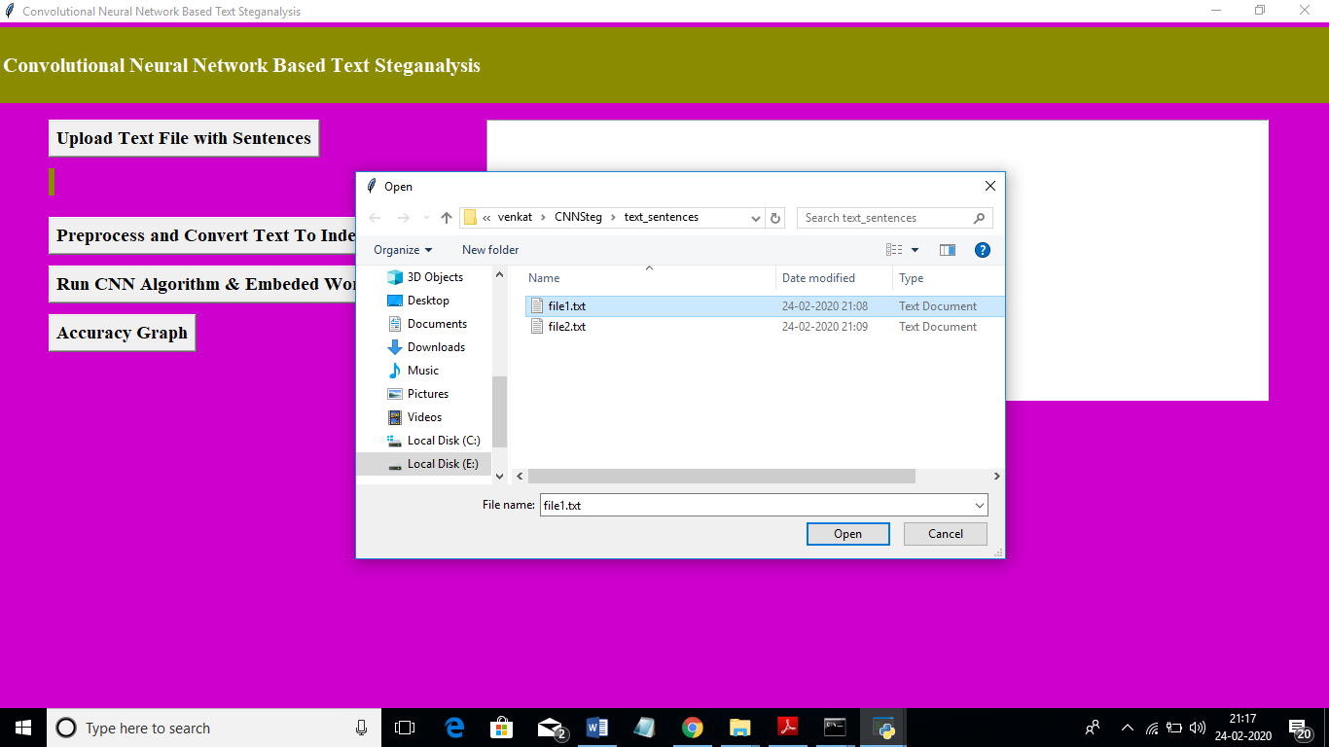

After uploading file will get below screen

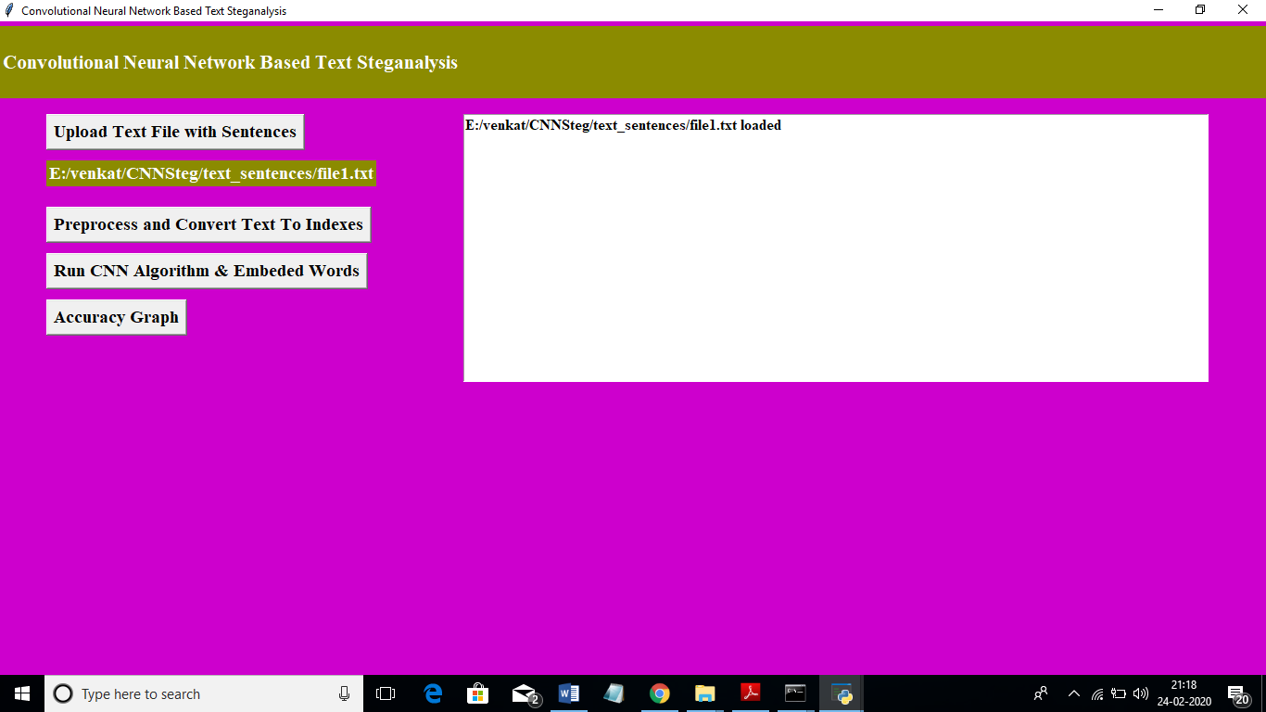

In above screen click on ‘Preprocess and Convert Text To Indexes’ to preprocess text and remove stop words from sentences

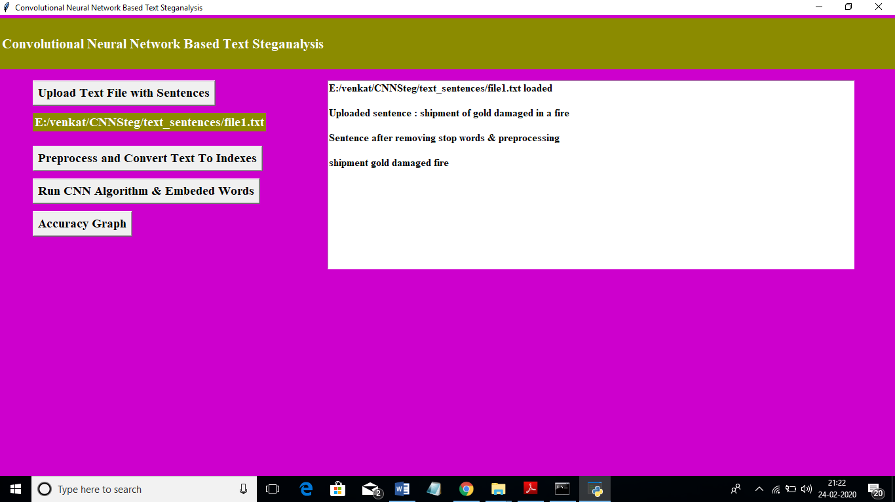

In above screen we can see the actual sentence is ‘shipment of gold damaged in a fire’ and after preprocess and stop word removal we got sentence as ‘shipment gold damaged fire’

Next part we will give later