**Control Systems**

**Scenario 1:**

SET SERVEROUTPUT ON;

BEGIN

  FOR customer_rec IN (

    SELECT c.CustomerID, TRUNC(MONTHS_BETWEEN(SYSDATE, c.DOB)/12) AS age

    FROM Customers c

    JOIN Loans l ON c.CustomerID = l.CustomerID

  ) LOOP

    IF customer_rec.age > 60 THEN

      UPDATE Loans

      SET InterestRate = InterestRate - 1

      WHERE CustomerID = customer_rec.CustomerID;

      DBMS_OUTPUT.PUT_LINE('Discount applied to CustomerID: ' || customer_rec.CustomerID);

    END IF;

  END LOOP;

END;

/

SELECT * FROM Loans;

**Output**:

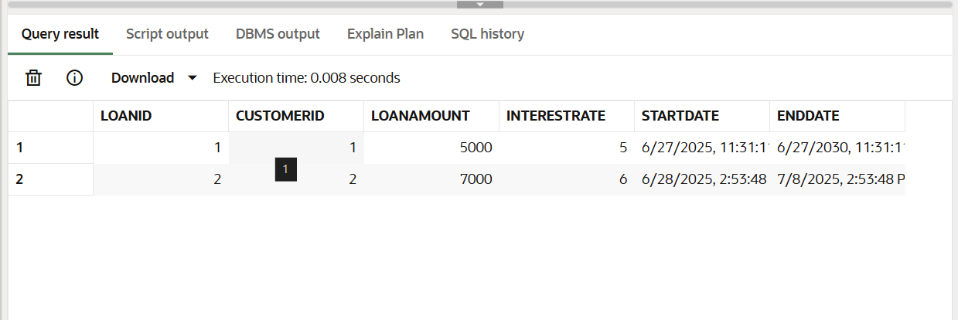

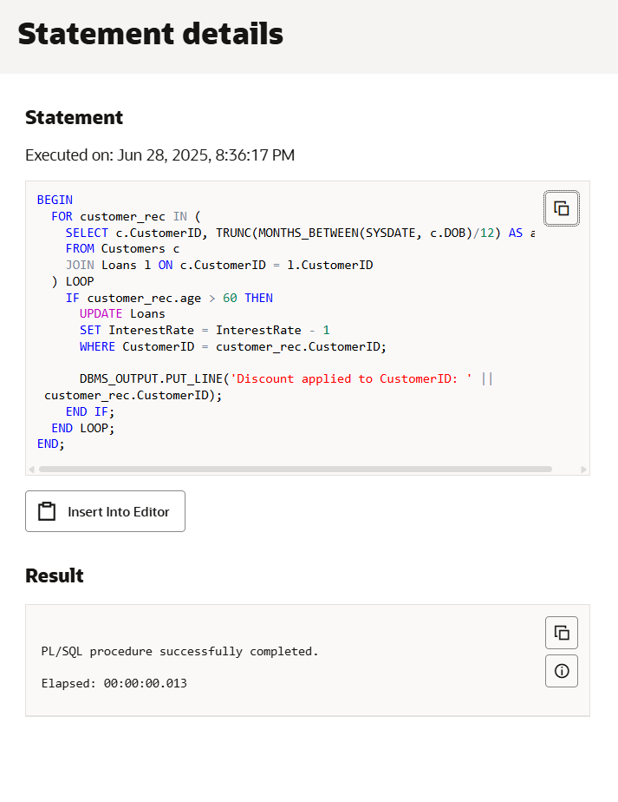

**Scenario 2:**

ALTER TABLE Customers

ADD IsVIP VARCHAR2(10);

BEGIN

  FOR cust_rec IN (

    SELECT CustomerID, Balance FROM Customers

  ) LOOP

    IF cust_rec.Balance > 10000 THEN

      UPDATE Customers

      SET IsVIP = 'True'

      WHERE CustomerID = cust_rec.CustomerID;

      DBMS_OUTPUT.PUT_LINE('Customer ' || cust_rec.CustomerID || ' promoted to VIP.');

    END IF;

  END LOOP;

END;

/

SELECT CustomerID, Balance, IsVIP FROM Customers;

**Output:**

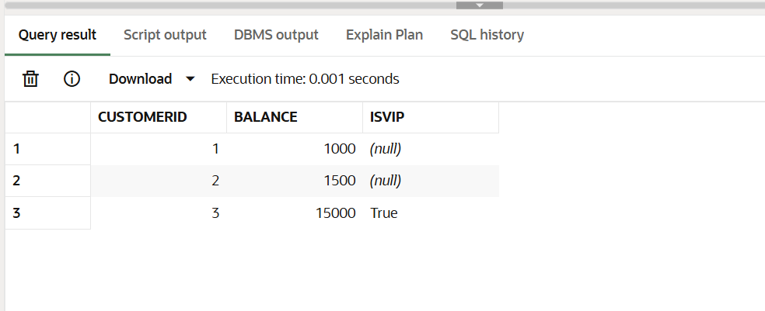

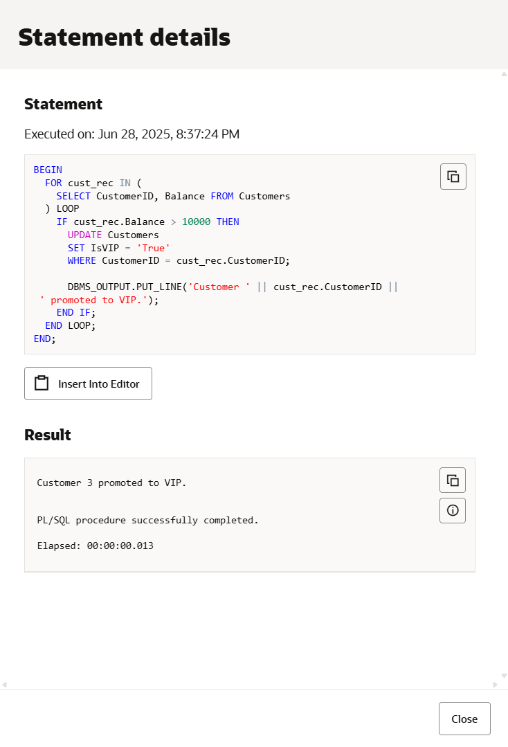

**Scenario 3:**

BEGIN

  FOR loan_rec IN (

    SELECT LoanID, CustomerID, EndDate

    FROM Loans

    WHERE EndDate BETWEEN SYSDATE AND SYSDATE + 30

  ) LOOP

    DBMS_OUTPUT.PUT_LINE('Reminder: Loan ID ' || loan_rec.LoanID ||

                         ' for Customer ID ' || loan_rec.CustomerID ||

                         ' is due on ' || TO_CHAR(loan_rec.EndDate, 'YYYY-MM-DD'));

  END LOOP;

END;

/

INSERT INTO Loans (LoanID, CustomerID, LoanAmount, InterestRate, StartDate, EndDate)

VALUES (2, 2, 7000, 6, SYSDATE, SYSDATE + 10);

SELECT LoanID, CustomerID, EndDate

FROM Loans

WHERE EndDate BETWEEN SYSDATE AND SYSDATE + 30;

**Output:**

