**Stored Procedures**

**Scenario 1:**

CREATE OR REPLACE PROCEDURE ProcessMonthlyInterest AS

BEGIN

    FOR acc IN (

        SELECT AccountID, Balance

        FROM Accounts

        WHERE AccountType = 'Savings'

    ) LOOP

        UPDATE Accounts

        SET Balance = acc.Balance + (acc.Balance * 0.01),

            LastModified = SYSDATE

        WHERE AccountID = acc.AccountID;

    END LOOP;

END;

/

SELECT * FROM Accounts WHERE AccountType = 'Savings';

EXEC ProcessMonthlyInterest;

SELECT * FROM Accounts WHERE AccountType = 'Savings';

**Output:**

**Before Execution**

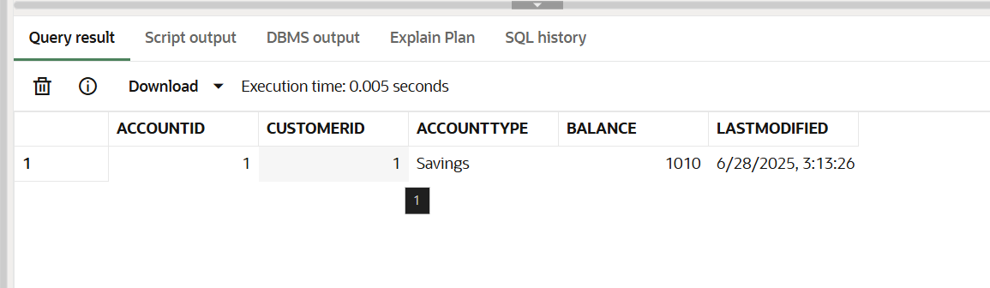

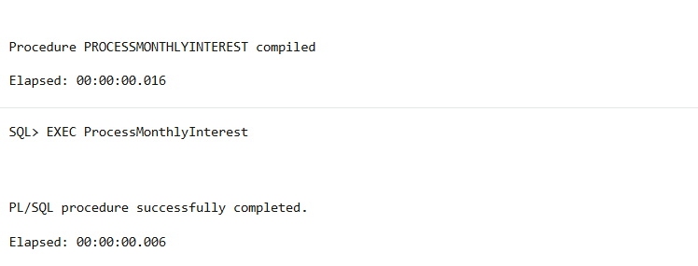

**After Execution**

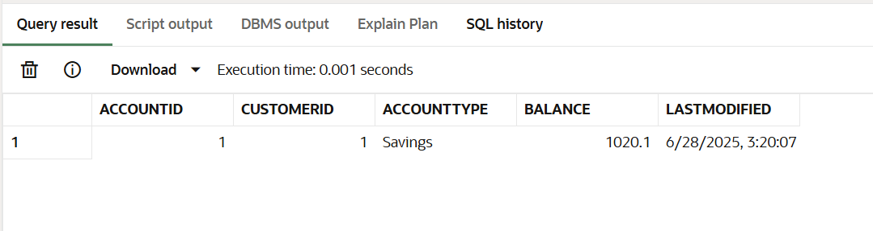

**Scenario 2:**

CREATE OR REPLACE PROCEDURE UpdateEmployeeBonus(

    dept IN VARCHAR2,

    bonus_pct IN NUMBER

) AS

BEGIN

    UPDATE Employees

    SET Salary = Salary + (Salary * (bonus_pct / 100))

    WHERE Department = dept;

END;

/

SELECT * FROM Employees WHERE Department = 'IT';

EXEC UpdateEmployeeBonus('IT', 10);

SELECT * FROM Employees WHERE Department = 'IT';

**Output:**

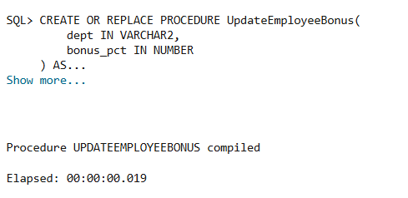

**Before**

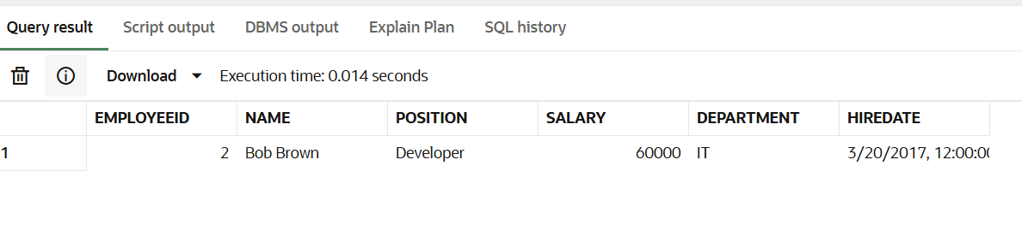

**After**

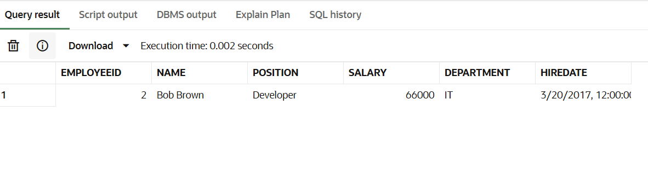

**Scenario 3:**

CREATE OR REPLACE PROCEDURE TransferFunds(

    from_account IN NUMBER,

    to_account IN NUMBER,

    amount IN NUMBER

) AS

    from_balance NUMBER;

BEGIN

    -- Get current balance

    SELECT Balance INTO from_balance FROM Accounts WHERE AccountID = from_account;

    IF from_balance >= amount THEN

        -- Deduct from sender

        UPDATE Accounts

        SET Balance = Balance - amount,

            LastModified = SYSDATE

        WHERE AccountID = from_account;

        -- Add to receiver

        UPDATE Accounts

        SET Balance = Balance + amount,

            LastModified = SYSDATE

        WHERE AccountID = to_account;

    ELSE

        DBMS_OUTPUT.PUT_LINE('Insufficient balance in source account.');

    END IF;

END;

/

SELECT * FROM Accounts WHERE AccountID IN (1, 2);

EXEC TransferFunds(1, 2, 500);

SELECT * FROM Accounts WHERE AccountID IN (1, 2);

**Output:**

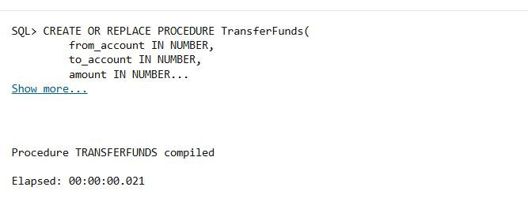

**Before**

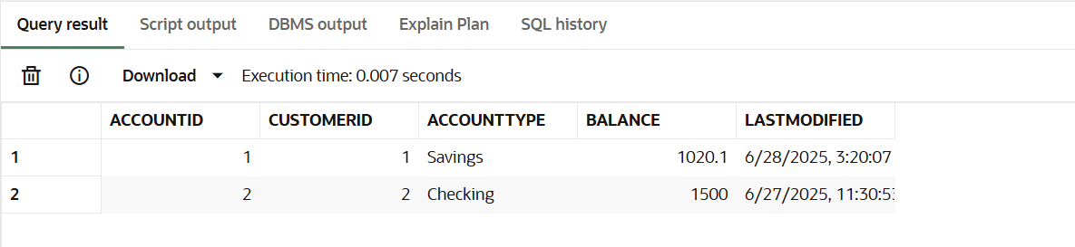

**After**

