Scenario : A company wants to build application which uses info on regional, national and international news with weather and sports scores. All details at one step. But, it would be difficult to start the application from start. And on the other hand all these functionalities are already provided by other available sites. So, it is better to use their existing logic in application

The solution for the above scenario is web services

With web services we can reuse someone else business logic instead of replicating it yourself, using just few lines of code

Similar to using dll ir libraries or plug ins in the code

But the main difference is that web service is located remotely on server

Note :

* Web services are not only limited to .net framework. These are defined and used by other vendors too
* These are cross platform, a service written in one language can be invoked by an application in some other language

As web service is cross platform, a common language should be there to send and receive response from service

Such standard common language is XML. As a result, data types used is limited to the data types used in XML

[WebService(Namespace=<http://tempuri.org>)]

[WebServiceBinding(ConformsTo=WsiProfiles.BasicProfile1_1)]

Public class CalWebService : System.Web.Services.WebService

{

[WebMethod]

Public string HelloWorld(){

Return “HelloWorld”;

}

}

[WebService(Namespace=<http://tempuri.org>)] : Tp decorate the class and say that a class is a webservice and the namespace is used to uniquely identify the web service over all the other web services available as web services with same name can be present in server

System.Web.Services.WebService : Not particularly important used when using asmx code

WebMethod -> attribute to tell that method is a part of web service. Access modifier should be public

To run the web service -> right click the .asmx file -> view in browser

http -> widely used protocol to send and receive message

messaging protocol is soap ( simple object access protocol) messages are in XML format

web services have .asmx extension so also called asmx services

<http://localhost:port/Calc.asmx?wsdl> => takes us to the wsdl documentation

wsdl : web service description language

now if we click on method, we go to the add service testing page

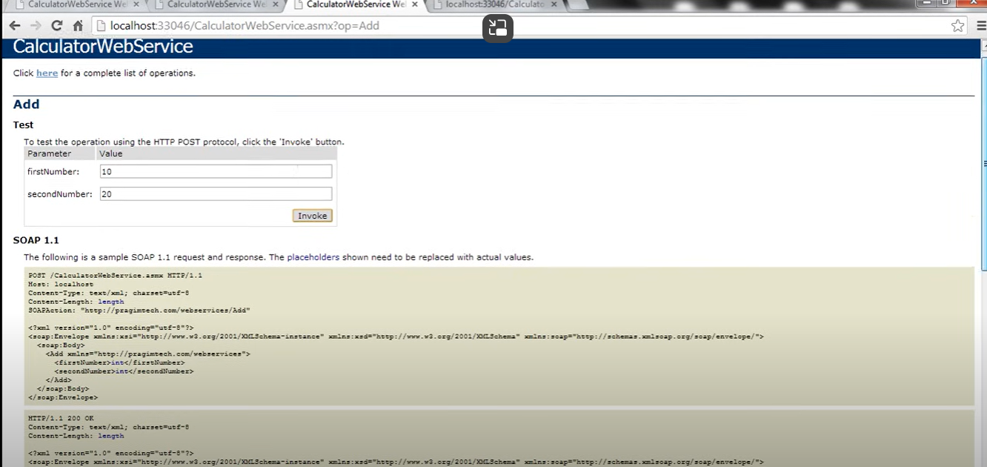

After clicking on invoke

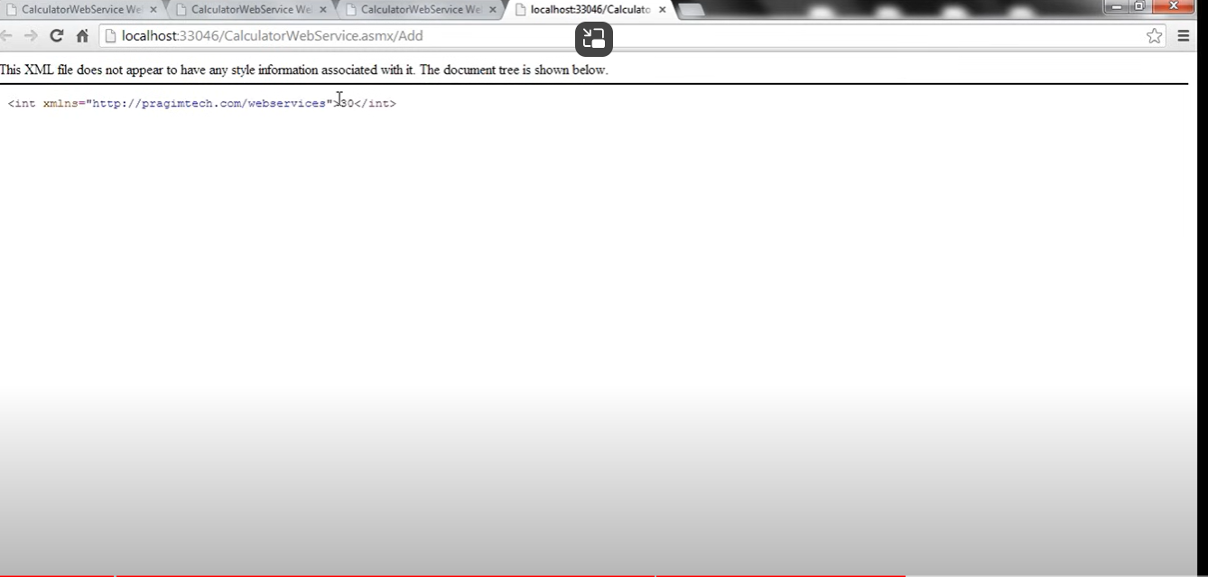

We have soap request and response in form of xml

The application to invoke web service(add method) the app should create a soap request and to get the output it should use soap response to generate the output

Consuming the asmx service

Using the wsdl a proxy class is generated

In the soln explorer of new application where u want to add service reference, add the service reference by pasting the address(<http://localhost:port/Calc.asmx?wsdl>) and now a proxy class is generated