Used Car Prices — Exploratory Data Analysis

Name – Nikhita Pillai

Batch – CDPA Batch 11
Dataset: car_prices.csv — 558,837 used-car auction records, 16 columns, sale dates December 2014 to July 2015, model years 1982–2015. All numbers below were produced by running car_prices_analysis.py on your file.

Key Findings & Insights
- Average Selling Price: The average selling price of used cars is $13,611, with prices ranging from $1 to $230,000. Such a wide range suggests that some extreme values may be unusual transactions or data errors.
- Factors Affecting Car Prices: Car age and mileage have a noticeable impact on selling prices. Newer cars generally sell for more (r = +0.59), while higher mileage is associated with lower prices (r = −0.59). MMR (estimated market value) shows a very strong correlation with selling price (r = +0.98), making it a useful price indicator.
- Impact of Mileage on Price: Average selling prices drop from $21,445 for cars driven under 20,000 miles to $9,333 for those driven 80,000–100,000 miles. Beyond 240,000 miles, prices remain relatively stable at around $2,300–$2,500. This shows that the price decline becomes less noticeable at very high mileage.
- Highest Sales by State and Model: Florida, California and Pennsylvania together account for 37.6% of total car sales. Nissan Altima, Ford F-150 and Ford Fusion are the most frequently sold models, showing a concentration of sales in certain states and models.
- States with Higher Selling Prices: Ohio records the highest combined average selling price ($29,917) for the two newer model years analysed, while New Jersey leads for 2015 models. This highlights regional differences in car selling prices.
- Most Affordable Cars in Top Condition: Saturn, smart and Pontiac have the lowest average prices among top-condition cars. Among commonly sold brands, Hyundai ($14,516) and Volkswagen ($14,717) are the most affordable options.
- Data Quality and Cleaning: The dataset had inconsistent brand names, placeholder values and different condition rating scales. These were addressed during data cleaning to improve accuracy and consistency for analysis.

Part 1 — Data Ingestion & Quality Profiling

1.1 & 1.2 Load, inspect and structure
Item | Result
Rows (records) | 558,837
Columns | 16
Numeric columns | year (int); condition, odometer, mmr, sellingprice (float)
Text columns | make, model, trim, body, transmission, vin, state, color, interior, seller, saledate
Note | saledate is stored as text; it was not needed for the required questions

1.3 Missing values
Column | Missing | % missing | Strategy applied
transmission | 65,352 | 11.69% | Fill with 'unknown' (too many rows to drop; can't guess automatic vs manual)
body | 13,195 | 2.36% | Fill with 'unknown'
condition | 11,820 | 2.12% | Fill with median (35) — robust to skew
trim | 10,651 | 1.91% | Fill with 'unknown'
model | 10,399 | 1.86% | Fill with 'unknown'
make | 10,301 | 1.84% | Fill with 'unknown'
color / interior | 749 each | 0.13% | Fill with 'unknown'
odometer | 94 | 0.02% | Fill with median
mmr, vin, sellingprice, saledate | 38 rows in total | <0.01% | Drop the rows — essential fields, negligible loss

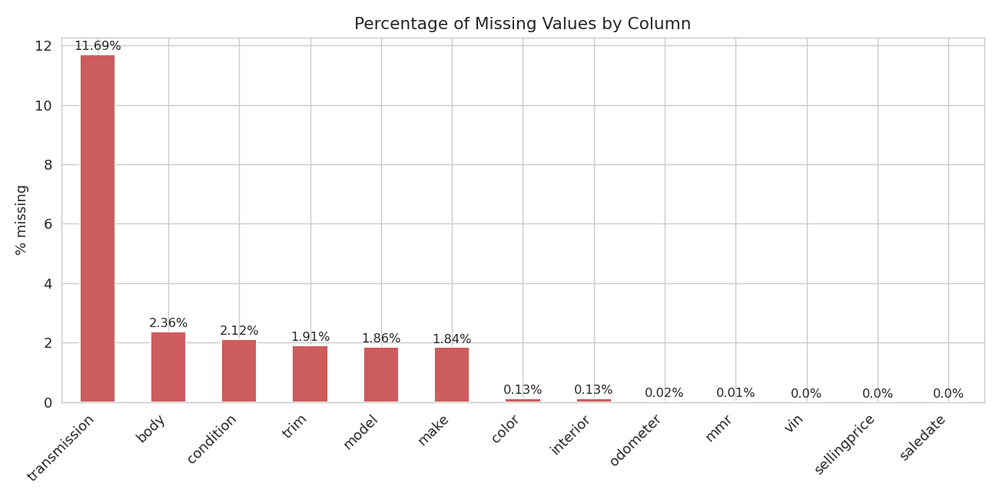
Figure 1 — Percentage of missing values per column
Insight: Only transmission is materially incomplete (11.7%). Every other column is under 2.5%, so no column needed to be dropped and no large block of rows was lost. Median is used for numeric columns because mileage and condition are skewed; 'unknown' keeps categorical rows usable without inventing facts.
Duplicates: 0 duplicate rows were found, so none were deleted. Rows removed in total: 38 (0.007%). Final clean shape: 558,799 × 16.

1.4 Anomalies found while profiling (extra, but important)
Problem found | Size | Action
'—' used as a blank in color / interior | 24,685 / 17,075 rows | Replaced by 'unknown'
Same brand typed in different case (e.g. 'bmw' vs 'BMW', 'porsche' vs 'Porsche') | 96 brands → 66; 973 models → 851 | Merged to the most common spelling
Odometer = 999,999 (a placeholder, not a real reading) | 72 rows | Replaced with median odometer
Shifted rows (VIN text inside the state column, 'sedan' inside transmission) | A handful | Already removed by the null-handling step; the script re-checks and finds 0 left
Condition is on two scales: whole numbers 1–5 and 11–49 (nothing in between) | 70,100 rows on the 1–5 scale | Kept (assignment cut-offs use it) but flagged in 3.5 and 3.6
Suspicious prices: $1 sales and a $230,000 Ford Escape | 23 cars ≤ $100; 1 car | Kept and flagged — see 2.1 and 2.4
Why this matters: Without merging spellings, brand-level answers (2.3, 2.6) would be split across duplicates; without handling 999,999, odometer averages and correlations would be distorted. Real analysts spend most of their time on exactly this kind of cleaning.

Part 2 — DataFrame Queries: Answers

2.1 Average, minimum and maximum car price
Answer: Average $13,611.36 · Minimum $1.00 · Maximum $230,000.00. The $1 minimum is almost certainly a data-entry artefact (23 cars sold for $100 or less).

2.2 Unique colors
Answer: 19 colors: beige, black, blue, brown, burgundy, charcoal, gold, gray, green, lime, off-white, orange, pink, purple, red, silver, turquoise, white, yellow (plus 'unknown' for missing values).

2.3 Unique brands and models
Answer: 66 unique brands and 851 unique models after merging spelling variants (raw file: 96 and 973).

2.4 Cars selling above $165,000
Year | Make | Model | Condition | Odometer | State | Price
2011 | Ferrari | 458 Italia | 46 | 12,116 | fl | $183,000
2015 | Mercedes-Benz | S-Class S65 AMG | 41 | 5,277 | ca | $173,000
2013 | Rolls-Royce | Ghost | 42 | 7,852 | fl | $171,500
2012 | Rolls-Royce | Ghost | 45 | 14,316 | fl | $169,500
2012 | Rolls-Royce | Ghost EWB | 36 | 11,832 | ca | $169,000
2012 | Rolls-Royce | Ghost | 44 | 5,215 | ca | $167,000
2014 | Ford | Escape Titanium | 43 | 27,802 | mo | $230,000
Answer: 7 cars. Six are genuine luxury cars (Rolls-Royce, Ferrari, Mercedes S65). The $230,000 Ford Escape is almost certainly a data error — a normal Escape sells for a small fraction of that.

2.5 Top 5 most frequently sold models
Rank | Model | Cars sold
1 | Altima | 19,349
2 | F-150 | 14,479
3 | Fusion | 12,945
4 | Camry | 12,549
5 | Escape | 11,893

2.6 Average selling price by brand
Top and bottom of the ranking (full 66-brand list is printed by the script):
Highest average | Price | Lowest average | Price
Rolls-Royce | $153,488 | Daewoo | $400
Ferrari | $127,211 | ford truck* | $483
Lamborghini | $112,625 | dot* | $500
Bentley | $74,368 | Geo | $529
Tesla | $67,054 | dodge tk* | $550
Aston Martin | $54,812
* Mislabeled/very small groups. 'airstream' ($71,000) is also a tiny group and is not a car brand in the usual sense.

2.7 Minimum selling price by interior color
Interior | Min price | Interior | Min price | Interior | Min price
black | $1 | blue | $150 | red | $200
gray | $1 | silver | $150 | gold | $250
green | $100 | unknown | $150 | white | $350
beige | $100 | burgundy | $175 | off-white | $900
tan | $100 | brown | $200 | orange | $1,200
purple | $200 | yellow | $3,100
Insight: The $1 floors for black and gray interiors are almost certainly bad-data or near-scrap sales; these are the most common interiors, so they have the most chances to include such records. Yellow and orange interiors have much higher floors, probably because there are far fewer of them (not checked in this analysis).

2.8 Highest odometer reading per year (high → low)
Answer: As recorded, 19 different model years show a maximum of 999,999 miles — a placeholder code. After replacing it, the highest readings are: 1993 → 980,113 · 1996 → 959,276 · 2002 and 2003 → 694,978 · 2007 → 621,388 · 2008 → 580,956 · 2013 → 522,212 … and the lowest are 1982 → 85,738 and 1983 → 42,697. The script prints all 34 years.
Caution: Readings near or above 500,000 miles on ordinary cars (and 522,212 on a 2013) are very likely typing errors as well. They are rare, so they do not change the conclusions.

2.9 Car age column
Answer: Added car_age = 2025 − year. Example: a 2015 car is 10 years old, a 2014 car is 11.

2.10 Condition ≥ 48 and odometer > 90,000
Answer: 746 cars. These are very well-kept cars that have nonetheless covered high mileage.

2.11 Which state has consistently higher prices for newer cars (year > 2013)?
In this dataset, 'newer than 2013' means model years 2014 and 2015. To judge consistency, each state's average price was computed per year (only states with at least 100 sales in both years) and then ranked.
State | Avg 2014 | Avg 2015 | Combined avg | Rank 2014 | Rank 2015
Ohio (oh) | $26,682 | $33,152 | $29,917 | 1 | 2
New Jersey (nj) | $22,378 | $33,459 | $27,919 | 2 | 1
Pennsylvania (pa) | $21,463 | $28,409 | $24,936 | 3 | 3
Tennessee (tn) | $21,420 | $27,670 | $24,545 | 4 | 5
Colorado (co) | $19,682 | $27,722 | $23,702 | 8 | 4
Answer: Ohio and New Jersey are the two states that rank in the top two in both years. Ohio has the higher combined average ($29,917); New Jersey is first in 2015. Pennsylvania is a steady third.
Caveat: 2015 model-year samples are small in these states (about 550–750 sales), so the 2015 ordering between Ohio and New Jersey is very close and could change with more data.

2.12 Value for money among top-20% condition cars
The top 20% of condition scores means condition ≥ 43. Brands with fewer than 30 such cars were ignored so a handful of sales cannot decide the ranking.
Make | Avg price | Cars | Make | Avg price | Cars
Saturn | $5,700 | 123 | Scion | $13,327 | 263
smart | $6,836 | 158 | Mitsubishi | $14,400 | 566
Pontiac | $7,687 | 148 | Hyundai | $14,516 | 5,052
Mercury | $9,022 | 97 | Volkswagen | $14,717 | 1,707
FIAT | $11,655 | 208 | Kia | $15,091 | 5,927
Answer: Saturn, smart and Pontiac have the lowest average prices for excellent-condition cars. Saturn, Pontiac and Mercury are discontinued brands, so for a buyer who wants a current, widely available brand, Hyundai, Volkswagen and Kia (each with 1,700+ cars) are the strongest value.

Part 3 — Data Visualization and Insights

3.1 Correlation of numeric features
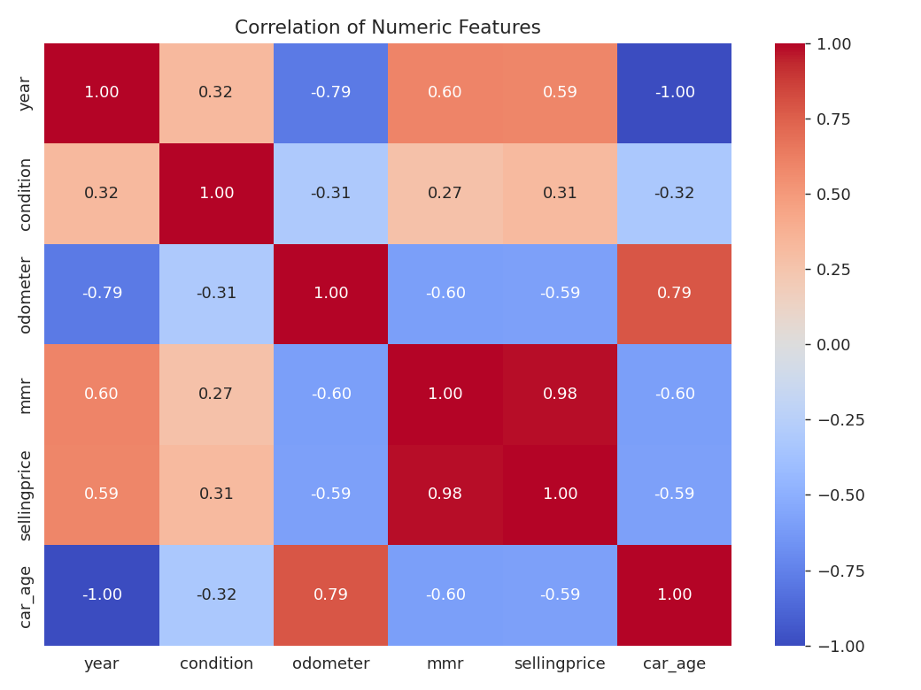
Figure 2 — Correlation matrix of numeric columns
Pair | Correlation | Meaning
sellingprice vs mmr | +0.98 | Near-identical: mmr is the market-value benchmark
sellingprice vs year | +0.59 | Newer cars sell for more
sellingprice vs odometer | −0.59 | More miles, lower price
sellingprice vs condition | +0.31 | Better condition helps, but less than age or mileage
year vs odometer | −0.79 | Newer cars have driven fewer miles
year vs car_age | −1.00 | car_age is just year reversed — redundant
Insight: Price is driven mainly by age/mileage, with condition a weaker secondary factor. If you ever build a prediction model, do not use mmr as an input (it nearly equals the answer), and use only one of year or car_age.

3.2 Average selling price by year
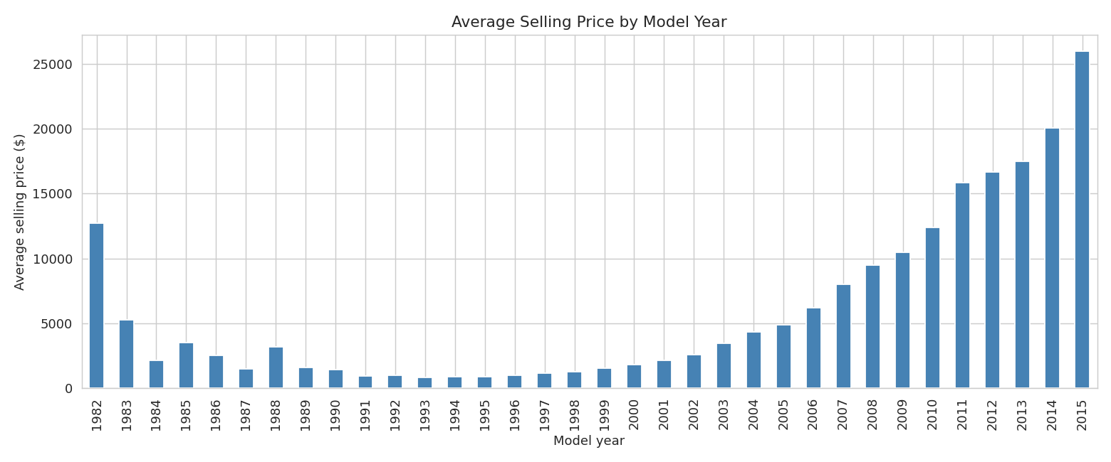
Figure 3 — Average selling price by model year (bar chart)
Which plot? A bar chart. Year is a small set of discrete categories and each bar is an average, so bars compare them clearly. A scatter plot is better for hundreds of thousands of raw points against a continuous measure (like mileage).
Pattern: Prices bottom out for 1991–1996 models (about $830–$990) and then rise steadily every year, reaching $25,966 for 2015 — a 29% jump over 2014 ($20,090). The tallest bars for 1982–1988 are misleading: those years have only 1–11 cars each (likely collectibles), so they are not reliable.

3.3 Average selling price by odometer
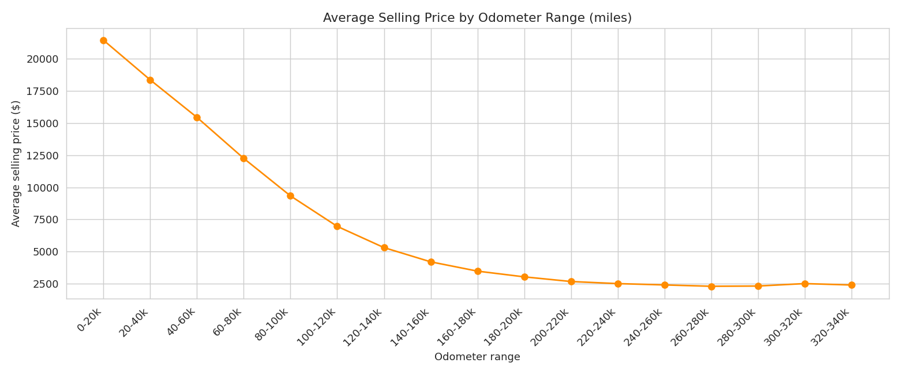
Figure 4 — Average selling price by odometer range (20,000-mile bands, ≥100 cars each)
Trend: A steep, almost straight decline: $21,445 for cars under 20k miles falls to $9,333 at 80–100k miles (−56%). Beyond about 240,000 miles the curve flattens at roughly $2,300–$2,500, which looks like a scrap-value floor. In practice, the first 100,000 miles cost a car most of its value.

3.4 Number of cars sold by state
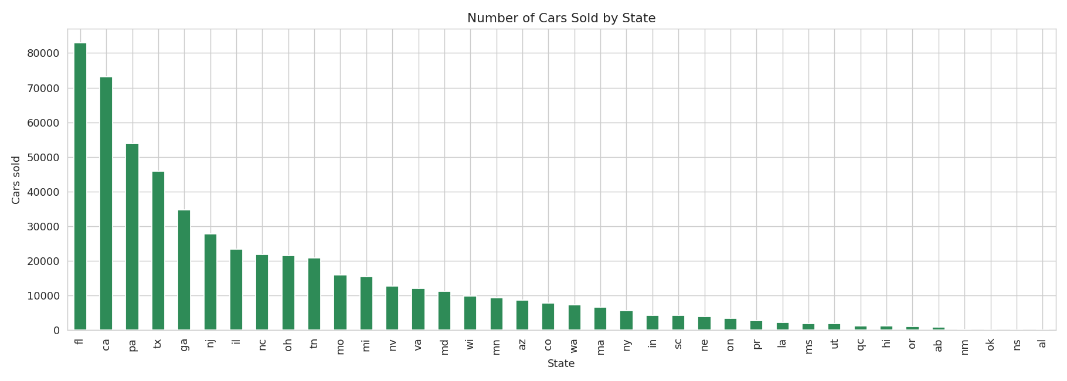
Figure 5 — Cars sold per state
Answer: Top three: Florida (82,945), California (73,148) and Pennsylvania (53,907) — together 37.6% of all sales. Texas (45,913) is fourth.

3.5 Average selling price by condition range (width 5)
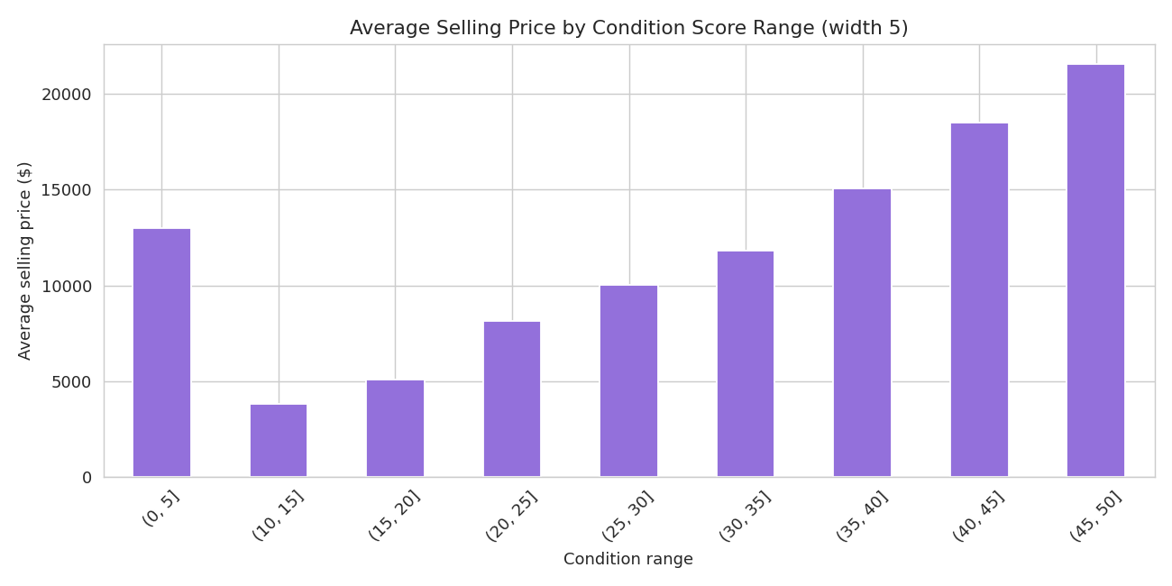
Figure 6 — Requested chart: all rows
Watch out: The first bar (0–5, $12,987) breaks the pattern. It contains the 70,100 cars scored on the separate 1–5 scale, so it mixes a different rating system. Note also that there is no 5–10 bar: no car has a score there.
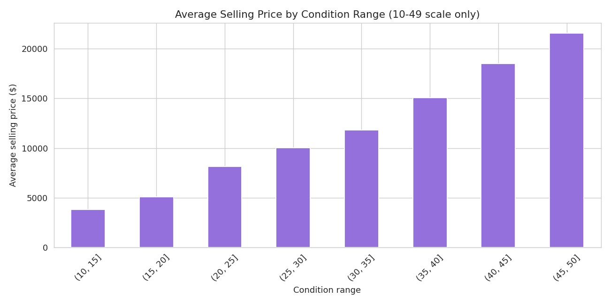
Figure 7 — Same chart, 11–49 scale only
Summary: On the 11–49 scale, price climbs with every band: $3,792 (11–15) → $5,070 → $8,131 → $10,037 → $11,797 → $15,038 → $18,494 → $21,536 (46–49). A top-band car sells for about 5.7× a bottom-band car, so condition is strongly tied to value.

3.6 Number of cars sold by condition range (width 10)
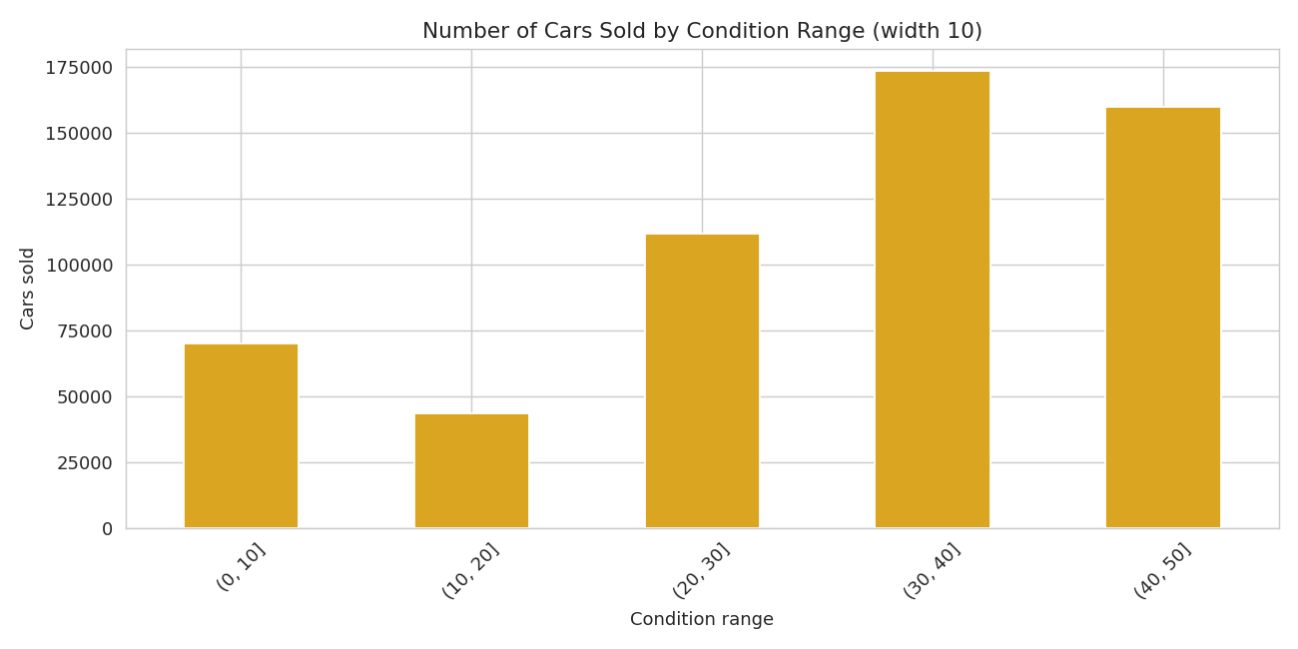
Figure 8 — Cars sold by condition range
Insights: Most cars sit in good condition: 31–40 holds 173,469 cars and 41–49 holds 159,973 — together 59.7% of all sales. Poor-condition cars (11–20) are the smallest group at 43,562. The 0–10 bar (70,100) is entirely the 1–5-scale group. The 31–40 bar is slightly inflated because the 11,820 missing condition values were filled with the median (35).

3.7 Box plot of selling price by color
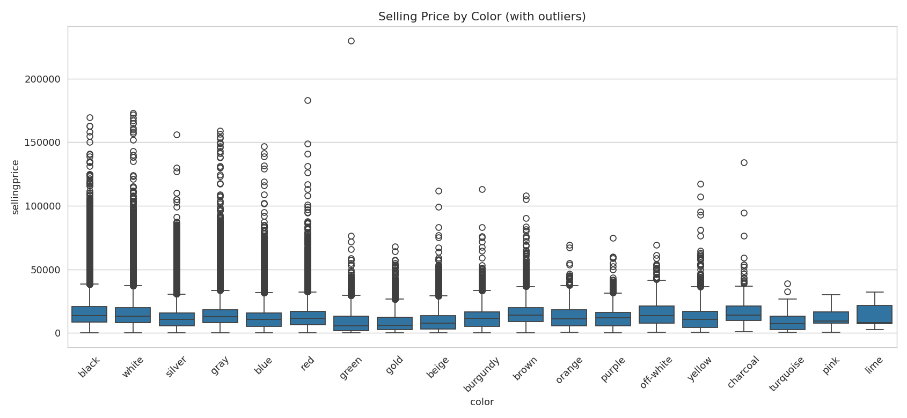
Figure 9 — With outliers
With outliers, every color shows a long tail of expensive cars that squashes the boxes and makes colors hard to compare. Outliers were removed with the IQR rule (values beyond 1.5 × IQR from the quartiles), applied within each color so each color is judged on its own spread. This removed 15,542 of 533,365 rows (2.9%; rows with unknown color were excluded from this chart).
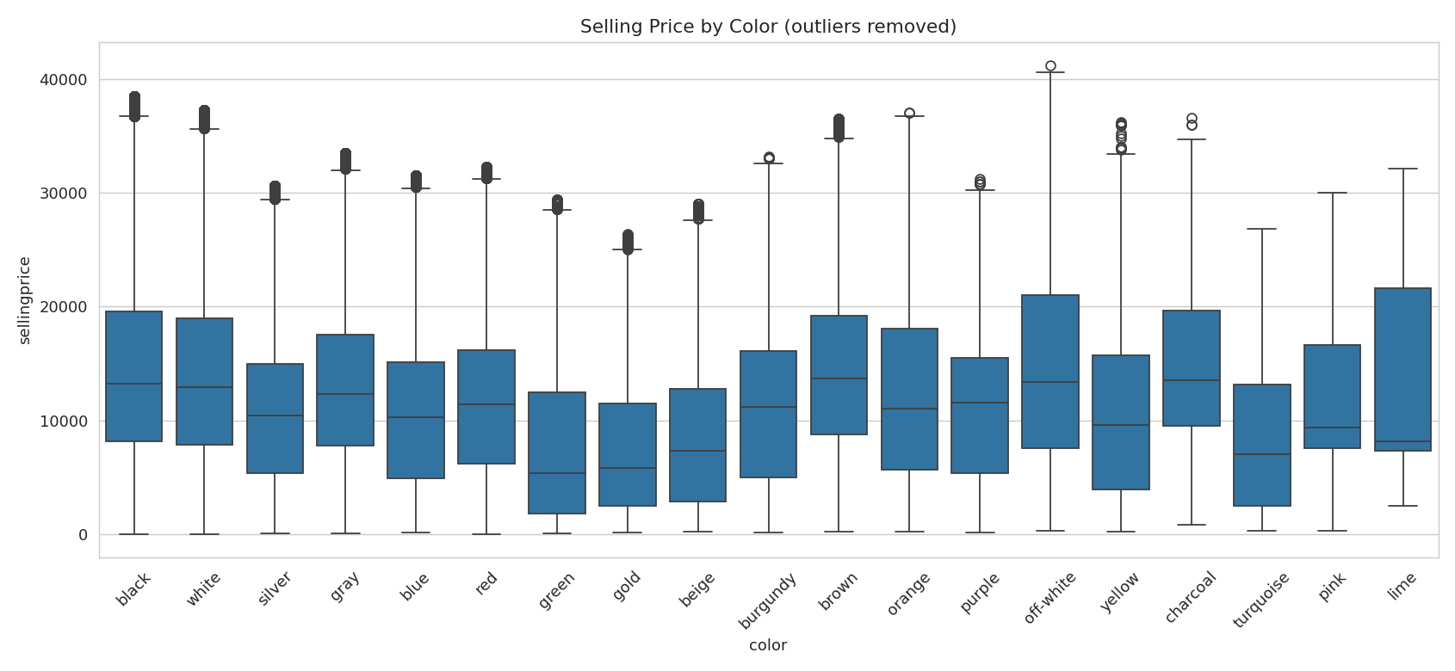
Figure 10 — Outliers removed
Insights: Median prices are highest for brown ($13,700), charcoal ($13,550), off-white ($13,350), black ($13,200) and white ($12,900), and lowest for green ($5,400), gold ($5,800), turquoise ($7,000) and beige ($7,300). The spread (box height) is wide for every color, so color explains little by itself. The differences probably reflect which kinds and ages of cars come in each color rather than color itself changing value (this was not tested here, and correlation is not causation). Small dots reappear after removal because the plot recomputes its quartiles — this is normal.

Conclusions and Recommendations
- Sellers: price mainly from age and mileage; condition adds a smaller premium. The biggest value loss happens in the first ~100,000 miles.
- Where to list: Florida, California and Pennsylvania have the deepest markets; Ohio and New Jersey fetched the highest prices for 2014–2015 models.
- Buyers seeking value: among excellent-condition cars, Hyundai, Volkswagen and Kia are the cheapest of the high-volume brands.
- Data owners: fix brand spelling, placeholder odometer/color values, the dual condition scale and obvious price errors at source.
- Limits: data covers one auction season (Dec 2014 – Jul 2015) and model years only up to 2015, so results describe that period, not today's market.

Appendix — How to Run the Python File
- Put car_prices.csv and car_prices_analysis.py in the same folder.
- Install the libraries once:
pip install pandas numpy matplotlib seaborn
- Open a terminal in that folder and run:
python car_prices_analysis.py
- The answers print in the terminal under numbered headings that match the assignment (1.1 … 3.7).
- All charts are saved automatically into a 'charts' folder — insert them in your submission.
- To save the printed output to a file instead: python car_prices_analysis.py > results.txt
Beginner tip: Read the script top to bottom — each block is labelled with its assignment question number. Change a number (for example 165000 in 2.4) and re-run to see how the answer changes; that is the fastest way to learn pandas.

