

# AEDID

**(AIRCRAFT EXTERIOR DEFECT** **INSPECTION & DETECTION)**

Software Requirement Specifications Report

Team 5 SUBMITTED BY:-

**M JAYANTH VIVEK -20N31A6633**

**M PAWAN KALYAN-20N31A6632**

Under the Guidance of: -

**MR CHANDRASEKHAR REDDY [Assistant Professor] Department of Computational Intelligence**

TABLE OF CONTENTS 2

INTRODUCTION 3

1. LITERATURE SURVEY 4-7
   1. Existing System 4
   2. Drawbacks of Existing System 4
   3. Proposed System 5
   4. Advantages 6
   5. System Architecture 7
   6. use case 9
2. OVERALL DESCRIPTION 8-9
   1. Feasibility Study 8
      1. Operational Feasibility 8
      2. Economic Feasibility 8-9
      3. Technical Feasibility 9
      4. Schedule Feasibility 9
3. SYSTEM ANALYSIS 10
   1. Software Requirement Specifications 10
      1. Hardware and Software Requirements 10
      2. Hardware Requirements 10
      3. Software Requirements 10
4. FUNCTIONAL REQUIREMENTS 11-12
   1. Python 11
   2. Google Translator 11
   3. Data collection and pre-processing 11
   4. Machine translation model training and evaluation 11
   5. Object detection model training and evaluation 11
   6. User interface and interaction 12
5. NON FUNCTIONAL REQUIREMENTS 13
   1. Performance 13
   2. Accuracy 13
   3. Robustness 13
   4. Compatibility 13
6. REFERENCE 14-15

## INTRODUCTION

On considering todays technology as primitive advantage, the advancements in science and technology lead to developing way more features out of the box. Here, we are familiar with the defects in aircraft management that lead to an irreversible course of collateral and life damage, though the defect is negligible. On using some Dl and ML combinations integrated with Keras, PyTorch, CNN, etc. modules we define a customizable and optimistic model that is iterated over time and time to provide the comfort for easy and fast detection of scrum or damage that appears on the outer body of any aircraft (Defence, domestic, etc), helps in immediate threat detection.

## LITERATURE SURVEY

## Existing System:

In the present system, there lies an embedded and encrypted port that is likely supportive of a robotic creature named kiropter which travels along the exterior surface of aircraft to detect the physical damages and classifies the damage with the poplar CNN algorithm especially integrated with a framework named SSD Mobile Net.

The interface is not yet notified with its fullest length which made the idea, just an idea. Also, their proposal is to have a Visual Inspection of the Aircraft Surface Using a Teleoperated Reconfigurable Climbing Robot and an Enhanced deep-learning technique.

## Drawbacks of Existing System:

* + - Limited scope
    - Lack of interpretability
    - Lack of generalizability
    - Limited accuracy
    - Data quality issues
    - Limited scalability

## Proposed System:

The proposed system is significantly different from the existing one in terms of operations and working model, we consider just the software model to train the classification of data and provide the particular indication using the basic API (application programming interface), such that is close enough for a situation where the customer of the hotel gives his order to waiter rather the cook, though gets his need fulfilled.

Also, we use advanced libraries of Deep Learning with the existing framework, such as Pytorch and Keras which gives us the fast computation for the CNN module to run faster. For machine training, we use algorithms like Adam, SGD, etc.

Here we are trying to build a software outcome that deals with image detection and classification, the input images are given by a camera, usually an object detection algorithm is used to provide the images in real time. Nothing like a robot or drone is projected for the image capturing, we are just implementing the software side of the coursework

## Advantages:

* + - Improved accuracy
    - Interpretable.
    - Generalizable.
    - Personalized inventions
    - Cost effective

## System Architecture:

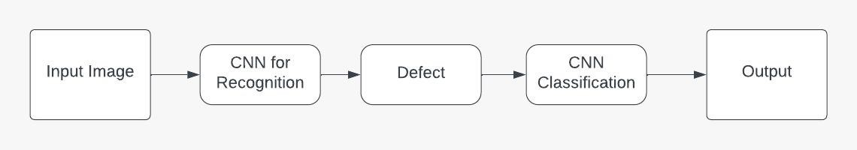

* 1. **Use-case Diagram:**

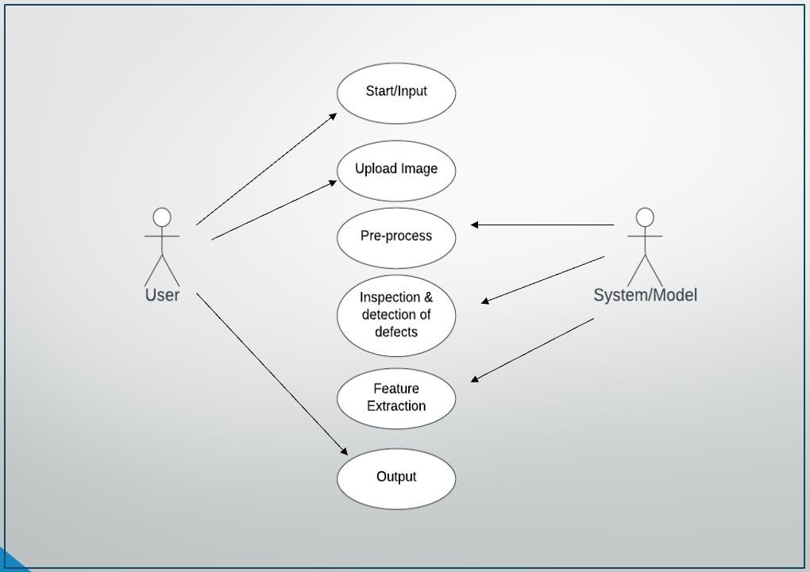

# OVERALL DESCRIPTION

## Feasibility Study:

A feasibility study is an important aspect of any research project, including a defect prediction system. Here is a brief overview of the feasibility studyaspect for a exterior aircraft defect prediction research paper.

### Operational Feasibility:

Operational feasibility involves assessing whether the exterior aircraft prediction system can be integrated into ground force aviation systems and workflows. This includes evaluating the impact of the system on aviation providers and clients, as well as any necessary changes to existing policies and procedures

### Economical Feasibility:

Economic feasibility involves assessing whether the development and implementation of a exterior aircraft detection system is financially viable. This includes analyzing the cost of hardware and software, as well as any ongoing costs associated with maintenance and support

### Technical Feasibility:

The technical feasibility of a aircraft defect detection system involves assessing whether the hardware and software requirements can be met. This includes evaluating the availability and cost of necessary hardware and software, as well as the skills and expertise required to implement and maintain the system

### Legal and Ethical Feasibility:

Legal and ethical feasibility involves assessing whether the aircraft defect detection system complies with relevant laws, regulations, and ethical standards. This includes ensuring that image data is handled appropriately and that the system is designed to protect patient privacy and confidentiality.

# SYSTEM ANALYSIS

## Software Requirement Specifications

A software requirements specification (SRS) is a comprehensive description of the intended purpose and environment for software under development. The SRS fully describes what the software will do and how it will be expected to perform. An SRS minimizes the time and effort required by developers to achieve desired goals and minimizes the development cost. A good SRS defines how an application will interact with system hardware, other programs, and human users in a wide variety of real-world situations. Hence, we start the srs with the feasibility study.

## Hardware and Software Requirements

### Hardware Requirements

* + - * CPU AND RAM
      * STORAGE
      * GPU
      * Network Connectivity
      * Operating system
      * Security

### Software Requirements

* + - * Programming Language: python, R
      * Machine Learning Libraries:sci-kit-learn, TensorFlow, and Keras,
      * Database Management System (DBMS):- MySQL or PostgreSQL
      * Data Preprocessing Tools:-pandas, NumPy, or OpenRefine
      * Web Framework:- Flask or Django

# FUNCTIONAL REQUIREMENTS

### Data Collection:

The system shall collect a dataset of defective images and classification with the following features: detent coordinates, types of physical or locomotive damage, duration and possible cause.

### Data Preprocessing:

The system shall preprocess the dataset by handling missing values, outliers, and categorical variables, and by normalizing the numerical features.

### Feature Selection:

The system shall select the most relevant features for exterior aircraft defect detection using deep learning and machine learning techniques such as pytorch, keras mobileNet framework, etc.

### Model Training:

The system shall train machine learning models such as logistic regression, decision tree, random forest, support vector machine, and neural network on the preprocessed dataset, using cross-validation and hyperparameter tuning to optimize the performance metrics.

### Model Evaluation:

The system shall evaluate the performance of the trained models on a test dataset, using various metrics such as accuracy, precision, recall, F1 score, and area

under the curve (AUC), and visualizing the results with confusion matrices and receiver operating characteristic (ROC) curves.

1. **NON FUNCTIONAL REQUIREMENTS**

Non-functional requirements are important considerations in the development and implementation of a heart disease prediction system. Here are some potential non-functional requirements for a heart disease prediction research paper

* 1. **Performance:** The system must perform efficiently and process tasks in a reasonable amount of time, with minimal latency and response time.
  2. **Accuracy:** The system must produce accurate results for object detection and machine translation tasks, with a high level of precision and recall
  3. **Robustness**: The system must be robust and resilient to handle unexpected errors or inputs, and recover gracefully from failures.
  4. **Compatibility:** The system must be compatible with various hardware and software configurations, and support different operating systems and platforms.

### Maintainability:

The system should be easy to maintain and update as needed to ensure ongoing effectiveness.

### Scalability:

The system should be able to scale up or down as needed to accommodate changing patient populations and healthcare systems.

**7 .REFERENCES:** [**https://www.hindawi.com/journals/ijae/2019/5137139/**](https://www.hindawi.com/journals/ijae/2019/5137139/)

* + - Jovancevi ˇ c, A. Arafat, J.-J. Orteu, and T. Sentenac, “Airplane inspection by image processing techniques,” in 2016 5th Mediterranean Conference on Embedded Computing (MECO). IEEE, 2016, pp. 176–179
    - T. Malekzadeh, M. Abdollahzadeh, H. Nejati, and N.-M. Cheung, “Aircraft fuselage defect detection using deep neural networks,” arXiv preprint arXiv:1712.09213, 2017.
    - K. He, G. Gkioxari, P. Dollar, and R. Girshick, “Mask r-cnn,” in Proceedings of the IEEE international conference on computer vision, 2017, pp. 2961–2969.