**urbanStep-Sneakers**

(A Frontend E-commerce Website)

An Industry Oriented Project Report Submitted

In partial fulfillment of the requirement for the award of the degree of

## Bachelor of Technology

In

**Computer Science and Engineering - Artificial Intelligence and Machine Learning**

by

**BHUKYA KALYAN - 22N31A6628**

**BOCHKAR NIKHITH - 22N31A6629**

**BODOLLA ABHILASH GOUD - 22N31A6630 .**

Under the Guidance of

**Mrs. P. Swapna**

**Assistant Professor**

**Department of Computational Intelligence**

**MRCET**



**DEPARTMENT OF COMPUTATIONAL INTELLIGENCE**

**MALLA REDDY COLLEGE OF ENGINEERING AND TECHNOLOGY**

(Affiliated to JNTU, Hyderabad)

**ACCREDITED by AICTE-NBA**

**Maisammaguda, Dhulapally post, Secunderabad-500014.**

**(2022-2026)**



**CERTIFICATE**

This is to certify that this is the bonafide record of the project titled **“urbanStep-Sneakers”** submitted by **Bhukya Kalyan (22N31A6628), Bochkar Nikhith (22N31A6629), Bodolla Abhilash Goud (22N31A6630)** of B.Tech in the partial fulfillment of the requirements for the degree of **Bachelor of Technology** in **Computer Science and Engineering - Artificial Intelligence and Machine Learning**, Dept. of CI during the year 2023-2024. The results embodied in this project report have not been submitted to any other university or institute for the award of any degree or diploma.

|  |  |  |
| --- | --- | --- |
| **Mrs. P. Swapna**  Assistant Professor  **INTERNAL GUIDE** | **EXTERNAL EXAMINER** | **Dr. D. Sujatha** Professor **HEAD OF THE DEPARTMENT** |

**DECLARATION**

## We hereby declare that the project entitled “urbanStep – Sneakers” submitted to Malla Reddy College of Engineering and Technology, affiliated to Jawaharlal Nehru Technological University Hyderabad (JNTUH) for the award of the degree of Bachelor of Technology in Computer Science and Engineering- Artificial Intelligence and Machine Learning is a result of original research work done by us.

It is further declared that the project report or any part thereof has not been previously submitted to any University or Institute for the award of degree or diploma.

by

**BHUKYA KALYAN (22N31A6628)**

**BOCHKAR NIKHITH (22N31A6629)**

**BODOLLA ABHILASH GOUD (22N31A6630)**

# **ACKNOWLEDGEMENT**

We feel honored and privileged to place our warm salutation to our college Malla Reddy College of Engineering and technology (UGC-Autonomous), our ***Dr. VSK Reddy*** who gave us the opportunity to have experience in engineering and profound technical knowledge.

We are indebted to our Principal ***Dr. S. Srinivasa Rao*** for providing us with facilities to do our project and his constant encouragement and moral support which motivated us to move forward with the project.

We would like to express our gratitude to our Head of the ***Dr. D. Sujatha*** for encouraging us in every aspect of our system development and helping us realize our full potential.

We would like to thank our application development guide as well as our internal guide***Mrs. P. Swapna, Assistant Professor*** for her structured guidance and never-ending encouragement. We are extremely grateful for valuable suggestions and unflinching co-operation throughout application development work.

We would also like to thank all supporting staff of department of CI and all other departments who have been helpful directly or indirectly in making our application development a success.

We would like to thank our parents and friends who have helped us with their valuable suggestions and support has been very helpful in various phases of the completion of the application development.

**BHUKYA KALYAN (22N31A6628)**

**BOCHKAR NIKHITH (22N31A6629)**

**BODOLLA ABHILASH GOUD (22N31A6630)**

**ABSTRACT**

In the digital age, E-commerce platforms redefine shopping with convenience and choice. urbanStep - Sneakers targets sneaker enthusiasts, blending creativity and functionality for a seamless online experience. Using HTML, CSS, and JavaScript, it captures urban culture. Its UI design ensures easy navigation, while JavaScript adds dynamic features like real-time filtering. The responsive design ensures usability across devices. JavaScript further enriches the experience with interactive elements like product carousels and personalized recommendations, boosting engagement and satisfaction. urbanStep - Sneakers signifies a shift in online sneaker shopping, setting a new standard with its innovative frontend and user-focused approach, redefining digital retail excellence and making the minimalistic interface a user friendly experience.

**TABLE OF CONTENTS**

CHAPTER 1

INTRODUCTION 1-2

1.1. Purpose 1

1.2. Background of project 1

1.3. Scope of the project 1

1.4. Project feature 2

**CHAPTER 2**

SYSTEM REQUIREMENTS 3-4

2.1. Hardware & Software Requirements 3

2.2. Functional Requirements 3

2.3. Existing System 3

2.4. Proposed System 4

**CHAPTER 3**

TECHNOLOGIES USED 5

**CHAPTER 4**

SYSTEM DESIGN 6-10

4.1. System Architecture 6

4.2. UML Diagrams 7

**CHAPTER 5**

IMPLEMENTATION 11-25

5.1. Source Code 11

5.2. Output Screens 22

5.3. Testing 25

**CHAPTER 6**

CONCLUSION AND FUTURE SCOPE 26-27

BIBILIOGRAPHY 27

**CHAPTER 1**

**INTRODUCTION**

* 1. **Purpose:**

The purpose of urbanStep-Sneakers is to democratize e-commerce by making it accessible to small retailers who want to expand their reach and improve their sales through online channels. The platform offers a localized e-commerce experience, enabling retailers to build strong relationships with their customers while maintaining their unique brand identity.

* 1. **Background of project:**

**urbanStep-Sneakers** is an innovative e-commerce platform specifically designed to empower small-scale retailers by providing them with the necessary tools to establish and manage their online presence. Unlike large, globally expansive e-commerce platforms, urbanStep-Sneakers focuses on local commerce, allowing retailers to connect with their community and target audience more effectively. The platform is tailored to the unique needs of small businesses, offering a user-friendly interface and a range of customizable features to enhance their online storefronts.

* 1. **Scope of project:**

The scope of the urbanStep-Sneakers project encompasses the development, implementation, and maintenance of an e-commerce platform tailored specifically for small-scale retailers. The primary aim is to provide these retailers with the tools and capabilities needed to establish and manage their online presence effectively, thereby increasing their reach and competitiveness in the digital marketplace.

* 1. **Project Features­­­:**

The system features are as follows:

* **Retailer-Centric Interface:** Intuitive tools for managing product listings, processing orders, and maintaining an online storefront.
* **Localized E-commerce Experience:** Fosters connections between retailers and their local communities.
* **Customization and Branding:** Allows retailers to customize their websites to reflect their unique branding.
* **Streamlined Selling Process:** Efficient order management, payment processing, and inventory tracking.
* **Support for Small-Scale Operations:** Cost-effective solutions and support services tailored to small retailers.
* **Community Engagement:** Features like user reviews, social media integration, and localized marketing initiatives.

# **CHAPTER 2**

# **SYSTEM REQUIREMENTS**

# 

**2.1 Hardware Requirements:**

* Modern desktop or laptop with internet connectivity
* Minimum 8GB RAM
* Minimum 128GB storage
* Any 2.2 GHz processor

**2.2 Software requirements:**

**Operating System:**

* Windows 10 or later
* macOS 10.14 (Mojave) or later
* Linux distributions such as Ubuntu 18.04 or later
* iOS 13 or later (for Apple devices)
* Android 9.0 (Pie) or later (for Android devices)

**Web Browser:**

* Latest versions of Chrome, Firefox, Safari, or Edge
* Mobile browsers: Latest versions of Safari (iOS) and Chrome (Android)

**2.3 Existing System:**

The current landscape of e-commerce for small retailers is dominated by large, globally expansive platforms such as Amazon, eBay, and Shopify. These platforms offer a range of services for online selling, including inventory management, payment processing, and customer service tools. However, small retailers often face several challenges when trying to establish and maintain an online presence on these platforms.

**2.3.1 Drawbacks of existing system:**

* **High Competition:** Difficult to stand out among large, established businesses and international sellers.
* **High Fees and Commissions:** Significant costs from listing, transaction, and payment processing fees.
* **Limited Customization:** Restricted ability to create a unique brand identity.
* **Complex Setup and Maintenance:** Requires technical expertise, leading to potential delays and increased costs.
* **Lack of Local Focus:** Tools not designed to connect with local customers.
* **Generic Customer Experience:** Standardized experiences reduce personal connection and customer loyalty.
* **Data Ownership and Control:** Limited access to valuable customer data and analytics.
* **Limited Support and Resources:** Generalized support not addressing specific needs of small retailers.

**2.4 Proposed System:** urbanStep-Sneakers

The proposed system, urbanStep-Sneakers, is an e-commerce platform specifically designed to address the needs and challenges of small retailers. The system aims to provide a user-friendly, customizable, and locally-focused online selling experience that empowers small businesses to thrive in the digital marketplace. urbanStep-Sneakers is designed to overcome the limitations of existing e-commerce platforms by providing a tailored, localized, and customizable solution for small retailers. By focusing on the specific needs of these businesses, urbanStep-Sneakers aims to empower small retailers to establish and grow their online presence effectively, fostering stronger community ties and enhancing their competitive edge in the digital marketplace.

**CHAPTER 3**

**TECHNOLOGIES USED**

**HTML5 (Hyper Text Markup Language):**

* **Purpose:** Provides the structure and content of web pages.
* **Usage:** Used to create the foundational layout of the e-commerce platform, including product pages, checkout forms, and user interfaces.

**CSS3 (Cascading Style Sheets):**

* **Purpose:** Defines the presentation and styling of web pages.
* **Usage:** Used to design visually appealing and responsive layouts, ensuring the platform looks good on all devices (desktop, tablet, mobile). Includes animations, transitions, and custom styling for brand identity.

**JavaScript (JS):**

* **Purpose:** Adds interactivity and dynamic functionality to web pages.
* **Usage:** Used for client-side scripting to enhance user experience, including features like form validation, interactive product galleries, dynamic content updates, and AJAX calls for asynchronous data fetching.

**CHAPTER 4**

**SYSTEM DESIGN**

**4.1 System Architecture**

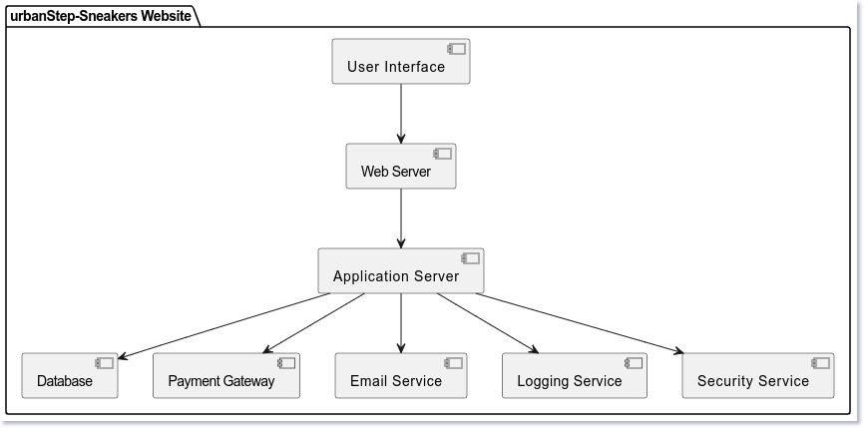

**Fig 4.1**

**4.2 UML Diagrams**

#### **4.2.1 Use case diagram**

#### 

Use Case during requirement elicitation and analysis to represent the functionality of the system. Use case describes a function by the system that yields a visible result for an actor. The identification of actors and use cases result in the definitions of the boundary of the system i.e., differentiating the tasks accomplished by the system and the tasks accomplished by its environment.

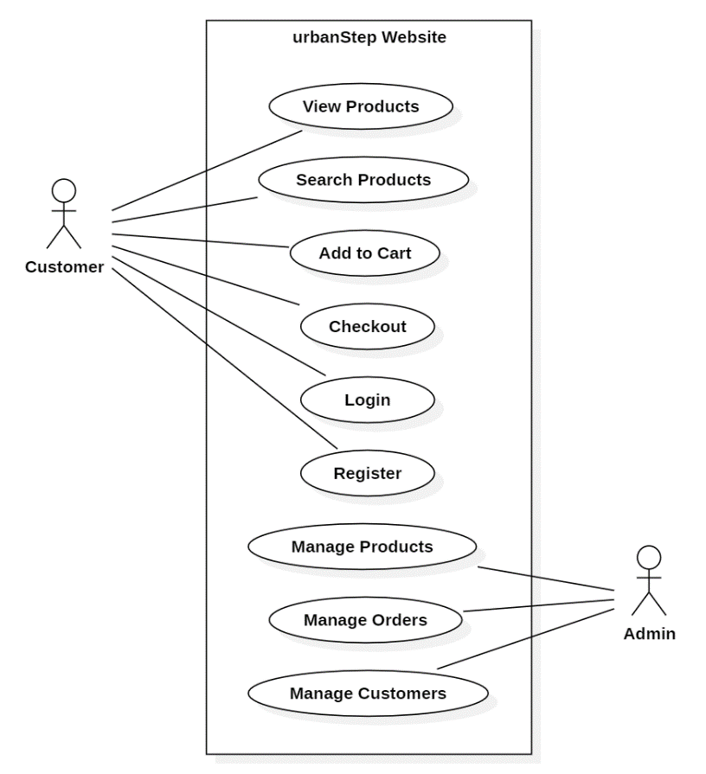

**Fig 4.2 (a)**

#### **4.2.2 Class Diagram**

#### 

Class diagrams model class structure and contents using design elements such as classes, packages and objects. Class diagram describe the different perspective when designing a system-conceptual, specification and implementation. Classes are composed of three things: name, attributes, and operations. Class diagram also display relationships such as containment, inheritance, association etc. The association relationship is most common relationship in a class diagram. The association shows the relationship between instances of classes.

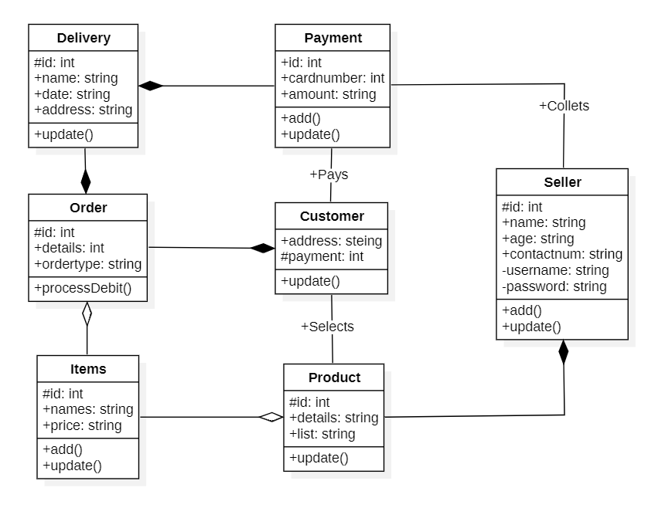

**Fig 4.2 (b)**

#### **4.2.3 Sequence Diagram**

#### Sequence diagram displays the time sequence of the objects participating in the interaction. This consists of the vertical dimension (time) and horizontal dimension (different objects). Objects: An object can be thought of as an entity that exists at a specified time and has a definite value, as well as a holder of identity. A sequence diagram depicts item interactions in chronological order. It illustrates the scenario's objects and classes, as well as the sequence of messages sent between them in order to carry out the scenario's functionality. In the Logical View of the system under development, sequence diagrams are often related with use case realizations. Event diagrams and event scenarios are other names for sequence diagrams. A sequence diagram depicts multiple processes or things that exist simultaneously as parallel vertical lines (lifelines), and the messages passed between them as horizontal arrows, in the order in which they occur

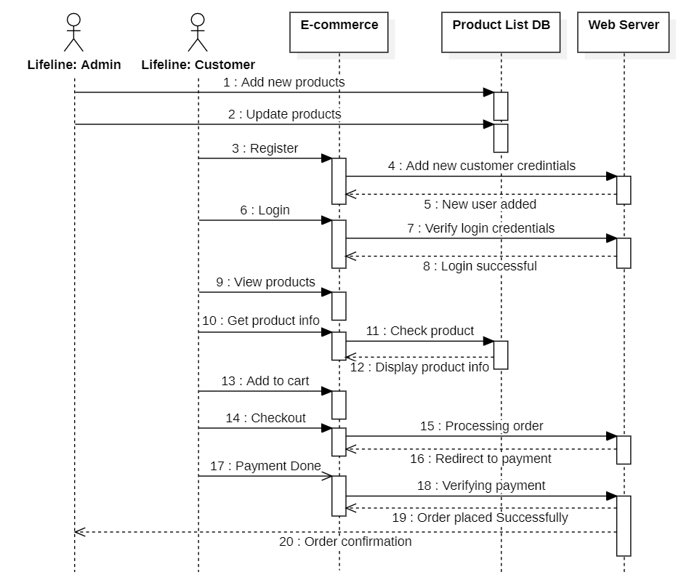

**:System**

**Fig 4.2 (c)**

#### **4.2.4 Activity Diagram**

The process flows in the system are captured in the activity diagram. Similar to a state diagram, an activity diagram also consists of activities, actions, transitions, initial and final states, and guard conditions.

#### 

**Fig 4.2 (d)**

**CHAPTER 5**

**IMPLEMENTATION**

**5.1: Code**

**HTML:**

**Login Page:**

<!DOCTYPE html>

<html lang="en">

<head>

    <meta charset="UTF-8">

    <meta name="viewport" content="width=device-width, initial-scale=1.0">

    <title>urbanStep - Login</title>

    <link rel="stylesheet" href="style.css">

    <link rel="stylesheet" href="cl-icon/css/all.min.css">

    <link rel="shortcut icon" href="/img/uS.png" type="image/x-icon">

</head>

<body>

    <div class="wrapper">

        <form action="" class="form">

            <img class="uslogo" src="/img/urbanStep.png" alt="">

            <div class="inp">

                <input type="text" name="" id="" class="input" placeholder="username">

                <i class="fa-solid fa-user"></i>

            </div>

            <div class="inp">

                <input type="password" name="" id="" class="input" placeholder="password">

                <i class="fa-solid fa-lock"></i>

            </div>

            <button  class="submit">Login</button>

            <p class="footer">You do not have an account?<a href="#" class="link"> Please Register</a></p>

            <p class="footer"><a href="/homepage/homepage.html" class="link"> Skip Login</a></p> <br>

        </form>

        <div></div>

        <div class="banner">

            <h1 class="wel_text">Welcome</h1><br><br>

            <p class="para"></p>

        </div>

    </div>

</body>

</html>

**Home Page:**

<html lang="en">

<head>

    <meta charset="UTF-8">

    <meta http-equiv="X-UA-Compatible" content="IE=edge">

    <meta name="viewport" content="width=device-width, initial-scale=1.0">

    <link

        href="https://fonts.googleapis.com/css2?family=Lato:ital,wght@0,100;0,300;0,400;0,700;0,900;1,100;1,300;1,400;1,700;1,900&display=swap"

        rel="stylesheet">

    <link rel="stylesheet" href="style.css">

    <link rel="shortcut icon" href="/img/uS.png" type="image/x-icon">

    <title>urbanStep - Sneakers</title>

</head>

<body>

    <nav id="nav">

        <div class="navTop">

            <div class="navItem">

                <img width="180" src="./img/urbanStep.png" alt="">

            </div>

            <div class="navItem">

                <div class="search">

                    <input type="text" placeholder="Search..." class="searchInput">

                    <img src="./img/search.png" width="20" height="20" alt="" class="searchIcon">

                </div>

            </div>

            <div class="navItem">

                <span href="#" class="limitedOffer">Limited Offer!</span>

            </div>

            <div class="profile">

                <img width="50" src="/homepage/img/profile white.png" alt="">

            </div>

        </div>

        <div class="navBottom">

            <h3 href="#" class="menuItem">AIR FORCE</h3>

            <h3 href="#" class="menuItem">JORDAN</h3>

            <h3 href="#" class="menuItem">BLAZER</h3>

            <h3 href="#" class="menuItem">CRATER</h3>

            <h3 href="#" class="menuItem">HIPPIE</h3>

        </div>

        <div class="Hello">

            <h2>Step into Style: Your Sole Destination for Trendsetting Sneakers </h2>

        </div>

    </nav>

    <div class="slider">

        <div class="sliderWrapper">

            <div class="sliderItem">

                <img src="./img/air.png" alt="" class="sliderImg">

                <div class="sliderBg"></div>

                <h1 class="sliderTitle">AIR FORCE</br> NEW</br> SEASON</h1>

                <h2 class="sliderPrice">₹3249</h2>

                <a href="#product">

                    <button class="buyButton">BUY NOW!</button>

                </a>

            </div>

            <div class="sliderItem">

                <img src="./img/jordan.png" alt="" class="sliderImg">

                <div class="sliderBg"></div>

                <h1 class="sliderTitle">AIR JORDAN</br> NEW</br> SEASON</h1>

                <h2 class="sliderPrice">₹4199</h2>

                <a href="#product">

                    <button class="buyButton">BUY NOW!</button>

                </a>

            </div>

            <div class="sliderItem">

                <img src="./img/blazer.png" alt="" class="sliderImg">

                <div class="sliderBg"></div>

                <h1 class="sliderTitle">BLAZER</br> NEW</br> SEASON</h1>

                <h2 class="sliderPrice">₹3099</h2>

                <a href="#product">

                    <button class="buyButton">BUY NOW!</button>

                </a>

            </div>

            <div class="sliderItem">

                <img src="./img/crater.png" alt="" class="sliderImg">

                <div class="sliderBg"></div>

                <h1 class="sliderTitle">CRATER</br> NEW</br> SEASON</h1>

                <h2 class="sliderPrice">₹3599</h2>

                <a href="#product">

                    <button class="buyButton">BUY NOW!</button>

                </a>

            </div>

            <div class="sliderItem">

                <img src="./img/hippie.png" alt="" class="sliderImg">

                <div class="sliderBg"></div>

                <h1 class="sliderTitle">HIPPIE</br> NEW</br> SEASON</h1>

                <h2 class="sliderPrice">₹2749</h2>

                <a href="#product">

                    <button class="buyButton">BUY NOW!</button>

                </a>

            </div>

        </div>

    </div>

    <div class="features">

        <div class="feature">

            <img src="./img/shipping.png" alt="" class="featureIcon">

            <span class="featureTitle">FREE SHIPPING</span>

            <span class="featureDesc">Free worldwide shipping on all orders.</span>

        </div>

        <div class="feature">

            <img class="featureIcon" src="./img/return.png" alt="">

            <span class="featureTitle">30 DAYS RETURN</span>

            <span class="featureDesc">No question return and easy refund in 14 days.</span>

        </div>

        <div class="feature">

            <img class="featureIcon" src="./img/gift.png" alt="">

            <span class="featureTitle">GIFT CARDS</span>

            <span class="featureDesc">Buy gift cards and use coupon codes easily.</span>

        </div>

        <div class="feature">

            <img class="featureIcon" src="./img/contact.png" alt="">

            <span class="featureTitle">CONTACT US!</span>

            <span class="featureDesc">Keep in touch via email and support system.</span>

        </div>

    </div>

    <div class="product" id="product">

        <img src="./img/air.png" alt="" class="productImg">

        <div class="productDetails">

            <h1 class="productTitle">AIR FORCE</h1>

            <h2 class="productPrice">₹3,249</h2>

            <p class="productDesc">Lorem ipsum dolor sit amet consectetur impal adipisicing elit. Alias assumenda

                dolorum

                doloremque sapiente aliquid aperiam.</p>

            <div class="colors">

                <div class="color"></div>

                <div class="color"></div>

            </div>

            <div class="sizes">

                <div class="size">38</div>

                <div class="size">40</div>

                <div class="size">42</div>

                <div class="size">43</div>

                <div class="size">44</div>

                <div class="size">46</div>

            </div>

            <button class="productButton">BUY NOW!</button>

        </div>

        <div class="payment">

            <h1 class="payTitle">Personal Information</h1>

            <label>Name and Surname</label>

            <input type="text" placeholder="John Doe" class="payInput">

            <label>Phone Number</label>

            <input type="text" placeholder="+1 234 5678" class="payInput">

            <label>Address</label>

            <input type="text" placeholder="Elton St 21 22-145" class="payInput">

            <h1 class="payTitle">Card Information</h1>

            <div class="cardIcons">

                <img src="./img/visa.png" width="40" alt="" class="cardIcon">

                <img src="./img/master.png" alt="" width="40" class="cardIcon">

            </div>

            <input type="password" class="payInput" placeholder="Card Number">

            <div class="cardInfo">

                <input type="text" placeholder="mm" class="payInput sm">

                <input type="text" placeholder="yyyy" class="payInput sm">

                <input type="text" placeholder="cvv" class="payInput sm">

            </div>

            <button class="payButton">Checkout!</button>

            <span class="close">X</span>

        </div>

    </div>

    <div class="gallery">

        <div class="galleryItem">

            <h1 class="galleryTitle">Be Yourself!</h1>

            <img src="https://images.pexels.com/photos/9295809/pexels-photo-9295809.jpeg?auto=compress&cs=tinysrgb&dpr=2&w=500"

                alt="" class="galleryImg">

        </div>

        <div class="galleryItem">

            <img src="https://images.pexels.com/photos/1040427/pexels-photo-1040427.jpeg?auto=compress&cs=tinysrgb&dpr=2&w=500"

                alt="" class="galleryImg">

            <h1 class="galleryTitle">This is the First Day of Your New Life</h1>

        </div>

        <div class="galleryItem">

            <h1 class="galleryTitle">Just Do it!</h1>

            <img src="https://images.pexels.com/photos/7856965/pexels-photo-7856965.jpeg?auto=compress&cs=tinysrgb&dpr=2&w=500"

                alt="" class="galleryImg">

        </div>

    </div>

    <div class="newSeason">

        <div class="nsItem">

            <img src="https://images.pexels.com/photos/4753986/pexels-photo-4753986.jpeg?auto=compress&cs=tinysrgb&dpr=2&w=500"

                alt="" class="nsImg">

        </div>

        <div class="nsItem">

            <h3 class="nsTitleSm">WINTER NEW ARRIVALS</h3>

            <h1 class="nsTitle">New Season</h1>

            <h1 class="nsTitle">New Collection</h1>

            <a href="#nav">

                <button class="nsButton">CHOOSE YOUR STYLE</button>

            </a>

        </div>

        <div class="nsItem">

            <img src="https://images.pexels.com/photos/7856965/pexels-photo-7856965.jpeg?auto=compress&cs=tinysrgb&dpr=2&w=500"

                alt="" class="nsImg">

        </div>

    </div>

    <footer>

        <div class="footerLeft">

            <div class="footerMenu">

                <h1 class="fMenuTitle">About Us</h1>

                <ul class="fList">

                    <li class="fListItem">Company</li>

                    <li class="fListItem">Contact</li>

                    <li class="fListItem">Careers</li>

                    <li class="fListItem">Affiliates</li>

                    <li class="fListItem">Stores</li>

                </ul>

            </div>

            <div class="footerMenu">

                <h1 class="fMenuTitle">Useful Links</h1>

                <ul class="fList">

                    <li class="fListItem">Support</li>

                    <li class="fListItem">Refund</li>

                    <li class="fListItem">FAQ</li>

                    <li class="fListItem">Feedback</li>

                    <li class="fListItem">Stories</li>

                </ul>

            </div>

            <div class="footerMenu">

                <h1 class="fMenuTitle">Products</h1>

                <ul class="fList">

                    <li class="fListItem">AIR FORCE</li>

                    <li class="fListItem">AIR JORDAN</li>

                    <li class="fListItem">BLAZER</li>

                    <li class="fListItem">CRATER</li>

                    <li class="fListItem">HIPPIE</li>

                </ul>

            </div>

        </div>

        <div class="footerRight">

            <div class="footerRightMenu">

                <h1 class="fMenuTitle">Subscribe to our newsletter</h1>

                <div class="fMail">

                    <input type="text" placeholder="your@email.com" class="fInput">

                    <button class="fButton">Join!</button>

                </div>

            </div>

            <div class="footerRightMenu">

                <h1 class="fMenuTitle">Follow Us</h1>

                <div class="fIcons">

                    <img src="./img/facebook.png" alt="" class="fIcon">

                    <img src="./img/twitter.png" alt="" class="fIcon">

                    <img src="./img/instagram.png" alt="" class="fIcon">

                    <img src="./img/whatsapp.png" alt="" class="fIcon">

                </div>

            </div>

            <div class="footerRightMenu">

                <span class="copyright">@urbanStep. All rights reserved. 2024.</span>

            </div>

        </div>

    </footer>

    <script src="./app.js"></script>

</body>

</html>

**CSS:**

*{

    margin: 0;

    padding: 0;

    font-family: arial;

    color: #fff;

}

body{

    width: 100vw;

    height: 100vh;

    background: rgb(19,19,19);

    display: grid;

    justify-content: center;

    align-content: center;

}

::-webkit-input-placeholder{

    color: #eee;

}

.wrapper{

    position: relative;

    width: 800px;

    height: 65vh;

    display: grid;

    grid-template-columns: 1fr 1fr;

    border: 3px solid #303030;

    box-shadow: 0 0 50px 0 rgb(59, 59, 59);

    overflow: hidden;

}

.form{

    display: flex;

    flex-direction: column;

    justify-content: center;

    align-items: center;

    overflow: hidden;

    z-index: 1;

}

.title{

    font-size: 35px;

}

.inp{

    padding-bottom: 10px;

    border-bottom: 2px solid #eee;

}

.input{

    border: none;

    outline: none;

    background: none;

    width: 260px;

    margin-top: 40px;

    padding-right: 10px;

    font-size: 17px;

    color: #eee;

}

.submit{

    border: none;

    outline: none;

    width: 288px;

    margin-top: 25px;

    padding: 10px 0;

    font-size: 20px;

    border-radius: 40px;

    letter-spacing: 1px;

    cursor: pointer;

    background: radial-gradient(circle at -4% -12.9%, rgb(74, 98, 110) 0.3%, rgb(30, 33, 48) 90.2%);

}

.footer{

    margin-top: 30px;

    letter-spacing: 0.5px;

    font-size: 14px;

}

.link{

    color: rgb(128, 247, 255);

    text-decoration: none;

}

.banner{

    position: absolute;

    top: 0;

    right: 0;

    width: 450px;

    height: 514px;

    background: radial-gradient(circle at -4% -12.9%, rgb(74, 98, 110) 0.3%, rgb(30, 33, 48) 90.2%);

    clip-path: polygon(0 0%, 100% 0, 100% 100%, 50% 100%);

    padding-right: 70px;

    text-align: right;

    display: flex;

    flex-direction: column;

    justify-content: center;

    align-items: flex-end;

}

.wel_text{

    position: relative;

    color:rgb(167, 255, 255);

    font-size: 60px;

    margin-top: -20px;

    margin-right: -20px;

    line-height: 50px;

    text-decoration: none;

    /* text-shadow: 0px 4px 10px rgba(0, 0, 0, 0.8) */

}

.wel_text:before {

    content: "";

    position: absolute;

    bottom: -8px;

    height: 6px;

    width: 0;

    background: aqua;

    border-radius: 100px;

    transition: width 0.3s ease;

  }

  .wel_text:hover:before{

    width: 100%;

  }

.para{

    margin-top: 10px;

    font-size: 18px;

    line-height: 24px;

    letter-spacing: 1px;

}

.uslogo{

    border: none;

    outline: none;

    width: 180px;

    margin-top: 25px;

    padding: 10px 0;

    font-size: 20px;

    border-radius: 40px;

    letter-spacing: 1px;

    cursor: pointer;

}

**JavaScript:**

const wrapper = document.querySelector(".sliderWrapper");

const menuItems = document.querySelectorAll(".menuItem");

const products = [

  {

    id: 1,

    title: "Air Force",

    price: 3249,

    colors: [

      {

        code: "black",

        img: "./img/air.png",

      },

      {

        code: "darkblue",

        img: "./img/air2.png",

      },

    ],

  },

  {

    id: 2,

    title: "Air Jordan",

    price: 4199,

    colors: [

      {

        code: "lightgray",

        img: "./img/jordan.png",

      },

      {

        code: "green",

        img: "./img/jordan2.png",

      },

    ],

  },

  {

    id: 3,

    title: "Blazer",

    price: 3099,

    colors: [

      {

        code: "lightgray",

        img: "./img/blazer.png",

      },

      {

        code: "green",

        img: "./img/blazer2.png",

      },

    ],

  },

  {

    id: 4,

    title: "Crater",

    price: 3599,

    colors: [

      {

        code: "black",

        img: "./img/crater.png",

      },

      {

        code: "lightgray",

        img: "./img/crater2.png",

      },

    ],

  },

  {

    id: 5,

    title: "Hippie",

    price: 2749,

    colors: [

      {

        code: "gray",

        img: "./img/hippie.png",

      },

      {

        code: "black",

        img: "./img/hippie2.png",

      },

    ],

  },

];

let choosenProduct = products[0];

const currentProductImg = document.querySelector(".productImg");

const currentProductTitle = document.querySelector(".productTitle");

const currentProductPrice = document.querySelector(".productPrice");

const currentProductColors = document.querySelectorAll(".color");

const currentProductSizes = document.querySelectorAll(".size");

menuItems.forEach((item, index) => {

  item.addEventListener("click", () => {

    //change the current slide

    wrapper.style.transform = `translateX(${-100 * index}vw)`;

    //change the choosen product

    choosenProduct = products[index];

    //change texts of currentProduct

    currentProductTitle.textContent = choosenProduct.title;

    currentProductPrice.textContent = "₹" + choosenProduct.price;

    currentProductImg.src = choosenProduct.colors[0].img;

    //assing new colors

    currentProductColors.forEach((color, index) => {

      color.style.backgroundColor = choosenProduct.colors[index].code;

    });

  });

});

currentProductColors.forEach((color, index) => {

  color.addEventListener("click", () => {

    currentProductImg.src = choosenProduct.colors[index].img;

  });

});

currentProductSizes.forEach((size, index) => {

  size.addEventListener("click", () => {

    currentProductSizes.forEach((size) => {

      size.style.backgroundColor = "white";

      size.style.color = "black";

    });

    size.style.backgroundColor = "black";

    size.style.color = "white";

  });

});

const productButton = document.querySelector(".productButton");

const payment = document.querySelector(".payment");

const close = document.querySelector(".close");

productButton.addEventListener("click", () => {

  payment.style.display = "flex";

});

close.addEventListener("click", () => {

  payment.style.display = "none";

});

**5.2: Output Screens**

**Login Page**

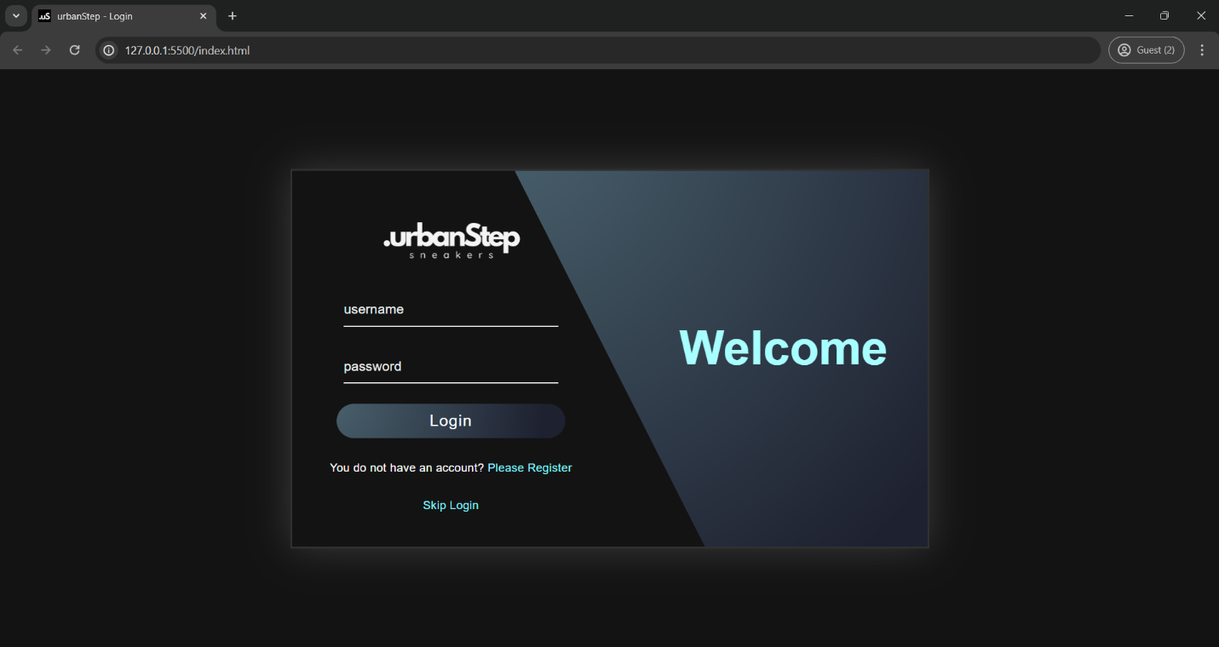

**Home Page**

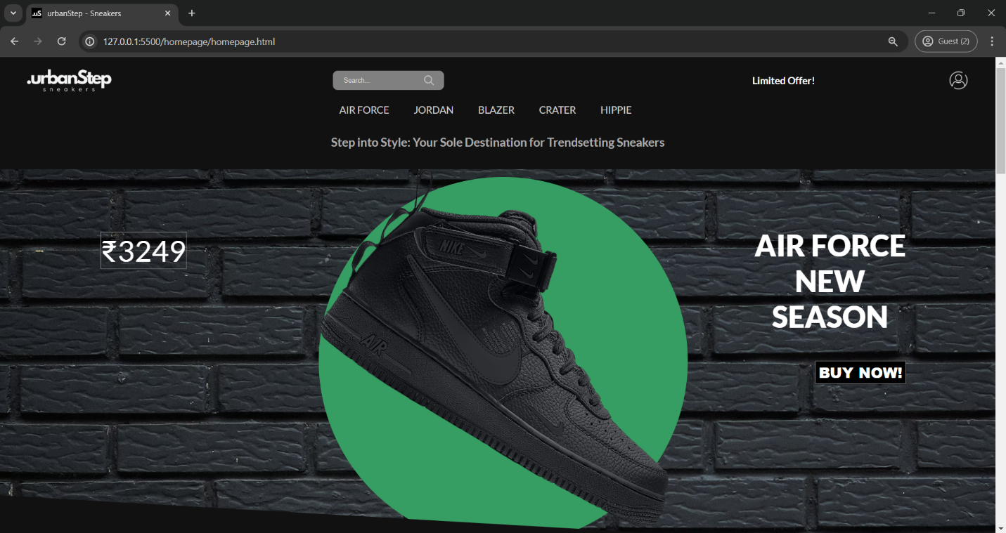

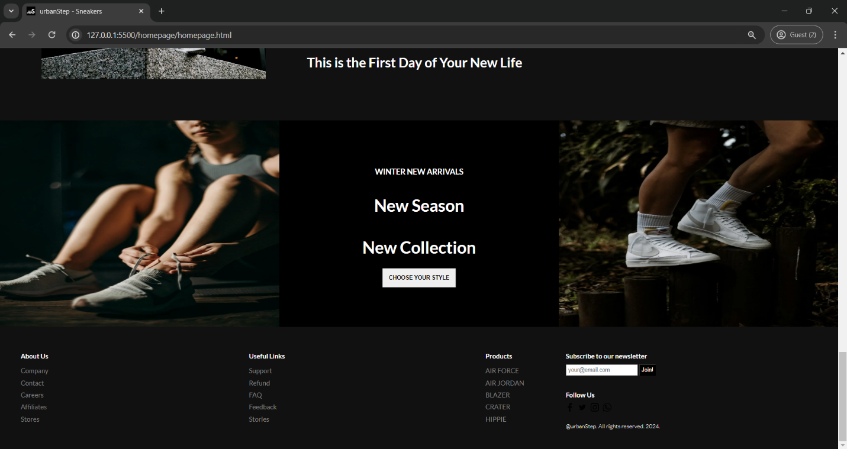

**Product Page**

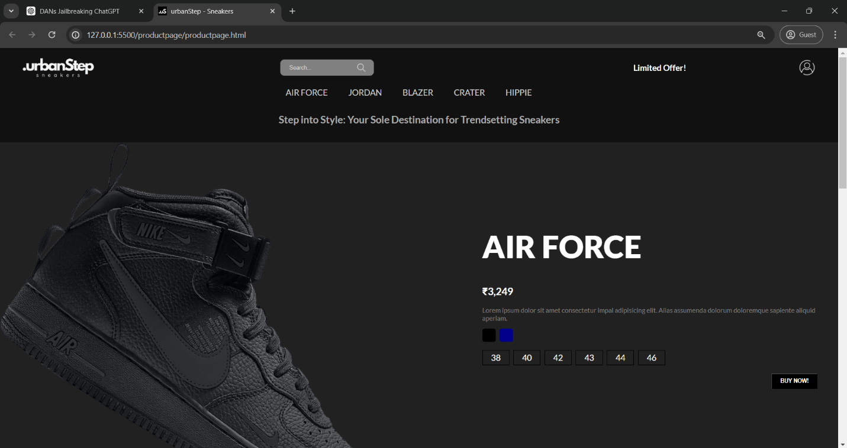

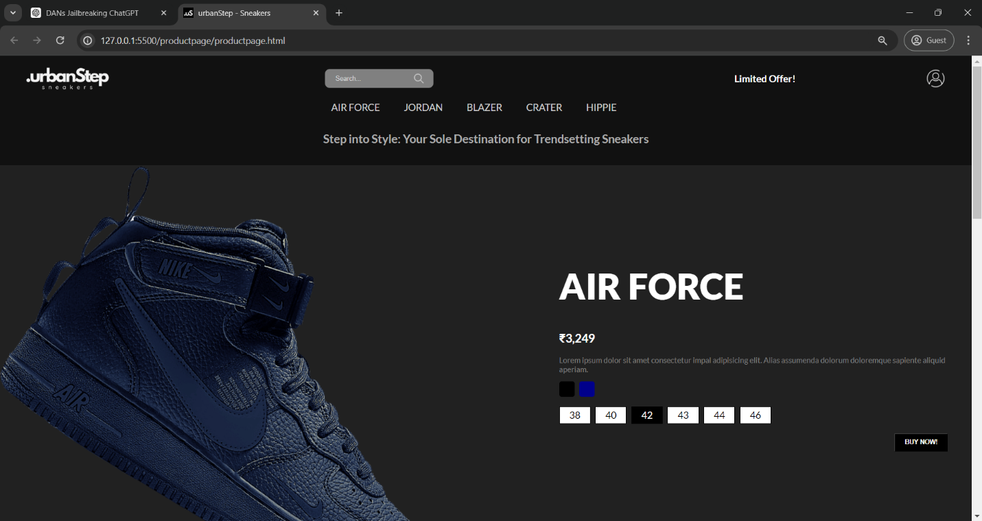

**Payment**

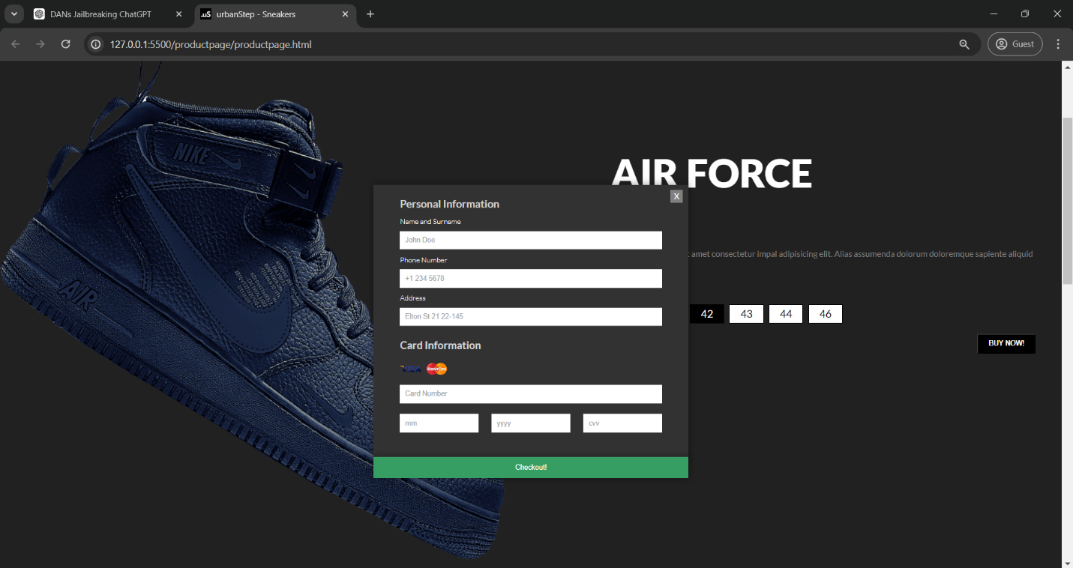

**5.3: Testing**

Software testing is a critical element of software quality assurance and represents the ultimate review of specification, design and code generation.

Testing for the urbanStep-Sneakers e-commerce platform involves ensuring functionality, usability, security, and performance.

1. **Functional Testing:**
   * Validate product management, order processing, storefront customization, and inventory tracking functionalities.
2. **Usability Testing:**
   * Evaluate user interface intuitiveness and responsiveness across devices.
   * Gather user feedback for improvements.
3. **Security Testing:**
   * Conduct penetration testing for vulnerabilities.
   * Ensure robust user authentication and secure payment processing.
4. **Performance Testing:**
   * Assess platform performance under normal and peak loads.
   * Test response times for critical actions.
5. **Compatibility Testing:**
   * Ensure compatibility with various browsers, operating systems, and devices.
6. **Regression Testing:**
   * Test existing functionality after updates to prevent regression issues.
7. **User Acceptance Testing (UAT):**
   * Validate platform meets stakeholder requirements.
   * Address feedback before production deployment.

Thorough testing ensures the platform delivers a reliable e-commerce experience for all users.

**CHAPTER 6**

**CONCLUSION & FUTURE SCOPE**

**Conclusion:**

The urbanStep-Sneakers e-commerce platform offers a comprehensive solution for small-scale retailers to establish and expand their online presence. With a focus on empowering local businesses, the platform provides intuitive tools for product management, order processing, storefront customization, and inventory tracking. Customers benefit from a seamless shopping experience, including browsing products, placing orders, and interacting with the community through reviews and feedback.By leveraging modern web technologies and robust security measures, urbanStep-Sneakers ensures a secure and reliable platform for retailers and customers alike. Usability testing and user feedback mechanisms help continually enhance the platform's user experience, ensuring satisfaction and loyalty among its users.

**Future Scope:**

Moving forward, urbanStep-Sneakers aims to further enhance its features and capabilities to meet evolving market demands and technological advancements. Some areas of future focus include:

**1. Enhanced Personalization:** Implement personalized recommendations and tailored shopping experiences based on customer preferences and browsing history.

**2. Expanded Community Engagement:** Introduce features to foster deeper community engagement, such as forums, live chat support, and user-generated content.

**3. Integration with Emerging Technologies:** Explore integration with emerging technologies like augmented reality (AR) for virtual try-ons and artificial intelligence (AI) for predictive analytics and customer support.

**4. Global Expansion:** Expand the platform's reach to new regions and markets, catering to a broader audience of retailers and customers.

**5. Advanced Analytics and Insights:** Develop advanced analytics and reporting capabilities to provide retailers with actionable insights into sales trends, customer behavior, and inventory management.

**6. Mobile Application Development: Develop** dedicated mobile applications for iOS and Android platforms to offer a seamless shopping experience on mobile devices. By continuously innovating and adapting to market trends, urbanStep-Sneakers aims to solidify its position as a leading e-commerce platform for small retailers, providing them with the tools and support they need to thrive in the digital marketplace.

## BIBILOGRAPHY

1. **"E-Commerce 2021: Business, Technology, Society"** by Kenneth C. Laudon and Carol Guercio Traver - This textbook provides comprehensive coverage of e-commerce concepts, technologies, and business models.

2. **"Web Development & Design Foundations with HTML5"** by Terry Felke-Morris - This book offers a solid introduction to web development principles, including HTML5, CSS, and JavaScript.

3**. "Building E-commerce Websites"** by Gail Stein - This guide offers practical insights and best practices for building successful e-commerce websites.

4. Online platforms like Coursera, Udemy, and Codecademy offer courses on web development, e-commerce, and related topics. These courses often provide hands-on experience and practical knowledge.

5. Technical documentation and tutorials from web development frameworks and platforms like Shopify, WooCommerce, and Magento can also be valuable resources for understanding e-commerce platform architecture and development.