**­­Software Requirements**

**Specification**

**for**

**urbanStep-Sneakers**

**(A Frontend E-commerce Website)**

Prepared by

**BHUKYA KALYAN (22N31A6628)**

**BOCHKAR NIKHITH (22N31A6629)**

**BODOLLA ABHILASH GOUD (22N31A6630) .**

Under the Guidance of



**Mrs. P. Swapna Reddy**

**Assistant Professor**

**Department of Computational Intelligence**

**MRCET**

**DEPARTMENT OF COMPUTATIONAL INTELLIGENCE**

**MALLA REDDY COLLEGE OF ENGINEERING AND TECHNOLOGY**

(Affiliated to JNTU, Hyderabad)

**ACCREDITED by AICTE-NBA**

**Maisammaguda, Dhulapally post, Secunderabad-500014.**

**(2022-2026)**

**­­Table of Contents**

**Table of Contents**

**Revision History**

1. **Introduction**
   1. Purpose
   2. Document Conventions
   3. Intended Audience and Reading Suggestions
   4. Product Scope
2. **Overall Description**
   1. Product Perspective
   2. Product Functions
   3. User Classes and Characteristics
   4. Operating Environment
   5. Design and Implementation Constraints
   6. User Documentation
   7. Assumptions and Dependencies
3. **External Interface Requirements**
   1. User Interfaces
   2. Hardware Interfaces
   3. Software Interfaces
   4. Communications Interfaces
4. **System Features**
   1. System Feature 1
5. **Other Nonfunctional Requirements**
   1. Performance Requirements
   2. Safety Requirements
   3. Security Requirements
   4. Software Quality Attributes
   5. Business Rules
6. **Other Requirements**

**Appendix A: Glossary**

**Appendix B: Analysis Models**

**Appendix C: To Be Determined List**

**1. Introduction**

**1.1 Purpose**

The software requirements specified in this document pertain to the "urbanStep-Sneakers" e-commerce platform, version 1.0. This Software Requirements Specification (SRS) outlines the scope of the product, focusing on its core functionalities and features.

**1.2 Document Conventions**

This SRS follows standard document conventions, including consistent formatting and terminology throughout. Priorities for requirements are indicated where applicable, ensuring clarity and understanding for all stakeholders.

**1.3 Intended Audience and Reading Suggestions**

This document is intended for various stakeholders involved in the development and implementation of the "urbanStep-Sneakers" platform, including developers, project managers, marketing staff, users, testers, and documentation writers. The SRS contains detailed descriptions of the system's requirements, organized in a logical manner for easy reference and comprehension. Readers are encouraged to begin with the overview sections and proceed through the document based on their specific roles and interests.

**1.4 Product Scope**

The "urbanStep-Sneakers" software is an e-commerce platform tailored for small retailers seeking to establish and expand their online presence. Its purpose is to empower local businesses by providing them with the tools and functionalities needed to manage their inventory, process orders, and engage with their community effectively. The software aligns with corporate goals of fostering local commerce and supporting small-scale entrepreneurs.

**2. Overall Description**

**2.1 Product Perspective**

The "urbanStep-Sneakers" platform is a standalone product developed to provide small retailers with an efficient and customizable e-commerce solution. It is not a part of any existing product family but rather a unique offering tailored to meet the needs of local businesses. While it operates independently, it may interface with external systems such as payment gateways and shipping providers to facilitate seamless transactions for retailers and customers.

**2.2 Product Functions**

* Manage product listings
* Process orders and payments
* Customize storefront designs
* Track inventory levels
* Engage with the local community through social media integration

**2.3 User Classes and Characteristics**

User classes for the "urbanStep-Sneakers" platform include:

* Retailers: Small-scale entrepreneurs with varying levels of technical expertise.
* Customers: Individuals seeking to purchase products from local retailers.

Retailers may require administrative privileges for managing their inventory and storefront, while customers primarily interact with the platform for browsing and purchasing products.

**2.4 Operating Environment**

The software operates in a web-based environment, compatible with modern web browsers such as Chrome, Firefox, and Safari. It is platform-independent and can run on any device with internet access. Additionally, it may integrate with external services such as payment processors and shipping APIs.

**2.5 Design and Implementation Constraints**

Design and implementation constraints for the "urbanStep-Sneakers" platform include:

* Compliance with industry-standard security protocols to protect sensitive customer information.
* Utilization of scalable technologies to accommodate potential growth in user base and transaction volume.
* Integration with third-party services must adhere to their respective APIs and guidelines.

**2.6 User Documentation**

User documentation for "urbanStep-Sneakers" will include:

* User manuals detailing platform functionalities and usage instructions.
* Online help resources accessible within the platform.
* Tutorials to guide retailers through setup and customization processes.

Documentation will be provided in digital formats, accessible through the platform's website.

**2.7 Assumptions and Dependencies**

Assumptions for the "urbanStep-Sneakers" platform include:

* Availability of stable internet connectivity for users accessing the platform.
* Dependence on third-party services such as payment gateways and shipping providers to facilitate transactions.
* Continued support and maintenance of underlying software frameworks and technologies.
* The project may be affected if these assumptions change or are not met as expected.

**3. External Interface Requirements**

**3.1 User Interfaces**

The user interface for "urbanStep-Sneakers" encompasses various components aimed at facilitating smooth interaction between users and the platform. This includes:

* Dashboard: Provides an overview of sales, orders, and inventory.
* Product Management: Allows retailers to add, edit, and delete product listings.
* Order Processing: Enables retailers to view and manage customer orders.
* Customization Tools: Allows retailers to customize their storefront design and branding elements.
* Help Functionality: Offers assistance and guidance to users navigating the platform.

**3.2 Hardware Interfaces**

The software product "urbanStep-Sneakers" primarily interacts with standard hardware components such as computers, tablets, and smartphones. It does not have any direct physical connections or dependencies on specific hardware configurations.

**3.3 Software Interfaces**

"urbanStep-Sneakers" interfaces with various software components to ensure seamless functionality:

* Database: Interaction with a database management system (e.g., MySQL) to store and retrieve product information, orders, and user data.
* Operating System: Compatibility with major operating systems such as Windows, macOS, and Linux for running the platform's web-based interface.
* Payment Gateways: Integration with payment processing services (e.g., PayPal, Stripe) for secure transaction processing.
* Shipping APIs: Communication with shipping service providers (e.g., UPS, FedEx) to generate shipping labels and track deliveries.

**3.4 Communications Interfaces**

The communication requirements for "urbanStep-Sneakers" include:

Web Browser: Compatibility with standard web browsers (e.g., Chrome, Firefox, Safari) for accessing the platform's web-based interface.

* HTTP/HTTPS: Utilization of HTTP/HTTPS protocols for communication between the user's device and the platform's servers.
* Encryption: Implementation of encryption standards (e.g., SSL/TLS) to ensure secure data transmission and protection of sensitive information.
* Data Transfer Rates: Support for high-speed data transfer to accommodate efficient browsing and order processing.

**4. System Features**

**4.1 System Feature: Product Listing Management**

**4.1.1 Description and Priority**

This feature enables retailers to manage their product listings on the "urbanStep-Sneakers" platform. It is of high priority as it forms the core functionality of the system, allowing retailers to showcase their products effectively.

**4.1.2 Stimulus/Response Sequences**

* User selects "Manage Listings" from the dashboard.
* System displays a list of existing product listings.
* User selects a listing to edit or deletes it.
* System prompts for confirmation before making changes.

**4.1.3 Functional Requirements**

* **REQ-1:** Allow retailers to add new product listings, including title, description, price, and images.
* **REQ-2:** Enable editing of existing product listings, allowing retailers to update information and images.
* **REQ-3:** Provide options for categorizing and tagging products to improve searchability.
* **REQ-4:** Implement validation checks to ensure all required fields are filled and data entered is valid.
* **REQ-5:** Display confirmation messages upon successful addition or modification of product listings.

**5. Other Nonfunctional Requirements**

**5.1 Performance Requirements**

The "urbanStep-Sneakers" platform must adhere to the following performance requirements:

* Response Time: The system should respond to user interactions within 2 seconds to ensure a seamless browsing and shopping experience.
* Scalability: The platform should be able to handle a minimum of 100 concurrent users without significant degradation in performance.
* Page Load Speed: Web pages should load within 3 seconds on standard internet connections to minimize user wait times.

**5.2 Safety Requirements**

As an e-commerce platform, "urbanStep-Sneakers" must prioritize the safety of user data and transactions. Safety requirements include:

* Data Encryption: All sensitive user information, such as payment details, should be encrypted to prevent unauthorized access.
* Secure Transactions: Payment processing must comply with industry-standard security protocols (e.g., PCI DSS) to safeguard against fraud and data breaches.

**5.3 Security Requirements**

To ensure the security and privacy of user data, "urbanStep-Sneakers" must adhere to the following security requirements:

* User Authentication: Implement robust user authentication mechanisms (e.g., password hashing, multi-factor authentication) to verify user identities and prevent unauthorized access.
* Compliance: Adhere to relevant data protection regulations (e.g., GDPR, CCPA) to protect user privacy and rights regarding their personal data.

**5.4 Software Quality Attributes**

"urbanStep-Sneakers" should prioritize the following software quality attributes:

* Usability: The platform should be intuitive and easy to navigate, ensuring a positive user experience for both retailers and customers.
* Reliability: The system should operate consistently without unexpected downtime or errors, promoting user trust and confidence in the platform.

**5.5 Business Rules**

Operating principles for "urbanStep-Sneakers" include:

* Only registered retailers can create and manage product listings.
* Customers must provide valid payment information to complete transactions.
* Retailers are responsible for fulfilling customer orders in a timely manner to maintain customer satisfaction.

**6. Other Requirements**

**Database Requirements:**

* The platform shall utilize a relational database management system (RDBMS) to store and manage product listings, orders, and user data.
* Database backups shall be performed regularly to ensure data integrity and availability in case of system failure.

**Internationalization Requirements:**

* The platform shall support multiple languages and currencies to cater to a diverse global audience.
* Internationalization efforts shall include localization of user interfaces, date formats, and currency symbols based on user preferences.

**Legal Requirements:**

* "urbanStep-Sneakers" must comply with all relevant laws and regulations governing e-commerce, including consumer protection, data privacy, and taxation laws.
* Terms of Service and Privacy Policy documents must be provided to users, outlining their rights and responsibilities when using the platform.

**Reuse Objectives:**

* The project shall prioritize the reuse of existing software components and libraries to minimize development time and cost.
* Code modularization and documentation shall be emphasized to facilitate future reuse and maintenance efforts.

**Appendix A: Glossary**

* **SRS**: Software Requirements Specification - A document that specifies the functional and nonfunctional requirements of a software product.
* **RDBMS**: Relational Database Management System - A software system used to manage relational databases
* **GDPR**: General Data Protection Regulation - A regulation in the European Union (EU) that governs data protection and privacy for individuals within the EU and the European Economic Area (EEA).
* **CCPA**: California Consumer Privacy Act - A state statute in California that enhances privacy rights and consumer protection for residents of California, United States.
* **UI**: User Interface - The means by which a user interacts with a computer system, including graphical elements such as screens, buttons, and menus.
* **API**: Application Programming Interface - A set of rules and protocols that allows different software applications to communicate with each other.
* **SSL**: Secure Sockets Layer - A standard security protocol for establishing encrypted links between a web server and a browser, ensuring data security during transmission.
* **PCI DSS**: Payment Card Industry Data Security Standard - A set of security standards designed to ensure that all companies that accept, process, store, or transmit credit card information maintain a secure environment.
* **Terms of Service**: Legal agreements between a service provider and a user that outline the rules and guidelines for using the service.
* **Privacy Policy**: A statement or legal document that discloses how a company gathers, uses, manages, and protects customer data.

**Appendix B: Analysis Models**

**UML Diagrams:**

1. **Proposed System Architecture**

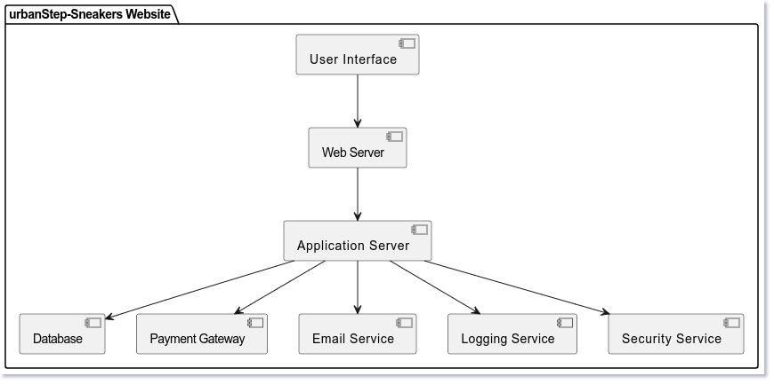

1. **Use Case Diagram**

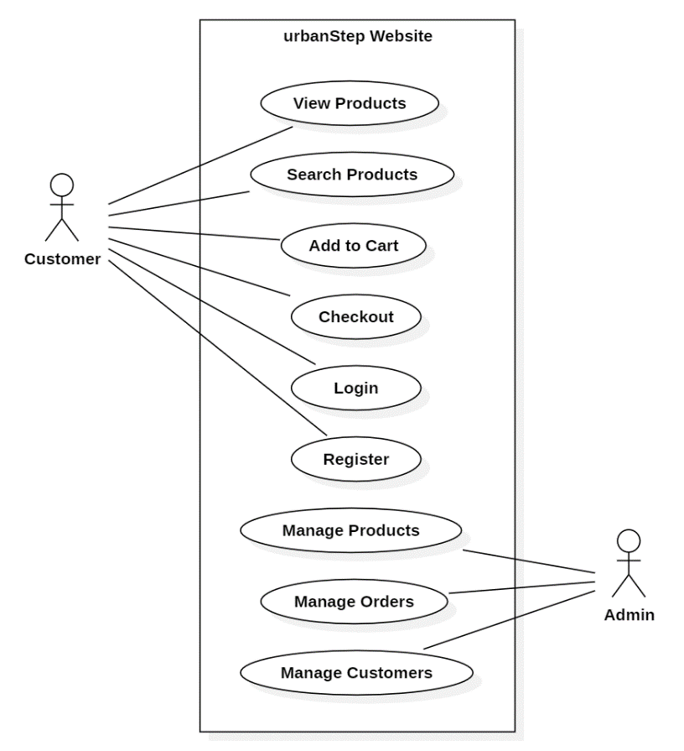

1. **Sequence Diagram**

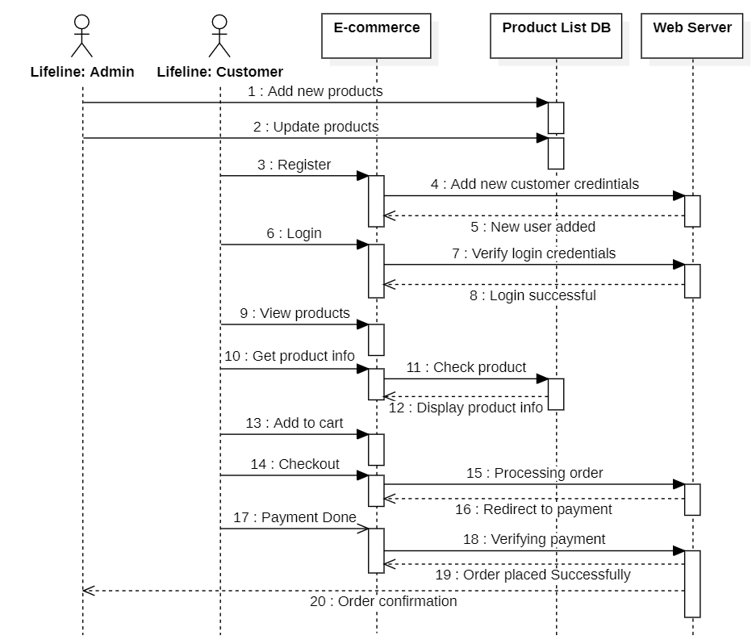

1. **Class Diagram**

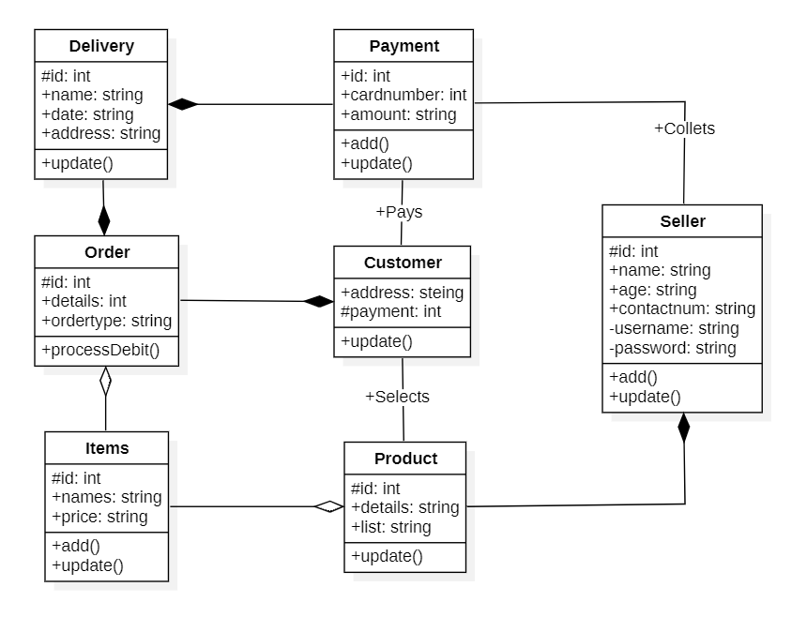

1. **Activity Diagram**

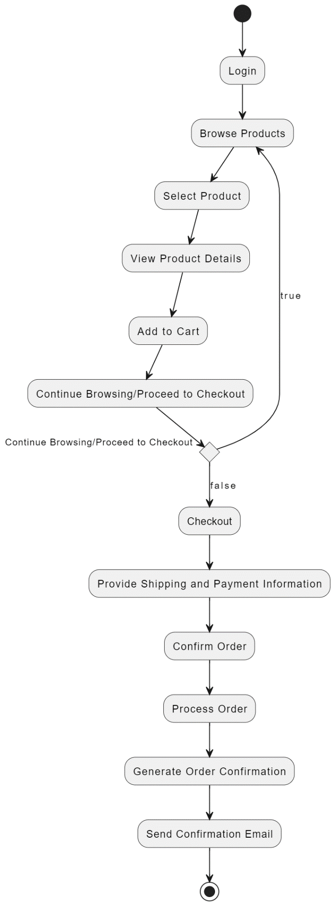

**Appendix C: To Be Determined List**

1. Performance requirements for high traffic scenarios.

2. Specific authentication mechanisms for user access.

3. Backup frequency and retention policy for database backups.

4. Languages and currencies to be supported for internationalization.

5. Legal requirements regarding taxation laws in various jurisdictions.

6. Reuse objectives for existing software components and libraries.

7. Glossary terms specific to the project.