**WEB TECHNOLOGIES**

# ASSIGNMENT-2

*College Website using Bootstrap,*

*Student information form using MVC*

**Done By:**

1602-20-737-087

1602-20-737-096

Features

# HTML

* 1. <html> tag
  2. <body> tag
  3. <head> tag
  4. <img> tag
  5. <link> tag
  6. <a> tag
  7. <header> tag
  8. <main> tag
  9. <footer> tag
  10. <nav> tag
  11. <div> tag
  12. <section> tag
  13. <span> tag
  14. <p> tag
  15. <script> tag
  16. <li> tag

# CSS

* 1. Class selectors
  2. Id selectors
  3. Element selectors
  4. Background-image
  5. Background-color
  6. Margin
  7. Border
  8. Flex
  9. Font-family
  10. Font-size
  11. Text-align
  12. Text-decoration
  13. Padding
  14. Border-radius
  15. Opacity
  16. Width
  17. Height

# JavaScript

* 1. Functions
  2. variables
  3. Form Validation
  4. Alert messages
  5. Focus
  6. Document value fetch

1. BootStrap
2. Components
3. Tables
4. Images
5. Navbar
6. Dropdowns
7. Carousel
8. Badges

1. **College Website: Design a responsive webpage using Bootstrap with the following components: Tables, Images, alerts, buttons, badges, progress bars, cards, drop downs, pagination, Collapse, Navbar, carousel. Submit a write up, as to what features are used.**

Code:

1.Index.html

<!DOCTYPE html>

<html>

    <head>

        <style>

            .center{

                text-align: center;

            }

            .left{

                list-style-position: outside;

            }

        </style>

        <meta name="viewport" content="width=device-width, initial-scale=1.0">

        <title>Vasavi College of Engineering</title>

        <link rel="icon" href="images/logo.png" type="image/png">

        <link rel="stylesheet" href="style.css">

        <link rel="preconnect" href="https://fonts.googleapis.com">

        <link rel="preconnect" href="https://fonts.gstatic.com" crossorigin>

        <link href="https://fonts.googleapis.com/css2?family=Poppins:wght@100;200;300;400;600;700&display=swap" rel="stylesheet">

        <link rel="stylesheet" href="https://stackpath.bootstrapcdn.com/font-awesome/4.7.0/css/font-awesome.min.css">

  <link rel="stylesheet" href="https://cdn.jsdelivr.net/npm/bootstrap@4.6.2/dist/css/bootstrap.min.css">

  <script src="https://cdn.jsdelivr.net/npm/jquery@3.6.4/dist/jquery.slim.min.js"></script>

  <script src="https://cdn.jsdelivr.net/npm/popper.js@1.16.1/dist/umd/popper.min.js"></script>

  <script src="https://cdn.jsdelivr.net/npm/bootstrap@4.6.2/dist/js/bootstrap.bundle.min.js"></script>

    </head>

    <body>

        <section class="sub-header sub-header-image-4">

            <nav>

                <div id = "container" style = "white-space:nowrap">

                    <div id = "image" style="display: inline;"><img src="vlogo.jpg" align = "Left"/></div>>

                    <div  style = "display: inline;" class = "center" class = "text-primary">

                        <h2 style="color:blue;">VASAVI COLLEGE OF ENGINEERING</h2>

                        <p>

                            (Private Un-aided Non-minority Autonomous Institution)<br><inline style="color:red;"> ACCREDITED BY NAAC WITH 'A++' GRADE</inline><br>Affiliated to Osmania University and Approved by AICTE

                        </p>

                    </div>

                </div>

                <br><br>

                <div class="nav-links" id="navLinks" >

                    <ul style = "color:darkgray;">

                        <li><a href="index.html">HOME</a></li>

                        <li><a href="about.html">ABOUT</a></li>

                        <li><a href="course.html">COURSES</a></li>

                        <li><a href="feedback.html">FEEDBACK</a></li>

                        <li><a href="contact.html">CONTACT</a></li>

                    </ul>

                </div>

            </nav>

        </section>

<!-- ------- COURSE ------- -->

<div class = "row">

    <div class = "col-sm-7">

        <div id="demo" class="carousel slide" data-ride="carousel">

    <!-- Indicators -->

    <ul class="carousel-indicators">

      <li data-target="#demo" data-slide-to="0" class="active"></li>

      <li data-target="#demo" data-slide-to="1"></li>

      <li data-target="#demo" data-slide-to="2"></li>

    </ul>

    <!-- The slideshow -->

    <div class="carousel-inner">

      <div class="carousel-item active">

        <img src="Vasavi1.jpg" alt="Los Angeles" width="500" height="500">

      </div>

      <div class="carousel-item">

        <img src="Nptelvasavi.jpg" alt="Chicago" width="500" height="500">

      </div>

      <div class="carousel-item">

        <img src="Best_Blood.jpg" alt="New York" width="500" height="500">

      </div>

    </div>

    <!-- Left and right controls -->

    <a class="carousel-control-prev" href="#demo" data-slide="prev">

      <span class="carousel-control-prev-icon"></span>

    </a>

    <a class="carousel-control-next" href="#demo" data-slide="next">

      <span class="carousel-control-next-icon"></span>

    </a>

  </div>

</div>

   <div class = "col-sm-4">

    <h1>Our Vision</h1>

        <p>"Striving for a symbiosis of technological excellence and human values."</p>

        <h1>Our Mission</h1>

        <p>"To arm young brains with competitive technology and nurture holistic development of the individuals for a better tomorrow."</p>

   </div>

</div>

<section class="course">

    <div>

    <h2>COURSE</h2>

    <div class="row">

        <div class="course-col">

            <h3>Under Graduation Programme</h3>

            <p>The college offers seven UG (Civil, Mechanical, ECE, CSE, CSE AI & ML, EEE and IT). BE in the case of our college.</p>

        </div>

        <div class = "course-col">

            <h3>Graduation Programme</h3>

            <p>The college offers Mtech and MBA.</p>

        </div>

    </div>

    </div>

</section>

<!-- ------- CAMPUS ------- -->

<section class="campus">

    <h1>Our Campus</h1>

    <div class="row">

        <div class="campus-col">

            <img src="Rblock.jpg">

            <div class="layer">

                <h3>IT Department</h3>

            </div>

        </div>

        <div class="campus-col">

            <img src="jcb.jpg">

            <div class="layer">

                <h3>Placement Block</h3>

            </div>

        </div>

        <div class="campus-col">

            <img src="library.jpg">

            <div class="layer">

                <h3>Library</h3>

            </div>

        </div>

    </div>

</section>

<!-- ------- Footer -------  -->

<section class="footer">

    <h4>About us</h4>

    <p>

        (Private Un-aided Non-minority Autonomous Institution)ACCREDITED BY NAAC WITH 'A++' GRADE<br>Affiliated to Osmania University and Approved by AICTE

    </p>

    <div class="icons">

        <a class="plain-link" href=#><i class="fa fa-twitter"></i></a>

        <a class="plain-link" href=#><i class="fa fa-facebook"></i></a>

        <a class="plain-link" href="https://www.instagram.com/ecellvce/?hl=en"><i class="fa fa-instagram"></i></a>

        <a class="plain-link" href="https://www.youtube.com/channel/UCufL_1MVGtcmLjm2rQFBY9g"><i class="fa fa-youtube"></i></a>

    </div>

    <p>

        <br>

        Copyright @ 2023. Vasavi College of Engineering, Ibrahimbagh, Hyderabad, India. All Rights Reserved.

            <a class="plain-link icons-blue" href="https://www.linkedin.com/in/devang-baheti/"><i class="fa fa-linkedin"></i></a>

            <a class="plain-link icons-blue" href="https://github.com/devangbaheti03"><i class="fa fa-github"></i></a>

            <a class="plain-link icons-blue" href="https://www.instagram.com/ecellvce/?hl=en"><i class="fa fa-instagram"></i></a>

            <a class="plain-link icons-blue" href="mailto:devangb03@gmail.com"><i class="fa fa-at"></i></a>

    </p>

</section>

<!-- -------------JavaScript for toggle menu------------ -->

        <script>

            var navLinks = document.getElementById("navLinks");

            function showMenu(){

                navLinks.style.right = "0";

            }

            function hideMenu(){

                navLinks.style.right = "-200px";

            }

        </script>

    </body>

</html>

2.About.html

<!DOCTYPE html>

<html>

    <head>

        <meta name="viewport" content="width=device-width, initial-scale=1.0">

        <title>About Us</title>

        <link rel="icon" href="images/logo.png" type="image/png">

        <link rel="stylesheet" href="style.css">

        <link rel="preconnect" href="https://fonts.googleapis.com">

        <link rel="preconnect" href="https://fonts.gstatic.com" crossorigin>

        <link href="https://fonts.googleapis.com/css2?family=Poppins:wght@100;200;300;400;600;700&display=swap" rel="stylesheet">

        <link rel="stylesheet" href="https://stackpath.bootstrapcdn.com/font-awesome/4.7.0/css/font-awesome.min.css">

    </head>

    <body>

        <section class="sub-header sub-header-image-4">

            <nav>

                <a href="index.html"><img src="vlogo.jpg"></a>

                <div class="nav-links" id="navLinks">

                    <i class="fa fa-times" onclick="hideMenu()"></i>

                    <ul>

                        <li><a href="index.html">HOME</a></li>

                        <li><a href="about.html">ABOUT</a></li>

                        <li><a href="course.html">COURSES</a></li>

                        <li><a href="feedback.html">FEEDBACK</a></li>

                        <li><a href="contact.html">CONTACT</a></li>

                    </ul>

                </div>

                <i class="fa fa-bars" onclick="showMenu()"></i>

            </nav>

            <h1>About Us</h1>

        </section>

<!-- --------About us content-------- -->

<section class="about-us">

    <div class="row">

        <div class="about-col">

            <h1>VASAVI COLLEGE OF ENGINEERING</h1>

            <p>Founded in 1981 by Vasavi Academy of Education, Vasavi College of Engineering represents a rich tradition of excellence in technology-based education. A premier-league institution among the affiliates of Osmania University, Vasavi College of Engineering owes its vision to Sri Pendekanti Venkata Subbaiah, a veteran statesman of Independent India.

                Vasavi College of Engineering, in its 42 years of existence, is a reputed institution in the State of Telangana. The college is ACCREDITED BY NAAC WITH 'A++' GRADE. The college in its pursuit for quality in technical education has earned 3rd ranking in the State and 32nd in the country (source: Hindustan Times on 24th June 2009).</p>

            <a href="http://www.rknec.edu/About/Administration/Principal-Office.aspx" class="hero-btn red-btn">EXPLORE NOW</a>

        </div>

        <div class="about-col">

            <img src="images/awards.jpg" alt="">

        </div>

    </div>

</section>

<!-- ------- COURSE ------- -->

<!-- ------- CAMPUS ------- -->

<!-- -------FACILITIES------- -->

<!-- -------Testimonials------- -->

<!-- --------Call to Action -------  -->

<!-- ------- Footer -------  -->

<section class="footer">

    <h4>About us</h4>

    <p>

        (Private Un-aided Non-minority Autonomous Institution)ACCREDITED BY NAAC WITH 'A++' GRADE<br>Affiliated to Osmania University and Approved by AICTE

    </p>

    <div class="icons">

        <a class="plain-link" href="https://twitter.com/RCOEM_Official"><i class="fa fa-twitter"></i></a>

        <a class="plain-link" href="https://www.facebook.com/Shri-Ramdeobaba-College-of-Engineering-and-Management-Nagpur-India-301344790226543/?skip_nax_wizard=true"><i class="fa fa-facebook"></i></a>

        <a class="plain-link" href="https://www.instagram.com/rcoem__official"><i class="fa fa-instagram"></i></a>

        <a class="plain-link" href="https://www.youtube.com/channel/UCufL_1MVGtcmLjm2rQFBY9g"><i class="fa fa-youtube"></i></a>

    </div>

    <p>

        <br>

        Copyright @ 2023. Vasavi College of Engineering, Ibrahimbagh, Hyderabad, India. All Rights Reserved.

            <a class="plain-link icons-blue" href="https://www.linkedin.com/in/devang-baheti/"><i class="fa fa-linkedin"></i></a>

            <a class="plain-link icons-blue" href="https://github.com/devangbaheti03"><i class="fa fa-github"></i></a>

            <a class="plain-link icons-blue" href="https://www.instagram.com/devang_baheti/"><i class="fa fa-instagram"></i></a>

            <a class="plain-link icons-blue" href="mailto:devangb03@gmail.com"><i class="fa fa-at"></i></a>

    </p>

</section>

<!-- -------------JavaScript for toggle menu------------ -->

        <script>

            var navLinks = document.getElementById("navLinks");

            function showMenu(){

                navLinks.style.right = "0";

            }

            function hideMenu(){

                navLinks.style.right = "-200px";

            }

        </script>

    </body>

</html>

3.Contactus.html

<!DOCTYPE html>

<html>

    <head>

        <meta name="viewport" content="width=device-width, initial-scale=1.0">

        <title>Contact Us</title>

        <link rel="icon" href="images/logo.png" type="image/png">

        <link rel="stylesheet" href="style.css">

        <link rel="preconnect" href="https://fonts.googleapis.com">

        <link rel="preconnect" href="https://fonts.gstatic.com" crossorigin>

        <link href="https://fonts.googleapis.com/css2?family=Poppins:wght@100;200;300;400;600;700&display=swap" rel="stylesheet">

        <link rel="stylesheet" href="https://stackpath.bootstrapcdn.com/font-awesome/4.7.0/css/font-awesome.min.css">

    </head>

    <body>

        <section class="sub-header sub-header-image-4">

            <nav>

                <a href="index.html"><img src="vlogo.jpg"></a>

                <div class="nav-links" id="navLinks">

                    <i class="fa fa-times" onclick="hideMenu()"></i>

                    <ul>

                        <li><a href="index.html">HOME</a></li>

                        <li><a href="about.html">ABOUT</a></li>

                        <li><a href="course.html">COURSES</a></li>

                        <li><a href="feedback.html">FEEDBACK</a></li>

                        <li><a href="contact.html">CONTACT</a></li>

                    </ul>

                </div>

                <i class="fa fa-bars" onclick="showMenu()"></i>

            </nav>

            <h1>Contact Us</h1>

        </section>

<!-- --------Contact us content-------- -->

<section class="contact-us">

    <div class="row">

        <div class="contact-col">

            <h1>Our Contact Details</h1>

            <div>

                <a class="plain-link" href="https://goo.gl/maps/jecTfZV9kF6eSs6F8"><i class="fa fa-home"></i></a>

                <a class="plain-link" href="https://goo.gl/maps/jecTfZV9kF6eSs6F8">

                <span>

                    <h5>Vasavi college of Engineering</h5>

                    <p>9-5-81, Ibrahim Bagh, Hyderabad, Telangana 500031</p>

                </span>

                </a>

            </div>

            <div>

                <a class="plain-link" href="tel: +91 40 23146003"><i class="fa fa-phone"></i></a>

                <a class="plain-link" href="fax: +91 40 23146090">

                <span>

                    <h5>(91)-(402) - 3146003</h5>

                </span>

                </a>

            </div>

            <div>

                <a class="plain-link" href="mailto:principal@staff.vce.ac.in"><i class="fa fa-envelope-o"></i></a>

                <span>

                    <a class="plain-link" href="mailto:principal@staff.vce.ac.in">

                    <h5>principal@staff.vce.ac.in</h5>

                    <p>Email us for admission related queries.</p>

                    </a>

                </span>

            </div>

        </div>

        <div class="contact-col">

            <h1>Post your Query</h1>

            <form action="https://formspree.io/f/xrgrdkry" id="contact-form" method="POST">

                <input type="text" name="Name" id="Name" placeholder="Enter your Name" required>

                <input type="email" name="Email" id="Email" placeholder="Enter your Email" required>

                <input type="text" name="Subject" id="Subject" placeholder="Enter your Subject" required>

                <textarea rows="8" name="Message" id="Message" placeholder="Message" required></textarea>

                <button type="submit" class="hero-btn red-btn submit-btn">Send Message</button>

            </form>

            <div id="status"></div>

        </div>

    </div>

</section>

<!-- ------- Footer -------  -->

<section class="footer">

    <h4>About us</h4>

    <p>

        (Private Un-aided Non-minority Autonomous Institution)ACCREDITED BY NAAC WITH 'A++' GRADE<br>Affiliated to Osmania University and Approved by AICTE

    </p>

    <div class="icons">

        <a class="plain-link" href="https://twitter.com/RCOEM_Official"><i class="fa fa-twitter"></i></a>

        <a class="plain-link" href="https://www.facebook.com/Shri-Ramdeobaba-College-of-Engineering-and-Management-Nagpur-India-301344790226543/?skip_nax_wizard=true"><i class="fa fa-facebook"></i></a>

        <a class="plain-link" href="https://www.instagram.com/rcoem__official"><i class="fa fa-instagram"></i></a>

        <a class="plain-link" href="https://www.youtube.com/channel/UCufL_1MVGtcmLjm2rQFBY9g"><i class="fa fa-youtube"></i></a>

    </div>

    <p>

        <br>

        Copyright @ 2023. Vasavi College of Engineering, Ibrahimbagh, Hyderabad, India. All Rights Reserved.

            <a class="plain-link icons-blue" href="https://www.linkedin.com/in/devang-baheti/"><i class="fa fa-linkedin"></i></a>

            <a class="plain-link icons-blue" href="https://github.com/devangbaheti03"><i class="fa fa-github"></i></a>

            <a class="plain-link icons-blue" href="https://www.instagram.com/devang_baheti/"><i class="fa fa-instagram"></i></a>

            <a class="plain-link icons-blue" href="mailto:devangb03@gmail.com"><i class="fa fa-at"></i></a>

    </p>

</section>

<!-- -------------JavaScript for form submission------------ -->

<script src="main.js"></script>

<!-- -------------JavaScript for toggle menu------------ -->

        <script>

            var navLinks = document.getElementById("navLinks");

            function showMenu(){

                navLinks.style.right = "0";

            }

            function hideMenu(){

                navLinks.style.right = "-200px";

            }

        </script>

    </body>

</html>

4.Course.html

<!DOCTYPE html>

<html>

    <head>

        <meta name="viewport" content="width=device-width, initial-scale=1.0">

        <title>Courses @VCE</title>

        <link rel="icon" href="images/logo.png" type="image/png">

        <link rel="stylesheet" href="style.css">

        <link rel="preconnect" href="https://fonts.googleapis.com">

        <link rel="preconnect" href="https://fonts.gstatic.com" crossorigin>

        <link href="https://fonts.googleapis.com/css2?family=Poppins:wght@100;200;300;400;600;700&display=swap" rel="stylesheet">

        <link rel="stylesheet" href="https://stackpath.bootstrapcdn.com/font-awesome/4.7.0/css/font-awesome.min.css">

    </head>

    <body>

        <section class="sub-header sub-header-image-4">

            <nav>

                <a href="index.html"><img src="vlogo.jpg"></a>

                <div class="nav-links" id="navLinks">

                    <i class="fa fa-times" onclick="hideMenu()"></i>

                    <ul>

                        <li><a href="index.html">HOME</a></li>

                        <li><a href="about.html">ABOUT</a></li>

                        <li><a href="course.html">COURSES</a></li>

                        <li><a href="feedback.html">FEEDBACK</a></li>

                        <li><a href="contact.html">CONTACT</a></li>

                    </ul>

                </div>

                <i class="fa fa-bars" onclick="showMenu()"></i>

            </nav>

            <h1>Our Courses</h1>

        </section>

<!-- --------Courses-------- -->

<section class="course">

    <h1>Courses we offer</h1>

    <p> Undergraduate Program  affiliated to

        <br> Osmania University and Approved by AICTE.</p>

    <div class="row">

        <div class="course-col">

            <h3>Under Graduation Programme</h3>

            <p>Undergraduate education is education conducted after secondary education and prior to postgraduate education. It typically includes all postsecondary programs up to the level of a bachelor's degree. BE in the case of our college.</p>

            <!-- <a href="ugcourses.html" class="hero-btn red-btn">EXPLORE</a> -->

        </div>

        <div class = "course-col">

            <h3>Graduation Programme</h3>

            <p>The college offers Mtech and MBA.</p>

        </div>

    </div>

</section>

<!-- -------FACILITIES------- -->

<section class="facilities">

    <h1>Our facilities</h1>

    <div class="row">

        <div class="facilities-col">

            <img src="images/library.jpg" alt="">

            <h3> Library</h3>

            <p>Dr. Sarvepalli Radhakrishnan Learning Resources Centre, the central Library has a

                floor area of 2977 Sq.Mtr. with a reading space 770 Sq.Mtr. It houses more than

                13,173 titles, 1,17,330 volumes (includes rare books 123 titles) and subscribes to 24985

                 E-Journals, 97608 E-Books and also 83 National and International print Journals & magazines.

                 It enables students to access remotely to IEEE IEL, ASME, ASCE, ELSEVIER, J-GATE e-journals,

                 NList, DELNET and NDLI.</p>

                <br>

        </div>

        <div class="facilities-col">

            <img src="images/canteen.png" alt="">

            <h3>Cafeteria</h3>

            <p> college cafeteria is a place where students can go to eat a variety of meals and snacks. The cafeteria  have a seating area where students can sit and eat their meals or hang out with friends</p>

            <br>

        </div>

        <div class="facilities-col">

            <img src="images/sports.jpg" alt="">

            <h3>Sports</h3>

            <p>The college has been actively encouraging students to participate in various sports & games as it believes that

                there should be holistic development of an individual. The Department of Physical Education conducts

                 sports and games for the staff and students viz., Cricket, Football etc.

                 Our students have excelled and won prizes in various intra-college, inter-college and university competitions.

                  </p>

                <br>

            </div>

    </div>

</section>

<!-- ------- Footer -------  -->

<section class="footer">

    <h4>About us</h4>

    <p>

        (Private Un-aided Non-minority Autonomous Institution)ACCREDITED BY NAAC WITH 'A++' GRADE<br>Affiliated to Osmania University and Approved by AICTE

    </p>

    <div class="icons">

        <a class="plain-link" href="https://twitter.com/RCOEM_Official"><i class="fa fa-twitter"></i></a>

        <a class="plain-link" href="https://www.facebook.com/Shri-Ramdeobaba-College-of-Engineering-and-Management-Nagpur-India-301344790226543/?skip_nax_wizard=true"><i class="fa fa-facebook"></i></a>

        <a class="plain-link" href="https://www.instagram.com/rcoem__official"><i class="fa fa-instagram"></i></a>

        <a class="plain-link" href="https://www.youtube.com/channel/UCufL_1MVGtcmLjm2rQFBY9g"><i class="fa fa-youtube"></i></a>

    </div>

    <p>

        <br>

        Copyright @ 2023. Vasavi College of Engineering, Ibrahimbagh, Hyderabad, India. All Rights Reserved.

            <a class="plain-link icons-blue" href="https://www.linkedin.com/in/devang-baheti/"><i class="fa fa-linkedin"></i></a>

            <a class="plain-link icons-blue" href="https://github.com/devangbaheti03"><i class="fa fa-github"></i></a>

            <a class="plain-link icons-blue" href="https://www.instagram.com/devang_baheti/"><i class="fa fa-instagram"></i></a>

            <a class="plain-link icons-blue" href="mailto:devangb03@gmail.com"><i class="fa fa-at"></i></a>

    </p>

</section>

<!-- -------------JavaScript for toggle menu------------ -->

        <script>

            var navLinks = document.getElementById("navLinks");

            function showMenu(){

                navLinks.style.right = "0";

            }

            function hideMenu(){

                navLinks.style.right = "-200px";

            }

        </script>

    </body>

</html>

5.Feedback.html

<!DOCTYPE html>

<html>

    <head>

        <meta name="viewport" content="width=device-width, initial-scale=1.0">

        <title>FEEDBACK</title>

        <link rel="icon" href="images/logo.png" type="image/png">

        <link rel="stylesheet" href="style.css">

        <link rel="preconnect" href="https://fonts.googleapis.com">

        <link rel="preconnect" href="https://fonts.gstatic.com" crossorigin>

        <link href="https://fonts.googleapis.com/css2?family=Poppins:wght@100;200;300;400;600;700&display=swap" rel="stylesheet">

        <link rel="stylesheet" href="https://stackpath.bootstrapcdn.com/font-awesome/4.7.0/css/font-awesome.min.css">

    </head>

    <body>

        <section class="sub-header sub-header-image-4">

            <nav>

                <a href="index.html"><img src="vlogo.jpg"></a>

                <div class="nav-links" id="navLinks">

                    <i class="fa fa-times" onclick="hideMenu()"></i>

                    <ul>

                        <li><a href="index.html">HOME</a></li>

                        <li><a href="about.html">ABOUT</a></li>

                        <li><a href="course.html">COURSES</a></li>

                        <li><a href="feedback.html">FEEDBACK</a></li>

                        <li><a href="contact.html">CONTACT</a></li>

                    </ul>

                </div>

                 <!--<p>The stakeholders involved in the successful operation of the institute are Students, Staff (Teaching and non teaching) , Alumni, Employers and Parents. It is pertinent to collect a feedback from time to time from these stake holders to look back and improve upon the operations/ performance of the institute. This feedback is collected in the curricular aspects, teaching – learning process and facilities provided. This feedback is collected at regular intervals involving the stake holders. In addition suggestion boxes are also installed at various academic blocks to receive the feedback.</p> -->

                <i class="fa fa-bars" onclick="showMenu()"></i>

            </nav>

            <h1>Feedback</h1>

        </section>

<!-- ------- Blog -------  -->

<section class="FEEDBACK">

    <div class="blog-left">

        <!-- <h2>About feedback</h2>

        <p>The stakeholders involved in the successful operation of the institute are Students, Staff (Teaching and non teaching) , Alumni, Employers and Parents. It is pertinent to collect a feedback from time to time from these stake holders to look back and improve upon the operations/ performance of the institute. This feedback is collected in the curricular aspects, teaching – learning process and facilities provided. This feedback is collected at regular intervals involving the stake holders. In addition suggestion boxes are also installed at various academic blocks to receive the feedback.</p> -->

        <div class="comment-box contact-col">

            <h3>Leave us a Comment/Feedback</h3>

            <form action="https://formspree.io/f/xrgrdkry" id="contact-form" method="POST">

                <input type="text" name="Name" id="Name" placeholder="Enter your Name" required>

                <input type="email" name="Email" id="Email" placeholder="Enter your Email" required>

                <input type="text" name="Subject" id="Subject" placeholder="Enter your Subject" required>

                <textarea rows="8" name="Message" id="Message" placeholder="Message" required></textarea>

                <button type="submit" class="hero-btn red-btn submit-btn">Send Message</button>

            </form>

            <div id="status"></div>

        </div>

        <div id="status"></div>

    </div>

    <div class="blog-right"></div>

</section>

<!-- ------- Footer -------  -->

<section class="footer">

    <h4>About us</h4>

    <p>

        (Private Un-aided Non-minority Autonomous Institution)ACCREDITED BY NAAC WITH 'A++' GRADE<br>Affiliated to Osmania University and Approved by AICTE

    </p>

    <div class="icons">

        <a class="plain-link" href="https://twitter.com/RCOEM_Official"><i class="fa fa-twitter"></i></a>

        <a class="plain-link" href="https://www.facebook.com/Shri-Ramdeobaba-College-of-Engineering-and-Management-Nagpur-India-301344790226543/?skip_nax_wizard=true"><i class="fa fa-facebook"></i></a>

        <a class="plain-link" href="https://www.instagram.com/rcoem__official"><i class="fa fa-instagram"></i></a>

        <a class="plain-link" href="https://www.youtube.com/channel/UCufL_1MVGtcmLjm2rQFBY9g"><i class="fa fa-youtube"></i></a>

    </div>

    <p>

        <br>

        Copyright @ 2023. Vasavi College of Engineering, Ibrahimbagh, Hyderabad, India. All Rights Reserved.

            <a class="plain-link icons-blue" href="https://www.linkedin.com/in/devang-baheti/"><i class="fa fa-linkedin"></i></a>

            <a class="plain-link icons-blue" href="https://github.com/devangbaheti03"><i class="fa fa-github"></i></a>

            <a class="plain-link icons-blue" href="https://www.instagram.com/devang_baheti/"><i class="fa fa-instagram"></i></a>

            <a class="plain-link icons-blue" href="mailto:devangb03@gmail.com"><i class="fa fa-at"></i></a>

    </p>

</section>

<!-- -------------JavaScript for form submission------------ -->

<script src="main.js"></script>

<!-- -------------JavaScript for toggle menu------------ -->

        <script>

            var navLinks = document.getElementById("navLinks");

            function showMenu(){

                navLinks.style.right = "0";

            }

            function hideMenu(){

                navLinks.style.right = "-200px";

            }

        </script>

    </body>

</html>

6.Main.js

window.addEventListener("DOMContentLoaded", function () {

    // get the form elements defined in your form HTML above

    var form = document.getElementById("contact-form");

    // var button = document.getElementById("my-form-button");

    var status = document.getElementById("status");

    // Success and Error functions for after the form is submitted

    function success() {

      form.reset();

      status.classList.add("success");

      status.innerHTML = "Message successfully sent!";

    }

    function error() {

      status.classList.add("failure");

      status.innerHTML = "Oops! There was a problem.";

    }

    // handle the form submission event

    form.addEventListener("submit", function (ev) {

      ev.preventDefault();

      var data = new FormData(form);

      ajax(form.method, form.action, data, success, error);

    });

  });

  // helper function for sending an AJAX request

  function ajax(method, url, data, success, error) {

    var xhr = new XMLHttpRequest();

    xhr.open(method, url);

    xhr.setRequestHeader("Accept", "application/json");

    xhr.onreadystatechange = function () {

      if (xhr.readyState !== XMLHttpRequest.DONE) return;

      if (xhr.status === 200) {

        success(xhr.response, xhr.responseType);

      } else {

        error(xhr.status, xhr.response, xhr.responseType);

      }

    };

    xhr.send(data);

  }

**SCREENSHOTS**

1.Home page

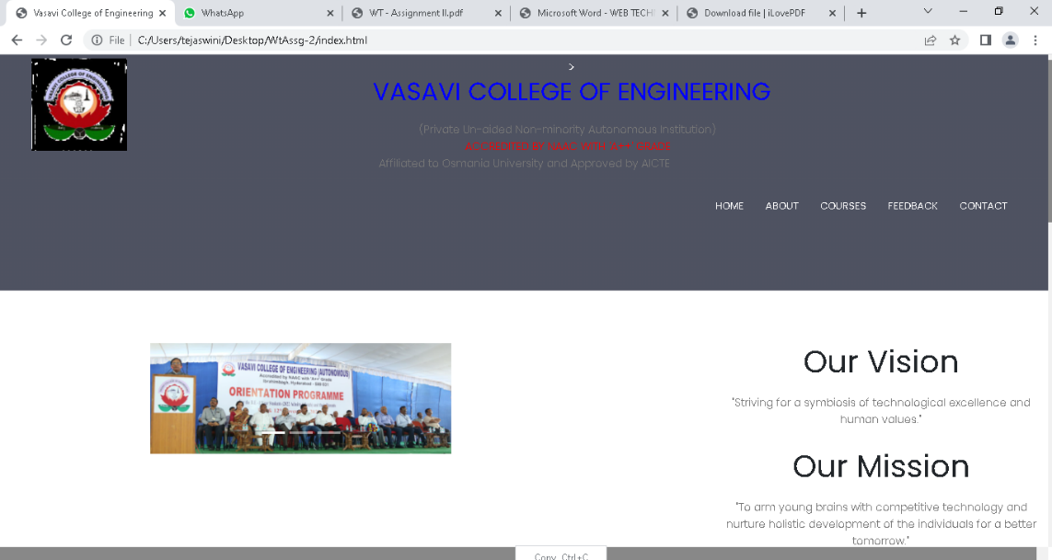

2.About

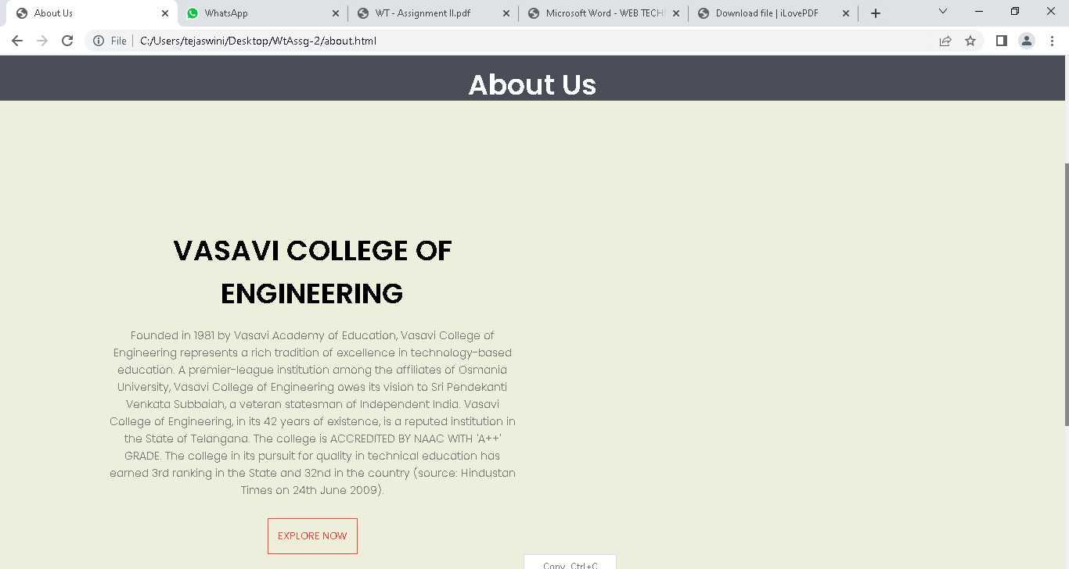

3.Contact

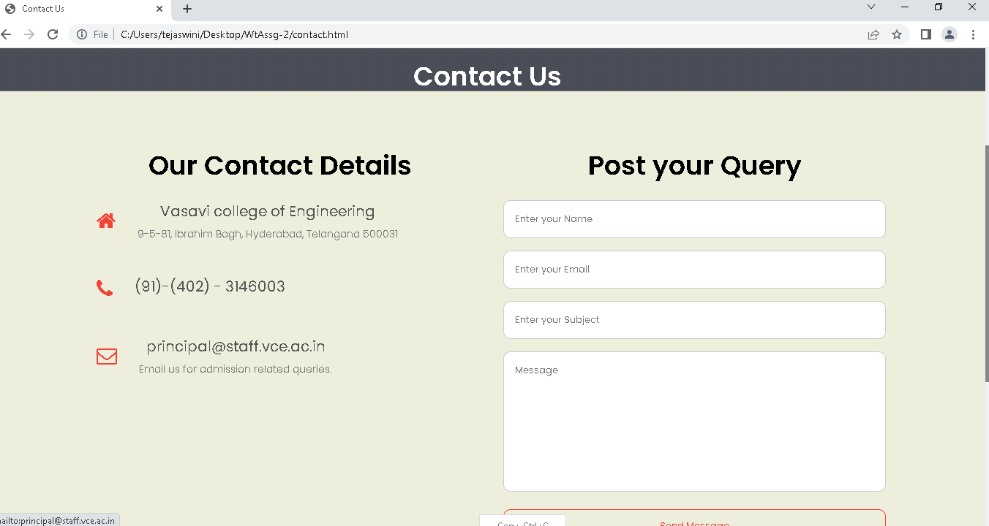

4.Courses

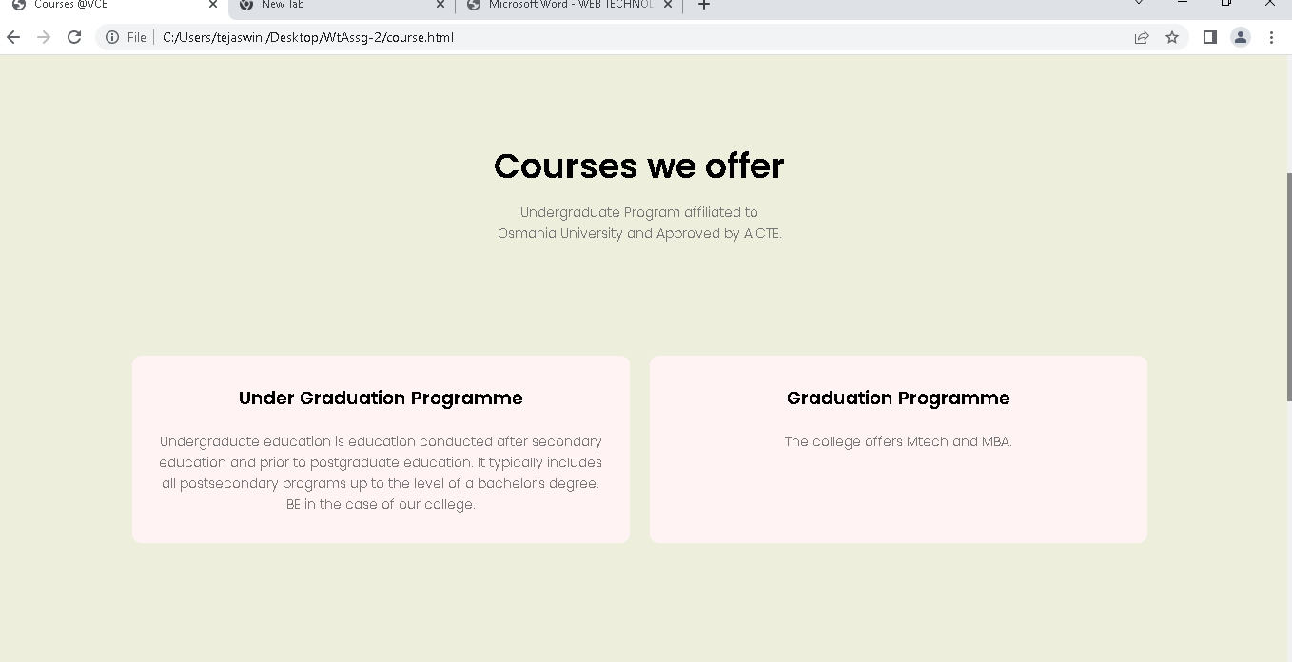

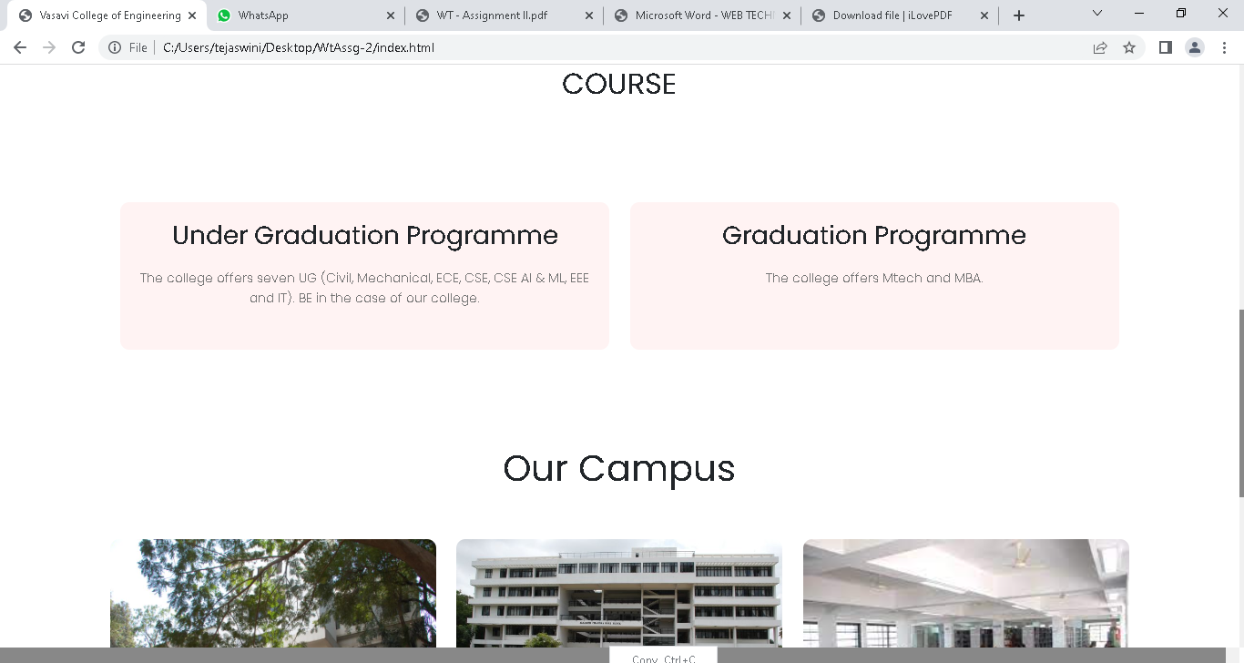

5.Feedback

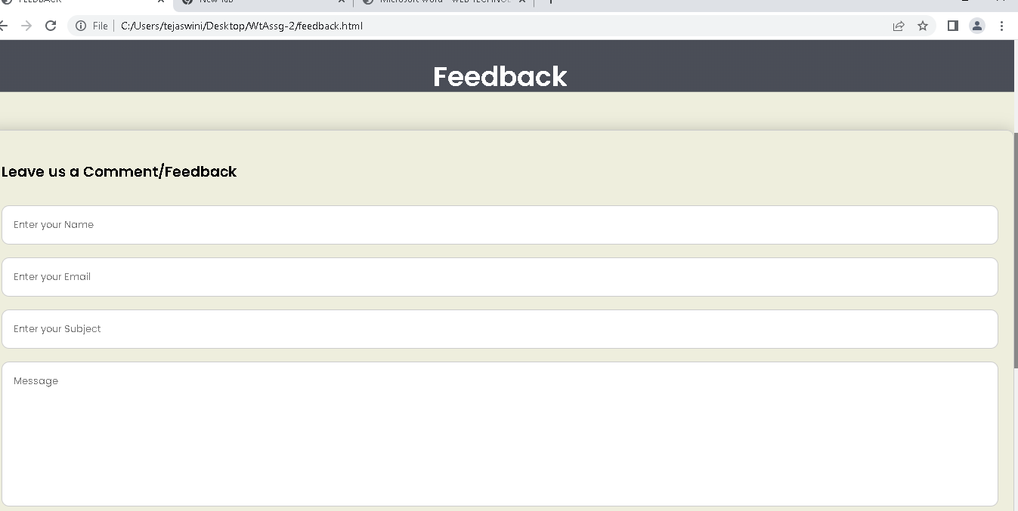

2**.Build a website with Form data (Student information ) and perform Insert, Delete, Update and view operations on the Database using MVC. Apply CSS to the web form.**

Code:

*1.HomeController.cs*

using System;

using System.Collections.Generic;

using System.Linq;

using System.Web;

using System.Web.Mvc;

namespace MVCCRUD.Controllers

{

public class HomeController : Controller

{

MVCCRUDDBContext _context=new MVCCRUDDBContext();

public ActionResult Index()

{

var listofData = _context.Students.ToList();

return View(listofData);

}

[HttpGet] public ActionResult Create()

{

return View();

}

[HttpPost] public ActionResult Create(Student model)

{

_context.Students.Add(model); _context.SaveChanges();

ViewBag.Message = "Data Insert Successfully";

return View();

}

[HttpGet] public ActionResult Edit(int id)

{

var data = _context.Students.Where(x => x.StudentId == id).FirstOrDefault();

return View(data);

}

[HttpPost] public ActionResult Edit(Student Model)

{

var data = _context.Students.Where(x => x.StudentId == Model.StudentId).FirstOrDefault();

if (data != null)

{

data.StudentCity = Model.StudentCity; data.StudentName = Model.StudentName;

data.StudentFees = Model.StudentFees;

_context.SaveChanges();

}

return RedirectToAction("index");

}

public ActionResult Detail(int id)

{

var data = _context.Students.Where(x => x.StudentId == id).FirstOrDefault();

return View(data);

}

public ActionResult Delete(int id)

{

var data = _context.Students.Where(x => x.StudentId == id).FirstOrDefault();

_context.Students.Remove(data); _context.SaveChanges();

ViewBag.Messsage = "Record Delete Successfully";

return RedirectToAction("index");

}

}

}

*2. Student.cs*

namespace MVCCRUD

{

using System;

using System.Collections.Generic;

public partial class Student

{

public int StudentId { get; set; }

public string StudentName { get; set; }

public Nullable<int> StudentFees { get; set; }

public string StudentCity { get; set; }

}

}

Screenshots:

