GRAPHICAL PASSWORD AUTHENTICATION
A
Mini Project Report
Submitted in partial fulfillment of the
Requirements for the award of the Degree of
BACHELOR OF ENGINEERING
IN
INFORMATION TECHNOLOGY
By
1602-20-737-087 – M.NIKHITHA
1602-20-737-081 – B. MANISHA
1602-20-737-309 - N. MADHUKAR

Department of Information Technology
Vasavi College of Engineering (Autonomous)
(Affiliated to Osmania University)
Ibrahimbagh, Hyderabad-31
2022

Vasavi College of Engineering (Autonomous)
(Affiliated to Osmania University)
Hyderabad-500 031
Department of Information Technology
DECLARATION BY THE CANDIDATE
We, M.Nikhitha, B.Manisha and N.Madhukar, bearing hall ticket numbers, 1602-20-737-087, 1602-20-737-081 and 1602-20-737-309, hereby declare that the project report entitled “Graphical Password Authentication ” is submitted in partial fulfillment of the requirement for the award of the degree of Bachelor of Engineering in Information Technology
This is a record of bonafide work carried out by us and the results embodied in this project report have not been submitted to any other university or institute for the award of any other degree or diploma.
M.Nikhitha 1602-20-737-087
B.Manisha 1602-20-737-081
N.Madhukar 1602-20-737-309

(Faculty In-Charge) (Head,Dept of IT)

ACKNOWLEDGEMENT

We are grateful to our mentor R.Dharma Reddy sir and our class coordinator Sreelakshmi ma’am for advising us and introducing the project in a easy to understand way which has helped us complete our project easily and effectively on time.

We are dearly obliged for giving us an opportunity to work on this project which will surely prove to be a great asset in the future and has a greater scope and updates in coming dates.

Thank you.

Table Of Content:

S. No. | Content | Page No.
1. | Abstract | 5
2. | Introduction | 6
3. | Design | 8
4. | Implementation | 13
5. | Result | 35
6. | Conclusion and Future Scope | 39
7. | References | 40

Abstract

The commonly used computer authentication method is to use alphanumerical usernames and passwords but this method has been shown to have drawbacks.
For Example, Users tent to pick password that can be guessed easily.
If a password is hard to guess then it is hard to remember. To address this problem authentication methods that use picture as password has been developed.
Graphical password schemes have been proposed as a possible alternative to text-based schemes, motivated partially by the fact that humans can remember pictures better than text.
One layer of protection gives a lot of security to the user details. Main aim is to protect the system and also to make sure that no non-human can log in to your account using different activities.

Introduction
We designed a Graphical Password Authentication System. This is used to increase the protection/security of a website.
Our system is divided into further 4 layers of protection and each layer is totally different and diverse than the others.
The motivation for this project came from a recent attack named Pegasus in which people had their mobile phones compromised for almost a decade without them ever getting the slightest clue. This motivated us to build a stronger authentication system that generates randomized methods which could weaken the attack and eventually prevent it.
The 4 layers of Protection that we are using are as follows:
- Segmented Images Authentication
- Password Image Authentication
- Obscured Images Authentication
- Garbled Images Authentication
- Segmented Images Authentication:
For this layer, the user will be showed 4 different images. These images will be a division of a whole image. User will have to select the correct order of the images.
2. Password Image Authentication:
A user is asked to select an image category from the 3 given categories:
- Cat
- Mouse
- Flower
3. Obscured Images Authentication:
We are enhancing security by introducing image-to-speech-to-text concept here. We are using “Speech Recognition” module of Python. User will be displayed the obscure text image and there will be a microphone button. When user will click the button, the recording will start and user will be asked to say the words in the image.
- Garbled Images Authentication:
In this layer, the user will be displayed a Garbled text whose readability will be really low and user will be asked to read and then type in the text.

Proposed work

a. Design

Actors Wise Use Cases
USER SYSTEM
- login Validate password
- Register Authenticate
- Type garbled text
- Arrange Segments
- Speak from the text
- Enter password

Use case Diagram:

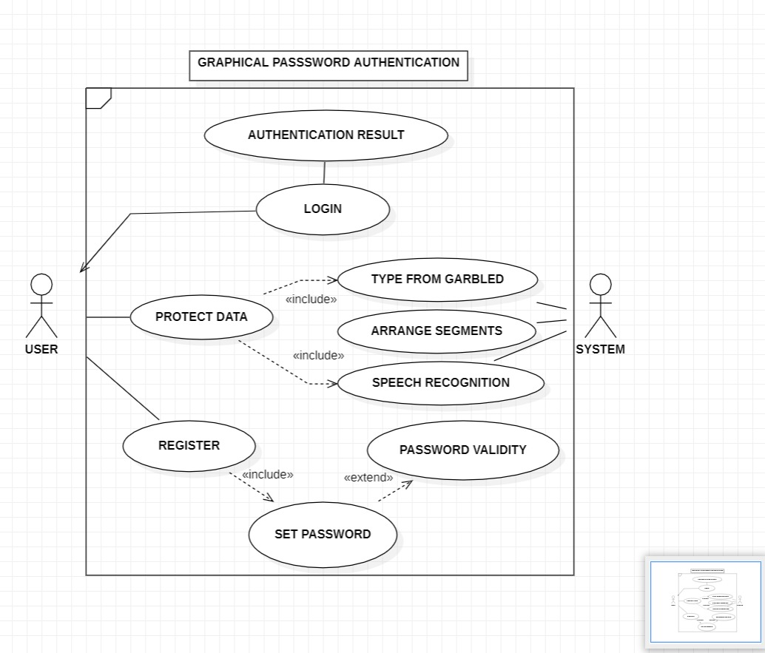

Use case Description :
Test Case ID: TC01 |  | Use Case ID:UC01
Test Case Title: Login
Test Case Description: Allow the user to login
Test Steps | Expected Result |  | Actual Result
Click the Button | User should login |  | User’s login is Successfull

Test Case ID: TC02 |  | Use Case ID:UC02
Test Case Title: Test Garbled
Test Case Description: Allow the user to rectify text from garbled image
Test Steps | Expected Result |  | Actual Result
Enter text | User should authenticate |  | User’s authentication is Successfull

Test Case ID: TC03 |  | Use Case ID:UC02
Test Case Title: Test obscured image
Test Case Description: Allow the user to speak from text
Test Steps | Expected Result |  | Actual Result
Click the mic button and speak | User should get authentication |  | User’s authentication is Successfull

Test Case ID: TC02 |  | Use Case ID:UC02
Test Case Title : Test segmented images
Test Case Description: Allow the to set the segmented images
Test Steps | Expected Result |  | Actual Result
Click the images in order | User should get authentication |  | User’s authentication is Successfull

Test Case ID: TC04 |  | Use Case ID:UC04
Test Case Title: Password authentication
Test Case Description: Allow the user to enter password
Test Steps | Expected Result |  | Actual Result
Enter the password and image | User should sign up |  | User’s sign up is Successfull

Activity Diagram :
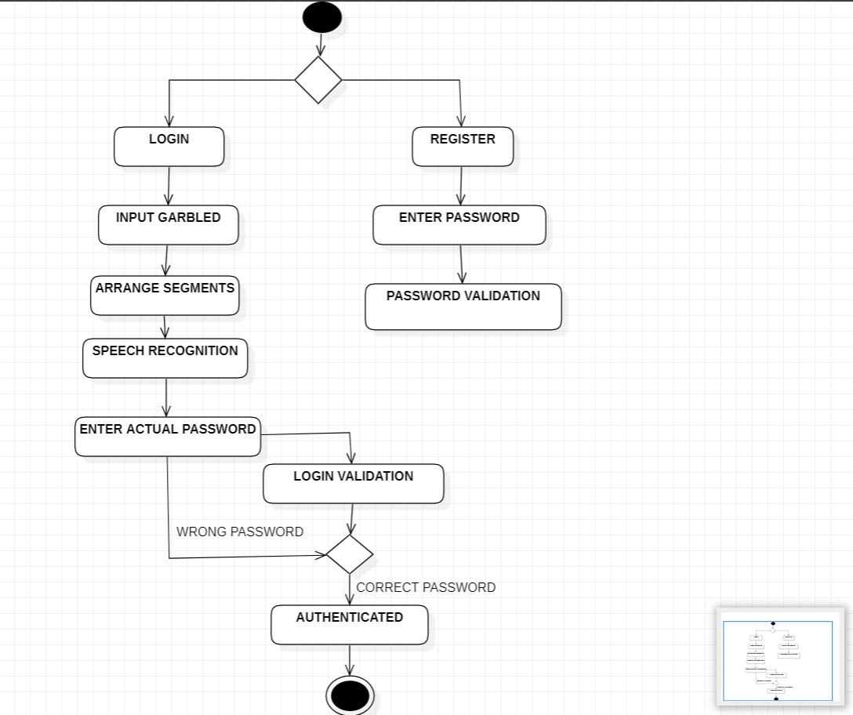

IMPLEMENTATION:

main_menu.py:
from tkinter import *
from tkinter import font
import custom_button
import garbled
import obscure
import password
import segments
def load_garbled(window, menu_frame):
menu_frame.pack_forget()
garbled.start(window)
def load_obscured(window, menu_frame):
menu_frame.pack_forget()
obscure.start(window)
def load_segmented(window, menu_frame):
menu_frame.pack_forget()
segments.start(window)
def load_password(window, menu_frame):
menu_frame.pack_forget()
password.start(window)
def start(win):
win.geometry("1280x600")
win.title("Graphical Authentication System")
menu_frame = Frame(win, height=600, width=1280)
menu_frame.pack(fill='both', expand=1)
label = Label(menu_frame, text="Graphical Authentication System", font=('Freestyle Script', 54))
label.pack(padx=40, pady=30)
btn_height = 90
btn_width = 450
btn_font = ('Trebuchet MS', 14)
btn1 = custom_button.TkinterCustomButton(master=menu_frame, text="Test Garbled Images", text_font=btn_font,
height=btn_height, width=btn_width, corner_radius=10,
command=lambda: load_garbled(win, menu_frame)).place(relx=0.3, rely=0.4,
anchor=CENTER)
btn2 = custom_button.TkinterCustomButton(master=menu_frame, text="Test Segmented Images", text_font=btn_font,
height=btn_height, width=btn_width, corner_radius=10,
command=lambda: load_segmented(win, menu_frame)).place(relx=0.3,
rely=0.7,
anchor=CENTER)
btn3 = custom_button.TkinterCustomButton(master=menu_frame, text="Test Obscured Images", text_font=btn_font,
height=btn_height, width=btn_width, corner_radius=10,
command=lambda: load_obscured(win, menu_frame)).place(relx=0.7,
rely=0.4,
anchor=CENTER)
btn4 = custom_button.TkinterCustomButton(master=menu_frame, text="Test Password/Image Authentication",
text_font=btn_font,
height=btn_height, width=btn_width, corner_radius=10,
command=lambda: load_password(win, menu_frame)).place(relx=0.7,
rely=0.7,
anchor=CENTER)
win.mainloop()
if __name__ == "__main__":
win = Tk()
start(win)

custom_button.py
Import tkinter
import sys
class TkinterCustomButton(tkinter.Frame):
""" tkinter custom button with border, rounded corners and hover effect
Arguments: master= where to place button
bg_color= background color, None is standard,
fg_color= foreground color, blue is standard,
hover_color= foreground color, lightblue is standard,
border_color= foreground color, None is standard,
border_width= border thickness, 0 is standard,
command= callback function, None is standard,
width= width of button, 110 is standard,
height= width of button, 35 is standard,
corner_radius= corner radius, 10 is standard,
text_font= (<Name>, <Size>),
text_color= text color, white is standard,
text= text of button,
hover= hover effect, True is standard,
image= PIL.PhotoImage, standard is None"""
def __init__(self,
bg_color=None,
fg_color="#2874A6",
hover_color="#5499C7",
border_color=None,
border_width=0,
command=None,
width=120,
height=40,
corner_radius=10,
text_font=None,
text_color="white",
text="CustomButton",
hover=True,
image=None,
*args, **kwargs):
super().__init__(*args, **kwargs)
if bg_color is None:
self.bg_color = self.master.cget("bg")
else:
self.bg_color = bg_color
self.fg_color = fg_color
self.hover_color = hover_color
self.border_color = border_color
self.width = width
self.height = height
if corner_radius*2 > self.height:
self.corner_radius = self.height/2
elif corner_radius*2 > self.width:
self.corner_radius = self.width/2
else:
self.corner_radius = corner_radius
self.border_width = border_width
if self.corner_radius >= self.border_width:
self.inner_corner_radius = self.corner_radius - self.border_width
else:
self.inner_corner_radius = 0
self.text = text
self.text_color = text_color
if text_font is None:
if sys.platform == "darwin": # macOS
self.text_font = ("Avenir", 13)
elif "win" in sys.platform: # Windows
self.text_font = ("Century Gothic", 11)
else:
self.text_font = ("TkDefaultFont")
else:
self.text_font = text_font
self.image = image
self.function = command
self.hover = hover
self.configure(width=self.width, height=self.height)
if sys.platform == "darwin" and self.function is not None:
self.configure(cursor="pointinghand")
self.canvas = tkinter.Canvas(master=self,
highlightthicknes=0,
background=self.bg_color,
width=self.width,
height=self.height)
self.canvas.place(x=0, y=0)
if self.hover is True:
self.canvas.bind("<Enter>", self.on_enter)
self.canvas.bind("<Leave>", self.on_leave)
self.canvas.bind("<Button-1>", self.clicked)
self.canvas.bind("<Button-1>", self.clicked)
self.canvas_fg_parts = []
self.canvas_border_parts = []
self.text_part = None
self.text_label = None
self.image_label = None
self.draw()
def draw(self):
self.canvas.delete("all")
self.canvas_fg_parts = []
self.canvas_border_parts = []
self.canvas.configure(bg=self.bg_color)
# border button parts
if self.border_width > 0:
if self.corner_radius > 0:
self.canvas_border_parts.append(self.canvas.create_oval(0,
0,
self.corner_radius * 2,
self.corner_radius * 2))
self.canvas_border_parts.append(self.canvas.create_oval(self.width - self.corner_radius * 2,
0,
self.width,
self.corner_radius * 2))
self.canvas_border_parts.append(self.canvas.create_oval(0,
self.height - self.corner_radius * 2,
self.corner_radius * 2,
self.height))
self.canvas_border_parts.append(self.canvas.create_oval(self.width - self.corner_radius * 2,
self.height - self.corner_radius * 2,
self.width,
self.height))
self.canvas_border_parts.append(self.canvas.create_rectangle(0,
self.corner_radius,
self.width,
self.height - self.corner_radius))
self.canvas_border_parts.append(self.canvas.create_rectangle(self.corner_radius,
0,
self.width - self.corner_radius,
self.height))
# inner button parts
if self.corner_radius > 0:
self.canvas_fg_parts.append(self.canvas.create_oval(self.border_width,
self.border_width,
self.border_width + self.inner_corner_radius * 2,
self.border_width + self.inner_corner_radius * 2))
self.canvas_fg_parts.append(self.canvas.create_oval(self.width - self.border_width - self.inner_corner_radius * 2,
self.border_width,
self.width - self.border_width,
self.border_width + self.inner_corner_radius * 2))
self.canvas_fg_parts.append(self.canvas.create_oval(self.border_width,
self.height - self.border_width - self.inner_corner_radius * 2,
self.border_width + self.inner_corner_radius * 2,
self.height-self.border_width))
self.canvas_fg_parts.append(self.canvas.create_oval(self.width - self.border_width - self.inner_corner_radius * 2,
self.height - self.border_width - self.inner_corner_radius * 2,
self.width - self.border_width,
self.height - self.border_width))
self.canvas_fg_parts.append(self.canvas.create_rectangle(self.border_width + self.inner_corner_radius,
self.border_width,
self.width - self.border_width - self.inner_corner_radius,
self.height - self.border_width))
self.canvas_fg_parts.append(self.canvas.create_rectangle(self.border_width,
self.border_width + self.inner_corner_radius,
self.width - self.border_width,
self.height - self.inner_corner_radius - self.border_width))
for part in self.canvas_fg_parts:
self.canvas.itemconfig(part, fill=self.fg_color, width=0)
for part in self.canvas_border_parts:
self.canvas.itemconfig(part, fill=self.border_color, width=0)
# no image given
if self.image is None:
# create tkinter.Label with text
self.text_label = tkinter.Label(master=self,
text=self.text,
font=self.text_font,
bg=self.fg_color,
fg=self.text_color)
self.text_label.place(relx=0.5, rely=0.5, anchor=tkinter.CENTER)
# bind events the the button click and hover events also to the text_label
if self.hover is True:
self.text_label.bind("<Enter>", self.on_enter)
self.text_label.bind("<Leave>", self.on_leave)
self.text_label.bind("<Button-1>", self.clicked)
self.text_label.bind("<Button-1>", self.clicked)
self.set_text(self.text)
# use the given image
else:
# create tkinter.Label with image on it
self.image_label = tkinter.Label(master=self,
image=self.image,
bg=self.fg_color)
self.image_label.place(relx=0.5,
rely=0.5,
anchor=tkinter.CENTER)
# bind events the the button click and hover events also to the image_label
if self.hover is True:
self.image_label.bind("<Enter>", self.on_enter)
self.image_label.bind("<Leave>", self.on_leave)
self.image_label.bind("<Button-1>", self.clicked)
self.image_label.bind("<Button-1>", self.clicked)
def configure_color(self, bg_color=None, fg_color=None, hover_color=None, text_color=None):
if bg_color is not None:
self.bg_color = bg_color
else:
self.bg_color = self.master.cget("bg")
if fg_color is not None:
self.fg_color = fg_color
# change background color of image_label
if self.image is not None:
self.image_label.configure(bg=self.fg_color)
if hover_color is not None:
self.hover_color = hover_color
if text_color is not None:
self.text_color = text_color
if self.text_part is not None:
self.canvas.itemconfig(self.text_part, fill=self.text_color)
self.draw()
def set_text(self, text):
if self.text_label is not None:
self.text_label.configure(text=text)
def on_enter(self, event=0):
for part in self.canvas_fg_parts:
self.canvas.itemconfig(part, fill=self.hover_color, width=0)
if self.text_label is not None:
# change background color of image_label
self.text_label.configure(bg=self.hover_color)
if self.image_label is not None:
# change background color of image_label
self.image_label.configure(bg=self.hover_color)
def on_leave(self, event=0):
for part in self.canvas_fg_parts:
self.canvas.itemconfig(part, fill=self.fg_color, width=0)
if self.text_label is not None:
# change background color of image_label
self.text_label.configure(bg=self.fg_color)
if self.image_label is not None:
# change background color of image_label
self.image_label.configure(bg=self.fg_color)
def clicked(self, event=0):
if self.function is not None:
self.function()
self.on_leave()

garbled.py
import tkinter
from tkinter import *
import custom_button
import main_menu
import utils
from PIL import ImageTk, Image
from tkinter import Entry
import random
def load_menu(window, frame):
frame.pack_forget()
main_menu.start(window)
def start(window):
filepath = "garbledImages/original_garbled.txt" # File Path
garbledImages = utils.getGarbledImages()
num = random.randint(0, len(garbledImages) - 1)
filename = garbledImages[num]
f = open(filepath, "r")
while True:
string = f.readline() # Reading file line by line
s1 = string.split(' ')[0] # Getting first word (filename) of line
if s1 == filename[0:len(filename) - 4]: # Don't need the file extension, only name
Break
# print("Original = ", string)
string = string[9:] # Cropping string
string = string.replace(' ', '-') # Replacing spaces with dashes
original_text = string
original_text = original_text.rstrip() # Removing \n
f.close()
print(original_text)
print(filename)
window.title("Graphical Authentication System")
window.geometry("1280x600")
garbled_frame = Frame(window, height=600, width=1280)
garbled_frame.pack(fill='both', expand=1)
label = Label(garbled_frame, text="Type the words in the image", font=('Calibri', 20))
label.pack(padx=40, pady=10)
canvas = Canvas(garbled_frame, width=450, height=300)
img = (Image.open("garbledImages/" + filename))
img = img.resize((450, 300), Image.ANTIALIAS)
img = ImageTk.PhotoImage(img)
canvas.create_image(10, 10, anchor=NW, image=img)
canvas.place(relx=0.45, rely=0.5, anchor=E)
def check():
entered_text = input.get()
if entered_text == original_text:
print("Authenticated")
utils.create_popup(msg="Authenticated :)", font="Gabriola 28 bold")
else:
print("Authentication Failed")
utils.create_popup(msg="Go Away Robot >_<", font="Gabriola 28 bold")
input = StringVar()
Label(garbled_frame, text="Enter word", font="ariel 16 bold").place(relx=0.7, rely=0.40, anchor=CENTER)
Entry(garbled_frame, textvariable=input, font="ariel 12 bold", relief="groove", width=30, justify=CENTER).place(
relx=0.7,
rely=0.5,
anchor=CENTER)
custom_button.TkinterCustomButton(master=garbled_frame, text="Check", height=40, corner_radius=10,
command=check).place(relx=0.7, rely=0.6, anchor=CENTER)
custom_button.TkinterCustomButton(master=garbled_frame, text="Go Back", height=40, corner_radius=10,
command=lambda: load_menu(window, garbled_frame)).place(relx=0.08, rely=0.08, anchor=CENTER)
while True:
window.update_idletasks()
window.update()

obscure.py
Import tkinter
from tkinter import *
import custom_button
import main_menu
import speech_recognition as sr
import utils
from PIL import ImageTk, Image
import random
def load_menu(window, frame):
frame.pack_forget()
main_menu.start(window)
original_text = []
def toggle(event):
input_text = None
while True:
e = sr.Recognizer() # Recognizes all input devices
with sr.Microphone() as source: # setting microphone as default input device
try:
print("Say Something. Say 'stop' inorder to stop")
audio = e.listen(source) # Listens audio
input_text = e.recognize_google(audio) # Recognizes text using speech recognition
if input_text == "stop": # Break condition
Break
except:
print("Exception occured when trying to record")
Break
input_text = input_text[:-5] # Removing stop from the end of line
input_text = input_text.rstrip() # Removing \n
input_text = input_text.lower() # Converting everything to lowercase
input_text = input_text.replace(' ', '-') # Replacing spaces with dashes
print("Original Text = ", original_text[0])
print("Input Text = ", input_text)
if original_text[0] == input_text:
print("Authenticated")
utils.create_popup(msg="Authenticated :)", font="Gabriola 28 bold")
else:
print("Authentication Failed")
utils.create_popup(msg="Go Away Robot >_<", font="Gabriola 28 bold")
def start(window):
obscuredImages = utils.getObscuredImages()
num = random.randint(1, len(obscuredImages) - 1)
filename = obscuredImages[num] # Filename that will be displayed
filepath = "obscuredImages/original_obscure.txt" # File Path
f = open(filepath, "r")
while True:
string = f.readline() # Reading file line by line
s1 = string.split(' ')[0] # Getting first word (filename) of line
if s1 == filename[0:len(filename) - 4]: # Don't need the file extension, only name
Break
# print("Original = ", string)
string = string[9:] # Cropping string
string = string.replace(' ', '-') # Replacing spaces with dashes
string = string
original_text.append(string.rstrip()) # Removing \n
f.close()
obscure_frame = Frame(window, height=600, width=1280)
obscure_frame.pack(fill='both', expand=1)
window.title("Graphical Authentication System")
window.geometry("1280x600")
label = Label(obscure_frame, text="Click on the microphone and speak the words in the following image",
font=('Calibri', 20))
label.pack(padx=40, pady=10)
canvas = Canvas(obscure_frame, width=450, height=300)
img = (Image.open("obscuredImages/" + filename))
img = img.resize((450, 300), Image.ANTIALIAS)
img = ImageTk.PhotoImage(img)
canvas.create_image(10, 10, anchor=NW, image=img)
canvas.pack(padx=10, pady=10)
canvas2 = Canvas(obscure_frame, width=200, height=170)
canvas2.bind("<Button-1>", toggle)
img2 = (Image.open("assets/mic.jpg"))
img2 = img2.resize((200, 170), Image.ANTIALIAS)
img2 = ImageTk.PhotoImage(img2)
canvas2.create_image(10, 10, anchor=NW, image=img2)
canvas2.pack(padx=20, pady=20)
custom_button.TkinterCustomButton(master=obscure_frame, text="Go Back", height=40, corner_radius=10,
command=lambda: load_menu(window, obscure_frame)).place(relx=0.08, rely=0.08,
anchor=CENTER)
while True:
window.update_idletasks()
window.update()
Password.py

import copy
import hashlib
from random import randint
import tkinter
from tkinter import *
import custom_button
import main_menu
import utils
from PIL import ImageTk, Image
from tkinter import Entry
s_image = []
s_image.append("")
def load_menu(window, frame):
frame.pack_forget()
main_menu.start(window)
# saves image selected by user
def clicked(canvas, img_name, event):
canvas.config(highlightthickness=1, highlightbackground="black")
s_image[0] = img_name;
# print(s_image[0])
# authenticate credentials provided by users
def authenticate(selected_image, selected_password, selected_name):
# checks if there is no empty entry
if selected_name == "":
messagebox.showinfo("Login System", "Please enter the Username")
elif selected_password == "":
messagebox.showinfo("Login System", "Please enter the Password")
elif selected_name == "" and selected_password == "":
messagebox.showinfo("Login System", "Please enter the Username and Password")
# print("hiii",selected_image)
# taking hash of password entered as its hash stored in backend
h = hashlib.new('sha512_256')
h.update(selected_password.encode())
selected_password = h.hexdigest()
filepath = "credentialImages/orig_credentials.txt" # File Path
f = open(filepath, "r")
name = ""
password = ""
image = ""
str = ""
isUser = 0
# file reading to get original credentials
while True:
string = f.readline() # Reading file line by line
if string == "":
if (isUser == 0):
print("username not exist")
messagebox.showinfo("Login System", "password is not correct")
break
info = string.split(" ")
name = copy.deepcopy(info[0])
password = copy.deepcopy(info[1])
image = copy.deepcopy(info[2])
name = name.rstrip()
password = password.rstrip()
image = image.rstrip()
# checks the credentials by somparing with original one
if name == selected_name:
isUser = 1
if password == selected_password:
if image == selected_image:
print("authenticated!!")
messagebox.showinfo("Login System", "authenticated!!")
Break
else:
print("image is not correct")
messagebox.showinfo("Login System", "image is not correct")
Break
else:
print("password is not correct")
messagebox.showinfo("Login System", "password is not correct")
Break
# login page canvas
def create_canvas(window):
window.title("Login Page")
window.geometry("1280x600")
root = Frame(window, height=600, width=1280)
root.pack(fill='both', expand=1)
#root.title("Login Page")
#root.resizable(0, 0)
width = 700
height = 700
# image class names
img_name1 = "cat"
img_name2 = "flower"
img_name3 = "mouse"
# Generates random number to display images
num = randint(0, 2)
print("Random number = ", num)
selected_image = ""
# getting image paths from utils
imgList = utils.getCredentialImages()
# canvas for title
canvas = Canvas(root, width=width, height=height, bd=0, highlightthickness=0)
canvas.pack(fill=BOTH, expand=True)
canvas.create_image(0, 0, anchor='nw')
label = Label(root, text="Login Page", font=("Ariel 15 bold"))
canvas.create_window(550, 40, anchor="nw", window=label)
# canvas for username title
user_label = Label(root, text="User name:", font=("Ariel 12 bold"))
canvas.create_window(480, 130, anchor="nw", window=user_label)
# canvas for password title
password_label = Label(root, text="Password:", font=("Ariel 12 bold"))
canvas.create_window(480, 210, anchor="nw", window=password_label)
# usernmae input feild display
user_entry = Entry(root, font=("Ariel 12"))
user_entry.focus()
selected_name = user_entry.get()
canvas.create_window(580, 130, anchor="nw", window=user_entry)
# password input feild display
pas = StringVar()
password_entry = Entry(root, textvar=pas, font=("Ariel 12"), show="*")
selected_password = password_entry.get()
canvas.create_window(580, 210, anchor="nw", window=password_entry)
# Random image display from first class
canvas2 = Canvas(root, width=110, height=70)
canvas2.bind("<Button-1>",
lambda event: clicked(canvas2, img_name1, event)) # binding button to check if image is clicked
canvas2.place(x=450, y=290)
img2 = (Image.open("credentialImages/" + imgList[num]))
img2 = img2.resize((90, 60), Image.ANTIALIAS)
img2 = ImageTk.PhotoImage(img2)
canvas2.create_image(10, 10, anchor="nw", image=img2)
# Random image display from second class
canvas3 = Canvas(root, width=110, height=70)
canvas3.bind("<Button-1>",
lambda event: clicked(canvas3, img_name2, event)) # binding button to check if image is clicked
canvas3.place(x=600, y=290)
img3 = (Image.open("credentialImages/" + imgList[num + 3]))
img3 = img3.resize((90, 60), Image.ANTIALIAS)
img3 = ImageTk.PhotoImage(img3)
canvas3.create_image(10, 10, anchor="nw", image=img3)
# Random image display from third class
canvas4 = Canvas(root, width=110, height=70)
canvas4.bind("<Button-1>",
lambda event: clicked(canvas4, img_name3, event)) # binding button to check if image is clicked
canvas4.place(x=750, y=290)
img4 = (Image.open("credentialImages/" + imgList[num + 6]))
img4 = img4.resize((90, 60), Image.ANTIALIAS)
img4 = ImageTk.PhotoImage(img4)
canvas4.create_image(10, 10, anchor="nw", image=img4)
# login button display
# calls authenticate on click with credentials as arguments
login = custom_button.TkinterCustomButton(master=root, text="Log In", height=40, corner_radius=10,
command=lambda: authenticate(s_image[0], password_entry.get(), user_entry.get())).place(relx=0.5, rely=0.7, anchor=CENTER)
custom_button.TkinterCustomButton(master=root, text="Go Back", height=40, corner_radius=10,
command=lambda: load_menu(window, root)).place(relx=0.08, rely=0.08,
anchor=CENTER)
window.mainloop()
def start(window):
create_canvas(window)

segment.py
import tkinter
from tkinter import *
import custom_button
import main_menu
import utils
from PIL import ImageTk, Image
import random
def load_menu(window, frame):
frame.pack_forget()
main_menu.start(window)
def start(window):
window.title("Graphical Authentication System")
window.geometry("1280x600")
segments_frame = Frame(window, height=600, width=1280)
segments_frame.pack(fill='both', expand=1)
label = Label(segments_frame, text="Please select the pictures in correct order", font=('Calibri', 20))
label.pack(padx=400, pady=10)
## Draw order image
canvas = Canvas(segments_frame, width=300, height=250)
canvas.bind("<Button-1>", utils.callback)
img = (Image.open("segmentedImages/order.jpg"))
img = img.resize((300, 250), Image.ANTIALIAS)
img = ImageTk.PhotoImage(img)
canvas.create_image(10, 10, anchor=NW, image=img)
canvas.pack(padx=10, pady=10)
imgList = utils.getSegmentedImages("circle")
random.shuffle(imgList)
imgClickData = []
for imgPath in imgList:
var = utils.imageClick(imgPath)
imgClickData.append(var)
# Draw shuffled segments
canvas2 = Canvas(segments_frame, width=200, height=150)
canvas2.bind("<Button-1>", imgClickData[0].clicked)
canvas2.place(x=100, y=400)
img2 = (Image.open(imgList[0]))
img2 = img2.resize((200, 150), Image.ANTIALIAS)
img2 = ImageTk.PhotoImage(img2)
canvas2.create_image(10, 10, anchor=NW, image=img2)
canvas3 = Canvas(segments_frame, width=200, height=150)
canvas3.bind("<Button-1>", imgClickData[1].clicked)
canvas3.place(x=400, y=400)
img3 = (Image.open(imgList[1]))
img3 = img3.resize((200, 150), Image.ANTIALIAS)
img3 = ImageTk.PhotoImage(img3)
canvas3.create_image(10, 10, anchor=NW, image=img3)
canvas4 = Canvas(segments_frame, width=200, height=150)
canvas4.bind("<Button-1>", imgClickData[2].clicked)
canvas4.place(x=700, y=400)
img4 = (Image.open(imgList[2]))
img4 = img4.resize((200, 150), Image.ANTIALIAS)
img4 = ImageTk.PhotoImage(img4)
canvas4.create_image(10, 10, anchor=NW, image=img4)
canvas5 = Canvas(segments_frame, width=200, height=150)
canvas5.bind("<Button-1>", imgClickData[3].clicked)
canvas5.place(x=1000, y=400)
img5 = (Image.open(imgList[3]))
img5 = img5.resize((200, 150), Image.ANTIALIAS)
img5 = ImageTk.PhotoImage(img5)
canvas5.create_image(10, 10, anchor=NW, image=img5)
custom_button.TkinterCustomButton(master=segments_frame, text="Go Back", height=40, corner_radius=10,
command=lambda: load_menu(window, segments_frame)).place(relx=0.08, rely=0.08,
anchor=CENTER)
while True:
window.update_idletasks()
window.update()
if utils.checkAllClicked(imgClickData):
sortedClickList = sorted(imgClickData)
if (sortedClickList[0].id == 1) and (sortedClickList[1].id == 2) and (sortedClickList[2].id == 3) and (
sortedClickList[3].id == 4):
utils.create_popup(msg="Authenticated :)", font="Gabriola 28 bold")
else:
utils.create_popup(msg="Go Away Robot >_<", font="Gabriola 28 bold")
utils.setAllUnclicked(imgClickData)

utils.py
import os
import datetime
from tkinter import *
from tkinter.ttk import *
from PIL import ImageTk, Image
def callback(event):
print("clicked at", event.x, event.y)
def getSegmentedImages(shape):
parentDir = "segmentedImages/" + shape
imagePaths = os.listdir(parentDir)
imagePaths = [parentDir + "/" + _path for _path in imagePaths]
return imagePaths
def getObscuredImages():
imagePaths = os.listdir("obscuredImages")
return imagePaths
def getGarbledImages():
imagePaths = os.listdir("garbledImages")
return imagePaths[:-1] # last file is txt file, don't need thats
def getCredentialImages():
imagePaths = os.listdir("credentialImages")
return imagePaths[:-1] # last file is txt file, don't need thats
class customImage:
def __init__(self, path, width=200, height=150):
self.path = path
self.img_width = width
self.img_height = height
def draw(self, window, c_width=200, c_height=150, img_x=0, img_y=400):
# Create a canvas
canvas = Canvas(window, width=c_width, height=c_height)
canvas.place(x=img_x, y=img_y)
# Load an image in the script
img = Image.open(self.path)
# Resize the Image using resize method
img = img.resize((self.img_width, self.img_height), Image.ANTIALIAS)
img = ImageTk.PhotoImage(img)
# Add image to the Canvas Items
canvas.create_image(10, 10, anchor=NW, image=img)
return canvas
class imageClick:
def __init__(self, path):
self.id = int(path[-5])
self.path = path
self.isClicked = False
self.timeClicked = None
def clicked(self, event):
self.isClicked = True
self.timeClicked = datetime.datetime.now()
print("img id = ", self.id, " has been clicked")
def __lt__(self, other):
return self.timeClicked < other.timeClicked
def setAllUnclicked(imgClickedData):
for obj in imgClickedData:
obj.isClicked = False
def checkAllClicked(imgClickedData):
for obj in imgClickedData:
if obj.isClicked is False:
return False
return True
def create_popup(size="500x200", msg="default", font='Arial 24', x=140, y=70):
win = Tk()
win.geometry(size)
win.title("Message")
Label(win, text=msg, font=font).place(x=x, y=y)
for i in range(300000):
win.update_idletasks()
win.update()
win.destroy()
return

GitLab Link : https://gitlab.vce.ac.in/Graphical_Password_Authentication/graphical_password_authentication
Result :

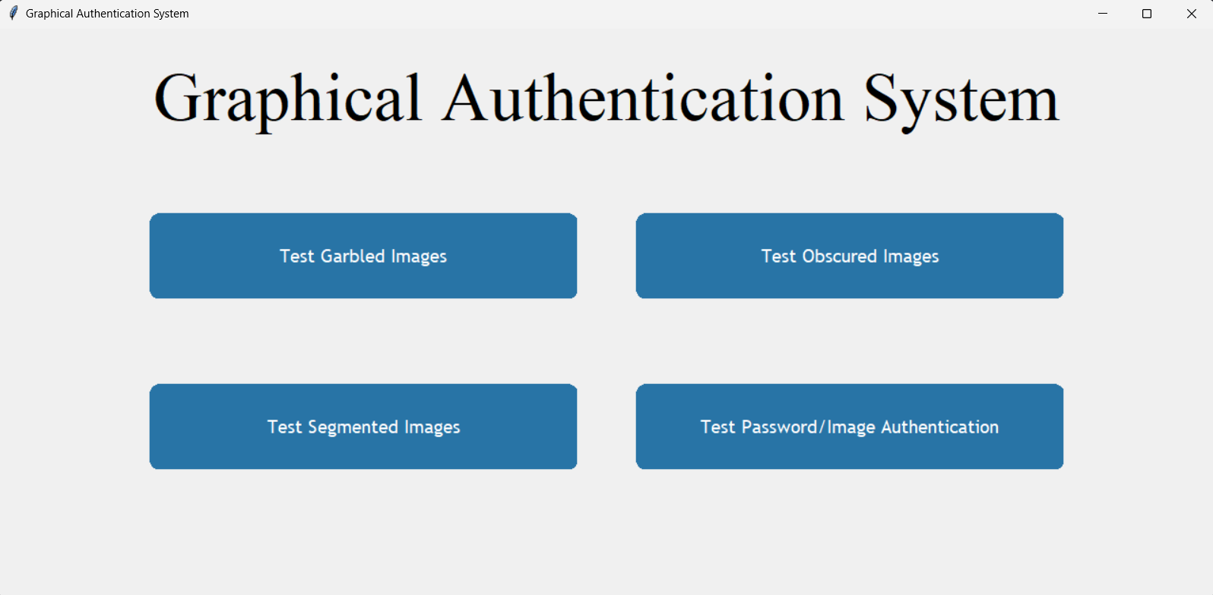

Test Garbled images

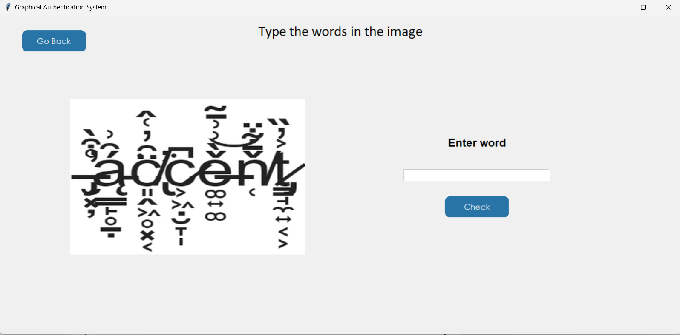

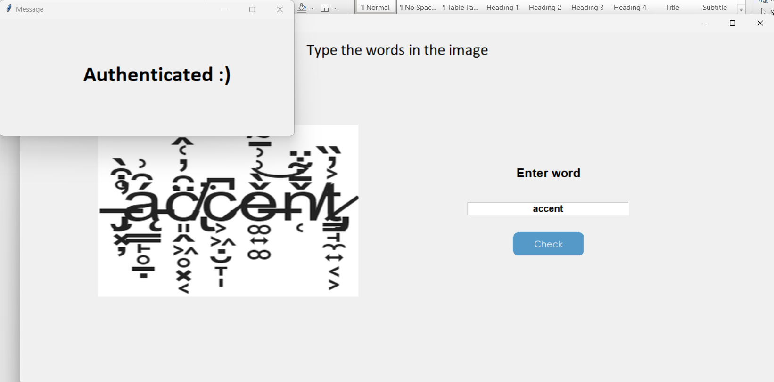

Test Obscured images

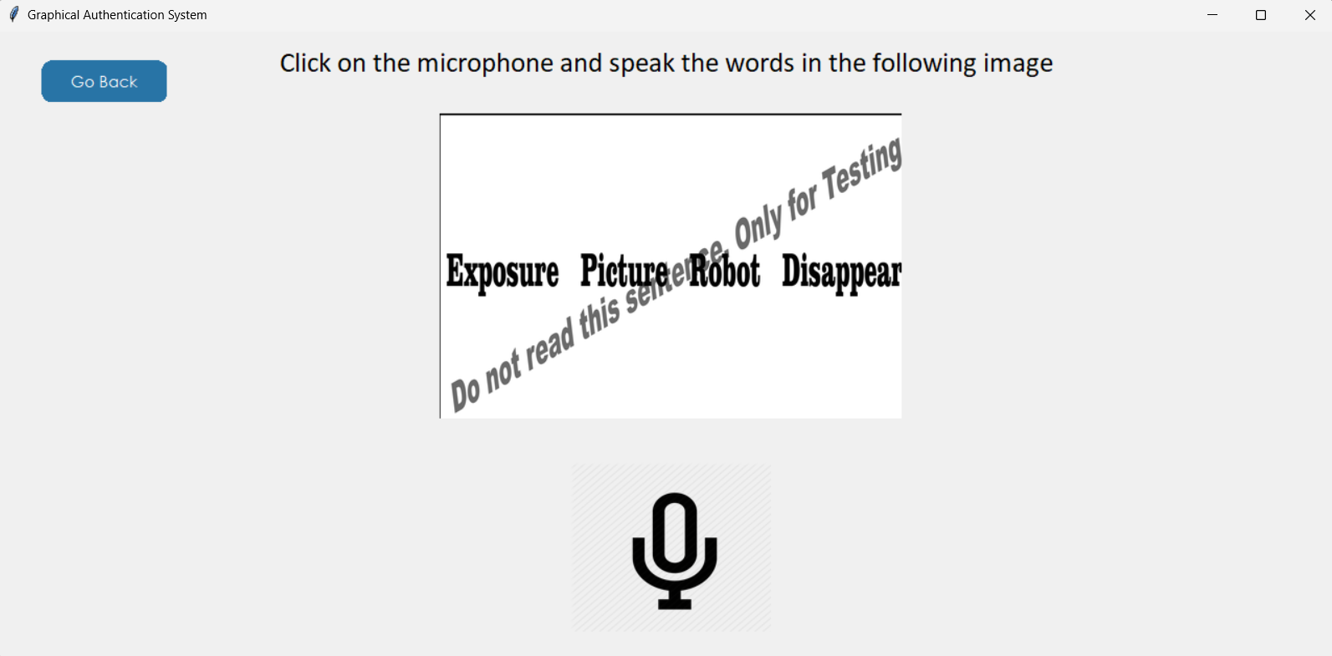

Test Segmented images:

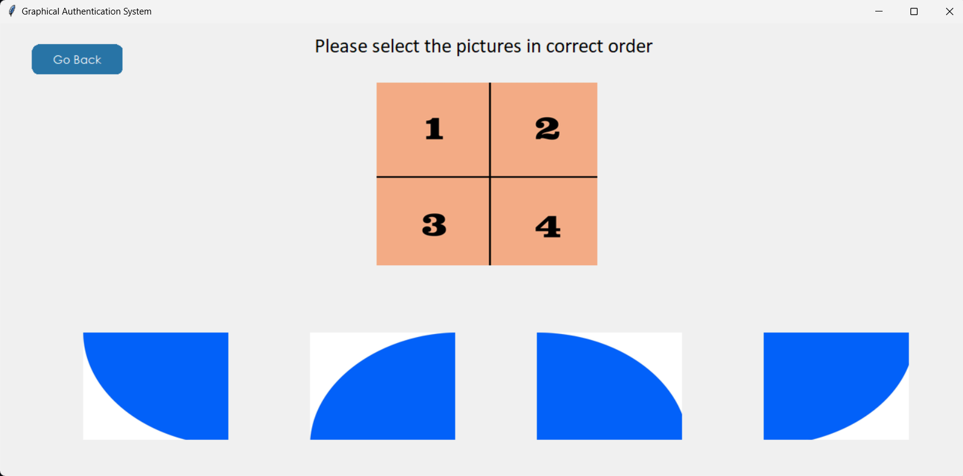

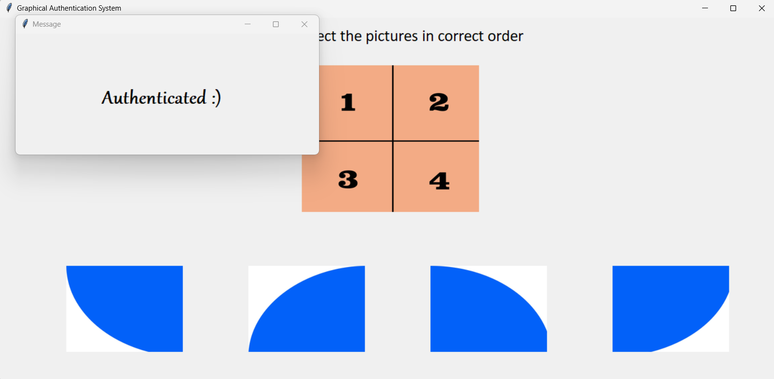

Test Password/Image Authentication

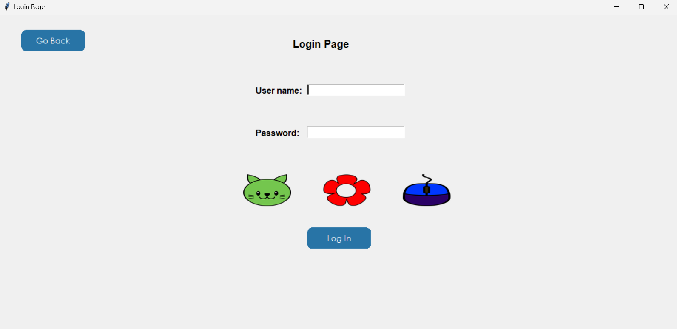

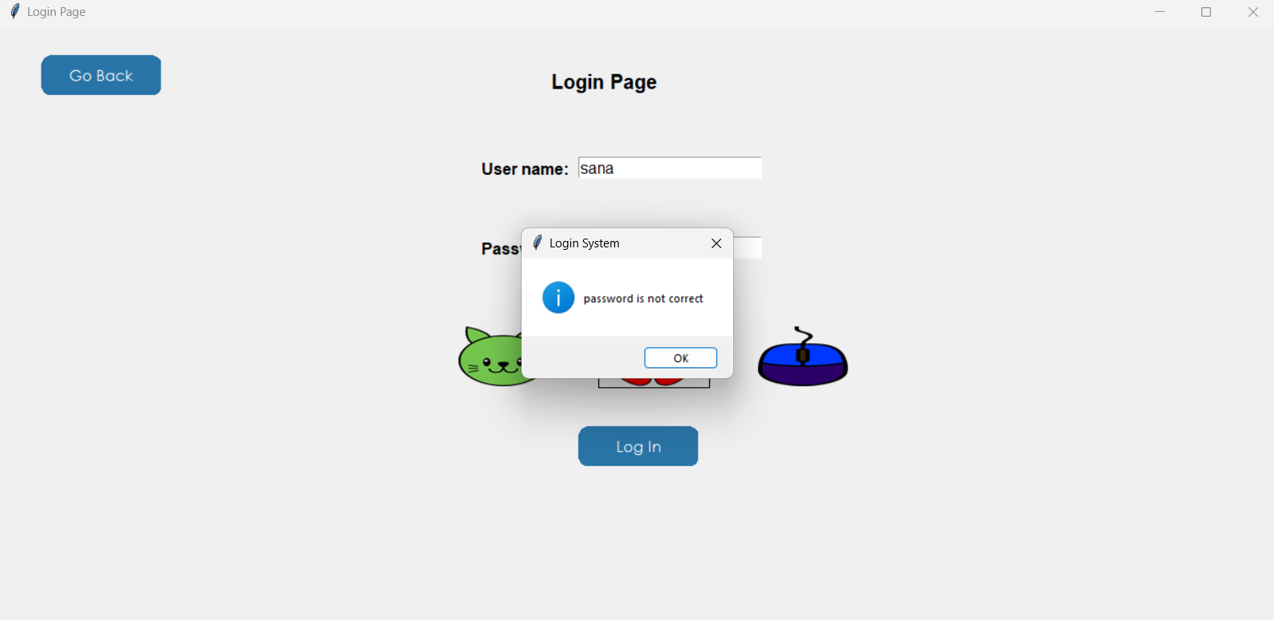
Conclusion and Future work

This type of authentication is difficult to break since neither brute force nor
dictionary attacks could breach it. We need techniques that can be easily
implemented and provide better results to this process.

- People who have difficulty in understanding or remembering passwords may find the current text based authentication difficult .This system may remove ambiguity as such.
- Graphics based authentication is easy to remember since the most of the datasets are used in every day life.
- This system can be further combined with visual AI technologies such that the
- passwords need not to be remembered ,since the passwords are automatically allocated by the eye movement of the user.
- We are planning to achieve better accuracy even in case of complex background voices by trying out various background subtraction algorithms regarding speech recognition.
- Further we’ll try to implement this type of authentication in different applications and websites.

References :

https://www.geeksforgeeks.org/graphical-password-authentication/
https://code.visualstudio.com/
https://sih.gov.in/sih2022PS?technology_bucket=Mg==&category=QWxs&organization=QWxs&organization_type=QWxs
https://docs.python.org/3/library/tkinter.html
https://www.tutorialspoint.com/python/python_gui_programming.htm#:~:text=Tkinter%20is%20the%20standard%20GUI,to%20the%20Tk%20GUI%20toolkit.&text=Import%20the%20Tkinter%20module
https://www.geeksforgeeks.org/python-convert-image-to-text-and-then-to-speech/https://pypi.org/project/SpeechRecognition/

