A Micro Project report on

EMPLOYEE MANAGEMENT SYSTEM

Submitted to the CMR Institute of Technology, Hyderabad in partial fulfilment of the requirement for the award of the Laboratory of

NODE JS/ANGULAR/REACT JS/DJANGO LAB

**of**

**II-B.Tech. II-Semester**

**in**

Computer Science and Engineering

Submitted by

|  |  |
| --- | --- |
| R. SRI NITHYA | 23R01A0557 |
| T. NIKHITHA | 23R01A0558 |
| T. AISHWARIYA | 23R01A0559 |
| V.SAHITI | 23R01A0560 |
| Y. VINAY KUMAR | 23R01A0561 |
| Y. AVINASH | 23R01A0563 |
| Y. SREEJA | 23R01A0564 |

Under the Guidance Of

Mr. Srinish Reddy

(Asst.Professor, Dept of CSE)



CMR INSTITUTE OF TECHNOLOGY

**(UGC AUTONOMUS)**

**(Approved by AICTE,Affiliated to JNTU,Kukatpally,Hyderabad)**

**Kandlakoya,Medchal Road,Hyderabad**

**2024-2025**

**CERTIFICATE**

This is to certify that a Micro Project entitled with: **“EMPLOYEE MANAGEMENT SYSTEM”** is being

Submitted By

|  |  |
| --- | --- |
| R. SRI NITHYA | 23R01A0557 |
| T. NIKHITHA | 23R01A0558 |
| T. AISHWARIYA | 23R01A0559 |
| V.SAHITI | 23R01A0560 |
| Y. VINAY KUMAR | 23R01A0561 |
| Y. AVINASH | 23R01A0563 |
| Y. SREEJA | 23R01A0564 |

In partial fulfilment of the requirement for award of the **NODE JS/ANGULAR/REACT JS/DJANGO LAB** of II-B.Tech II- Semester in CSE towards a record of a Bonafide work carried out under our guidance and supervision.

**Signature of HOD**

Mr. A. Prakash

(Head Of the Department)

Dept. Of CSE

**Signature of Faculty**

Mr. Srinish Reddy

(Assistant Professor)

Dept. Of CSE

**ACKNOWLEDGEMENT**

We are extremely grateful to **Dr. M. Janga Reddy**, **Director**, **Dr. G. Madhusudhana Rao**, **Principal** and **Dr. A. Prakash**, **Head of Department**, Dept of Computer Science and Engineering, CMR Institute of Technology for their inspiration and valuable guidance during entire duration.

We are extremely thankful to our NODE JS/ANGULAR/REACT JS/DJANGO faculty in-charge Mr. Srinish Reddy, Computer Science and Engineering department, CMR Institute of Technology for his constant guidance, encouragement and moral support throughout the project.

We express our thanks to all staff members and friends for all the help and coordination extended in bringing out this Project successfully in time.

Finally, we are very much thankful to our parents and relatives who guided directly or indirectly for successful completion of the project.

|  |  |
| --- | --- |
| R. SRI NITHYA | 23R01A0557 |
| T. NIKHITHA | 23R01A0558 |
| T. AISHWARIYA | 23R01A0559 |
| V.SAHITI | 23R01A0560 |
| Y. VINAY KUMAR | 23R01A0561 |
| Y. AVINASH | 23R01A0563 |
| Y. SREEJA | 23R01A0564 |

**CONTENTS**

|  |  |  |
| --- | --- | --- |
| **SL. NO.** | **CONTENT** | **PAGE NO.** |
| **1** | Introduction | 5 |
| **2** | Algorithm | 6 |
| **3** | Requirements | 9 |
| **4** | Implementation | 10 |
| **5** | Results | 18 |
| **6** | Conclusion | 21 |
| **7** | References | 22 |

**INTRODUCTION**

An Employee Management System (EMS) is a vital organizational tool designed to streamline, centralize, and optimize the multifaceted aspects of human resource (HR) management. It integrates a wide range of functionalities into a single, unified platform, enabling efficient handling of employee data, payroll, attendance, performance, recruitment, and compliance, among others. By serving as a centralized repository for all employee-related information, an EMS significantly reduces administrative overhead, enhances data accuracy, and minimizes the risk of errors and redundancies inherent in manual HR processes.

One of the standout advantages of an EMS is its capacity to automate routine HR tasks, transforming time-consuming, manual processes into streamlined digital workflows. For example, payroll processing, traditionally a labour-intensive activity, can be executed with precision and speed, ensuring timely and accurate compensation while adhering to tax regulations and benefits administration.

The system also supports attendance and time tracking, integrating with biometric systems, RFID cards, GPS-enabled mobile apps, or facial recognition technology. This ensures precise recording of work hours, absenteeism, and leave balances, which directly feeds into payroll and performance calculations.

Additionally, EMS platforms often feature end-to-end recruitment modules, handling everything from job posting distribution, applicant tracking, resume parsing, and candidate communication to digital onboarding. This not only accelerates the hiring cycle but also improves the candidate experience and ensures consistent compliance with hiring policies and labor laws.

Modern EMS solutions come equipped with advanced reporting and analytics capabilities. Managers and HR professionals can generate real-time, data-driven reports on key metrics such as workforce productivity, employee engagement, turnover rates, attendance trends, and payroll costs. These insights empower organizations to make strategic decisions, identify emerging issues early, and implement proactive solutions to enhance performance and retain top talent.

Incorporating AI and machine learning algorithms, some EMS platforms can even predict employee attrition, suggest training programs for skill development, and recommend workforce optimization strategies based on historical data.

Another critical advantage of an EMS is its role in improving internal communication and employee engagement. Through self-service portals and mobile apps, employees can access their records, download payslips, request time off, update personal information, and track performance goals—without having to go through HR. This not only enhances transparency but also empowers employees and increases their satisfaction.

**ALGORITHM**

**1. Initialization and Setup**

* Define the objectives, scope, and expected outcomes of the EMS.
* Gather and analyse requirements from stakeholders, including HR, management, IT, and employees.
* Allocate necessary resources—hardware, software, budget, and personnel.

**2. Data Collection and Storage**

* Design a secure, scalable database schema for storing employee information.
* Define essential data fields (e.g., personal details, contact info, job history, benefits).
* Implement robust data validation rules to ensure data integrity and consistency.

**3. Employee Onboarding and Administration**

* Develop standardized workflows for recruitment, hiring, and onboarding processes.
* Digitize new hire documentation such as contracts, benefits enrolment, and compliance forms.
* Generate and assign unique employee IDs; track employment status and updates.

**4. Attendance and Time Tracking**

* Integrate attendance tracking solutions (biometric systems, RFID, mobile apps, etc.).
* Create algorithms to compute working hours, overtime, late arrivals, and leave balances.
* Automate generation of attendance reports and alert mechanisms for exceptions.

**5. Payroll Management**

* Develop payroll processing algorithms based on validated attendance and time data.
* Calculate gross wages, tax deductions, benefits contributions, and net pay.
* Generate digital pay stubs and support direct deposit or physical check issuance.

**6. Performance Evaluation and Feedback**

* Define KPIs and criteria for regular employee performance evaluations.
* Establish workflows for collecting feedback, setting goals, and conducting appraisals.
* Implement performance analytics to track progress and support decision-making.

**7. Employee Self-Service and Communication**

* Design intuitive portals or mobile apps for employees to access and manage their data (e.g., pay stubs, leave requests, benefits).
* Enable secure, bidirectional communication between employees and HR.
* Ensure compliance with data protection regulations (e.g., GDPR, CCPA) and uphold privacy standards.

**8. Reporting and Analytics**

* Build reporting modules to track HR metrics like turnover rates, absenteeism, and payroll costs.
* Incorporate dashboards and data visualization tools for managerial insights.
* Automate the scheduling and distribution of key reports to relevant stakeholders.

**9. Maintenance and Updates**

* Establish protocols for routine maintenance, system backups, and disaster recovery.
* Schedule regular updates to incorporate enhancements and patch security vulnerabilities.
* Provide continuous training and support for end-users to ensure smooth operation.

**10. Security and Compliance**

* Implement stringent security protocols, including encryption and role-based access control, to protect sensitive HR data.
* Monitor compliance with labour laws, data protection regulations, and organizational policies.
* Conduct periodic audits and vulnerability assessments to ensure system integrity.

**11. Integration with Other Systems**

* Identify and document integration requirements with other enterprise systems (e.g., ERP, finance, CRM).
* Develop or configure APIs/middleware to enable seamless data synchronization and workflow automation.
* Test and validate integration points to ensure operational consistency.

**12. Feedback and Continuous Improvement**

* Collect user feedback regularly from HR personnel, managers, and employees.
* Analyse usage patterns and pain points to identify enhancement opportunities.
* Continuously evolve the EMS based on organizational growth, user needs, and technological trends.

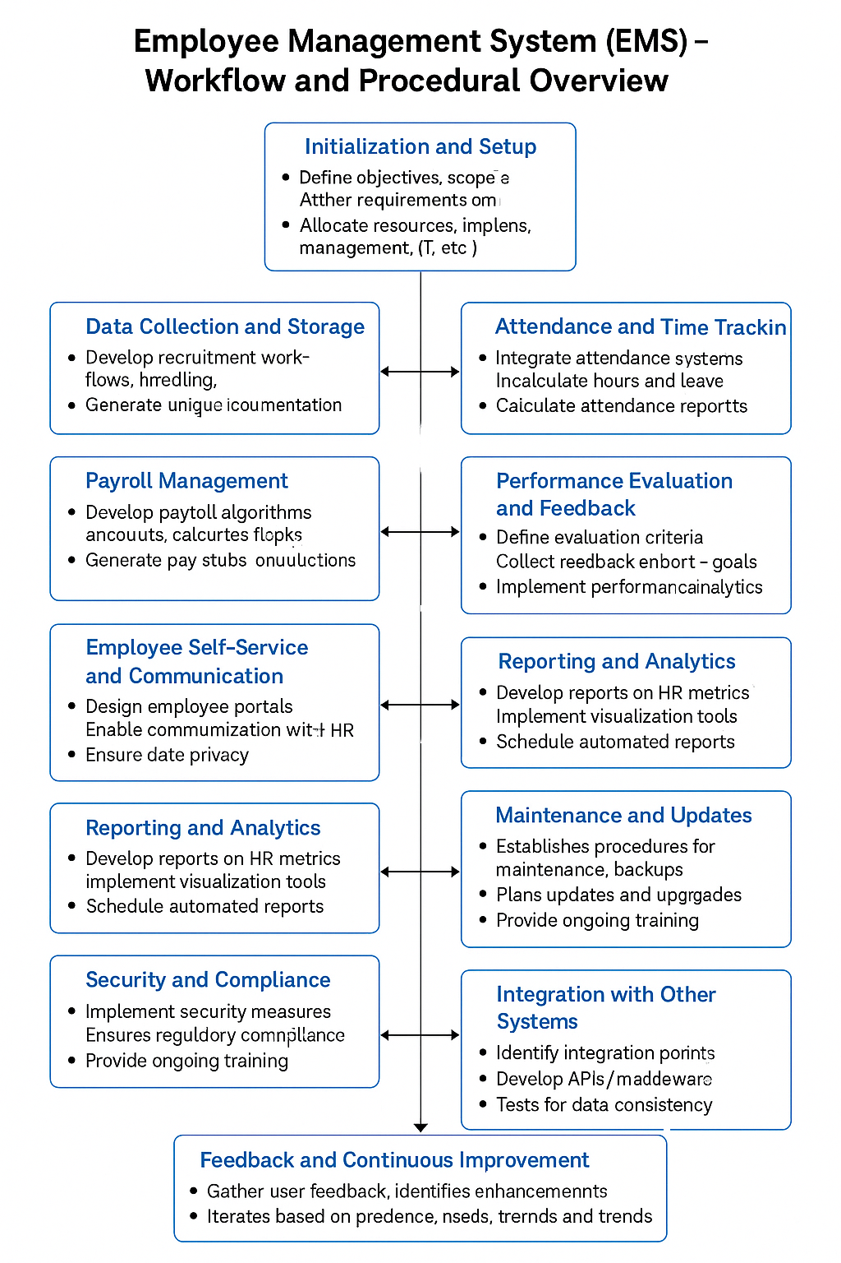

**REQUIREMENTS**

Hardware Requirements

A stable and secure hardware foundation is essential for hosting, processing, and managing EMS operations. Key components include:

* Server Infrastructure: A dedicated or cloud-based server with sufficient processing power, RAM, and storage to handle employee records, transactions, and concurrent user access. For larger organizations, high-availability server clusters may be required.
* Data Storage Solutions: Scalable storage (e.g., SSDs or NAS systems) for storing sensitive employee data, backups, and application files.
* Networking Equipment: Routers, switches, and firewalls to ensure fast, secure, and uninterrupted communication between users and the EMS server.
* Backup and Recovery Systems: Redundant storage and automated backup solutions for disaster recovery and data integrity.

Software Requirements

EMS software encompasses a suite of tools and platforms designed to cover various HR functions. Critical software components include:

* Database Management System (DBMS): Robust solutions like MySQL, PostgreSQL, SQL Server, or Oracle Database to securely store and manage structured employee data.
* Application Development Tools: Integrated Development Environments (IDEs) such as Visual Studio, Eclipse, or JetBrains tools for building and customizing EMS modules.
* Payroll and Attendance Modules: Specialized software for automating payroll calculations, tax deductions, direct deposits, and time tracking.
* Performance Management Tools: Modules that support employee evaluations, goal setting, feedback collection, and analytics.
* Reporting and Analytics Platforms: Tools for generating reports, visualizing HR metrics, and enabling data-driven decision-making (e.g., Power BI, Tableau, or custom dashboards).
* Web & Mobile Interfaces: User-friendly, responsive portals for HR personnel and employees, offering features like self-service, request submission, and real-time access to records.
* Data Encryption (at rest and in transit)
* Role-based Access Controls and multi-factor authentication
* Regular updates and patching to address vulnerabilities
* Compliance with regulations such as GDPR, CCPA, and relevant labor laws
* Audit trails for accountability and regulatory reviews

**IMPLEMENTATION**

***App.js***

const express = require('express');

const bodyParser = require('body-parser');

const db = require('./config/mongoose');

const app = express();

const port = 8000;

app.use(bodyParser.urlencoded({ extended: true }));

app.use(express.static('./public'));

app.set('view engine', 'ejs');

app.set('views', './views');

// Routes

app.use('/', require('./routes/index'));

// Start server

app.listen(port, function (err) {

    if (err) {

        console.log('Error:', err);

        return;

    }

    console.log('Server running on port ', port);

});

***Config/mongoose.js***

<!DOCTYPE html>

<html>

<head>

    <title>Edit Employee</title>

    <link rel="stylesheet" href="/css/style.css">

</head>

<body>

    <h1>Edit Employee</h1>

    <div class="edit-container">

        <h2>Edit Employee</h2>

        <form action="/update/<%= employee._id %>" method="POST">

            <label for="name">Name</label>

            <input type="text" name="name" value="<%= employee.name %>" required>

            <label for="email">Email</label>

            <input type="email" name="email" value="<%= employee.email %>" required>

            <label for="position">Position</label>

            <input type="text" name="position" value="<%= employee.position %>" required>

            <button type="submit">Update</button>

        </form>

    </div>

</body>

</html>

***Controllers/homeController.js***

const Employee = require('../models/employee');

module.exports.home = async (req, res) => {

    const employees = await Employee.find();

    res.render('home', { employees });

};

module.exports.create = async (req, res) => {

    await Employee.create(req.body);

    res.redirect('/');

};

module.exports.delete = async (req, res) => {

    await Employee.findByIdAndDelete(req.params.id);

    res.redirect('/');

};

module.exports.edit = async (req, res) => {

    const emp = await Employee.findById(req.params.id);

    res.render('edit', { employee: emp });

};

module.exports.update = async (req, res) => {

    await Employee.findByIdAndUpdate(req.params.id, req.body);

    res.redirect('/');

};

***Models/employee.js***

const mongoose = require('mongoose');

const employeeSchema = new mongoose.Schema({

    name: String,

    email: String,

    job: String,

    salary: Number

});

const Employee = mongoose.model('Employee', employeeSchema);

module.exports = Employee;

***routes/index.js***

const express = require('express');

const router = express.Router();

const homeController = require('../controllers/homeController');

router.get('/', homeController.home);

router.post('/create', homeController.create);

router.get('/delete/:id', homeController.delete);

router.get('/edit/:id', homeController.edit);

router.post('/update/:id', homeController.update);

module.exports = router;

***views/home.ejs***

<!DOCTYPE html>

<html>

<head>

    <title>EMS</title>

    <link rel="stylesheet" href="/css/style.css">

</head>

<body>

    <h1>Employee List</h1>

    <form action="/create" method="POST">

        <input name="name" placeholder="Name" required>

        <input name="email" placeholder="Email" required>

        <input name="job" placeholder="Job Title" required>

        <input name="salary" type="number" placeholder="Salary" required>

        <button type="submit">Add</button>

    </form>

    <ul>

        <% employees.forEach(function(emp){ %>

            <li>

                <%= emp.name %> - <%= emp.job %> - $<%= emp.salary %>

                <a href="/edit/<%= emp._id %>">Edit</a>

               <a href="/delete/<%= emp._id %>">Delete</a>

            </li>

        <% }) %>

    </ul>

</body>

</html>

***Views/edit.ejs***

<!DOCTYPE html>

<html>

<head>

    <title>Edit Employee</title>

    <link rel="stylesheet" href="/css/style.css">

</head>

<body>

    <h1>Edit Employee</h1>

    <div class="edit-container">

        <h2>Edit Employee</h2>

        <form action="/update/<%= employee._id %>" method="POST">

            <label for="name">Name</label>

            <input type="text" name="name" value="<%= employee.name %>" required>

            <label for="email">Email</label>

            <input type="email" name="email" value="<%= employee.email %>" required>

            <label for="position">Position</label>

            <input type="text" name="position" value="<%= employee.position %>" required>

            <button type="submit">Update</button>

        </form>

    </div>

</body>

</html>

***Public/css/style.css***

body {

    font-family: 'Segoe UI', Tahoma, Geneva, Verdana, sans-serif;

    background: linear-gradient(to right, #0a0f1a, #102a42, #0077b6);

    color: #ffffff;

    margin: 0;

    padding: 40px;

    min-height: 100vh;

}

h1 {

    text-align: center;

    color: #cccccc;

    margin-bottom: 30px;

    font-size: 2.5rem;

    text-shadow: 1px 1px 3px rgba(0, 0, 0, 0.5);

}

form {

    display: flex;

    justify-content: center;

    flex-wrap: wrap;

    gap: 12px;

    margin-bottom: 40px;

}

form input, form button {

    padding: 12px 14px;

    border-radius: 8px;

    border: none;

    font-size: 16px;

    transition: all 0.3s ease-in-out;

}

form input {

    background-color: #1c2b3a;

    color: #ffffff;

    border: 1px solid #4f8fb1;

}

form input:focus {

    border-color: #5bc0f8;

    outline: none;

    box-shadow: 0 0 6px #5bc0f8;

}

form button {

    background: linear-gradient(to right, #0096c7, #023e8a);

    color: white;

    font-weight: bold;

    cursor: pointer;

    box-shadow: 0 4px 8px rgba(0, 191, 255, 0.3);

}

form button:hover {

    background: linear-gradient(to right, #0077b6, #001f3f);

    transform: translateY(-1px);

}

ul {

    list-style: none;

    padding: 0;

    max-width: 800px;

    margin: 0 auto;

}

li {

    background-color: rgba(10, 25, 47, 0.95);

    border: 1px solid #5bc0f8;

    padding: 16px;

    border-radius: 10px;

    margin-bottom: 15px;

    display: flex;

    justify-content: space-between;

    align-items: center;

    transition: transform 0.2s, box-shadow 0.2s;

}

li:hover {

    transform: translateY(-3px);

    box-shadow: 0 8px 16px rgba(91, 192, 248, 0.3);

}

li span {

    font-weight: 500;

    color: #ffffff;

}

li a {

    margin-left: 10px;

    text-decoration: none;

    color: #61dafb;

    font-weight: bold;

    transition: color 0.3s;

}

li a:hover {

    color: #90e0ef;

}

@media (max-width: 600px) {

    form {

        flex-direction: column;

        align-items: center;

    }

    form input, form button {

        width: 90%;

    }

    li {

        flex-direction: column;

        align-items: flex-start;

    }

}

form {

    display: flex;

    flex-direction: column;

    align-items: center;

    gap: 16px;

    margin-bottom: 40px;

}

form input, form button {

    width: 300px;

    padding: 12px 14px;

    border-radius: 8px;

    border: none;

    font-size: 16px;

    transition: all 0.3s ease-in-out;

}

/* Edit Form Specific Styles */

.edit-container {

    max-width: 500px;

    margin: 0 auto;

    background-color: rgba(10, 25, 47, 0.95);

    padding: 30px;

    border-radius: 12px;

    border: 1px solid #5bc0f8;

    box-shadow: 0 0 15px rgba(91, 192, 248, 0.2);

}

.edit-container h2 {

    color: #cccccc;

    text-align: center;

    margin-bottom: 20px;

}

.edit-container label {

    display: block;

    margin-bottom: 6px;

    font-weight: 500;

    color: #b0bec5;

}

.edit-container input[type="text"],

.edit-container input[type="email"],

.edit-container input[type="number"] {

    width: 100%;

    padding: 12px;

    border-radius: 6px;

    border: 1px solid #4f8fb1;

    background-color: #1c2b3a;

    color: #ffffff;

    margin-bottom: 20px;

    transition: 0.3s ease;

}

.edit-container input:focus {

    border-color: #5bc0f8;

    box-shadow: 0 0 5px #5bc0f8;

    outline: none;

}

.edit-container button {

    width: 100%;

    background: linear-gradient(to right, #0096c7, #023e8a);

    border: none;

    color: white;

    font-weight: bold;

    padding: 12px;

    border-radius: 6px;

    cursor: pointer;

    transition: background-color 0.3s ease;

}

.edit-container button:hover {

    background: linear-gradient(to right, #0077b6, #001f3f);

}

***Port:***

**http://localhost:8000/**

**RESULTS**

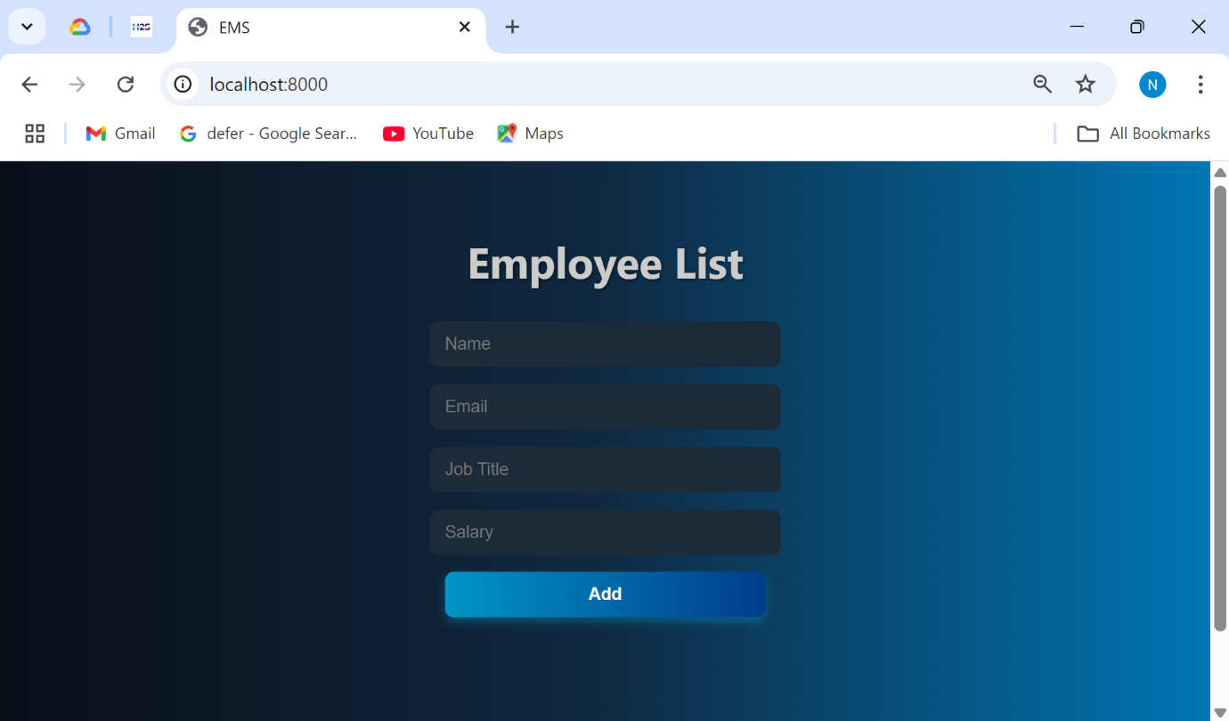

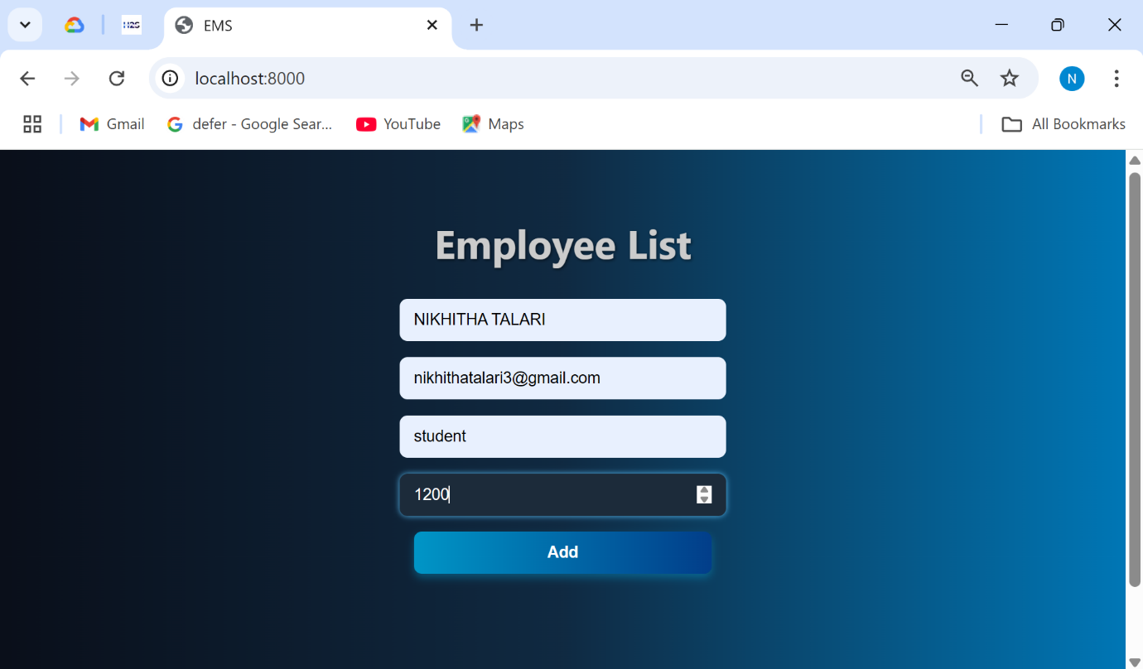

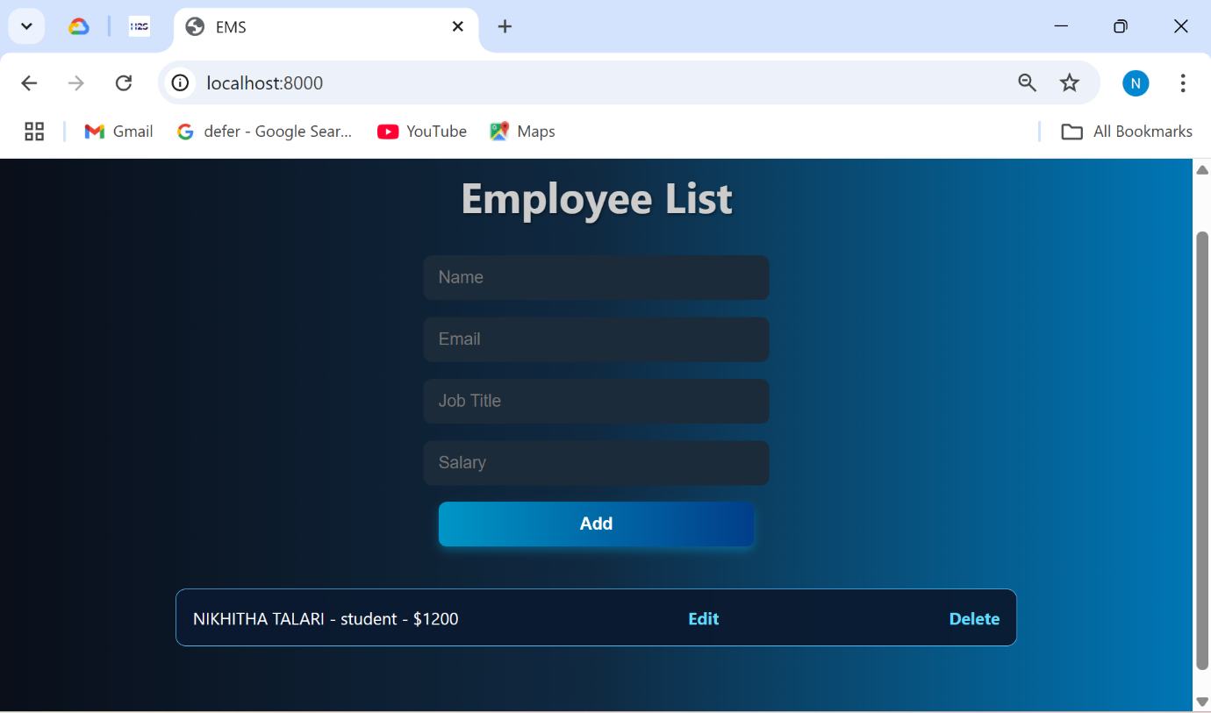

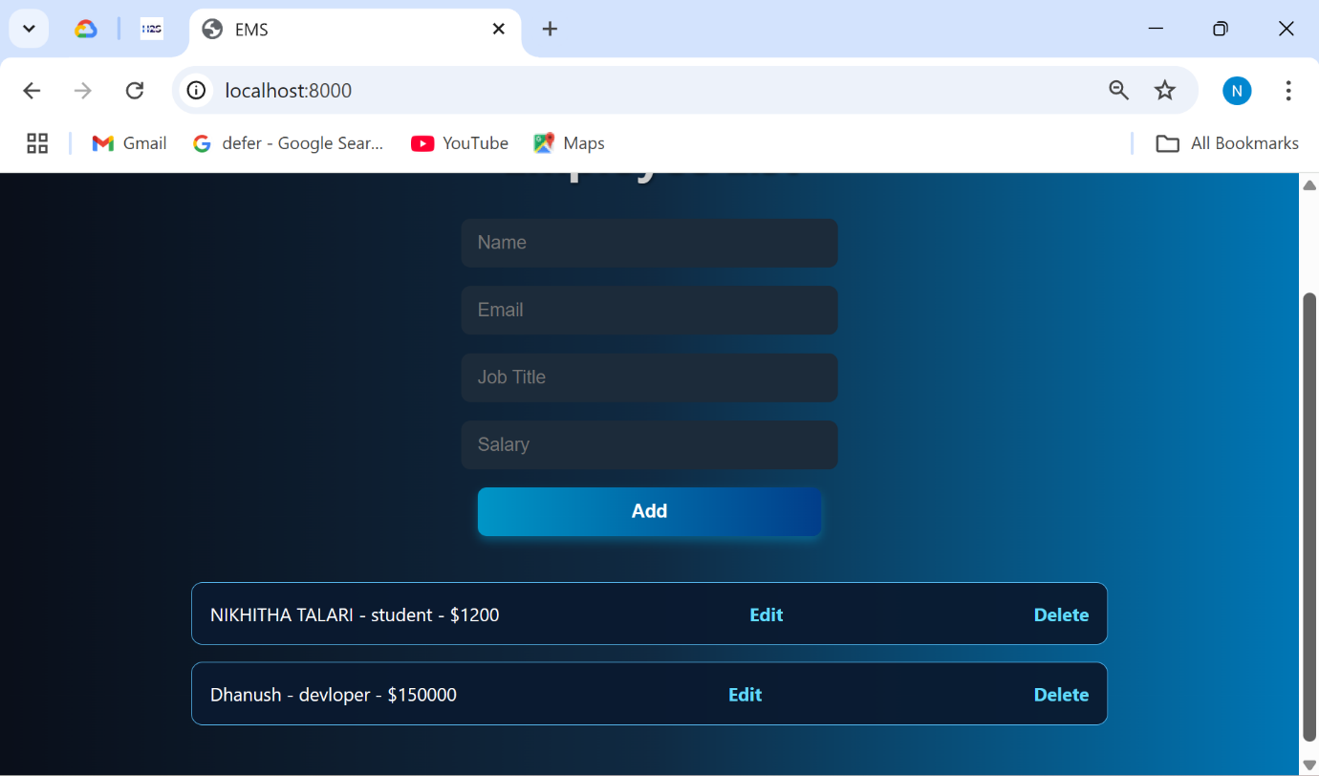

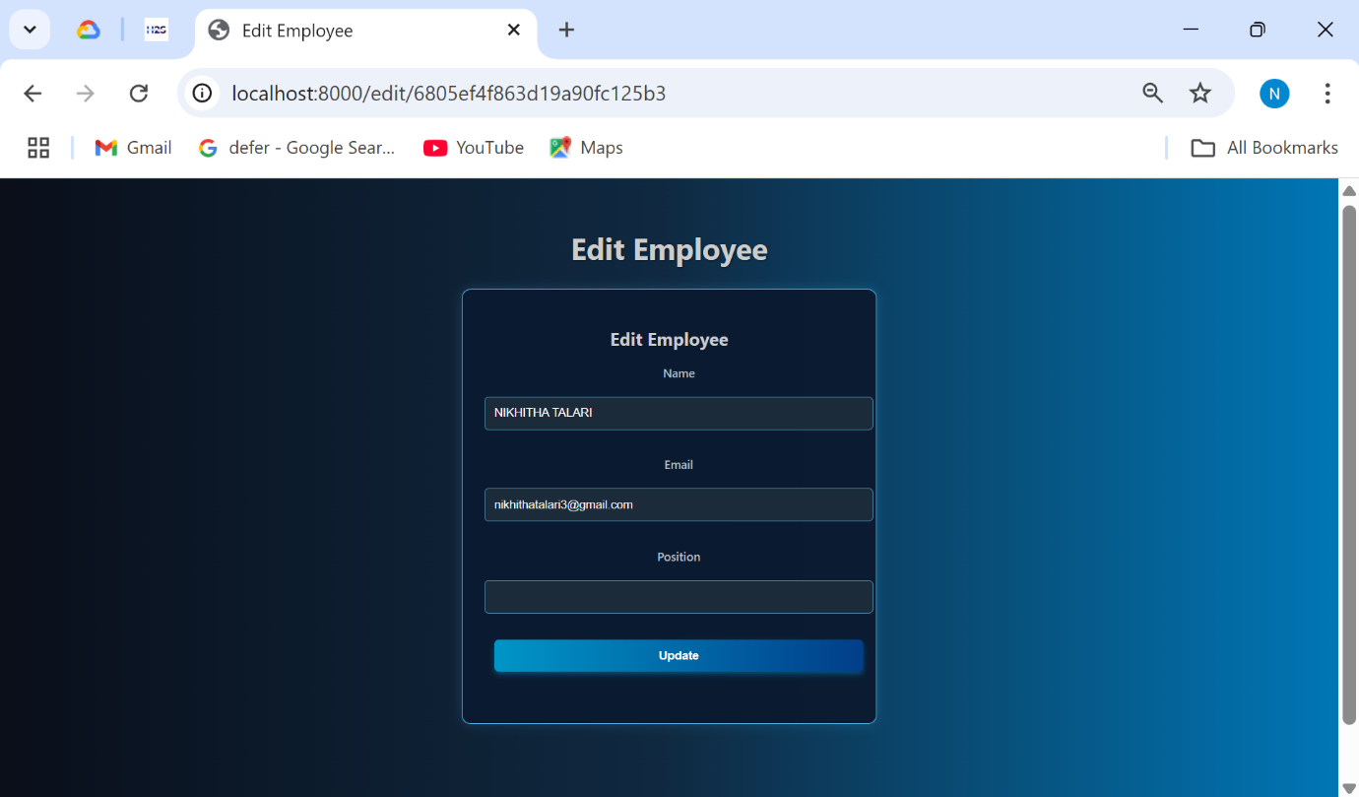

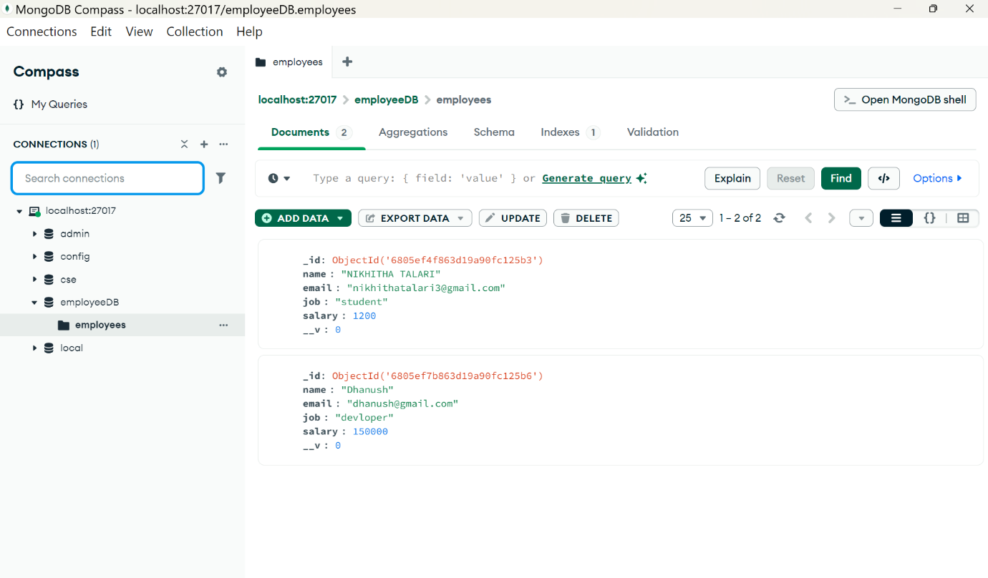

**CONCLUSION**

In conclusion, the implementation of an Employee Management System (EMS) has become an indispensable component for contemporary organizations striving to enhance operational efficiency and streamline human resource management processes. An EMS provides a centralized platform that integrates a wide range of core HR functionalities, including but not limited to payroll administration, attendance and leave tracking, performance appraisal, and employee self-service capabilities. These integrated features significantly reduce the administrative burden on HR personnel, minimize the risk of human error, and ensure the consistency and accuracy of employee-related data across the organization.

Beyond administrative efficiency, an EMS plays a critical role in facilitating strategic decision-making. With advanced reporting and analytics tools, organizations can access real-time insights into workforce metrics such as employee turnover, attendance patterns, productivity levels, and performance trends. These insights enable data-driven planning and policy formulation, allowing businesses to align their human resource strategies with broader organizational goals.

Moreover, a robust EMS fosters improved communication and transparency between HR departments, managers, and employees. Through accessible portals and automated workflows, employees can independently manage tasks such as updating personal information, requesting leave, or viewing performance reviews—thereby enhancing engagement and satisfaction. Managers, in turn, are better equipped to oversee teams, monitor objectives, and provide timely feedback.

As organizations continue to navigate the complexities of a dynamic and increasingly digital business environment, the adoption of a well-designed EMS is not merely a technological upgrade—it is a strategic investment. It empowers organizations to effectively manage their most valuable asset—their workforce—while promoting agility, compliance, and long-term sustainability in human resource practices.

**REFERENCES**

* [https://www.adp.com/resources/articles-andinsights/articles/e/employee-management.aspx](https://www.adp.com/resources/articles-and-insights/articles/e/employee-management.aspx)
* [https://www.geeksforgeeks.org/program-for-employee-managementsystem/](https://www.geeksforgeeks.org/program-for-employee-management-system/)
* <https://www.youtube.com/watch?v=7-mCJxMw6OA>
* <https://www.geeksforgeeks.org/how-to-build-employee-management-system-using-node-js/>
* <https://www.slmanju.com/2018/01/node-employee-management-system.html>