
RollNo: 24WH5A0503 Date: 5-12-25

Title: To implement Node.js backend server for the Campus
Feedback Portal. Page No: 1

Aim:
To set up the backend server and connect it with MongoDB for handling portal requests. .

Description:
In this experiment, the backend server for the Campus Feedback Portal is implemented using Node.js, Express.js, and MongoDB. The required modules such as Express, Mongoose, and CORS are imported and configured. The server is initialized to accept JSON data and cross-origin requests from the frontend. The MongoDB database is connected so that user and feedback information can be stored and retrieved successfully. The backend routes for authentication and feedback operations are also attached to the server. This experiment forms the foundation for all further backend operations in the project because it makes the server ready to process user requests from the frontend.

Source Code:
server.js:
const express = require("express");
const mongoose = require("mongoose");
const cors = require("cors");

const authRoutes = require("./routes/authRoutes");
const feedbackRoutes = require("./routes/feedbackRoutes");

const app = express();

app.use(cors());
app.use(express.json());

mongoose.connect("mongodb://127.0.0.1:27017/campusFeedback")
.then(()=>console.log("MongoDB Connected"))
.catch(err=>console.log(err));

app.use("/api/auth", authRoutes);
app.use("/api/feedback", feedbackRoutes);

app.listen(5000, () => {
console.log("Server running on port 5000");
});


RollNo: Title:
24WH5A0503 Date:

Page No: 2

Output:

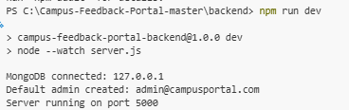

RollNo: 24WH5A0503 Date:12-12-25

Title: To implement user registration and login authentication using Node.js and MongoDB in Campus Feedback Portal.
Page No: 3

Aim:
To register users securely and allow authenticated login using encrypted passwords and JWT tokens.

Description:
In this experiment, the user authentication system is implemented for the Campus Feedback Portal. During registration, user details such as name, email, password, and department are collected and stored in MongoDB. Before storing, the password is encrypted using bcrypt.js, which improves security by avoiding plain-text password storage. During login, the entered email and password are verified against the database. If the credentials are valid, a JWT token is generated and returned to the user. This token is later used to access protected feedback routes. This experiment is essential because authentication provides secure access control and distinguishes between student and admin users.

Source code:

const router = require("express").Router();
const User = require("../models/User");
const bcrypt = require("bcryptjs");
const jwt = require("jsonwebtoken");

router.post("/register", async (req,res)=>{

const {name,email,password,department} = req.body;

const hashed = await bcrypt.hash(password,10);

const user = new User({
name,
email,
password:hashed,
department
});

await user.save();

res.json({msg:"User registered"});

});

router.post("/login", async (req,res)=>{

const {email,password} = req.body;

const user = await User.findOne({email});

if(!user) return res.status(400).json({msg:"User not found"});

const isMatch = await bcrypt.compare(password,user.password);

if(!isMatch) return res.status(400).json({msg:"Wrong password"});


RollNo: Title:
24WH5A0503 Date:

Page No:4

const token = jwt.sign(
{ id:user._id, role:user.role },
"secretkey"
);

res.json({
token,
role:user.role
});

});

module.exports = router;

Output:

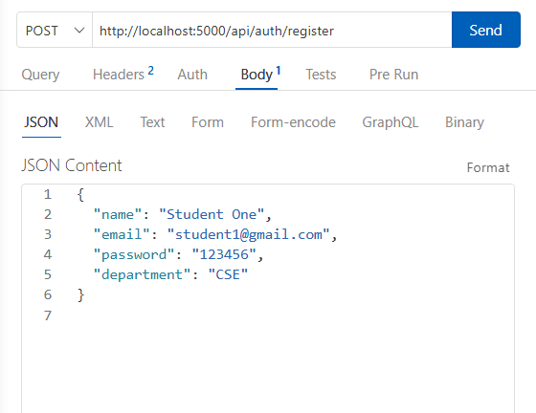

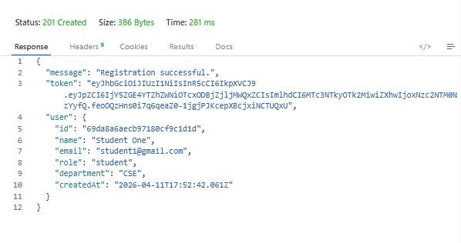


RollNo: 24WH5A0503 Date:12-12-25

Title: To implement the user schema in MongoDB for storing

Student and admin details. Page No:5

Aim:
To define the structure of user data in the Campus Feedback Portal..

Description:
This experiment creates the user model using Mongoose. The schema stores user information such as name, email, password, role, and department. The email field is kept unique so that duplicate accounts cannot be created. A default role of student is assigned when a user registers. This schema is important because it organizes the user data in a consistent structure and supports role-based access in the portal.

Source code:

const mongoose = require("mongoose");

const userSchema = new mongoose.Schema(
{
name: {
type: String,
required: true,
trim: true
},
email: {
type: String,
required: true,
unique: true,
lowercase: true,
trim: true
},
password: {
type: String,
required: true,
minlength: 6
},
role: {
type: String,
enum: ["student", "admin"],
default: "student"
},
department: {
type: String,
required: true,
trim: true
}
},
{
timestamps: true
}
);

module.exports = mongoose.model("User", userSchema);


RollNo: 24WH5A0503 Date:

Title: Page No:6

Output:

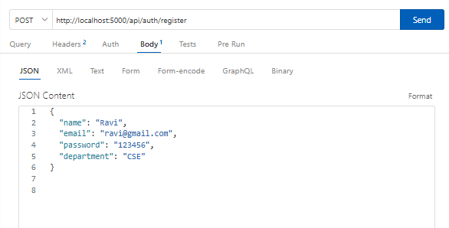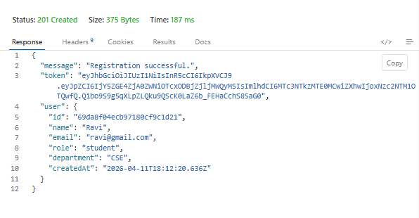

RollNo: 24WH5A0503 Date:19-12-25

Title: To implement MongoDB database connection for the Campus
Feedback Portal. Page No:7

Aim:
To establish a reusable connection between the application and MongoDB.

Description:
This experiment demonstrates the MongoDB connection setup using Mongoose. A separate database utility file is created so that the database connection logic can be reused throughout the application. The backend connects to the campusFeedback database, which stores all user and feedback records. This experiment is important because a stable database connection is necessary for maintaining persistent application data and supporting future scalability..

Source code:

Server.js:
const mongoose = require("mongoose");

const connectDatabase = async () => {
try {
await mongoose.connect(process.env.MONGODB_URI || "mongodb://127.0.0.1:27017/campus_feedback_portal");
console.log("MongoDB connected successfully");
} catch (error) {
console.error("Database connection failed:", error.message);
process.exit(1);
}
};

module.exports = connectDatabase;


RollNo: 24WH5A0503 Date:

Title: Page No:8

Output:



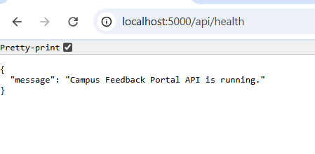
Roll No: 24WH5A0503 Date:2-1-26

Title: To implement JWT authentication middleware for protecting feedback Page No:9

routes.


Aim:
To verify the token sent by the user before allowing access to protected routes.

Description:
This experiment implements the authentication middleware using JSON Web Token. The middleware checks whether the authorization token is present in the request header. If the token exists, it is verified using the secret key. When the token is valid, the decoded user details are attached to the request object and the request is allowed to continue. If the token is missing or invalid, access is denied. This experiment is important because it secures the private routes of the application and ensures that only authenticated users can perform feedback operations.

Source code:
const jwt = require("jsonwebtoken");
const User = require("../models/User");
const protect = async (req, res, next) => {
try {
const authHeader = req.headers.authorization;
if (!authHeader || !authHeader.startsWith("Bearer ")) {
return res.status(401).json({ message: "Not authorized, token missing" });
}
const token = authHeader.split(" ")[1];
const decoded = jwt.verify(
token,
process.env.JWT_SECRET || "replace_with_a_strong_secret"
);
const user = await User.findById(decoded.id).select("-password");
if (!user) {
return res.status(401).json({ message: "User not found" });
}
req.user = user;
next();
} catch (error) {
return res.status(401).json({ message: "Not authorized, token invalid" });
}
};
module.exports = { protect };


RollNo:24WH5A0503 Date:

Title: Page No:10

Output:

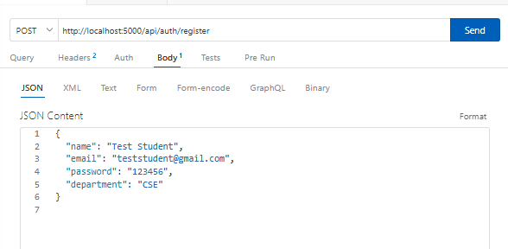

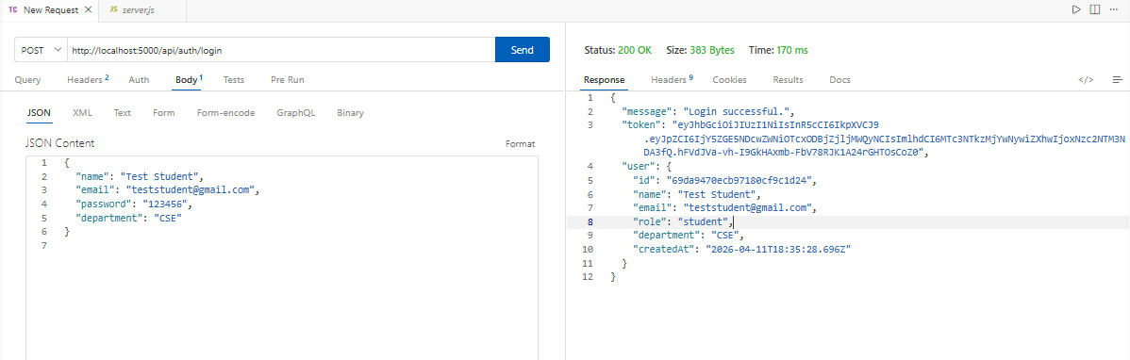

RollNo: 24WH5A0503

6)
Title: To implement the Feedback schema in MongoDB for storing students feedback details.
Date:9-1-26

Page No:11



Aim:
To define the structure of feedback data submitted by students.

Description:
In this experiment, the feedback model is created using Mongoose. The schema stores the student ID reference, subject name, faculty name, rating, comment, and submission date. The student ID is linked with the User collection, which makes it possible to identify which student submitted the feedback. This experiment is important because the feedback schema acts as the core data model of the project and supports feedback storage, retrieval, and management.

Source code:
const mongoose = require("mongoose");

const feedbackSchema = new mongoose.Schema(
{
studentId: {
type: mongoose.Schema.Types.ObjectId,
ref: "User",
required: true
},
subject: {
type: String,
required: true,
trim: true
},
facultyName: {
type: String,
required: true,
trim: true
},
rating: {
type: Number,
required: true,
min: 1,
max: 5
},
comment: {
type: String,
required: true,
trim: true
},
submittedAt: {
type: Date,
default: Date.now
}
},
{
timestamps: true
}
);

module.exports = mongoose.model("Feedback", feedbackSchema);


RollNllNo: 24WH5A0503 Date:

Title: Page No:12

Output:

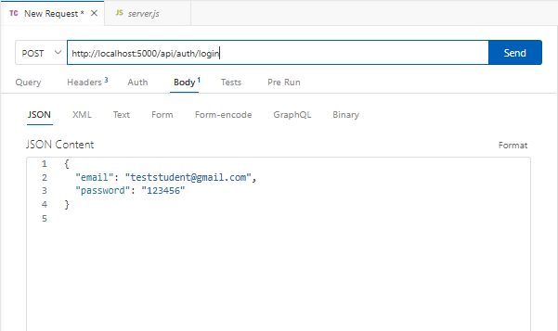

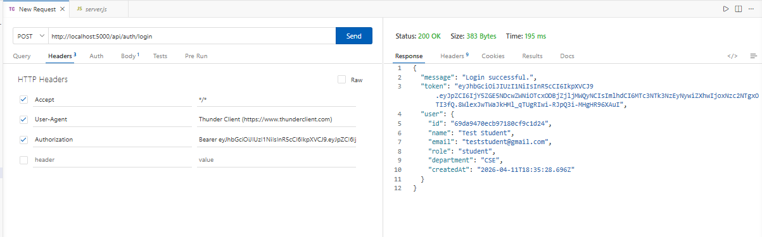


RollNo: 24WH5A0503 Date:

Title: Page No:13

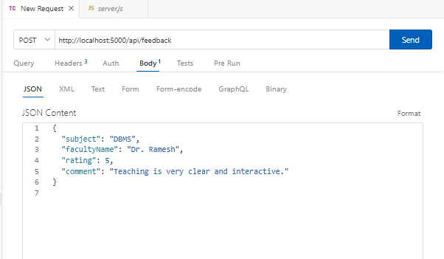

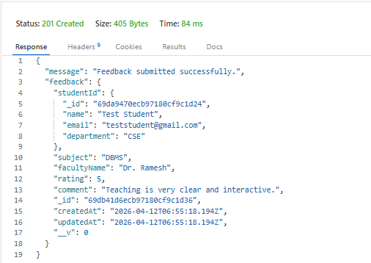

RollNo: 24WH5A0503 Date:9-1-26

Title: To implement CRUD operations for feedback management Page No:14
Using Node.js and MongoDB.

Aim:
To create, read, update, and delete feedback records in the Campus Feedback Portal..

Description:
This experiment demonstrates feedback CRUD operations using Express.js and MongoDB. Authenticated students can submit feedback, and all feedback records can be retrieved from the database. The backend also supports updating existing feedback records and deleting them when needed. The feedback routes are protected using JWT middleware so that only authorized users can access them. This experiment is an important part of the project because CRUD functionality forms the main backend logic for managing feedback data.

Source code:
const router = require("express").Router();
const Feedback = require("../models/Feedback");
const auth = require("../middleware/authMiddleware");

router.post("/", auth, async (req, res) => {
const feedback = new Feedback({
studentId: req.user.id,
subject: req.body.subject,
facultyName: req.body.facultyName,
rating: req.body.rating,
comment: req.body.comment
});

await feedback.save();

res.json({ msg: "Feedback submitted" });
});

router.get("/", auth, async (req, res) => {
const feedbacks = await Feedback.find().populate("studentId", "name");
res.json(feedbacks);
});

router.put("/:id", auth, async (req, res) => {
await Feedback.findByIdAndUpdate(req.params.id, req.body);
res.json({ msg: "Updated" });
});

router.delete("/:id", auth, async (req, res) => {
await Feedback.findByIdAndDelete(req.params.id);
res.json({ msg: "Deleted" });
});


RollNo: 24WH5A0503 Date:

Title: Page No:15

module.exports = router;

Output:

Student-feedback:

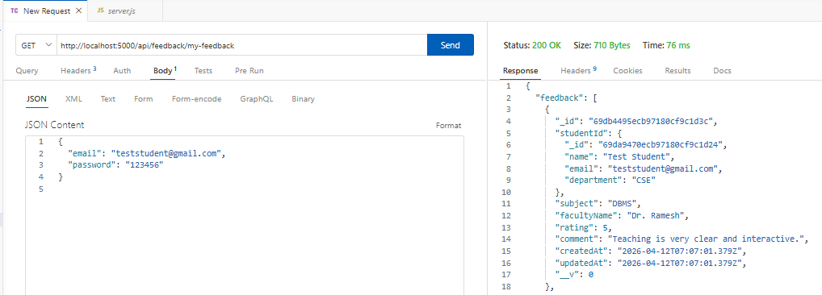

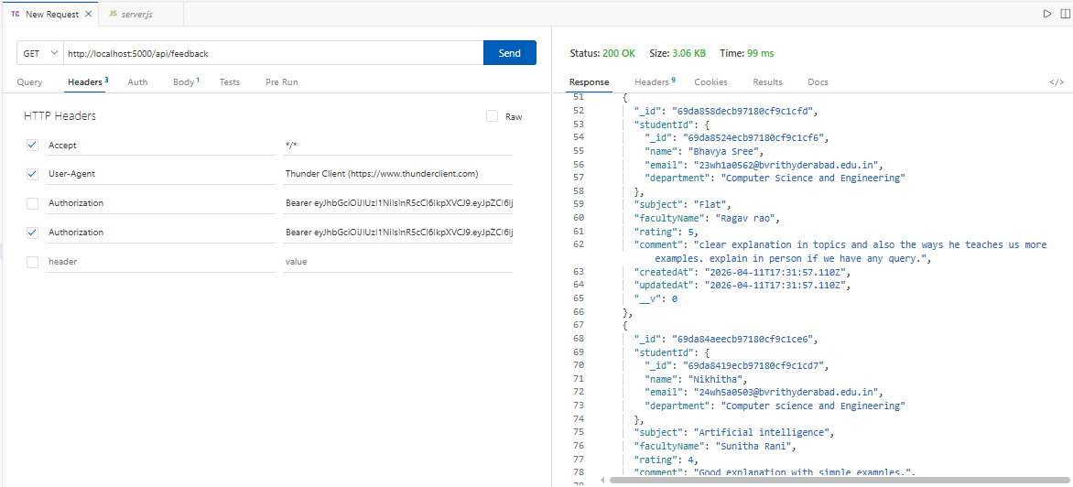


RollNo: 24WH5A0503 Date:23-1-26

Title: To implement the React frontend routing system for the CFP . Page No:16

Aim:
To create a multi-page React application using component-based routing.

Description:
This experiment demonstrates frontend page navigation using React Router. Separate pages are created for login, registration, student dashboard, feedback submission, and admin dashboard. Routing allows users to move from one page to another without reloading the browser. This improves the user experience and organizes the application into reusable components. This experiment is important because it provides a structured frontend interface for both students and administrators.

Source code:

import React from "react";
import {BrowserRouter,Routes,Route} from "react-router-dom";

import Login from "./pages/Login";
import Register from "./pages/Register";
import StudentDashboard from "./pages/StudentDashboard";
import SubmitFeedback from "./pages/SubmitFeedback";
import AdminDashboard from "./pages/AdminDashboard";

function App(){
return(
<BrowserRouter>
<Routes>

<Route path="/" element={<Login/>}/>
<Route path="/register" element={<Register/>}/>
<Route path="/student" element={<StudentDashboard/>}/>
<Route path="/submit" element={<SubmitFeedback/>}/>
<Route path="/admin" element={<AdminDashboard/>}/>

</Routes>
</BrowserRouter>
);
}
export default App;


RollNo: 24WH5A0503 Date:

Title: Page No:17

Output:

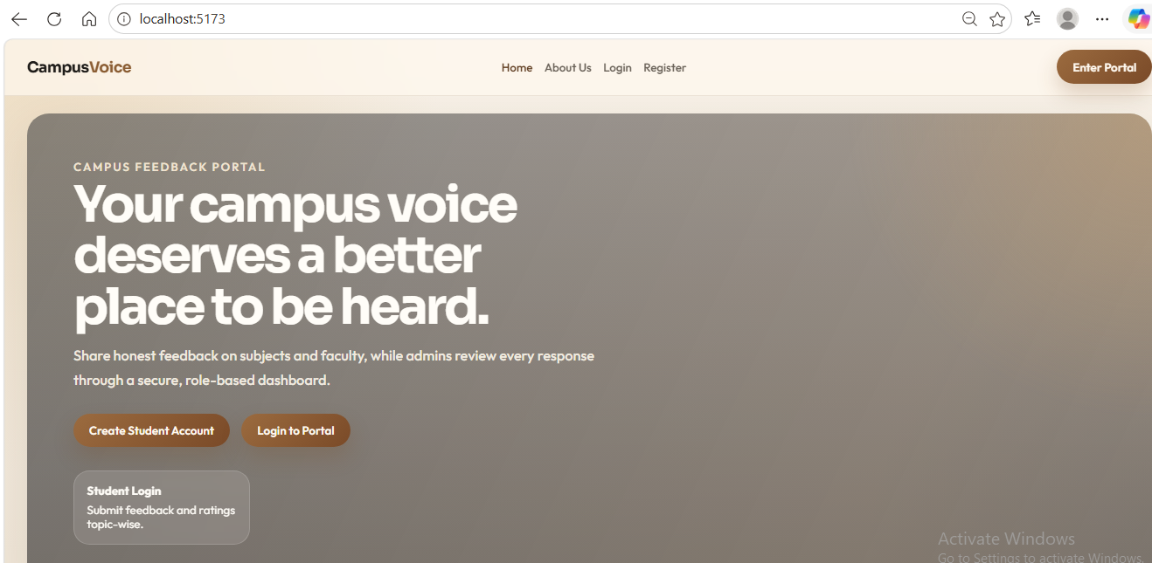
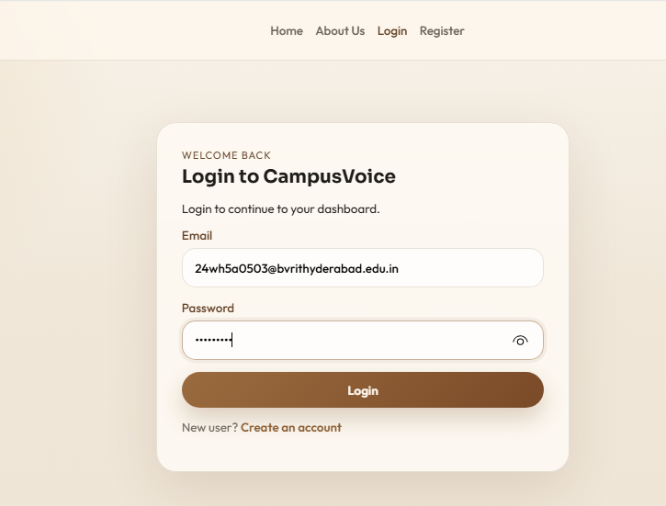
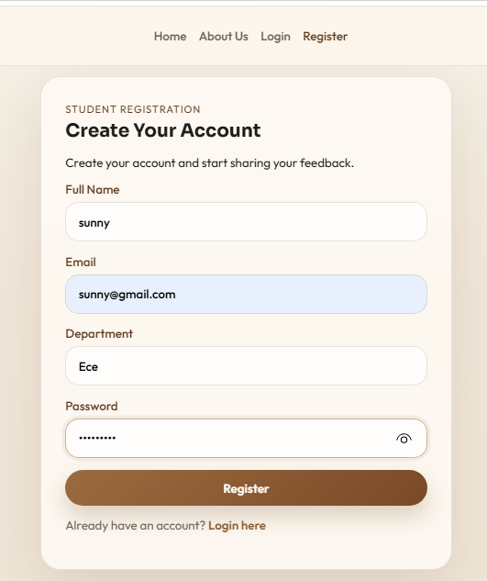


RollNo: 24WH5A0503 Date:

Title: Page No:18

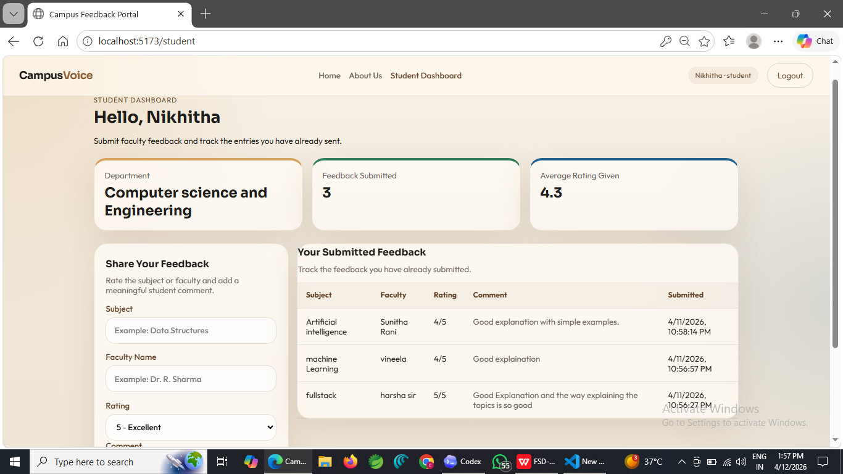

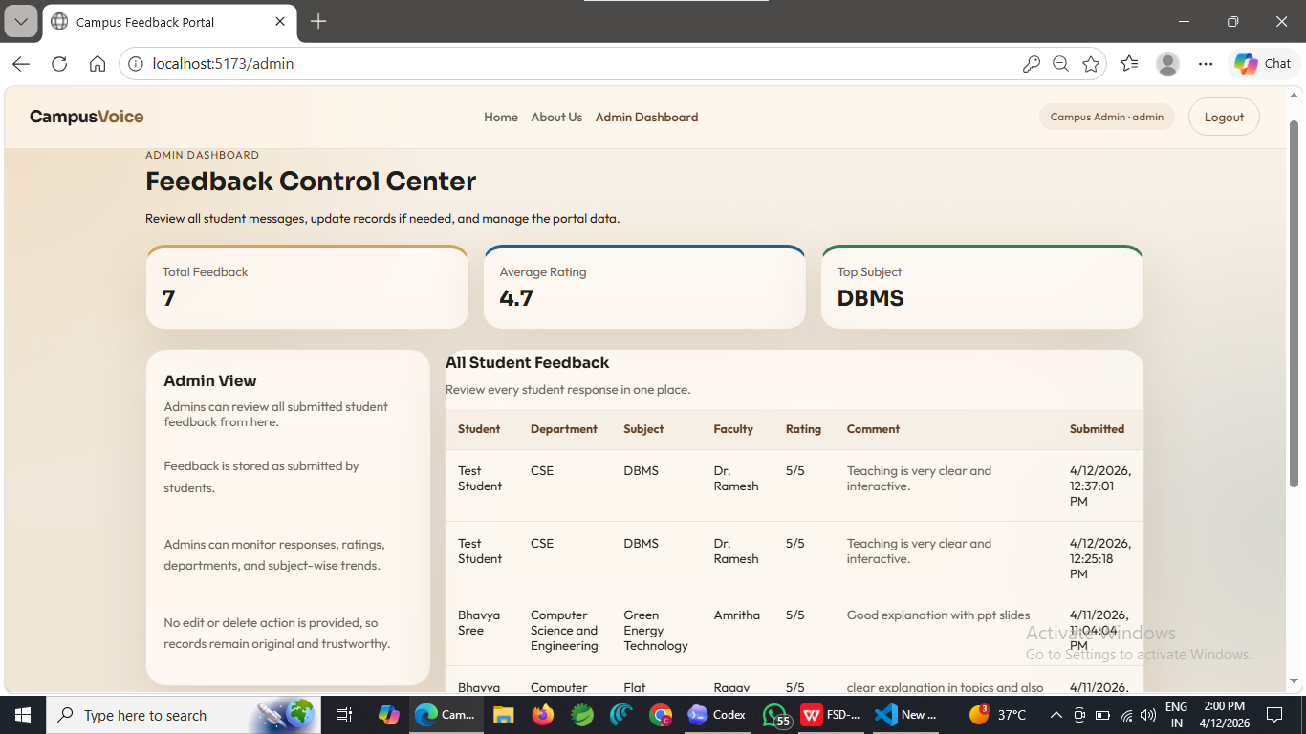


RollNo: 24WH5A0503 Date:30-1-26

Title: To implement the react login and registration from in the CFP. Page No:19

Aim:
To collect user details through forms and send them to the backend for registration and login..

Description:
This experiment demonstrates frontend form handling in React for user registration and login. The registration page collects user details such as name, email, department, and password. The login page collects email and password, sends them to the backend, and stores the returned token in local storage. Based on the returned role, the user is redirected either to the student dashboard or the admin dashboard. This experiment is important because it connects the frontend user interface with the backend authentication system..

Source code:

Login.js:
import React,{useState} from "react";
import api from "../api";
import {useNavigate} from "react-router-dom";

function Login(){

const[email,setEmail]=useState("");
const[password,setPassword]=useState("");

const navigate=useNavigate();

const login=async()=>{

const res = await api.post("/auth/login",{email,password});

localStorage.setItem("token",res.data.token);

if(res.data.role==="admin"){
navigate("/admin");
}
else{
navigate("/student");
}

};

return(
<div>
<h2>Login</h2>
<input placeholder="Email" onChange={e=>setEmail(e.target.value)}/>
<input type="password" placeholder="Password"
onChange={e=>setPassword(e.target.value)}/>
<button onClick={login}>Login</button>
</div>
);
}
export default Login;


RollNo: 24WH5A0503 Date:

Title: Page No:20

Register.js:
import React,{useState} from "react";
import api from "../api";

function Register(){

const[name,setName]=useState("");
const[email,setEmail]=useState("");
const[password,setPassword]=useState("");
const[department,setDepartment]=useState("");

const register=async()=>{

await api.post("/auth/register",{
name,email,password,department
});

alert("Registered");

};

return(
<div>
<h2>Register</h2>
<input placeholder="Name" onChange={e=>setName(e.target.value)}/>
<input placeholder="Email" onChange={e=>setEmail(e.target.value)}/>
<input placeholder="Department" onChange={e=>setDepartment(e.target.value)}/>
<input type="password" placeholder="Password" onChange={e=>setPassword(e.target.value)}/>
<button onClick={register}>Register</button>
</div>
);
}

export default Register;

Output:

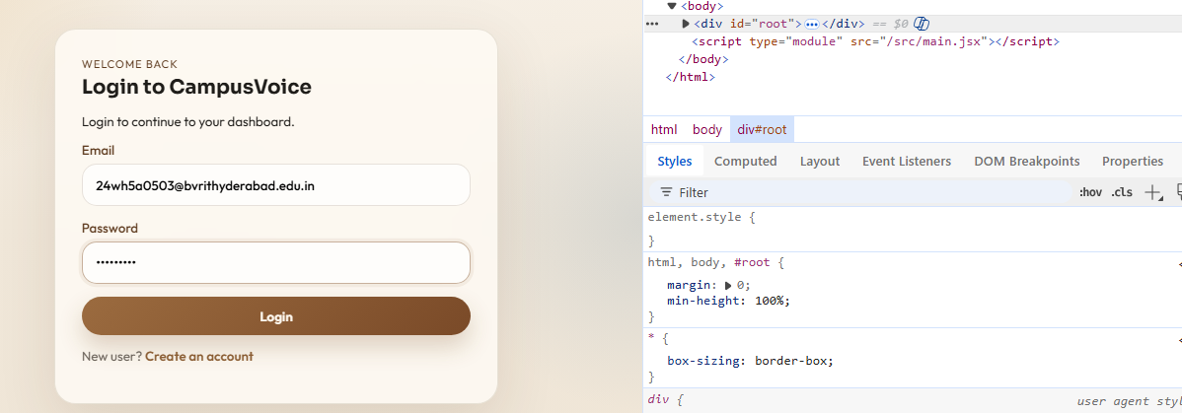


RollNo: 24WH5A0503 Date:20-2-26

Title: To implement a react-based feedback submission form in the CFP.
Page No:21

Aim:
To allow students to enter and submit feedback through the frontend interface.

Description:
This experiment implements the feedback submission page using React. The form allows the student to enter subject name, faculty name, rating, and comments. The entered values are stored using React state and sent to the backend through an API call. The JWT token stored in local storage is included in the request header for authentication. This experiment is important because it represents the main user activity of the portal, which is to submit feedback digitally in a structured form.
Source code:
SubmitFeedback.js:

import React,{useState} from "react";
import api from "../api";

function SubmitFeedback(){

const[subject,setSubject]=useState("");
const[facultyName,setFaculty]=useState("");
const[rating,setRating]=useState("");
const[comment,setComment]=useState("");

const submit=async()=>{

await api.post("/feedback",
{subject,facultyName,rating,comment},
{headers:{authorization:localStorage.getItem("token")}}
);

alert("Feedback submitted");

};

return(
<div>
<h2>Submit Feedback</h2>
<input placeholder="Subject" onChange={e=>setSubject(e.target.value)}/>
<input placeholder="Faculty Name" onChange={e=>setFaculty(e.target.value)}/>
<input placeholder="Rating" onChange={e=>setRating(e.target.value)}/>
<textarea placeholder="Comment" onChange={e=>setComment(e.target.value)}/>
<button onClick={submit}>Submit</button>
</div>
);
}

export default SubmitFeedback;


RollNo: 24WH5A0503 Date:

Title: Page No:22

Output:

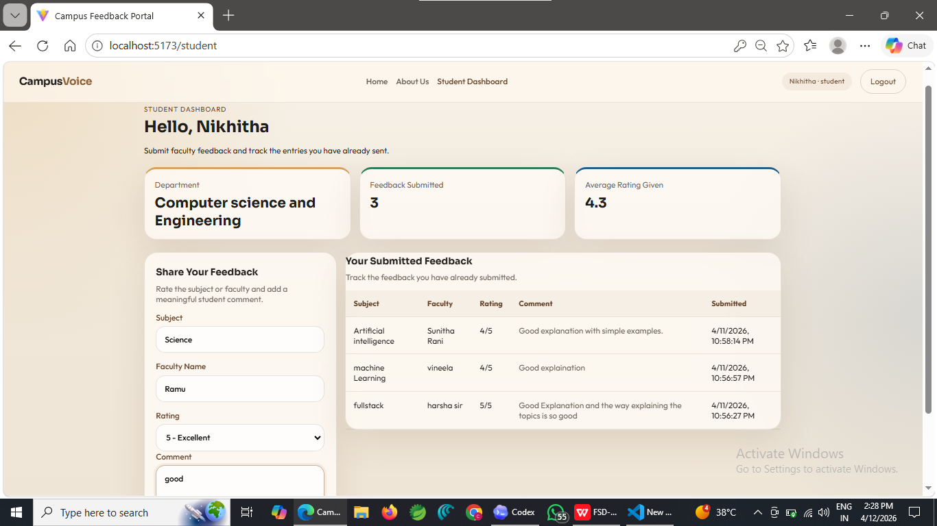



11)
RollNo: 24WH5A0503

Title: To implement feedback fetching and display in the admin dashboard using React.
Date:27-2-26

Page No:23


Aim:
To retrieve all submitted feedback records from the backend and display them in the admin interface.

Description:
This experiment demonstrates how feedback data is fetched from the backend and displayed dynamically in the React admin dashboard. When the admin dashboard loads, the frontend sends a request to the feedback API with the stored token. The returned feedback records are stored in React state and rendered on the page. Each feedback entry shows details such as subject, faculty name, rating, and comment. This experiment is important because it allows administrators to monitor submitted feedback and manage the records from one place.

Source code:
AdminDashboard.js
import React,{useEffect,useState} from "react";
import api from "../api";

function AdminDashboard(){

const[feedbacks,setFeedbacks]=useState([]);

useEffect(()=>{

fetchData();

},[]);

const fetchData=async()=>{

const res = await api.get("/feedback",{
headers:{authorization:localStorage.getItem("token")}
});

setFeedbacks(res.data);

};

const deleteFeedback=async(id)=>{

await api.delete("/feedback/"+id,{
headers:{authorization:localStorage.getItem("token")}
});

fetchData();
};


RollNo: 24WH5A0503 Date:

Title: Page No:24

return(
<div>
<h2>Admin Dashboard</h2>

{feedbacks.map(f=>(
<div key={f._id}>
<h3>{f.subject}</h3>
<p>{f.facultyName}</p>
<p>{f.rating}</p>
<p>{f.comment}</p>

<button onClick={()=>deleteFeedback(f._id)}>Delete</button>
</div>
))}
</div>
);
}

export default AdminDashboard;

Output:

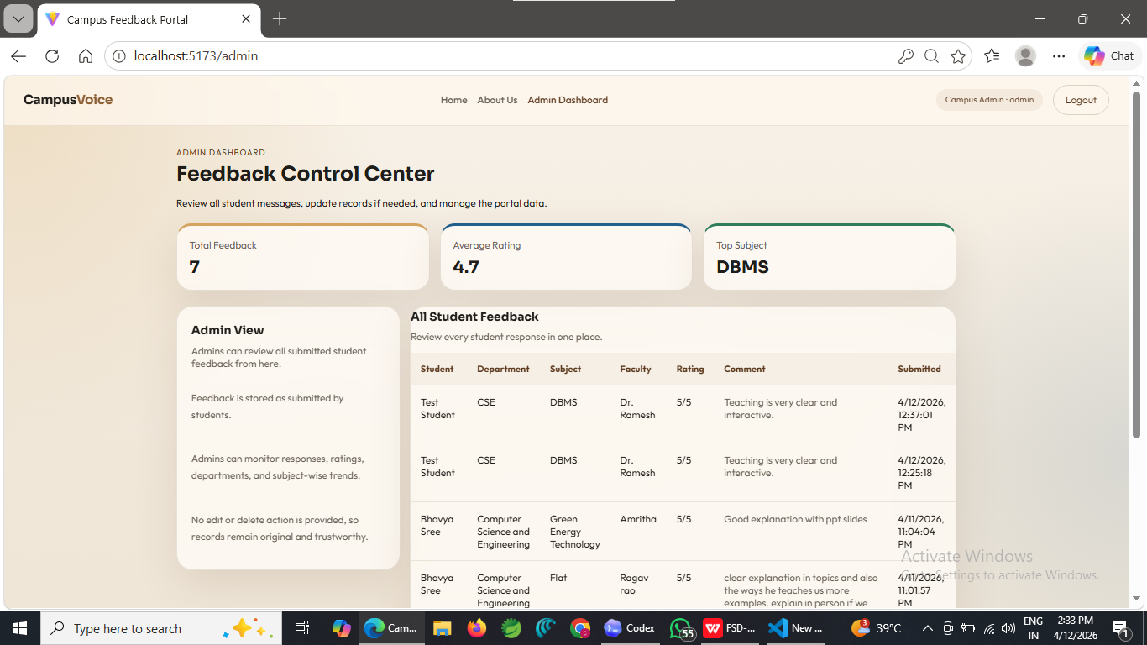


RollNo: 24WH5A0503 Date:6-3-26

12) Title: To implement frontend-backend integration in the CFP using Page No:25 React,Node.js and MongoDB.

Aim:
To connect the React frontend with the Node.js backend and MongoDB database into one working application.

Description:
This experiment demonstrates the full-stack integration of the Campus Feedback Portal. The React frontend sends requests through Axios to the Express backend. The backend processes user and feedback requests and stores the results in MongoDB. Authentication tokens are stored in local storage and included in API requests for protected routes. Students can register, log in, and submit feedback, while administrators can log in, view all submitted feedback, and delete entries. This experiment proves that the frontend, backend, and database are working together as a complete application.

Source code:

import axios from "axios";

export default axios.create({
baseURL:"http://localhost:5000/api"
});

await api.post("/auth/login",{email,password});
await api.post("/feedback",
{subject,facultyName,rating,comment},
{headers:{authorization:localStorage.getItem("token")}}
);
const res = await api.get("/feedback",{
headers:{authorization:localStorage.getItem("token")}
});

Output:

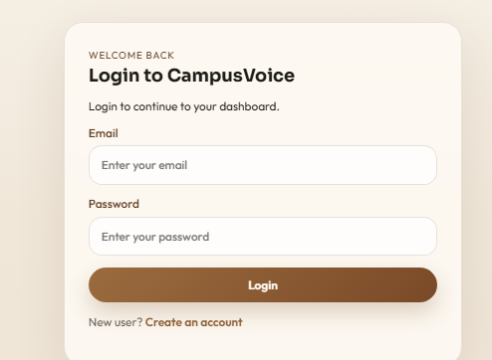



RollNo: 24WH5A0503

Title:

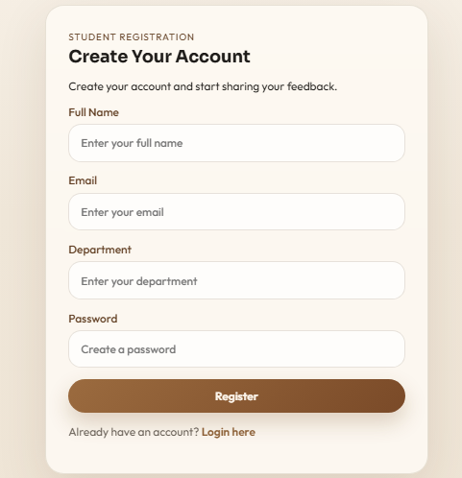


Date:

Page No:26

13)
RollNo: 24WH5A0503

Title: To implement a student dashboard in React for navigation feedback submission in the CFP.
Date:13-3-26

Page No:27



Aim:
To create a student dashboard that allows users to access the feedback submission module easily.

Description:
This experiment demonstrates the implementation of the student dashboard in the Campus Feedback Portal using React. After successful login, student users are redirected to the dashboard page. This page acts as the main navigation area for students and provides access to the feedback submission form. The dashboard is designed using React components and React Router links, which allow page navigation without reloading the browser. This experiment is important because it improves usability by providing students with a clear entry point to perform the main operation of the project, which is feedback submission.

Source code:

StudentDashboard.js:
import React from "react";
import {Link} from "react-router-dom";

function StudentDashboard(){

return(

<div>

<h2>Student Dashboard</h2>

<Link to="/submit">Submit Feedback</Link>

</div>

);

}

export default StudentDashboard;

Output:


RollNo: 24WH5A0503 Date:

Title: Page No:28

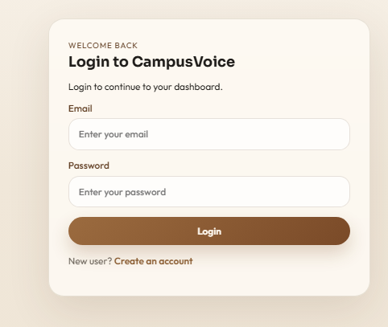

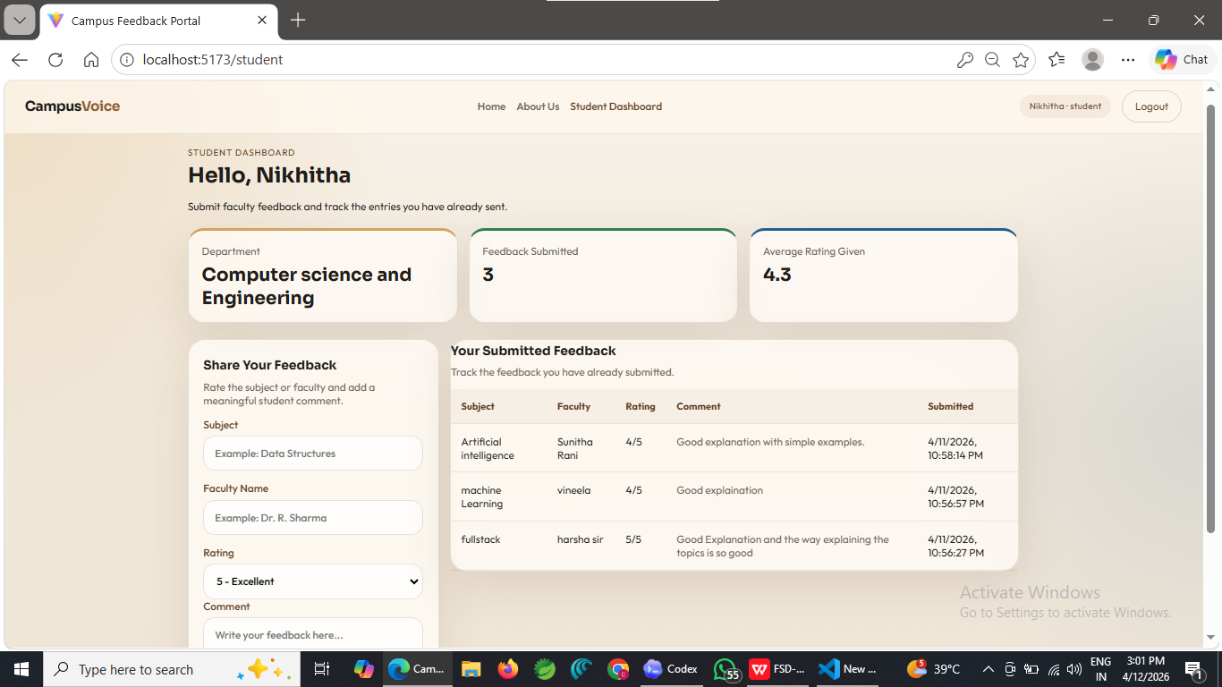



14)
RollNo: 24WH5A0503

Title: To implement Axios API integration in React for connecting the frontend with the backendin the CFP.
Date:20-3-26

Page No:29

Aim:
To establish communication between the React frontend and Express backend using Axios.

Description:
This experiment demonstrates the integration of the frontend with the backend API using Axios in the Campus Feedback Portal. A separate API utility file is created in the React application to define the backend base URL. This allows all frontend components such as login, registration, feedback submission, and admin dashboard to send HTTP requests in a reusable and consistent way. Using Axios simplifies API communication and reduces repeated code across components. This experiment is important because it forms the communication layer between the user interface and the backend server, enabling full-stack functionality in the project.

Source code:

import axios from "axios";

export default axios.create({
baseURL:"http://localhost:5000/api"
});

Usage in Components:

const res = await api.post("/auth/login",{email,password});

await api.post("/auth/register",{
name,email,password,department
});

await api.post("/feedback",
{subject,facultyName,rating,comment},
{headers:{authorization:localStorage.getItem("token")}}
);

const res2 = await api.get("/feedback",{
headers:{authorization:localStorage.getItem("token")}
});


RollNo: 24WH5A0503 Date:

Title: Page No:30

Output:



