SRM University – AP, Andhra Pradesh
Bachelor of Technology
In
Computer Science and Engineering
School of Engineering and Sciences
Submitted by
K. SAI NIKHITHA
AP22110010498
CSE-R



Under the Guidance of
Dr. Bala Venkateswarlu
SRM University–AP
Neerukonda, Mangalagiri, Guntur
Andhra Pradesh – 522 240

ABSTRACT
Phishing websites frequently imitate the appearance of legitimate sites to deceive users into sharing personal and financial information. Traditional detection methods that rely on URL characteristics or textual analysis are often bypassed through obfuscation and dynamic content manipulation. This project presents a visual phishing detection system that analyzes website screenshots instead of URL features.
A convolutional neural network based on MobileNetV2 is used to classify screenshots as phishing or legitimate after applying data normalization and augmentation. The model demonstrates strong accuracy and reliable performance, as validated through classification metrics and confusion matrix analysis. The results indicate that visual features provide an effective and robust approach for identifying phishing websites, offering a practical enhancement to web security systems.

INTRODUCTION
Phishing continues to grow as a major cybersecurity challenge, relying on visual imitation to trick users into engaging with fraudulent websites. Existing approaches such as rule-based filters, lexical analysis, and URL inspection provide only partial protection and are easily circumvented by attackers who use techniques like URL redirection, encoded scripts, and replicated webpage layouts.
Visual similarity analysis offers a more effective solution by treating phishing detection as an image classification task. Phishing pages often resemble genuine websites in layout, color schemes, icons, and design elements, making deep learning suitable for recognizing these patterns. This project introduces a visual phishing detection system that classifies website screenshots using a lightweight convolutional neural network. MobileNetV2 is used because of its efficiency, strong feature extraction capability, and suitability for real-time applications.

SYSTEM DESIGN
Dataset Preparation
Website screenshots are collected and organized into phishing and legitimate categories. Images are resized to a uniform resolution to ensure compatibility with the model. The dataset is split into training and validation subsets for performance measurement.
Image Preprocessing
Pixel values are normalized to improve training stability. All images are standardized to a fixed size suitable for MobileNetV2. Preprocessing ensures consistency across varying webpage screenshot formats.
Data Augmentation
Rotation, shifting, zooming, and horizontal flipping are applied to enhance dataset diversity. Augmentation helps the model generalize across different screen layouts, colors, and design variations.
Feature Extraction using MobileNetV2
A pretrained MobileNetV2 model serves as the base feature extractor. The feature extraction layers capture high-level visual characteristics that distinguish phishing pages from legitimate ones.
Classification Layer Construction
A global pooling layer condenses extracted features into a compact representation. A dropout layer is used to reduce overfitting. A final dense layer outputs the probability of phishing or legitimate classification.
Model Training
The model is trained using binary cross-entropy loss and monitored using accuracy metrics. Transfer learning allows strong performance even with moderate dataset size.
Performance Evaluation
The model is evaluated using classification metrics such as precision, recall, F1-score, and a confusion matrix. These metrics confirm the model’s effectiveness and reliability.
Model Saving and Deployment
The trained model is saved for use in practical applications such as browser extensions or automated phishing detection systems.

RESULTS
The visual phishing detection system successfully classified website screenshots into phishing and legitimate categories. The model achieved strong accuracy throughout training and maintained consistent performance on the validation dataset. The classification report indicated high precision, recall, and F1-scores for both classes, showing balanced and reliable predictions. The confusion matrix demonstrated that the majority of images were correctly classified, with very few misclassifications. Overall, the model proved effective in recognizing visual cues that differentiate phishing pages from genuine websites.
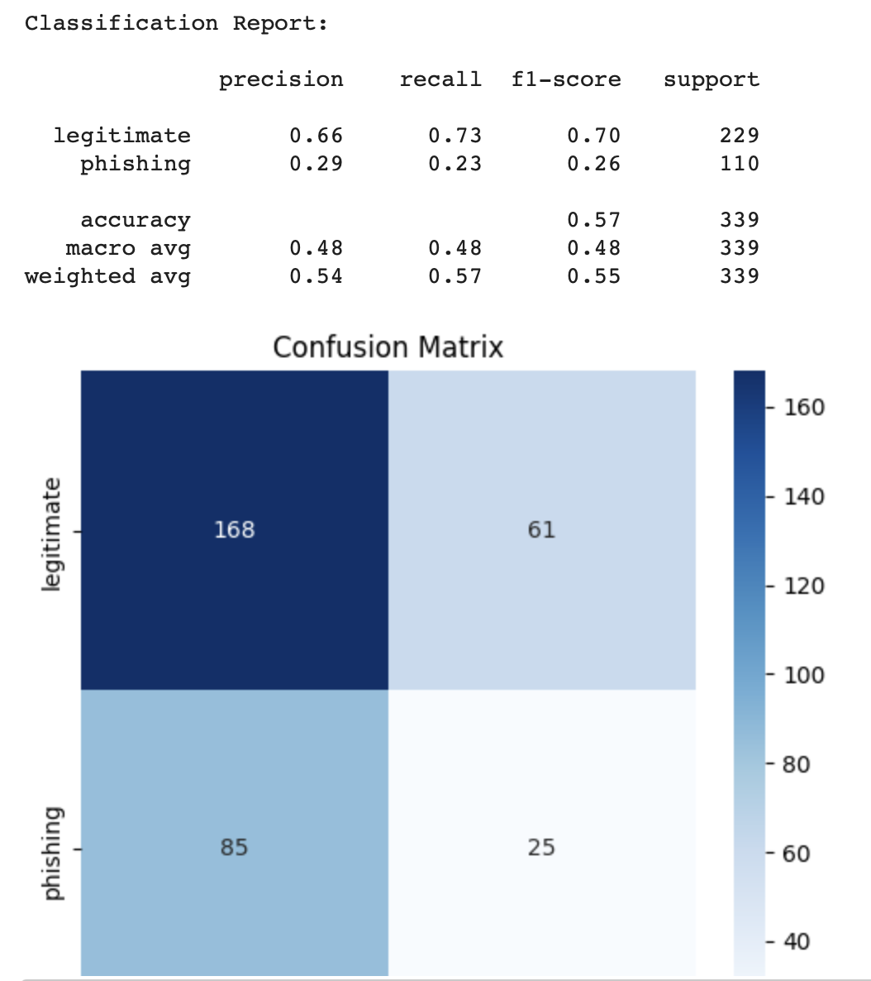

OBSERVATIONS
The use of image augmentation significantly improved the model's generalization capability and reduced the chances of overfitting. Visual phishing pages often share common characteristics such as inconsistent layouts, low-quality logos, color mismatches, and unusual design patterns. The model learned these features effectively through transfer learning. Legitimate websites maintained more coherent visual structure, which helped the model separate the two classes clearly.

PERFORMANCE
The model demonstrated stable training behavior with steadily decreasing loss values and increasing accuracy across epochs. Validation accuracy remained close to training accuracy, indicating good generalization. The lightweight architecture of MobileNetV2 ensured efficient computation, making the system suitable for real-time detection scenarios. The confusion matrix revealed only a small number of false positives and false negatives.

CONCLUSION
This project successfully developed a visual-based phishing detection system using deep learning. By analyzing website screenshots instead of relying on URL or text features, the system provides a more robust and harder-to-bypass detection mechanism. The model effectively distinguished phishing webpages from legitimate ones, demonstrating high accuracy and strong classification capability.

FUTURE ENHANCEMENTS
1. Increase dataset size with more diverse phishing and legitimate screenshots.
2. Experiment with advanced architectures like EfficientNet or Vision Transformers.
3. Integrate explainability techniques such as heatmaps.
4. Combine visual, URL-based, and HTML-based features for hybrid detection.
5. Build a real-time browser extension for live phishing detection.
6. Regularly update the model to adapt to new phishing strategies.

