PYTHON

DEEP LEARNING

ICP – 6

Authored By

Nikhitha Kolluri – 12

**Lesson Overview:**

In this lesson, we are going to discuss types and applications of Autoencoder.

**Use Case Description:**

1. Simple autoencoder-Reconstructing the existing image, which will contain most important features of the image

2. Stacked autoencoder

**Programming elements:**

1. Basics of Autoencoders

2. Role of Autoencoders in unsupervised learning

3. Types of Autoencoders

4. Use case: Simple autoencoder-Reconstructing the existing image, which will contain most important features of the image

5. Use case: Stacked autoencoder

**In class programming:**

1. Add one more hidden layer to autoencoder

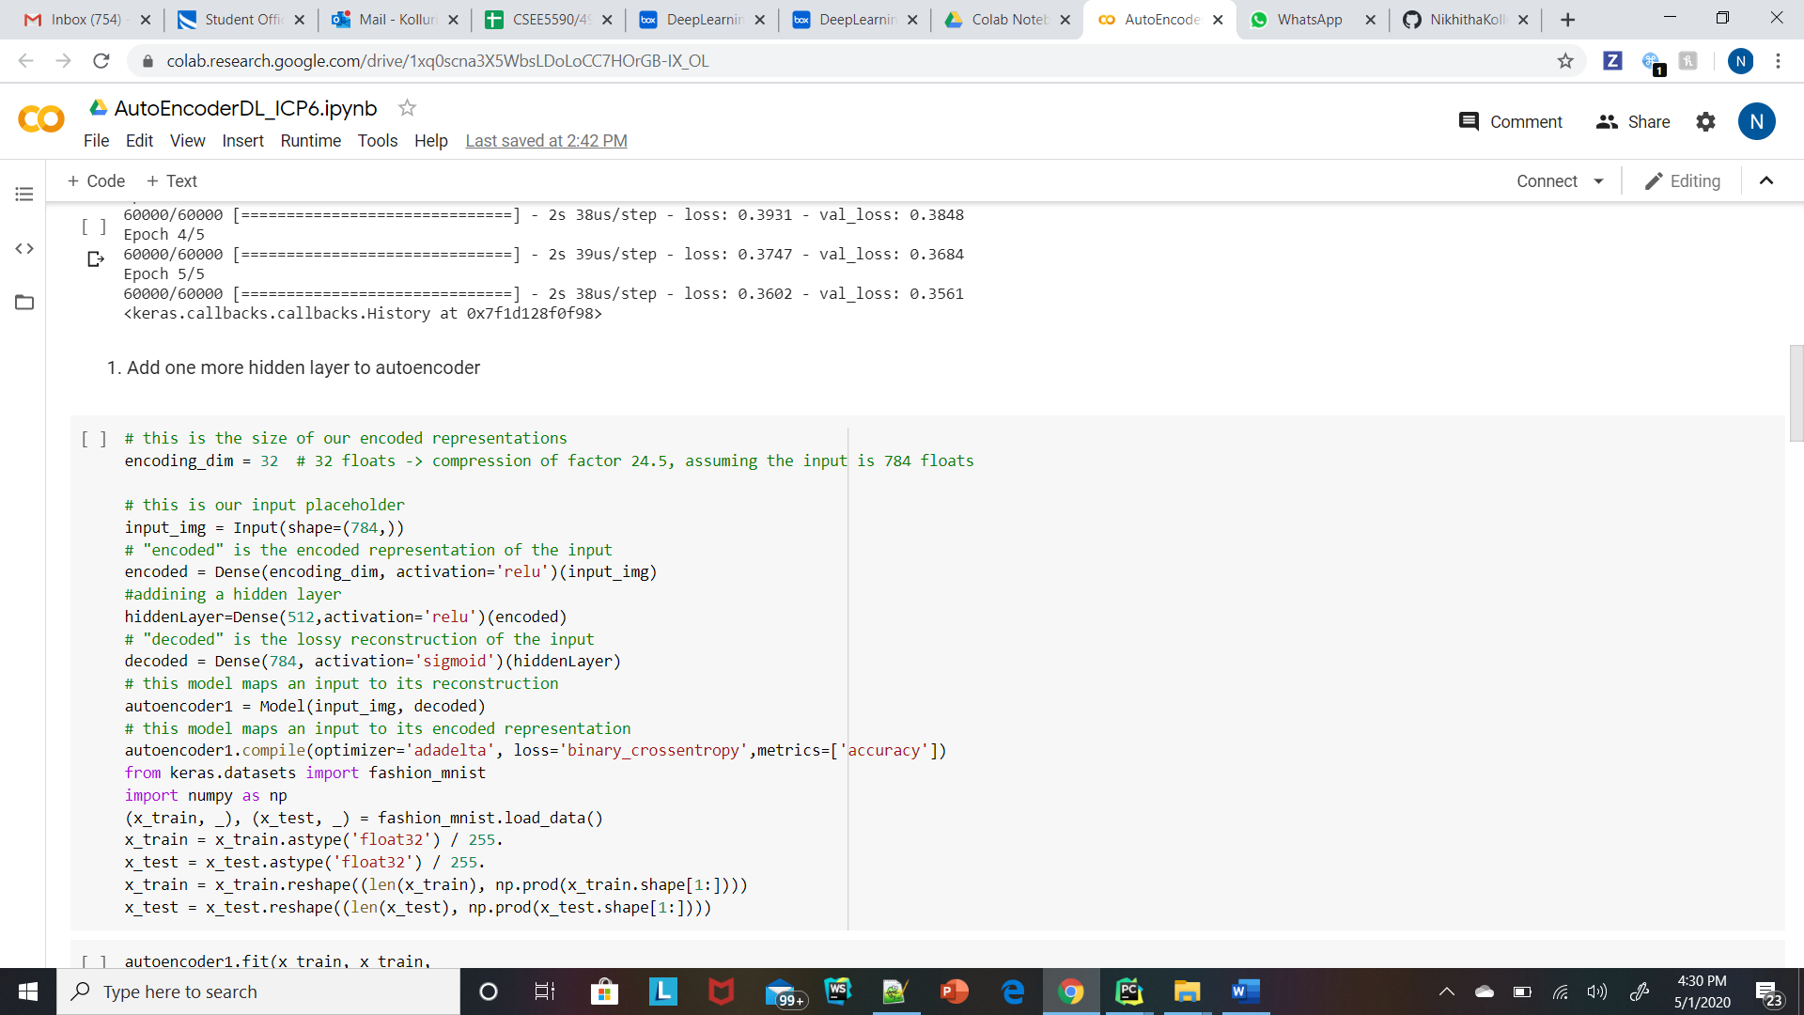

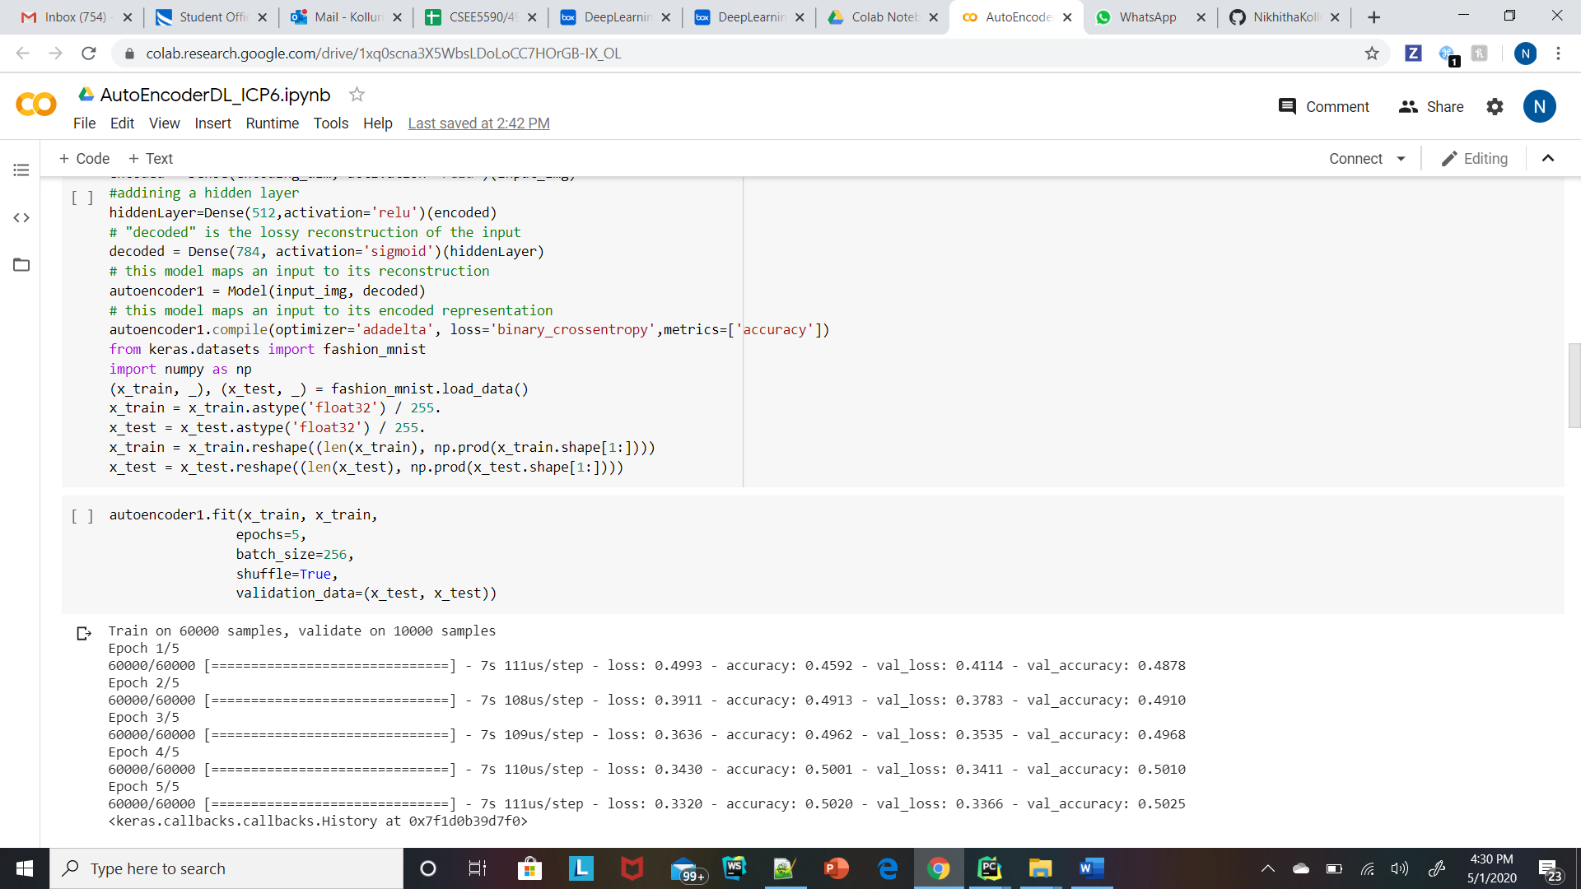

1. visualize the input and reconstructed representation of the autoencoder using Matplotlib

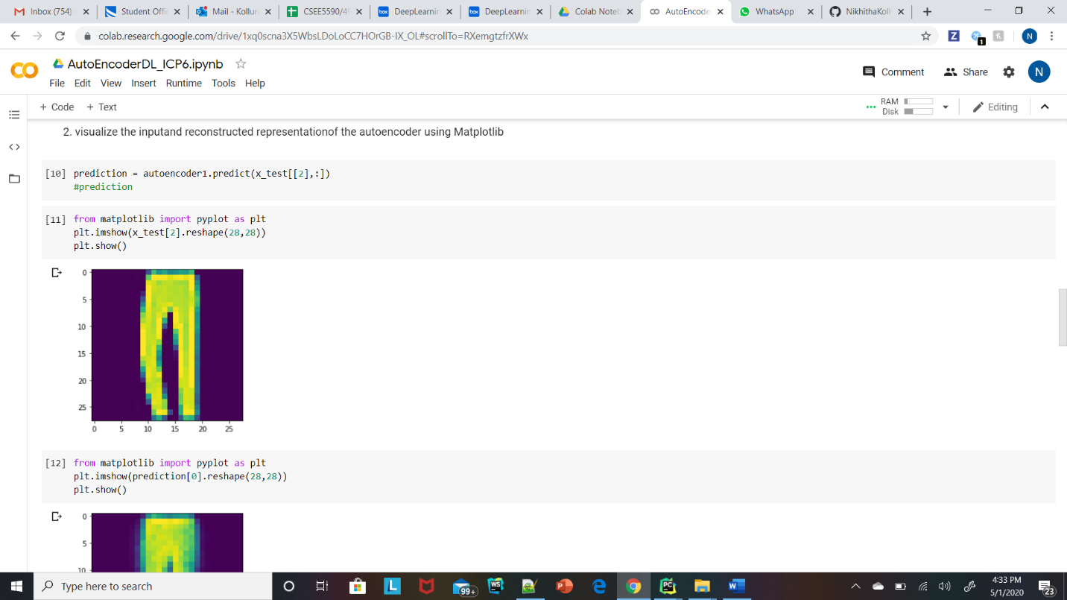

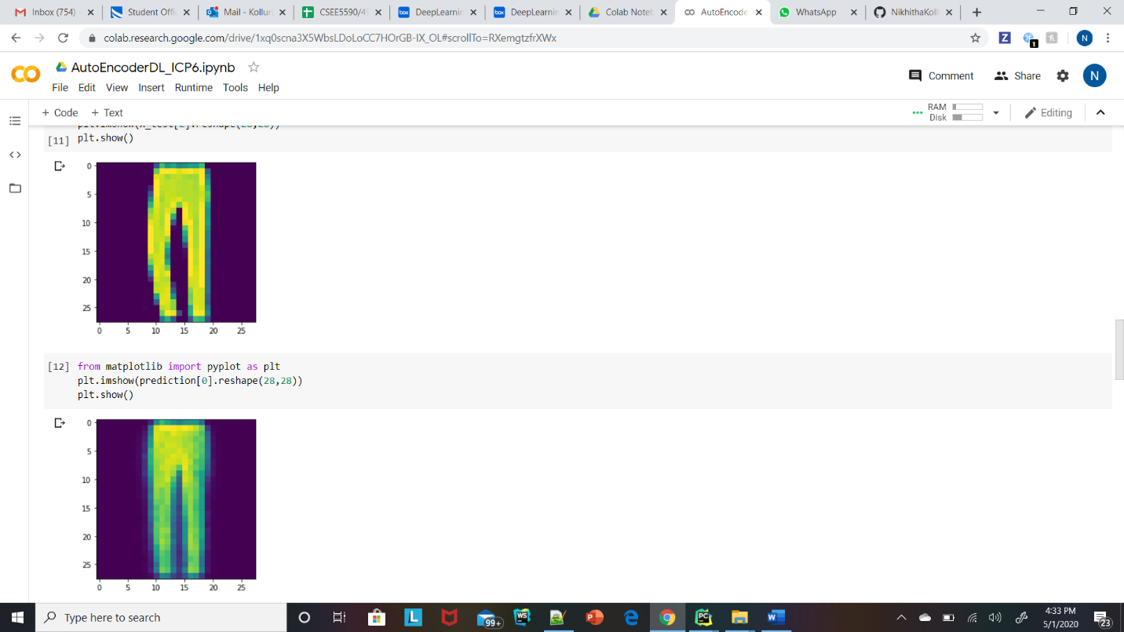

1. visualize the input, noisy input and reconstructed representation (denoised output)of the Denoising_Autoencoder using Matplotlib

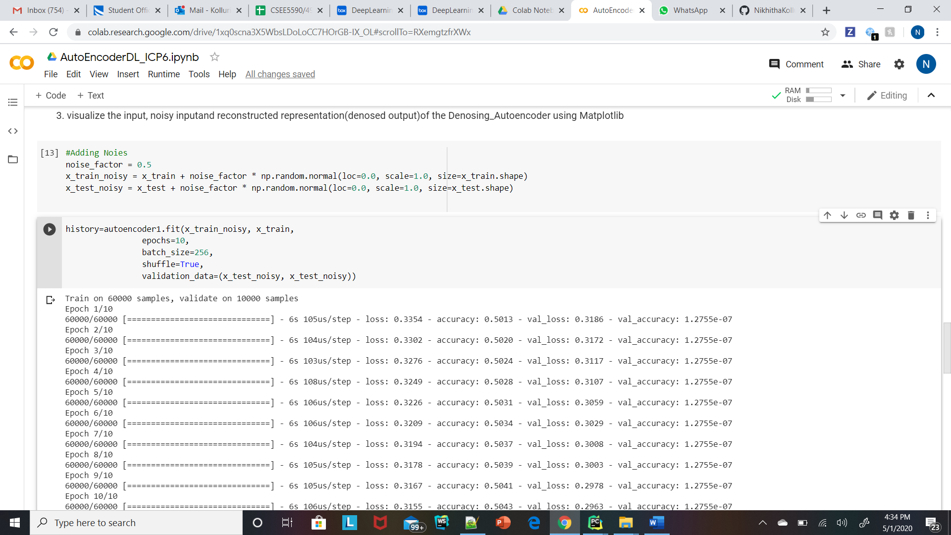

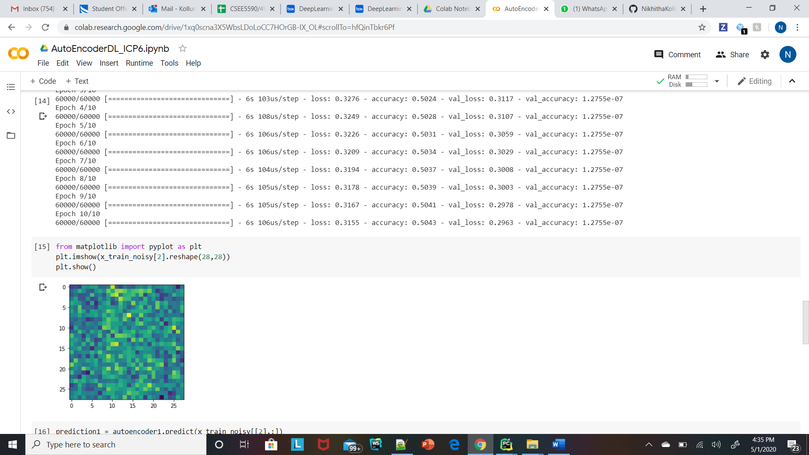

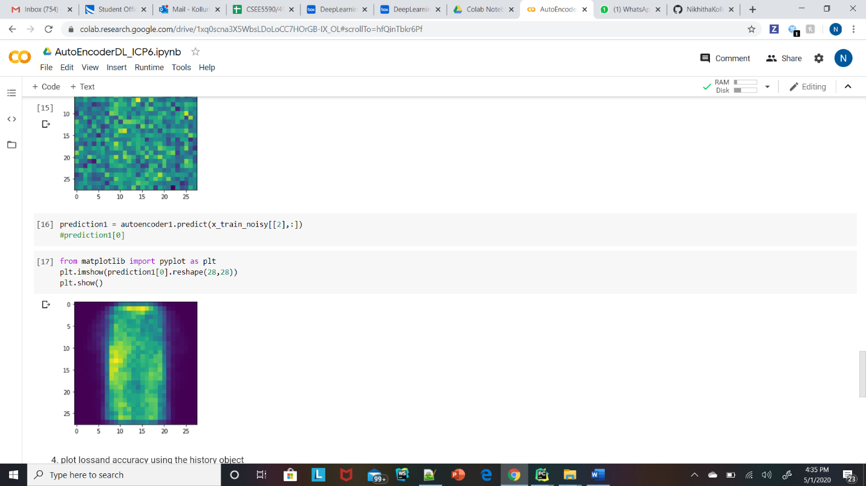

1. plot loss and accuracy using the history object

