PYTHON

ICP – 2

Authored By

Nikhitha Kolluri

* In this lesson we have learnt all kinds of controls in python.

a.Working with for loops

b.Working with Tuples, Lists, Functions

c.Various kinds of Loops: definite and indefinite loops, using files in loops, Nested Loops

1. Write a program, which reads weights (lbs.) of Nstudents into a list and convert these weights to kilograms in a separate list using:

1) Loops and

2) List comprehensions

N: No of students (Read input from user)

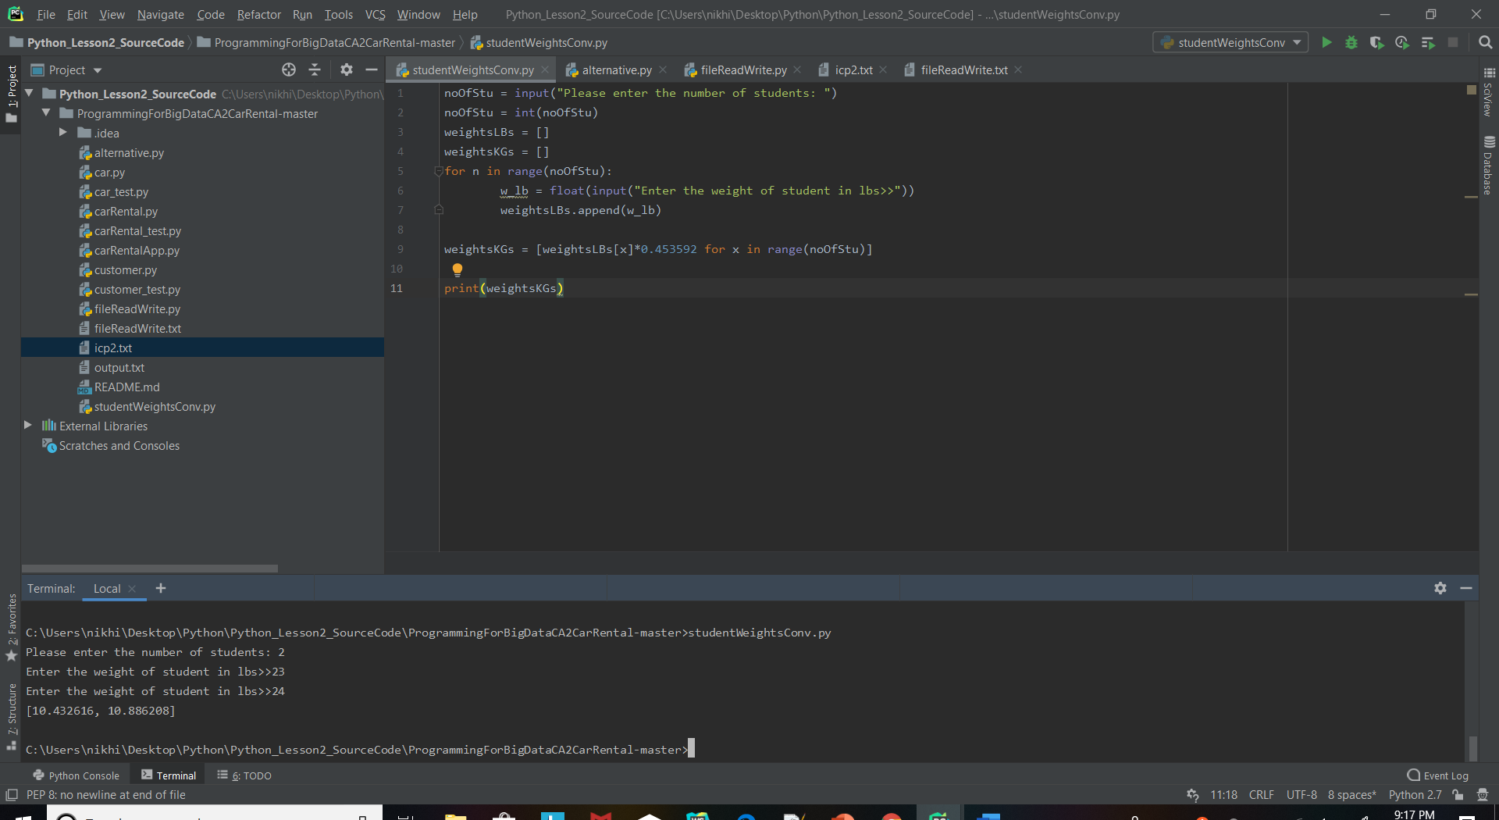

2. Write a program that returns every other char of a given string starting with first using a function named “string_alternative”

Str = “Good evening”

Output: Go vnn

Note: You need to create a function named “string_alternative” for this program and call it from main function.

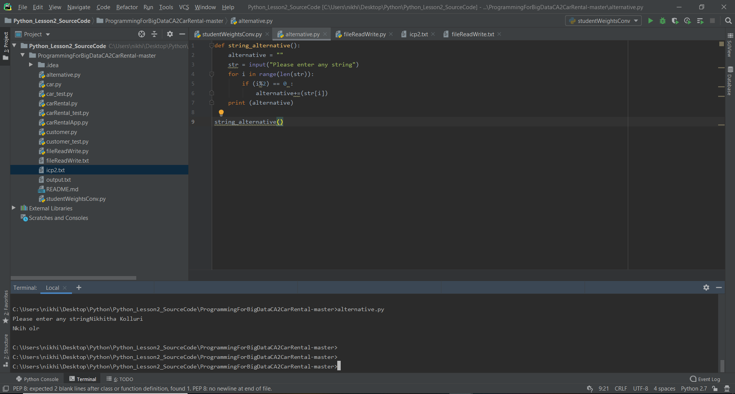

3. Write a python program to find the wordcountin a file for each line and thenprint the output.

Input:a file includes two line

Python Course

Deep Learning Course

Output:

Python: 1

Course: 2

Deep: 1

Learning: 1

Note: Your program should work for any number of lines.

