PYTHON

ICP – 3

Authored By

Nikhitha Kolluri

Lesson Overview:

In this lesson, we have reviewed Object Oriented Python and NumPy package.Classes are one of the important concepts of Python. Everything in Python is an Object. Classes enable us to encapsulate data, restrict the scope of data members and functions. They help us in reusability by inheritance. We can define the various level of data encapsulation like private, protected and public.

In class programming:

1. Create a class Employee and then do the following

a. Create a data member to count the number of Employees

b. Create a constructor to initialize name, family, salary, department

c. Create a function to average salary

d. Create a Fulltime Employeeclass and it should inherit the properties of Employee class

e. Create the instances of Fulltime Employee class and Employee class and call their member functions.

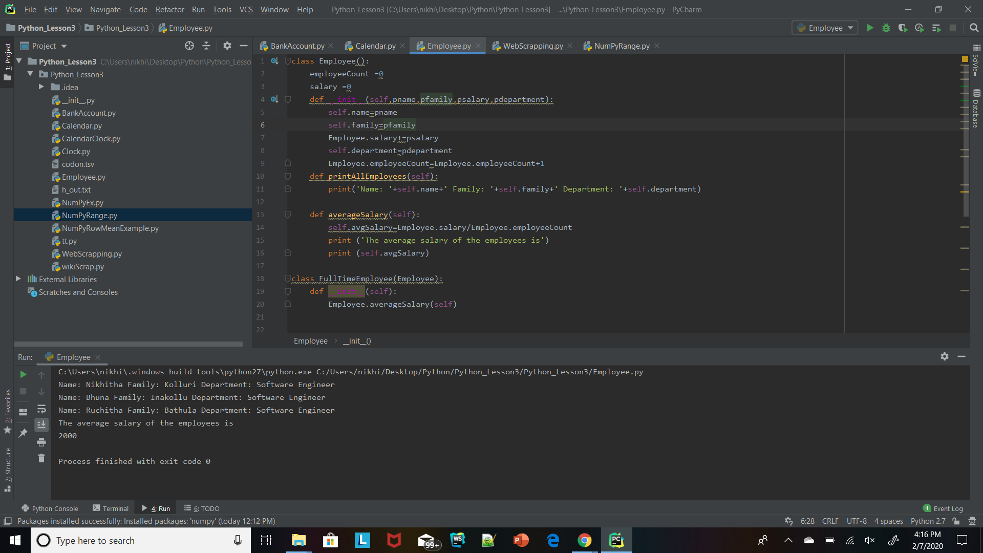

2. Web scraping

Write a simple program that parse a Wiki page mentioned below and follow the instructions:

https://en.wikipedia.org/wiki/Deep_learning

a. Print out the title of the page

b. Find all the links in the page (‘a’ tag)

c. Iterate over each tag(above) then return the link using attribute "href" using get

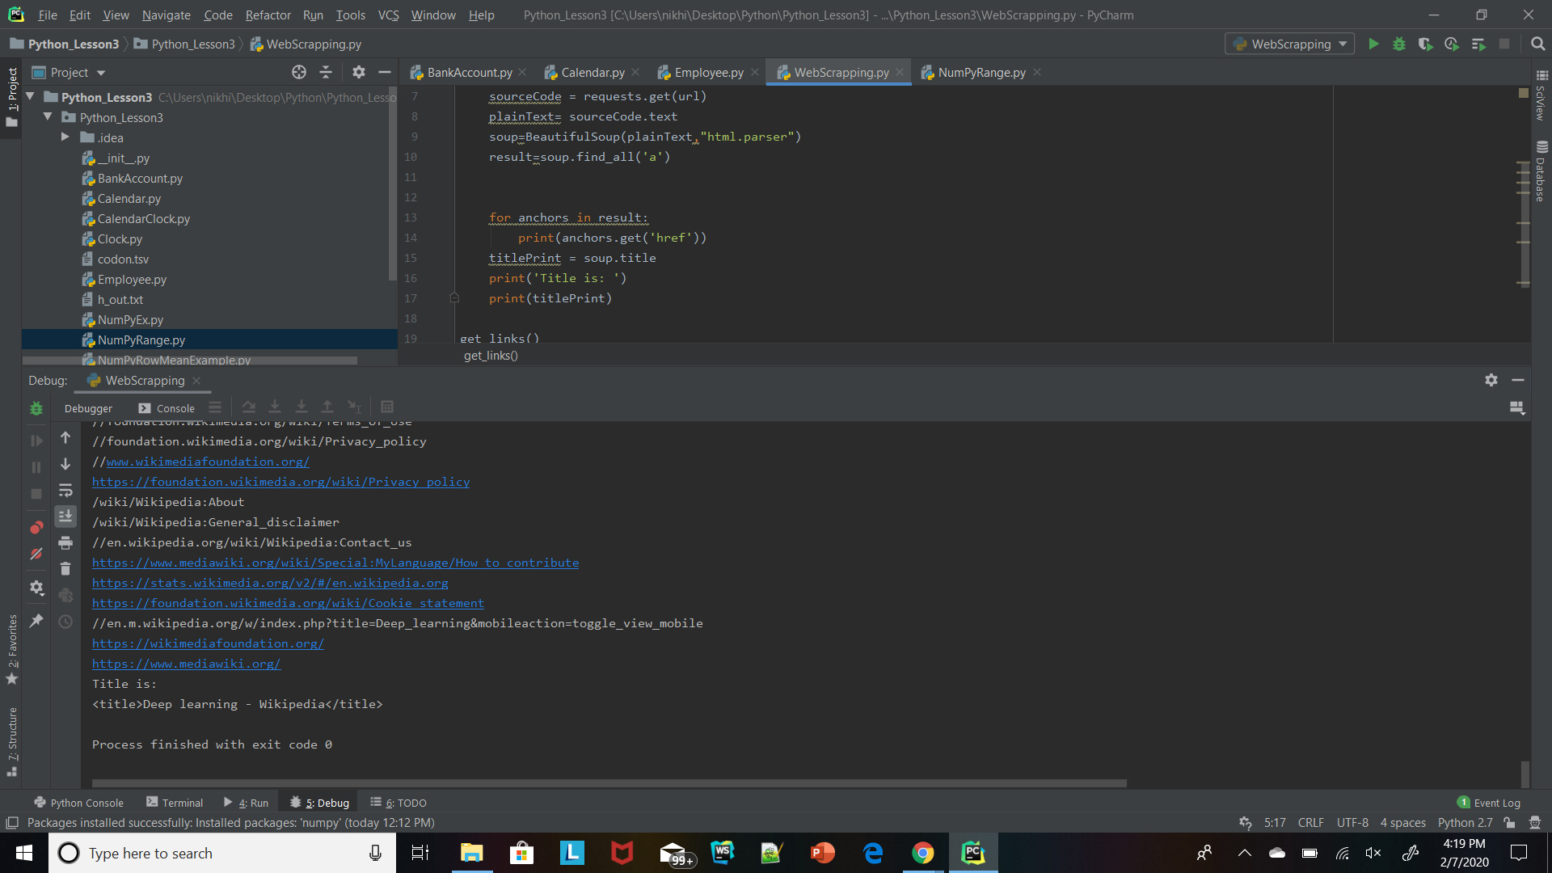

3. Numpy

Using NumPy create random vector of size 15 having only Integers in the range 1-20.

Then reshape the array to 3 by 5

Then replace the max in each row by 0(you can NOT implement it via for loop. You need to use np.where, reshape)

