PYTHON

ICP – 3

Authored By

Nikhitha Kolluri

**Lesson Overview:**

In this lesson we will introduce classification.

b. Classification algorithm

c. Scikit learn

d. Advanced concept related to machine learning algorithm like overfitting, underfitting, cross validation, evaluation for clustering methods

**Use Case Description:**

k-nearest neighbor classifier

**Programming elements:**

Classification

**In class programming:**

1. Find the correlation between ‘survived’(target column) and ‘sex’ column for the Titanic use case in class. Do you think we should keep this feature?

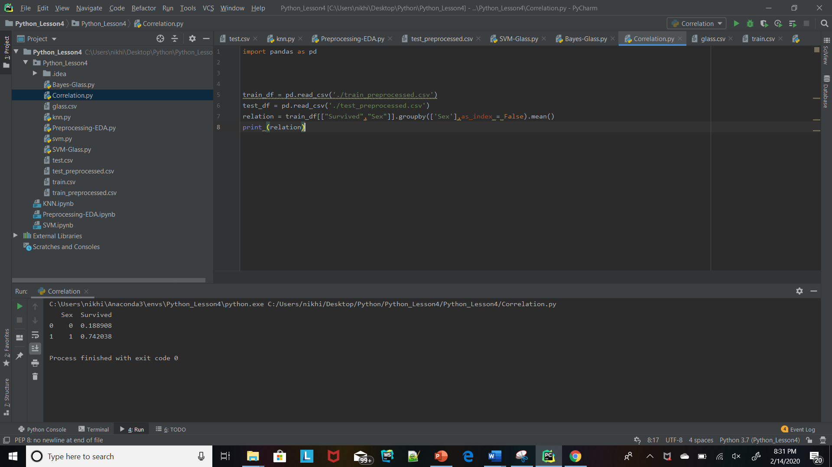

1. Implement Naïve Bayes method using scikit-learn library

Use dataset available in https://umkc.box.com/s/anji6c8g6034ptm0hgii6fhcu919kx8xUse train_test_splitto create training and testing partEvaluate the model on testing partusing score.

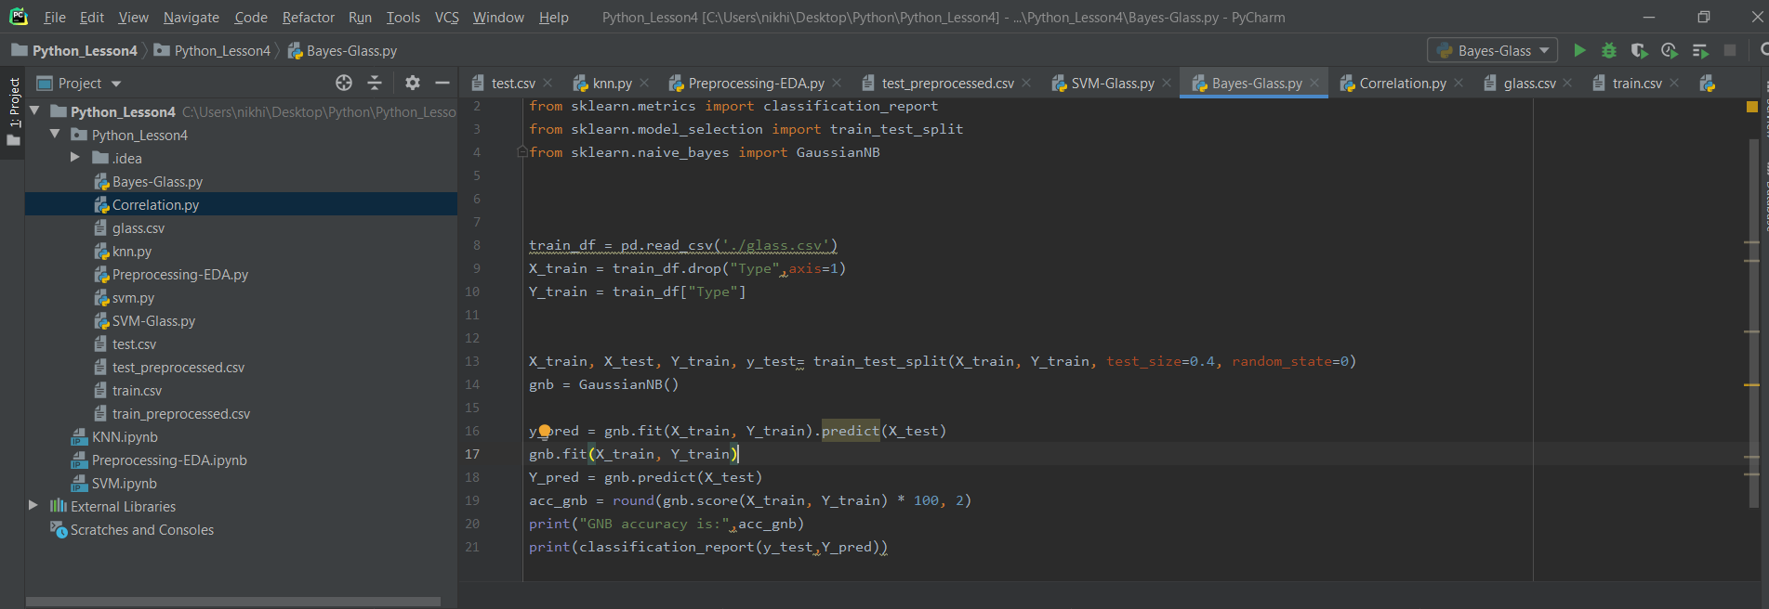

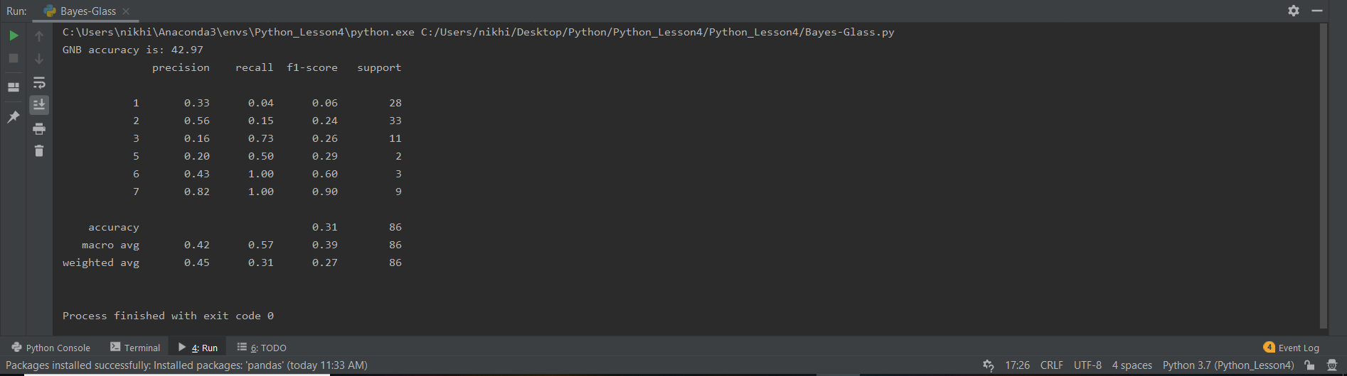

1. Implement linear SVM method using scikit library

Use the same dataset above

Use train_test_split to create training and testing part. Evaluate the model on testing part using score

