PYTHON

ICP – 5

Authored By

Nikhitha Kolluri

Lesson Overview:

In this lesson we will review regression techniques

Regression techniques

a.Linear Regression

b.Multiple Regression

Use Case Description:

Multiple Linear Regression

Programming elements:

Linear Regression and Data Analysis

Source Code:

<https://umkc.box.com/s/r2ba7hswsvf0e6wrt575qkx0mx6codl3>

In class programming:

1.Delete all the outlierdata for the GarageArea field (for the same data set in the use case: House Prices).\* for this task you need to plot GaurageArea field and SalePrice in scatter plot, then check which numbers are anomalies.

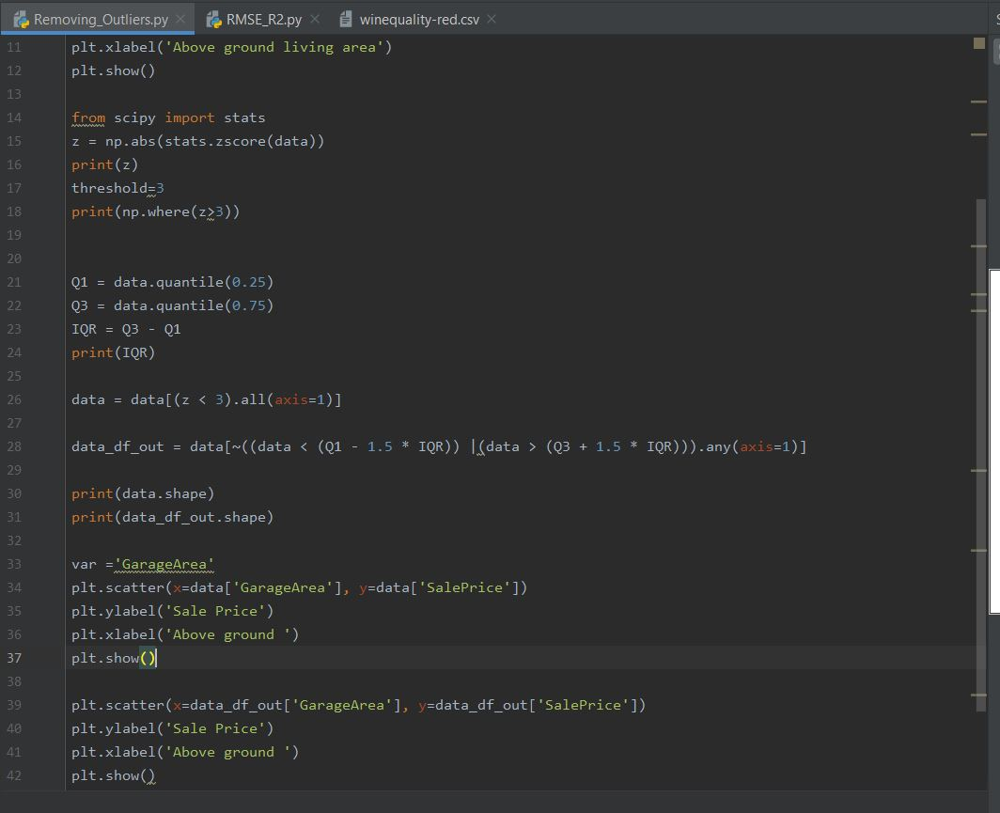

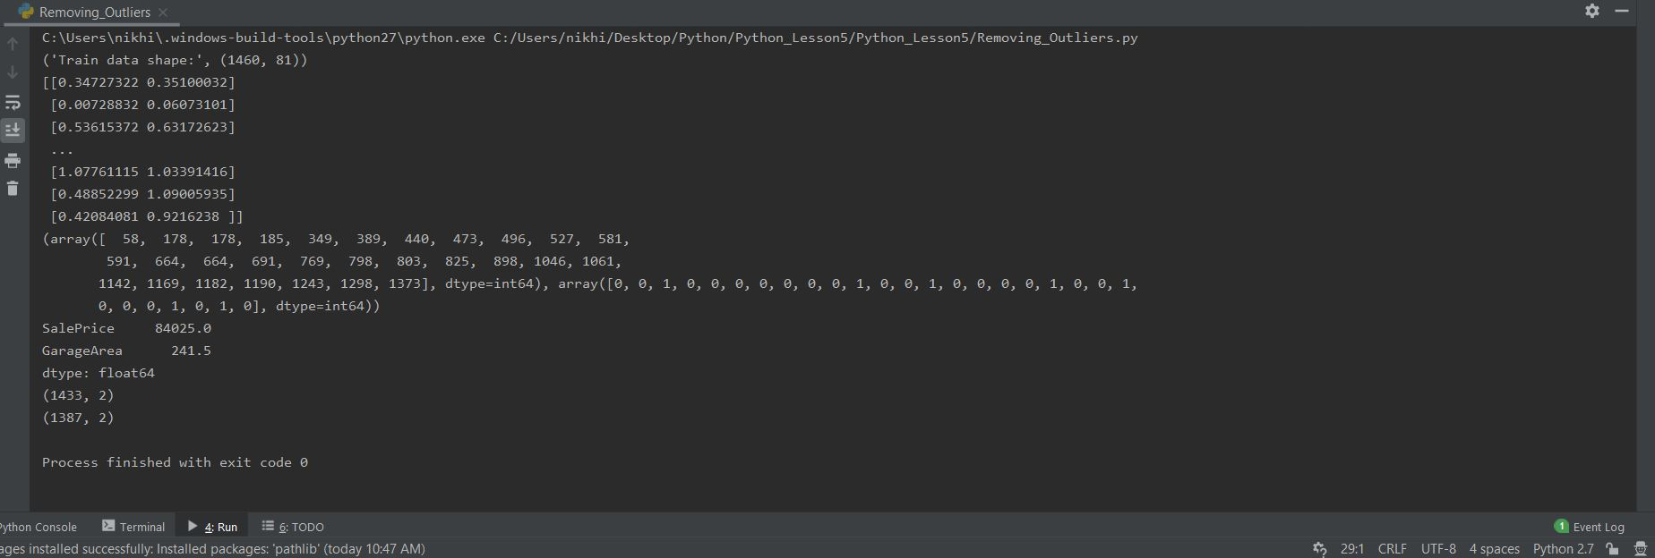

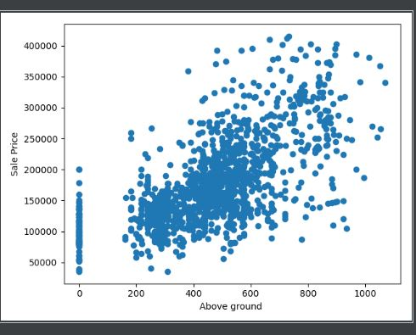

2. Create Multiple Regression for the “wine quality” dataset.

In this data set “quality” is the target label.

Evaluate themodel using RMSE and R2 score.

<https://umkc.box.com/s/4hb8p4de88gg1osc10jdex2qscm2l4af>

\*\*You need to delete the null values in the data set

\*\*You need to find the top 3 most correlated features to the target label(quality)

