8QUEENS
"Join us for a fun and challenging activity at our upcoming fest! Can you conquer the 8 Queen Puzzle and earn the title of chessboard champion? Come show off your strategic skills and see if you have what it takes to solve this classic puzzle."

Objective: On Chess board the player has to place 8 queens in such a way that no two queens threaten each other ; thus a solution requires that no two queens share the same row , column or diagonal.

Components required:
- Hardware:
1.Arduinouno
2 Push button (64)
3.Connecting wires
4.Jumper wires
5.Led-Red(1)
-Green(1)
6.Battery

- Software:
1.Arduino ide

Circuit Diagram: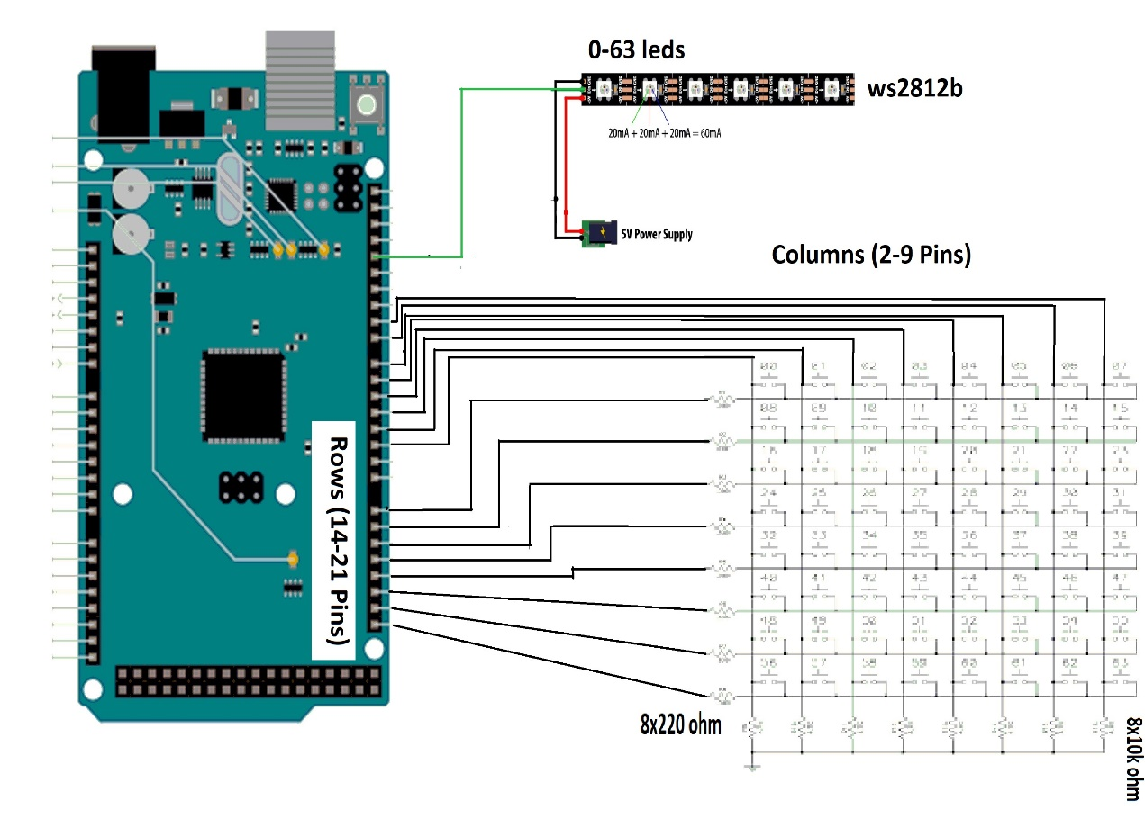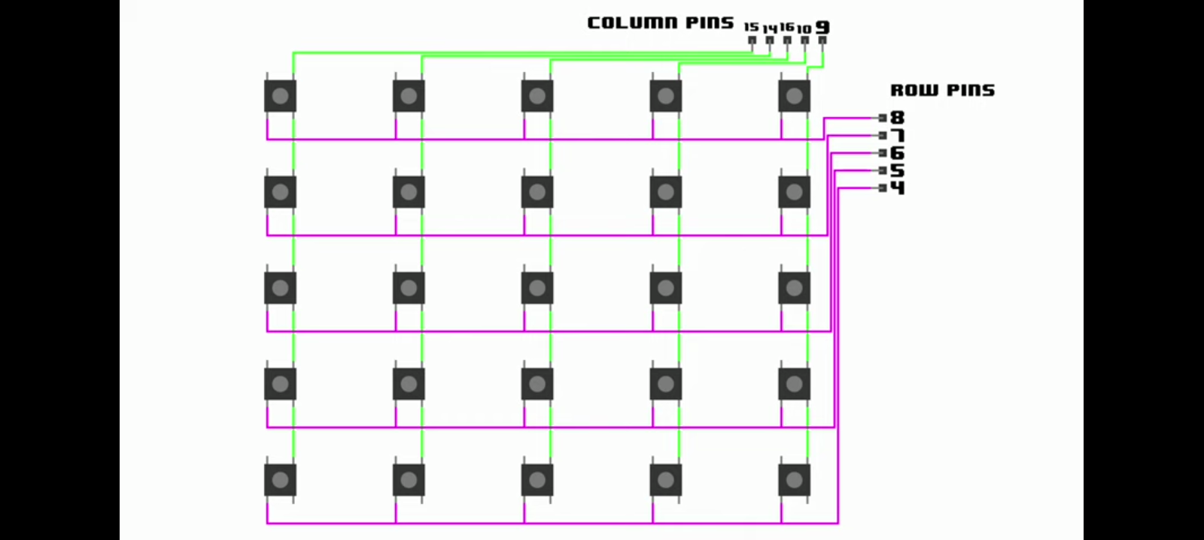
Software code:
1.push button check code
const int ROWS = 4;
const int COLS = 4;
const int rowPins[ROWS] = {2, 3, 4, 5};
const int colPins[COLS] = {6, 7, 8, 9};
// Define a struct to hold the row and column indices of a button press
struct point {
int row;
int col;
};
// Create an array of ButtonPress structures to hold the coordinates
point p[8];
void setup() {
Serial.begin(9600);
for (int r = 0; r < ROWS; r++) {
pinMode(rowPins[r], OUTPUT);
digitalWrite(rowPins[r], HIGH);
}
for (int c = 0; c < COLS; c++) {
pinMode(colPins[c], INPUT_PULLUP);
}
}
void loop() {
int count = 0;
bool buttonPressed = false;
while (!buttonPressed) {
for (int r = 0; r < ROWS; r++) {
digitalWrite(rowPins[r], LOW);
for (int c = 0; c < COLS; c++) {
if (digitalRead(colPins[c]) == LOW) {
// Store the button press coordinates in the array of structures
p[count].row = r;
p[count].col = c;
count++;
while (digitalRead(colPins[c]) == LOW) {} // Wait for key release
if (count == 8) { // Stop accepting input after 8 button presses
buttonPressed = true;
break;
}
}
}
digitalWrite(rowPins[r], HIGH);
if (buttonPressed) {
break;
}
}
}
// Print out the button press coordinates
for (int i = 0; i < count; i++) {
Serial.print("Button pressed at: (");
Serial.print(p[i].row + 1); // Add 1 to row and col to convert from zero-indexed to one-indexed
Serial.print(", ");
Serial.print(p[i].col + 1);
Serial.println(")");
}
}
2.main code
#include <stdint.h>
const int ROWS = 4;
const int COLS = 4;
const int rowPins[ROWS] = {2, 3, 4, 5};
const int colPins[COLS] = {A0, A1, A2, A3};
// Define a struct to hold the row and column indices of a button press
struct point {
int row;
int col;
};
//check for the cooridinate of the queen placed
bool issafe(int arr[4][4], int x, int y) {
//check for row
for (int i=0;i<4;i++) {
if (arr[x][i]==1 && i!=y) { // check for row and exclude current position
return false;
}
if (arr[i][y]==1 && i!=x) { // check for column and exclude current position
return false;
}
}
//check for left diagonal
int row=x;
int col=y;
while(row>=0 && col>=0) {
if (arr[row][col]==1 && (row!=x || col!=y)) { // check for left diagonal and exclude current position
return false;
}
row--;
col--;
}
//check for right diagonal
row = x;
col = y;
while (row >= 0 && col < 4) {
if (arr[row][col] == 1 && (row!=x || col!=y)) { // check for right diagonal and exclude current position
return false;
}
row--;
col++;
}
return true;
}
// Define the game function
bool game(int arr[4][4],struct point p[4]) {
for (int i=0; i<4; i++) {
if (!issafe(arr, p[i].row, p[i].col)) {
return false;
}
}
return true;
}
void setup() {
Serial.begin(9600);
for (int r = 0; r < ROWS; r++) {
pinMode(rowPins[r], OUTPUT);
digitalWrite(rowPins[r], HIGH);
}
for (int c = 0; c < COLS; c++) {
pinMode(colPins[c], INPUT_PULLUP);
}
}
void loop() {
for(int i=0;i<10;i++){
// Create an array of ButtonPress structures to hold the coordinates
struct point p[4];
int s[4][4]={0};
int count = 0;
bool buttonPressed = false;
while (!buttonPressed) {
for (int r = 0; r < ROWS; r++) {
digitalWrite(rowPins[r], LOW);
for (int c = 0; c < COLS; c++) {
if (digitalRead(colPins[c]) == LOW) {
// Check if the button has already been pressed
bool alreadyPressed = false;
for (int i = 0; i < count; i++) {
if (p[i].row == r && p[i].col == c) {
alreadyPressed = true;
break;
}
}
if (!alreadyPressed) {
// Store the button press coordinates in the array of structures
p[count].row = r;
p[count].col = c;
count++;
}
while (digitalRead(colPins[c]) == LOW) {} // Wait for key release
if (count == 4) { // Stop accepting input after 8 button presses
buttonPressed = true;
break;
}
}
}
digitalWrite(rowPins[r], HIGH);
if (buttonPressed) {
break;
}
}
}
// Print out the button press coordinates
for (int i = 0; i < count; i++) {
Serial.print("Button pressed at: (");
Serial.print(p[i].row ); // Add 1 to row and col to convert from zero-indexed to one-indexed
Serial.print(", ");
Serial.print(p[i].col);
Serial.println(")");
}
for(int i=0;i<count;i++){
s[p[i].row][p[i].col]=1;
}
if (game(s,p)) {
pinMode(12,OUTPUT);
digitalWrite(12,HIGH);
Serial.println("You won!");
delay(10000);
digitalWrite(12,LOW);
}
else {
pinMode(13,OUTPUT);
digitalWrite(13,HIGH);
Serial.println("You lost!");
delay(10000);
digitalWrite(13,LOW);
}
delay(1000);
}
}

OUTPUTS:
