**Machine Learning**

**What is Machine Learning?**

Machine learning is a data analytics technique that teaches computers to do what comes naturally to humans and animals: learn from experience. Machine learning algorithms use computational methods to “learn” information directly from data without relying on a predetermined equation as a model. The algorithms adaptively improve their performance as the number of samples available for learning increases.

**Why Machine Learning Matters?**

With the rise in big data, machine learning has become a key technique for solving problems in areas, such as:

* **Computational finance**, for [credit scoring](https://www.mathworks.com/discovery/credit-scoring-model.html) and [algorithmic trading](https://www.mathworks.com/discovery/algorithmic-trading.html)
* **Image processing and computer vision**, for face recognition, motion detection, and [object detection](https://www.mathworks.com/discovery/object-detection.html)
* **Computational biology**, for tumour detection, drug discovery, and DNA sequencing
* **Energy production**, for price and [load forecasting](https://www.mathworks.com/discovery/load-forecasting.html)
* **Automotive, aerospace, and manufacturing**, for [predictive maintenance](https://www.mathworks.com/solutions/predictive-maintenance.html)
* **Natural language processing**, for voice recognition applications

**How Machine Learning Works?**

Machine learning uses two types of techniques: **supervised learning**, which trains a model on known input and output data so that it can predict future outputs, and **unsupervised learning**, which finds hidden patterns or intrinsic structures in input data.

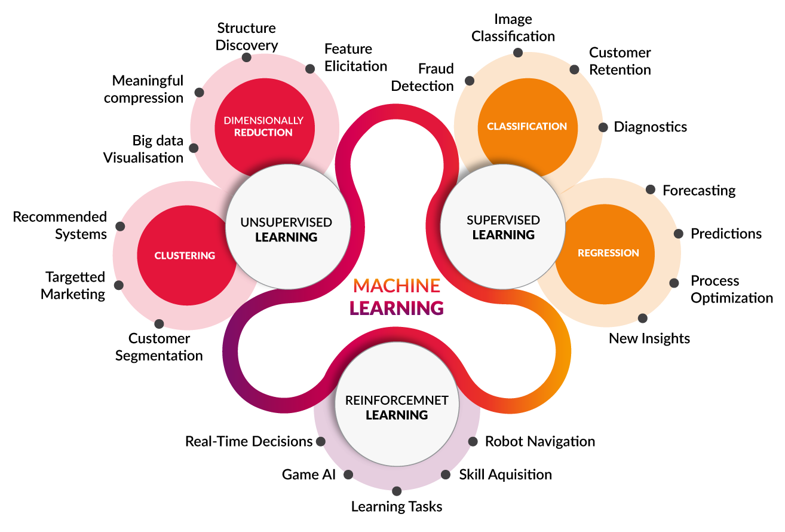

**Supervised Machine Learning**

[Supervised machine learning](https://www.mathworks.com/discovery/supervised-learning.html) builds a model that makes predictions based on evidence in the presence of uncertainty. A supervised learning algorithm takes a known set of input data and known responses to the data (output) and trains a model to generate reasonable predictions for the response to new data. Use supervised learning if you have known data for the output you are trying to predict.

Supervised learning uses classification and regression techniques to develop [machine learning models](https://www.mathworks.com/discovery/machine-learning-models.html).

**Classification techniques**

predict discrete responses—for example, whether an email is genuine or spam, or whether a tumour is cancerous or benign. Classification models classify input data into categories. Typical applications include medical imaging, speech recognition, and credit scoring.

Use classification if your data can be tagged, categorized, or separated into specific groups or classes. For example, applications for hand-writing recognition use classification to recognize letters and numbers. In image processing and computer vision, [unsupervised pattern recognition](https://www.mathworks.com/discovery/pattern-recognition.html) techniques are used for object detection and image segmentation.

Common algorithms for performing classification include [support vector machine (SVM)](https://www.mathworks.com/help/stats/support-vector-machine-classification.html), [boosted](https://www.mathworks.com/help/stats/classification-ensembles.html) and [bagged](https://www.mathworks.com/help/stats/classification-ensembles.html) [decision trees](https://www.mathworks.com/help/stats/classification-trees.html), [*k*-nearest neighbour](https://www.mathworks.com/help/stats/classification-nearest-neighbors.html), [Naïve Bayes](https://www.mathworks.com/help/stats/classification-naive-bayes.html), [discriminant analysis](https://www.mathworks.com/help/stats/classification-discriminant-analysis.html), [logistic regression](https://www.mathworks.com/help/stats/generalized-linear-regression-1.html), and [neural networks](https://www.mathworks.com/help/deeplearning/pattern-recognition-and-classification.html).

**Regression techniques**

 predict continuous responses—for example, changes in temperature or fluctuations in power demand. Typical applications include electricity load forecasting and algorithmic trading.

Use regression techniques if you are working with a data range or if the nature of your response is a real number, such as temperature or the time until failure for a piece of equipment.

Common regression algorithms include [linear model](https://www.mathworks.com/help/stats/multiple-linear-regression-1.html), [nonlinear model](https://www.mathworks.com/help/stats/nonlinear-models.html), [regularization](https://www.mathworks.com/help/stats/regularization-1.html), [stepwise regression](https://www.mathworks.com/help/stats/stepwise-regression-1.html), [boosted](https://www.mathworks.com/help/stats/classification-ensembles.html) and [bagged](https://www.mathworks.com/help/stats/classification-ensembles.html) [decision trees](https://www.mathworks.com/help/stats/classification-trees.html), [neural networks](https://www.mathworks.com/help/deeplearning/function-approximation-and-nonlinear-regression.html), and [adaptive neuro-fuzzy learning](https://www.mathworks.com/help/fuzzy/anfis.html).

**Unsupervised Machine Learning**

[Unsupervised learning](https://www.mathworks.com/discovery/unsupervised-learning.html) finds hidden patterns or intrinsic structures in data. It is used to draw inferences from datasets consisting of input data without labelled responses.

[Clustering](https://www.mathworks.com/discovery/cluster-analysis.html) is the most common unsupervised learning technique. It is used for exploratory data analysis to find hidden patterns or groupings in data. Applications for [cluster analysis](https://www.mathworks.com/discovery/cluster-analysis.html) include gene sequence analysis, market research, and object recognition.

For example, if a cell phone company wants optimize the locations where they build cell phone towers, they can use machine learning to estimate the number of clusters of people relying on their towers. A phone can only talk to one tower at a time, so the team uses clustering algorithms to design the best placement of cell towers to optimize signal reception for groups, or clusters, of their customers.

Common algorithms for performing clustering include [k-means](https://www.mathworks.com/help/stats/k-means-clustering-12.html), [hierarchical clustering](https://www.mathworks.com/help/stats/hierarchical-clustering-12.html), [Gaussian mixture models](https://www.mathworks.com/help/stats/gaussian-mixture-models.html), [hidden Markov models](https://www.mathworks.com/help/stats/hidden-markov-models.html), [self-organizing maps,](https://www.mathworks.com/help/deeplearning/self-organizing-maps.html) [fuzzy c-means clustering](https://www.mathworks.com/help/fuzzy/fcm.html), and [subtractive clustering](https://www.mathworks.com/help/fuzzy/subclust.html).

**Reinforcement Machine learning**

Reinforcement learning is a type of machine learning technique where a computer agent learns to perform a task through repeated trial and error interactions with a dynamic environment. This learning approach enables the agent to make a series of decisions that maximize a reward metric for the task without human intervention and without being explicitly programmed to achieve the task.

### **Examples of Reinforcement Learning Applications**

[Deep neural networks](https://www.mathworks.com/discovery/neural-network.html) trained with reinforcement learning can encode complex behaviours. This allows an alternative approach to applications that are otherwise intractable or more challenging to tackle with more traditional methods. For example, in autonomous driving, a neural network can replace the driver and decide how to turn the steering wheel by simultaneously looking at multiple sensors such as camera frames and lidar measurements. Without neural networks, the problem would normally be broken down in smaller pieces like extracting features from camera frames, filtering the lidar measurements, [fusing the sensor outputs](https://www.mathworks.com/products/sensor-fusion-and-tracking.html), and making “driving” decisions based on sensor inputs.

While reinforcement learning as an approach is still under evaluation for production systems, some industrial applications are good candidates for this technology.

**Advanced controls**: Controlling nonlinear systems is a challenging problem that is often addressed by linearizing the system at different operating points. Reinforcement learning can be applied directly to the nonlinear system.

**Automated driving**: Making driving decisions based on camera input is an area where reinforcement learning is suitable considering the success of deep neural networks in image applications.

**Robotics**: Reinforcement learning can help with applications like robotic grasping, such as teaching a robotic arm how to manipulate a variety of objects for pick-and-place applications. Other robotics applications include human-robot and robot-robot collaboration.

**Scheduling**: Scheduling problems appear in many scenarios including traffic light control and coordinating resources on the factory floor towards some objective. Reinforcement learning is a good alternative to evolutionary methods to solve these combinatorial optimization problems.

**Calibration**: Applications that involve manual calibration of parameters, such as electronic control unit (ECU) calibration, may be good candidates for reinforcement learning.

