1)Create 3 tables named students,department,year
mysql> use nikhitha;
Database changed

#creaating department table
mysql> -- Create the department table
mysql> CREATE TABLE department (
-> dept_id INT PRIMARY KEY AUTO_INCREMENT,
-> dept_name VARCHAR(50) NOT NULL -> );
Query OK, 0 rows affected (0.01 sec)

#creating year table
mysql>
mysql> -- Create the year table
mysql> CREATE TABLE year (
-> year_id INT PRIMARY KEY AUTO_INCREMENT,
-> year_name VARCHAR(20) NOT NULL
-> );
Query OK, 0 rows affected (0.01 sec)
2)student should contain relationship to both department and year
#creating student table
mysql>
mysql> -- Create the students table with foreign key relationships
mysql> CREATE TABLE students (
-> student_id INT PRIMARY KEY AUTO_INCREMENT,
-> student_name VARCHAR(100) NOT NULL,
-> dept_id INT,
-> year_id INT,
-> FOREIGN KEY (dept_id) REFERENCES department(dept_id),
-> FOREIGN KEY (year_id) REFERENCES year(year_id)
-> );
Query OK, 0 rows affected (0.03 sec)

mysql> desc department;
+-----------+-------------+------+-----+---------+----------------+
| Field | Type | Null | Key | Default | Extra |
+-----------+-------------+------+-----+---------+----------------+
| dept_id | int | NO | PRI | NULL | auto_increment |
| dept_name | varchar(50) | NO | | NULL | |
+-----------+-------------+------+-----+---------+----------------+
2 rows in set (0.00 sec)
mysql> desc year;
+-----------+-------------+------+-----+---------+----------------+
| Field | Type | Null | Key | Default | Extra |
+-----------+-------------+------+-----+---------+----------------+
| year_id | int | NO | PRI | NULL | auto_increment |
| year_name | varchar(20) | NO | | NULL | |
+-----------+-------------+------+-----+---------+----------------+
2 rows in set (0.00 sec
mysql> desc student;
+--------------+--------------+------+-----+---------+----------------+
| Field | Type | Null | Key | Default | Extra |
+--------------+--------------+------+-----+---------+----------------+
| student_id | int | NO | PRI | NULL | auto_increment |
| student_name | varchar(100) | NO | | NULL | |
| dept_id | int | YES | MUL | NULL | |
| year_id | int | YES | MUL | NULL | |
+--------------+--------------+------+-----+---------+----------------+
4 rows in set (0.00 sec)

3)use chatgpt and ask like "this is my table in mysql how can i create same in mongodb

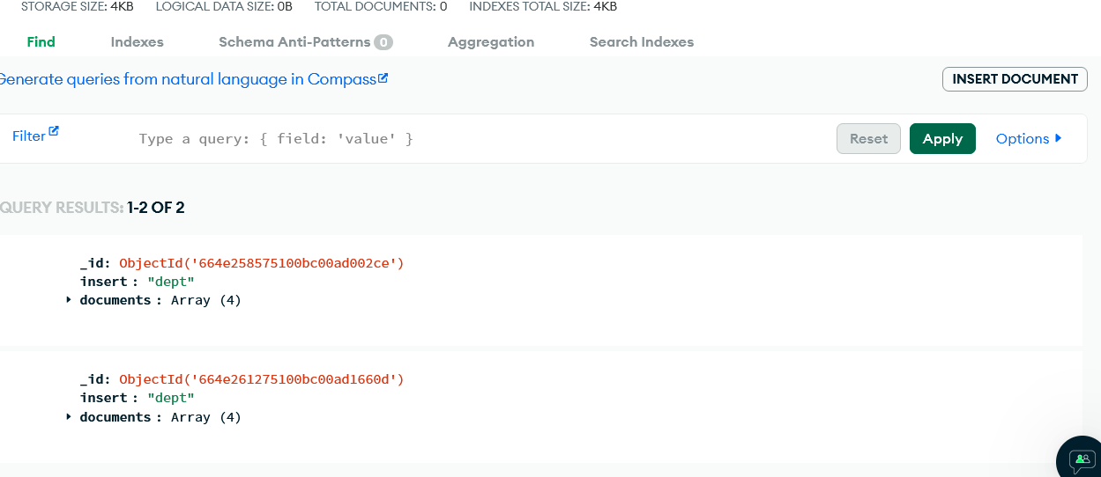

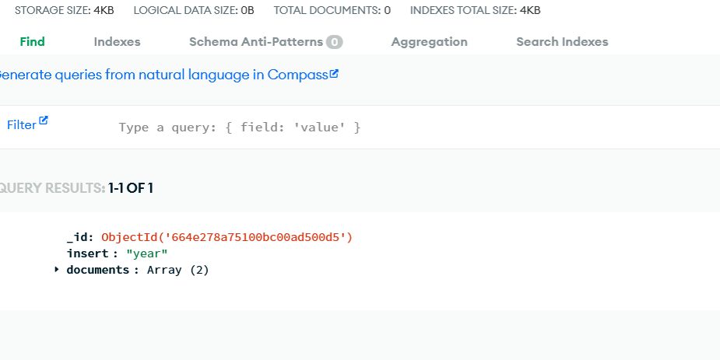

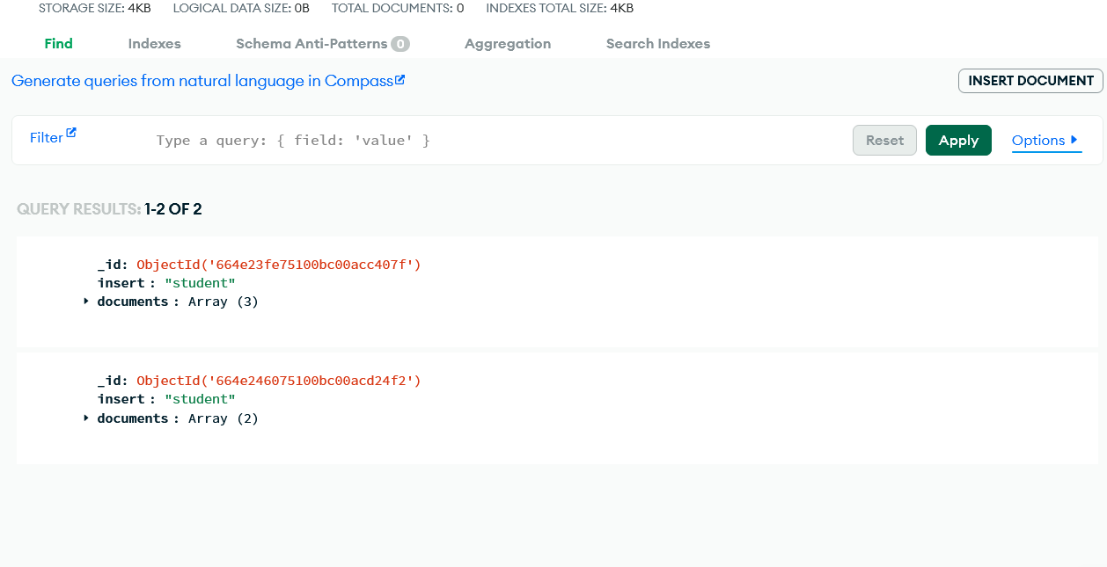

#inserting values into student table
mysql> INSERT INTO students (student_name, dept_id, year_id) VALUES
-> ('Student 1 - CSE', 1, 1), ('Student 2 - CSE', 1, 2), ('Student 3 - CSE', 1, 3), ('Student 4 - CSE', 1, 4),
-> ('Student 1 - ECE', 2, 1), ('Student 2 - ECE', 2, 2), ('Student 3 - ECE', 2, 3), ('Student 4 - ECE', 2, 4),
-> ('Student 1 - EE', 3, 1), ('Student 2 - EE', 3, 2), ('Student 3 - EE', 3, 3), ('Student 4 - EE', 3, 4),
-> ('Student 1 - ME', 4, 1), ('Student 2 - ME', 4, 2), ('Student 3 - ME', 4, 3), ('Student 4 - ME', 4, 4),
-> ('Student 1 - Civil', 5, 1), ('Student 2 - Civil', 5, 2), ('Student 3 - Civil', 5, 3), ('Student 4 - Civil', 5, 4); Query OK, 20 rows affected (0.00 sec)
Records: 20 Duplicates: 0 Warnings:

#Displaying values of student table
mysql> select * from students;
+------------+-------------------+---------+---------+
| student_id | student_name | dept_id | year_id |
+------------+-------------------+---------+---------+
| 1 | Student 1 - CSE | 1 | 1 |
| 2 | Student 2 - CSE | 1 | 2 |
| 3 | Student 3 - CSE | 1 | 3 |
| 4 | Student 4 - CSE | 1 | 4 |
| 5 | Student 1 - ECE | 2 | 1 |
| 6 | Student 2 - ECE | 2 | 2 |
| 7 | Student 3 - ECE | 2 | 3 |
| 8 | Student 4 - ECE | 2 | 4 |
| 9 | Student 1 - EE | 3 | 1 |
| 10 | Student 2 - EE | 3 | 2 |
10 rows in set(0.00sec)

5)write a query to display students from CSE department

mysql> SELECT students.student_id, students.student_name, department.dept_name
-> FROM students
-> JOIN department ON students.dept_id = department.dept_id
-> WHERE department.dept_name = 'CSE';
+------------+-----------------+-----------+
| student_id | student_name | dept_name |
+------------+-----------------+-----------+
| 1 | Student 1 - CSE | CSE |
| 2 | Student 2 - CSE | CSE |
| 3 | Student 3 - CSE | CSE |
| 4 | Student 4 - CSE | CSE |
+------------+-----------------+-----------+
4 rows in set (0.01 sec

6)write a query to display only deptname using student table

mysql> SELECT DISTINCT department.dept_name
-> FROM students
-> JOIN department ON students.dept_id = department.dept_id;
+-----------+
| dept_name |
+-----------+
| CSE |
| ECE |
| EE |
| ME |
| Civil |
+-----------+
5 rows in set (0.00 sec)

7)write a query to display students sorted by dept and firstname

mysql> SELECT students.student_id, students.student_name, department.dept_name
-> FROM students
-> JOIN department ON students.dept_id = department.dept_id
-> ORDER BY department.dept_name, students.student_name;
+------------+-------------------+-----------+
| student_id | student_name | dept_name |
+------------+-------------------+-----------+
| 17 | Student 1 - Civil | Civil |
| 18 | Student 2 - Civil | Civil |
| 19 | Student 3 - Civil | Civil |
| 20 | Student 4 - Civil | Civil |
| 1 | Student 1 - CSE | CSE |
| 2 | Student 2 - CSE | CSE |
| 3 | Student 3 - CSE | CSE |
| 4 | Student 4 - CSE | CSE |
| 5 | Student 1 - ECE | ECE |
9 rows in set (0.01 sec)

