5. Import/Exporting Transport Packages, UME Properties, Portal Work List, Multi Language Support, Portal Activity Report

Import/Exporting .epa Files:
Transporting:
1. A package is a transportable archive containing the portal objects that can be exported or imported.
2. It means we have transport to the All objects from Portal Content Directory (PCD) can be exported and imported (for example roles, worksets, pages, iViews) from one portal Server to another portal Server by using transport Operation.

Transport Package: It is nothing but collection of portal Content
Package: Having all files like iView, Pages, Work Set, Roles
We have to Export the portal Content .epa file structure and import that .epa into another portal Server.
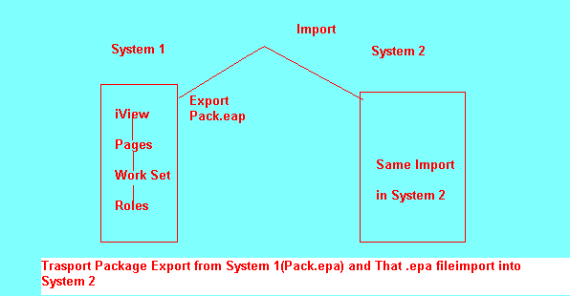
Export the Transport Package (Pack.epa) File Folder structure path. Import to the another System same folder Structure will be created in System2 also

How Importing and Exporting Transport Packages and .epa (Enterprise Portal Archive) Files

Transporting iView, Page, work set, Role all under PCD (Portal Content Development)
PCD path is D:\usr\sap\BPE\SYS\global\pcd (Here Export/Import Folders Available)

Export the File is .epa file

How to Export Package from Portal Component

- Go to System Administrator-→Transport-→Transport Package-→Click on Export-→Portal Content--→Go to our Folder (SapExamPro)---Here What u want Require Like u need
iView, Page, Work set, Role
You need total folder
RC-→NEW-→Click on Transport Package
Here Enter
Transport Package Name: Pack1
Transport Package ID: PackID1
-→Next--→FINISH-→Select Open object for editing--→ OK
iView/Page/Work Set/Role/Folder/-→RC-→Click on Add Object to Transport Package-→Click on Export button

Here Change File Name: Pack1.epa---→Click on Start Export Button.

Now you will see that Pack1.epa file created or not
Go this Path D:\usr\sap\BPE\SYS\global\pcd\Export
Here Pack1.epa File Available.
Or you can download from portal also. When you are export that .epa file click on Start Export Button after one download link available. So we can download here also.
How to Import to Portal Component

Go to System Administrator-→Transport Package--→Click on IMPORT.
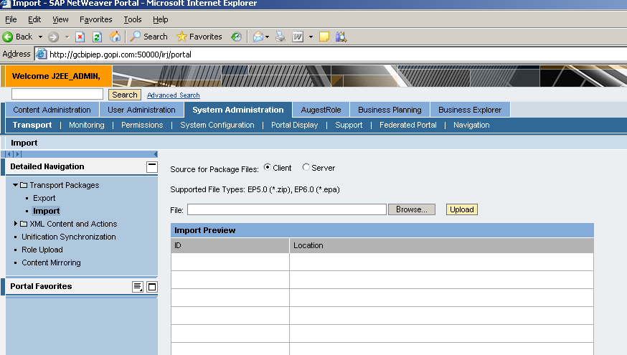
Select Source for Package Files: Client
Browse the Pack1.epa file-→And click on Upload--→Click on Import button.

Now How to Check it in Local System (Our System) Pack1.eap file Upload or Not.
Go to portal Content delete some iViews and pages. And again import
Export Pack1.epa file having only iView.
Delete iView and Import Pack1.epa file. Now iView Available.

