10. Config Tool, SLD user, Creating Technical System, JCO Creation to ECC6.0, Model Data and Meta Data:

JCO:
**1. JCO is a SAP java library to connect to a SAP R/3 System. It can be used by independent (i.e. non-portal) application.
**2. If we use WebDynpro Application, we configure JCO in the WAS, and then use the plug-ins to create connections to R/3 RFC Functions.
We will get data from SAP Systems by using JCO’s.

Java Connector Purpose
**1. SAP Java Connector (SAP JCO) is a middleware component that allows the development of SAP-compatible components and applications in Java. SAP JCO supports communication with the SAP Server in both directions: inbound calls (Java calls ABAP) and outbound calls (ABAP calls Java).
SAP JCO can be implemented with Desktop applications and with Web server applications.

SAP JCO Architecture
The following diagram shows the technical schema of data conversion in SAP JCO (standalone version). Starting from a Java application, a Java method is forwarded via the JCO Java API (Application Programming Interface) and an additional Middleware Interface to RFC Middleware, where it is converted to an RFC (ABAP) call using the JNI (Java Native Interface) layer, and sent to the SAP system. Using the same method in the other direction, an RFC Call is converted to Java and forwarded to the Java application:

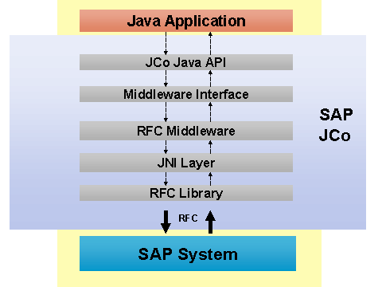

The SAP JCO is generally used in two different ways: As an integrated component of an SAP technology component, or as a standalone tool that you can use to connect an external Java application to the ABAP environment of an SAP server.
Flow
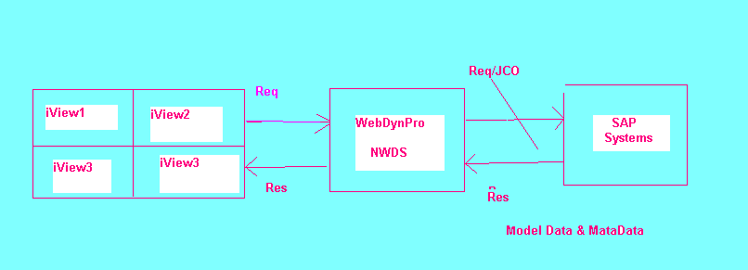

To maintain Jco’s Required Steps.
- SLD User Activation using Visual Admin tool.
- Create new Technical Systems (By Using SAP Server Properties)
3. Create JCo
This has Model Data and Meta Data
Model data: it contains actual data which are passing to BABI’s
Metadata: structure of the actual data. Or description about an actual data.

- SLD User Activation:
SLD---System Landscape Directory
Go to this Path
D:\usr\sap\BPE\DVEBMGS00\j2ee\admin\Click on Go. Bat File
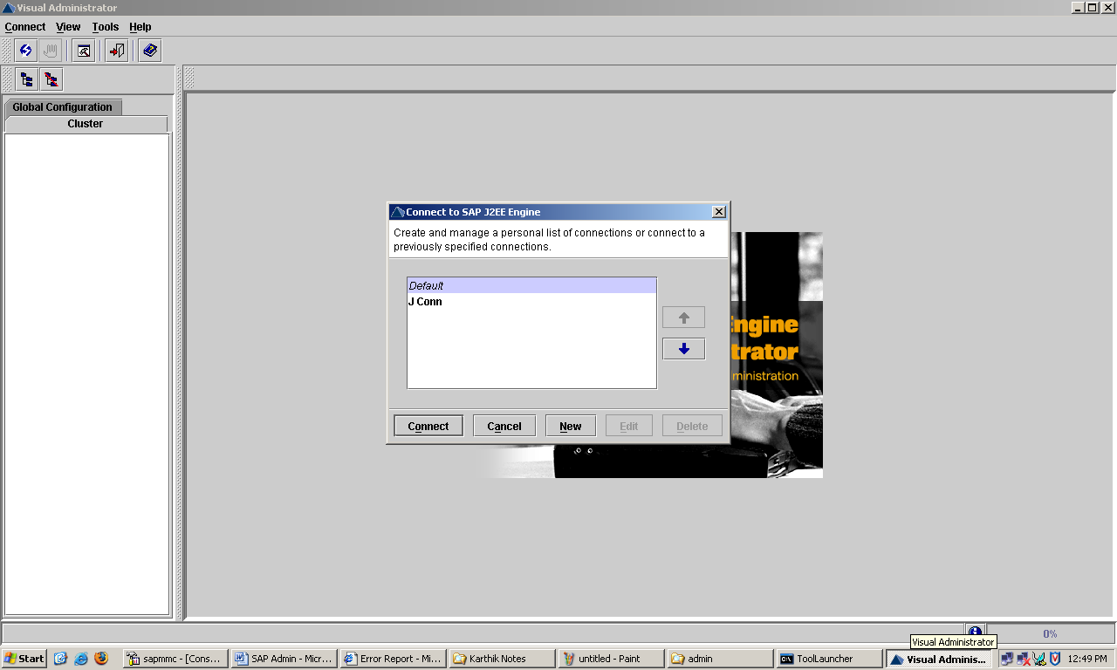
Select Default Click on Connect.
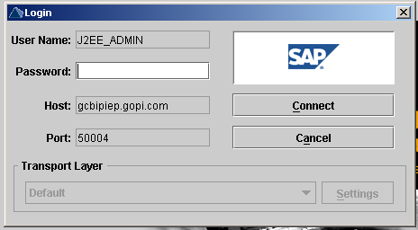

Here Enter User Name = J2EE_ADMIN
Password = india123
Host Name = gcbipep.gopi.com this database host name
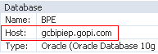
Port = 50004
This port number cluster P4 Port number
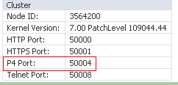

Click on Connect.
After Display this window.
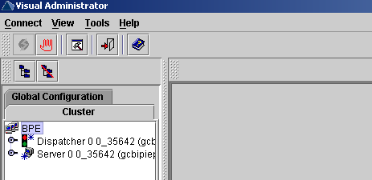

Here Go to Server--→Services-→Click on SLD Data Supplier.
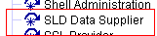

Click on SLD Data Supplier. It Display
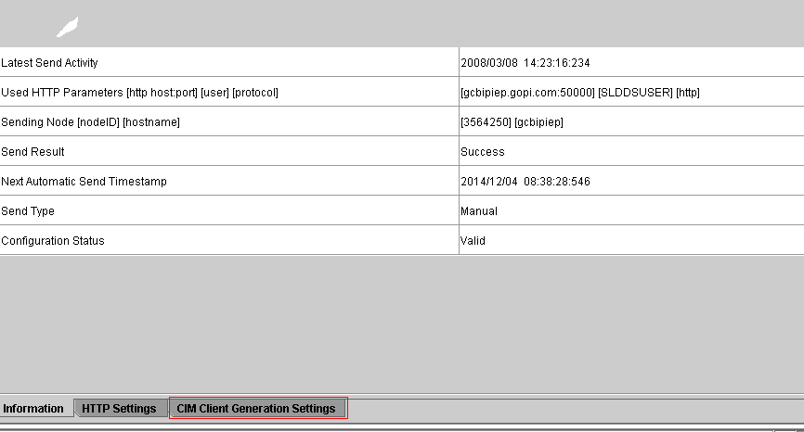

Here Click on CIM Client Generation Setting
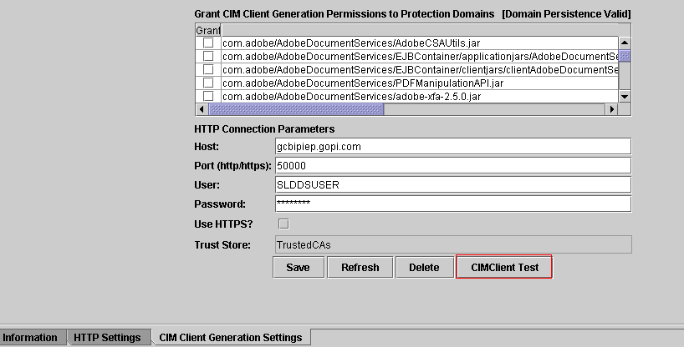
Here Enter
Host = gcbipiep.gopi.com
Port = 50000 this port number is HTTP Port Number.
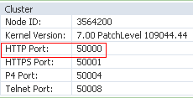
User = SAPUSER
Password = india123

Here Click on CIM Client Text
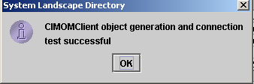

Click on OK. Now SLD (System Landscape Directory) User is activated.
Activated means Create JCo, Maintain JCo and Start SLD and Check SLD Buttons Enable mode. Before these button in disable mode.

2. Create New Technical System.

Open Explorer http://gcbipiep.gopi.com:50000/
Open this up to Port Number.
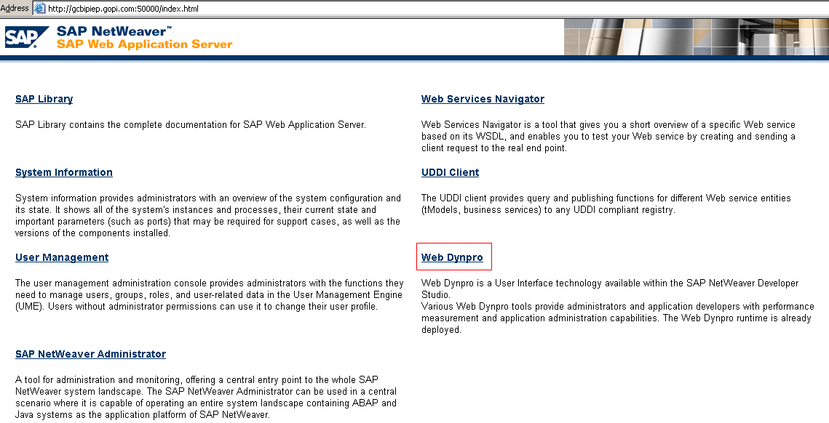

Click on WebDynpro.

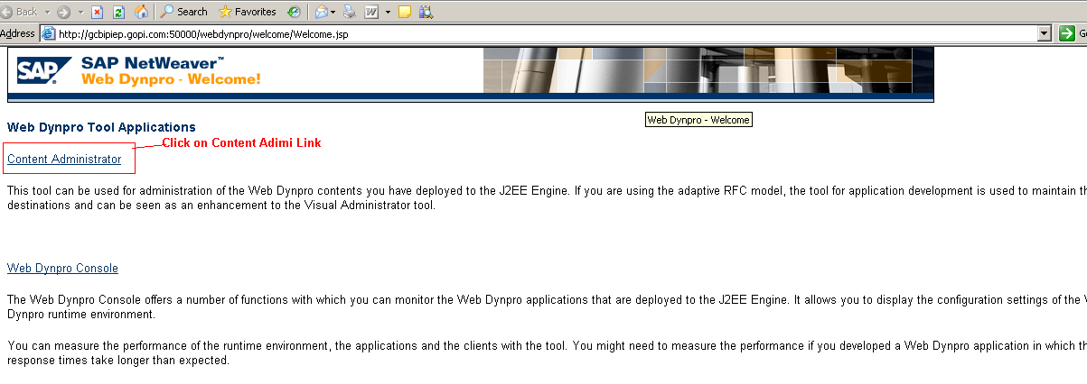
Here Click on Content administrator

Here Asking User id and password
It display this window
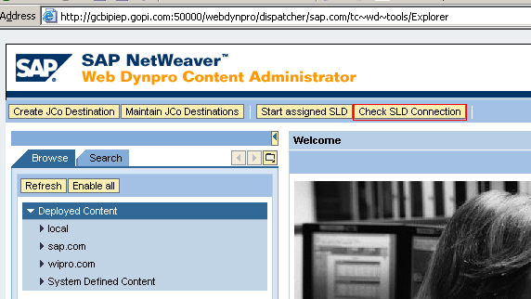

Here Click on Check SLD Connection. It display this window
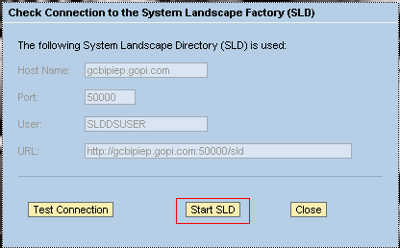
Here click on Start SLD. It displays this window.
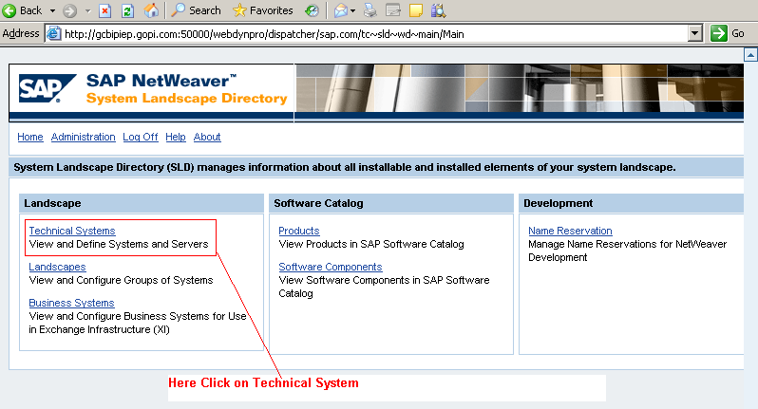

Here click on Technical System. It display this window
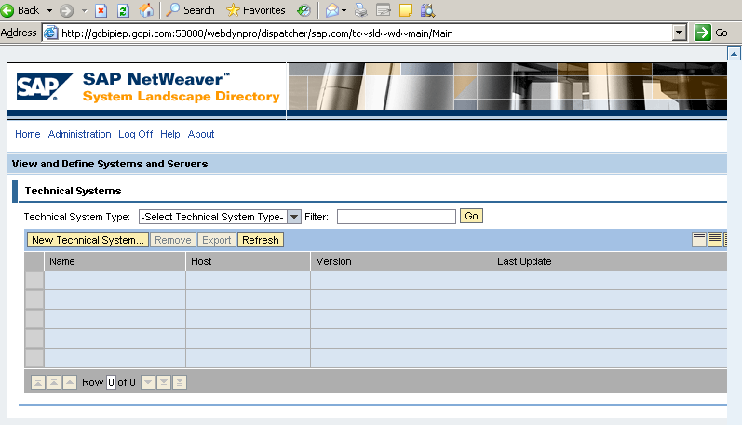

Here Select Technical System Type= web as ABAP
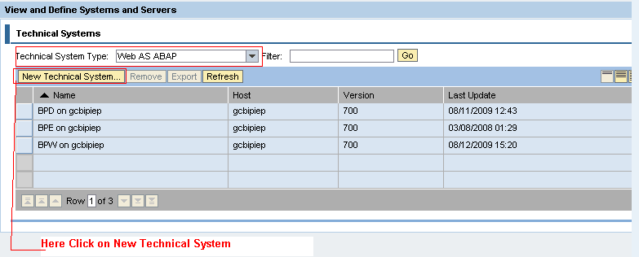
Here Click on New Technical System. It display this window
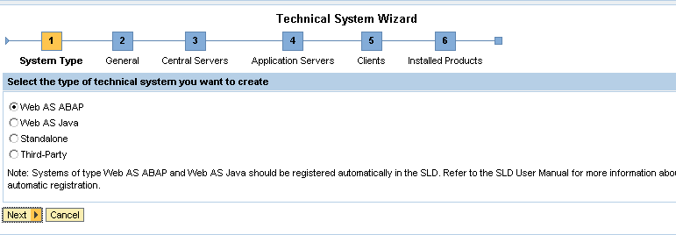

Here select web as ABAP-→Click on Next
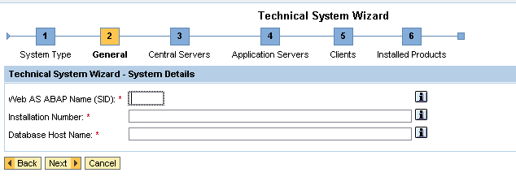

Here Enter
Web as ABAP Name (SID) = BPE (System ID)
Installation Number = INITIAL
Database Host Name= GCBIPIEP
How to see these values
Open 
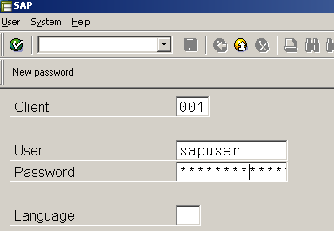

Here Enter User and password.
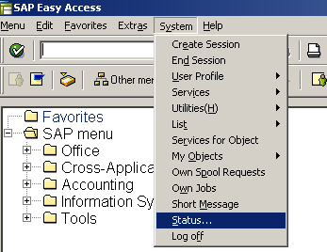

Here click on Status
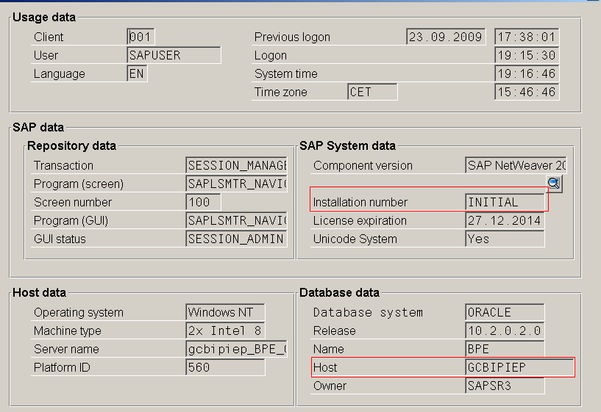

Here
Enter
Web as ABAP Name (SID) = SSO (System ID)
Installation Number = INITIAL
Database Host Name= GCBIPIEP
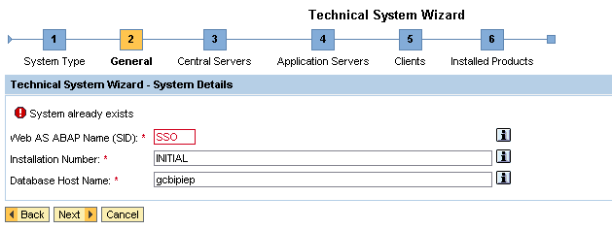

Click on Next
Here Enter Message Server Port =3600 36+SystemNumber (00) Total =3600
And Instance Number = 00

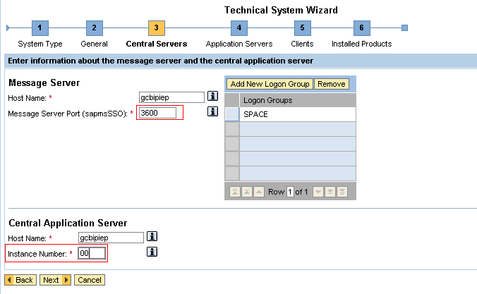

Enter these fields -→Click on Next. It display this window.

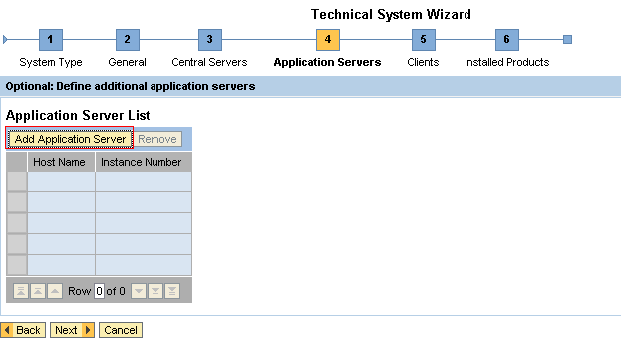

Here Click on Add Application Server Button. It displays this window.
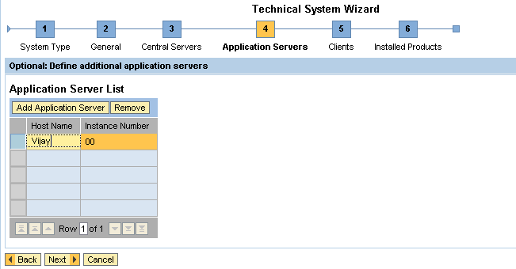

Here Enter Host Name = Vijay--→Click on Next. It displays this window.

Here Enter
Client Number = 001
Logical Client Name = LS001CL
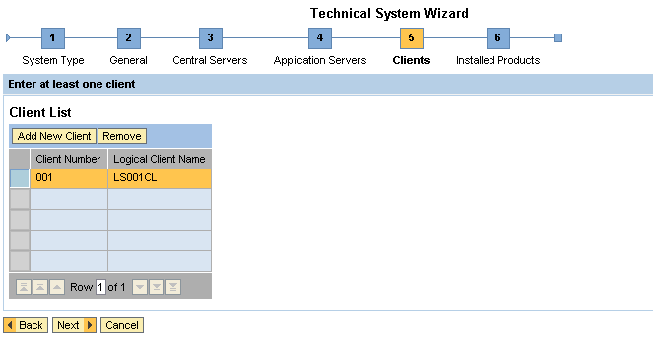
Click on Next. It display this window

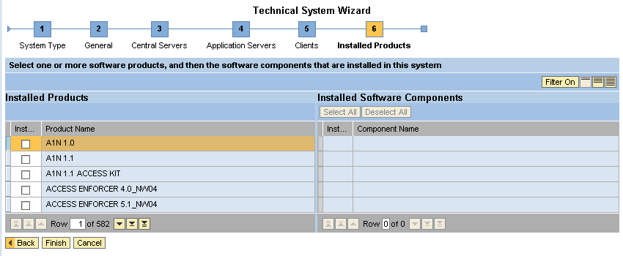
Here Click on Filter On

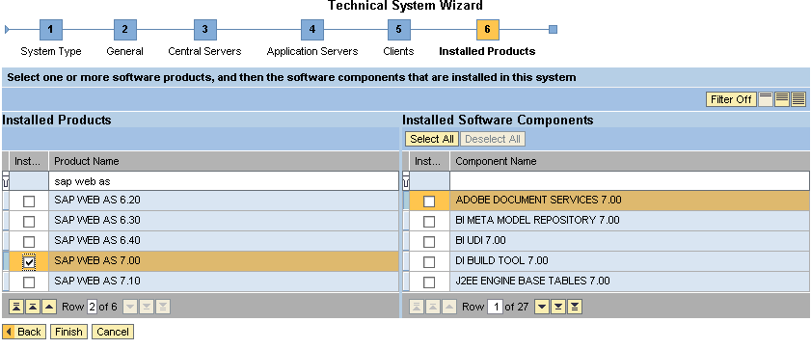
Search Product Name = search sap web as
Left side Select SAP WEB AS 7.00
And Right Side Click on select all button
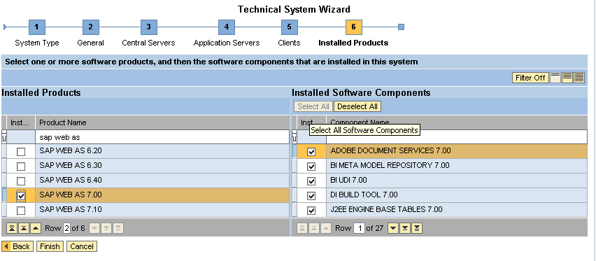
Next Click on FINISH. It display this window

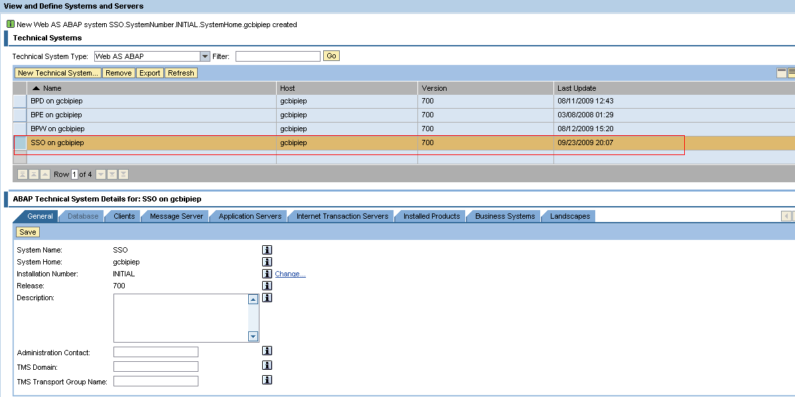

In red mark SSO will be created.
New Web AS ABAP system SSO.SystemNumber.INITIAL.SystemHome.gcbipiep created

This is another Way for Creating Technical System
Go to Up to Port Number put sld and then click on Enter Button
http://gcbipiep.gopi.com:50000/sld

Next Process Same.

3. Creating JCO

Open this URL http://gcbipiep.gopi.com:50000/ Up to Port Number
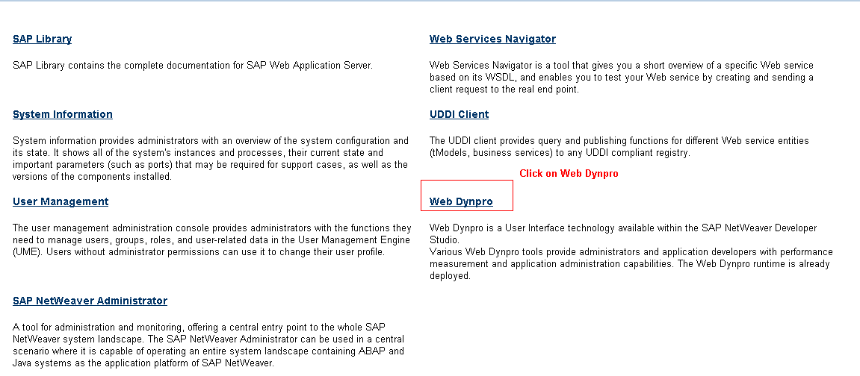

Here Click on Web Dynpro. It display this window
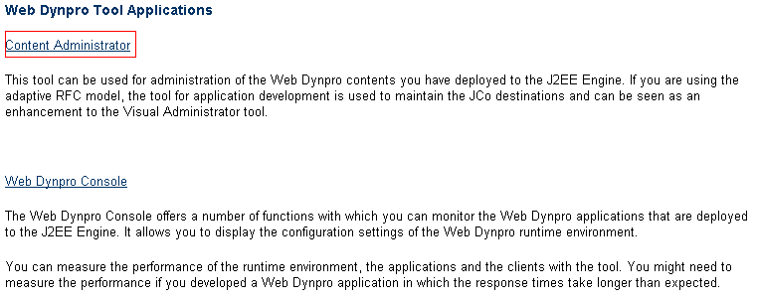
Here click on Content Administrator. It display another window
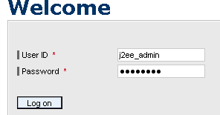

Here enter User ID and Password

Here Now Create Meta Data Creation

Here Create JCo
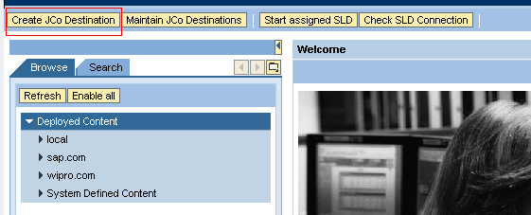

Click on Create JCo Destination. It display this window
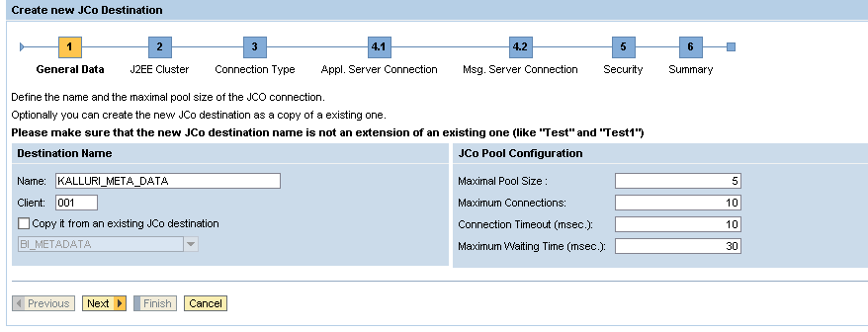
Here Enter
Name = KALLURI_META_DATA
Client = 001
Click on NEXT. It displays this window.
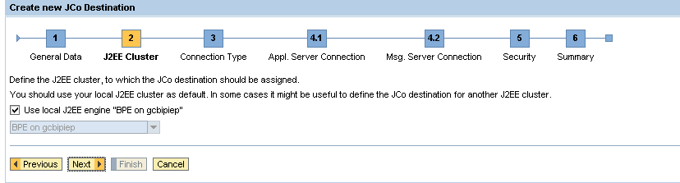

Again Click on NEXT. It display this window

Here Select Dictionary Meta Data
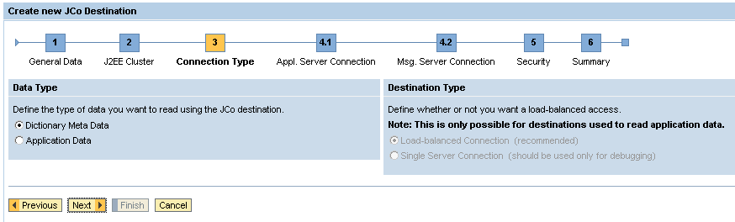
Click on NEXT. It display this window
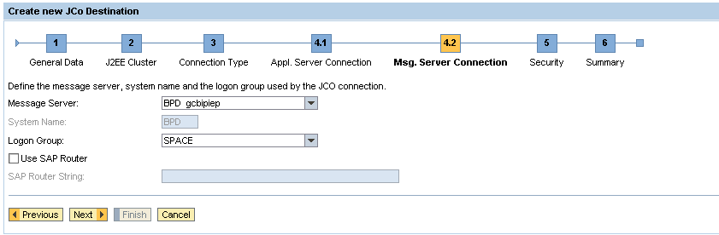

Click on Next. It display this window
Here Enter
Name = sapuser
Password = india123
Confirm Password = india123

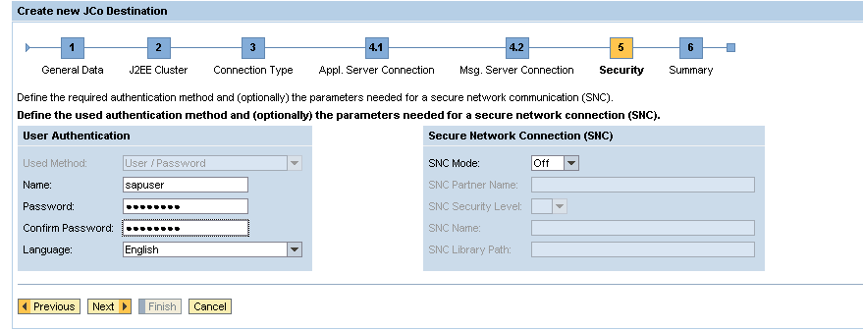

Click on Next. It display this window
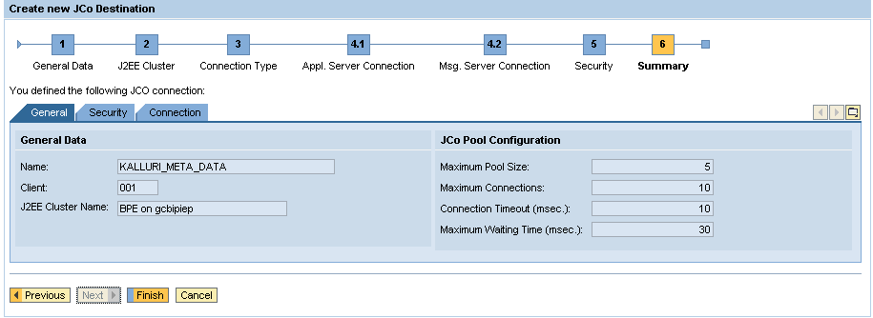

Again click on FINISH.

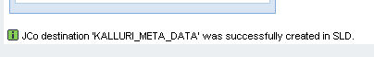

Now Create MODEL DATA

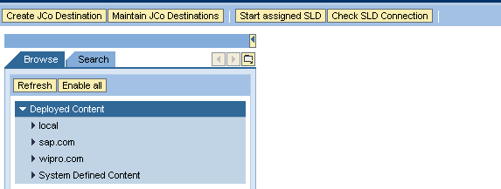

Click on Create JCo Destination. It display this window
Here Enter
Name = KALLURI_MODEL_DATA
Client = 001
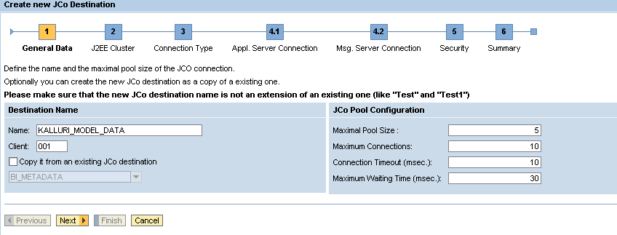
Click on Next
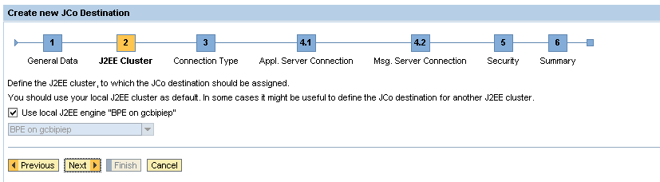

Click on NEXT
Here Select Application Data

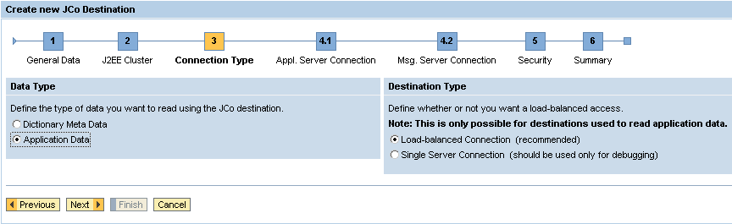
Load-balanced Connection: It is nothing but connect to multiple Servers.
Single Server Connection: It is nothing but connect to Single Server.

Click on NEXT
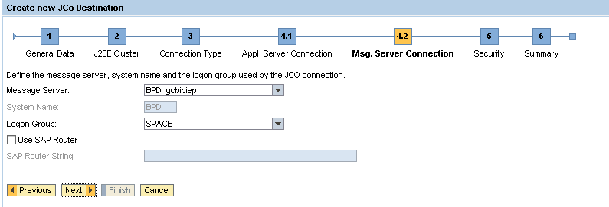

Click on NEXT

Here Enter
Name = sapuser
Password = india123
Confirm Password = india123
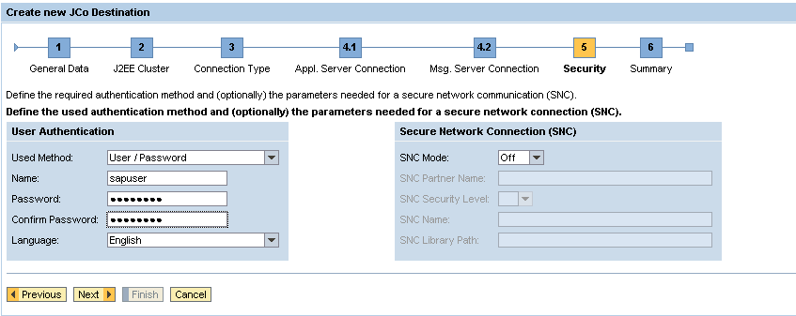

Click on NEXT.
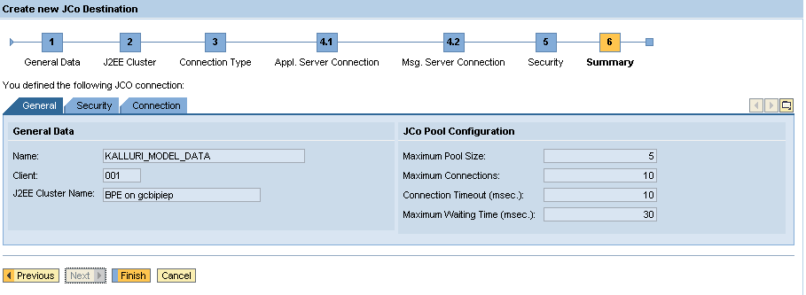

Click on FINISH.
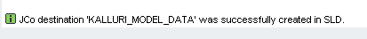

How to Check Model Data (KALLURI_MODEL_DATA) and Meta Data (KALLURI_META_DATA) working or not
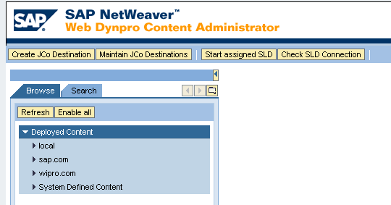

Click on Maintain JCo Destinations

