8. SSO Connecting from Portal to NON SAP, App Integrator Uploading .der files in ECC Server.

9. SSO Connecting from Portal to SAP, Using Logon Ticket.

When we are working on SSO in LogonTicket Method. First Download Certifications in Portal and Import into SAP System. We are not importing this Certification in SAP System SSO Not Working.
How to download certifications in portal and How to import in SAP System

System Administrator-→System Configuration-→Go to Keystore Administration

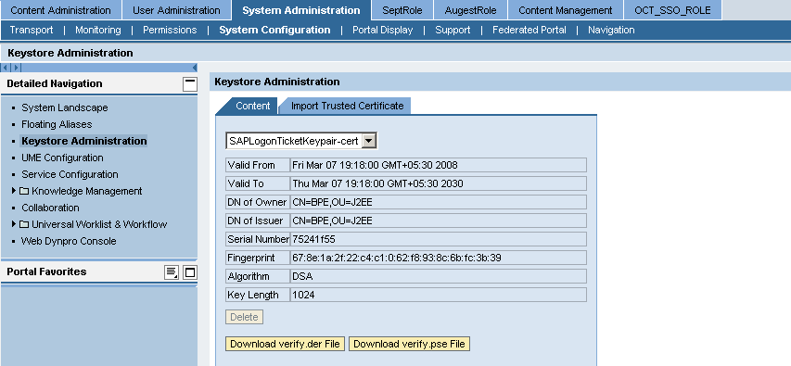
Here Download verify .der File --→For Portal to SAP System
Download verify .pse File -→For Portal to Non-SAP System
Download these 2 files upload in SAP System
How to Upload in SAP System

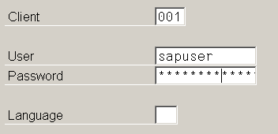

Login into SAP System
Step 1
Enter this Tcode = strustsso2 next click on Enter
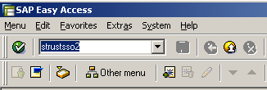
Open this window

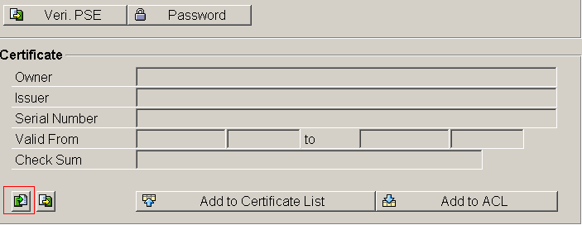

Here click on this import certification button.
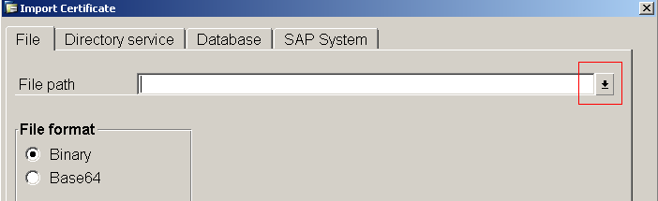 Here Click on Red mark. Here Browse the certification file -→Click on Write Mark button
Step 2
Next Click on ADD to ACL Button. It display this window
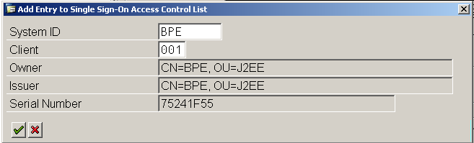

Here click on write mark. And Click on SAVE Button
Step 3
Go to menu
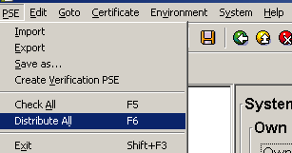

Click on Distribute All and Click on SAVE Button.
Next Enter another Tcode = /nrz10 next click on Enter
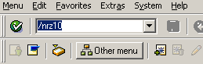
It display this window
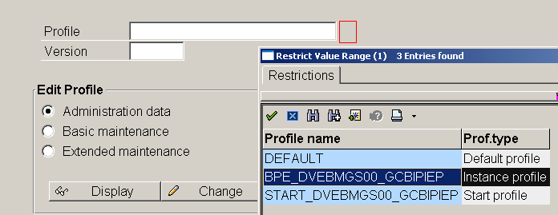

Here click on red mark .it display this window here double click on this BPE_DVEBMGSOO_GCBIPEP
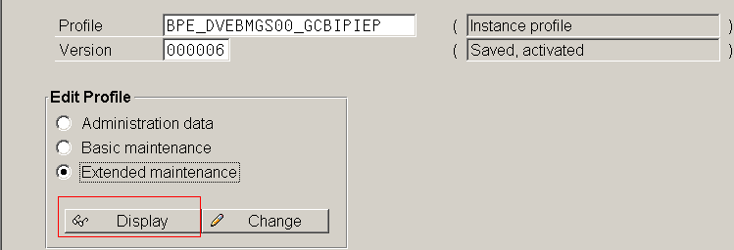

Next click on display button. It display this window
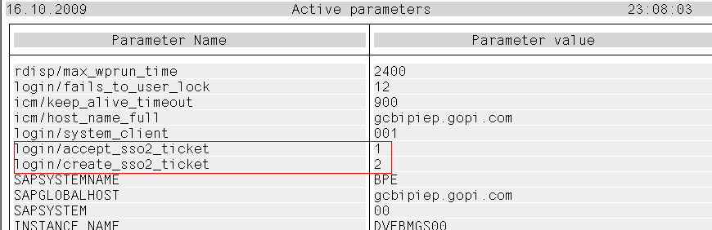

One certification successful import in SAP System that times these two parameters will display here. These two parameters not display here certification not successfully imported. That time we can’t do any work on SSO
Here
login/accept_sso2_ticket
login/create_sso2_ticket

***These two parameters not display here Portal TO SAP System and NON-SAP System not working.

SSO (Single Sing on):

The main Advantage SSO is Single userid/pwd can Communicate with different landscapes. To achieve SSO have to provide logon methods and as well as user mapping fields to the system object
SSO is 2 Types
- Portal to SAP System
1.1 uid/pwd type
1.2 Logon Ticket Type
- Portal to Non-SAP System

Uid/pwd type: If Portal id and SAP id both are different.
So this method always requires user mapping. The portal ID is mapped to the user ID and password of the back-end system.

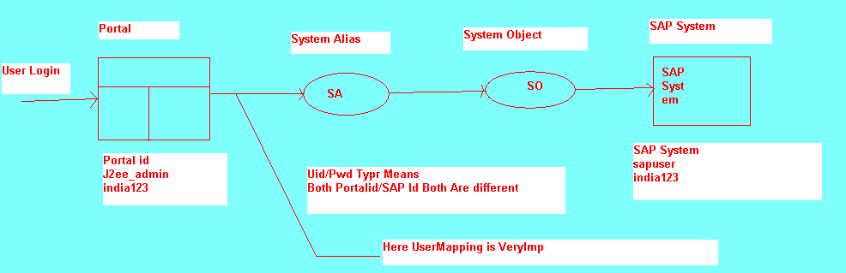
Logon Ticket:
1. If Portal id and SAP id both are same.
2. So this method only requires user mapping if users have different user IDs in the
SAP NetWeaver Portal and SAP System. Passwords are not mapped.
- And here no need to User Mapping
4. The portal user ID and the SAP System user ID are stored in these users’s logon ticket. When the users try to access a back-end system, the system extracts the user ID from the logon ticket.
The logon Ticket follows Some Rules.
- Portal user ID and one mapped user ID for external applications
- Authentication scheme
- Validity period
- Information identifying the issuing system
- Digital signature

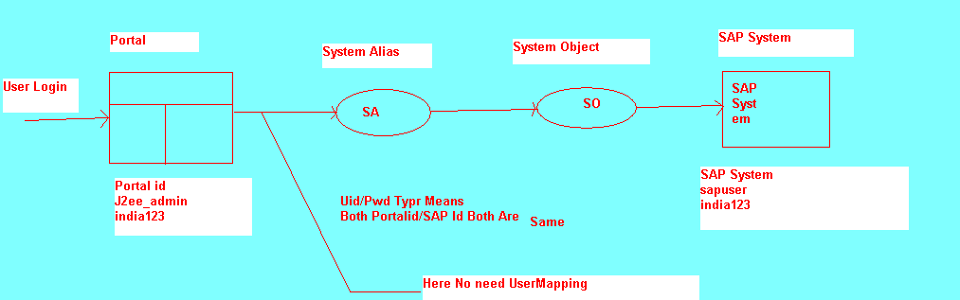

Connected Portal to SAP System
1. Creating System Object
It is connected to SAP System.
2. Logon Method:
Uid/pwd type: If Portal id and SAP id both are different.
Logon Ticket: If Portal id and SAP id both are same.
3. System Alias
To Secure the System Object.
If server modify (IP add, Client No, Logical Sys), it doesn’t effect to the current iViews. Which are connected to the SAP System?
4. User Mapping
Uid/pwd type: Mapping Portal id with SAP Id
Logon Ticket: No Mapping Here.
5. Creating an iView of type “SAP Transaction iView”.
Here Calls “System Alias”.

Flow: iView--→System Alias--→System Object-→SAP System

- Portal to SAP Systems using userid/pwd
- Portal to SAP Systems using Logon ticket.
- Portal to SAP Systems using Non-SAP System.

Requirements:
System Name: gcbipiep
System Number: 00
System ID: BPE
Logon R3 Server (SAP Logon)
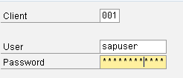
Client Number: 001
User ID: sapuser
Pwd: india123
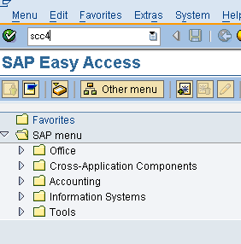
Enter Tcode →scc4--→Click on Enter it Display another Window. i.e.
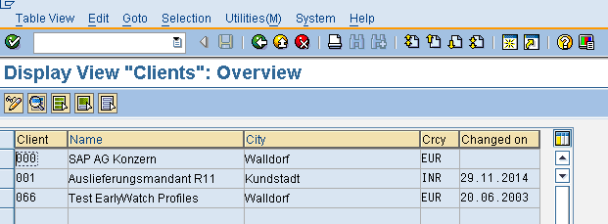

Here Double Click in 001 it display another window i.e.
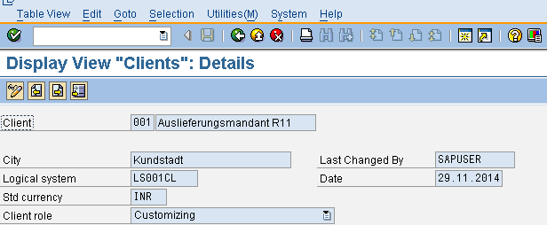

Here Logical Number: LS001CL

- Portal to Sap System using uid/pwd:
  - Creating Object:
System Administration -→System Configuration-→System Landscape
-→Portal Content--→go to our Folder (SapExamPro)→RC -→New-→Click on System (From Template)-→Select SAP system using dedicated application server
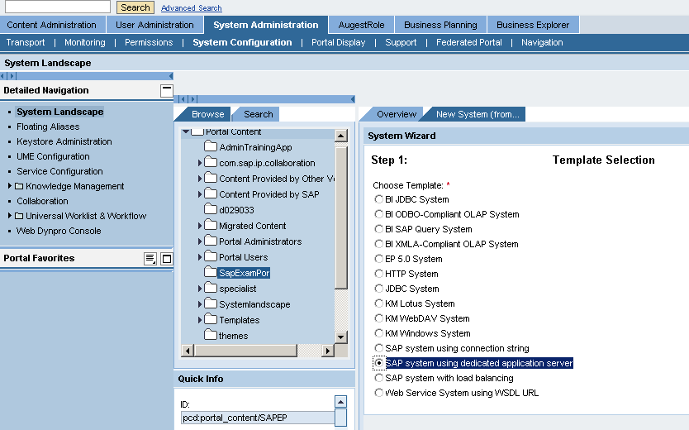

Click on Next-→Enter System Name: PortalToSAP_UIDType
System ID: PortalToSAP_UIDTypeID
Next-→FINISH-→Select Open --→OK
Go to Properties Category = Select Connector
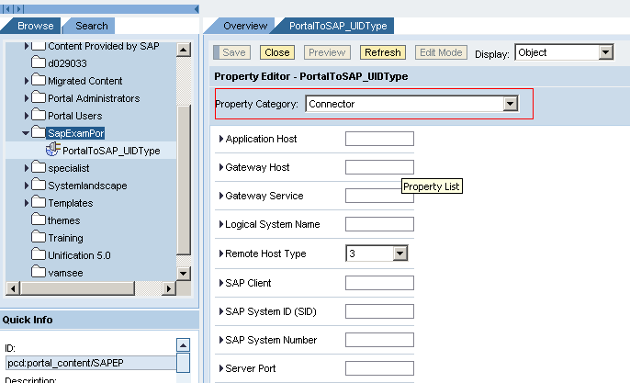

Here Enter All Fields
Application Host: gcbipiep
Gateway Host: gcbipiep
Gateway Service: 33+System Number =3300
Logical System Name: LS001CL
Remote Host Type: 3
SAP Client: 001
SAP System ID: BPE
SAP System Number: 00
Server port: 32+System Number=3200
System Type: SAP_R3

Next Click on SAVE.

- Logon Method :
Property Category =Select User Management
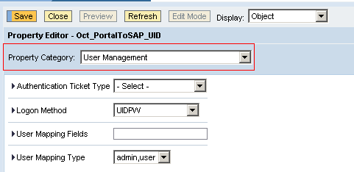

Here Enter
Authentication Ticket Type=Select
Logon Method: UIDPW
User Mapping Type: admin, user
And Click on
SAVE.
In Real Time Work we can Enter ITS and WAS Details also
Property Category =Select Internet Transaction Server (ITS)

ITS Description =
ITS Host Name =
ITS Path =
ITS Protocol = http
Property Category =Select Web Application Server (Web AS)

Web AS Description =
Web AS Host Name =
Web AS Path =
Web AS Protocol = http

- Create System Alias:

Go to Display = Select System Aliases it display one window i.e.
Here Enter Only Alias Name: PortalToSAPUidAlias
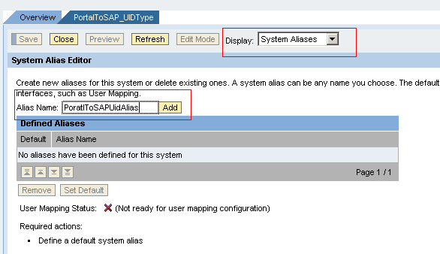
--→Click on ADD.
Select that PortalToSAPUidAlias -→SAVE.

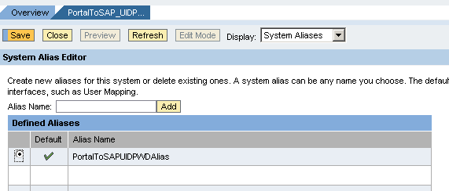

- User Mapping:
Go to User Administrator -→ Identity Management--→Search user=j2ee_admin-→Click on Go

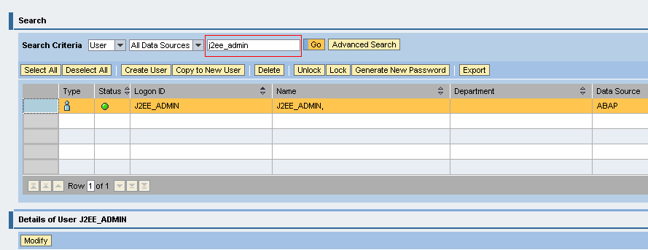

Select User (J2EE_admin)--→Click on Modify-→Go to User Mapping For System Access Tab.
Here Select
System=PortalToSAPUidAlias
Mapped User Id=sapuser
Mapped Password=india123
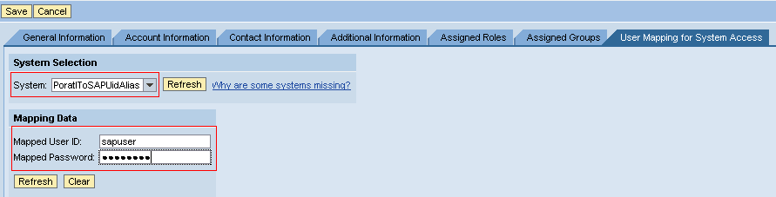

And Click On SAVE.

- iView Creation:
Content Administrator-→Portal Content-→Go to our folder (SapExamPro)-→RC--→New-→iView-→Select iView template--→Select SAP Transaction iView-→Next-→Enter
iView Name= PortalToSAPUidiView
iView ID= PortalToSAPUidiViewID

-→Click on NEXT-→Select SAP GUI for Window--→Next--→System=PoratalToSAPUidAlias and Transaction Code=se37--→NEXT-→FINISH.

Check Statues RC on PortalToSAPUidiView-→Preview
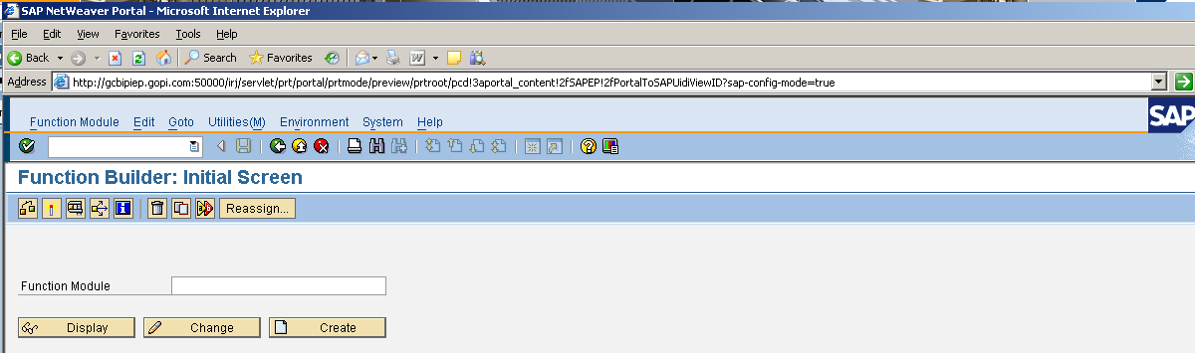

Its working Fine.

1. Create New Work Set (SSO)
RC on Folder (SapExamPro)-→New-→Click on Work Set-→
Enter Work Set name: SSO
Work Set ID: SSOID-→NEXT-→FINISH-→Select Open Object for Editing--→OK

- RC on PortalToSAPUidiView---Add iView to Work Set→Click on Delta Link.
- RC on Work Set (SSO)-→Add Work Set to Role--→Click on Delta Link.

2. Portal to SAP System using Logon ticket:

  - Creating Object:
System Administration -→System Configuration-→System Landscape
-→Portal Content--→go to our Folder (SapExamPro)→RC -→New-→Click on System (From Template)-→Select SAP system using dedicated application server

Click on Next-→Enter System Name: PortalToSAP_LononTicketType
System ID: PortalToSAP_LononTicketType ID
Next-→FINISH-→Select Open --→OK
Go to Properties Category = Select Connector
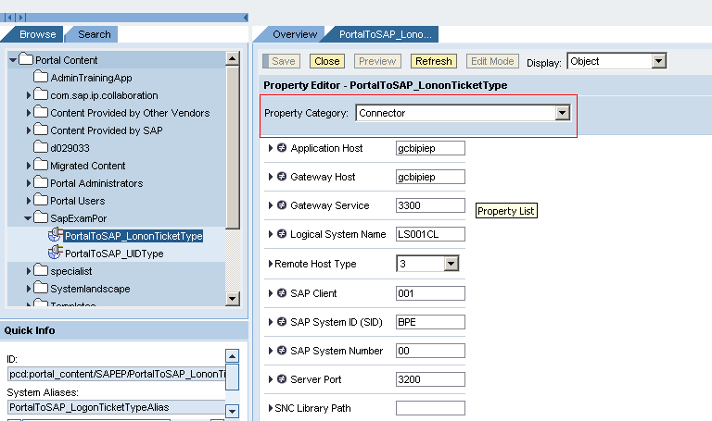

Here Enter All Fields
Application Host: gcbipiep
Gateway Host: gcbipiep
Gateway Service: 33+System Number =3300
Logical System Name: LS001CL
Remote Host Type: 3
SAP Client: 001
SAP System ID: BPE
SAP System Number: 00
Server port: 32+System Number=3200
System Type: SAP_R3

Next Click on SAVE.
  - Logon ticket :
Property Category =Select User Management

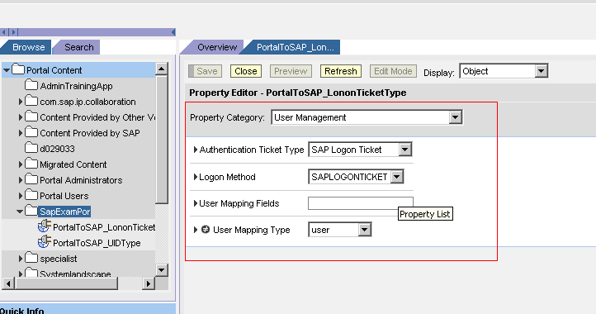
Here Enter
Logon Method: SAPLOGONTICKET
User Mapping Type: user
And Click on SAVE.

In Real Time Work we can Enter ITS and WAS Details also
Property Category =Select Internet Transaction Server (ITS)

ITS Description =
ITS Host Name =
ITS Path =
ITS Protocol = http
Property Category =Select Web Application Server (Web AS)

Web AS Description =
Web AS Host Name =
Web AS Path =
Web AS Protocol = http

3. Create System Alias:
Go to Display = Select System Aliases it display one window i.e.
Here Enter Only Alias Name: PortalToSAP_LononTicketTypeAlias

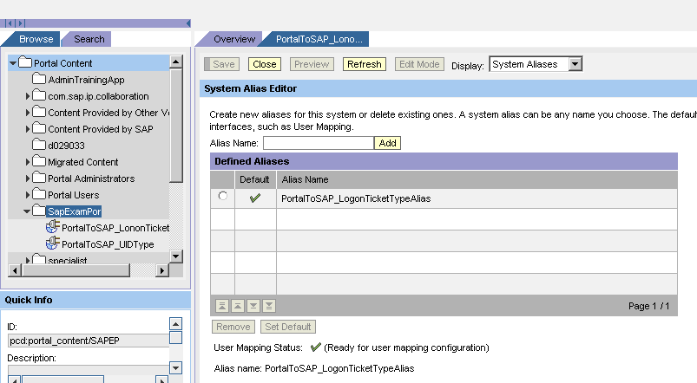
--→Click on ADD
Select PortalToSAP_LononTicketTypeAlias -→SAVE.
4. User Mapping:
No need to User Mapping Here.
If means both uid/pwd are same.
It is directly connected to Alias.
5. iView Creation:
Content Administrator-→Portal Content-→Go to our folder (SapExamPro)-→RC--→New-→iView-→Select iView template--→Select SAP Transaction iView-→Next-→Enter
iView Name= PortalToSAP_LogonTicketType
iView ID= PortalToSAP_LogonTicketTypeID

-→Click on NEXT-→Select SAP GUI for Window--→Next--→
System= PortalToSAP_LononTicketTypeAlias and Transaction Code=se37--→NEXT-→FINISH.

Check Statues RC on PortalToSAP_LononTicketTypeAlias-→Preview

Its working Fine.

1. Create New Work Set (LogonTicket)
RC on Folder (SapExamPro)-→New-→Click on Work Set-→
Enter Work Set name: LogonTicket
Work Set ID: LogonTicketID-→NEXT-→FINISH-→Select Open Object for Editing--→OK

6. RC on PortalToSAP_LogonTicketType---Add iView to Work Set→Click on Delta Link.
7. RC on Work Set (LogonTicket)-→Add Work Set to Role--→Click on Delta Link.

3. Portal to NON SAP System.
Take this .par File (com.sap.portal.howtos.webapp.par) upload the Administrator Console
See
Go to System Administrator -→Supports-→Click on Portal Runtime-→Click on Administrator Console.
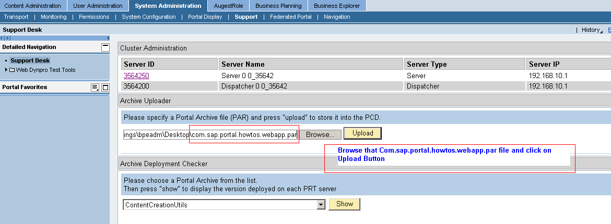

Browse com.sap.portal.howtos.webapp.par file And Upload that File.

1. Creating System Object:
Go to System Administrator-→System Configuration--→System Landscape-→Portal Content-→Go to Our Folder (SapExamPro)-→RC-→NEW-→Click on System (from Par).
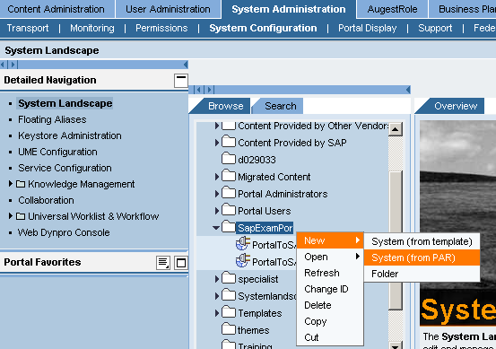

Click on System (From PAR)-→Select com.sap.portal.howtos.webapp.par File
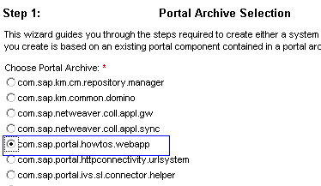
Click on NEXT-→Select Web Application-→Next--->
Here Enter
System Name: PortalToSAP_NONSAP
System ID: PortalToSAP_NONSAPID
Click on NEXT-→FINISH-→Select Open Object for Editing-→OK

Here Enter
Property Category=System Definition
Here Enter
Name of the Server: login.yahoo.com
Port Number: 80 (default port num)
Protocol of target System: HTTP
URI of Web application: /config/mail
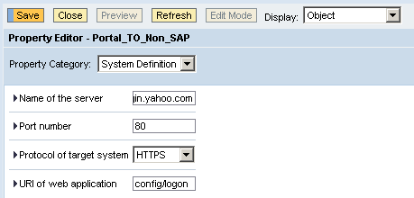

Next Click on SAVE.
2. Logon Method

Property Category= User Management
Enter Logon Method: UIDPW
User Mapping Type: admin, user
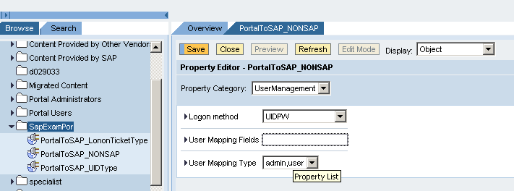

Next Click on SAVE.

3. Creating System Alias:
Go to Display= Select System Aliases
Here Enter Alias Name: PortalToSap_NonSAP 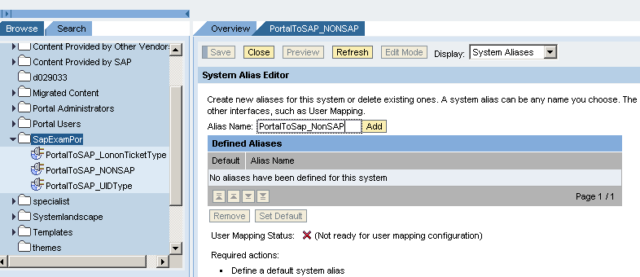
Click on ADD--→SAVE.

4. User Mapping:
Go to User Administrator -→ Identity Management--→Search user=j2ee_admin-→Click on Go

Select User (J2EE_admin)--→Click on Modify-→Go to User Mapping For System Access Tab.
Here Select
System= PortalToSap_NonSAP
Mapped User Id=kallurivijay@gmail.com
Mapped Password=Here Enter you are Gmail Pwd
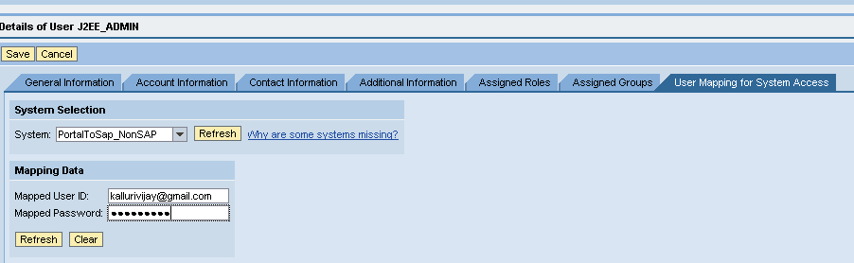

And Click On SAVE.

5. Create iView:
Go to Content Administrator-→Portal Content-→Go to our folder (SapExamPro)-→RC--→New-→iView-→Select Portal Component--→Select com.sap.portal.appintegrator.sap

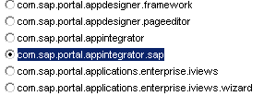

-→Next-→Select Generic
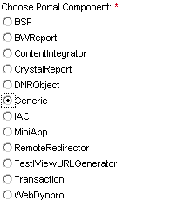
Click on NEXT--→Enter
iView Name= PortalToSAP_NonSAP
iView ID= PortalToSAP_NonSAPID
-→Click on NEXT→FINISH-→Select Open Object for Editing-→OK

Here Select Property category=Content-Generic Launcher
Here Enter
System: PortalToSap_NonSAP (Here Enter System Alias Name)
URL Template: <System.protocol>://<System.server>/<System.uri>?<Authentication>
URL Template Fragment for User Mapping:
login=<MappedUser>&passwd=<MappedPassword>

Next Click On SAVE.

Create one Work set (Non_SAP_Workset)
RC on iView (PortalToSAP_NonSAP)-→Add iView to Work Set→Click on Delta Link.
RC on Work Set (Non_SAP_Workset)-→Add Work Set to Role--→Click on Delta Link.

