6. Portal Desktop – Themes, Default Framework Page, Rules & Collections

Portal Desktop:

This total Screen having all Portal Masthead, Portal Tool Area, Top-Level Navigation, Light Top-Level Navigation, Light Detailed Navigation, Portal Body and Navigation Panel .we have to modify the page depending upon client requirement. Here we have to Put the client company logos and we have to change look and feel like colors all this.

Portal Desktop Having Themes, Default F/W Page (DFP), Portal Desktop (PDO) and rules & Collections

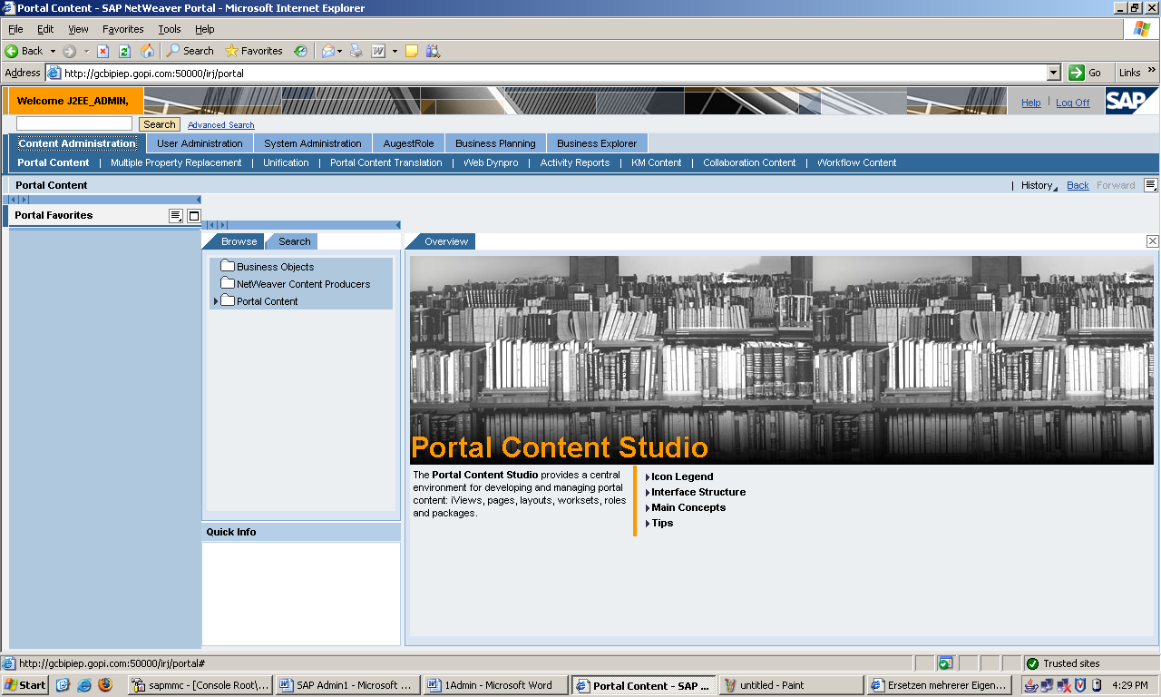

- Themes: It is used to modify Text, color, images, Font like etc. we have to change look and feel depending upon Client Requirement. Once we have to Finish the themes we have to modify the Default Frame work Page
- DFP: It is comprise the layout and structure of the portal desktop. If we want to any modification in DFP take backup and do modifications. This is
Very important. So we can do working carefully. So we can take backup to another folder here we can do modification of the Client Requirement.
- Portal Desktop (PD): It is nothing but collection of framework pages and portal themes. After that the portal desktop is assign to users and group of users in that organization
- Rules & Collections: Used to assign portal desktop to end users (Groups and Role) through the portal display rules and rules collection.

Flow: Themes--→DFP--→PD--→Users & Group.

This is the Flow for Creation of Portal Desktop:
- Themes:
Go to System Administrator -→ Portal Display--→themes Editor--→Choose one Themes. Click on that Themes.

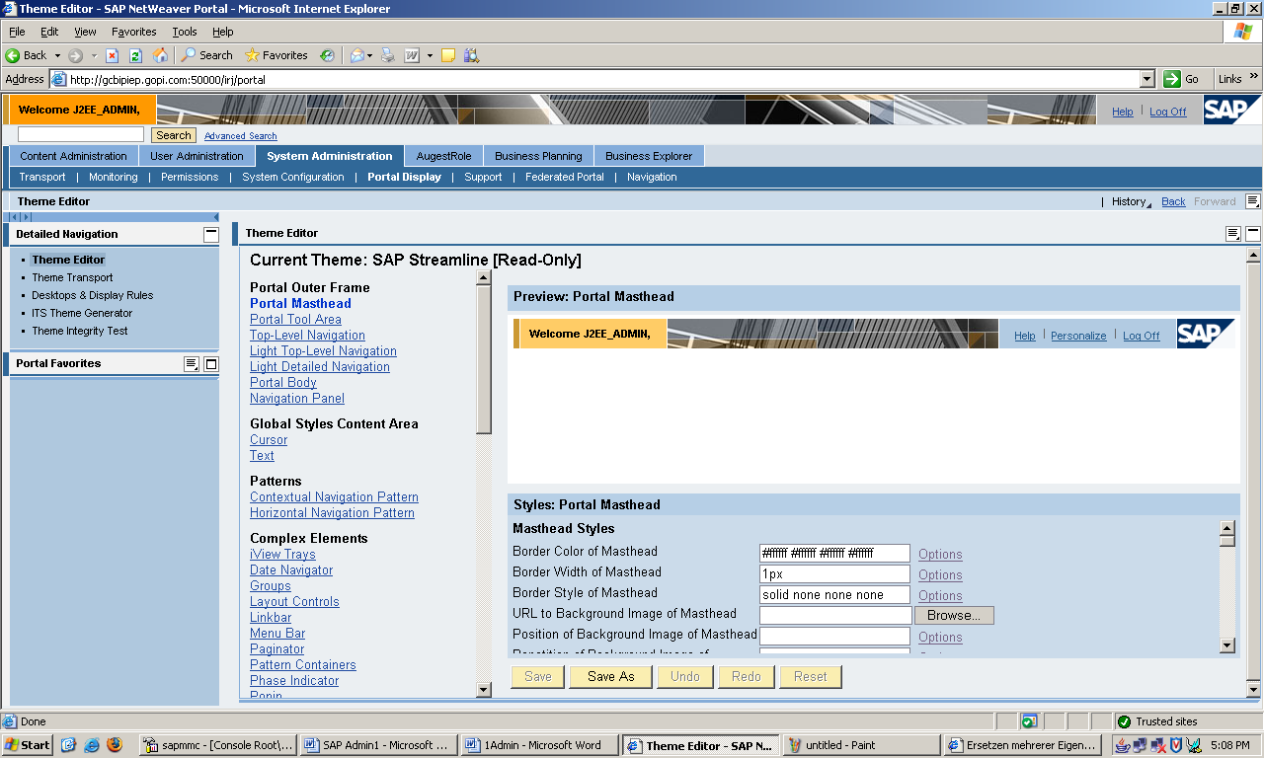

Here modify all Portal Masthead, Portal Tool Area, Top-Level Navigation, Light Top-Level Navigation, Light Detailed Navigation, Portal Body, Navigation Panel --→Click on SAVE.
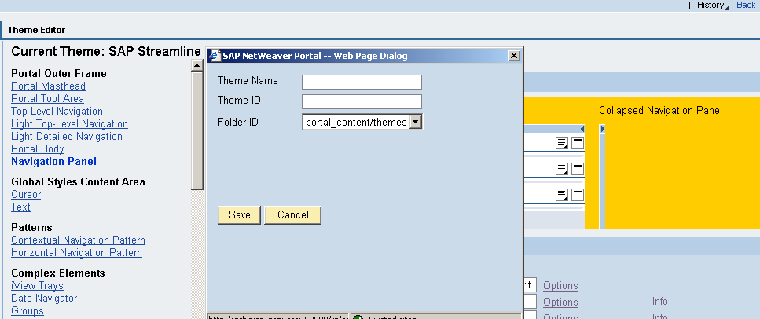
This window Open
Here Enter Theme Name: Theme_Exmp
Theme ID : Theme_ExmpID
Folder ID: Poratal_Content/themes
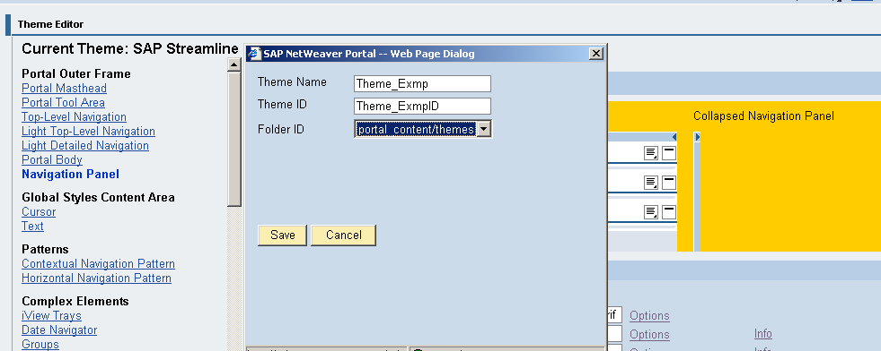
Click on SAVE.
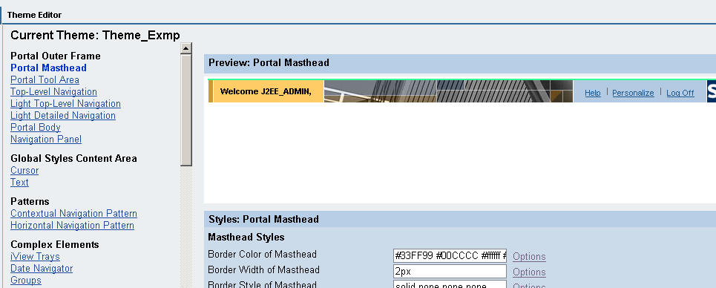

- Default F/W Page (DFP):
Go to Content Administrator--→Portal Content--→Portal User---→Standard Portal user--→Double Click on Default F/W(Here we Can do Any Work Carefully. this is Very Imp. So Copy Default F/W to Past to another Folder (SapExamPro). Here we can do R&D).
Copy DF/W--→Past As DataLink in Our Folder (SapExamPro)

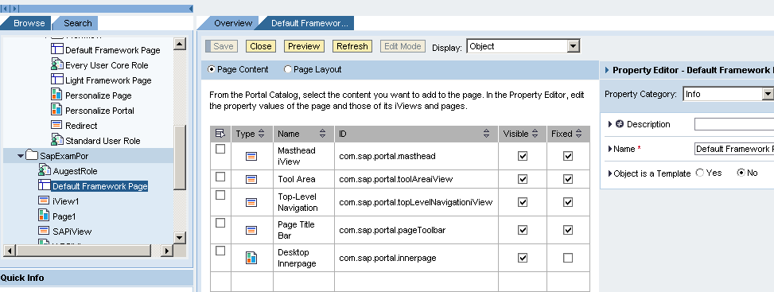

- Portal Desktop Object:
Go to System Administrator --→Portal Display--→Desktops & Display Rules--→Portal Content--→Our Folder (SapExamPro)--→RC-→NEW-→Click on Portal Desktop
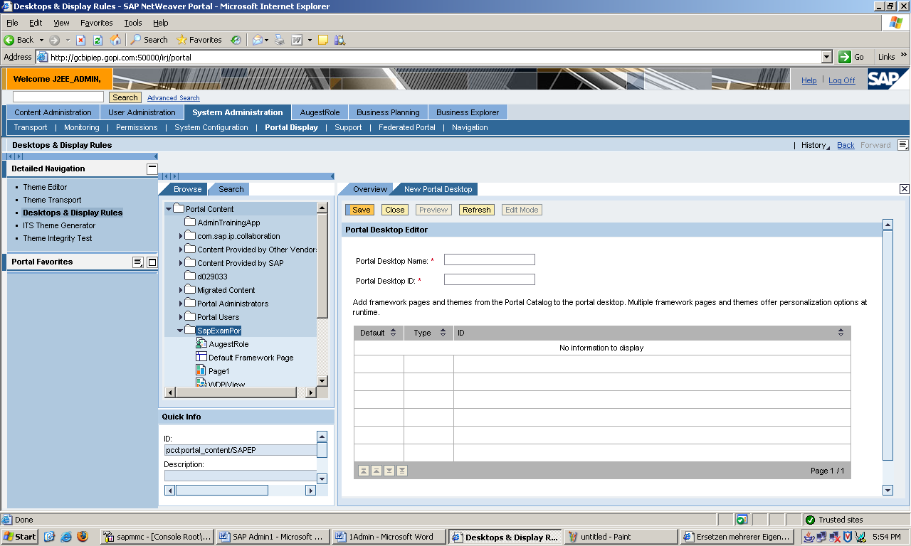

Here Enter Portal Desktop Name: Text_PortalDesktop
Portal Desktop ID: Text_PortalDesktopID
3.1. RC on Default F/W-→Click on Add F/W Page to Desktop
3.2. Go to Themes-→our Themes (Theme_Exmp) -→RC Theme_Exmp-→Click on Add theme to Portal Desktop.

Next Click on SAVE.

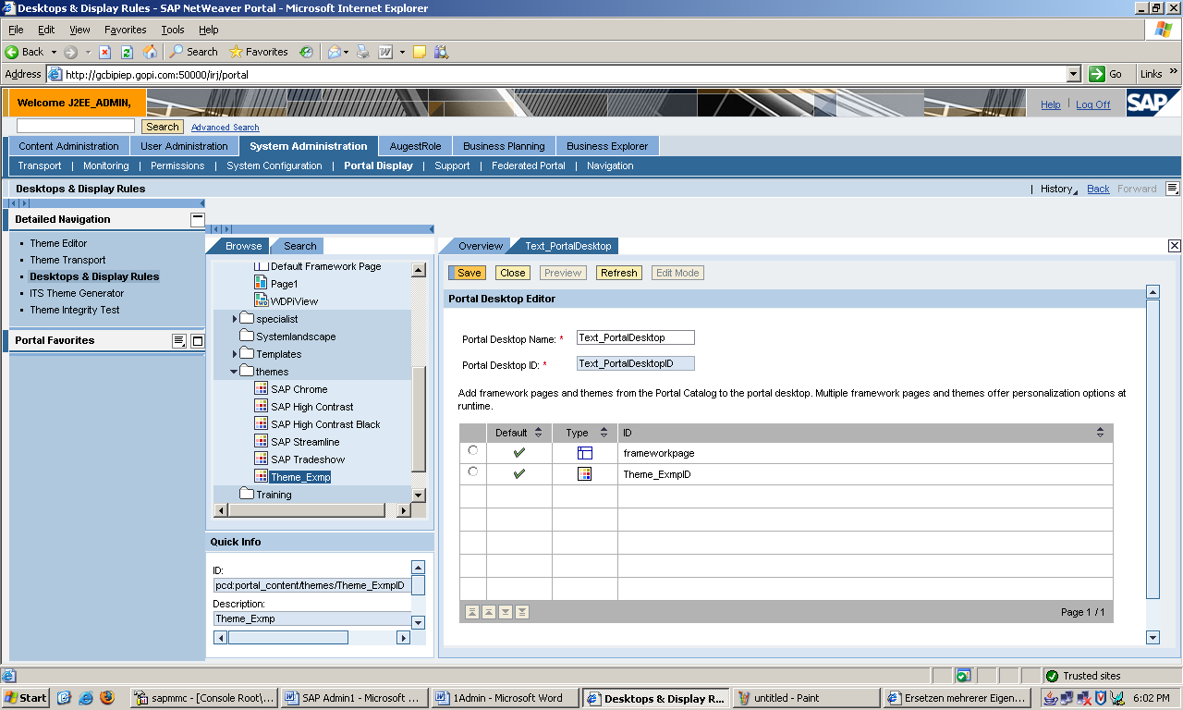

Take this in Notepad ID= pcd:portal_content/themes/Theme_ExmpID

4. Users & groups:
Go to System Administrator --→Portal Display-→Desktop & Display Rules--→Portal Administrator--→Super Administrator --→Double Click on Mater Rules Collection
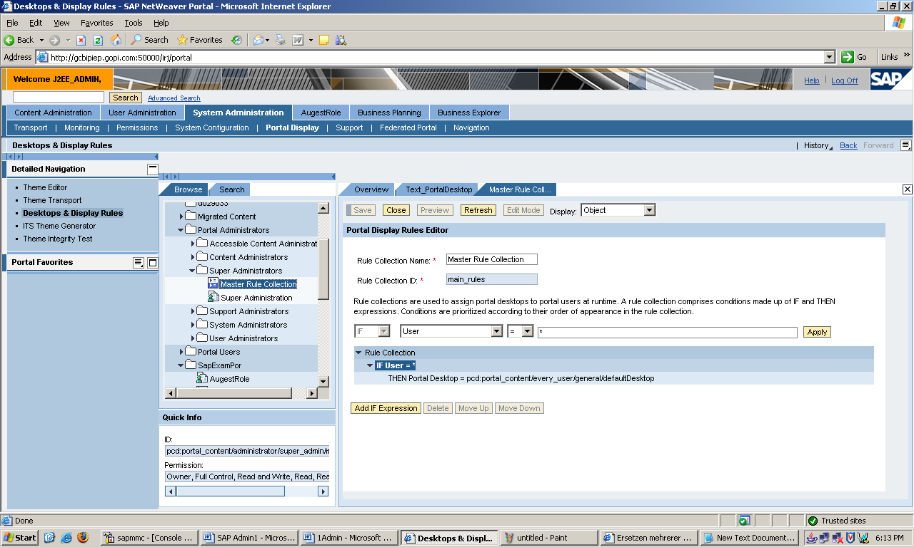

Click on Add IF Expression
User=usera
THEN Portal Destop=pcd:portal_content/themes/Theme_ExmpID

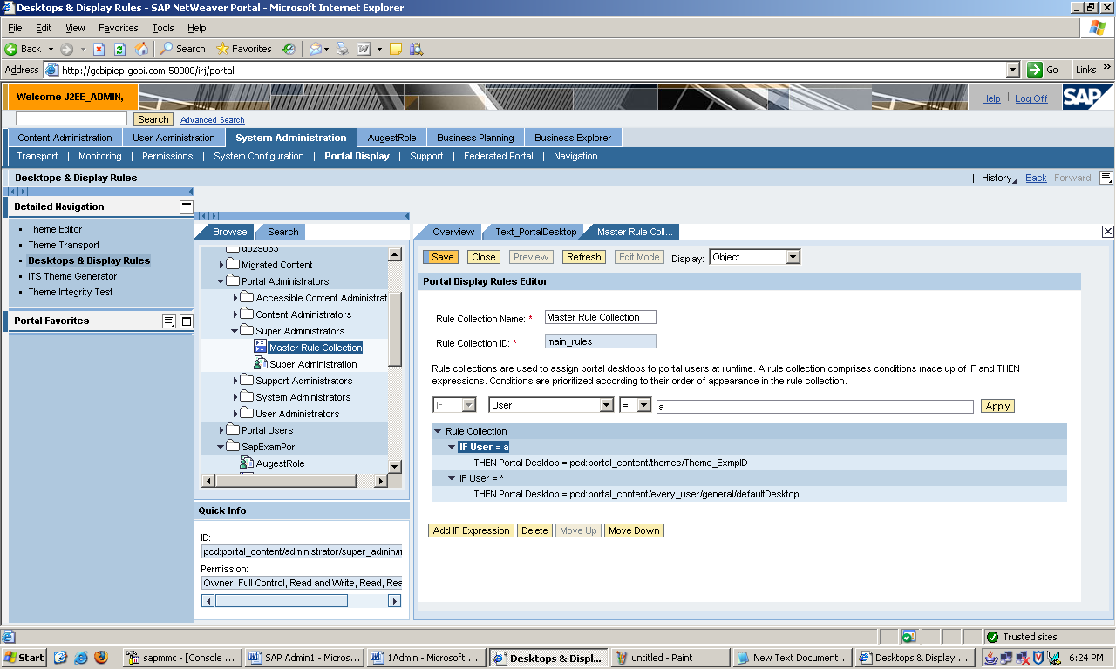

And Click on SAVE.

