http://HostName:PortNumber/sap/bc/ui5_ui5/ui2/ushell/shells/abap/FioriLaunchpad.html

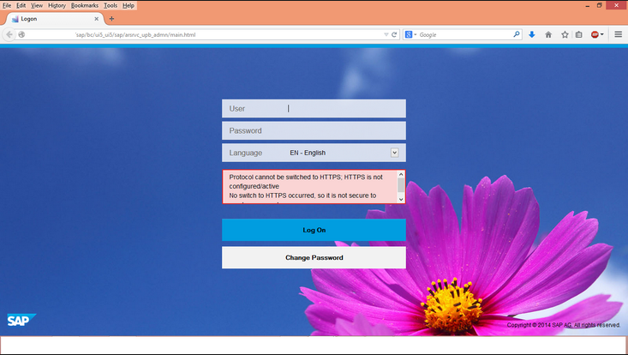

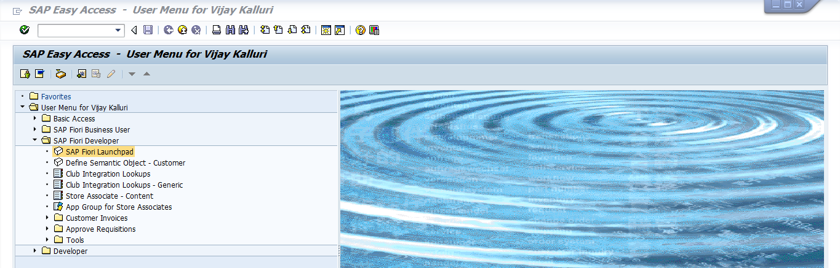

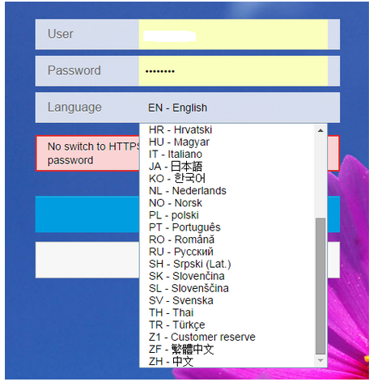

Here we will give Our **UserName** and **Password** for logging into the launch pad.

Along with User Name We can select the Language. Whatever you selected language here It will come to URL like (sap-language=en)

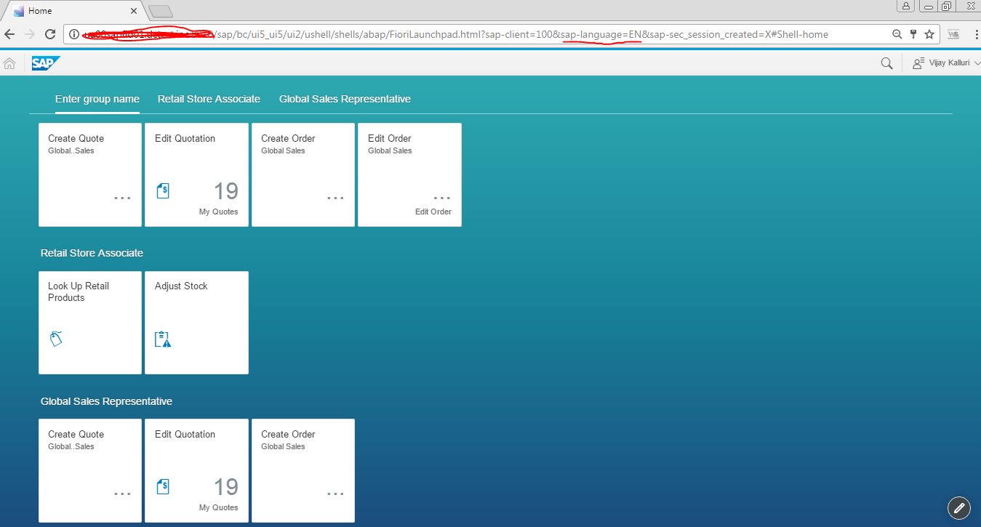

Deepening upon this name we can convert from English to German.

http://HostName:PortNumber/sap/bc/ui5_ui5/ui2/ushell/shells/abap/FioriLaunchpad.html?sap-client=100&**sap-language=EN**&sap-sec_session_created=X#Shell-home

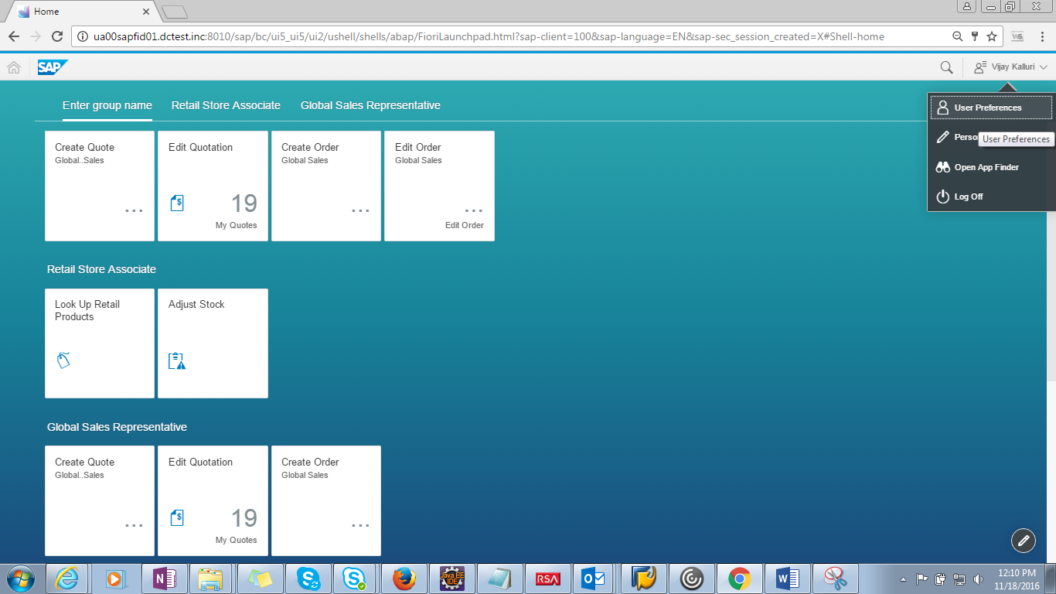

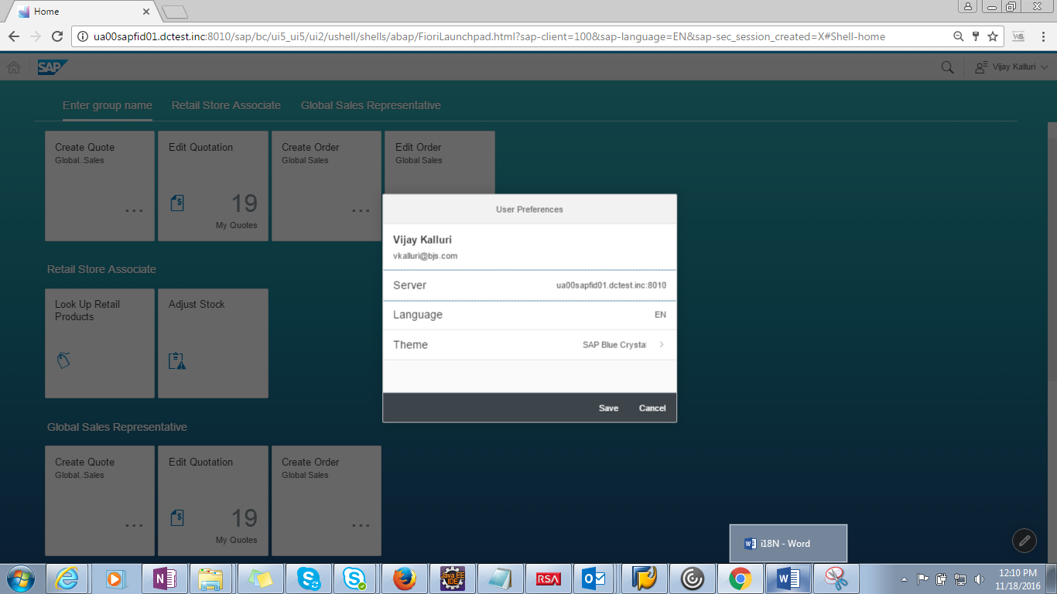

The Fiori Applications in general supports 14 languages are the configuration can be done as below :

1) Run T code **SICF**

2) Navigate to **/default_host/sap/bc/ui5_ui5/ui2/launchpage**

3) The screen looks as in the screenshot below

[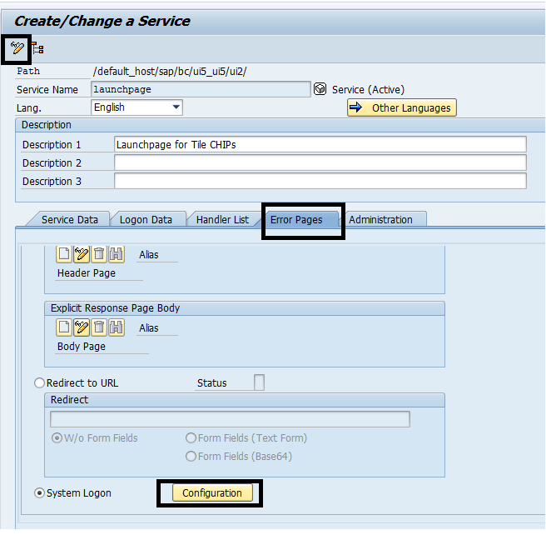](https://archive.sap.com/servlet/JiveServlet/showImage/2-15381493-541646/Fiori%20Launch%20Pad%20-%20Settings%20Navigation.png)

Make sure you are in **edit mode** and select configuration.

[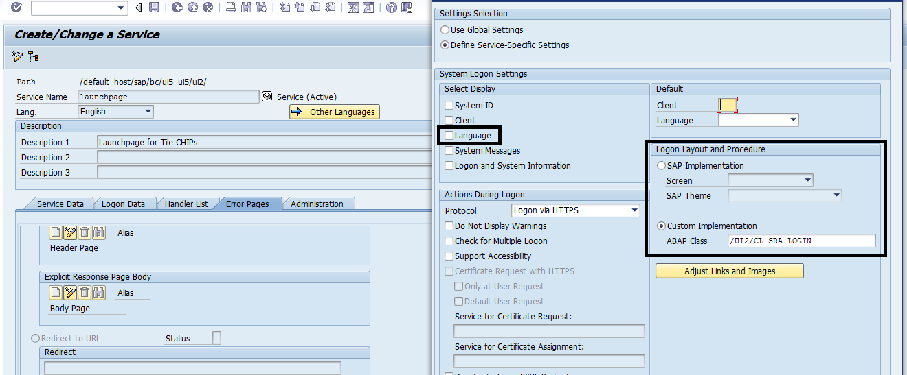](https://archive.sap.com/servlet/JiveServlet/showImage/2-15381493-541659/Launguage%20changes-%20Fiori%20Launchpad.png)

System Login Settings contains the **languages** option. If **enabled** , will be appeared in Launchpad

Also look at PAM for the list of languages supported by the applications.

Supported languages are in PAM. <http://service.sap.com/pam>.

14 languages are supported.

Chinese

Czech

English

French

German

Hungarian

Italian

Japanese

Norwegian

Polish

Portuguese

Russian

Spanish

Turkish

You can easily add additional languages by creating i18n resource files.