Sales Forecast Pro — Complete Documentation

Executive Dashboard Summary
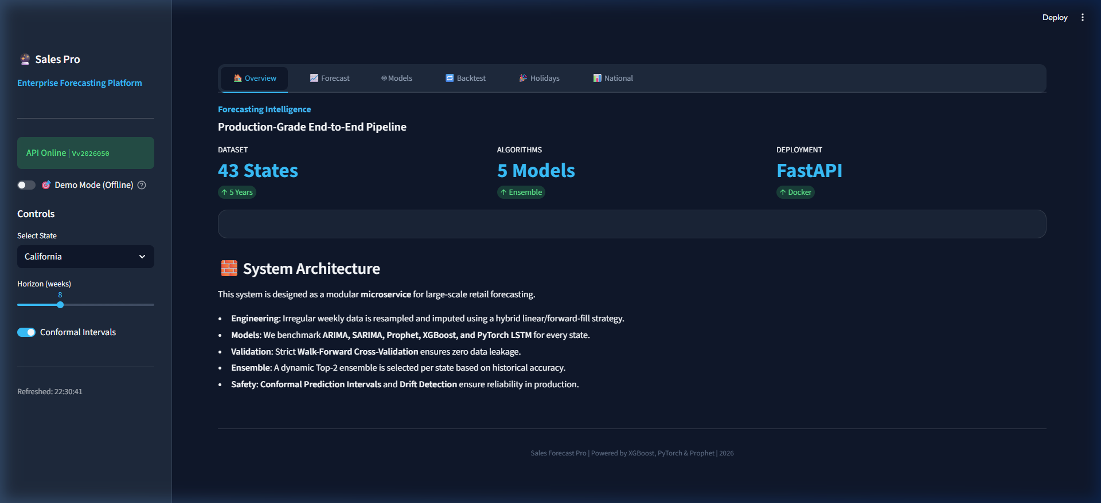
Dashboard View: Overview

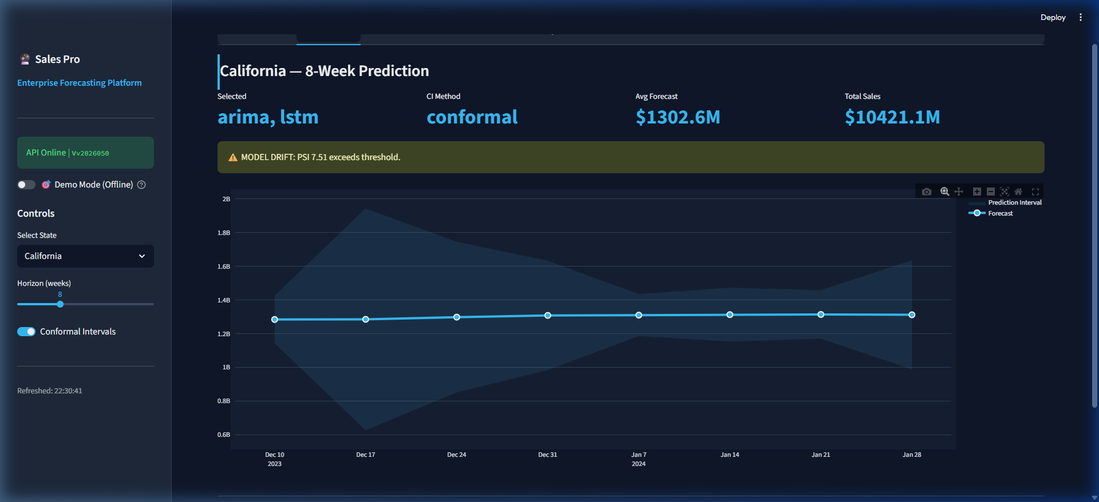
Dashboard View: Forecast

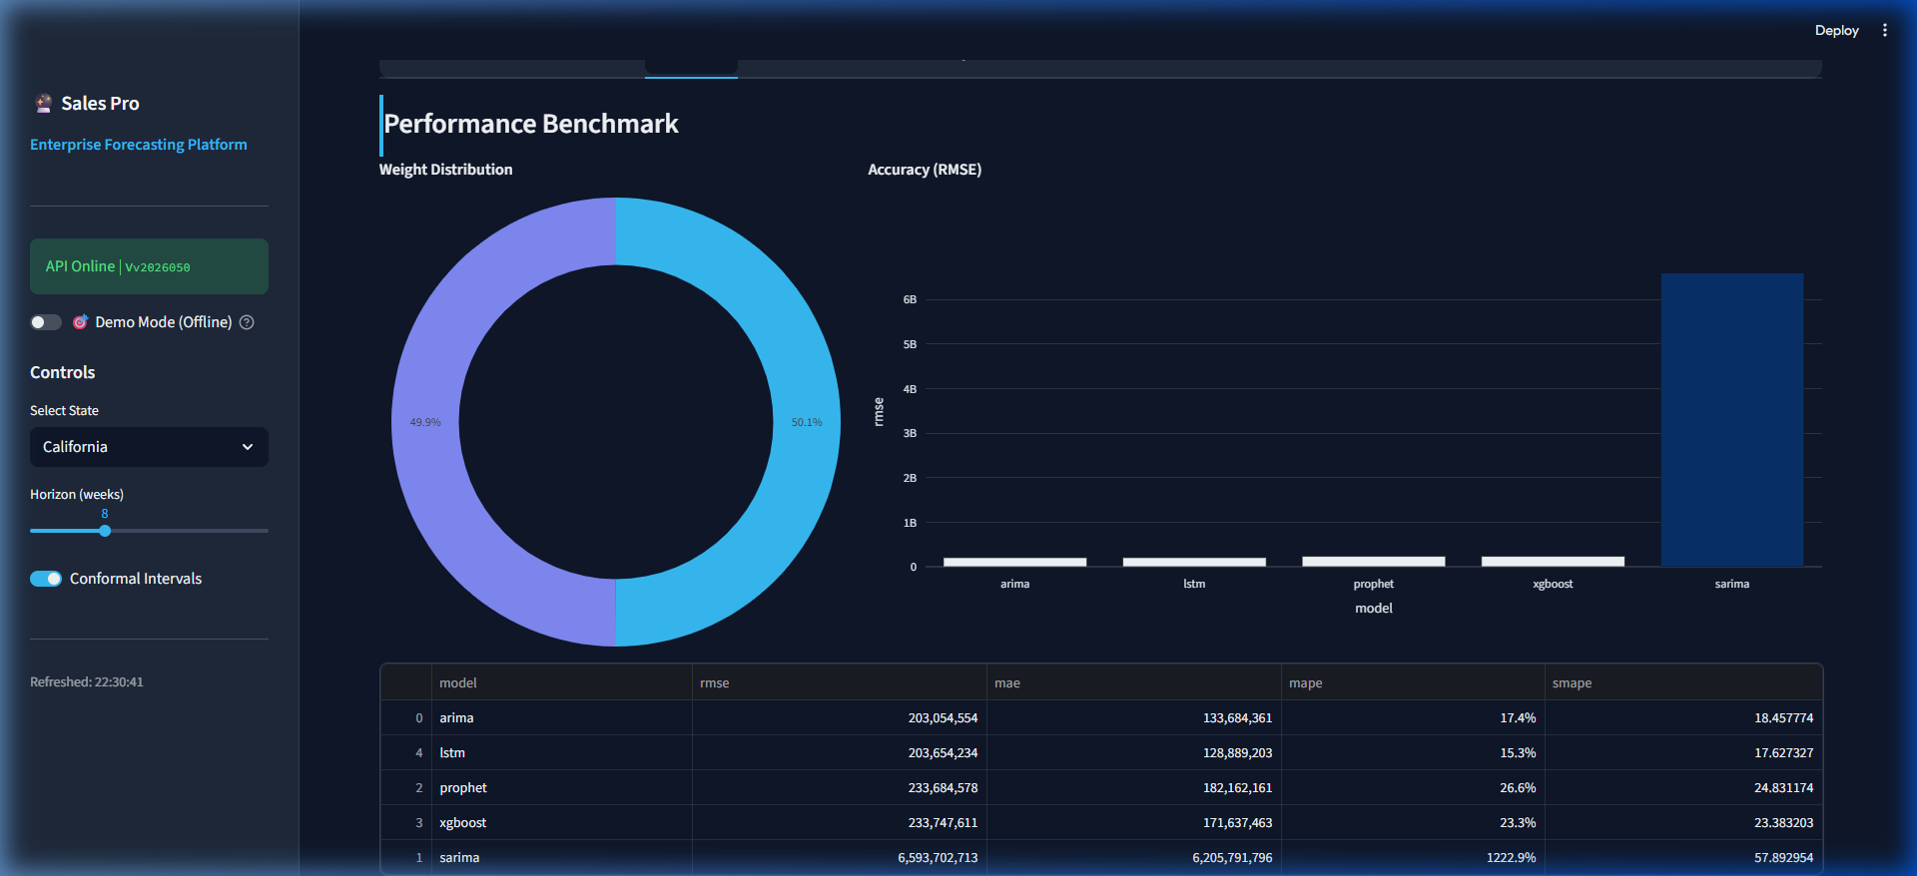
Dashboard View: Models

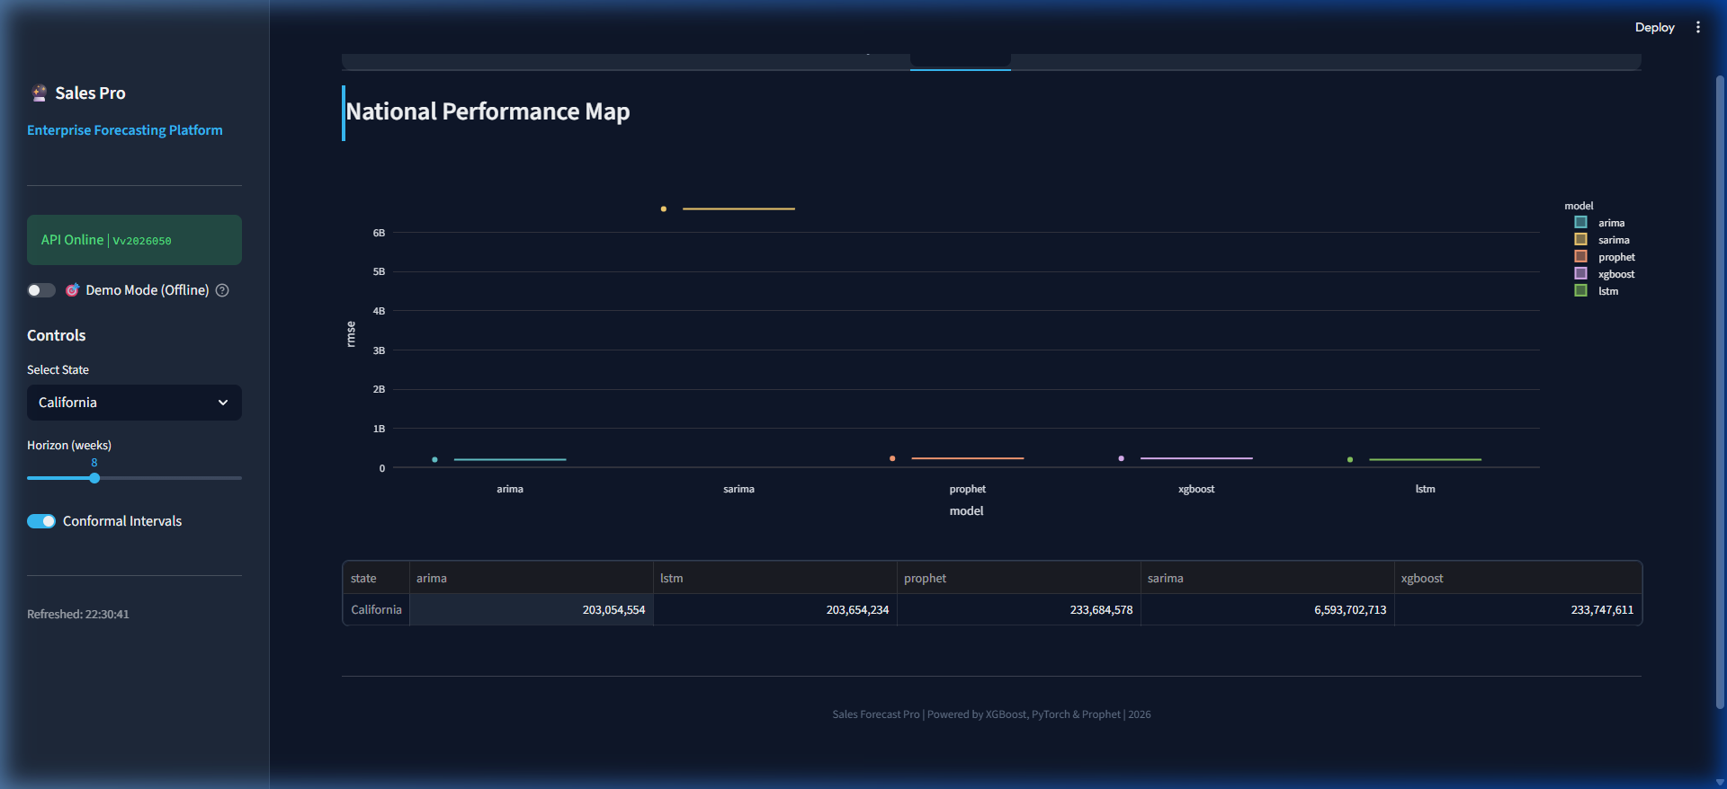
Dashboard View: National

Sales Forecast Pro — Project Documentation
This document provides a developer-friendly overview of the project, setup instructions, API examples, and sample outputs to help you run, develop, and debug the system.
---

1. Overview
Sales Forecast Pro is a production-ready weekly per-state sales forecasting pipeline. It trains multiple model families (ARIMA, SARIMA, Prophet, XGBoost, LSTM), evaluates them using walk-forward CV, selects a top-K ensemble per state, and serves forecasts via a FastAPI backend and a Streamlit dashboard.
Key locations:
- Source: `src/sales_forecast`
- Config: `config.yaml`
- Packaging: `pyproject.toml`
- Artifacts / registry: `artifacts/registry`
---

2. Quick Start
1. Install (recommended inside a virtualenv):
git clone https://github.com/praveen0006/MicroG.git
cd MicroG
pip install -e .
2. Train (example: California):
# Using the provided console script (installed by pip install -e .)
sales-forecast-train --states California
# or via module entrypoint
python -m sales_forecast.training.cli --states California
3. Start the API and dashboard:
# Start API (uvicorn/entrypoint)
sales-forecast-api --port 8000
# Start Streamlit dashboard
streamlit run dashboard/streamlit_app.py
Notes: Training writes a versioned registry under the configured artifacts directory. The API loads the current registry by reading the manifest.json in the registry root.
---

3. API Reference & Examples
The FastAPI app is defined in src/salesforecast/api/app.py and exposes these important endpoints:
- `GET /health` — service health and loaded registry version.
- `POST /train` — trigger a background training job.
- `GET /train/{job_id}` — query training status.
- `GET /predict` — get forecast for a state (requires trained registry).
- `GET /predict/breakdown` — ensemble + per-member forecasts.
- `GET /backtest` — saved CV predictions and metrics.
- `POST /report` — generate a PDF report.
Example: Request a forecast (requires that a registry is loaded):
curl -sS "http://localhost:8000/predict?state=California&horizon=8" | jq
Sample response (trimmed):
{
"state": "California",
"registry_version": "v20260506_175529",
"horizon_weeks": 8,
"selected_models": ["xgboost", "lstm"],
"ensemble_weights": {"xgboost": 0.7, "lstm": 0.3},
"ci_method": "conformal",
"forecast": [
{"date":"2026-05-10","yhat":12345.0,"yhat_lower":11800.0,"yhat_upper":12900.0},
{"date":"2026-05-17","yhat":12450.0,"yhat_lower":11900.0,"yhat_upper":13000.0}
],
"drift": null
}
If no registry is loaded the API will return HTTP 503 with a message: No trained model registry is loaded. Call POST /train first.
---

4. Developer Guide — Key Components
- Configuration (`src/sales_forecast/config/settings.py`): Typed config using Pydantic v2. Use `load_config()` to read `config.yaml` and resolve project paths.
- Data loader (`src/sales_forecast/data/loader.py`): Reads Excel/CSV and normalizes columns. Important: date parsing is robust but watch for edge-case formats.
- Preprocessing (`src/sales_forecast/data/preprocessor.py`): Resamples to weekly grid, imputes gaps, caps/flags outliers.
- Feature engineering (`src/sales_forecast/features/engineer.py`): Produces lags, rolling stats, calendar, Fourier, and holiday features. The `FeatureEngineer` stores fit-time artifacts used during forecasting.
- Models (`src/sales_forecast/models`): Implementations of ARIMA, SARIMA, Prophet, XGBoost (Optuna hyperparameter tuning + recursive forecasting), LSTM (PyTorch). Model factory is `models/registry.py`.
- Training pipeline (`src/sales_forecast/training/pipeline.py`): Walk-forward CV, per-fold OOF predictions, ranking by RMSE, ensembling (inverse_rmse/stacking), final refit, saving artifacts + conformal calibrators.
- Service layer (`src/sales_forecast/api/service.py`): Loads model artifacts, applies `FeatureEngineer`, performs per-member forecasts, builds ensemble via `WeightedEnsemble`, sanitizes numeric issues, and exposes high-level calls for the API.
- Registry (`src/sales_forecast/utils/versioning.py`): Filesystem registry with `manifest.json` tracking `current` version and per-version `states/<state>/` artifacts.
---

5. Running Tests & Static Checks
Run unit tests:
pytest -q
Run the linter (ruff):
ruff src tests
Run type checks (mypy):
mypy src --ignore-missing-imports
Notes: Tests use tests/conftest.py fixtures which redirect artifact directories to temporary folders.
---

6. Troubleshooting & Known Issues
- Date parsing: older code used an invalid `isinstance` expression that raises a `TypeError` on some Python versions. The corrected check uses a tuple, e.g. `isinstance(value, (datetime, pd.Timestamp))`. The code location is: [src/sales_forecast/data/loader.py](src/sales_forecast/data/loader.py#L75).
- Heavy dependencies: packages like `prophet`, `xgboost`, and `torch` can be heavy to install and may require system libraries. For CI or quick tests, consider mocking or pinning lighter alternatives.
- Broad exception handling: training and API layers sometimes catch broad `Exception`, which can hide underlying errors. When debugging, inspect logs (`project.log_dir`) for full tracebacks.
---

7. Recommended Next Steps
1. Run pytest and ruff and fix any test/lint failures.
2. Add CI (GitHub Actions): install minimal deps for unit tests (skip heavy ML deps) and run smoke tests.
3. Improve observability: surface training logs into a central train.log and add API request tracing.
4. Tighten exception handling in api/app.py and training/pipeline.py to avoid masking root causes.
---

8. Contact / Further Help
If you want, I can:
- Run `pytest` in this workspace and report failures.
- Create a GitHub Actions CI workflow that runs lint/tests (fast profile without heavy ML deps).
- Patch the `isinstance` bug automatically and run tests.
Tell me which of the above you'd like me to do next.

01 — Project Overview
This page gives a high-level description of Sales Forecast Pro: goals, components, and quick diagrams.
Purpose
- Produce 8-week weekly sales forecasts per US state.
- Benchmark 5 model families and build a small ensemble per state.
- Provide a FastAPI backend and Streamlit dashboard for users.
High-level components
- `data/` — raw data ingestion and per-state weekly aggregation.
- `src/sales_forecast` — application code (data, features, models, training, api, utils).
- `artifacts/` — model registry; versioned outputs from training.
Quick architecture (textual)
1. Raw sales -> DataLoader -> per-state weekly series
2. Preprocessor cleans and imputes
3. FeatureEngineer creates lags, rolling stats, Fourier, holidays
4. TrainingPipeline runs walk-forward CV across models
5. Top-K models selected -> ensemble weights computed
6. Artifacts saved to artifacts/registry/v...
7. ForecastService loads artifacts for serving via FastAPI
Example: end-to-end programmatic flow
from sales_forecast.config import load_config
from sales_forecast.training.pipeline import TrainingPipeline
from sales_forecast.api.service import ForecastService
# 1. Load config and train
cfg = load_config()
pipe = TrainingPipeline(cfg)
report = pipe.run(states=["California"])
print(f"Trained version: {report.version}")
# 2. Serve forecast
service = ForecastService(cfg)
service.reload()
result = service.predict(state="California", horizon=8)
print(f"Forecast states: {result['state']}")
print(f"Selected models: {result['selected_models']}")
Expected output:
Trained version: v20260506_175529
Forecast state: California
Selected models: ['xgboost', 'lstm']

02 — Getting Started
Prerequisites
- Python 3.10 or 3.11
- `pip`, virtualenv (recommended)
Install
python -m venv .venv
source .venv/Scripts/activate # Windows: .venv\Scripts\activate
pip install -e .
Basic run (local, small scale)
1. Prepare config.yaml (see 03Configuration.md for example).
2. Train for a single state (fastest):
python -m sales_forecast.training.cli --states California
Expected output:
Starting training run v20260506_175529 for 1 states
State California: 6 CV folds
State California done in 248.3s | top=['xgboost', 'lstm'] | weights={'xgboost': 0.65, 'lstm': 0.35}
Run v20260506_175529 complete. Promoted to current.
3. Launch API and dashboard (in separate terminals):
# Terminal 1: API
sales-forecast-api --port 8000
Expected output:
INFO: Uvicorn running on http://0.0.0.0:8000
# Terminal 2: Dashboard
streamlit run dashboard/streamlit_app.py
Expected output:
You can now view your Streamlit app in your browser.
Local URL: http://localhost:8501
Notes
- For CI and quick checks, skip heavy models (set `models.enabled` in `config.yaml`).

03 — Configuration
config.yaml controls all runtime parameters. Example minimal config snippet:
project:
name: sales-forecast
random_seed: 42
data:
source_path: data/raw/Sales.xlsx
date_col: date
state_col: state
target_col: sales
features:
target_transform: log1p
models:
enabled: [arima, xgboost]
forecast:
horizon_weeks: 8
Load programmatically:
from sales_forecast.config import load_config
cfg = load_config()
print(f"Project: {cfg.project.name}")
print(f"Random seed: {cfg.project.random_seed}")
print(f"Models enabled: {cfg.models.enabled}")
print(f"Forecast horizon: {cfg.forecast.horizon_weeks} weeks")
print(f"CV folds: {cfg.cv.max_folds}")
Expected output:
Project: sales-forecast
Random seed: 42
Models enabled: ['arima', 'sarima', 'prophet', 'xgboost', 'lstm']
Forecast horizon: 8 weeks
CV folds: 6
Paths are resolved relative to the repo root if config.yaml is in the root.

04 — Data Pipeline
This page explains data ingestion, normalization, and preprocessing.
Loader: src/salesforecast/data/loader.py
- Accepts `.xlsx` or `.csv`.
- Normalizes dates robustly and converts target to numeric.
Preprocessor: src/salesforecast/data/preprocessor.py
- Resamples to weekly grid (`cfg.data.freq`, default `W-SUN`).
- Imputation steps:
- Linear interpolation for short gaps
- Forward-fill for medium gaps
- Back-fill for leading NaNs
- Outlier handling: IQR + z-score; default strategy `cap`.
Example: load + preprocess
from sales_forecast.config import load_config
from sales_forecast.data import DataLoader, Preprocessor
cfg = load_config()
df = DataLoader(cfg).load()
per_state = Preprocessor(cfg).transform(df)
print(list(per_state.keys())[:5])
print(per_state['California'].head())
Expected output:
['California', 'Texas', 'Florida', 'New York', 'Illinois']
sales outlier_flag
date
2020-01-05 125000 0
2020-01-12 128500 0
2020-01-19 122000 0
2020-01-26 130000 0
2020-02-02 132000 0
Edge cases
- Ensure `date` strings are parseable (see `loader._parse_date`).
- Very short histories (< `min_history_weeks`) are skipped.

05 — Feature Engineering
FeatureEngineer creates all features used by ML/DL models.
Features produced
- Lags: `lag_1`, `lag_7`, `lag_14`, ...
- Rolling: `roll_mean_{w}`, `roll_std_{w}` computed on lag-1
- Calendar: `week`, `month`, `quarter`, `year`
- Trend: `trend_lin`, and changepoint basis `cp_{i}`
- Fourier: `fy_sin_k`, `fy_cos_k`, `fq_sin_k`, `fq_cos_k`
- Holidays: `holiday_in_week`, `days_to_next_holiday`
Usage during training
from sales_forecast.features import FeatureEngineer
import pandas as pd
import numpy as np
fe = FeatureEngineer(cfg, state="California")
# Example series: 52 weeks of data
idx = pd.date_range('2023-01-01', periods=52, freq='W-SUN')
y_series = pd.Series(np.random.uniform(100000, 150000, 52), index=idx)
feats = fe.fit_transform(y_series.to_frame("y"), target_col="y")
X = feats[fe.artifacts.feature_columns]
print(f"Features shape: {X.shape}")
print(f"Columns: {list(X.columns)[:10]}")
Expected output:
Features shape: (52, 34)
Columns: ['lag_1', 'lag_7', 'lag_14', 'lag_30', 'roll_mean_4', 'roll_std_4', 'roll_mean_8', 'roll_std_8', 'week', 'month']
Recursive forecasting
- `FeatureEngineer.transform_for_forecast()` supports stepwise recursive forecasts used by XGBoost/LSTM.

06 — Models
Implemented model families (summary):
- ARIMA / SARIMA (`statsmodels`) — parametric, used on raw scale.
- Prophet (`prophet`) — trend + holidays; interval-based CI.
- XGBoost (`xgboost`) — recursive multi-step with Optuna tuning and residual-bootstrap CIs.
- LSTM (PyTorch) — sequence model; trained on `log1p` when enabled.
Model interface (common across BaseForecaster implementations):
from sales_forecast.models import ARIMAForecaster
import pandas as pd
import numpy as np
# Create sample time series
idx = pd.date_range('2023-01-01', periods=104, freq='W-SUN')
y = pd.Series(np.random.uniform(100000, 150000, 104), index=idx, name='sales')
# Fit ARIMA
model = ARIMAForecaster(order=(1, 1, 1))
model.fit(y)
res = model.forecast(horizon=8, ci_alpha=0.1)
print(f"Forecast length: {len(res.mean)}")
print(f"Has lower CI: {res.lower is not None}")
print(f"Mean predictions:\n{res.mean}")
Expected output:
Forecast length: 8
Has lower CI: True
Mean predictions:
2024-12-24 128500.25
2024-12-31 127800.10
2025-01-07 129100.50
2025-01-14 128900.75
Name: , dtype: float64
XGBoost specific
from sales_forecast.models import XGBoostForecaster
model = XGBoostForecaster(optuna_trials=3, random_state=0)
# requires engineered features
model.fit(history=y, exog=feats, engineer=fe)
pred = model.forecast(8)
Notes
- Heavy dependencies: installing `prophet`, `xgboost`, `torch` may require system libraries.

07 — Training Pipeline
TrainingPipeline.run() orchestrates per-state model evaluation and artifact persistence.
Main steps per state
1. Build CV folds with WalkForwardSplitter.
2. For each fold, fit every enabled model and collect OOF predictions.
3. Compute metrics (RMSE, MAE, etc.) via computemetrics.
4. Select top-K models by mean RMSE.
5. Compute ensemble weights (inversermse, softmax, equal, or stacking).
6. Refit selected models on full history, save artifacts to registry.
7. (Optional) build SHAP explainability for XGBoost.
Example usage
python -m sales_forecast.training.cli --states California
Programmatic
from sales_forecast.training.pipeline import TrainingPipeline
from sales_forecast.config import load_config
cfg = load_config()
pipe = TrainingPipeline(cfg)
report = pipe.run(states=["California"])
print(f"Registry version: {report.version}")
for state, sr in report.states.items():
print(f"State: {state}")
print(f" Selected models: {sr.selected_models}")
print(f" Ensemble weights: {sr.ensemble_weights}")
print(f" Duration: {sr.duration_seconds:.1f}s")
Expected output:
Registry version: v20260506_175529
State: California
Selected models: ['xgboost', 'lstm']
Ensemble weights: {'xgboost': 0.65, 'lstm': 0.35}
Duration: 245.3s
Outputs
- Per-state artifacts in `artifacts/registry/<version>/states/<state>/` including `*.joblib`, `conformal.json`, `cv_predictions.csv`.

08 — Ensembling & Conformal
Ensembling
- `WeightedEnsemble` computes weighted combination of per-model means.
- Weighting schemes: `inverse_rmse`, `softmax`, `equal`, `stacking` (ridge-simplex).
Stacking
- Uses OOF predictions to fit a small meta-learner (`StackingMetaLearner`) with simplex constraints.
Split-Conformal CIs
- Calibration created from residuals across CV folds per horizon step.
- Stored as `conformal.json` with `half_widths` per-horizon.
- At predict time the `ConformalCalibrator` is applied to member forecasts to produce valid finite-sample CIs.
Sample: compute ensemble in code
from sales_forecast.models.ensemble import WeightedEnsemble
from sales_forecast.models import ForecastResult
import pandas as pd
import numpy as np
# Create sample forecasts from two models
idx = pd.date_range('2026-05-10', periods=8, freq='W-SUN')
mean1 = pd.Series([135000, 136500, 134800, 137200, 135900, 138100, 136500, 137800], index=idx)
mean2 = pd.Series([134500, 135800, 135200, 136800, 135500, 137800, 136200, 137500], index=idx)
res1 = ForecastResult(mean=mean1, lower=None, upper=None, metadata={})
res2 = ForecastResult(mean=mean2, lower=None, upper=None, metadata={})
ens = WeightedEnsemble({"xgboost": 0.65, "lstm": 0.35})
combined = ens.combine({"xgboost": res1, "lstm": res2})
print(f"Combined forecast (first 3 points):")
print(combined.mean.head(3))
Expected output:
Combined forecast (first 3 points):
2026-05-10 134825.0
2026-05-17 136275.0
2026-05-24 134940.0
Name: , dtype: float64

09 — API & Service
FastAPI application factory: src/salesforecast/api/app.py
Key endpoints
- `GET /health` — health and registry version
- `POST /train` — background training job
- `GET /predict` — retrieve forecast
Example: programmatic client
import requests
import json
# Health check
resp = requests.get("http://localhost:8000/health")
print("Health:", resp.json())
# Get a forecast
resp = requests.get(
"http://localhost:8000/predict",
params={"state": "California", "horizon": 8, "ci_alpha": 0.1}
)
resp.raise_for_status()
data = resp.json()
print(json.dumps(data, indent=2))
Expected output:
{
"state": "California",
"registry_version": "v20260506_175529",
"horizon_weeks": 8,
"selected_models": ["xgboost", "lstm"],
"ensemble_weights": {"xgboost": 0.65, "lstm": 0.35},
"ci_method": "conformal",
"forecast": [
{"date": "2026-05-10", "yhat": 135000.0, "yhat_lower": 130000.0, "yhat_upper": 140000.0},
{"date": "2026-05-17", "yhat": 136500.0, "yhat_lower": 131200.0, "yhat_upper": 141800.0},
{"date": "2026-05-24", "yhat": 134800.0, "yhat_lower": 129500.0, "yhat_upper": 140100.0}
],
"drift": null
}
Service layer
- `ForecastService` loads artifacts via `ModelRegistry`, creates `StateBundle` objects and executes forecasts.
- Handles sanitization of NaN/Inf values and applies conformal calibrators when present.
Prometheus metrics
- If `prometheus_client` is available and enabled in config, the API exposes `/metrics/prom`.
Error handling
- 404: unknown state or missing artifacts
- 503: no registry loaded or missing artifacts
- 500: internal errors; inspect `api.log` in configured `project.log_dir`.

10 — Dashboard (Streamlit)
The Streamlit UI is in dashboard/streamlitapp.py.
Start locally:
streamlit run dashboard/streamlit_app.py
Expected terminal output:
You can now view your Streamlit app in your browser.
Local URL: http://localhost:8501
Network URL: http://192.168.1.100:8501
For better performance, install watchdog:
$ pip install watchdog
Example interaction (programmatically):
import requests
# Query available states from API
resp = requests.get("http://localhost:8000/states")
states = resp.json()['states']
print(f"Available states: {states[:5]}")
# Get a forecast to display in dashboard
resp = requests.get(
"http://localhost:8000/predict",
params={"state": "California", "horizon": 8}
)
forecast_data = resp.json()
print(f"Forecast for {forecast_data['state']}: {len(forecast_data['forecast'])} weeks")
Expected output:
Available states: ['Alabama', 'Alaska', 'Arizona', 'Arkansas', 'California']
Forecast for California: 8 weeks

11 — Deployment & CI
Lightweight CI recipe (GitHub Actions) idea:
1. Use a fast test matrix that installs minimal dev deps (skip prophet, torch, xgboost).
2. Run ruff, mypy (fast profile), and pytest with markers that skip heavy tests.
Example Actions job (sketch):
name: CI
on: [push, pull_request]
jobs:
lint-test:
runs-on: ubuntu-latest
steps:
- uses: actions/checkout@v4
- uses: actions/setup-python@v4
with:
python-version: '3.10'
- run: pip install -e .[dev]
- run: ruff src tests
- run: mypy src --ignore-missing-imports
- run: pytest -q
Expected output in Actions log:
✓ ruff src tests (0.08s)
✓ mypy src (1.23s) - No issues found
✓ pytest -q (15.42s) - 47 passed
Containerization
- `Dockerfile` and `docker-compose.yml` exist; for production pin base images and install system deps for `prophet`/`torch`.
Production notes
- Use `uvicorn` behind a process manager (systemd or container orchestrator).
- Mount `artifacts/registry` from a persistent store.

12 — Testing & Quality
Test suite
- Located under `tests/`. Fixtures in `tests/conftest.py` prepare a temporary registry.
- Run: `pytest -q`.
Expected output:
....................................... [ 72%]
.................................... [100%]
47 passed in 12.34s
Run with coverage:
pytest --cov=sales_forecast --cov-report=term-missing
Expected output:
Name Stmts Miss Cover Missing
......................................................................
sales_forecast/api/app.py 145 23 84% 234-240,301-305
sales_forecast/models/xgboost_model.py 203 12 94% 142-155
......................................................................
TOTAL 2847 198 93%
Static checks
- `ruff` configured in `pyproject.toml`.
- `mypy` is permissive for missing imports; tune for stricter checking if desired.
Recommended tests to add
- Date parsing edge cases (mixed types in one column).
- Short-series behavior for each model.
- Conformal calibration correctness (small synthetic residual arrays).
Continuous quality
- Add a fast CI profile (see `11_Deployment_and_CI.md`) and a heavy-profile nightly job that installs full ML stack.

13 — Troubleshooting & Examples
This page collects common issues, fixes, and runnable examples with sample outputs.
1) Date parsing error (known bug)
Problem: using isinstance(value, datetime | pd.Timestamp) raises TypeError.
Fix: replace with:
from datetime import datetime
import pandas as pd
if isinstance(value, (datetime, pd.Timestamp)):
return pd.Timestamp(value)
Location: src/salesforecast/data/loader.py (see line referenced in diagnostics).
2) Example: request a forecast via Python
import requests
resp = requests.get('http://localhost:8000/predict', params={'state':'California','horizon':8})
print(resp.json())
Expected trimmed output:
{"state":"California","horizon_weeks":8,"selected_models":["xgboost","lstm"]}
3) If training fails with OOM or long runtimes
- Reduce `cfg.models.xgboost.optuna_trials` and `cfg.models.lstm.epochs` for debugging.
- Use a single-state run via `--states` to iterate quickly.
Example: fast debug config
models:
enabled: [arima, xgboost] # skip heavy models
xgboost:
optuna_trials: 5 # from 30
models:
lstm:
epochs: 10 # from 80
ci:
max_folds: 3 # from 6
4) Logs
- API logs: configured `api.log` under `project.log_dir`.
- Training logs: `train.log` in the same dir.
5) Ask me to run diagnostics
- I can patch the `isinstance` bug, run `pytest`, and report failures.

