California Housing Price Prediction
Machine Learning Final Project

Group Members: [Names Here]
Date: [Insert Date]

1. Introduction and Problem Statement
We picked the California Housing dataset to build a regression model that predicts median house prices at the district level. Each row in the data represents a census block group — basically a neighborhood — with features like income, number of rooms, population, and proximity to the ocean.
We chose this dataset because the features are easy to understand and it has enough real-world issues (missing values, skewed data, an artificial value cap) to make us go through a proper pipeline instead of just running one model and calling it a day.
The pipeline follows the standard steps: inspect the data, clean it, engineer new features, explore it visually, train multiple models, and compare them with proper metrics.

2. Dataset Description
Source: 1990 California census, available on Kaggle. 20,640 rows, 10 columns. Each row is a census block group of roughly 600–3,000 people.

Feature | Type | Description
longitude, latitude | Float | District GPS coordinates
housing_median_age | Float | Median age of houses (years)
total_rooms, total_bedrooms | Float | Total counts for the whole district, not per house
population, households | Float | People and households in the district
median_income | Float | Median income (tens of thousands $)
ocean_proximity | Categorical | 5 categories: INLAND, NEAR BAY, <1H OCEAN, NEAR OCEAN, ISLAND
median_house_value | Float | Target — what we’re trying to predict

Assumptions and Limitations
- Target is capped at $500,001 — about 5% of rows hit this ceiling, real values could be much higher.
- Housing age caps at 52 years.
- These are district-level aggregates, not individual houses.
- Data is from 1990 — dollar amounts are in 1990 dollars.
- The 207 missing values in total_bedrooms are assumed to be missing at random.

3. Data Preprocessing

3.1 Missing Values
Only total_bedrooms had missing data: 207 out of 20,640 rows (about 1%). We filled with the median because the column is right-skewed — the mean would be inflated by a few very large districts. We also checked for duplicate rows and found none.

3.2 Feature Engineering
The raw columns total_rooms, total_bedrooms, and population are totals for the whole district. Districts vary a lot in size, so the raw totals don’t tell you much. We created three ratio features:

Feature | Formula | What it captures
rooms_per_household | total_rooms / households | Average home size
bedrooms_per_household | total_bedrooms / households | Average bedrooms per home
population_per_household | population / households | How crowded each household is

3.3 Outlier Detection and Removal
We found obviously wrong values like 141 rooms per household and 1,200+ people per household. We used the IQR method with a 3x threshold to remove these while keeping real variation. The $500k value cap and age cap at 52 were not treated as outliers.

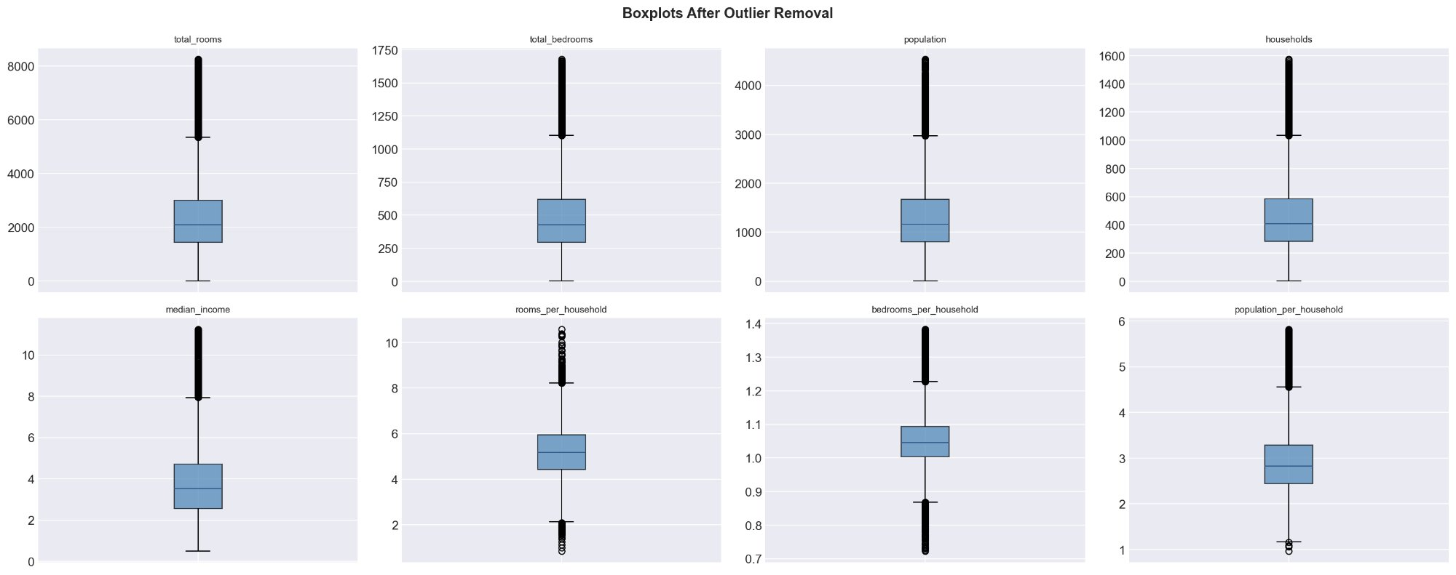
Figure 1: Boxplots after outlier removal

3.4 Encoding
We one-hot encoded ocean_proximity (no natural ordering) and dropped one column (drop_first=True) to avoid the dummy variable trap.

3.5 Train/Test Split and Scaling
80/20 split with random_state=42. StandardScaler fitted only on training data to prevent data leakage.

4. Exploratory Data Analysis

4.1 Target Variable Distribution
Right-skewed, most values between $100k–$250k. Clear spike at $500,001 from the census cap.
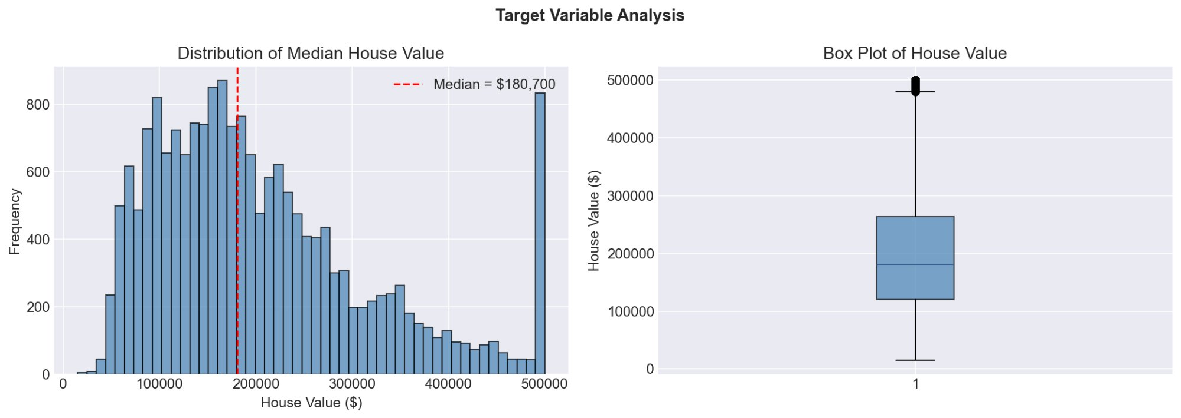
Figure 2: Target variable — histogram and boxplot

4.2 Ocean Proximity vs House Value
NEAR BAY and NEAR OCEAN districts are roughly double the price of INLAND (~$230k vs ~$110k). ISLAND is the most expensive but only 5 districts.
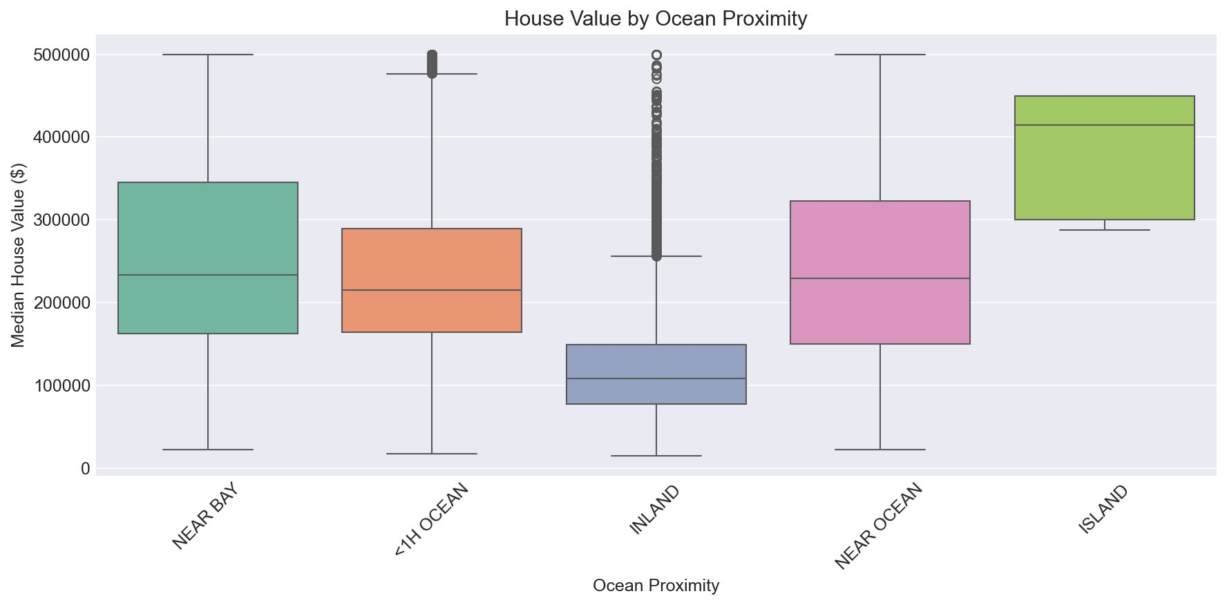
Figure 3: House value by ocean proximity

4.3 Income vs House Value
Strong upward trend. The spread gets wider at higher incomes. The horizontal band at $500k is the value cap.
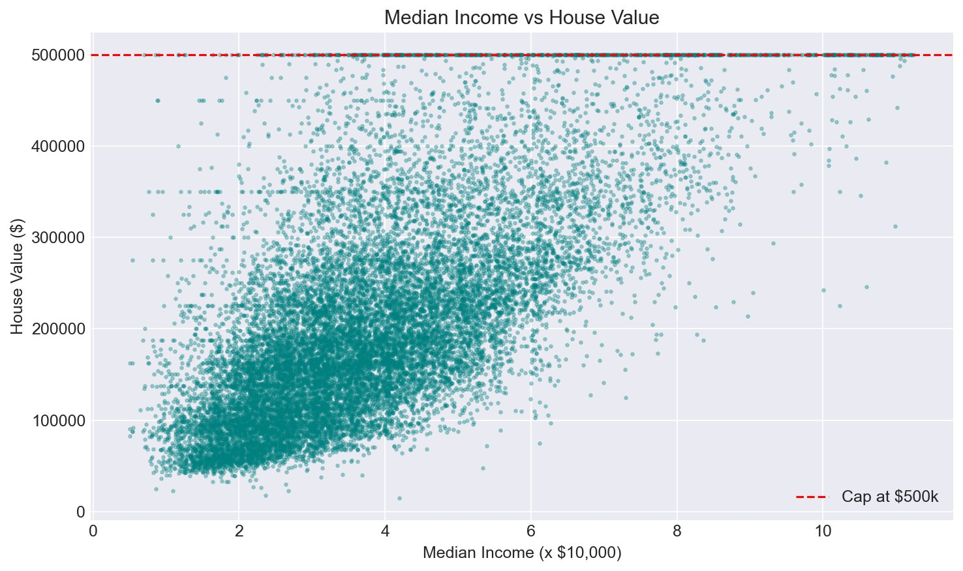
Figure 4: Median income vs house value

4.4 Geographic Distribution
Expensive districts cluster along the coast (San Francisco, Los Angeles). Inland areas are consistently cheaper.
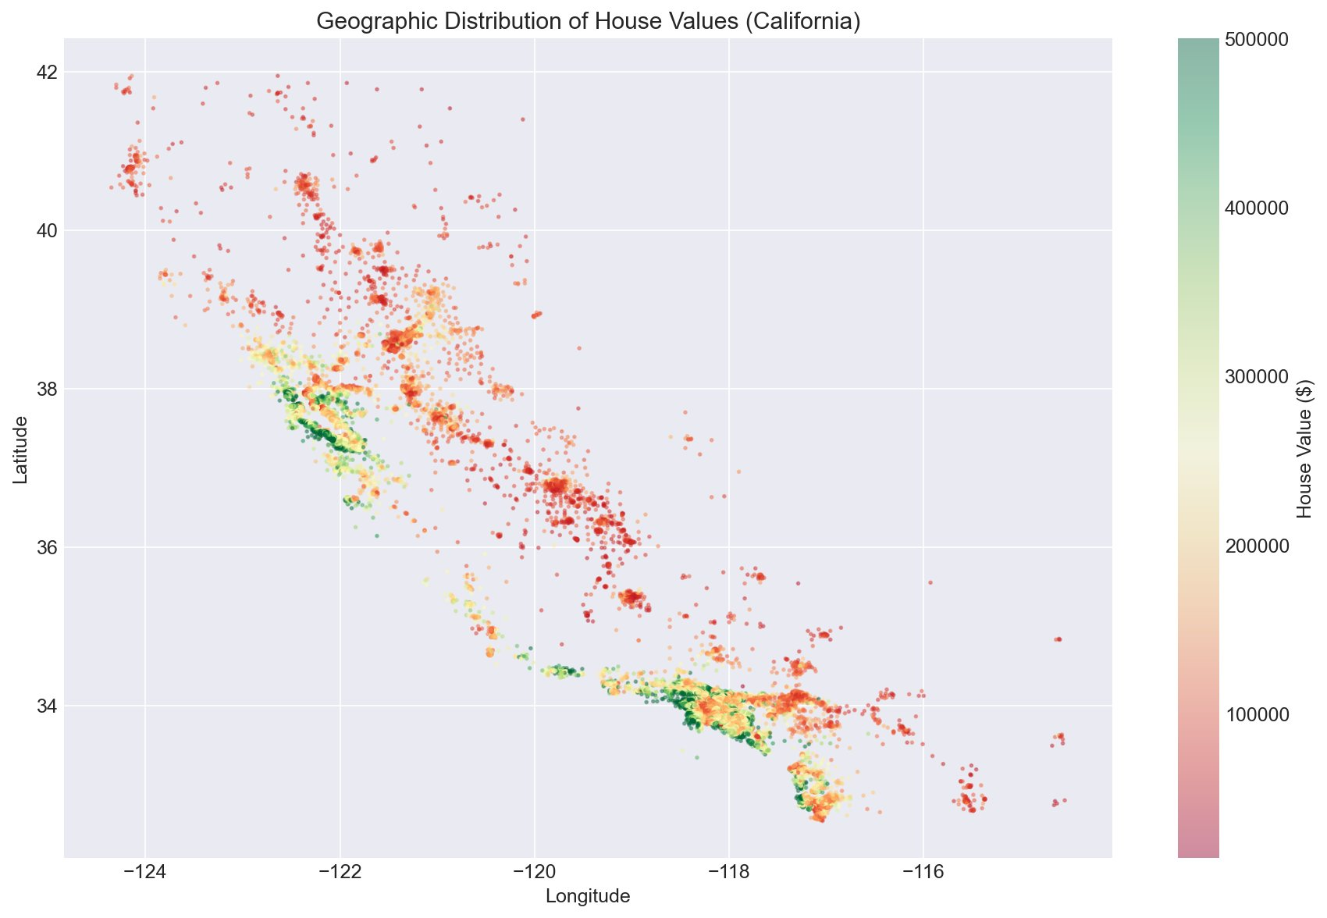
Figure 5: Geographic distribution of house values

4.5 Correlation Analysis
median_income has the strongest correlation with house value (r = 0.68). Count features are highly correlated with each other (>0.85), confirming redundancy.
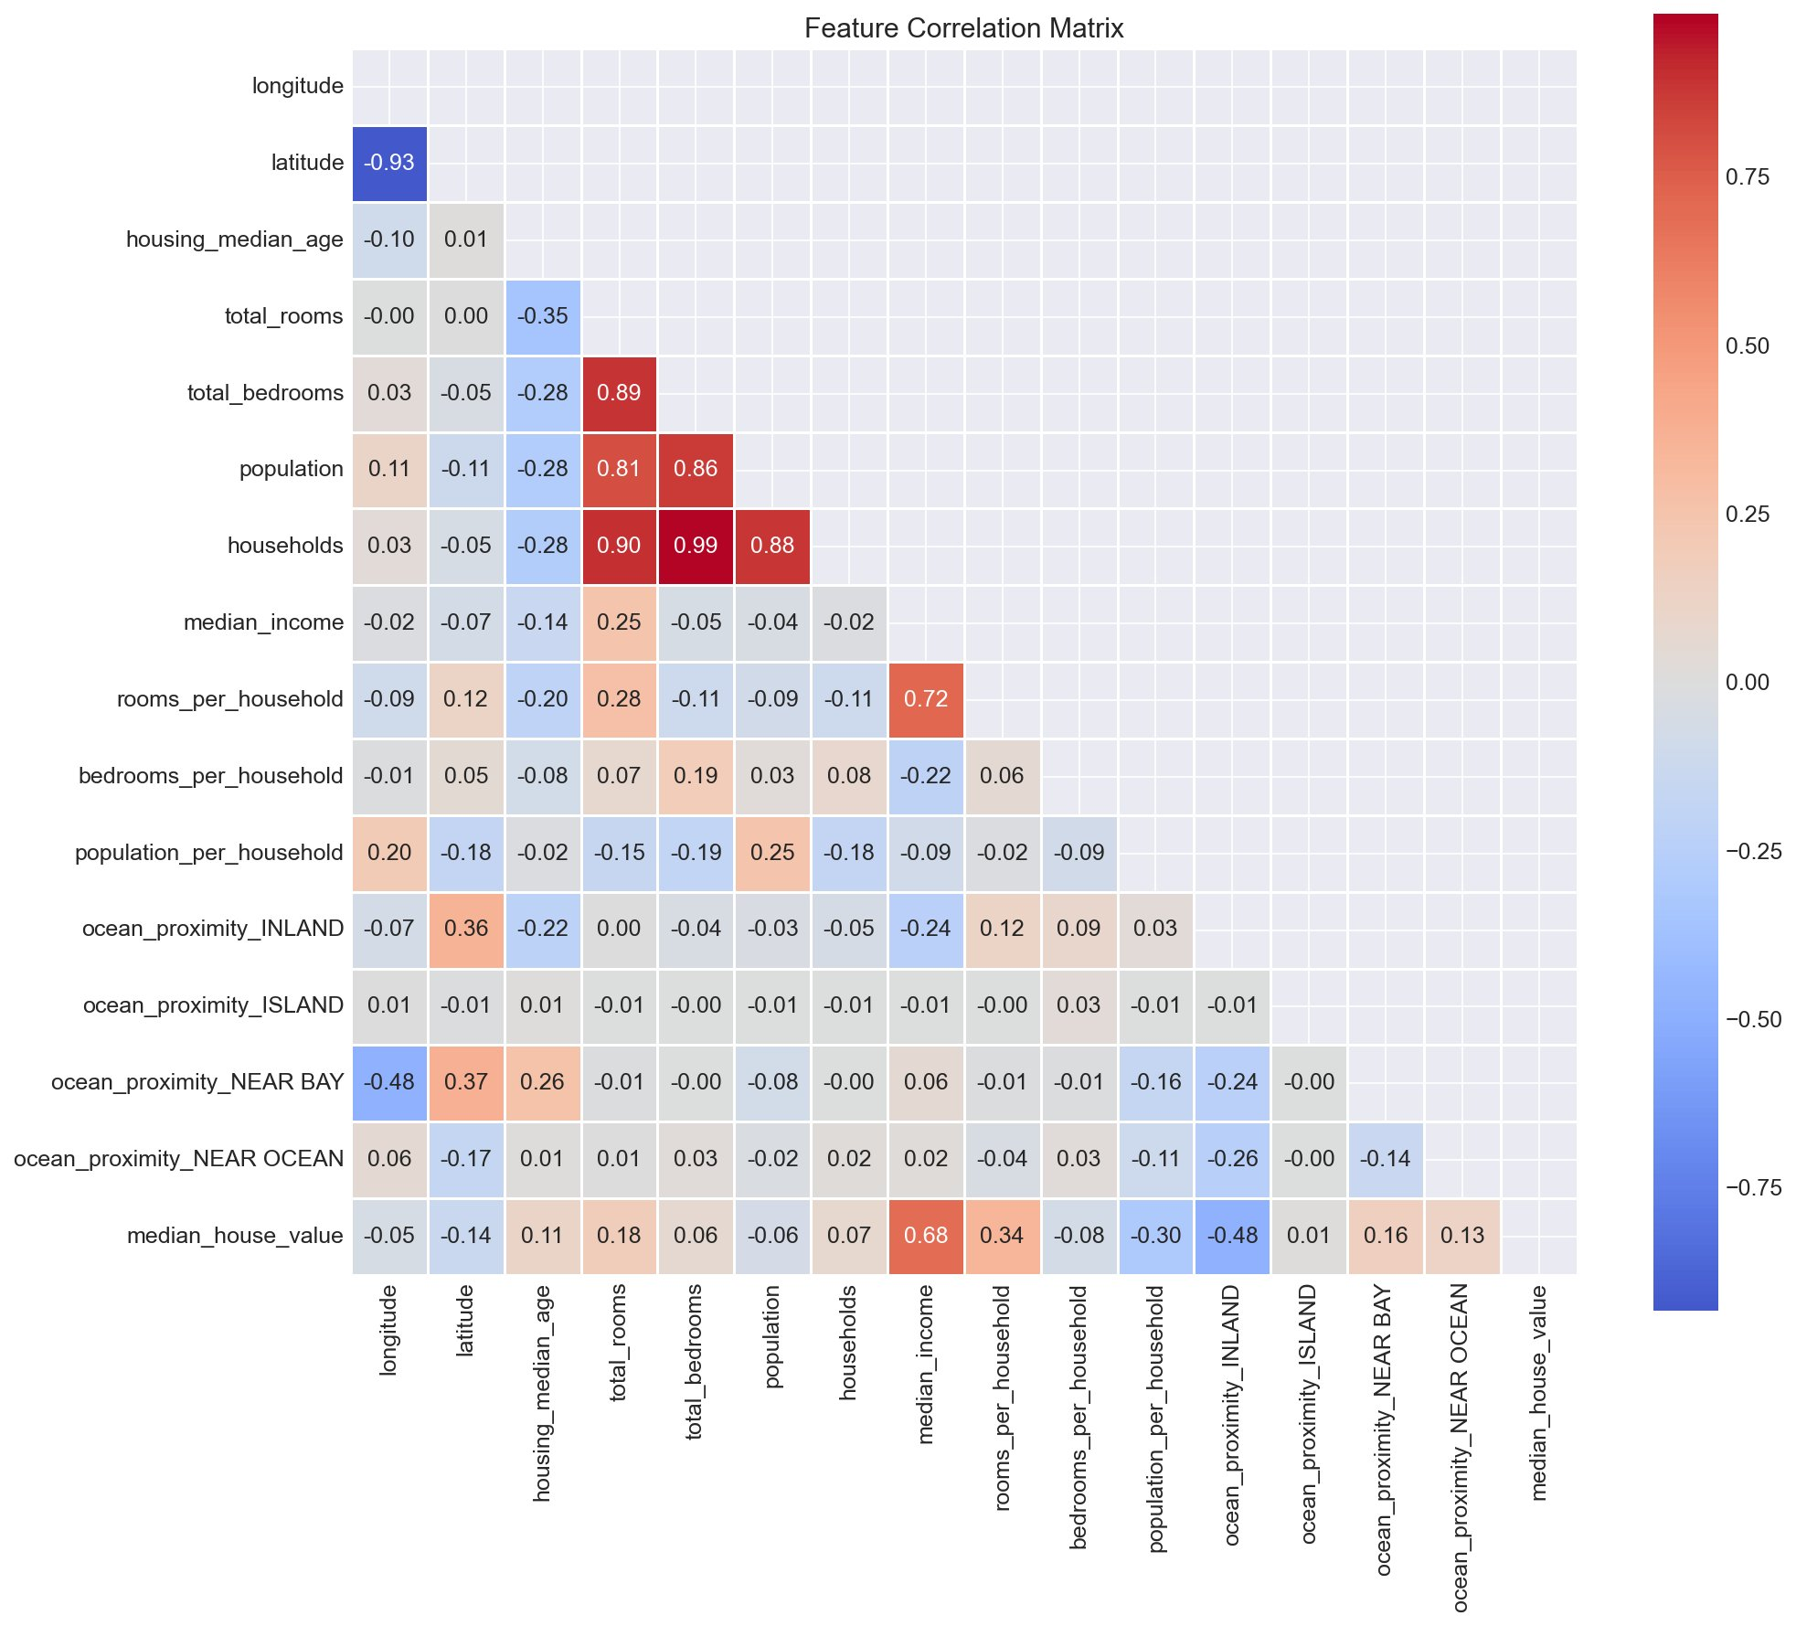
Figure 6: Feature correlation matrix

4.6 Pairplot
The bottom row shows each feature vs house_value. Only median_income shows a clear linear pattern; the others need non-linear models to capture their relationships.
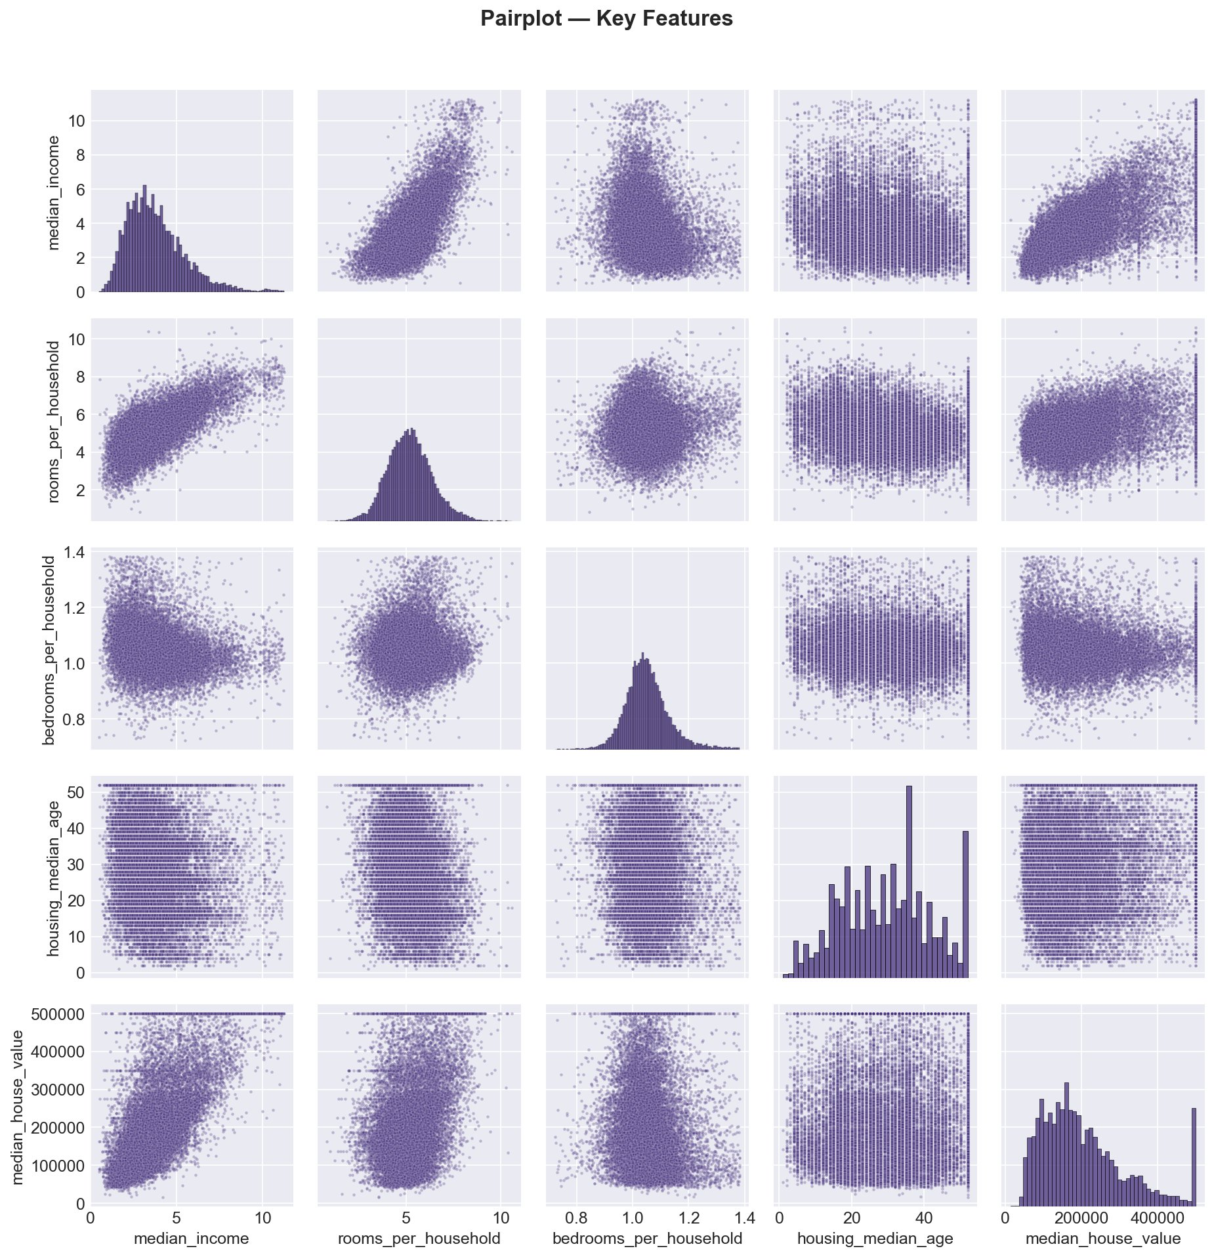
Figure 7: Pairplot of key features

5. Model Selection and Training
We trained 7 models from 4 algorithm families with 5-fold cross-validation:

Model | Family | Why
Linear Regression | Linear | Simplest baseline
Ridge (L2) | Linear + regularization | Handles multicollinearity
Lasso (L1) | Linear + regularization | Can zero out useless features
KNN (k=5) | Distance-based | Captures local patterns
Decision Tree | Tree-based | Non-linear but tends to overfit
Random Forest | Ensemble (bagging) | Averages many trees
Gradient Boosting | Ensemble (boosting) | Sequential error correction

All ensemble models used 200 estimators with random_state=42. No hyperparameter tuning beyond defaults.

6. Evaluation Results
We used R², RMSE, and MAE on the test set, plus cross-validation R² for stability.

Rank | Model | R² | RMSE ($) | MAE ($)
1 | Gradient Boosting | 0.8134 | $48,977 | $33,479
2 | Random Forest | 0.8090 | $49,551 | $32,331
3 | KNN (k=5) | 0.7211 | $59,883 | $41,241
4 | Linear Regression | 0.6840 | $63,744 | $46,932
5 | Ridge (L2) | 0.6840 | $63,744 | $46,931
6 | Lasso (L1) | 0.6840 | $63,744 | $46,932
7 | Decision Tree | 0.6293 | $69,039 | $44,241

All values from notebook run with random_state=42.

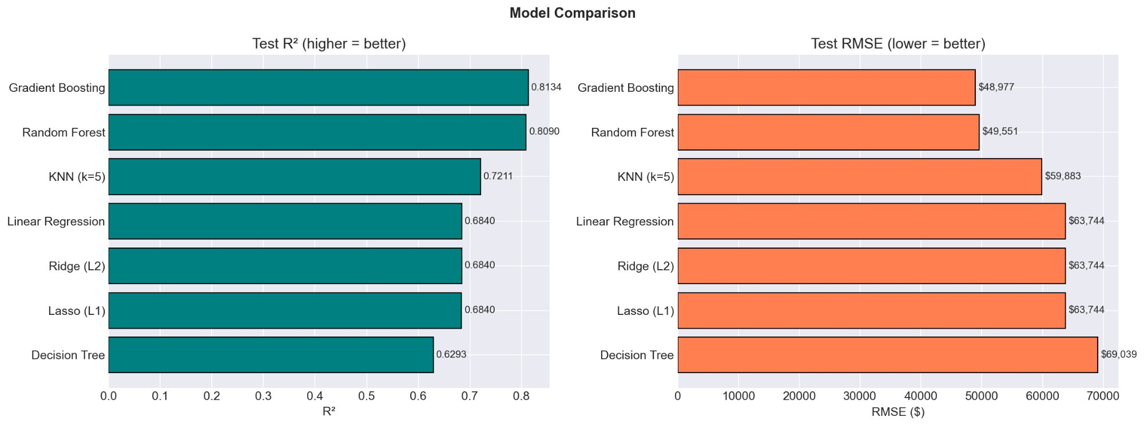
Figure 8: Model comparison — R² and RMSE

Gradient Boosting wins with R² = 0.8134 and RMSE of ~$49k. Linear models all plateau at 0.6840 — regularization doesn’t help because the problem isn’t overfitting, it’s that the relationship isn’t linear. Decision Tree overfits badly.

7. Best Model Deep Dive

7.1 Feature Importance
median_income dominates at 0.53, followed by ocean_proximity_INLAND and population_per_household. Location features (longitude, latitude) also contribute. The engineered features rank higher than the raw counts, validating our feature engineering.
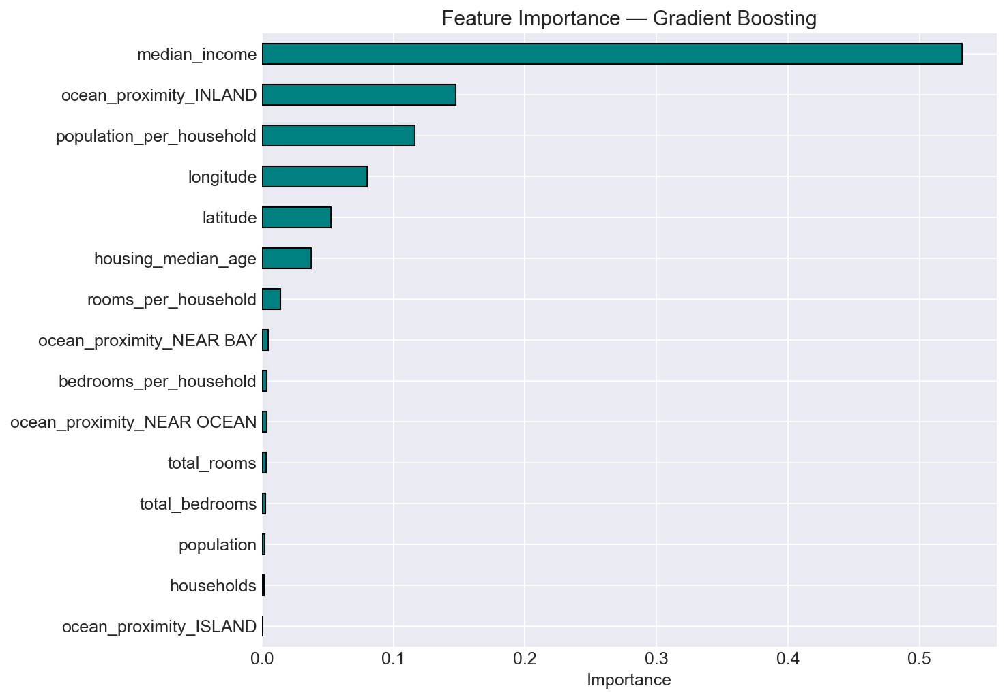
Figure 9: Feature importance — Gradient Boosting

7.2 Actual vs Predicted
Most points cluster around the diagonal. Predictions get noisier at high prices, especially near the $500k cap where the vertical cluster of dots shows the model struggling with capped values.
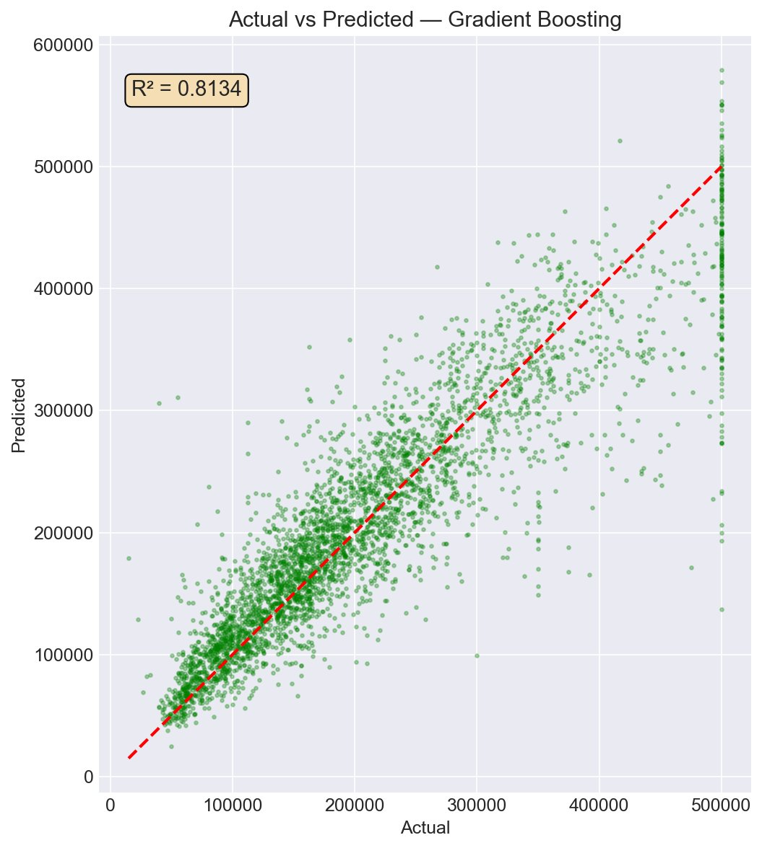
Figure 10: Actual vs predicted — Gradient Boosting (R² = 0.8134)

7.3 Residual Analysis
Residuals are centered around zero and roughly bell-shaped. The Q-Q plot shows deviation at the tails, which is expected with the value cap. Errors increase for more expensive districts — a data limitation, not a model problem.
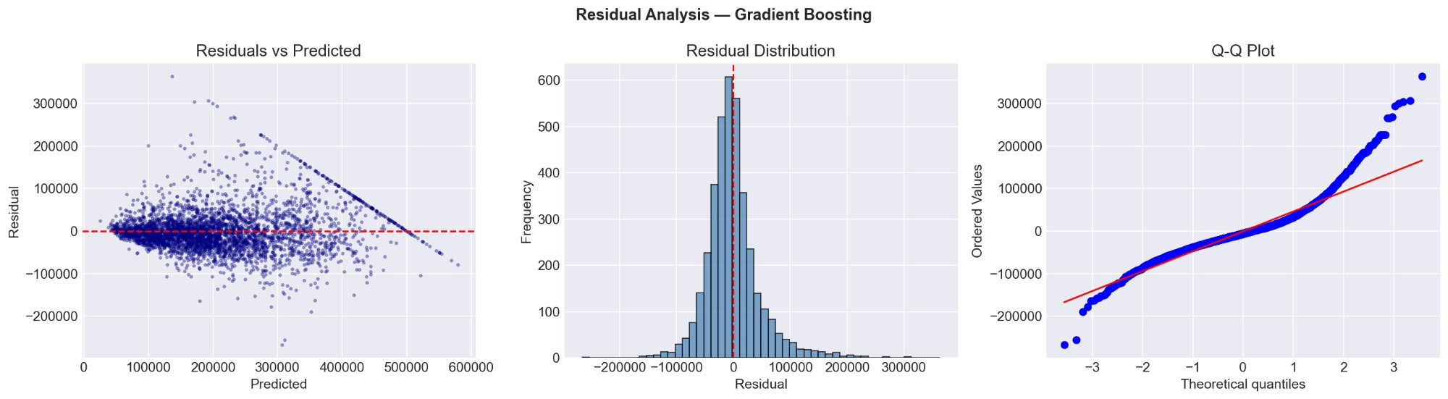
Figure 11: Residual analysis — Gradient Boosting

8. Conclusions
We built an end-to-end pipeline for California housing price prediction. Main findings:
- Income is the strongest predictor, followed by location and ocean proximity.
- Feature engineering (per-household ratios) added useful signal.
- Gradient Boosting achieved R² = 0.8134, significantly outperforming linear models (R² = 0.6840).
- The $500k value cap is the main accuracy bottleneck.

Possible Improvements
- Hyperparameter tuning with GridSearchCV or Optuna.
- Remove or log-transform capped values.
- Add external data (school ratings, crime stats, commute times).
- Try XGBoost and LightGBM.
- Model stacking — combining predictions from multiple models.

Decision Rationale Summary
Step | Decision | Why
Missing data | Median imputation | Robust to skew, only 1% missing
Features | Per-household ratios | Normalize for district size
Outliers | IQR method (3x) | Removes clearly wrong data
Encoding | One-hot, drop_first | No ordering; avoid dummy trap
Split | 80/20, seed=42 | Standard, reproducible
Scaling | StandardScaler (train only) | Prevent data leakage
Models | 7 models, 4 families | Fair comparison
Metrics | R², RMSE, MAE, 5-fold CV | Multiple perspectives

