AJAX

what is AJAX?

- Asynchronous Javascript And Xml

-Not Programming Language

-use combo of XMlHTTPREQUEST + JS&Html DOM

-AJAX allows web pages to be updated asynchronously by exchanging data with a web server behind the scenes. This means that it is possible to update parts of a web page, without reloading the whole page.

How it works?

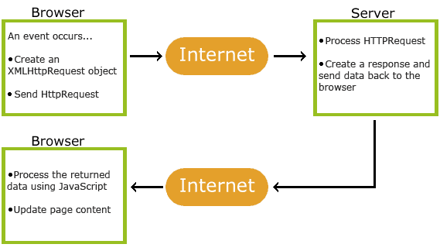

Modern Browsers can use Fetch API instead of the XMLHttpRequest Object.

The Fetch API interface allows web browser to make HTTP requests to web servers.

If you use the XMLHttpRequest Object, Fetch can do the same in a simpler way.

|  |  |
| --- | --- |
| onload | Defines a function to be called when the request is received (loaded) |
| onreadystatechange | Defines a function to be called when the readyState property changes |
| readyState | Holds the status of the XMLHttpRequest. 0: request not initialized 1: server connection established 2: request received 3: processing request 4: request finished and response is ready |
| responseText | Returns the response data as a string |
| responseXML | Returns the response data as XML data |
| status | Returns the status-number of a request 200: "OK" 403: "Forbidden" 404: "Not Found" For a complete list go to the [Http Messages Reference](https://www.w3schools.com/tags/ref_httpmessages.asp) |
| statusText | Returns the status-text (e.g. "OK" or "Not Found") |

METHODS

1.onload = calls after loading data

2.open (method,url,async)= xhr.open(“GET”,”url”,true)

3.send = xhr.send()

4. xhttp.setRequestHeader("Content-type", "application/x-www-form-urlencoded");

5. getResponseHeader = gets specific response info

6. this.getAllResponseHeaders(); = get all response header info

7.abort = cancel current req

8.onprogress = while req is in progress.