VirtualBox, VM Creation &
OS installation

Installation of VirtualBox

Step 1: Download the latest virtual box- executable file from https://www.virtualbox.org/wiki/Downloads, download VirtualBox.latest.version for Windows hosts

Step 2: Install VirtualBox by double clicking on the downloaded file.
Click install to install VirtualBox with default settings.
If the installation is successful, you will see a Virtual Manager window to manage VMs.

Creating a Virtual Machine (For Guest OS)

Open Application -> System Tools -> VirtualBox (Command name is “virtualbox”)

Click Machine -> New. This will launch a “Create New Virtual Machine” wizard. Click Next.

Enter the name of the Guest machine as you desire and choose the Operating system and Version that
you are planning to install as follows, and click “Next”.

Enter the RAM size that you want to provide to your Guest machine as follows.

Now it will ask you to choose your “Virtual Hard Disk” for installing the guest OS as follows.

Since this is the first time we are installing, click “Create New Hard disk”.

Create “New Virtual Disk” wizard will open. Click Next

Now we need to choose, whether the disk has to be “Dynamically expanding disk” or “Fixed-size storage”.

Remember, for a guest machine, it sees a file residing in the host machine as the “Hard Disk”.

Whenever a guest machine does any write to disk, it will be written into the file which resides on the host machine

If we select “Fixed storage” and if we choose the size as 10GB then, in host machine (by default under .VirtualBox/Guest-Machine/Guest-Machine.vdi ) a file will be created with 10GB of size

If we select “Dynamic storage” then, .VirtualBox/Guest-Machine/Guest-Machine.vdi will initially be a small size file, but it will grow whenever the guest machine writes data to the disk.

Choose “Fixed storage” and click Next.
Click Finish. Now a file named “Guest-Machine.vdi” will be created under “.VirtualBox/Guest-Machine/”

Click “Finish” to complete the creation of Virtual Machine.

Now a new “Virtual Machine” is created and it will be in “power off” state.

Installing OS in a Virtual machine

We can install any OS (personally tested windows and Linux) on a virtual machine. We can install the OS in virtual machine by 2 methods
• Through OS-DVD
• Through ISO image of the OS

Here we will cover the installation using an ISO image, although using DVD is very similar to this.
Make sure that the iso file of your distribution is present in the host machine.

Launch “virtualbox”. Select the newly created virtual machine. Click “Settings”.

Now a new window will open which will list out the settings group on left panel and actual setting on the right side as follows.

Select “System”. On the right panel ensure that the boot order is correct (Similar to setting the boot order in BIOS).

Use the “Move Up” or “Move Down” button to change the boot order, and make sure CD/DVD is selected as the “First boot device” and click “Ok”.

The next step is to map the “ISO file” of your distribution to the virtual CD/DVD device.
Under “Settings” go to “Storage”, the following screen will appear.

Click the “CD icon” and choose the “iso file of the OS”, here I used “Centos-ISO”.

The following screen will appear once you have chosen the ISO file. Click “Ok”.

Now select the virtual machine, and click “Start”. It will start to boot from the CD/DVD which is mapped to the ISO file. Follow the instructions of installation and create root password.

That’s All! Now the machine is ready with CentOS 7.

Select the device to boot from, in your BIOS option. As soon as CentOS 7.1 (1503) boots, select Install Centos 7.
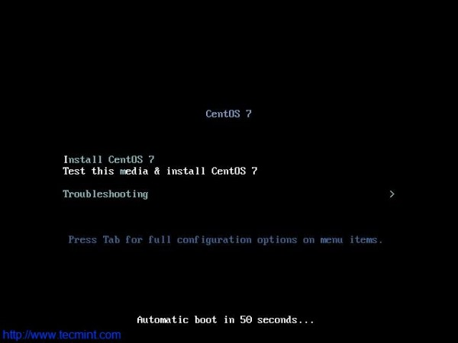

Select the desired Language for the installation process

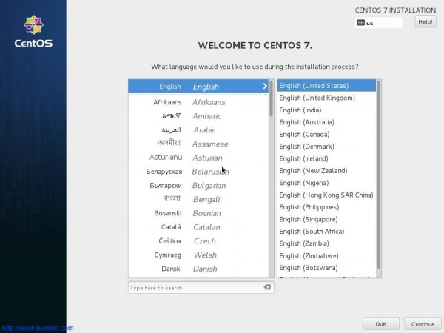

The interface to configure Date, Time, Keyboard, Language, Installation Source, Software selection, Installation Destination, Kdump, Networks and Hostname.

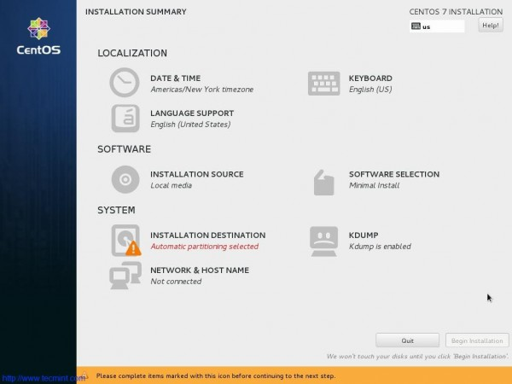
Set Installation Source. You may include network source as well. If you are not sure of network source better stick to auto-detected Installation Media. Click Done.

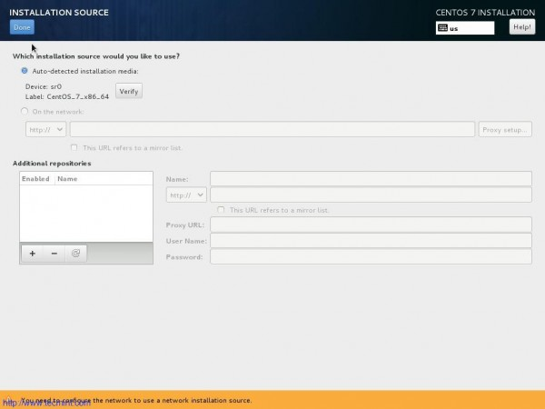

Next select Software selection. If you are setting up production server, You should go with Minimal Install.
Minimal Install will install just the basic software and services required for basic setup and nothing extra. This way you can configure your server and packages, more on a monolithic side. (I am selecting Gnome Desktop, since I will be using GUI and I will not be using it in production).
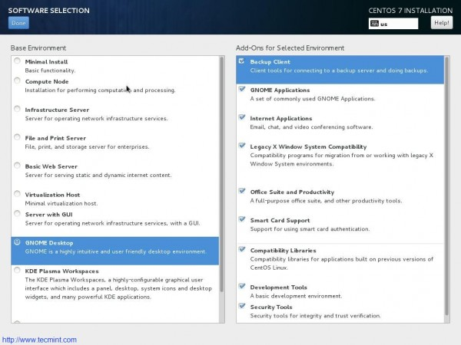

Next is Installation Destination. Select disk and Choose “I will configure Partitioning”. You may encrypt your data with paraphrase for additional security. Click done.
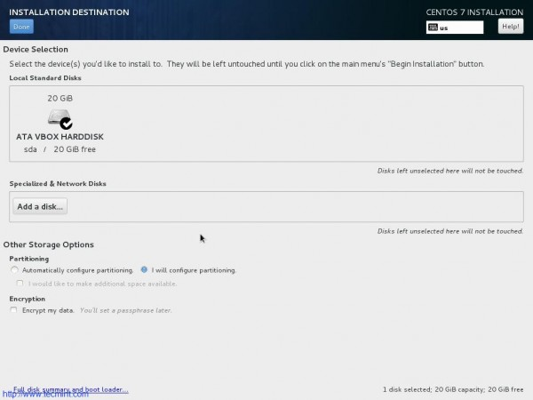

Select LVM in Partitioning Scheme.
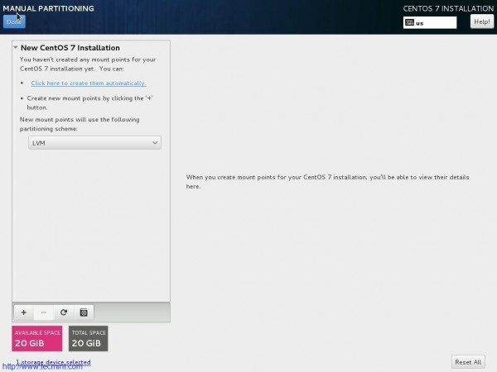

Add a new Mount Point (/boot) by clicking on + also enter Desired Capacity. Finally Click “Add Mount Point”.

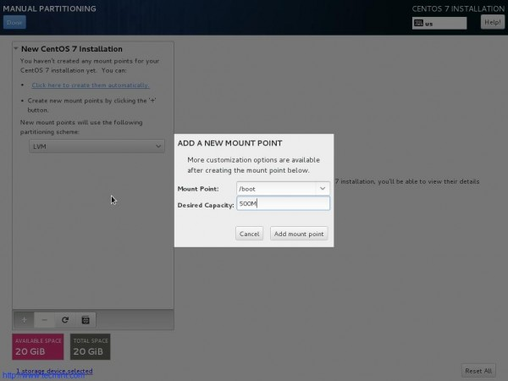

Finally “Accept Changes” when prompted for disk format and create.

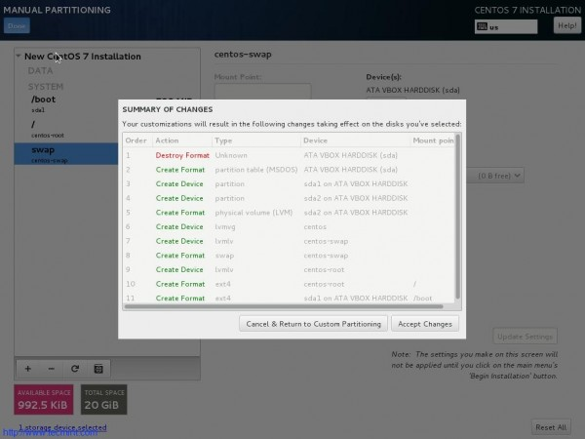

Back to the Installation Summary Interface. Now everything seems at its place. Click “Begin Installation”.

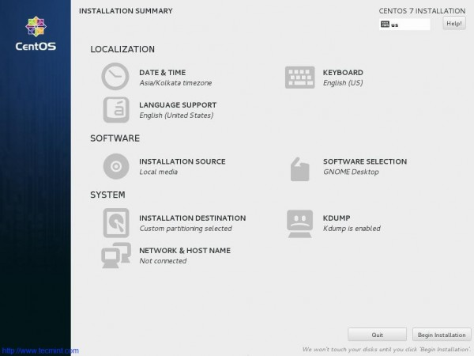

Now packages will start installing. Time to set Root Password and create a new user.
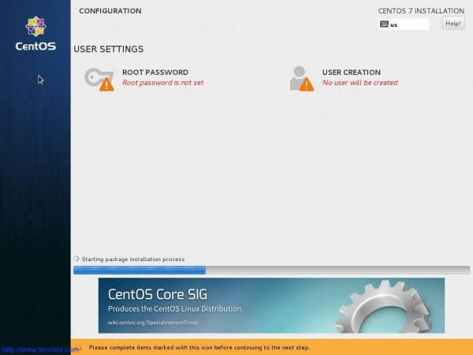

Enter Root password and click done
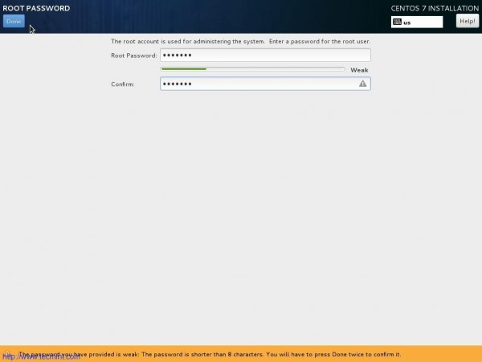

Create a new user. Provide name, user_name and password. Click Done.
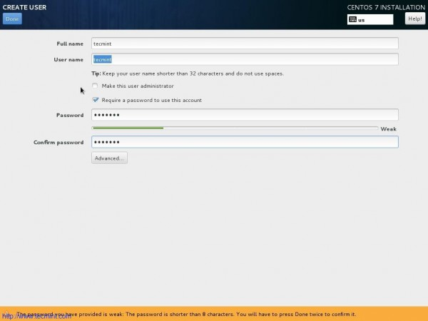

Complete!!! Time to reboot the machine.
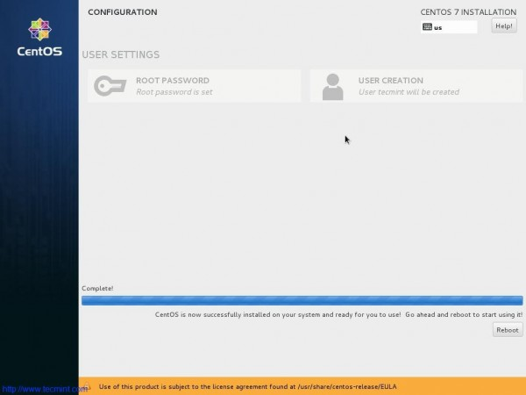

After Successful Installation, here is the boot prompt and login screen.
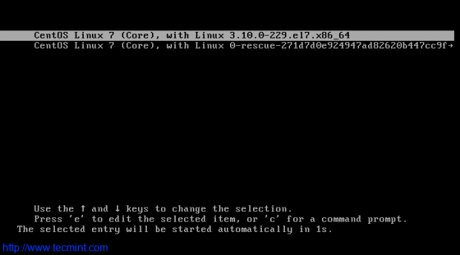

Interface After successful login.
