Digital Forensics CTF Solution Flow Report
Nikiraj Konwar

Digital Forensics CTF Solution Flow Report

1. Introduction
This report explains the solution flow for two digital forensics Capture The Flag challenges:
- Image Metadata Disk Forensics Challenge
- Suspicious Network Traffic PCAP Challenge
The purpose of the report is to show how each challenge was solved from the provided evidence files, including the commands used, the meaning of each result, and the final flags recovered from the evidence.

2. Tools Used
The following command-line tools were used during the investigation:
- ls to confirm that evidence files exist.
- xz to decompress the disk image.
- mmls to inspect the disk image partition table.
- foremost to recover deleted files from the disk image.
- exiftool to inspect image metadata.
- tshark to inspect packet capture traffic.
- strings to extract readable strings from binary files.
- grep to filter important output.
- base64 to decode the encoded payload found in the PCAP.

Task 1: Image Metadata Disk Forensics

3. Challenge Objective
The first challenge is named Deleted Cat Evidence.
The provided evidence file is:
Image_ctf/final.dd.xz
The objective is to analyze the compressed disk image, recover the deleted image file, and extract the hidden flag from the recovered image metadata.

4. Solution Flow

Step 1: Confirm the evidence file and decompress the disk image
The first step was to confirm that the compressed disk image existed:
ls -lh Image_ctf/final.dd.xz
The output showed that final.dd.xz was present. After that, a working directory was created and the compressed disk image was decompressed:
mkdir -p work/image_ctf
xz -dc Image_ctf/final.dd.xz > work/image_ctf/final.dd
This created a working copy named work/image_ctf/final.dd. This is important because the original challenge evidence should not be modified during analysis.
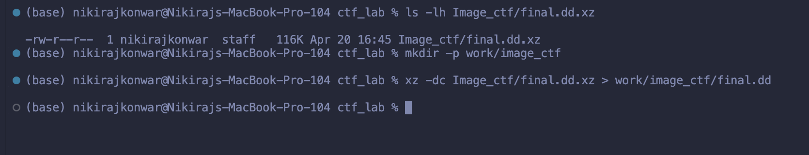
Screenshot 1: Evidence file check and decompression command.

Step 2: Inspect the disk image structure
After decompression, the disk image was inspected with mmls:
mmls work/image_ctf/final.dd
The output showed a GUID Partition Table and a partition beginning at sector 40:
004: 000 0000000040 0000614359 0000614320 disk image
This confirmed that the file was a valid disk image and that forensic recovery could continue.
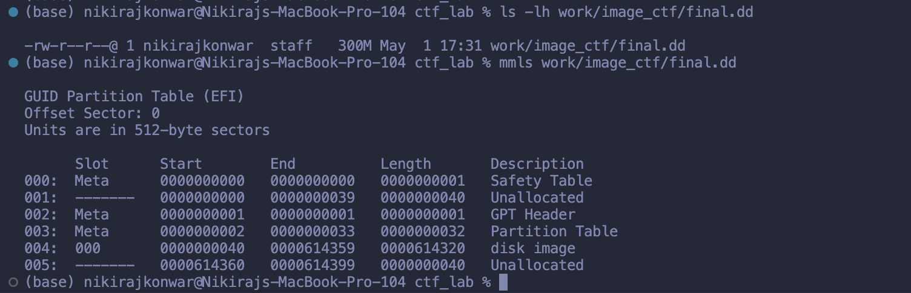
Screenshot 2: Partition table shown by mmls.

Step 3: Recover deleted files from the disk image
The next step was to carve files from the disk image using foremost:
foremost -i work/image_ctf/final.dd -o work/image_ctf/recovered
foremost processed the disk image and recovered files into the work/image_ctf/recovered folder. The warning about foremost.conf did not stop the recovery; the tool still processed the image successfully.
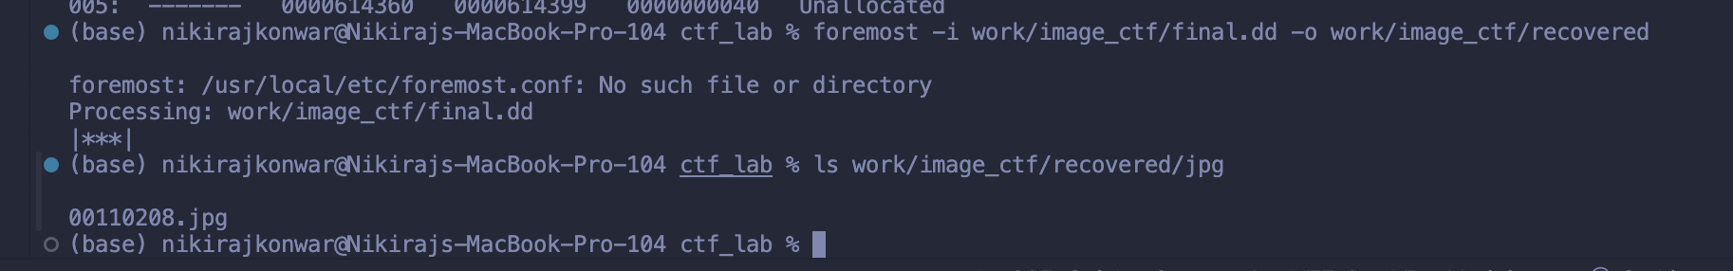
Screenshot 3: foremost recovering files from the disk image.

Step 4: Locate the recovered JPG and read metadata
The recovered JPG folder was listed:
ls work/image_ctf/recovered/jpg
The recovered file was:
00110208.jpg
The image metadata was then inspected:
exiftool work/image_ctf/recovered/jpg/00110208.jpg | grep -i "Comment"
The metadata comment contained the flag:
Comment : FLAG{Drunk_cat_is_here}
Screenshot 4: Recovered JPG and metadata flag.

5. Task 1 Result
The hidden flag was found in the Comment metadata field of the recovered JPG image.
Task 1 flag:
FLAG{Drunk_cat_is_here}

Task 2: Suspicious Network Traffic PCAP

6. Challenge Objective
The second challenge is named Suspicious Office Traffic.
The provided evidence file is:
pcap_ctf/challenge.pcap
The objective is to analyze the packet capture, identify suspicious communication, find the suspicious domain, extract the encoded payload, and decode the final flag.

7. Solution Flow

Step 1: Confirm the PCAP and view IP conversations
The first step was to confirm that the PCAP file existed:
ls -lh pcap_ctf/challenge.pcap
Then the IP conversations were viewed with tshark:
tshark -r pcap_ctf/challenge.pcap -q -z conv,ip
The conversation table showed suspicious communication between:
192.168.10.5 <-> 10.0.0.66
This indicates that internal host 192.168.10.5 communicated with external IP address 10.0.0.66.
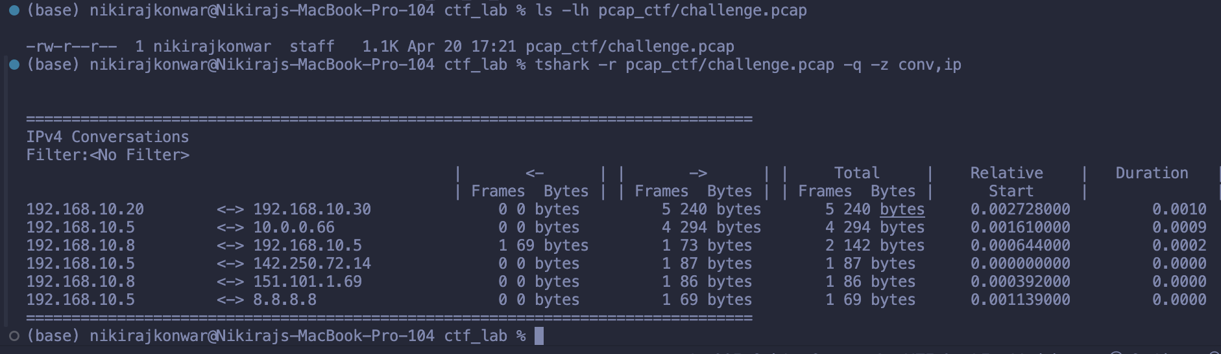
Screenshot 5: PCAP file check and IP conversation table.

Step 2: Identify the suspicious DNS request
DNS traffic was filtered with tshark:
tshark -r pcap_ctf/challenge.pcap -Y dns -T fields -e frame.number -e ip.src -e ip.dst -e dns.qry.name
The important result was:
5 192.168.10.5 8.8.8.8 sync-checker-update.com
This shows that host 192.168.10.5 queried the suspicious domain sync-checker-update.com.
The screenshot also shows an accidental attempt to run sync-checker-update.com as a terminal command. The zsh: command not found message is not part of the forensic result. The important evidence is the DNS query output above it.

Step 3: Extract the encoded payload from the PCAP
Readable strings were extracted from the PCAP and filtered for the Base64-looking payload:
strings pcap_ctf/challenge.pcap | grep Rkx
The encoded payload found was:
RkxBR3tuZXR3b3JrX2ZvcmVuc2ljc19jYXNlfQ==
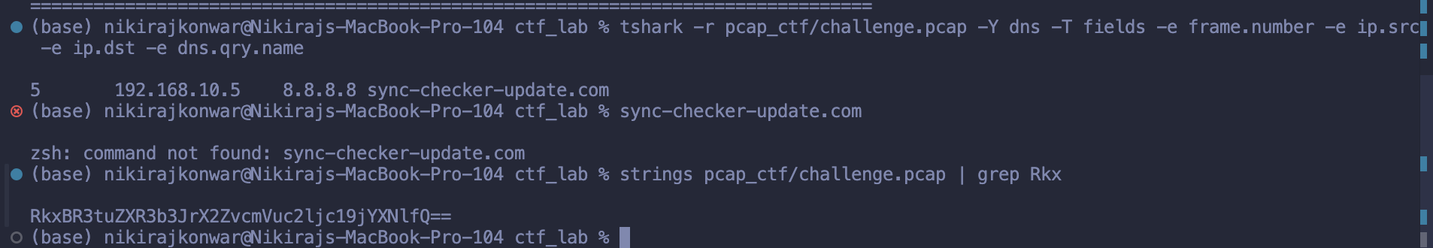
Screenshot 6: DNS query and encoded payload extraction.

Step 4: Decode the Base64 payload
The encoded string was decoded with base64:
echo "RkxBR3tuZXR3b3JrX2ZvcmVuc2ljc19jYXNlfQ==" | base64 -d
The decoded output revealed the flag:
FLAG{network_forensics_case}
The % shown after the flag in the terminal is not part of the flag. It is the shell showing that the decoded output did not end with a newline.
Screenshot 7: Base64 decoding result showing the PCAP flag.

8. Task 2 Result
The suspicious host was 192.168.10.5. It communicated with 10.0.0.66, queried the suspicious domain sync-checker-update.com, and contained a Base64-encoded payload in the PCAP.
Task 2 flag:
FLAG{network_forensics_case}

9. Final Results
The final recovered flags are:
Task 1 Image CTF Flag: FLAG{Drunk_cat_is_here}
Task 2 PCAP CTF Flag: FLAG{network_forensics_case}

10. Conclusion
Both challenges were completed successfully.
The image forensics challenge demonstrated disk image handling, partition inspection, deleted file recovery, and metadata analysis. The hidden flag was recovered from the comment field of the deleted JPG image.
The PCAP forensics challenge demonstrated network traffic analysis, suspicious host identification, DNS investigation, encoded payload extraction, and Base64 decoding. The hidden flag was recovered by decoding the suspicious payload found inside the packet capture.

