Exercise 1: Spatial filters
Artifacts are a major issue in BCI. One way to reduce the impact of artifacts are spatial filters. In this exercise you will study the effects of different spatial filters on artifact-contaminated EEG.
The file artefacts.mat contains a segment of a 120 channel EEG recording that is contaminated with artifacts. Use the MATLAB function load to load the .mat file. The EEG is sampled at a rate of 500 Hz and band pass filtered between 1 Hz and 200 Hz. Electrode setup and channel information are shown on the next pages. Please compute the following spatial filters for positions Fz, Cz and Oz. Note: in the case of laplacian derivation, anterior means to the front, posterior means to the back, dexter means to the right and sinister to the left with respect to a chosen electrode position on which the spatial filter is applied.
Exercise 1.1: Bipolar derivation $X_{bip}=X_{anterior}-X_{posterior}$
Exercise 1.2: Laplace derivation $X_{lap}=X-\frac{1}{4}\left({X_{anterior}+X_{dexter}+X}_{posterior}+X_{sinister}\right)$
Exercise 1.3: Common average reference derivation (CAR) $X_{CAR}=X-average(all channels)$
Task:
- Describe the effects of the different spatial filters on the EEG signal, especially on artifacts.
Exercise 2: Artifacts in EEG
Below are some examples of EEG independent components. Label them correctly and briefly explain your reasons. Note that some components might not be artefactual, but brain related.

1.
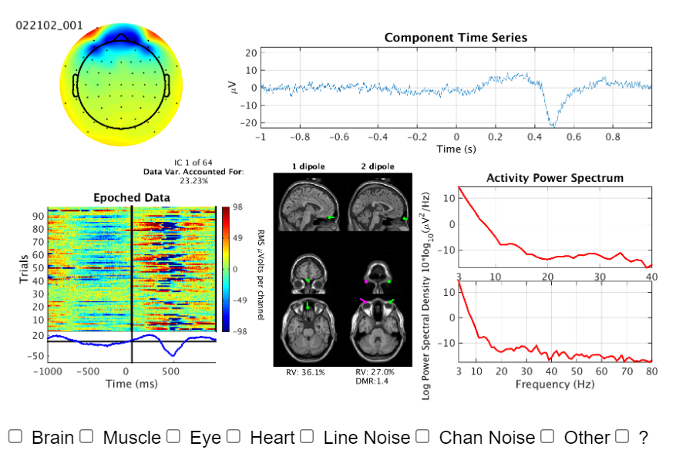

2.
–

3.
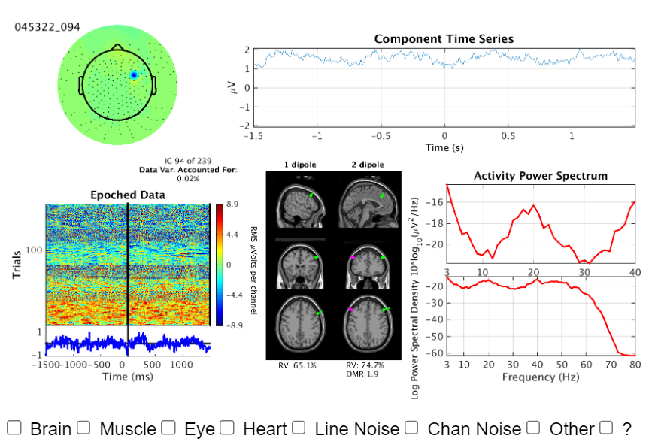
4.
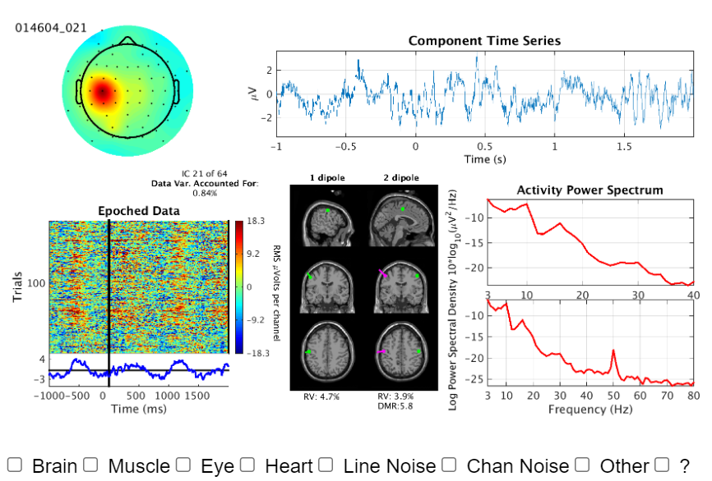
5.
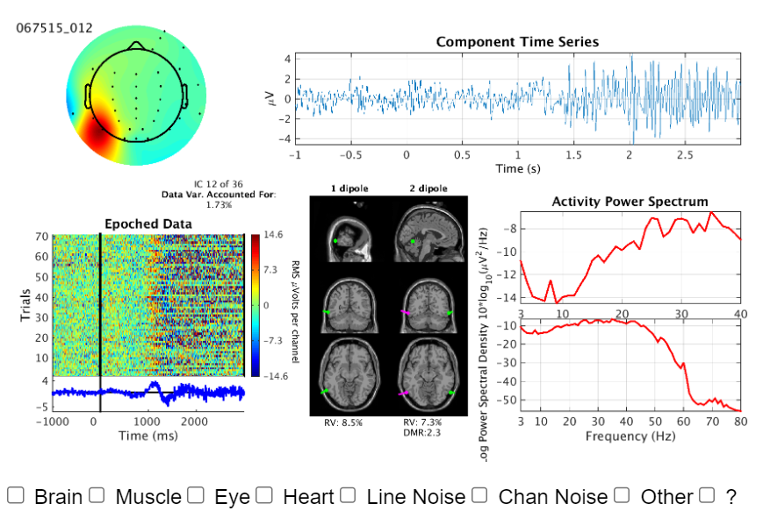

6.
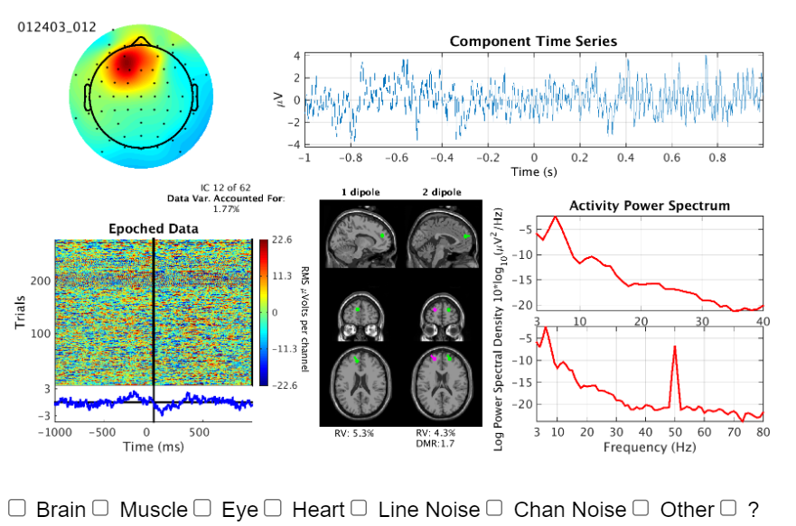

Exercise 3: P300 Evoked Potentials
The file BI5_segments_HTS.mat contains data from an auditory P300 BCI experiment. Study participants were asked to concentrate on a target tone, which was higher than the non-target tone. The multidimensional matrix segments stores the following information:
- First dimension: Channels (Fz, Cz and Pz, you can look that up in “ch_selection”).
- Second dimension: Time course (77 time points, Sample rate: 64 Hz).
- Third dimension: Trials (2200).
Use the classlabels vector to identify non-target trials (class 1) and target trials (class 2). Store them in separate matrices and calculate their means.
Tasks:
- Compute the EPs by averaging the trials for each channel and modality (non-target and target) separately.
- Plot a figure for each channel with the two modalities (hold on).
- Describe the differences between the two modalities (P300).
- Are the differences the same for all channels?

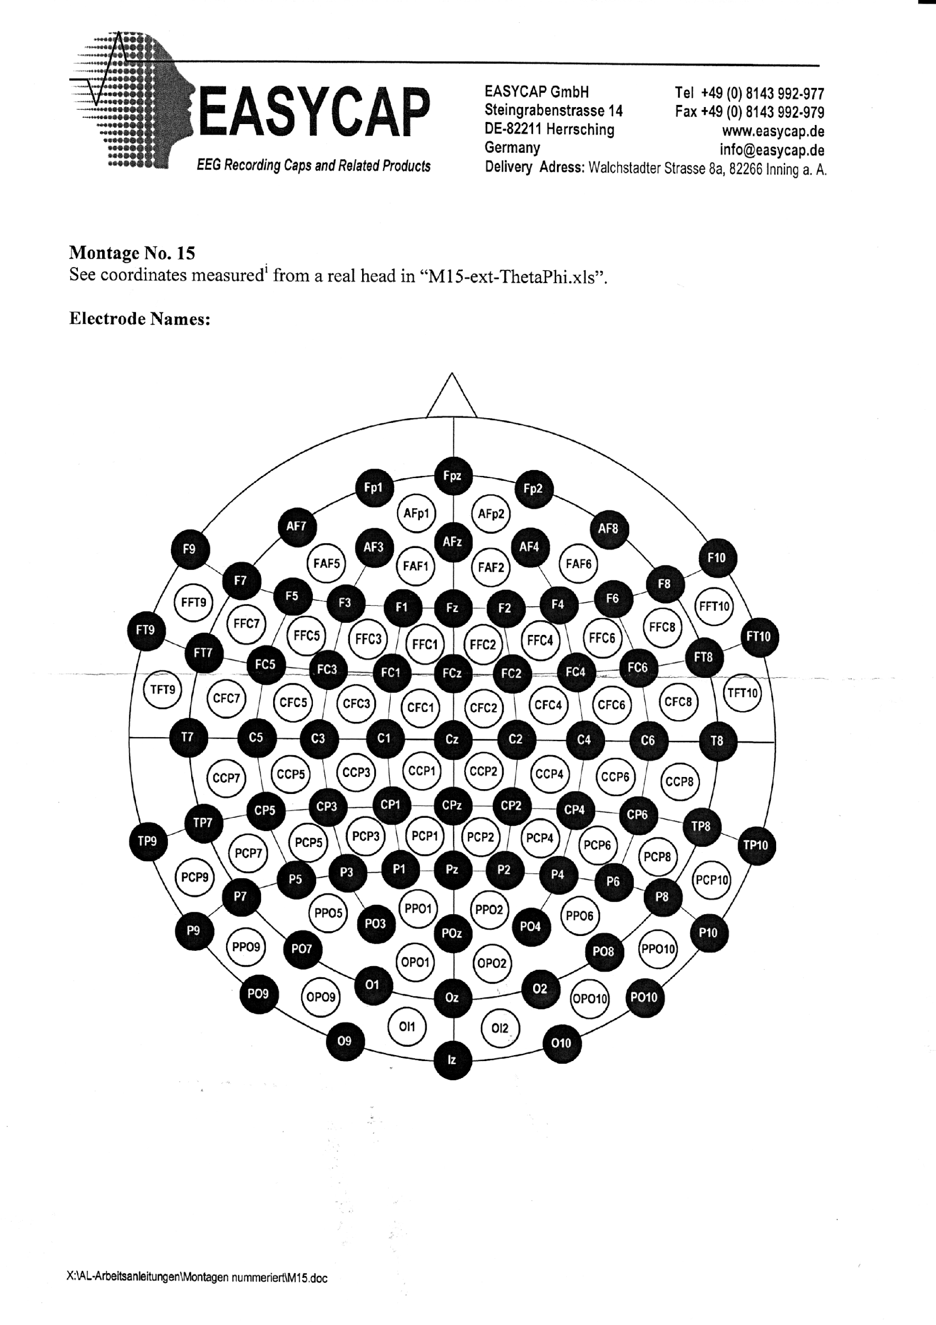

Electrode positions:
1 | Fp1
2 | Fpz
3 | Fp2
4 | AFp1
5 | AFp2
6 | AF3
7 | AFz
8 | AF4
9 | FAF1
10 | FAF2
11 | F1
12 | Fz
13 | F2
14 | FFC1
15 | FFC2
16 | FC1
17 | FCz
18 | FC2
19 | CFC1
20 | CFC2
21 | C1
22 | Cz
23 | C2
24 | CCP1
25 | CCP2
26 | CP1
27 | CPz
28 | CP2
29 | PCP1
30 | PCP2
31 | P1
32 | Pz
33 | P2
34 | PPO1
35 | PPO2
36 | PO3
37 | POz
38 | PO4
39 | OPO1
40 | OPO2
41 | O1
42 | Oz
43 | O2
44 | OI1
45 | OI2
46 | I1
47 | Iz
48 | I2
49 | AF7
50 | F9
51 | F7
52 | FT9
53 | FAF5
54 | F5
55 | FFC7
56 | FT7
57 | F3
58 | FFC5
59 | FC5
60 | CFC7
61 | T7
62 | FFC3
63 | FC3
64 | CFC5
65 | C5
66 | CCP7
67 | TP7
68 | P9
69 | CFC3
70 | C3
71 | CCP5
72 | CP5
73 | PCP7
74 | P7
75 | P09
76 | CCP3
77 | CP3
78 | PCP5
79 | P5
80 | PO7
81 | OPO9
82 | PCP3
83 | P3
84 | PPO5
85 | AF8
86 | F10
87 | F8
88 | FT10
89 | FAF6
90 | F6
91 | FFC8
92 | FT8
93 | F4
94 | FFC6
95 | FC6
96 | CFC8
97 | T8
98 | FFC4
99 | FC4
100 | CFC6
101 | C6
102 | CCP8
103 | TP8
104 | P10
105 | CFC4
106 | C4
107 | CCP6
108 | CP6
109 | PCP8
110 | P8
111 | PO10
112 | CCP4
113 | CP4
114 | PCP6
115 | P6
116 | PO8
117 | OPO10
118 | PCP4
119 | P4
120 | PPO6
121 | EMG1SL
122 | EMG1IL
123 | EMG2SL
124 | EMG2IL
125 | EMG1SR

