**3.1**

db.restaurants.find({cuisine: "Chinese", borough: "Queens"}).count()

728

**3.2**

db.restaurants.find({}, {"grades.score": 1}).sort({"grades.score": -1}).limit(1)

5c0c263aa09a80bc2f793a9e

**3.3**

db.restaurants.updateMany({borough: "Manhattan"}, {$push: {grades: { grade: "A", score: 7, date: ISODate()}}})

{ "acknowledged" : true, "matchedCount" : 10259, "modifiedCount" : 10259 }

**3.4**

db.restaurants.find({"grades.8.score": {$lt: 7}}, {"name": 1, "_id": 0})

{ "name" : "Silver Krust West Indian Restaurant" }

{ "name" : "Pure Food" }

**3.5**

db.restaurants.find({"cuisine": "Seafood", "grades": {$elemMatch: {"grade": "B", $and: [{"date": {$gt: ISODate("2014-02-01")}}, {"date": {$lt: ISODate("2014-03-01")}}]}}}, {"borough": 1})

{ "_id" : ObjectId("5c0c263ba09a80bc2f796eac"), "borough" : "Bronx" }

{ "_id" : ObjectId("5c0c263ba09a80bc2f797122"), "borough" : "Manhattan" }

**4.1**

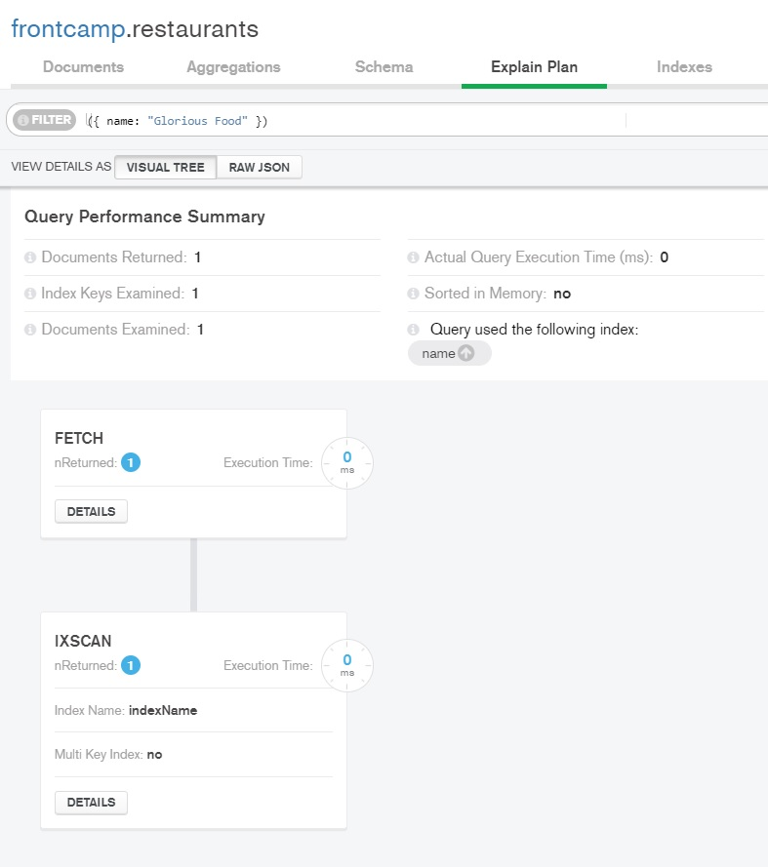

**4.2**

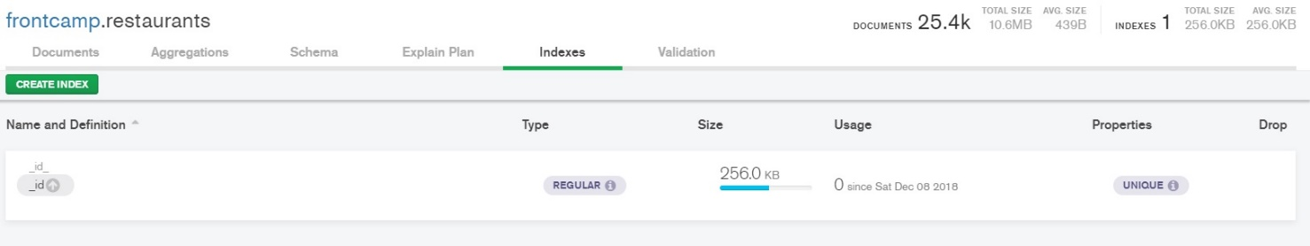

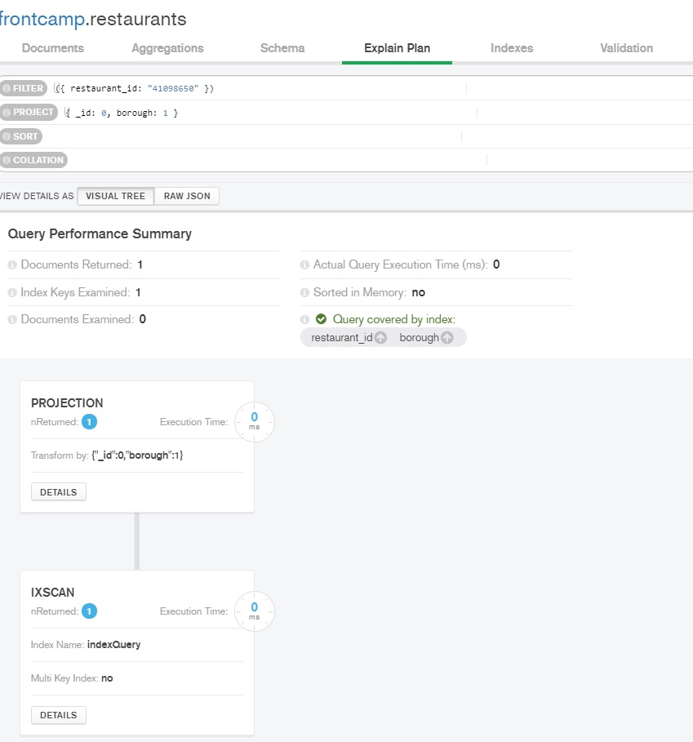**4.3**

**4.4**

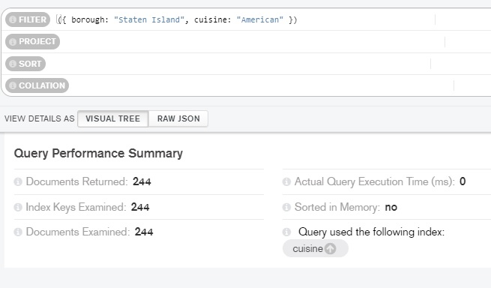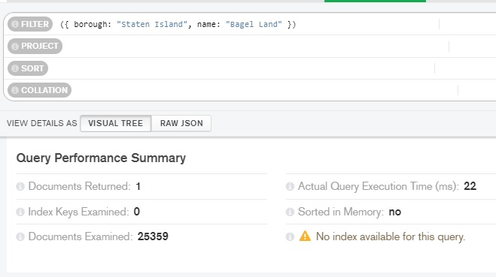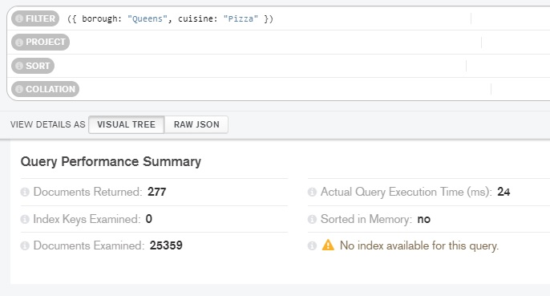

**4.5**

