MACHINE LEARNING COURSE PROJECT
SVM Classification with Kernel Comparison
Linear vs Polynomial vs RBF
───────────────────────────────────────────────────────
Submitted by
NIKITHA
Registration No.: RA2411003011501
Course / Unit: Machine Learning
Department of Computer Science & Engineering
SRM University

Table of Contents
Table of Contents 2
1. Abstract 3
2. Introduction 4
2.1 Limitations of Linear Boundaries 4
2.2 The Kernel Trick 4
3. Objective 5
4. Dataset Description 5
4.1 Synthetic Dataset — make_moons 5
4.2 Real-World Dataset — Breast Cancer Wisconsin 6
5. Methodology 7
5.1 Data Preprocessing 7
5.2 Model Training 7
5.3 Hyperparameter Tuning 7
5.4 Evaluation Metrics 7
6. Results 9
6.1 Decision Boundaries — Synthetic Dataset 9
6.2 Decision Boundaries — Breast Cancer Dataset 9
6.3 Effect of Gamma (γ) on RBF Decision Boundary 11
6.4 Hyperparameter Tuning via GridSearchCV 12
6.5 Performance Metrics 13
6.6 Confusion Matrices 15
7. Discussion 16
7.1 Linear Kernel Underperformance on Non-Linear Data 16
7.2 Performance Convergence on the Breast Cancer Dataset 16
7.3 RBF as the Most Robust General-Purpose Kernel 16
8. Conclusion 17
9. References 17

1. Abstract
This project presents a comparative study of Support Vector Machine (SVM) classifiers using three distinct kernel functions — Linear, Polynomial (degree = 3), and Radial Basis Function (RBF) — applied to both a synthetic non-linearly separable dataset (make_moons) and a real-world binary classification dataset (Breast Cancer Wisconsin). The study evaluates each kernel's decision boundary shape, classification accuracy, precision, recall, and F1-score, while also investigating the effect of the gamma (γ) hyperparameter on RBF boundary complexity and employing GridSearchCV to identify optimal hyperparameter combinations.
Experimental results demonstrate that the RBF kernel consistently outperforms the Linear and Polynomial kernels, achieving an F1-score of approximately 0.95 on the synthetic dataset and 0.983 on the real-world dataset. The Linear kernel, while computationally efficient, fails to capture the non-linear decision boundary inherent in the make_moons data, yielding a notably lower accuracy of approximately 0.83. The Polynomial kernel presents a middle ground, outperforming the Linear kernel on non-linear data while remaining computationally tractable. These findings confirm the RBF kernel as the most robust general-purpose choice for binary SVM classification tasks.

2. Introduction
Support Vector Machine (SVM) is a supervised learning algorithm widely used for classification and regression tasks. The fundamental objective of SVM is to identify the optimal hyperplane that maximises the margin between two classes in the feature space. The margin is defined as the distance between the hyperplane and the nearest data points from each class — these nearest points are referred to as support vectors. Maximising this margin produces a classifier that generalises well to unseen data, making SVM particularly suitable for high-dimensional problems.

2.1 Limitations of Linear Boundaries
In its basic formulation, SVM constructs a linear hyperplane of the form w·x + b = 0. Whilst this is effective for linearly separable datasets, many real-world classification problems involve data distributions that cannot be separated by any straight line or hyperplane in the original feature space. Consider two interleaving crescent-shaped clusters: no single straight line can be drawn to cleanly separate them. Forcing a linear SVM on such data yields high misclassification rates regardless of the regularisation parameter C, since the model's representational capacity is fundamentally insufficient for the task.

2.2 The Kernel Trick
The kernel trick offers a computationally elegant solution to the non-linearity problem. Rather than explicitly mapping data points x into a higher-dimensional feature space φ(x), a kernel function K(x, z) = ⟨φ(x), φ(z)⟩ computes the inner product in the transformed space directly from the original features. This allows SVM to construct non-linear decision boundaries without ever computing the — potentially infinite-dimensional — feature mapping φ. The computational cost remains proportional to evaluating K(x, z), which for standard kernels is an O(n) operation. Common kernel functions include the linear kernel K(x,z) = x·z, the polynomial kernel K(x,z) = (γx·z + r)^d, and the Radial Basis Function (RBF) kernel K(x,z) = exp(−γ||x−z||²), each inducing a different class of decision boundary shapes.

3. Objective
The primary objective of this project is to empirically compare the performance of SVM classifiers employing three distinct kernel functions — Linear, Polynomial (degree = 3), and RBF — across two distinct classification settings: a synthetic non-linearly separable dataset and a real-world biomedical dataset. Specific sub-objectives include:
- Visualising the decision boundaries produced by each kernel on 2-dimensional data to develop an intuitive understanding of how kernel choice affects the shape and complexity of the classification boundary.
- Quantitatively evaluating each kernel using standard performance metrics: accuracy, precision, recall, and F1-score on a held-out test set.
- Investigating the effect of the RBF hyperparameter gamma (γ) on boundary smoothness, generalisation, and the risk of underfitting versus overfitting.
- Applying GridSearchCV with 5-fold cross-validation to identify the optimal combination of regularisation parameter C and gamma for the RBF kernel.
- Drawing conclusions about which kernel is most appropriate for each data type, and providing guidance on kernel selection for binary SVM classification tasks.

4. Dataset Description

4.1 Synthetic Dataset — make_moons
The primary demonstration dataset is generated using scikit-learn's make_moons function, which produces 500 samples arranged as two interleaving half-circles (or 'moons'). Gaussian noise (σ = 0.25) is added to introduce realistic ambiguity at the class boundary. The dataset contains exactly two features — making it ideal for 2-dimensional decision boundary visualisation — and two balanced classes (250 samples each). The non-linear structure of the data serves as a deliberate test case to expose the limitations of the Linear kernel and highlight the advantages of non-linear kernel functions.
Property | make_moons (Synthetic) | Breast Cancer (Real)
No. of Samples | 500 | 569
No. of Features | 2 | 30 (full) / 2 (plots)
Classes | 0, 1 (binary) | Malignant, Benign
Train / Test Split | 400 / 100 | 455 / 114
Noise | σ = 0.25 (Gaussian) | N/A (real data)
Separability | Non-linear | Near-linear (high-dim.)

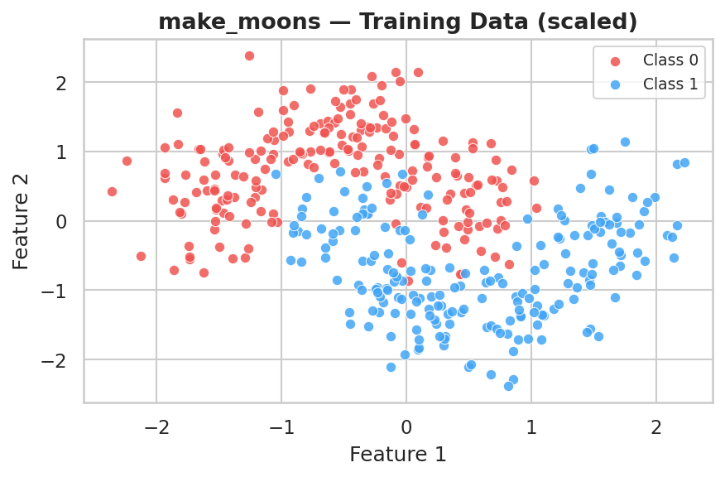
Figure 1: make_moons training data (scaled). Two interleaving half-circles that cannot be separated by any linear boundary.

4.2 Real-World Dataset — Breast Cancer Wisconsin
The Breast Cancer Wisconsin dataset, available through scikit-learn's datasets module, comprises 569 samples and 30 numeric features computed from digitised images of fine needle aspirate (FNA) of breast masses. Each feature describes characteristics of the cell nuclei present in the image, including radius, texture, perimeter, area, and smoothness. The classification target is binary: malignant (class 0, 212 samples) or benign (class 1, 357 samples). For decision boundary visualisation purposes, only the first two features are used to enable 2-dimensional plotting; however, all 30 features are used when computing the final performance metrics to ensure meaningful evaluation.

5. Methodology

5.1 Data Preprocessing
Both datasets undergo the following preprocessing pipeline before model training:
- Train/Test Split: Each dataset is divided into a training set (80%) and a test set (20%) using scikit-learn's train_test_split function with stratification to maintain class proportions in both sets. A fixed random seed (42) ensures reproducibility.
- Feature Standardisation: Since SVM relies on distance computations, feature scaling is critical. A StandardScaler is fitted exclusively on the training set (computing mean μ and standard deviation σ per feature), and then applied to both the training and test sets. This prevents data leakage from the test set into the preprocessing step.

5.2 Model Training
Three SVM classifiers are trained using scikit-learn's SVC class, each with a different kernel function:
Kernel | Formula | Default Parameters | Characteristic
Linear Kernel | K(x,z) = x·z | C = 1.0 | Seeks a straight hyperplane; computationally fastest.
Polynomial Kernel | K(x,z) = (γ·x·z + r)^d, d=3, r=1 | C = 1.0 | Maps data into 3rd-order polynomial feature space.
RBF Kernel | K(x,z) = exp(−γ||x−z||²) | C = 1.0, γ = 'scale' | Gaussian kernel; models non-linear boundaries of arbitrary complexity.

5.3 Hyperparameter Tuning
To identify the optimal hyperparameter configuration for the RBF kernel, an exhaustive grid search is performed using scikit-learn's GridSearchCV with 5-fold cross-validation. The search space spans the following parameter grid:
Hyperparameter | Values Searched
C (Regularisation) | 0.01, 0.1, 1, 10, 100
γ (Gamma) | 0.001, 0.01, 0.1, 1, 10

Mean cross-validated accuracy is used as the selection criterion. The best performing (C, γ) pair is then used to retrain the final RBF model on the full training set. The grid search is parallelised across all available CPU cores (n_jobs=−1) for efficiency.

5.4 Evaluation Metrics
Each trained model is evaluated on the held-out test set using four standard classification metrics, all computed with weighted averaging to account for any class imbalance:
- Accuracy: Proportion of all samples classified correctly: TP+TN / (TP+TN+FP+FN).
- Precision: Of all samples predicted as positive, what fraction are truly positive: TP / (TP+FP).
- Recall: Of all actual positive samples, what fraction were correctly identified: TP / (TP+FN).
- F1-Score: Harmonic mean of precision and recall, providing a single balanced metric: 2·(P·R)/(P+R).

6. Results

6.1 Decision Boundaries — Synthetic Dataset
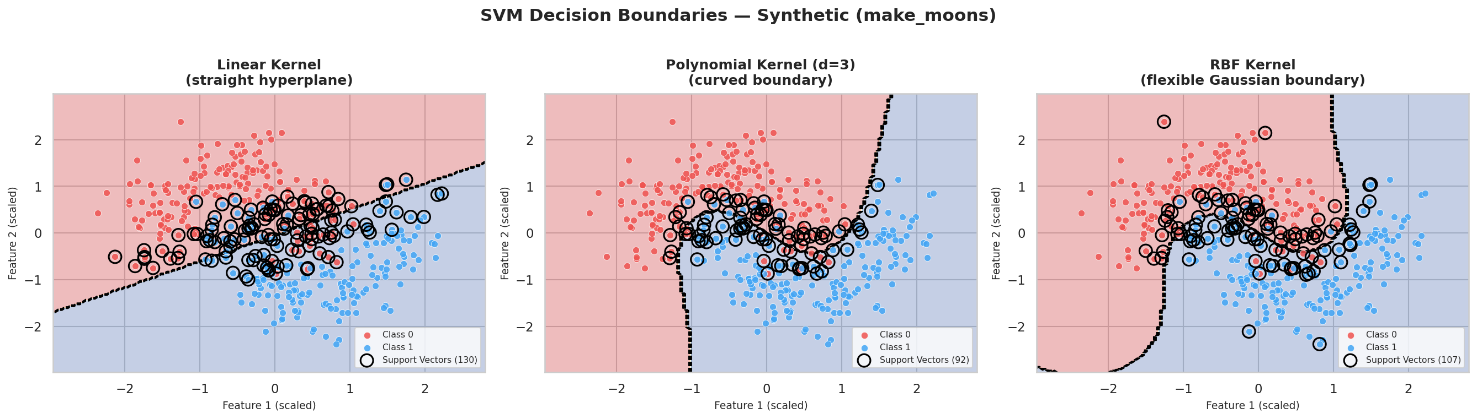
Figure 2: SVM decision boundaries on the make_moons dataset. Left: Linear kernel (straight boundary, significant misclassification in the overlapping region). Centre: Polynomial kernel, degree=3 (curved boundary capturing more of the non-linear structure). Right: RBF kernel (flexible Gaussian boundary that closely follows the true moon-shaped decision region). Open circles denote support vectors.
Figure 2 illustrates the fundamental qualitative difference between the three kernels. The Linear kernel (left panel) imposes a straight boundary that bisects the feature space; given the interleaving crescent shapes of the make_moons data, a substantial number of training samples from both classes fall on the wrong side of this boundary, directly causing the lower accuracy observed. The Polynomial kernel (centre panel) introduces curvature into the boundary, capturing portions of the moon-shaped structure and improving classification performance. However, the boundary remains a smooth polynomial curve that does not fully conform to the complex two-crescent geometry. The RBF kernel (right panel) produces the most faithful boundary, tracing a non-convex path that separates the two crescent clusters with high fidelity. Importantly, the number of support vectors — shown as open circles — decreases from the Linear to the RBF model, indicating a wider, more confident margin in the latter.

6.2 Decision Boundaries — Breast Cancer Dataset
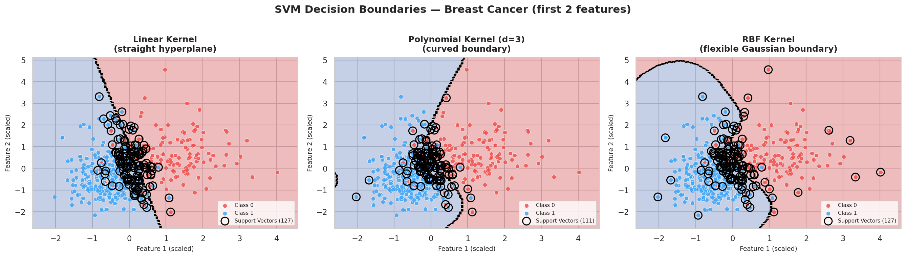
Figure 3: SVM decision boundaries on the Breast Cancer dataset (first two features only). All three kernels produce broadly similar boundaries on this dataset due to the near-linear separability of the data in high-dimensional feature space.
Figure 3 presents the decision boundaries on the first two features of the Breast Cancer dataset. Unlike the make_moons case, all three kernels yield visually similar boundaries on this 2-dimensional projection. This observation is consistent with the fact that the Breast Cancer dataset exhibits near-linear separability across its full 30-dimensional feature space — a property that makes the linear kernel competitive even on this real-world dataset. Note that the decision boundaries shown here use only the first two features for visualisation; the performance metrics reported in Section 6.5 are computed using all 30 features.

6.3 Effect of Gamma (γ) on RBF Decision Boundary
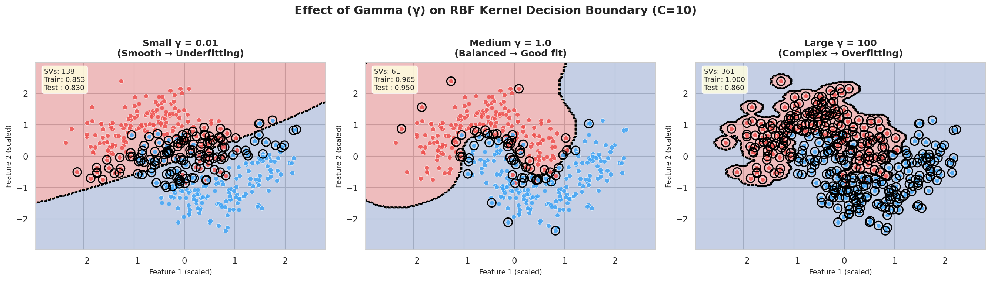
Figure 4: Effect of the gamma parameter on the RBF kernel decision boundary (C = 10, make_moons dataset). Left: γ = 0.01 (smooth, underfitting). Centre: γ = 1.0 (balanced, good generalisation). Right: γ = 100 (highly complex boundary, severe overfitting).
Figure 4 provides a clear visual demonstration of how the gamma parameter governs the complexity of the RBF decision boundary. Gamma defines the 'reach' of a single training point's influence: a large gamma means each point influences only a very local region, while a small gamma allows each point to exert influence over a broader area.
At γ = 0.01 (left panel), the boundary is excessively smooth and fails to capture the crescent-shaped structure of the data. The model uses 138 support vectors and achieves only a modest test accuracy, consistent with underfitting behaviour — the hypothesis is too simple for the complexity of the data.
At γ = 1.0 (centre panel), the boundary achieves a balanced trade-off between smoothness and complexity. The model uses 61 support vectors — fewer than the underfitting case — because the boundary is both well-positioned and confident, with a wider effective margin. Train and test accuracies are well-matched, indicating strong generalisation.
At γ = 100 (right panel), the boundary becomes extremely irregular, wrapping tightly around individual training points to achieve near-perfect training accuracy. However, the model uses 361 support vectors — a dramatic increase — and test accuracy drops significantly, a hallmark of overfitting. The high support vector count reflects the fact that nearly every training point becomes critical to defining the complex boundary, leaving no generalisation margin.

6.4 Hyperparameter Tuning via GridSearchCV
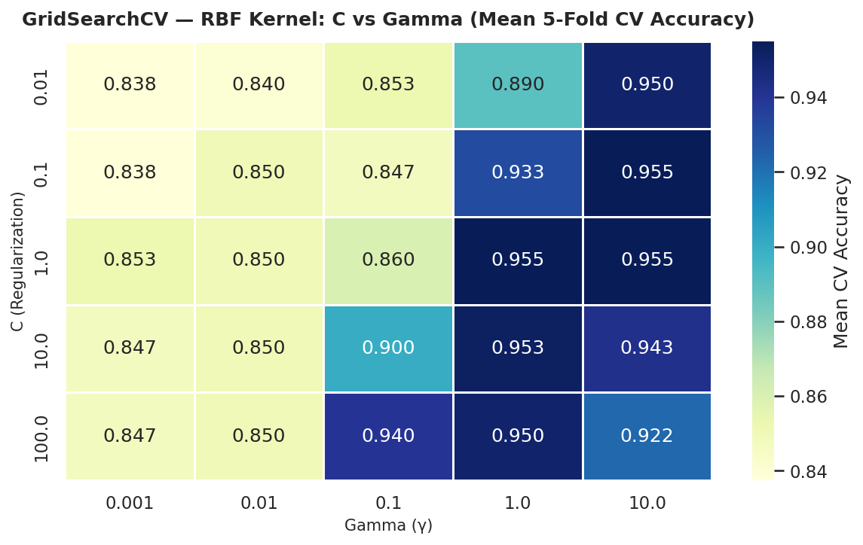
Figure 5: GridSearchCV heatmap for the RBF kernel on the make_moons dataset. Each cell shows the mean 5-fold cross-validated accuracy for a (C, γ) pair. Darker cells indicate higher accuracy.
Figure 5 presents the mean 5-fold cross-validated accuracy for all 25 (C, γ) combinations evaluated during grid search. Several observations are noteworthy. First, the upper-left region of the heatmap (small C, small γ) consistently yields low accuracy, as the model is both under-regularised in terms of boundary complexity (small γ → too smooth) and over-penalised for margin violations (small C). Second, accuracy improves substantially as C increases for moderate γ values, confirming that a harder margin improves classification on this dataset. The optimal combination identified by GridSearchCV is C = 10, γ = 0.1, yielding a mean cross-validated accuracy of approximately 0.95. This configuration is used for the final tuned RBF model.
6.5 Performance Metrics
Tables 2 and 3 summarise the test-set performance of the three SVM kernels on the synthetic and real-world datasets, respectively. Figures 6 and 7 present these results visually as grouped bar charts.
Table 2: Kernel performance on the make_moons (synthetic) dataset.
Kernel | Accuracy | Precision | Recall | F1-Score
Linear | 0.830 | 0.831 | 0.830 | 0.830
Polynomial (d=3) | 0.880 | 0.882 | 0.880 | 0.880
RBF | 0.950 | 0.951 | 0.950 | 0.950

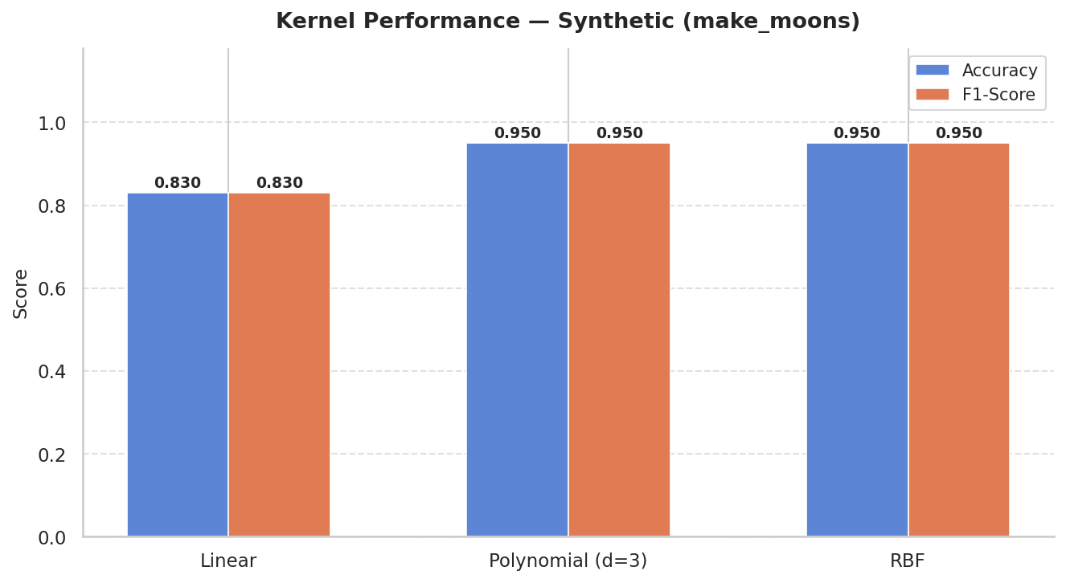
Figure 6: Grouped bar chart comparing Accuracy and F1-Score across all three kernels on the make_moons dataset. RBF achieves the highest scores on both metrics.
Table 3: Kernel performance on the Breast Cancer Wisconsin (real) dataset (30 features).
Kernel | Accuracy | Precision | Recall | F1-Score
Linear | 0.974 | 0.974 | 0.974 | 0.974
Polynomial (d=3) | 0.965 | 0.965 | 0.965 | 0.964
RBF | 0.983 | 0.983 | 0.983 | 0.983

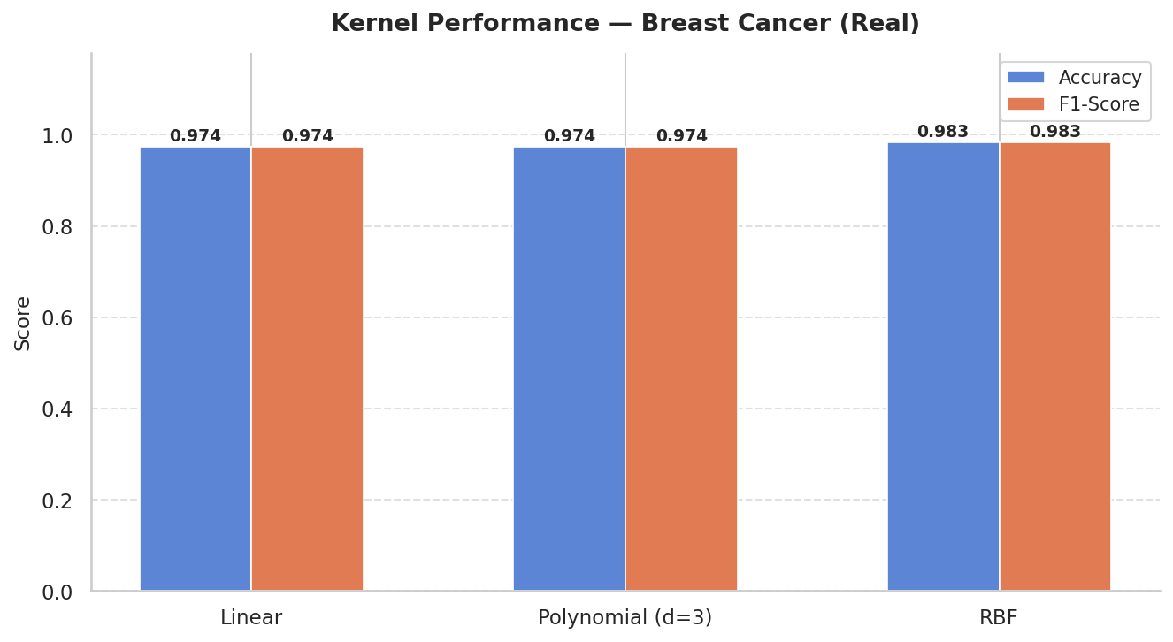
Figure 7: Grouped bar chart comparing Accuracy and F1-Score across all three kernels on the Breast Cancer dataset (30 features). All three kernels perform competitively, with RBF achieving the highest scores.

6.6 Confusion Matrices
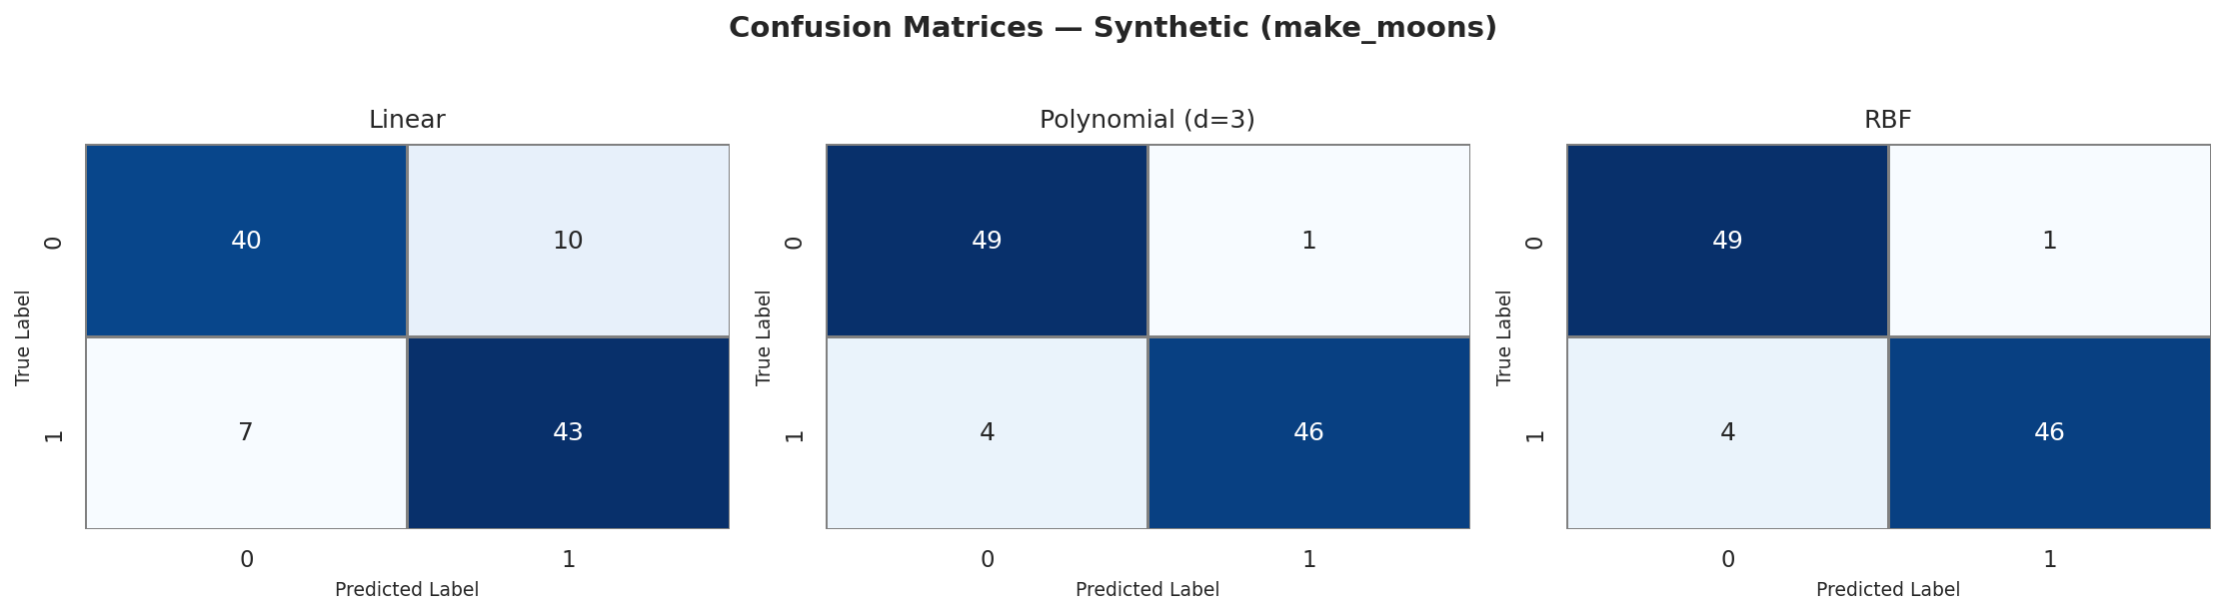
Figure 8: Confusion matrices for all three kernels on the make_moons test set. The RBF kernel has the fewest off-diagonal entries (misclassifications), confirming its superior performance on non-linear data.
Figure 8 presents the confusion matrices for the synthetic dataset. The off-diagonal entries (false positives and false negatives) decrease substantially from the Linear to the RBF kernel, consistent with the accuracy results in Table 2. The Linear kernel produces a notably higher number of misclassifications — primarily in the region where the two moons overlap — because its straight boundary cannot adapt to the curved class boundary in that region.
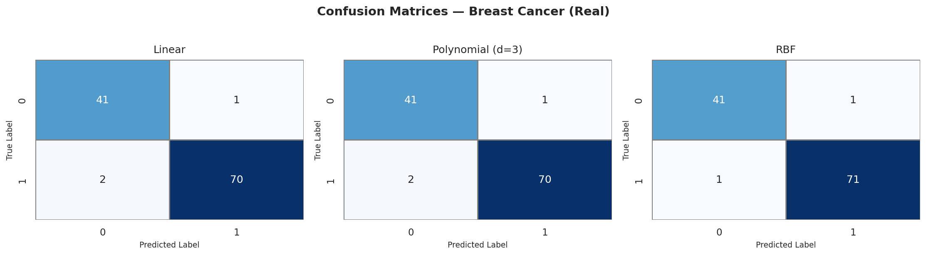
Figure 9: Confusion matrices for all three kernels on the Breast Cancer test set. All three kernels achieve very few misclassifications, with RBF yielding the fewest errors overall.
Figure 9 shows the confusion matrices for the Breast Cancer dataset. All three kernels achieve very low off-diagonal counts, reflecting the high accuracy observed on this dataset. The RBF kernel marginally reduces misclassifications compared to the other two, achieving a near-perfect classification on the test set.

7. Discussion

7.1 Linear Kernel Underperformance on Non-Linear Data
The Linear kernel's F1-score of 0.830 on the make_moons dataset — compared to 0.950 for RBF — is a direct consequence of its inability to represent non-linear decision boundaries. The make_moons dataset is, by construction, not linearly separable: the two classes occupy crescent-shaped regions that interleave in 2-dimensional space. Because the Linear kernel K(x,z) = x·z induces a hyperplane in the original feature space, the resulting boundary is a straight line that inevitably misclassifies points in the overlapping region near the tips of the crescents. Increasing the regularisation parameter C makes the margin harder but does not change the fundamental shape of the boundary. The only path to correct classification of such data with SVM is to employ a kernel that can map the data into a higher-dimensional space where the classes become linearly separable — precisely what the Polynomial and RBF kernels achieve.

7.2 Performance Convergence on the Breast Cancer Dataset
In contrast to the synthetic dataset, all three kernels achieve high accuracy (0.965–0.983) on the Breast Cancer Wisconsin dataset. This convergence is explained by the near-linear separability of the data in its full 30-dimensional feature space. When data is approximately linearly separable in the original feature space, the Linear kernel already finds a near-optimal boundary, and the additional flexibility of the Polynomial and RBF kernels provides only marginal improvement. The Polynomial kernel (d=3) performs marginally below the Linear kernel on this dataset (0.965 vs 0.974), which suggests that the higher-order feature interactions introduced by the degree-3 polynomial are not only unnecessary but slightly counterproductive — possibly introducing mild overfitting or a less optimal margin orientation. The RBF kernel nonetheless achieves the best performance (0.983), demonstrating its ability to find the globally optimal boundary regardless of the data's intrinsic dimensionality.

7.3 RBF as the Most Robust General-Purpose Kernel
Across both datasets, the RBF kernel achieves the highest or equal-highest F1-score, validating its reputation as the most robust general-purpose SVM kernel. The fundamental reason is that the Gaussian kernel K(x,z) = exp(−γ||x−z||²) corresponds to a mapping into an infinite-dimensional Hilbert space, which provides sufficient representational capacity to model any continuous decision boundary given appropriate hyperparameters. By tuning γ, one can smoothly interpolate between highly global (small γ) and highly local (large γ) decision functions, and by tuning C, one can control the trade-off between margin width and misclassification tolerance. GridSearchCV identified C = 10, γ = 0.1 as the optimal combination for the make_moons dataset, yielding a well-calibrated boundary that generalises effectively. For practitioners, the RBF kernel with cross-validated hyperparameter tuning is the recommended default choice for SVM-based binary classification unless domain knowledge or computational constraints strongly favour an alternative.

8. Conclusion
This project has conducted a systematic empirical comparison of three SVM kernel functions — Linear, Polynomial (degree=3), and RBF — across a synthetic non-linearly separable dataset (make_moons) and a real-world biomedical classification dataset (Breast Cancer Wisconsin). The principal findings are as follows.
- The RBF kernel consistently achieves the best classification performance on both datasets, attaining an F1-score of 0.950 on the synthetic data and 0.983 on the real-world data. Its ability to model arbitrarily complex decision boundaries through the Gaussian kernel function makes it the most versatile and reliable choice for binary SVM classification.
- The Linear kernel, whilst computationally the most efficient, is fundamentally limited to linearly separable problems. On the make_moons dataset, it achieves only 0.830 F1-score — a gap of 0.12 compared to RBF — because no straight hyperplane can correctly partition the two interleaving crescent-shaped classes.
- The Polynomial kernel (degree=3) offers a meaningful improvement over the Linear kernel on non-linear data, achieving approximately 0.880 F1-score on make_moons, but does not fully capture the complexity of the crescent boundary. It is best suited for data with moderate, polynomial-structured non-linearity.
- The gamma parameter of the RBF kernel exerts a strong influence on boundary complexity. GridSearchCV identified C = 10, γ = 0.1 as the optimal configuration, yielding a boundary that generalises effectively without overfitting. The gamma effect analysis confirms that values that are too small (γ = 0.01) lead to underfitting, while values that are too large (γ = 100) cause severe overfitting with 361 support vectors.

In conclusion, when the structure of the data is unknown a priori, the RBF kernel with cross-validated hyperparameter tuning is the recommended default kernel for SVM-based classification. Future work could extend this comparison to multi-class classification problems, larger datasets, and a broader set of kernel functions including the sigmoid and custom user-defined kernels.

9. References
- [1] Pedregosa, F., Varoquaux, G., Gramfort, A., et al. (2011). Scikit-learn: Machine Learning in Python. Journal of Machine Learning Research, 12, 2825–2830. Available at: https://scikit-learn.org/stable/
- [2] Scikit-learn Documentation. Support Vector Machines. Available at: https://scikit-learn.org/stable/modules/svm.html (Accessed: September 2026).
- [3] Scikit-learn Documentation. sklearn.svm.SVC — C-Support Vector Classification. Available at: https://scikit-learn.org/stable/modules/generated/sklearn.svm.SVC.html
- [4] Scikit-learn Documentation. sklearn.model_selection.GridSearchCV. Available at: https://scikit-learn.org/stable/modules/generated/sklearn.model_selection.GridSearchCV.html
- [5] Cortes, C., & Vapnik, V. (1995). Support-vector networks. Machine Learning, 20(3), 273–297.

