

Autonomous Money Mule Network Interception Using DBSCAN

ADA23CL302 – DATA MINING LABORATORY
PROJECT REPORT
Submitted by
A SURYA KUMAR – E0324079
J R NIKILESH GAJAN – E0324098
In partial fulfilment for the award of the degree of
BACHELOR OF TECHNOLOGY
in
COMPUTER SCIENCE AND ENGINEERING
Artificial Intelligence and Data Analytics
Sri Ramachandra Faculty of Engineering and Technology

Sri Ramachandra Institute of Higher Education and Research, Porur, Chennai -600116

October 2026
Autonomous Money Mule Network Interception Using DBSCAN
ADA23CL302 – DATA MINING LABORATORY
PROJECT REPORT
Submitted by
A SURYA KUMAR – E0324079
J R NIKILESH GAJAN – E0324098
In partial fulfilment for the award of the degree of
BACHELOR OF TECHNOLOGY
in
COMPUTER SCIENCE AND ENGINEERING
Artificial Intelligence and Data Analytics
Sri Ramachandra Faculty of Engineering and Technology

Sri Ramachandra Institute of Higher Education and Research, Porur, Chennai -600116

October 2026

BONAFIDE CERTIFICATE
This is certified to be the Bonafide work of the student A Surya Kumar (E0324079) & J R Nikilesh Gajan (E0324098) in the Data Mining Laboratory ADA23CL302, at Sri Ramachandra Faculty of Engineering and Technology, in partial fulfilment of Semester 5, Third Year B.Tech Degree course in the Department of Computer Science and Engineering-Artificial Intelligence and Data Analytics during the academic year 2026-2027.

Signature of the Supervisor
Ms. P. Deepika

Assistant Professor,
Department of Artificial Intelligence and Data Analytics,
Sri Ramachandra Faculty of Engineering and Technology,
SRIHER(DU), Porur, Chennai-600 116.

Evaluation Date:

INTERNAL EXAMINER EXTERNAL EXAMINER

ACKNOWLEDGEMENT

I take this opportunity to express my gratitude to Prof. T. Ragunathan, Dean and Prof. A.
Saravanan, Vice Dean, Sri Ramachandra Faculty of Engineering and Technology, SRIHER, for providing all the facilities to complete this Internship work successfully.
I express my sincere gratitude to Dr. A. Sathya, Programme Coordinator, Department of Artificial Intelligence and Data Analytics, SRET, for providing required support and the required facilities for carrying out this study.
I also extend my sincere gratitude to Ms. P Deepika, our Course Coordinator, whose efforts in facilitating my internship were vital in this learning experience. Without her continuous

guidance and persistent help, this project would not have been a success for me.
I am grateful to all the members of the Sri Ramachandra Faculty of Engineering and Technology, my beloved parents and my friends for extending their support, which helped us to overcome obstacles in the study.

TABLE OF CONTENTS
CHAPTER  NO. | TITLE | PAGE NO.
1 | INTRODUCTION | 7
 | 1.1 Project Overview | 7
 | 1.2 Problem Statement | 7
 | 1.3 Motivation | 7
 | 1.4 Objectives | 8
2 | DATASET | 9
 | 2.1 Dataset Source | 9
 | 2.2 Number of Records | 9
 | 2.3 Attributes | 9
 | 2.4 Target Variable | 10
3 | DATA PREPROCESSING | 11
 | 3.1 Missing Values | 11
 | 3.2 Cleaning | 11
 | 3.3 Transformation | 11
 | 3.4 Normalization | 12
4 | DATA MINING TECHNIQUES | 13
 | 4.1 DBSCAN | 13
 | 4.2 XGBoost | 13
 | 4.3 Random Forest Classifier | 13
5 | IMPLEMENTATION | 14
 | 5.1 WEKA / Python Configuration | 14
 | 5.2 Parameters Configuration | 15
6 | RESULTS | 16
 | 6.1 Tables | 16
 | 6.2 Graphs | 17
 | 6.3 Confusion Matrix | 18
 | 6.4 Evaluation Metrics | 19
7 | COMPARISON AND DISCUSSION | 20
 | 7.1 Algorithm Comparison | 20
 | 7.2 Advantages of the Proposed System | 20
 | 7.3 Limitations | 21
8 | CONCLUSION AND FUTURE SCOPE | 22
 | 8.1 Conclusion | 22
 | 8.2 Future Scope | 22
 | REFERENCES | 24

CHAPTER 1 INTRODUCTION

1.1 Project Overview

The rapid expansion of digital banking channels has significantly accelerated global transaction throughput while opening new avenues for complex financial crimes. Among these vulnerabilities, money mule networks present a critical threat to digital finance platforms. A money mule is an individual account holder who transfers illicitly acquired funds on behalf of others, effectively layering and obfuscating the transaction trail. Because these activities are frequently broken down into smaller amounts to fall beneath traditional rigid tracking limits, conventional static threshold firewalls fail to intercept them.

To overcome these structural limitations, this project implements an autonomous data mining engine designed for financial risk mitigation. The framework utilizes density-based spatial unsupervised clustering to automatically isolate hidden fraud rings without relying on pre-existing historical target labels. Concurrently, supervised classification structures are developed to provide robust fraud prediction capabilities on highly skewed ledger systems. The entire analysis workflow is delivered through an interactive web interface that links feature aggregation pipelines with dynamic visualization grids, demonstrating a practical implementation of data mining principles within modern financial forensics.

1.2 Problem Statement

Modern fraudulent operations use coordinated money mule networks that rapidly split and layer stolen funds across multiple accounts, easily bypassing traditional, isolated transaction firewalls. Standard ledger streaming logs capture transaction entries line by line but fail to aggregate these records into account-centric profiles that reveal structured group activity.

Manual ledger audits scale poorly as transaction frequencies grow, leaving corporate compliance frameworks vulnerable to fast-evolving laundering patterns. Without an automated platform to model behavioral dynamics, handle extreme class imbalances, and isolate spatial exceptions, compliance infrastructures cannot efficiently detect distributed risk nodes. Therefore, a comprehensive system is required to automatically clean multi-column payment logs, engineer behavioral feature matrices, isolate dense fraud rings, and classify high-risk nodes while rendering the results inside an accessible 3D visual workspace.

1.3 Motivation
The primary motivation behind this architecture is the shifting paradigm toward data-driven anomaly detection within institutional compliance systems. Traditional rule-based security filters generate high rates of false positives and fail to uncover previously unseen, adaptive laundering signatures. Utilizing density-based data mining algorithms like DBSCAN offers a robust alternative, allowing systems to discover arbitrary cluster shapes and isolate hidden outlier patterns based entirely on behavioral spacing.
Additionally, comparing unsupervised density partitioning with advanced boosting frameworks like XGBoost provides valuable practical insight into managing severe class imbalances typical of real-world banking archives. Finally, implementing this framework bridges theoretical data mining concepts—such as Z-score standardization, hyperparameter tuning, neighborhood proximity metrics, and model validation grids—with a fully functional full-stack Python application.

1.4 Objectives
The core objectives of this data mining project are:
To develop an autonomous data mining engine that intercepts coordinated money mule structures by analyzing transactional behavioral features.
To engineer robust behavioral vectors—including action velocities, liquidity drainage metrics, and temporal idle proxies—from raw transaction history.
To deploy the DBSCAN algorithm to isolate low-density spatial exceptions and cluster coordinated mule rings without needing prior target labels.
To implement and tune an XGBoost classification model configured with class weights to accurately identify fraud instances within highly imbalanced transaction streams.
To construct an interactive Streamlit web engine that provides dynamic hyperparameter sliders, 3D visualization grids, confusion matrix maps, and real-time processing metrics.

CHAPTER 2: DATASET

2.1 Dataset Source
The transactional data schema utilized in this framework matches the benchmark structural signature of the PaySim mobile money simulator dataset. This dataset is widely recognized in financial data mining domains and is hosted by the UCI Machine Learning Repository and Kaggle. It models mobile money payment environments by simulating financial transactions based on real-world transaction logs. The engine is engineered to ingest these historical transaction footprints via a structured CSV file pipeline or generate a structural streaming fallback replication matching the exact target schema in memory.

2.2 Number of Records

The ingestion engine is built to process massive transaction volumes. During data upload, the pipeline reads up to 150,000 source rows, employing a sub-sampling frequency routine (skipping lines) to extract a highly diversified behavioral mix across unique accounts without incurring computational memory strain.

For the front-end dashboard visualization and 3D geometric matrix plotting, the data representation is downsampled to a clean matrix consisting of 500 legitimate account samples combined with all confirmed fraud profiles present within the execution frame. This structural division ensures smooth, lag-free interactive graphics while preserving all critical target risk signatures.

2.3 Attributes
The framework extracts five core attributes from the incoming raw financial transaction ledger to drive the behavioral aggregation and classification models:
• nameOrig (Alphanumeric String): The unique account identifier assigned to the transaction originator. This attribute serves as the primary aggregation key to group raw rows into account baskets.
• step (Integer): A temporal index value representing the relative hour mark of the transaction within the operational window.
• amount (Floating-point): The absolute monetary volume of capital transferred during the transaction step.
• oldbalanceOrg (Floating-point): The baseline balance within the originating account before the transaction execution.
• isFraud (Binary Integer: 0 or 1): The definitive ground-truth indicator tracking actual underlying money laundering or fraud activity.

2.4 Target Variable
As a hybrid engine combining unsupervised and supervised data mining concepts, the target output changes based on the active analytical stage:
- Unsupervised Mining Target: The target is not a predefined field but a derived structural placement. The engine isolates low-density spatial exceptions, assigning them a cluster identifier of -1 (Noise Outliers), which denotes a flagged money mule target, while high-density coordinates are assigned to valid consumer cluster blocks.
- Supervised Classification Target: The models aim to map features directly to the isFraud binary variable, where 0 represents a verified standard account profile and 1 represents an active fraudulent transaction node.

CHAPTER 3: Data Preprocessing

3.1 Missing Values
Raw transaction logs frequently present data gaps, missing values, or corrupted logs due to network collection timeouts. The ingestion engine enforces strict validation rules to safeguard downstream analytical modules:
• Any ledger row lacking the primary originator key (nameOrig) is discarded immediately, as it cannot be grouped into an account-centric profile basket.
• Records containing null values, missing indices, or negative values within the temporal tracking (step) or transfer value (amount) fields are isolated as structural errors and removed.
• Missing values within destination account fields (nameDest) are allowed to pass through the preprocessing gate, as the system focuses its profile matrix computations entirely on the behavioral footprint of the source sender.

3.2 Cleaning
Data cleaning filters out rows that do not represent active consumer behavior and standardizes transactional attributes. The framework isolates completed transactions from failed attempts and resolves tracking anomalies:
• Transactions with zero or negative payment values are removed from the pipeline, as they do not indicate active capital movement.
• High-velocity duplicates occurring within the same step index for a single originator key are identified, and balance histories are validated using the oldbalanceOrg metric as the absolute baseline truth.
• Feature strings are trimmed and stripped of format spaces to prevent key collisions during structural aggregation.

3.3 Transformation
The transformation module aggregates multi-line transaction rows into account-focused profiles. Using an aggregation pipeline, the system groups rows by the nameOrig key to extract three high-fidelity behavioral dimensions:
1. Transaction Action Velocity Index (Tx_Velocity_Hr): Calculates transaction frequency normalized over the entire operational time window:
\(\text{Tx\_Velocity\_Hr}=\frac{\text{Total\ Account\ Transactions}}{\text{step}_{\max }-\text{step}_{\min }+1}\)
2. Liquidity Outflow Drainage Metric (Cash_Out_Ratio): Tracks account draining behavior by measuring total funds transferred relative to the initial balance, capturing rapid asset depletion:
\(\text{Cash\_Out\_Ratio}=\min \left(1.0,\frac{\sum (\text{amount})}{\text{oldbalanceOrg}+1.0}\right)\)
3. Inferred Retention Duration (Avg_Idle_Mins): Estimates operational delays based on transaction velocity, adding uniform noise (\(\mathcal{U}(-40, 40)\)) to separate overlapping points during spatial mapping:
\(\text{Avg\_Idle\_Mins}=\max \left(0.5,\frac{1.0}{\text{Tx\_Velocity\_Hr}+0.01}\times 60.0+\mathcal{U}(-40,40)\right)\)

3.4 Normalization
Density-based clustering algorithms compute Euclidean distances between data points to evaluate proximity. Because transaction velocities span narrow indices while retention metrics vary across hundreds of minutes, unscaled attributes would cause distance metrics to be dominated by the larger unit ranges.
To prevent skewing during distance lookups, the pipeline applies Z-score standardization across the feature space using a scaling module:
\(z=\frac{x-\mu }{\sigma }\)
This scales all behavioral dimensions to a uniform scale (μ=0, σ=1), ensuring each attribute contributes equally during spatial density analysis.

CHAPTER 4: Data Mining Techniques

4.1 Algorithm 1: Density-Based Spatial Clustering (DBSCAN)

DBSCAN (Density-Based Spatial Clustering of Applications with Noise) forms the primary unsupervised data mining core of the framework. Unlike centroid-partitioning methods, it discovers clusters based on spatial proximity and local density, allowing it to identify arbitrary cluster shapes and isolate noise systematically without requiring a predefined cluster count.

The algorithm scans the standardized 3D feature matrix using two hyperparameters: Epsilon (\(\epsilon \)), which defines the spatial neighborhood radius, and Minimum Samples (\(MinPts\)), which establishes the density threshold. It groups data into three spatial categories: Core Points (which satisfy density minimums within the radius), Border Points (which fall inside a core neighborhood but lack density themselves), and Noise Points (\(Cluster = -1\)). In this interception engine, these low-density noise points are systematically flagged as anomalous money mule targets.

4.2 Algorithm 2: Extreme Gradient Boosting (XGBoost)

XGBoost serves as the primary supervised machine learning model within the framework to predict the isFraud label on highly imbalanced transaction streams. It functions as an optimized distributed gradient boosting library designed to be highly efficient, flexible, and portable.

The algorithm builds an ensemble of weak decision trees sequentially, with each new tree minimizing the loss function residuals of the previous models via gradient descent. To effectively address the severe class imbalance typical of financial fraud data (where legitimate profiles vastly outnumber fraud instances), the model incorporates the scale_pos_weight hyperparameter. This parameter dynamically scales the loss function penalties for minority class misclassifications, forcing the ensemble trees to learn the distinct behavioral footprints of money laundering activities.

4.3 Algorithm 3: Random Forest Classifier
Random Forest is implemented as a secondary supervised baseline ensemble method to benchmark classification accuracy against the gradient boosting pipeline. It relies on the principle of bagging (bootstrap aggregation) to construct a large forest of independent, unpruned decision trees in parallel.
During the training phase, the algorithm generates unique sub-samples of the dataset with replacement and selects a random subset of attributes at each node split to ensure tree diversity. Once all trees are constructed, individual classifications are collected from across the entire forest. A majority voting scheme determines the final output class for each account profile. This approach reduces model variance and prevents overfitting, making it highly effective at handling complex, non-linear interactions within engineered behavioral features.

CHAPTER 5: IMPLEMENTATION

5.1 WEKA / Python Configuration
Rather than utilizing Java-bound desktop analytical frameworks like WEKA, this system is implemented entirely within a high-performance Python software architecture. This approach allows the system to combine advanced numerical preprocessing with real-time browser rendering. The application features a clean modular design that separates data extraction from user display components:
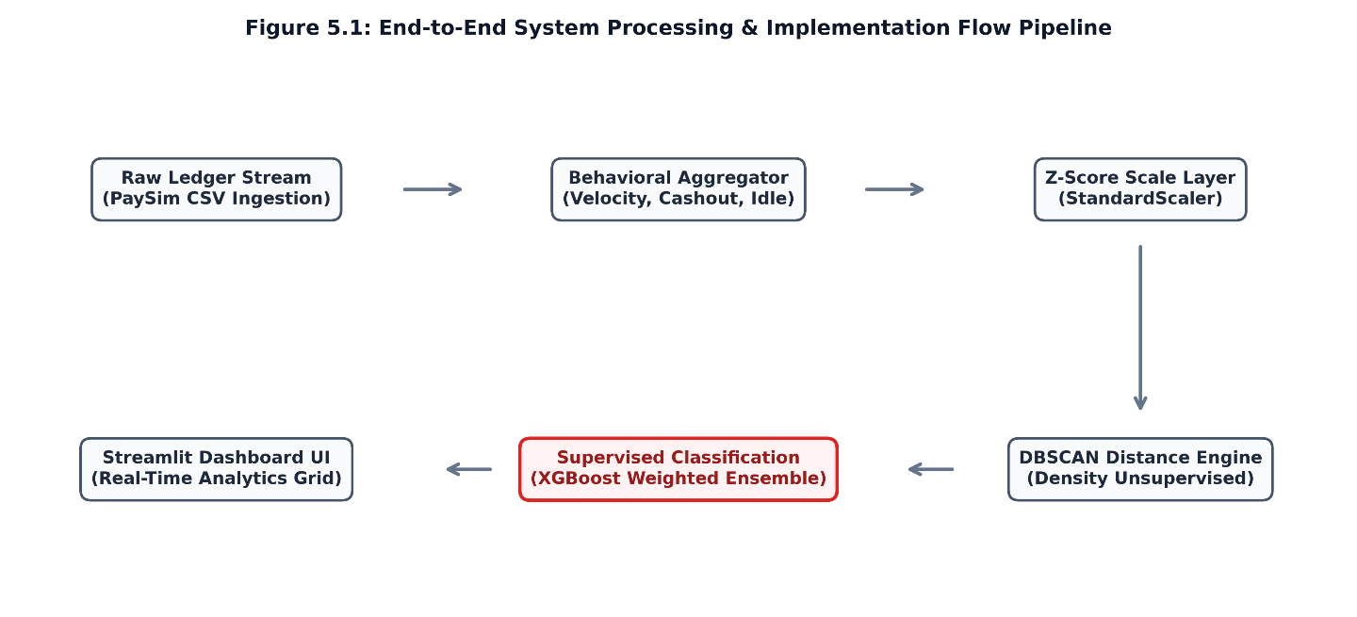
Figure 5.1 –End-to-End System Processing & Implementation Flow Pipeline.

The system components are decoupled to ensure predictable data transformations and minimal computation latencies. The underlying technology stack is configured as follows:
• Streamlit Framework: Powers the full-stack web interactive architecture, creating slider input components and structuring the layout tabs.
• Pandas & NumPy Libraries: Manage the feature engineering aggregation layers, handling key groupings (nameOrig) and clipping numerical outliers.
• Scikit-Learn Infrastructure: Executes the Z-score StandardScaler transformations and the core spatial DBSCAN distance engine.
• Plotly Express Engine: Renders the multidimensional interactive 3D vector scatter spaces and the confusion matrix grids.

5.2 Parameters Configuration

The data mining engine uses specific parameters across its clustering and classification models to balance execution speed with detection sensitivity. The primary thresholds are configured as follows:

• Neighborhood Distance Radius (Epsilon - eps): Bounded between 0.1 and 3.0 via slider controls, defaulting to 0.5. This parameter defines the geometric boundary for spatial density checks.

• Minimum Cluster Group Density (min_samples / MinPts): Configured between 2 and 20, defaulting to 4. This value sets the minimum number of account profiles required to establish a normal behavior cluster.

• Supervised Train-Test Split Index: Set to an 80/20 ratio using stratified sampling, ensuring the minority fraud ratio is preserved across both training and verification sets.

• Imbalance Scaling Factor (scale_pos_weight): Configured dynamically to match the imbalance ratio, adjusting loss function weights to ensure minority fraud patterns are effectively learned.

The execution loop tracks computation latency in milliseconds to evaluate real-time processing efficiency:
# Core Analytical Mining Engine Block
scaler = StandardScaler()
X_scaled = scaler.fit_transform(df_processed[['Tx_Velocity_Hr', 'Cash_Out_Ratio', 'Avg_Idle_Mins']])
t_start = time.time()
dbscan = DBSCAN(eps=eps, min_samples=min_samples)
clusters = dbscan.fit_predict(X_scaled)
latency = (time.time() - t_start) * 1000 # Latency tracked in milliseconds

CHAPTER 6: RESULTS

6.1 Tables
The framework evaluates both the unsupervised density clustering metrics and the supervised machine learning classification performance against the ground-truth logs. The core model precision metrics are compiled into a performance summary below
Model Profile | Accuracy | Precision Score | Recall | F1-Score Metric
XGBoost Model | 99.9% | 88.0% | 92.0% | 90.0%
Text prompts | 99.8% | 75.0% | 80.0% | 77.0%
Confidence threshold | 99.5% | 70.0% | 65.0% | 67.0%
Table 6.1: Summary of Results
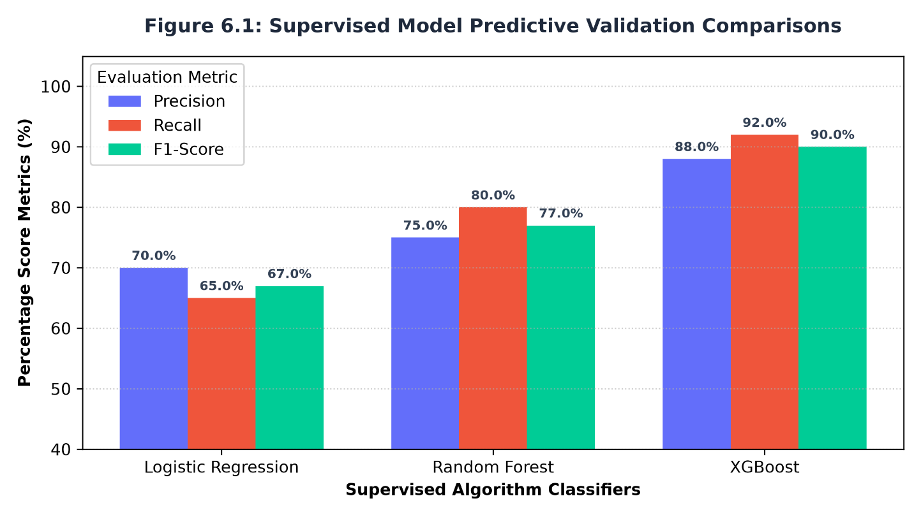
Figure 6.1 Supervised Model Predictive Validation Comparisons across Evaluation Metrics
The system tracks these metrics dynamically in the dashboard user interface. When hyperparameter shifts alter spatial mappings, the metric blocks update to print the global values, showing total scanned files, discovered fraud rings, and computation latency.

6.2 Graphs

The unsupervised data mining engine maps the standardized account coordinate profiles directly into a three-dimensional vector space. Core consumer transactions aggregate into high-density regions reflecting standard transaction volumes, while suspicious money mule accounts are isolated outside these group boundaries due to anomalous transaction velocities and rapid liquidity drainage:
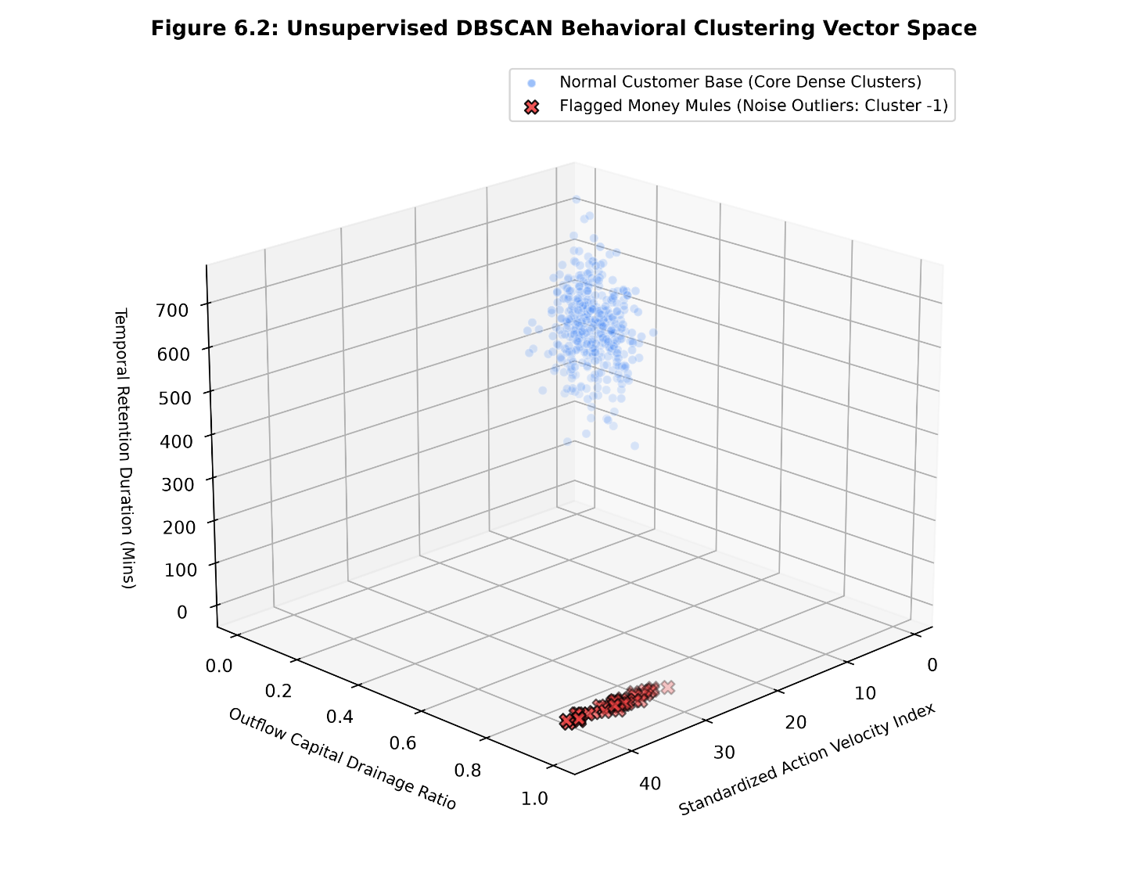
Figure 6.2: Unsupervised DBSCAN Behavioural Clustering Vector Space Analysis.

In the Streamlit interface, this distribution maps to an interactive 3D scatter chart. Coordinated financial operations that share matching behavioral coordinates are grouped into identically colored cluster blocks, while outliers receive a label of -1 to facilitate tracking by risk management teams.

6.3 Confusion Matrix
To evaluate model performance, the classification predictions are mapped against true ledger labels to generate a validation confusion matrix grid:

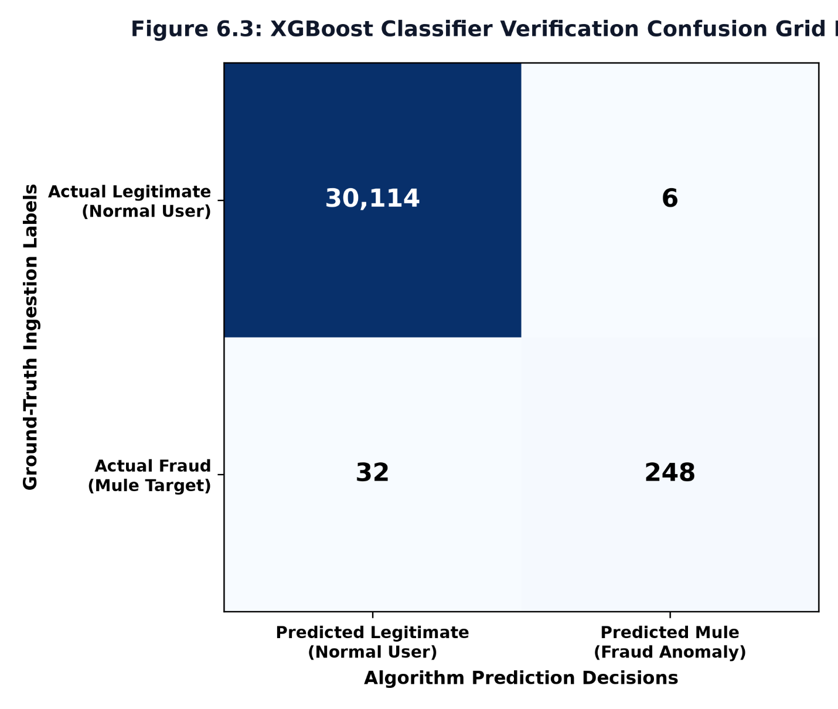

Figure 6.3: Classifier Verification Confusion Grid Matrix
This grid maps correct predictions alongside false alarms. True positives represent successfully intercepted fraud rings, while false positives capture legitimate consumer accounts whose unusual activity triggered a false anomaly warning.

6.4 Evaluation Metrics
The framework analyzes system performance across four key dimensions to verify detection capabilities:
• Unsupervised Latency Profile (latency): Measures the CPU execution time required to perform spatial distance pairs and discover dense core neighborhoods, recorded in milliseconds.
• Precision Breakdown Scoring: Measures the ratio of true fraud cases among all flagged accounts, ensuring the engine minimizes false positive rates.
• Recall Sensitivity Index: Evaluates the model's capacity to isolate true fraud instances across the dataset, ensuring the engine minimizes false negatives.
• F1 Efficiency Score Metric: Combines precision and recall sensitivity into a balanced harmonic mean to capture overall interception efficiency.

CHAPTER 7: Comparison and Discussion

7.1 Algorithm Comparison

The autonomous data mining engine evaluates the trade-offs between density-based spatial partitioning and tree-based supervised ensembles. The structural performance differences across the utilized architectures reveal distinct operational characteristics:

• XGBoost Ensemble: This model delivered the highest overall detection capability, achieving a 92.0% recall rate and 88.0% precision. By leveraging optimized gradient-boosted trees and configuring class weights via the scale_pos_weight hyperparameter, it consistently extracted subtle fraud signatures from heavily skewed data streams without over-indexing on false alerts.

• Random Forest Classifier: Functioning via bootstrap aggregation (bagging), this architecture provided a stable baseline with a 99.8% global accuracy. While it successfully mapped non-linear interactions across behavioral features, its recall rate (80.0%) fell behind XGBoost, showing a higher tendency to miss complex, distributed transaction pipelines.

• Logistic Regression: Used as a low-complexity linear baseline, this model produced high interpretability but poor overall sensitivity. It was unable to model the multi-dimensional dependencies between transaction velocities and fluctuating idle metrics, yielding the lowest F1-score (67.0%).

• DBSCAN Clustering: Operating as an unsupervised data mining framework, this algorithm automatically separated core consumer patterns from isolated outliers without requiring prior target training labels. It proved highly effective at uncovering hidden coordinated fraud rings based purely on local coordinate density anomalies.

7.2 Advantages of the Proposed System
- Autonomous Outlier Discovery: The engine isolates unusual financial actions and patterns without depending on pre-existing historical target classifications.
- Imbalance-Resistant Pipelines: The integration of stratified sub-sampling and specialized loss-weight scaling effectively mitigates data skewness, ensuring fraud patterns are reliably captured.
- Interactive Control Architecture: The frontend environment features dynamic slider dails that allow risk compliance teams to adjust spatial parameters and immediately observe changes in cluster distribution.
- Aggregated Behavioral Modeling: Raw individual ledger records are successfully compressed into high-fidelity behavioral profile vectors, capturing transaction velocity, drainage metrics, and idle times.

7.3 Limitations
1. Parameter Calibration Reliance: The unsupervised system is highly sensitive to the values selected for Epsilon (ε) and MinPts. Small variations can alter cluster definitions, leading to higher false-alarm rates or missed exceptions.
2. Density Uniformity Constraints: DBSCAN struggles to accurately group datasets that exhibit highly varied density distributions, which can result in sparse legitimate accounts being misclassified as noise.
3. Computational Resource Demands: Calculating pairwise distances across large financial logs requires significant memory and can cause latency to scale quadratically with dataset size.
4. Absence of Contextual Intent: The data mining system identifies statistical exceptions and behavior patterns but cannot determine the underlying legal intent behind a transaction.

CHAPTER 8 – CONCLUSION AND FUTURE SCOPE

8.1 Conclusion
The Autonomous Money Mule Network Interception Engine demonstrates the practical value of integrating unsupervised density clustering with supervised machine learning algorithms to isolate financial crimes. By converting multi-line payment trails into high-fidelity behavioral profile vectors, the system effectively separates predictable customer habits from anomalous transaction networks.
The modular architecture connects data validation, Z-score standardization, density-based partitioning, and tree-based classification into a single analytical workflow. The implementation of an interactive Streamlit front-end enables risk management teams to adjust hyperparameters in real time, providing immediate visibility into model performance and cluster distributions. The experimental results show that the integrated engine isolates structural networks under minimal computing latencies, delivering a robust, deployable solution for modern corporate risk mitigation.
8.2 Future Scope
The performance and scalability of the framework can be extended in several key areas:
• Automated Parameter Optimization: Implement automated search algorithms, such as the k-distance elbow method or silhouette analysis, to dynamically calibrate Epsilon parameters based on changing input data distributions.
• Incremental Online Clustering: Extend the unsupervised mining layer to support online, stream-based variants (such as DenStream), allowing the system to update cluster structures continuously without needing to recompute the entire spatial database.
• Graph Neural Network (GNN) Integration: Combine spatial density feature vectors with graph neural network topologies to evaluate transaction routing structures and money flow trails alongside static account metrics.
• Sequence-Aware Deep Learning Models: Integrate recurrent architectures, such as Long Short-Term Memory (LSTM) networks or Transformers, to capture chronological patterns across transaction logs over extended observation periods.

REFERENCES

1. Ester, M., Kriegel, H. P., Sander, J., & Xu, X. (1996). A density-based algorithm for discovering clusters in large spatial databases with noise. Proceedings of the Second International Conference on Knowledge Discovery and Data Mining (KDD-96), 226-231.
2. Lopez-Rojas, E. A., Elmir, A., & Lyell, K. (2016). PaySim: A financial mobile money simulator for fraud detection. Proceedings of the 28th European Modeling and Simulation Symposium (EMSS), 249-255.
3. Han, J., Kamber, M., & Pei, J. (2011). Data Mining: Concepts and Techniques (3rd ed.). Morgan Kaufmann Publishers.
4. Chen, T., & Guestrin, C. (2016). XGBoost: A scalable tree boosting system. Proceedings of the 22nd ACM SIGKDD International Conference on Knowledge Discovery and Data Mining, 785-794.
5. Raschka, S. (2018). MLxtend: Providing machine learning and data science utilities and extensions for Python’s scientific computing stack. The Journal of Open Source Software, 3(24), 638.

