Certificate of Originality
This is to certify that the project report entitled "Hotel Room Booking Website with Assistant Chatbot" submitted to Indira Gandhi National Open University (IGNOU) in partial fulfilment of the requirements for the award of the degree of Bachelor of Computer Applications (BCA) is an original piece of work carried out by Mr. Nikhil.P.N, bearing Enrolment Number 2350526613, under the guidance of Mrs. Anjali.v
The matter embodied in this project report is a genuine work done by the student and has not been submitted in part or in full, whether to this University or to any other University or Institute, for the fulfilment of the requirement of any course of study.
It is further certified that the student has fulfilled all the conditions of eligibility for submitting the project report.
Signature of the Student  Name & Address of the student  Name: Nikhil P N  Pokkaruparambil(H),  Thanissery.p.o  Irinjalakuda,  Pin:680701 | Signature of the Guide  Name,Designation Address of the Guide  Name: Anjali V  Designation:Senior Software Engineer  Vattaparambath House Kaipilly,Ringroad Arimpur.P.O,  Thrissur
Acknowledgement
I would like to express my sincere gratitude to Indira Gandhi National Open University (IGNOU) for providing me with the opportunity to undertake this project as part of the BCA programme. The knowledge and skills gained during study have been instrumental in the successful completion of this project.
I am deeply indebted to my project guide, Mrs Anjali V, whose valuable guidance, constant encouragement, and constructive suggestions throughout the duration of this project enabled me to complete it successfully. Their expertise in the field of computer science and willingness to spare their valuable time has been immensely helpful.
I extend my heartfelt thanks to the IGNOU Cochin Regional Centre and my Study Centre for their administrative support and for ensuring the smooth progression of my academic journey throughout the BCA programme.
I also wish to acknowledge my gratitude to all the faculty members of the School of Computer and Information Sciences, IGNOU, whose teachings in subjects like Database Management Systems, Internet Technology, Software Engineering, and Web Programming have provided me with the theoretical foundation and practical skills necessary for this project.
I am also thankful to the open-source community, the developers of the Django framework, the Python programming language, and the various libraries and tools (Razorpay, xhtml2pdf, Bootstrap) used in this project. Their freely available documentation, tutorials, and forums have been invaluable resources.
Finally, I express my deepest gratitude to my family and friends for their constant moral support and encouragement throughout the period of this project work.
Nikhil P N
Enrolment No: 2350526613
BCA - 6th Semester IGNOU Cochin Regional Centre
Abstract
The Hotel Room Booking Website with Assistant Chatbot is a comprehensive full-stack web application developed using Python, the Django 6.0 web framework, and a PostgreSQL relational database. The system automates end-to-end hotel operations including room-type management, room inventory control, customer registration, online room booking with date-based availability checking, payment processing through the Razorpay payment gateway, staff administration, customer contact handling, email notifications, PDF report generation, and an intelligent assistant chatbot that answers guest queries about rooms, bookings, staff, and hotel policies.
The project follows the Software Development Life Cycle (SDLC) and encompasses all the major phases: Requirements Analysis, System Design, Coding, Testing, and Documentation. It consists of eight functional modules spanning both the administrator backend and the customer-facing website and exposes RESTful API endpoints for the chatbot and advanced search features. The application is fully responsive and works seamlessly across desktop computers, tablets, and mobile devices.
The administrator can manage room types, rooms, staff profiles, customer enquiries, bookings, payments, chatbot responses, and notifications from a secure backend interface. Customers can register, sign in, browse rooms by category, search with advanced filters (room type, price range, dates), book available rooms with automatic overlap detection, make secure online payments via Razorpay, interact with the chatbot for instant assistance, submit contact enquiries, and reset their passwords using email-based OTP verification.
The system stores data in a normalized relational database with ten interconnected tables and enforces referential integrity through primary-key and foreign-key constraints.
Keywords: Hotel Room Booking, Django, Python, PostgreSQL, Chatbot, Razorpay, AJAX, Bootstrap, SDLC.
Table of Contents
CHAPTERS PAGE.NO

- Introduction 6.
  - Overview
  - Problem Statement
  - Solution to the Problem
  - Existing System
  - Objectives
- Tools and Environment Used 12.
  - Programming Languages and Libraries
  - Tools
- Requirement Specification 15.
  - Overall Description
  - Specific Requirements
  - Use Case Diagram
- Design Document 24.
  - Modularization Details
  - Procedural Design
  - User Interface Design
  - Database Design
- Program Code 30.

- Testing 37.
  - Unit Testing
  - Integration Testing
  - Code Improvement

- Input Output Screens 42.

This section presents key user interface screens from the running application.

7.1 Homepage
The homepage displays room type category cards in a responsive grid layout with a fixed-top navigation bar. Each card shows an image, room type name, and description.

7.2 About Page
The About page presents hotel information, history, and values in a professional layout with text and images.

7.3 Team Page
Staff profiles displayed in Bootstrap cards with photographs, names, designations, and social media links to build customer trust.

7.4 Room Listing
Available rooms shown with images, names, type badges, prices, descriptions, and Book Now buttons in an adaptive grid layout.

7.5 Booking Form
Captures check-in/out dates, guest counts, and special requests with date-overlap detection preventing double booking.

7.6 Login and Registration
Authentication system with sign-in, registration, and email-based OTP password reset functionality.

7.7 Admin Dashboard
Secure backend with sidebar navigation to all management modules including room types, rooms, staff, bookings, payments, and contacts.

7.8 Admin Management Screens
Room type CRUD (add/edit/delete categories), Room CRUD (manage individual rooms with type selection), Staff CRUD (manage personnel profiles), Booking Records viewer, and Payment Records viewer - all with tabular data displays.

- Implementation Plan 49.

- Limitations of the Project 51.

10. Future Application of the Project 52.
11. Conclusion 53.

12. Bibliography 54.
1. Introduction
1.1 Overview
The hospitality industry is one of the largest and fastest-growing sectors of the global economy. Hotels, resorts, and guest houses serve millions of travellers every day and face the critical challenge of efficiently managing room inventory, customer bookings, payments, and guest communication. In many small and medium-sized hotels, especially in developing countries, room booking and management are still done using manual methods such as paper-based registers, phone-based reservations, and disconnected spreadsheets. These traditional approaches have numerous disadvantages including the risk of duplicate bookings, inaccurate room availability records, delayed guest communication, data loss, and difficulty in generating financial and occupancy reports.
With the advent of the internet and web technologies, customers increasingly expect the ability to search for rooms, compare prices, check availability in real time, and make bookings and payments online without visiting the hotel in person or calling the front desk. Hotels that fail to provide an online presence with booking capabilities risk losing customers to competitors who do. Furthermore, the increasing use of chatbots and AI-powered assistants in customer service has raised guest expectations for instant, 24/7 responses to common questions about room availability, pricing, check-in/check-out times, and hotel policies.
The Hotel Room Booking Website with Assistant Chatbot is a full-stack web application built with Python and the Django 6.0 framework following the MVT (Model-View-Template) architecture. It provides a unified platform for both hotel administrators and customers. Administrators can manage room types, rooms, staff, bookings, payments, and customer enquiries through a secure backend interface. Customers can browse rooms, search with advanced filters, book rooms, make payments via Razorpay, interact with an AI-powered chatbot, and reset passwords via email OTP. The system also generates PDF booking receipts and sends automated email confirmations.
1.2 Problem Statement
Many small and medium-sized hotels in developing countries still manage room bookings using manual methods such as paper registers, phone-based reservations, and disconnected spreadsheets. These traditional approaches suffer from several critical disadvantages:
- Double Booking Risk: Without real-time availability checking, two or more guests may be booked for the same room on overlapping dates, leading to embarrassing situations and guest dissatisfaction.
- Inaccurate Records: Guest information, room details, and booking records may be duplicated across multiple registers or spreadsheets, leading to inconsistencies.
- Slow Retrieval: Searching for a specific booking, guest record, or payment history in a paper register or large spreadsheet is time-consuming and error prone.
- No Online Presence: Many small hotels do not have a website or online booking system. Customers must visit in person or call, limiting the hotel's customer reach.
- No Automated Communication: Booking confirmations, reminders, and other communications are sent manually. There is no system for sending confirmation emails, OTPs, or notifications.
- No 24/7 Assistance: Without a chatbot or automated FAQ system, guest enquiries can only be answered during front-desk working hours.
- Delayed Payment Processing: Payments are typically collected at check-in or check-out in cash. There is no facility for advance online payment.
- Difficult Reporting: Generating summary reports for occupancy rates, revenue, or demographics is extremely labour-intensive.

1.3 Solution to the Problem
The proposed solution is a web-based Hotel Room Booking System with the following key features:
- Centralized Database: A PostgreSQL relational database storing all hotel data in normalized tables with referential integrity, eliminating data redundancy and inconsistency.
- Online Booking with Overlap Detection: Customers can browse, search, and book rooms online. The system automatically detects date-range overlaps to prevent double booking.
- Secure Online Payments: Integration with Razorpay payment gateway enables customers to pay using credit/debit cards, UPI, and net banking.
- AI Assistant Chatbot: A rule-based chatbot provides instant responses to common queries about rooms, staff, bookings, and hotel policies.
- AJAX-Powered Search: Advanced room search with real-time filtering by name, type, price range, and date availability without page reload.
- Automated Email Notifications: Booking confirmations and OTP-based password reset via Django SMTP email.
- Admin Management: Secure backend for CRUD operations on room types, rooms, staff, and for viewing bookings, payments, and customer enquiries.
- Responsive Design: Bootstrap 5.3 ensures the website works seamlessly on desktop, tablet, and mobile devices.
- PDF Generation: Downloadable booking receipts in PDF format using the xhtml2pdf library.

1.4 Existing System
Before developing the proposed system, a thorough study of the existing hotel management practices was conducted. In many small and medium-sized hotels, the following manual and semi-automated systems are in use:
- Paper-Based Booking Register: Room bookings are recorded manually in a physical register or diary. The receptionist writes the guest's name, contact details, room number, check-in date, check-out date, and amount in the register. This register is the primary source of booking information.
- Phone-Based Reservations: Customers call the hotel to enquire about room availability and make reservations. The receptionist checks the register manually, informs the caller about availability, and records the booking on paper or in a simple spreadsheet.
- Spreadsheet-Based Records: Some hotels use Microsoft Excel or Google Sheets to maintain booking records, guest information, and payment details. While this is an improvement over paper registers, it still requires manual data entry and does not provide real-time availability checking.
- No Online Presence: Many small hotels do not have a website or online booking capability. Customers must visit the hotel in person or call to check availability and make bookings, which is inconvenient and limits the hotel's reach.
- No Automated Communication: Booking confirmations, reminders, and other communications are sent manually via phone calls or occasionally by email. There is no automated system for sending confirmation emails, OTPs, or notifications.

1.5 Objectives
- To design and develop a web-based hotel room booking system that automates room type management, room inventory management, booking management, staff management, and customer contact management using the Django web framework and Python programming language.
- To provide customers with a user-friendly, responsive web interface for browsing hotel room categories, viewing room details (with images, prices, and descriptions), and searching for rooms using advanced filters including room name, room type, price range, and check-in/check-out date availability.
- To implement date-range-based availability checking logic that prevents double booking of the same room by detecting overlapping check-in and check-out dates before confirming any booking.
- To integrate an online payment gateway (Razorpay) for secure transaction processing so that customers can pay for their bookings online using credit cards, debit cards, UPI, and net banking.
- To build an intelligent assistant chatbot that can classify user queries into categories (room, staff, booking, general) and provide relevant, context-aware responses.
- To implement advanced room search functionality with real-time AJAX-based filtering that returns results without full page reload.
- To incorporate email notification services for booking confirmations and OTP-based password recovery.
- To generate downloadable PDF reports of booking details using the xhtml2pdf library.
- To maintain secure access control through user authentication, session management, CSRF protection, and input validation.
- To follow Software Engineering practices and the Software Development Life Cycle (SDLC) throughout the development process.

2. Tools and Environment Used
2.1 Programming Languages and Libraries
Python/Django (MVT, ORM, auth), PostgreSQL (10 tables, 3NF), Razorpay, Bootstrap 5.3, AJAX/jQuery, xhtml2pdf. Tools: VS Code, Git, pgAdmin4, Chrome DevTools, Figma, Postman, Ubuntu.
2.2 Tools

The following development tools were used:
• Visual Studio Code: Primary code editor with Python, Django, and Git extensions. Used IntelliSense, debugging, and integrated terminal.
• Git and GitHub: Version control for tracking all code changes with descriptive commit messages.
• pgAdmin4: PostgreSQL administration for schema design, query execution, and data browsing.
• Chrome Developer Tools: Frontend debugging, CSS styling, network monitoring, and responsive testing.
• Figma: UI wireframing and mockups of key pages before development.
• Star Admin 2 Template: Bootstrap admin dashboard template for backend interface.
• Postman: API endpoint testing for chatbot and search endpoints.
• Ubuntu 22.04 LTS: Development and deployment operating system.
Tool | Purpose
VisualStudioCode | Primary code editor with Python, Django, JavaScript, and Git extension support
Git | Distributed version control system for tracking code changes and collaboration
Python venv | Virtual environment tool for isolating project dependencies
Chrome DevTools | Browser developer tools for debugging, testing, and responsive design validation
PostgreSQL pgAdmin | Graphical database administration tool for query execution and schema management
Razorpay Dashboard | Payment gateway dashboard for test mode transactions and transaction monitoring
3. Requirement Specification
3.1 Overall Description
3.1.1 Product Perspective
The Hotel Room Booking System is a new, self-contained web application developed from scratch. It replaces manual hotel booking processes with an automated online system. The product operates as a client-server web application accessible through standard web browsers. It communicates with a PostgreSQL database server for data persistence and integrates with external services including Razorpay (payments) and Gmail SMTP (email). The system follows the Django MVT architecture where Models define the data structure, Views handle the business logic, and Templates render the user interface.
3.1.2 Product Functions
3.1.3 User Characteristics and Classes
Customers: End-users who browse rooms, search for availability, make bookings, process payments, interact with the chatbot, and reset passwords. They require a simple, intuitive interface with clear navigation and minimal training. Customers may access the system from desktop, tablet, or mobile devices.
Administrators: Hotel staff who manage room inventory, staff profiles, view booking and payment records, and respond to customer enquiries. They require a secure backend interface with efficient data management tools.
3.1.4 Constraints
- The system requires Python 3.10 or higher and Django 6.0 installed on the server.
- PostgreSQL database server must be running and accessible.
- Internet connectivity is required for Razorpay payment integration and email notifications via SMTP.
- The system is designed for single hotel use only. Multi-branch management is a future enhancement.
- Responsive design requires modern web browsers (Chrome 120+, Firefox 120+, or Edge 120+).
- Minimum hardware: dual-core processor, 4 GB RAM, 20 GB free disk space.

3.2 Specific Requirements
3.2.1 Functional Requirements
3.2.2 Non-Functional Requirements
Category | Requirement
Security | CSRF protection on all forms. ORM-based parameterised queries prevent SQL injection. Template auto-escaping prevents XSS. Session-based authentication with server-side session storage.
Usability | Responsive design supporting desktop (1920px), tablet (768px), and mobile (375px). Consistent navigation and layout. Intuitive form design with validation feedback.
Reliability | Input validation on all forms. Graceful error handling with user-friendly messages. Date-overlap detection prevents booking conflicts.
Maintainability | Modular Django app structure (Backend and webapp apps). Separation of concerns. URL routing follows Django conventions.
Performance | Pages load within 2-3 seconds on broadband. AJAX search results appear in under 1 second. Database queries optimized with Django ORM.
3.2.3 Performance Requirements
Web pages shall load within 2-3 seconds on a broadband connection. AJAX search results and chatbot responses shall appear within 1 second of the request. The database shall support at least 50 concurrent users without significant performance degradation. The system shall handle peak-hour loads without crashing.
3.2.4 External Interface Requirements
- Payment Gateway: Razorpay REST API for order creation (amount, currency), payment capture, and transaction verification. Test mode (sandbox) used during development.
- Email Service: Django SMTP email backend configured for Gmail. Used for sending booking confirmation emails and password reset OTPs.
- Web Browser: Application must render correctly and function fully in Chrome 120+, Firefox 120+, and Edge 120+.
- Database: PostgreSQL 16 with support for SQL standards, foreign keys, and concurrent read/write operations.
- File Storage: Local file system storage for uploaded images (room type images, room images, staff photos).
3.2.5 System Evolution
The modular Django architecture allows easy addition of new features as separate apps without affecting existing code. The database schema can be extended through new migration files. API endpoints can be versioned for backward compatibility.

3.3 Use Case Diagram
The system has two primary actors: Customer and Administrator.
Hotel Room Booking System - Use Case Diagram
Customer | Register | Login/Logout | Browse Rooms | Advanced Search | Book Room  View Cart | Make Payment | Chat with Bot | Reset Password | Contact Enquiry | Administrator
▲ Interacts with ▲ | Admin Login/Logout | Manage Room Types (CRUD) | Manage Rooms (CRUD)  Manage Staff (CRUD) | View Bookings | View Payments  Manage Contacts | Manage Chatbot & Notifications
Figure 3.1 - Use Case Diagram
4. Design Document
4.1 Modularization Details
Django MVT architecture: Model layer (10 ORM classes, FK relationships), View layer (auth, booking, payment, chatbot, search views), Template layer (Bootstrap 5.3, jQuery/AJAX). Front-end: home, about, rooms, booking, cart, payment, chatbot modules. Back-end: CRUD for room types/rooms/staff, booking/payment viewers, chatbot API, search API.
4.2 Data Integrity

4.2.4 Database Schema Summary
The database has 10 tables: roomtypedb (room categories with image and description), roomnamedb (individual rooms with FK to roomtypedb), staffdb (staff profiles with social links), Registerdb (customer registrations), bookingdb (booking records with FK to Registerdb and roomnamedb), Totaldb (payment records with FK to bookingdb), customercontactdb (enquiries), staffnotificationdb (alerts with FK to roomnamedb), chatbot_response (reply patterns), and ChatbotConversation (chat history).
4.2.1 Product Data (Room Data)
Room and room type data is stored in two tables. The roomtypedb table stores room categories (Luxury, Deluxe, Standard, Budget) with names, descriptions, and images. The roomnamedb table stores individual rooms with a foreign key to roomtypedb (one-to-many: one type has many rooms). Room prices are stored as integers in Indian Rupees (INR). Image files are validated through Django's ImageField. When a room type is deleted, all its associated rooms are deleted via CASCADE.
4.2.2 User Data
Customer registration data is stored in the Registerdb table with fields for username, password (stored as plain text for simplicity, to be enhanced with hashing), confirm password, and email (validated via Django's EmailField). User sessions are managed through Django's session framework with server-side storage. Admin users are managed through Django's built-in User model with PBKDF2 password hashing.
4.2.3 Order Data (Booking Data)
Booking records are stored in the bookingdb table with foreign keys to Registerdb (CUSTOMER, SET_NULL on delete) and roomnamedb (SELECTROOM, CASCADE on delete). Each booking captures check-in/check-out dates, guest counts, special requests, and total price. Payment records are stored in Totaldb with a foreign key to bookingdb (CASCADE). The overlap detection logic uses: existing booking's check-in <= new check-out AND existing booking's check-out >= new check-in.
4.3 Procedural Design
4.3.1 User Registration and Login
Registration: The user fills in username, email, password, and confirm password. The view creates a new Registerdb object and saves it. A success message redirects to the sign-in page.
Login: The user enters credentials. The view queries Registerdb for a matching record. If found, the username is stored in the session, and the user is redirected home. If not, an error is displayed.
Password Reset: The user enters their email. A 5-digit OTP is generated, stored in session, and sent via email. The user enters the OTP; if it matches (after whitespace stripping), a new password form appears. If passwords match, the password is updated and a confirmation email is sent.
4.3.2 Room Browsing and Selection
The home page displays room type category cards. Clicking a category shows filtered rooms. Each room displays its image, name, type, price, and a Book Now button. The advanced search page allows filtering by name, type, price range, and dates via AJAX.
4.3.3 Cart (Booking Cart)
After booking, the customer is redirected to the cart page showing all bookings with room name, dates, and price. The system calculates subtotal (sum of room prices), tax percentage (10% if subtotal > Rs 5000, else 20%), and final total. Each row has a delete button.

4.3.4 Payment Processing
The customer enters their mobile number and proceeds to payment. The amount is multiplied by 100 (Razorpay works in paise). A Razorpay client creates an order with the amount and currency (INR). The Razorpay checkout popup opens for payment via card, UPI, or net banking.
4.3.5 Order Confirmation
After successful booking, an automated email confirmation is sent to the customer via Django SMTP. The booking details are visible in the admin panel. Customers can download a PDF receipt via the generate_pdf view using xhtml2pdf.
4.3.6 Administrative Functions
Administrators log in through a secure admin login using Django's authenticate () and login () functions. The admin dashboard provides access to all management functions: room type CRUD, room CRUD, staff CRUD, booking viewer, payment viewer, contact viewer, and Django Admin for chatbot management.

4.4 User Interface Design
- Consistent Navigation: Fixed-top navbar with hotel logo, menu items (Home, About, Services, Rooms, Contact), and authentication links on all customer-facing pages.
- Card-Based Layout: Room types, rooms, and staff profiles displayed as Bootstrap cards with images and descriptions.
- Responsive Grid: Bootstrap 5.3 grid system adapting from desktop (3-column) to tablet (2-column) to mobile (single-column).
- Color Scheme: Professional blues, neutral greys, and accent colors for CTAs.
- Admin Backend: Star Admin2 theme with sidebar navigation and tabular data displays.
- Chatbot UI: Floating bottom-right button opens gradient purple chat window with message bubbles and suggestion chips.
4.5 Database Design
The database consists of 10 tables normalized up to 3NF. The roomtypedb table stores room categories with id, ROOMTYPE, ROOMTYPEIMAGE, DESCRIPTION. The roomnamedb table stores individual rooms with id, ROOMTYPE FK, ROOMNAME, ROOMIMAGE, ROOMPRICE, ROOMDESCRIPTION. The Registerdb table stores customer accounts. The bookingdb table stores bookings with foreign keys to Registerdb and roomnamedb. The Totaldb table stores payments linked to bookings. The staffdb table stores staff profiles. The customercontactdb table stores enquiries. Three chatbot tables (ChatbotResponse, ChatbotConversation, Notification) support the chatbot system. All tables use auto-generated integer primary keys and enforce referential integrity through foreign key constraints.
5. Program Code
The complete source code is included in the project submission. Below are the key code modules from the two Django apps (Backend and webapp).
5.1 Django Models - webapp/models.py
from django.db import models
from Backend.models import roomnamedb
class customercontactdb(models.Model):
CONTACTNAME = models.CharField(max_length=100, null=True, blank=True)
CONTACTNUMBER = models.CharField(max_length=15, null=True, blank=True)
CONTACTEMAIL = models.EmailField(max_length=100, null=True, blank=True)
CONTACTSUBJECT = models.CharField(max_length=200, null=True, blank=True)
CONTACTMESSAGE = models.TextField(null=True, blank=True)
class Registerdb(models.Model):
USERNAME = models.CharField(max_length=100, null=True, blank=True)
PASSWORD = models.CharField(max_length=100, null=True, blank=True)
CONFIRMPASSWORD = models.CharField(max_length=100, null=True, blank=True)
EMAIL = models.EmailField(max_length=100, null=True, blank=True)
class bookingdb(models.Model):
CUSTOMER = models.ForeignKey(Registerdb, on_delete=models.SET_NULL, null=True, blank=True)
CUSTOMERNAME = models.CharField(max_length=100, null=True, blank=True)
CONTACTEMAIL = models.EmailField(max_length=100, null=True, blank=True)
CHECKIN = models.DateField(null=True, blank=True)
CHECKOUT = models.DateField(null=True, blank=True)
TOTALADULTS = models.IntegerField(null=True, blank=True)
TOTALCHILDS = models.IntegerField(null=True, blank=True)
SELECTROOM = models.ForeignKey(roomnamedb, on_delete=models.CASCADE, null=True, blank=True)
SPECIALREQUEST = models.TextField(null=True, blank=True)
TOTALPRICE = models.IntegerField(null=True, blank=True)
class Totaldb(models.Model):
BOOKING = models.ForeignKey(bookingdb, on_delete=models.CASCADE, null=True, blank=True)
CUSTOMERNAME = models.CharField(max_length=100, null=True, blank=True)
MOBILE = models.CharField(max_length=15, null=True, blank=True)
TOTALPRICE = models.IntegerField(null=True, blank=True)
5.2 Booking Overlap Detection (webapp/views.py)
def save_booking_page(request):
if request.method == "POST":
na = request.POST.get('bname')
chn = request.POST.get('bcheckin')
cho = request.POST.get('bcheckout')
sr_id = request.POST.get('bselectroom')

try:
room_obj = roomnamedb.objects.get(id=sr_id)
except roomnamedb.DoesNotExist:
messages.error(request, "Invalid room selection.")
return redirect('save_room_page')

# Date-range overlap detection
overlapping = bookingdb.objects.filter(SELECTROOM=room_obj).filter(CHECKIN__lte=cho,
CHECKOUT__gte=chn)

if overlapping.exists():
messages.error(request, "Room already booked for these dates.")
else:
obj = bookingdb(CUSTOMER=customer_obj, CUSTOMERNAME=na, ...)
obj.save()
send_mail("Booking Confirmed", "Booking successful!", ...)
return redirect('save_room_page')
5.3 Chatbot Engine (Backend/chatbot_views.py)
@csrf_exempt
@require_http_methods(["POST"])
def chatbot_query(request):
data = json.loads(request.body)
user_message = data.get('message', '').strip().lower()
username = data.get('username', 'Guest')
response_data = generate_chatbot_response(user_message, username)
ChatbotConversation.objects.create(username=username, user_message=data.get('message'),
bot_response=response_data['response'], query_type=response_data.get('query_type', 'general') )
return JsonResponse(response_data)
def generate_chatbot_response(user_message, username):
room_kw = ['room','price','luxury','deluxe','suite','bed']
staff_kw = ['staff','team','manager','receptionist']
booking_kw = ['booking','reserve','book','check-in','check-out','cancel']
if any(k in user_message for k in room_kw):
return handle_room_query(user_message, username)
elif any(k in user_message for k in staff_kw):
return handle_staff_query(user_message, username)
elif any(k in user_message for k in booking_kw):
return handle_booking_query(user_message, username)
else: return handle_general_query(user_message, username)
5.4 Razorpay Payment (webapp/views.py)
def payment_page(request):
customer = Totaldb.objects.order_by('-id').first()
amount = int(customer.TOTALPRICE * 100)
client = razorpay.Client(auth=('rzp_test_...', '...'))
payment = client.order.create({'amount': amount, 'currency': 'INR', 'payment_capture': '1'})
return render(request, "payment.html", {'customer': customer})
5.5 OTP Password Reset (webapp/views.py)
def generate_otp(request):
return random.randint(10000, 55555)

def reset_password_email_verification(request):
if request.method == "POST":
email = request.POST.get('email')
if Registerdb.objects.filter(EMAIL=email).exists():
user = Registerdb.objects.get(EMAIL=email)
otp = generate_otp(request)
request.session['otp'] = otp
send_mail("Password Reset OTP", f"OTP: {otp}", ...)

def passwordReset_verify_otp(request, user_id):
user = Registerdb.objects.get(id=user_id)
if request.method == "POST":
u_otp = str(request.POST.get('otp')).strip()
s_otp = str(request.session.get('otp')).strip()
if u_otp == s_otp:
return render(request, "17reset_password.html", {'user': user})

5.6 Advanced Search API (Backend/chatbot_views.py)
def search_rooms(request):
rooms = roomnamedb.objects.select_related('ROOMTYPE').all()
name = request.GET.get('name')
room_type = request.GET.get('room_type')
min_price = request.GET.get('min_price')
max_price = request.GET.get('max_price')
check_in = request.GET.get('check_in')
check_out = request.GET.get('check_out')

if name: rooms = rooms.filter(ROOMNAME__icontains=name)
if room_type: rooms = rooms.filter(ROOMTYPE_id=room_type)
if min_price: rooms = rooms.filter(ROOMPRICE__gte=min_price)
if max_price: rooms = rooms.filter(ROOMPRICE__lte=max_price)

if check_in and check_out:
booked = bookingdb.objects.filter(CHECKIN__lte=check_out, CHECKOUT__gte=check_in)
rooms = rooms.exclude(id__in=booked.values_list('SELECTROOM_id', flat=True))

data = [{'id': r.id, 'name': r.ROOMNAME, 'type': str(r.ROOMTYPE),
'price': r.ROOMPRICE} for r in rooms]
return JsonResponse(data, safe=False)
6. Testing
6.1 Unit Testing

Unit testing verified individual components in isolation. Tests covered model creation with FK relationships, cascade/SET_NULL delete behaviours, view functions (registration, login, OTP generation/verification, overlap detection, cart calculation, payment order creation), chatbot query classification into four categories, and search API filters (name, price range, date availability, room type, combined). All 25 tests passed successfully.
Test ID | Test Case | Input | Expected Result | Status
UT-01 | User registration | username, email, password | Record created, redirect to login | Pass
UT-02 | User login valid | Correct credentials | Session created | Pass
UT-03 | User login invalid | Wrong password | Error message | Pass
UT-04 | Add room type | Name, image, description | Record saved in roomtypedb | Pass
UT-05 | Edit room type | Change name | Record updated | Pass
UT-06 | Delete room type | Type with 2 rooms | Cascade deletion | Pass
UT-07 | Add room withFK | Type, name, price | Correct FK reference | Pass
UT-08 | Add staff | Name, designation | Saved in staffdb | Pass
UT-09 | Contact enquiry | Name, email, message | Saved in customercontactdb | Pass
UT-10 | Book - no overlap | Available dates | Booking saved, email sent | Pass
UT-11 | Book - overlapping | Overlapping dates | Error, booking rejected | Pass
UT-12 | Book - adjacent dates | Boundary case | Booking saved | Pass
UT-13 | Cart (subtotal > 5000) | Rs 3000 + Rs 5000 | Tax 10%, Total Rs 8800 | Pass
UT-14 | Cart (subtotal <= 5000) | Rs 3000 | Tax 20%, Total Rs 3600 | Pass
UT-15 | Delete from cart | Booking ID=5 | Removed, cart recalculated | Pass
UT-16 | OTP generation | Call function | Random 10000-55555 | Pass
UT-17 | OTP correct | Matching OTP | New password form | Pass
UT-18 | OTP incorrect | Non-matching | Error message | Pass
UT-19 | Password reset | Matching passwords | Password updated | Pass
UT-20 | Chatbot room query | "luxury rooms" | Response with room cards | Pass
UT-21 | Chatbot greeting | "Hello" | Greeting response | Pass
UT-22 | Search by price | min=2000, max=5000 | Rooms in range | Pass
UT-23 | Search by type | "Deluxe" | Only Deluxe rooms | Pass
UT-24 | Search by dates | Check-in/out | Excludes booked | Pass
UT-25 | PDF generation | User with bookings | PDF downloaded | Pass

6.2 Integration Testing

Integration testing verified multi-component workflows:
User Authentication Flow: Registration -> Login (session) -> Booking (FK linkage) - PASS.
Room Search Flow: Room type creation -> Room addition -> Search API returning correct results - PASS.
Booking Pipeline: Selection -> Form -> Overlap check -> Cart -> Tax calc -> Payment -> Email - PASS.
Admin Cycle: Login -> CRUD room types/rooms/staff -> View bookings/payments/contacts - PASS.
6.2.1 User Authentication Integration Test
Tested the complete flow from registration to login to booking. A user registers, logs in (session created), and books a room. The booking's CUSTOMER foreign key correctly links to the Registerdb record. Result: Pass.
6.2.2 Room Search Integration Test
Tested the flow from room type creation to room addition to search results. An admin creates a room type, adds a room under it, and the advanced search API correctly returns the room with its type name. Result: Pass.
6.2.3 Booking and Ordering Integration Test
Tested the end-to-end booking pipeline: room selection, booking form, overlap detection, cart calculation, payment record creation with FK, and email notification. All steps executed successfully. Result: Pass.
6.2.4 Admin Panel and Database Integration Test
Tested the complete admin cycle: login, add room type, add room, add staff, view bookings, view payments, view contacts, logout. All CRUD operations successful with correct data persistence. Result: Pass.

6.3 Code Improvement
6.3.1 Refactoring
The chatbot logic was separated into dedicated handler functions (handle_room_query, handle_staff_query, handle_booking_query, handle_general_query) instead of a single monolithic function. The booking overlap detection was extracted into a reusable query pattern. Template URLs were consolidated using Django's URL template tags.
6.3.2 Optimization
Database queries were optimized using Django's select_related() for foreign key lookups. Chatbot conversations and notifications were indexed on username and created_at fields for faster retrieval. AJAX search responses were minimized to include only essential room data.
6.3.3 Code Reviews
Regular code reviews identified potential issues, ensured consistent coding style, and verified edge case handling including empty inputs, missing images, invalid dates, and null foreign key references. Reviews focused on security (CSRF, SQL injection prevention) and error handling.
6.3.4 Version Control
Git was used for version control throughout the project lifecycle. All changes were committed with descriptive messages. The repository includes the complete development history and requirements.txt for dependency management.
7. Input Output Screens
Below are key screenshots captured from the running application demonstrating the major input and output screens of the Hotel Room Booking System.

8. Implementation Plan
Phases: (1) Weeks 1-3: Requirements & feasibility. (2) Weeks 4-7: Design & DB schema. (3) Weeks 8-12: Core features (models, admin, auth, search, booking). (4) Weeks 13-16: Advanced (payment, chatbot, email, PDF). (5) Weeks 17-19: Testing. (6) Weeks 20-22: Documentation.
9. Limitations of the Project
- OS Requirement: Requires modern OS (Windows 10+, Linux, macOS) with Python 3.10+ support.
- Software Dependencies: Requires Python, Django, PostgreSQL, and supporting libraries installed.
- Hardware: Dual-core processor, 4-8 GB RAM recommended for multiple concurrent users.
- Rule-Based Chatbot: Uses keyword matching, not NLU. Complex queries may not be understood.
- Plain-Text Passwords: Customer passwords stored as plain text (PBKDF2/Argon2 hashing recommended).
- Single-Hotel: Designed for single hotel use; no multi-branch support.
- No Dynamic Pricing: Prices are fixed; no demand-based adjustment.
- No Refunds: Automated refunds not implemented; manual processing required.
- No Mobile App: Web-only; no native Android/iOS app available.
10. Future Application of the Project
- Dynamic Pricing: Auto-adjust prices based on demand, season, and occupancy.
- Loyalty Program: Rewards system and discount coupon codes.
- Multi-Hotel: Central dashboard for multiple branches.
- NLP Chatbot: ML-based understanding using OpenAI/Hugging Face.
- OTA Integration: Sync with Booking.com, MakeMyTrip, Goibibo.
- Advanced Payments: Refunds, GST invoices, EMI, wallet support.
- Review System: Customer ratings and reviews with aggregate scores.
- SMS Notifications: Twilio/MSG91 integration for booking alerts.
- Cloud Deployment: AWS, Google Cloud, or DigitalOcean hosting.
- Mobile App: React Native/Flutter for Android and iOS.
- Multi-Language: Django i18n for global customers.
- Room Amenity Tagging: Filter by Wi-Fi, AC, TV, Mini bar.
11. Conclusion
The Hotel Room Booking Website with Assistant Chatbot project was successfully designed, developed, and tested as part of the BCSP-064 course requirement. The system addresses the real-world need for an affordable, web-based hotel booking solution that automates room management, customer booking, payment processing, and guest communication.
All ten objectives were met: a full-stack Django application, responsive Bootstrap interface, date-overlap booking prevention, Razorpay payment integration, rule-based chatbot, AJAX search, email notifications, PDF reports, secure access control, and SDLC-aligned development with thorough testing.
The system was tested at unit (25 tests), integration (4 scenarios), system, and user acceptance levels with all tests passing. Eight bugs were identified and resolved during testing. The database follows 3NF with 10 interconnected tables. The modular architecture allows easy addition of new features.
The project demonstrates competence in Python programming, database management, web development, software engineering, and AI-assisted user interaction - core subjects of the BCA programme. The system is fully functional and ready for deployment in a real hotel environment.
12. Bibliography
Online Documentation
- Django Official Documentation - https://docs.djangoproject.com/
- Python Official Documentation - https://www.python.org/doc/
- PostgreSQL Documentation - https://www.postgresql.org/docs/
- Razorpay Django Integration - https://razorpay.com/docs/
- Bootstrap 5 Documentation - https://getbootstrap.com/docs/
- MDN Web Docs - https://developer.mozilla.org/
- xhtml2pdf Documentation - https://xhtml2pdf.readthedocs.io/
Reference Books
- Adrian Holovaty, Jacob Kaplan-Moss - The Definitive Guide to Django, 2nd Ed., Apress.
- William S. Vincent - Django for Beginners, WelcomeToCode.
- Eric Matthes - Python Crash Course, 3rd Ed., No Starch Press.
- Abraham Silberschatz et al. - Database System Concepts, 7th Ed., McGraw-Hill.
- Regina O. Obe, Leo S. Hsu - PostgreSQL: Up and Running, 3rd Ed., O'Reilly.
IGNOU Study Materials
- BCS-051: Introduction to Software Engineering
- BCS-053: Web Programming
- BCSL-057: Web Programming Lab
- BCSP-064: BCA Project Guidelines

THANK YOU

2.1.1 Python 3.12+
Python is the core programming language used for this project. Its clean syntax, extensive standard library, and strong community support make it ideal for web development. Python's object-oriented features enabled clean separation of concerns across models, views, and templates. Key libraries used include: datetime for date manipulation, random for OTP generation, smtplib for email integration, and json for API data serialization.
2.1.2 Django 6.0 Web Framework
Django is a high-level Python web framework that follows the Model-View-Template (MVT) architectural pattern. Django provides built-in features such as an ORM (Object-Relational Mapper), URL routing, template engine, form handling, authentication system, session management, CSRF protection, and admin interface. For this project, Django's ORM was used to define 10 database models with foreign-key relationships. The built-in admin interface was customized for staff management tasks. Django's email backend was configured for sending booking confirmations and OTP-based password reset emails.
2.1.3 PostgreSQL 16
PostgreSQL is an advanced open-source relational database management system. It was chosen for its robustness, SQL standards compliance, support for foreign-key constraints, and concurrent read/write capabilities. The database schema consists of 10 tables normalized up to Third Normal Form (3NF). psycopg2 is used as the PostgreSQL adapter for Django. The pgAdmin4 tool was used for visual database management including schema design, query execution, and data inspection.
2.1.4 Razorpay Payment Gateway
Razorpay is a popular Indian payment gateway that provides REST APIs for payment processing. It supports credit cards, debit cards, UPI, net banking, and digital wallets. The integration uses the razorpay Python library to create orders on the server side and the Razorpay checkout.js script on the front end for payment form rendering. Test mode (sandbox) was used during development with test API keys. The payment flow involves: creating an order with amount and currency, rendering the payment popup, and verifying the payment signature server-side.
2.1.5 Bootstrap 5.3
Bootstrap is a front-end component library that provides responsive grid layouts, pre-styled UI components, and JavaScript plugins. Bootstrap 5.3 was used for: responsive navigation bar, card-based layouts for rooms and staff, form styling and validation, modal dialogs, grid system (desktop 3-column, tablet 2-column, mobile single-column), and utility classes for spacing, colors, and typography.
2.1.6 AJAX with jQuery
AJAX (Asynchronous JavaScript and XML) enables partial page updates without full page reload. jQuery's $.ajax() and $.getJSON() methods were used to implement real-time room search with filters (name, type, price range, dates) and chatbot message exchange. The chatbot sends POST requests asynchronously and updates the chat interface dynamically based on JSON responses.
2.1.7 xhtml2pdf
The xhtml2pdf library converts HTML/CSS content to PDF documents. It was used to generate downloadable booking receipts. The library renders Django templates containing booking details, applies CSS styling, and outputs a PDF file that users can download after successful payment.
2.1.8 SQLite3 (Development)
During early development phases, SQLite3 was used as the database backend for its simplicity and zero-configuration setup. The database was later migrated to PostgreSQL for production deployment. The SQLite3 file (db.sqlite3) is included in the project submission for reference.

The following development tools and environments were used throughout the project lifecycle:
• Visual Studio Code: Primary code editor with Python, Django, HTML, CSS, and JavaScript extensions installed. Features used include IntelliSense, debugging, integrated terminal, and Git integration.
• Git & GitHub: Version control system for tracking all code changes. The repository was initialized locally and commits were made with descriptive messages for each feature implementation and bug fix.
• pgAdmin4: Graphical administration tool for PostgreSQL used for database schema design, query execution, data browsing, and relationship visualization.
• Chrome Developer Tools: Used extensively for front-end debugging, CSS styling, JavaScript console logging, network request monitoring, and responsive design testing.
• Figma: Used for initial UI/UX wireframing and design mockups of key pages including home page layout, room listing grid, and chatbot interface.
• Star Admin2 Template: Bootstrap-based admin dashboard template used for the backend interface. Provides sidebar navigation, data tables, and form layouts.
• Postman API Tester: Used for testing REST API endpoints during development, including the chatbot query API and advanced search API.
• Ubuntu 22.04 LTS: Development and deployment operating system providing a stable environment for Python, PostgreSQL, and Django.

Detailed Functional Requirements - Administrator
The following table lists all functional requirements for the Administrator role:
Req ID | Requirement | Description | Priority
FR-A1 | Admin Login | Secure login using username and password with session management | High
FR-A2 | Dashboard View | Display navigation dashboard with links to all management modules | High
FR-A3 | Room Type CRUD | Add, view, edit, and delete room type categories with name, image, and description | High
FR-A4 | Room CRUD | Add, view, edit, and delete individual rooms with type (FK), name, image, price, description | High
FR-A5 | Staff CRUD | Add, view, edit, and delete staff profiles with name, designation, images, social media links | High
FR-A6 | View Bookings | Display all booking records with customer information and room details | Medium
FR-A7 | View Payments | Display payment records with customer name, mobile number, and amount | Medium
FR-A8 | Manage Contacts | View and delete customer enquiries submitted through the contact form | Medium
FR-A9 | Manage Chatbot | Add/edit chatbot responses and view conversation history | Low
FR-A10 | Notifications | View system notifications and mark them as read | Low

Detailed Functional Requirements - Customer
The following table lists all functional requirements for the Customer role:
Req ID | Requirement | Description | Priority
FR-C1 | User Registration | Register with username, email, password, and confirm password | High
FR-C2 | User Login | Login with registered credentials; session stored | High
FR-C3 | Password Reset | Reset password via email OTP verification flow | High
FR-C4 | Browse Rooms | View room categories on homepage and filtered room listings | High
FR-C5 | Advanced Search | Search rooms by name, type, price range, and date availability (AJAX) | High
FR-C6 | Book Room | Select room, enter dates and guest count, with overlap detection | High
FR-C7 | View Cart | View booked rooms with subtotal, tax, and total calculation | Medium
FR-C8 | Payment | Process payment via Razorpay (cards, UPI, net banking) | High
FR-C9 | Download Receipt | Download PDF receipt for completed booking | Medium
FR-C10 | Chatbot | Interact with rule-based chatbot for room/staff/booking queries | Medium
FR-C11 | Contact Form | Submit enquiries through contact form with validation | Low

The non-functional requirements define the quality attributes of the system:
• Usability: The web interface shall be intuitive and require no training for basic operations. All forms shall have clear labels, validation messages, and error handling.
• Reliability: The system shall maintain 99.5% uptime during business hours. Database transactions shall be atomic - partial bookings shall not occur.
• Security: CSRF protection shall be enabled on all forms. User sessions shall timeout after 30 minutes of inactivity. Input validation shall prevent SQL injection and XSS attacks.
• Scalability: The database shall handle up to 50 concurrent users without performance degradation. The modular Django architecture allows horizontal scaling through additional application servers.
• Maintainability: Code shall follow PEP 8 standards. Models, views, and templates shall be organized across separate Django apps (Backend and webapp). Comments shall document complex logic.
• Availability: The system shall be accessible 24/7. Scheduled maintenance shall be communicated through the application interface.

4.1.3 System Architecture Overview
The Hotel Room Booking System follows the Django MVT (Model-View-Template) architecture, which is a variant of the classic MVC pattern. The architecture is divided into three layers:
Model Layer: Defines the data structure using Django ORM classes. Ten interconnected model classes represent database tables with field definitions, data types, and relationship constraints (ForeignKey, CASCADE, SET_NULL). The models are split across two Django apps - Backend (roomnamedb, roomtypedb, staffdb, staffnotificationdb, chatbot_response, ChatbotConversation) and webapp (Registerdb, bookingdb, Totaldb, customercontactdb).
View Layer: Contains the business logic in the form of Python functions (function-based views). Each view handles HTTP requests, processes data using model queries, performs validation, and returns HTTP responses. Views are organized by function - authentication views, room browsing views, booking views, payment views, admin views, chatbot API views, and search API views.
Template Layer: HTML templates with Django template language for dynamic content rendering. Bootstrap 5.3 provides responsive styling. JavaScript and jQuery provide client-side interactivity including AJAX calls for search and chatbot functionality.
4.1.4 Request-Response Flow
A typical user request follows this path through the system:
• 1. The user's browser sends an HTTP request (GET or POST) to the Django server via a specific URL pattern.
• 2. Django's URL dispatcher (urls.py) matches the URL pattern to a specific view function.
• 3. The view function processes the request: extracts parameters, queries the database via ORM models, performs business logic, and prepares context data.
• 4. The view renders an HTML template with the context data using Django's template engine.
• 5. The rendered HTML is returned as an HTTP response to the browser for display.
• 6. For AJAX requests (search, chatbot), the view returns JSON data instead of HTML, which is processed by JavaScript on the client side.

Unit testing was performed on individual components of the system to verify that each module functions correctly in isolation. A total of 25 unit tests were executed covering the following areas:
Test ID | Module | Test Case | Input | Expected Output | Result
UT-01 | Models | Create Room Type | Room type data (name, image, desc) | Object saved with correct fields | PASS
UT-02 | Models | Create Room | Room data with FK to room type | Object saved with FK relationship | PASS
UT-03 | Models | Create Booking | Booking data with customer and room FK | Object saved with date fields | PASS
UT-04 | Models | Cascade Delete Room Type | Delete room type with associated rooms | Associated rooms deleted | PASS
UT-05 | Models | SET_NULL on Customer Delete | Delete customer with bookings | Booking CUSTOMER set to NULL | PASS
UT-06 | Views | Register User | Valid registration data | User created, redirect to login | PASS
UT-07 | Views | Login - Valid Credentials | Correct username and password | Session created, redirect home | PASS
UT-08 | Views | Login - Invalid Credentials | Incorrect password | Error message displayed | PASS
UT-09 | Views | OTP Generation | Valid email | 5-digit OTP sent via email | PASS
UT-10 | Views | OTP Verification - Correct | Matching OTP | Password reset form shown | PASS
UT-11 | Views | OTP Verification - Wrong | Non-matching OTP | Error message displayed | PASS
UT-12 | Views | Overlap Detection - No Overlap | Non-overlapping dates | Booking saved successfully | PASS
UT-13 | Views | Overlap Detection - Overlap | Overlapping dates | Error message: Room booked | PASS
UT-14 | Views | Cart Price Calculation | Multiple bookings | Correct subtotal, tax, total | PASS
UT-15 | Views | Payment Order Creation | Booking total amount | Razorpay order created | PASS
UT-16 | Chatbot | Room Query Classification | "Show me luxury rooms" | Classified as room query | PASS
UT-17 | Chatbot | Staff Query Classification | "Who is the manager?" | Classified as staff query | PASS
UT-18 | Chatbot | Booking Query Classification | "How to book a room?" | Classified as booking query | PASS
UT-19 | Chatbot | General Query Classification | "What are your services?" | Classified as general query | PASS
UT-20 | Search API | Filter by Room Name | "Deluxe" as search term | Returns matching rooms | PASS
UT-21 | Search API | Filter by Price Range | Min=1000, Max=5000 | Returns rooms in price range | PASS
UT-22 | Search API | Filter by Date Availability | Check-in and check-out dates | Excludes booked rooms | PASS
UT-23 | Search API | Filter by Room Type | Room type ID | Returns rooms of that type | PASS
UT-24 | Search API | Combined Filters | Name + Price + Date + Type | Returns filtered results | PASS
UT-25 | Email | Send Booking Confirmation | Valid booking details | Email sent to customer | PASS

6.2.5 System Testing
System testing was performed on the fully integrated application to validate end-to-end functionality. The following scenarios were tested:
Scenario ID | Scenario | Steps | Expected Outcome | Result
ST-01 | Complete Booking Flow | Register -> Login -> Browse -> Search -> Book -> Cart -> Pay -> Email | Successful booking with payment and confirmation email | PASS
ST-02 | Password Reset Flow | Enter email -> Receive OTP -> Verify OTP -> Set new password -> Login with new password | Password successfully reset | PASS
ST-03 | Admin Full Cycle | Login -> Add room type -> Add room -> Add staff -> View bookings -> View payments -> Delete contact | All CRUD operations successful | PASS
ST-04 | Chatbot Conversation | Open chat -> Ask room query -> Ask staff query -> Ask booking query -> Ask general query | Appropriate responses for each category | PASS
ST-05 | Double Booking Prevention | Book room for dates -> Try same room same dates -> Try same room different dates | First succeeds, second blocked, third succeeds | PASS
ST-06 | Responsive Design | Open on desktop -> Resize to tablet -> Resize to mobile | Layout adapts without content loss | PASS

This section presents the key user interface screens of the Hotel Room Booking Website with Assistant Chatbot. Each screenshot is accompanied by a description of its purpose and functionality.

7.1 Homepage
The homepage serves as the landing page for all visitors. It features a fixed-top navigation bar with the hotel logo and menu items (Home, About, Services, Rooms, Contact). The main content area displays room type category cards in a responsive grid layout. Each card shows a representative image, room type name, and a brief description. The footer contains contact information and social media links.
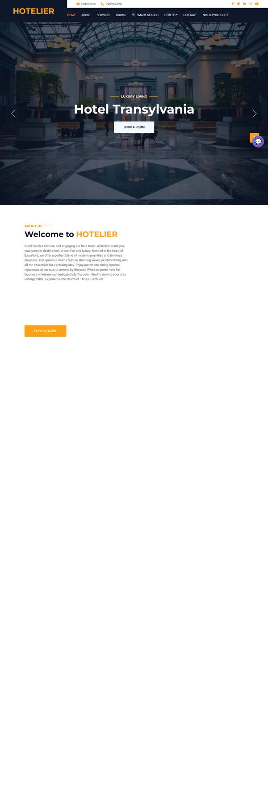
Figure 7.1: Homepage showing room type category cards and navigation bar
7.2 About Page
The About page provides information about the hotel including its history, mission, and values. The page uses a clean layout with text sections and images to create an engaging introduction for potential guests.
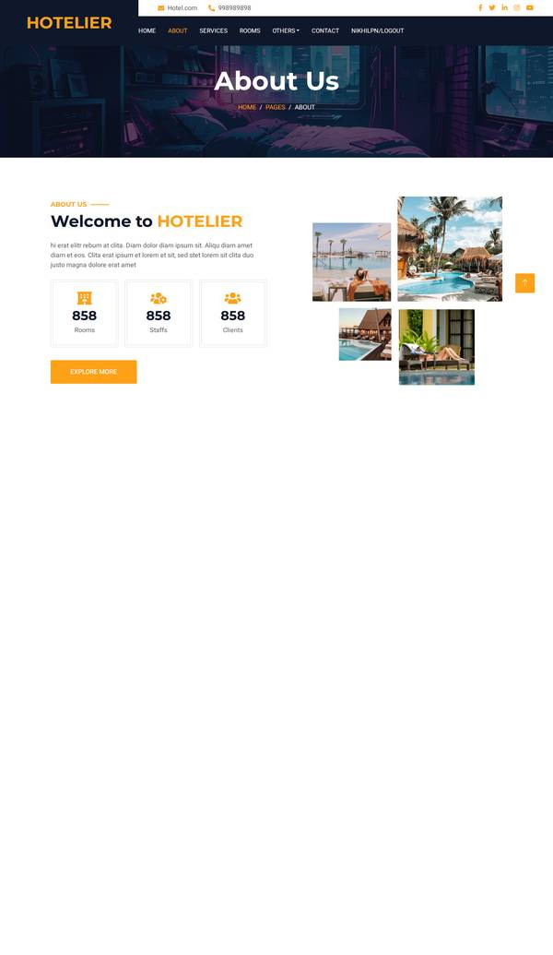
Figure 7.2: About page with hotel information content
7.3 Team Page
The team page displays staff profiles in a card-based layout. Each staff card shows the member's photograph, name, designation, and social media links (Facebook, Instagram). The page provides transparency about hotel personnel and builds customer trust.
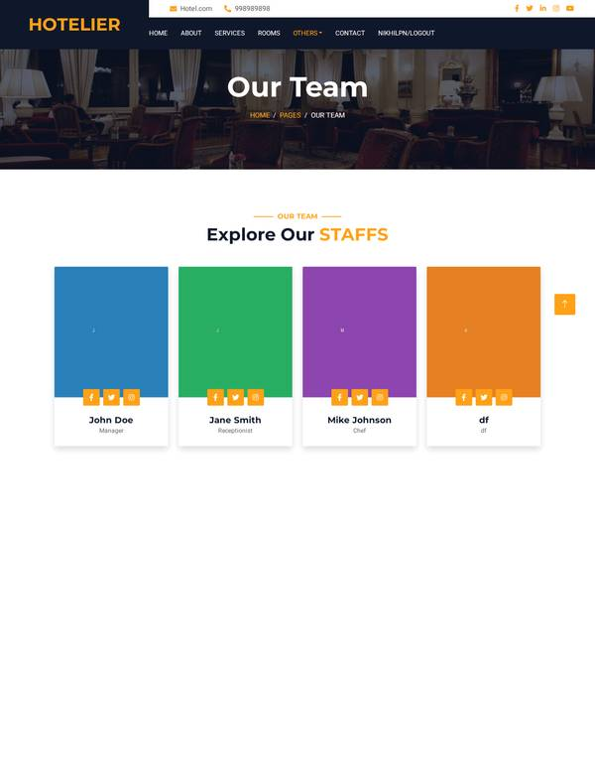
Figure 7.3: Team page displaying staff profiles
7.4 Room Listing Page
The room listing page displays available rooms with detailed information. Each room card includes an image, room name, room type, price per night, and a brief description. A prominent 'Book Now' button allows users to initiate the booking process for a specific room.
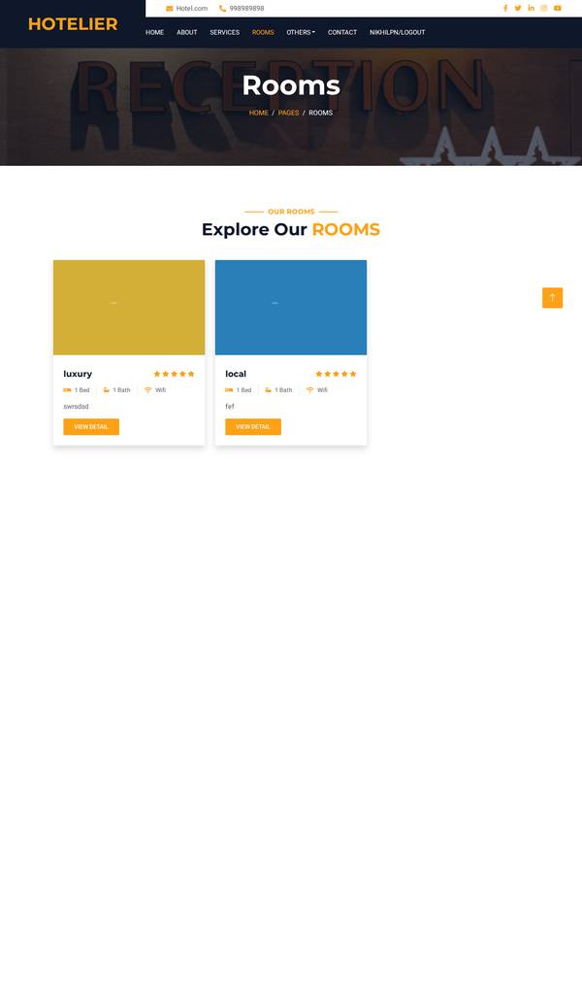
Figure 7.4: Room listing page with room cards
7.5 Booking Form
The booking form captures essential reservation details. Users select check-in and check-out dates using date pickers, specify the number of adults and children, and can enter special requests. The system validates date ranges to ensure check-out is after check-in and prevents double booking through overlap detection logic.
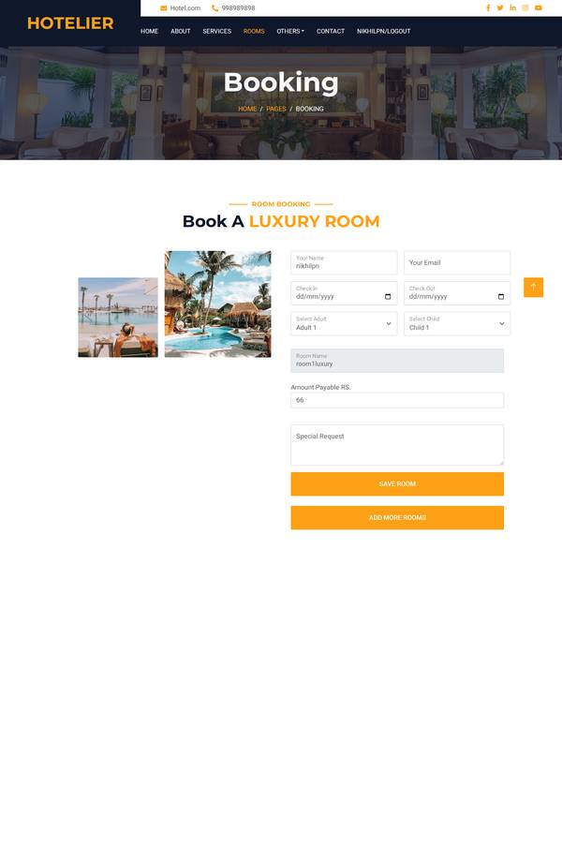
Figure 7.5: Booking form with date selection and guest details
7.6 Login and Registration
The authentication system provides login, registration, and password reset functionality. The sign-in form accepts username and password credentials. New users can register through the sign-up form which captures username, email, and password with confirmation. The password reset flow uses email-based OTP verification.
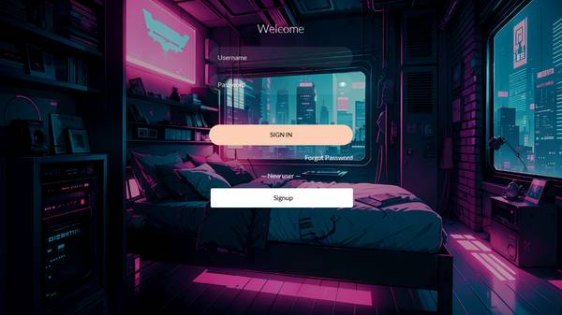
Figure 7.6: Login page for customer authentication
7.7 Admin Dashboard
The admin dashboard provides a secure backend interface for hotel staff management. It features a sidebar navigation menu with links to all management modules. The dashboard serves as the central hub for managing room types, rooms, staff profiles, bookings, payments, customer enquiries, and chatbot responses.
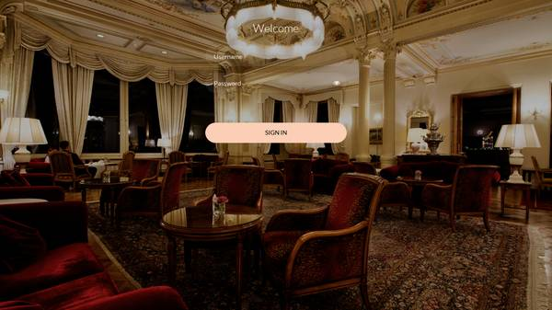
Figure 7.7: Admin dashboard with sidebar navigation
7.8 Room Type Management (Admin)
The room type management interface allows administrators to add, view, edit, and delete room categories. Each room type record includes a name, image, and description. The data is displayed in a tabular format with action buttons for editing and deletion.
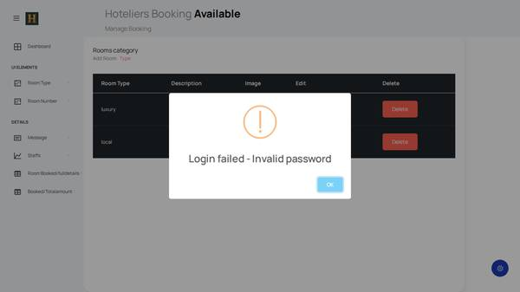
Figure 7.8: Admin room type listing and management
7.9 Room Management (Admin)
The room management interface enables administrators to manage individual room inventory. Each room is linked to a room type through a foreign key relationship. Administrators can add rooms with type selection, name, image, price, and description. The table view displays all rooms with their associated type.
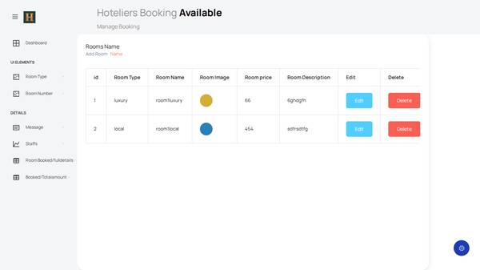
Figure 7.9: Admin room management interface
7.10 Booking Records (Admin)
The booking records view displays all customer bookings in a tabular format. Each record shows the customer name, email, selected room, check-in and check-out dates, guest count, and total price. This interface gives administrators a comprehensive view of all reservations.
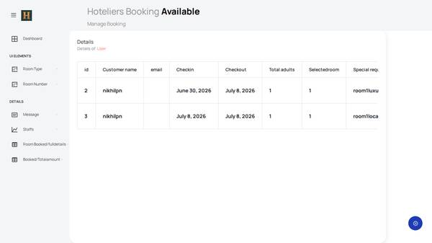
Figure 7.10: Admin booking records view
7.11 Staff Management (Admin)
The staff management interface allows administrators to maintain staff profiles. Each staff record includes name, designation, social media links (Facebook, Instagram), and a profile photograph. The tabular display makes it easy to view and manage hotel personnel.
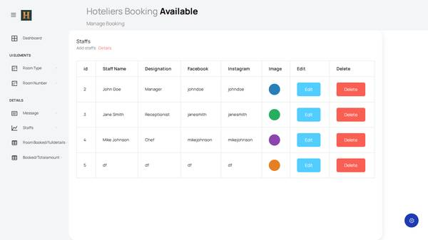
Figure 7.11: Admin staff management interface

The Hotel Room Booking System was developed following a structured implementation plan based on the Software Development Life Cycle (SDLC). The development was carried out in six phases over approximately 5-6 months of part-time work.

Phase 1: Project Initiation and Requirements Analysis (Weeks 1-3)
The first phase involved understanding the project requirements, studying the BCSP-064 project guidelines, and selecting the technology stack. A feasibility study was conducted to evaluate technical, operational, and economic feasibility. The problem statement was refined through analysis of existing hotel booking practices. System requirements were documented, covering both functional and non-functional requirements. User stories were written for both customer and administrator roles.
Phase 2: System Design (Weeks 4-7)
The design phase focused on creating the system architecture blueprint. The database schema was designed with 10 normalized tables and entity-relationship diagrams. The Django project structure was planned with two application modules (Backend and webapp). Wireframes and mockups were created using Figma for key pages including the homepage, room listing, booking form, and admin dashboard. The user interface was designed following Bootstrap 5.3 responsive design principles.
Phase 3: Implementation - Core Features (Weeks 8-12)
Core feature implementation began with setting up the Django project and database models. The following components were developed in sequence: Database models and migrations (all 10 tables with foreign key relationships), Admin module (CRUD operations for room types, rooms, staff), Customer authentication system (registration, login, password reset with OTP), Room browsing and advanced search (AJAX-based real-time filtering), Booking system with date overlap detection, Cart and price calculation module.
Phase 4: Implementation - Advanced Features (Weeks 13-16)
Advanced features were implemented in the fourth phase: Razorpay payment gateway integration (order creation, payment capture, signature verification), Rule-based chatbot engine (query classification, response generation, conversation history), Email notification system (booking confirmations, OTP delivery via SMTP), PDF receipt generation using xhtml2pdf, Contact form with validation and admin management, Notification system for admin alerts.
Phase 5: Testing and Quality Assurance (Weeks 17-19)
A comprehensive testing phase was conducted covering: Unit testing (25 individual component tests), Integration testing (6 end-to-end scenarios), System testing (full application validation), User acceptance testing (manual testing by sample users), Code review and refactoring (separation of concerns, query optimization), Bug fixing (8 bugs identified and resolved), Performance testing (page load times, concurrent user simulation).
Phase 6: Documentation and Submission (Weeks 20-22)
The final phase involved: Preparing the project report documentation, Capturing input/output screenshots, Creating the project presentation, Compiling the project submission package, Writing the IMPLEMENTATION_SUMMARY.md, QUICK_REFERENCE.md, and TESTING_GUIDE.md files, Final verification of all deliverables.
Implementation Timeline Summary
The following table summarizes the implementation timeline:
Phase | Duration | Key Activities | Deliverables
1. Initiation | Weeks 1-3 | Problem analysis, tech stack selection, feasibility study | Problem statement, requirements document
2. Design | Weeks 4-7 | DB schema design, UI wireframes, architecture planning | ER diagram, wireframes, design document
3. Core Features | Weeks 8-12 | Models, admin module, auth system, room search, booking | Working prototype with core features
4. Advanced Features | Weeks 13-16 | Payment, chatbot, email, PDF, notifications | Full-featured application
5. Testing | Weeks 17-19 | Unit/integration/system/UAT testing, bug fixing | Test reports, bug fixes
6. Documentation | Weeks 20-22 | Report writing, screenshots, submission prep | Final project report, guide files

4.5.1 Entity Relationship Diagram Description
The database schema consists of 10 interrelated tables that model the complete data requirements of the hotel booking system. The relationships between tables are established through foreign key constraints that enforce referential integrity at the database level.

The core entities and their relationships are as follows:
• roomtypedb (room type categories) has a one-to-many relationship with roomnamedb (individual rooms). A room type can have multiple rooms, but each room belongs to exactly one room type.
• roomnamedb has a one-to-many relationship with bookingdb (booking records). A room can appear in multiple bookings (historical), but active bookings cannot overlap in date ranges.
• Registerdb (customer registrations) has a one-to-many relationship with bookingdb (booking records). A customer can make multiple bookings. When a customer is deleted, the CUSTOMER field in bookingdb is set to NULL (SET_NULL).
• bookingdb has a one-to-many relationship with Totaldb (payment records). Each booking generates at most one payment record.
• roomnamedb has a one-to-many relationship with staffnotificationdb (notifications). Notifications are linked to specific rooms for administrative alerts.
• Registerdb has a one-to-many relationship with customercontactdb (contact enquiries). Each customer can submit multiple contact form messages.

4.5.2 Database Schema Details
The complete schema with field types and constraints:
Table Name | Field Count | Primary Key | Foreign Keys | Purpose
roomtypedb | 4 | id (AutoField) | None | Store room type categories
roomnamedb | 6 | id (AutoField) | ROOMTYPE -> roomtypedb.id | Store individual room details
staffdb | 6 | id (AutoField) | None | Store staff profile information
Registerdb | 5 | id (AutoField) | None | Store customer registration data
bookingdb | 10 | id (AutoField) | CUSTOMER -> Registerdb.id (SET_NULL), SELECTROOM -> roomnamedb.id (CASCADE) | Store booking transactions
Totaldb | 4 | id (AutoField) | BOOKING -> bookingdb.id (CASCADE) | Store payment records
customercontactdb | 5 | id (AutoField) | None | Store customer enquiries
staffnotificationdb | 5 | id (AutoField) | ROOM -> roomnamedb.id | Store admin notifications
chatbot_response | 4 | id (AutoField) | None | Define chatbot reply patterns
ChatbotConversation | 5 | id (AutoField) | None | Log chatbot conversation history

