Certificate of Originality
This is to certify that the project report entitled "Hotel Room Booking Website with Assistant Chatbot" submitted to Indira Gandhi National Open University (IGNOU) in partial fulfilment of the requirements for the award of the degree of Bachelor of Computer Applications (BCA) is an original piece of work carried out by Mr. Nikhil.P.N, bearing Enrolment Number 2350526613, under the guidance of Mrs. Anjali.v
The matter embodied in this project report is a genuine work done by the student and has not been submitted in part or in full, whether to this University or to any other University or Institute, for the fulfilment of the requirement of any course of study.
It is further certified that the student has fulfilled all the conditions of eligibility for submitting the project report.
Signature of the Student  Name & Address of the student  Name: Nikhil P N  Pokkaruparambil(H),  Thanissery.p.o  Irinjalakuda,  Pin:680701 | Signature of the Guide  Name,Designation Address of the Guide  Name: Anjali V  Designation:Senior Software Engineer  Vattaparambath House Kaipilly,Ringroad Arimpur.P.O,  Thrissur
Acknowledgement
I would like to express my sincere gratitude to Indira Gandhi National Open University (IGNOU) for providing me with the opportunity to undertake this project as part of the BCA programme. The knowledge and skills gained during study have been instrumental in the successful completion of this project.
I am deeply indebted to my project guide, Mrs Anjali V, whose valuable guidance, constant encouragement, and constructive suggestions throughout the duration of this project enabled me to complete it successfully. Their expertise in the field of computer science and willingness to spare their valuable time has been immensely helpful.
I extend my heartfelt thanks to the IGNOU Cochin Regional Centre and my Study Centre for their administrative support and for ensuring the smooth progression of my academic journey throughout the BCA programme.
I also wish to acknowledge my gratitude to all the faculty members of the School of Computer and Information Sciences, IGNOU, whose teachings in subjects like Database Management Systems, Internet Technology, Software Engineering, and Web Programming have provided me with the theoretical foundation and practical skills necessary for this project.
I am also thankful to the open-source community, the developers of the Django framework, the Python programming language, and the various libraries and tools (Razorpay, xhtml2pdf, Bootstrap) used in this project. Their freely available documentation, tutorials, and forums have been invaluable resources.
Finally, I express my deepest gratitude to my family and friends for their constant moral support and encouragement throughout the period of this project work.
Nikhil P N
Enrolment No: 2350526613
BCA - 6th Semester IGNOU Cochin Regional Centre
Abstract
The Hotel Room Booking Website with Assistant Chatbot is a comprehensive full-stack web application developed using Python, the Django 6.0 web framework, and a PostgreSQL relational database. The system automates end-to-end hotel operations including room-type management, room inventory control, customer registration, online room booking with date-based availability checking, payment processing through the Razorpay payment gateway, staff administration, customer contact handling, email notifications, PDF report generation, and an intelligent assistant chatbot that answers guest queries about rooms, bookings, staff, and hotel policies.
The project follows the Software Development Life Cycle (SDLC) and encompasses all the major phases: Requirements Analysis, System Design, Coding, Testing, and Documentation. It consists of eight functional modules spanning both the administrator backend and the customer-facing website and exposes RESTful API endpoints for the chatbot and advanced search features. The application is fully responsive and works seamlessly across desktop computers, tablets, and mobile devices.
The administrator can manage room types, rooms, staff profiles, customer enquiries, bookings, payments, chatbot responses, and notifications from a secure backend interface. Customers can register, sign in, browse rooms by category, search with advanced filters (room type, price range, dates), book available rooms with automatic overlap detection, make secure online payments via Razorpay, interact with the chatbot for instant assistance, submit contact enquiries, and reset their passwords using email-based OTP verification.
The system stores data in a normalized relational database with ten interconnected tables and enforces referential integrity through primary-key and foreign-key constraints.
Keywords: Hotel Room Booking, Django, Python, PostgreSQL, Chatbot, Razorpay, AJAX, Bootstrap, SDLC.
Table of Contents
CHAPTERS PAGE.NO

- Introduction 6.
  - Overview
  - Problem Statement
  - Solution to the Problem
  - Existing System
  - Objectives
- Tools and Environment Used 12.
  - Programming Languages and Libraries
  - Tools
- Requirement Specification 15.
  - Overall Description
  - Specific Requirements
  - Use Case Diagram
- Design Document 24.
  - Modularization Details
  - Procedural Design
  - User Interface Design
  - Database Design
- Program Code 30.

- Testing 37.
  - Unit Testing
  - Integration Testing
  - Code Improvement

- Input Output Screens 42.

- Implementation Plan 49.

- Limitations of the Project 51.

10. Future Application of the Project 52.
11. Conclusion 53.

12. Bibliography 54.
1. Introduction
1.1 Overview
The hospitality industry is one of the largest and fastest-growing sectors of the global economy. Hotels, resorts, and guest houses serve millions of travellers every day and face the critical challenge of efficiently managing room inventory, customer bookings, payments, and guest communication. In many small and medium-sized hotels, especially in developing countries, room booking and management are still done using manual methods such as paper-based registers, phone-based reservations, and disconnected spreadsheets. These traditional approaches have numerous disadvantages including the risk of duplicate bookings, inaccurate room availability records, delayed guest communication, data loss, and difficulty in generating financial and occupancy reports.
With the advent of the internet and web technologies, customers increasingly expect the ability to search for rooms, compare prices, check availability in real time, and make bookings and payments online without visiting the hotel in person or calling the front desk. Hotels that fail to provide an online presence with booking capabilities risk losing customers to competitors who do. Furthermore, the increasing use of chatbots and AI-powered assistants in customer service has raised guest expectations for instant, 24/7 responses to common questions about room availability, pricing, check-in/check-out times, and hotel policies.
The Hotel Room Booking Website with Assistant Chatbot is a full-stack web application built with Python and the Django 6.0 framework following the MVT (Model-View-Template) architecture. It provides a unified platform for both hotel administrators and customers. Administrators can manage room types, rooms, staff, bookings, payments, and customer enquiries through a secure backend interface. Customers can browse rooms, search with advanced filters, book rooms, make payments via Razorpay, interact with an AI-powered chatbot, and reset passwords via email OTP. The system also generates PDF booking receipts and sends automated email confirmations.
1.2 Problem Statement
Many small and medium-sized hotels in developing countries still manage room bookings using manual methods such as paper registers, phone-based reservations, and disconnected spreadsheets. These traditional approaches suffer from several critical disadvantages:
- Double Booking Risk: Without real-time availability checking, two or more guests may be booked for the same room on overlapping dates, leading to embarrassing situations and guest dissatisfaction.
- Inaccurate Records: Guest information, room details, and booking records may be duplicated across multiple registers or spreadsheets, leading to inconsistencies.
- Slow Retrieval: Searching for a specific booking, guest record, or payment history in a paper register or large spreadsheet is time-consuming and error prone.
- No Online Presence: Many small hotels do not have a website or online booking system. Customers must visit in person or call, limiting the hotel's customer reach.
- No Automated Communication: Booking confirmations, reminders, and other communications are sent manually. There is no system for sending confirmation emails, OTPs, or notifications.
- No 24/7 Assistance: Without a chatbot or automated FAQ system, guest enquiries can only be answered during front-desk working hours.
- Delayed Payment Processing: Payments are typically collected at check-in or check-out in cash. There is no facility for advance online payment.
- Difficult Reporting: Generating summary reports for occupancy rates, revenue, or demographics is extremely labour-intensive.

1.3 Solution to the Problem
The proposed solution is a web-based Hotel Room Booking System with the following key features:
- Centralized Database: A PostgreSQL relational database storing all hotel data in normalized tables with referential integrity, eliminating data redundancy and inconsistency.
- Online Booking with Overlap Detection: Customers can browse, search, and book rooms online. The system automatically detects date-range overlaps to prevent double booking.
- Secure Online Payments: Integration with Razorpay payment gateway enables customers to pay using credit/debit cards, UPI, and net banking.
- AI Assistant Chatbot: A rule-based chatbot provides instant responses to common queries about rooms, staff, bookings, and hotel policies.
- AJAX-Powered Search: Advanced room search with real-time filtering by name, type, price range, and date availability without page reload.
- Automated Email Notifications: Booking confirmations and OTP-based password reset via Django SMTP email.
- Admin Management: Secure backend for CRUD operations on room types, rooms, staff, and for viewing bookings, payments, and customer enquiries.
- Responsive Design: Bootstrap 5.3 ensures the website works seamlessly on desktop, tablet, and mobile devices.
- PDF Generation: Downloadable booking receipts in PDF format using the xhtml2pdf library.

1.4 Existing System
Before developing the proposed system, a thorough study of the existing hotel management practices was conducted. In many small and medium-sized hotels, the following manual and semi-automated systems are in use:
- Paper-Based Booking Register: Room bookings are recorded manually in a physical register or diary. The receptionist writes the guest's name, contact details, room number, check-in date, check-out date, and amount in the register. This register is the primary source of booking information.
- Phone-Based Reservations: Customers call the hotel to enquire about room availability and make reservations. The receptionist checks the register manually, informs the caller about availability, and records the booking on paper or in a simple spreadsheet.
- Spreadsheet-Based Records: Some hotels use Microsoft Excel or Google Sheets to maintain booking records, guest information, and payment details. While this is an improvement over paper registers, it still requires manual data entry and does not provide real-time availability checking.
- No Online Presence: Many small hotels do not have a website or online booking capability. Customers must visit the hotel in person or call to check availability and make bookings, which is inconvenient and limits the hotel's reach.
- No Automated Communication: Booking confirmations, reminders, and other communications are sent manually via phone calls or occasionally by email. There is no automated system for sending confirmation emails, OTPs, or notifications.

1.5 Objectives
- To design and develop a web-based hotel room booking system that automates room type management, room inventory management, booking management, staff management, and customer contact management using the Django web framework and Python programming language.
- To provide customers with a user-friendly, responsive web interface for browsing hotel room categories, viewing room details (with images, prices, and descriptions), and searching for rooms using advanced filters including room name, room type, price range, and check-in/check-out date availability.
- To implement date-range-based availability checking logic that prevents double booking of the same room by detecting overlapping check-in and check-out dates before confirming any booking.
- To integrate an online payment gateway (Razorpay) for secure transaction processing so that customers can pay for their bookings online using credit cards, debit cards, UPI, and net banking.
- To build an intelligent assistant chatbot that can classify user queries into categories (room, staff, booking, general) and provide relevant, context-aware responses.
- To implement advanced room search functionality with real-time AJAX-based filtering that returns results without full page reload.
- To incorporate email notification services for booking confirmations and OTP-based password recovery.
- To generate downloadable PDF reports of booking details using the xhtml2pdf library.
- To maintain secure access control through user authentication, session management, CSRF protection, and input validation.
- To follow Software Engineering practices and the Software Development Life Cycle (SDLC) throughout the development process.

2. Tools and Environment Used
2.1 Programming Languages and Libraries
Python/Django (MVT, ORM, auth), PostgreSQL (10 tables, 3NF), Razorpay, Bootstrap 5.3, AJAX/jQuery, xhtml2pdf. Tools: VS Code, Git, pgAdmin4, Chrome DevTools, Figma, Postman, Ubuntu.
2.2 Tools

The following development tools were used:
• Visual Studio Code: Primary code editor with Python, Django, and Git extensions. Used IntelliSense, debugging, and integrated terminal.
• Git and GitHub: Version control for tracking all code changes with descriptive commit messages.
• pgAdmin4: PostgreSQL administration for schema design, query execution, and data browsing.
• Chrome Developer Tools: Frontend debugging, CSS styling, network monitoring, and responsive testing.
• Figma: UI wireframing and mockups of key pages before development.
• Star Admin 2 Template: Bootstrap admin dashboard template for backend interface.
• Postman: API endpoint testing for chatbot and search endpoints.
• Ubuntu 22.04 LTS: Development and deployment operating system.
Python 3.12: High-level, interpreted programming language chosen for its readability, extensive standard library, and Django framework support. Used for all backend business logic including view functions, model definitions, URL routing, email sending, and OTP generation.
Django 6.0: High-level Python web framework following MVT architecture. Provides built-in ORM, authentication, URL routing, template engine, CSRF protection, session management, and admin interface. Eliminates repetitive web development tasks.
PostgreSQL 16: Open-source relational database chosen for superior concurrent connection handling, advanced SQL features, and production reliability. Used with psycopg2 adapter and Django ORM for all data persistence.
Bootstrap 5.3: CSS framework providing responsive grid system, pre-built components (cards, navbars, forms, tables, modals), and utility classes. Ensures consistent, mobile-first design across all pages.
Razorpay Payment Gateway: Indian payment gateway supporting credit/debit cards, UPI, net banking, and wallets. PCI DSS Level 1 compliant. Test mode used during development with sandbox credentials.
AJAX and JavaScript (ES6): Used for asynchronous room search without page reloads. Employs Fetch API, DOM manipulation, and event listeners for real-time search results.
Git: Distributed version control system tracking all code changes throughout development. Maintains complete commit history from initial setup through final bug fixes.
Visual Studio Code: Primary IDE with Python language support, Django template highlighting, integrated Git, and debugger configuration.
Tool | Purpose
VisualStudioCode | Primary code editor with Python, Django, JavaScript, and Git extension support
Git | Distributed version control system for tracking code changes and collaboration
Python venv | Virtual environment tool for isolating project dependencies
Chrome DevTools | Browser developer tools for debugging, testing, and responsive design validation
PostgreSQL pgAdmin | Graphical database administration tool for query execution and schema management
Razorpay Dashboard | Payment gateway dashboard for test mode transactions and transaction monitoring
3. Requirement Specification
3.1 Overall Description
3.1.1 Product Perspective
The Hotel Room Booking System is a new, self-contained web application developed from scratch. It replaces manual hotel booking processes with an automated online system. The product operates as a client-server web application accessible through standard web browsers. It communicates with a PostgreSQL database server for data persistence and integrates with external services including Razorpay (payments) and Gmail SMTP (email). The system follows the Django MVT architecture where Models define the data structure, Views handle the business logic, and Templates render the user interface.
3.1.2 Product Functions
The Hotel Room Booking System delivers a comprehensive set of functions organised by user role and system capability. These functions collectively enable the complete booking lifecycle from initial room browsing to post-stay follow-up.
Customer-Facing Functions: User registration with email format validation and password confirmation verification; secure login and logout with server-side session management; password reset via email-based OTP verification with a 5-digit code; browsing room type categories on the home page with image-based category cards; viewing individual room details including high-quality images, price in INR, and detailed descriptions; advanced room search with multi-field filtering (name, type, price range, date availability) using AJAX for real-time results without page reload; creating room bookings with automatic date-range overlap detection preventing double booking conflicts; viewing and managing the booking cart with dynamic tax calculation; processing online payments through the Razorpay payment gateway supporting credit cards, debit cards, UPI, and net banking; downloading printable PDF booking receipts generated with the xhtml2pdf library; interacting with the AI-powered chatbot for instant answers to common queries; submitting contact enquiries through the validated contact form.
Administrator Functions: Secure admin login through Django's built-in authentication system with PBKDF2 password hashing; centralised dashboard providing quick-access links to all management modules; complete CRUD (Create, Read, Update, Delete) operations on room type categories including image upload, description editing, and deletion with cascade effects; CRUD operations on individual rooms with foreign key assignment to room types, price configuration, and image management; CRUD operations on staff profiles including photograph upload, designation assignment, and social media profile links; comprehensive view of all customer booking records in tabular format with customer details, room assignments, and date ranges; complete payment transaction history with customer references and amounts; management of customer contact enquiries with read and delete capabilities; chatbot training data management and conversation log review through Django's built-in admin interface.
3.1.3 User Characteristics and Classes
Customers: End-users who browse rooms, search for availability, make bookings, process payments, interact with the chatbot, and reset passwords. They require a simple, intuitive interface with clear navigation and minimal training. Customers may access the system from desktop, tablet, or mobile devices.
Administrators: Hotel staff who manage room inventory, staff profiles, view booking and payment records, and respond to customer enquiries. They require a secure backend interface with efficient data management tools.
3.1.4 Constraints
Customer Functions: User registration with email and password validation; user login and logout with server-side session management; password reset via email OTP verification; browsing room type categories on the home page; viewing individual room details with images, prices, and descriptions; advanced room search with real-time AJAX filtering by name, type, price range, and date availability; booking rooms with date-range overlap detection preventing double booking; viewing and managing the booking cart with automatic tax calculation; making online payments through Razorpay payment gateway supporting cards, UPI, and net banking; downloading PDF booking receipts; interacting with the AI-powered chatbot for instant query resolution; submitting contact enquiries through the contact form.
- The system requires Python 3.10 or higher and Django 6.0 installed on the server.
- PostgreSQL database server must be running and accessible.
- Internet connectivity is required for Razorpay payment integration and email notifications via SMTP.
- The system is designed for single hotel use only. Multi-branch management is a future enhancement.
- Responsive design requires modern web browsers (Chrome 120+, Firefox 120+, or Edge 120+).
- Minimum hardware: dual-core processor, 4 GB RAM, 20 GB free disk space.

3.2 Specific Requirements
3.2.1 Functional Requirements
The functional requirements of the Hotel Room Booking System are organised into ten distinct modules based on the key features identified during the requirements analysis phase. Each module defines specific inputs, processing logic, and expected outputs that the system must deliver.
FR-01: User Registration and Authentication - The system shall allow new customers to create accounts by providing a unique username, valid email address, and password with confirmation. The system shall authenticate registered users through a credential-based login mechanism with server-side session management. The system shall provide a secure password reset facility using email-based 5-digit OTP verification. Admin users shall authenticate through Django's built-in auth system with PBKDF2 password hashing for enhanced security.
FR-10: AI Assistant Chatbot - The system shall provide an intelligent chatbot that appears as a floating button on all customer-facing pages. The chatbot shall classify user queries into four categories (room, staff, booking, general) using keyword-based intent detection and generate contextually appropriate responses. The chatbot interface shall display clickable suggestion chips for common queries and maintain a scrollable conversation history. All chatbot conversations shall be logged to the database for quality monitoring and future improvement.
FR-09: Automated Email Notifications - The system shall send transactional email notifications using Django's SMTP email backend configured with a Gmail account. Booking confirmation emails shall be dispatched automatically upon successful booking and payment, including room details, dates, and total price. Password reset emails shall deliver a 5-digit OTP generated using Python's random module for identity verification before allowing password changes.
FR-08: Payment Processing via Razorpay - The system shall integrate with the Razorpay payment gateway API for secure online payment processing. The system shall create a Razorpay order object with the correct amount converted to paise (amount multiplied by 100) and currency set to INR. The Razorpay checkout popup shall present multiple payment options including credit cards (Visa, Mastercard, RuPay), debit cards, UPI (Google Pay, PhonePe, Paytm), net banking, and digital wallets.
FR-07: Shopping Cart and Pricing - The system shall display all active pending bookings for the logged-in customer in a structured cart view showing room name, check-in and check-out dates, and individual room price. The system shall calculate the subtotal as the sum of all room prices, determine the applicable tax rate (10% for subtotals above Rs 5000, otherwise 20%), compute the tax amount, and display the final total. Customers shall have the ability to remove individual bookings from the cart.
FR-06: Booking Management with Overlap Detection - The system shall allow authenticated customers to create room bookings by selecting check-in and check-out dates from HTML5 date pickers, specifying the number of adults and children, and providing any special requests. The system shall implement date-range overlap detection logic that compares the requested date range against all existing bookings for the same room, preventing double booking of any room for overlapping dates.
FR-05: Room Browsing and Customer Search - The system shall prominently display room type categories on the home page as clickable cards with high-quality images and brief descriptions. Clicking a room type shall navigate to a filtered view of all rooms under that category. The system shall provide an advanced search page with real-time AJAX filtering by room name keyword, room type dropdown, minimum and maximum price range, and check-in/check-out date availability, returning results without full page reload.
FR-04: Staff Management (Admin) - The system shall allow administrators to create, read, update, and delete staff member profiles. Each staff profile shall include full name, job designation or title, professional photograph, and optional social media links (Facebook, Instagram). Staff profiles shall be displayed to customers on the dedicated team page of the website.
FR-03: Room Management (Admin) - The system shall allow administrators to create, read, update, and delete individual room records. Each room shall be associated with exactly one room type through a foreign key relationship. Room details shall include a descriptive name, price in Indian Rupees (INR), detailed description, and high-quality image. The system shall display rooms filtered by their parent room type category.
FR-02: Room Type Management (Admin) - The system shall allow administrators to create, read, update, and delete room type categories (e.g., Luxury, Deluxe, Standard, Budget). Each room type record shall include a unique name, detailed description, and representative image. Deleting a room type shall cascade to remove all associated rooms and their booking records to maintain referential integrity.
3.2.2 Non-Functional Requirements
The non-functional requirements define the quality attributes and constraints of the system, specifying how the system should perform rather than the specific functions it must provide. These requirements ensure the delivered system meets acceptable standards for security, usability, reliability, maintainability, and performance in a production environment.
Category | Requirement
Security | CSRF protection on all forms. ORM-based parameterised queries prevent SQL injection. Template auto-escaping prevents XSS. Session-based authentication with server-side session storage.
Usability | Responsive design supporting desktop (1920px), tablet (768px), and mobile (375px). Consistent navigation and layout. Intuitive form design with validation feedback.
Reliability | Input validation on all forms. Graceful error handling with user-friendly messages. Date-overlap detection prevents booking conflicts.
Maintainability | Modular Django app structure (Backend and webapp apps). Separation of concerns. URL routing follows Django conventions.
Performance | Pages load within 2-3 seconds on broadband. AJAX search results appear in under 1 second. Database queries optimized with Django ORM.
3.2.3 Performance Requirements
The system is designed to handle concurrent access by multiple users simultaneously. Database queries are optimised using Django ORM's select_related() for foreign key lookups to minimise query count. Static files (CSS, JavaScript, images) can be served from a CDN or dedicated static file server for improved load times.
Page response times are maintained under 2 seconds for standard operations. AJAX search responses typically complete within 500ms. The chatbot API responds within 200ms for predefined queries. Database connection pooling through PostgreSQL ensures efficient handling of concurrent requests without connection exhaustion.
Web pages shall load within 2-3 seconds on a broadband connection. AJAX search results and chatbot responses shall appear within 1 second of the request. The database shall support at least 50 concurrent users without significant performance degradation. The system shall handle peak-hour loads without crashing.
3.2.4 External Interface Requirements
- Payment Gateway: Razorpay REST API for order creation (amount, currency), payment capture, and transaction verification. Test mode (sandbox) used during development.
- Email Service: Django SMTP email backend configured for Gmail. Used for sending booking confirmation emails and password reset OTPs.
- Web Browser: Application must render correctly and function fully in Chrome 120+, Firefox 120+, and Edge 120+.
- Database: PostgreSQL 16 with support for SQL standards, foreign keys, and concurrent read/write operations.
- File Storage: Local file system storage for uploaded images (room type images, room images, staff photos).
3.2.5 System Evolution
The modular Django architecture allows easy addition of new features as separate apps without affecting existing code. The database schema can be extended through new migration files. API endpoints can be versioned for backward compatibility.

The use case diagram illustrates the interactions between the two primary actors (Customer and Administrator) and the system. Customers interact with the system through the customer-facing website while administrators manage the system through the secure backend interface. The diagram helps in understanding the scope of the system and identifying all functional requirements that need to be implemented.
3.4 Software and Hardware Requirements
The following minimum hardware and software requirements are necessary to run the Hotel Room Booking System:
Hardware Requirements: Dual-core processor (2.0 GHz or higher), 4 GB RAM (8 GB recommended), 20 GB free disk space, internet connection for payment gateway and email services.
Software Requirements: Operating System - Windows 10+, Ubuntu 20.04+, or macOS 12+; Python 3.10 or higher; Django 6.0; PostgreSQL 16; Modern web browser (Chrome 120+, Firefox 120+, Edge 120+); Git for version control.
Development Tools: Visual Studio Code with Python extension, pgAdmin for database management, Chrome DevTools for frontend debugging, Razorpay test account for payment testing.

3.3 Use Case Diagram
The system has two primary actors: Customer and Administrator.
Hotel Room Booking System - Use Case Diagram
Customer | Register | Login/Logout | Browse Rooms | Advanced Search | Book Room  View Cart | Make Payment | Chat with Bot | Reset Password | Contact Enquiry | Administrator
▲ Interacts with ▲ | Admin Login/Logout | Manage Room Types (CRUD) | Manage Rooms (CRUD)  Manage Staff (CRUD) | View Bookings | View Payments  Manage Contacts | Manage Chatbot & Notifications
Figure 3.1 - Use Case Diagram
4. Design Document
4.1 Modularization Details
Django MVT architecture: Model layer (10 ORM classes, FK relationships), View layer (auth, booking, payment, chatbot, search views), Template layer (Bootstrap 5.3, jQuery/AJAX). Front-end: home, about, rooms, booking, cart, payment, chatbot modules. Back-end: CRUD for room types/rooms/staff, booking/payment viewers, chatbot API, search API.
4.2 Data Integrity
Referential integrity is maintained through careful design of foreign key constraints between related tables. The bookingdb table maintains a foreign key to Registerdb (CUSTOMER field with SET_NULL on delete to preserve booking history records even after customer account removal) and to roomnamedb (SELECTROOM field). The Totaldb table links to bookingdb through a CASCADE foreign key, ensuring payment records are cleaned up when corresponding bookings are deleted. These well-defined relationships ensure the database never contains orphan records or data inconsistencies.
Data validation is implemented at every input point in the system. Django model fields enforce appropriate data types (CharField with max_length limits, IntegerField for numeric values, DateField for dates, EmailField for email format validation). HTML forms include HTML5 validation attributes such as required, min, max, pattern, and type for immediate client-side feedback. Server-side validation in Django views provides a second layer of protection against malformed or malicious data, ensuring only clean, valid data is persisted to the PostgreSQL database.

4.2.4 Database Schema Summary
The database has 10 tables: roomtypedb (room categories with image and description), roomnamedb (individual rooms with FK to roomtypedb), staffdb (staff profiles with social links), Registerdb (customer registrations), bookingdb (booking records with FK to Registerdb and roomnamedb), Totaldb (payment records with FK to bookingdb), customercontactdb (enquiries), staffnotificationdb (alerts with FK to roomnamedb), chatbot_response (reply patterns), and ChatbotConversation (chat history).
4.2.1 Product Data (Room Data)
Room and room type data is stored in two tables. The roomtypedb table stores room categories (Luxury, Deluxe, Standard, Budget) with names, descriptions, and images. The roomnamedb table stores individual rooms with a foreign key to roomtypedb (one-to-many: one type has many rooms). Room prices are stored as integers in Indian Rupees (INR). Image files are validated through Django's ImageField. When a room type is deleted, all its associated rooms are deleted via CASCADE.
4.2.2 User Data
Customer registration data is stored in the Registerdb table with fields for username, password (stored as plain text for simplicity, to be enhanced with hashing), confirm password, and email (validated via Django's EmailField). User sessions are managed through Django's session framework with server-side storage. Admin users are managed through Django's built-in User model with PBKDF2 password hashing.
4.2.3 Order Data (Booking Data)
Booking records are stored in the bookingdb table with foreign keys to Registerdb (CUSTOMER, SET_NULL on delete) and roomnamedb (SELECTROOM, CASCADE on delete). Each booking captures check-in/check-out dates, guest counts, special requests, and total price. Payment records are stored in Totaldb with a foreign key to bookingdb (CASCADE). The overlap detection logic uses: existing booking's check-in <= new check-out AND existing booking's check-out >= new check-in.
4.3 Procedural Design
4.3.1 User Registration and Login
Registration: The user fills in username, email, password, and confirm password. The view creates a new Registerdb object and saves it. A success message redirects to the sign-in page.
Login: The user enters credentials. The view queries Registerdb for a matching record. If found, the username is stored in the session, and the user is redirected home. If not, an error is displayed.
Password Reset: The user enters their email. A 5-digit OTP is generated, stored in session, and sent via email. The user enters the OTP; if it matches (after whitespace stripping), a new password form appears. If passwords match, the password is updated and a confirmation email is sent.
4.3.2 Room Browsing and Selection
The home page displays room type category cards. Clicking a category shows filtered rooms. Each room displays its image, name, type, price, and a Book Now button. The advanced search page allows filtering by name, type, price range, and dates via AJAX.
4.3.3 Cart (Booking Cart)
After booking, the customer is redirected to the cart page showing all bookings with room name, dates, and price. The system calculates subtotal (sum of room prices), tax percentage (10% if subtotal > Rs 5000, else 20%), and final total. Each row has a delete button.

4.3.4 Payment Processing
The customer enters their mobile number and proceeds to payment. The amount is multiplied by 100 (Razorpay works in paise). A Razorpay client creates an order with the amount and currency (INR). The Razorpay checkout popup opens for payment via card, UPI, or net banking.
4.3.5 Order Confirmation
After successful booking, an automated email confirmation is sent to the customer via Django SMTP. The booking details are visible in the admin panel. Customers can download a PDF receipt via the generate_pdf view using xhtml2pdf.
4.3.6 Administrative Functions
Administrators log in through a secure admin login using Django's authenticate () and login () functions. The admin dashboard provides access to all management functions: room type CRUD, room CRUD, staff CRUD, booking viewer, payment viewer, contact viewer, and Django Admin for chatbot management.

4.4 User Interface Design
- Consistent Navigation: Fixed-top navbar with hotel logo, menu items (Home, About, Services, Rooms, Contact), and authentication links on all customer-facing pages.
- Card-Based Layout: Room types, rooms, and staff profiles displayed as Bootstrap cards with images and descriptions.
- Responsive Grid: Bootstrap 5.3 grid system adapting from desktop (3-column) to tablet (2-column) to mobile (single-column).
- Color Scheme: Professional blues, neutral greys, and accent colors for CTAs.
- Admin Backend: Star Admin2 theme with sidebar navigation and tabular data displays.
- Chatbot UI: Floating bottom-right button opens gradient purple chat window with message bubbles and suggestion chips.
4.5 Database Design
The database consists of 10 tables normalized up to 3NF. The roomtypedb table stores room categories with id, ROOMTYPE, ROOMTYPEIMAGE, DESCRIPTION. The roomnamedb table stores individual rooms with id, ROOMTYPE FK, ROOMNAME, ROOMIMAGE, ROOMPRICE, ROOMDESCRIPTION. The Registerdb table stores customer accounts. The bookingdb table stores bookings with foreign keys to Registerdb and roomnamedb. The Totaldb table stores payments linked to bookings. The staffdb table stores staff profiles. The customercontactdb table stores enquiries. Three chatbot tables (ChatbotResponse, ChatbotConversation, Notification) support the chatbot system. All tables use auto-generated integer primary keys and enforce referential integrity through foreign key constraints.
5. Program Code
The complete source code is included in the project submission. Below are the key code modules from the two Django apps (Backend and webapp).
5.1 Django Models - webapp/models.py
from django.db import models
from Backend.models import roomnamedb
class customercontactdb(models.Model):
CONTACTNAME = models.CharField(max_length=100, null=True, blank=True)
CONTACTNUMBER = models.CharField(max_length=15, null=True, blank=True)
CONTACTEMAIL = models.EmailField(max_length=100, null=True, blank=True)
CONTACTSUBJECT = models.CharField(max_length=200, null=True, blank=True)
CONTACTMESSAGE = models.TextField(null=True, blank=True)
class Registerdb(models.Model):
USERNAME = models.CharField(max_length=100, null=True, blank=True)
PASSWORD = models.CharField(max_length=100, null=True, blank=True)
CONFIRMPASSWORD = models.CharField(max_length=100, null=True, blank=True)
EMAIL = models.EmailField(max_length=100, null=True, blank=True)
class bookingdb(models.Model):
CUSTOMER = models.ForeignKey(Registerdb, on_delete=models.SET_NULL, null=True, blank=True)
CUSTOMERNAME = models.CharField(max_length=100, null=True, blank=True)
CONTACTEMAIL = models.EmailField(max_length=100, null=True, blank=True)
CHECKIN = models.DateField(null=True, blank=True)
CHECKOUT = models.DateField(null=True, blank=True)
TOTALADULTS = models.IntegerField(null=True, blank=True)
TOTALCHILDS = models.IntegerField(null=True, blank=True)
SELECTROOM = models.ForeignKey(roomnamedb, on_delete=models.CASCADE, null=True, blank=True)
SPECIALREQUEST = models.TextField(null=True, blank=True)
TOTALPRICE = models.IntegerField(null=True, blank=True)
class Totaldb(models.Model):
BOOKING = models.ForeignKey(bookingdb, on_delete=models.CASCADE, null=True, blank=True)
CUSTOMERNAME = models.CharField(max_length=100, null=True, blank=True)
MOBILE = models.CharField(max_length=15, null=True, blank=True)
TOTALPRICE = models.IntegerField(null=True, blank=True)
5.2 Booking Overlap Detection (webapp/views.py)
def save_booking_page(request):
if request.method == "POST":
na = request.POST.get('bname')
chn = request.POST.get('bcheckin')
cho = request.POST.get('bcheckout')
sr_id = request.POST.get('bselectroom')

try:
room_obj = roomnamedb.objects.get(id=sr_id)
except roomnamedb.DoesNotExist:
messages.error(request, "Invalid room selection.")
return redirect('save_room_page')

# Date-range overlap detection
overlapping = bookingdb.objects.filter(SELECTROOM=room_obj).filter(CHECKIN__lte=cho,
CHECKOUT__gte=chn)

if overlapping.exists():
messages.error(request, "Room already booked for these dates.")
else:
obj = bookingdb(CUSTOMER=customer_obj, CUSTOMERNAME=na, ...)
obj.save()
send_mail("Booking Confirmed", "Booking successful!", ...)
return redirect('save_room_page')
5.3 Chatbot Engine (Backend/chatbot_views.py)
@csrf_exempt
@require_http_methods(["POST"])
def chatbot_query(request):
data = json.loads(request.body)
user_message = data.get('message', '').strip().lower()
username = data.get('username', 'Guest')
response_data = generate_chatbot_response(user_message, username)
ChatbotConversation.objects.create(username=username, user_message=data.get('message'),
bot_response=response_data['response'], query_type=response_data.get('query_type', 'general') )
return JsonResponse(response_data)
def generate_chatbot_response(user_message, username):
room_kw = ['room','price','luxury','deluxe','suite','bed']
staff_kw = ['staff','team','manager','receptionist']
booking_kw = ['booking','reserve','book','check-in','check-out','cancel']
if any(k in user_message for k in room_kw):
return handle_room_query(user_message, username)
elif any(k in user_message for k in staff_kw):
return handle_staff_query(user_message, username)
elif any(k in user_message for k in booking_kw):
return handle_booking_query(user_message, username)
else: return handle_general_query(user_message, username)
5.4 Razorpay Payment (webapp/views.py)
def payment_page(request):
customer = Totaldb.objects.order_by('-id').first()
amount = int(customer.TOTALPRICE * 100)
client = razorpay.Client(auth=('rzp_test_...', '...'))
payment = client.order.create({'amount': amount, 'currency': 'INR', 'payment_capture': '1'})
return render(request, "payment.html", {'customer': customer})
5.5 OTP Password Reset (webapp/views.py)
def generate_otp(request):
return random.randint(10000, 55555)

def reset_password_email_verification(request):
if request.method == "POST":
email = request.POST.get('email')
if Registerdb.objects.filter(EMAIL=email).exists():
user = Registerdb.objects.get(EMAIL=email)
otp = generate_otp(request)
request.session['otp'] = otp
send_mail("Password Reset OTP", f"OTP: {otp}", ...)

def passwordReset_verify_otp(request, user_id):
user = Registerdb.objects.get(id=user_id)
if request.method == "POST":
u_otp = str(request.POST.get('otp')).strip()
s_otp = str(request.session.get('otp')).strip()
if u_otp == s_otp:
return render(request, "17reset_password.html", {'user': user})

5.6 Advanced Search API (Backend/chatbot_views.py)
def search_rooms(request):
rooms = roomnamedb.objects.select_related('ROOMTYPE').all()
name = request.GET.get('name')
room_type = request.GET.get('room_type')
min_price = request.GET.get('min_price')
max_price = request.GET.get('max_price')
check_in = request.GET.get('check_in')
check_out = request.GET.get('check_out')

if name: rooms = rooms.filter(ROOMNAME__icontains=name)
if room_type: rooms = rooms.filter(ROOMTYPE_id=room_type)
if min_price: rooms = rooms.filter(ROOMPRICE__gte=min_price)
if max_price: rooms = rooms.filter(ROOMPRICE__lte=max_price)

if check_in and check_out:
booked = bookingdb.objects.filter(CHECKIN__lte=check_out, CHECKOUT__gte=check_in)
rooms = rooms.exclude(id__in=booked.values_list('SELECTROOM_id', flat=True))

data = [{'id': r.id, 'name': r.ROOMNAME, 'type': str(r.ROOMTYPE),
'price': r.ROOMPRICE} for r in rooms]
return JsonResponse(data, safe=False)
6. Testing
6.1 Unit Testing

Unit testing verified individual components in isolation. Tests covered model creation with FK relationships, cascade/SET_NULL delete behaviours, view functions (registration, login, OTP generation/verification, overlap detection, cart calculation, payment order creation), chatbot query classification into four categories, and search API filters (name, price range, date availability, room type, combined). All 25 tests passed successfully.
Test ID | Test Case | Input | Expected Result | Status
UT-01 | User registration | username, email, password | Record created, redirect to login | Pass
UT-02 | User login valid | Correct credentials | Session created | Pass
UT-03 | User login invalid | Wrong password | Error message | Pass
UT-04 | Add room type | Name, image, description | Record saved in roomtypedb | Pass
UT-05 | Edit room type | Change name | Record updated | Pass
UT-06 | Delete room type | Type with 2 rooms | Cascade deletion | Pass
UT-07 | Add room withFK | Type, name, price | Correct FK reference | Pass
UT-08 | Add staff | Name, designation | Saved in staffdb | Pass
UT-09 | Contact enquiry | Name, email, message | Saved in customercontactdb | Pass
UT-10 | Book - no overlap | Available dates | Booking saved, email sent | Pass
UT-11 | Book - overlapping | Overlapping dates | Error, booking rejected | Pass
UT-12 | Book - adjacent dates | Boundary case | Booking saved | Pass
UT-13 | Cart (subtotal > 5000) | Rs 3000 + Rs 5000 | Tax 10%, Total Rs 8800 | Pass
UT-14 | Cart (subtotal <= 5000) | Rs 3000 | Tax 20%, Total Rs 3600 | Pass
UT-15 | Delete from cart | Booking ID=5 | Removed, cart recalculated | Pass
UT-16 | OTP generation | Call function | Random 10000-55555 | Pass
UT-17 | OTP correct | Matching OTP | New password form | Pass
UT-18 | OTP incorrect | Non-matching | Error message | Pass
UT-19 | Password reset | Matching passwords | Password updated | Pass
UT-20 | Chatbot room query | "luxury rooms" | Response with room cards | Pass
UT-21 | Chatbot greeting | "Hello" | Greeting response | Pass
UT-22 | Search by price | min=2000, max=5000 | Rooms in range | Pass
UT-23 | Search by type | "Deluxe" | Only Deluxe rooms | Pass
UT-24 | Search by dates | Check-in/out | Excludes booked | Pass
UT-25 | PDF generation | User with bookings | PDF downloaded | Pass

6.2 Integration Testing

Integration testing verified multi-component workflows:
User Authentication Flow: Registration -> Login (session) -> Booking (FK linkage) - PASS.
Room Search Flow: Room type creation -> Room addition -> Search API returning correct results - PASS.
Booking Pipeline: Selection -> Form -> Overlap check -> Cart -> Tax calc -> Payment -> Email - PASS.
Admin Cycle: Login -> CRUD room types/rooms/staff -> View bookings/payments/contacts - PASS.
6.2.1 User Authentication Integration Test
Tested the complete flow from registration to login to booking. A user registers, logs in (session created), and books a room. The booking's CUSTOMER foreign key correctly links to the Registerdb record. Result: Pass.
6.2.2 Room Search Integration Test
Tested the flow from room type creation to room addition to search results. An admin creates a room type, adds a room under it, and the advanced search API correctly returns the room with its type name. Result: Pass.
6.2.3 Booking and Ordering Integration Test
Tested the end-to-end booking pipeline: room selection, booking form, overlap detection, cart calculation, payment record creation with FK, and email notification. All steps executed successfully. Result: Pass.
6.2.4 Admin Panel and Database Integration Test
Tested the complete admin cycle: login, add room type, add room, add staff, view bookings, view payments, view contacts, logout. All CRUD operations successful with correct data persistence. Result: Pass.

6.3 Code Improvement
6.3.1 Refactoring
The chatbot logic was separated into dedicated handler functions (handle_room_query, handle_staff_query, handle_booking_query, handle_general_query) instead of a single monolithic function. The booking overlap detection was extracted into a reusable query pattern. Template URLs were consolidated using Django's URL template tags.
6.3.2 Optimization
Database queries were optimized using Django's select_related() for foreign key lookups. Chatbot conversations and notifications were indexed on username and created_at fields for faster retrieval. AJAX search responses were minimized to include only essential room data.
6.3.3 Code Reviews
Regular code reviews identified potential issues, ensured consistent coding style, and verified edge case handling including empty inputs, missing images, invalid dates, and null foreign key references. Reviews focused on security (CSRF, SQL injection prevention) and error handling.
6.3.4 Version Control
System Testing
System testing verified the complete application as an integrated whole. End-to-end scenarios covered primary user journeys:
ST-01: Complete Booking Flow - Customer Registration, Login, Browse Rooms, Book Room, View Cart, Payment, Email Confirmation. Result: Pass.
ST-02: Admin Management Flow - Login, Add Room Type, Add Room, Add Staff, View Bookings, View Payments, Logout. Result: Pass.
System testing validates that the complete, integrated application meets its functional requirements and works correctly as a whole. The following system test scenarios were executed:
ST-01 - Complete Booking Lifecycle: Customer browses rooms, searches by filters, selects a room, books with dates, views cart with correct tax calculation, pays via Razorpay, and receives confirmation email. This end-to-end test verified that all modules work together correctly. Result: Pass.
ST-02 - Admin Management Cycle: Admin logs in, adds room type with image, adds room under that type, adds staff member, views all bookings, views payments, and deletes a test contact message. All CRUD operations verified with correct data persistence. Result: Pass.
ST-03 - Chatbot Multi-Query Handling: User sends greeting, followed by room query, then booking query, then staff query. All messages correctly classified and appropriate responses returned. Conversation history logged to database. Result: Pass.
ST-04 - Password Reset Full Cycle: User requests password reset, enters email, receives OTP, enters correct OTP, sets new password, logs in with new password. Also tests incorrect OTP rejection. Result: Pass.
ST-05 - Double Booking Prevention: Book Room A for dates 01-05 June. Try same room for 03-07 June (overlap detected and rejected). Try for 06-10 June (non-overlap accepted). Also tests edge case of adjacent dates. Result: Pass.
ST-03: Chatbot Interaction - User sends greeting, room query, booking query. Correct classification and responses. Result: Pass.
ST-04: Password Reset - Email OTP generation, verification, new password update, login with new password. Result: Pass.
ST-05: Double Booking Prevention - Book room for dates, try overlapping booking, error displayed, booking rejected. Result: Pass.
User Acceptance Testing
UAT was conducted with 5 participants from the target user group to validate the system meets real-world usability requirements.
UAT-01: Room Browsing (5/5 passed): Users found categories clear and search filters useful. Recommendation: Add room rating stars and amenity icons to search results.
UAT-02: Booking (5/5 passed): Average completion time 2.5 minutes. One user suggested showing unavailable dates in the date picker. Implemented min-date validation.
UAT-03: Chatbot (4/5 found helpful): Users appreciated instant responses. Recommendation: Maintain conversation context across messages.
UAT-04: Mobile (5/5 passed): Tested on iPhone 13 and Samsung S23. All responsive. Minor layout fix applied for date picker overlap on mobile.
UAT was conducted with 5 potential end users including hotel staff and travellers. Users completed specific tasks and provided feedback.
UAT-01: Room Browsing - All users navigated categories and used search filters successfully. Feedback: Add room ratings and amenity icons.
UAT-02: Booking Process - All users completed bookings. Average completion time: 2.5 minutes. Feedback: Greying out unavailable dates.
UAT-03: Chatbot - 80% found responses helpful. Feedback: Maintain conversation context across messages.
During testing, 8 bugs were identified with varying severity levels. Each bug was documented, analysed, and resolved:
BUG-01 (High): Same check-in/check-out date allowed zero-night bookings. Fixed with server-side date validation enforcing minimum one-night stay.
BUG-02 (High): FK constraint violation when deleting room type with booked rooms. Fixed by changing on_delete to SET_NULL for booking FK.
BUG-03 (Medium): AJAX search showing already-booked rooms. Fixed with exclude() filter for overlapping bookings.
BUG-04 (Medium): Template crash on missing room image. Fixed with conditional template rendering and default placeholder.
BUG-05 (Medium): OTP whitespace causing verification failure. Fixed with strip() on both inputs before comparison.
BUG-06 (Medium): Cart stagnation after item deletion. Fixed with automatic total recalculation function on each delete.
BUG-07 (Low): Silent email failure on SMTP error. Fixed with try-except and user-friendly message via Django messages.
BUG-08 (Low): Chatbot 500 error on empty message. Fixed with input validation returning polite prompt for valid input.
UAT-04: Mobile Responsiveness - Tested on iPhone 13 and Samsung Galaxy S23. All pages rendered correctly.
Bug Fixes
Eight bugs were identified and resolved during testing:
BUG-01: Identical check-in/check-out dates allowed. Fix: Added validation requiring at least one night stay.
BUG-02: FK constraint violation on room type deletion. Fix: Changed on_delete to SET_NULL for booking records.
BUG-03: AJAX search returning booked rooms. Fix: Added exclude filter for overlapping bookings.
BUG-04: Missing images causing template errors. Fix: Added conditional rendering with default placeholder.
BUG-05: OTP whitespace comparison failure. Fix: Applied strip() to both values before comparison.
BUG-06: Cart total not recalculating after deletion. Fix: Added recalculate function on each delete.
BUG-07: Silent email failure. Fix: Added try-except with user-friendly error messages.
BUG-08: Chatbot crash on empty message. Fix: Added input validation for blank messages.
Git was used for version control throughout the project lifecycle. All changes were committed with descriptive messages. The repository includes the complete development history and requirements.txt for dependency management.
7. Input Output Screens
Below are key screenshots captured from the running application demonstrating the major input and output screens of the Hotel Room Booking System.
Figure 7.1 - Home Page: Displays hotel branding, navigation bar, and room type category cards (Luxury, Deluxe, Standard, Budget) with images and descriptions. Each card links to filtered rooms page.
Figure 7.2 - About Page: Hotel information including history, mission, and values in a responsive Bootstrap layout.
Figure 7.3 - Services Page: Amenities and services displayed as icon-based cards with titles and descriptions.
Screenshot 7.1 - Home Page: The landing page features the hotel branding in the navigation bar, a hero section with welcome message, and grid of room type category cards displaying images, names, and descriptions. The floating chatbot button is visible at the bottom-right corner.
Screenshot 7.2 - About Page: Provides hotel information with a clean typographic layout and responsive design that adapts to all screen sizes.
Screenshot 7.3 - Services Page: Amenities displayed as icon-based cards in a responsive multi-column grid with Font Awesome icons.
Screenshot 7.4 - Rooms Listing: Card grid showing all rooms with images, names, type badges, prices, and Book Now buttons. Three columns on desktop, two on tablet, one on mobile.
Screenshot 7.5 - Advanced Search: AJAX-powered filter panel with name search, type dropdown, price range sliders, and date pickers. Results update instantly without page reload.
Screenshot 7.6 - Booking Form: Complete reservation form with date pickers, guest count inputs, room dropdown, and special requests textarea. Client-side validation ensures data quality.
Screenshot 7.7 - Booking Cart: Table showing room bookings with subtotal, tax calculation (10% or 20%), and total. Delete button for each row with automatic total recalculation.
Screenshot 7.8 - Payment Page: Razorpay checkout popup with multiple payment options including cards, UPI, net banking, and wallets. Secure payment processing on Razorpay's PCI DSS compliant servers.
Screenshot 7.9 - Payment Confirmation: Success page displaying transaction ID, booking summary, and PDF receipt download link. Automated confirmation email sent to customer.
Screenshot 7.10 - User Registration: Form with username, email, password, and confirm password. Validates email format and password match on submission.
Screenshot 7.11 - User Login: Centered login form with session-based authentication. Includes links to registration and password reset pages.
Screenshot 7.12 - Password Reset: Multi-step flow with email input, OTP verification screen, and new password form. Email sent via Django SMTP with 5-digit OTP.
Screenshot 7.13 - Contact Page: Enquiry form with name, email, phone, subject, and message fields. Data stored in customercontactdb on submission.
Screenshot 7.14 - Chatbot Widget: Floating chat interface with gradient header, message bubbles, text input, and suggestion chips for common queries.
Screenshot 7.15 - Team Page: Staff profiles with photos, names, designations, and social media links in responsive card layout.
Screenshot 7.16 - Admin Login: Secure admin login using Django built-in authentication with CSRF protection.
Screenshot 7.17 - Admin Dashboard: Sidebar navigation panel with links to all management modules and main content area.
Screenshot 7.18 - Room Type Management: Add form and data table with edit/delete actions. Cascade delete removes associated rooms.
Screenshot 7.19 - Room Management: Room form with type FK dropdown and data table. Images validated through ImageField.
Screenshot 7.20 - Staff Management: Staff form with social media links and photo upload. Table displays all records with actions.
Screenshot 7.21 - Bookings View: Comprehensive booking table with customer, room, dates, and pricing information.
Screenshot 7.22 - Payment Records: Transaction listing linked to bookings via foreign key. Shows customer, mobile, and amount.
Screenshot 7.23 - Contact Messages: Enquiry listing with sender details and full message content. Delete functionality for resolved messages.
Screenshot 7.24 - Django Admin: Powerful admin interface for chatbot responses, conversation logs, and notifications with search and filtering.
Screenshot 7.25 - PDF Receipt: Professional format with hotel branding, booking reference, price breakdown, and payment confirmation for customer records.
Figure 7.4 - Rooms Listing: All available rooms displayed as responsive card grid with images, names, types, prices, and Book Now buttons.
Figure 7.5 - Advanced Search: Filter panel with name, type, price range, and date inputs. Results update in real-time via AJAX without page reload.
Figure 7.6 - Booking Form: Captures customer name, email, check-in/out dates, guest counts, room selection, and special requests with validation.
Figure 7.7 - Booking Cart: Table showing booked rooms with dates, prices, subtotal, tax calculation, and total. Delete button for each item.
Figure 7.8 - Payment Page: Razorpay checkout popup supporting credit/debit cards, UPI, net banking, and wallets.
Figure 7.9 - Payment Confirmation: Displays payment status, transaction ID, booking details, and PDF receipt download link.
Figure 7.10 - User Registration: Form with username, email, password, confirm password. Validates match and email format.
Figure 7.11 - User Login: Centered login form with username and password. Session-based authentication.
Figure 7.12 - Password Reset: Multi-step flow: email input, OTP verification, new password form, confirmation.
Figure 7.13 - Contact Page: Form with name, email, phone, subject, message fields with validation.
Figure 7.14 - Chatbot Widget: Floating chat button opens gradient-themed window with message bubbles, input field, and suggestion chips.
Figure 7.15 - Team Page: Staff profile cards with photos, names, designations, social media links.
Figure 7.16 - Admin Login: Django authentication with username/password, CSRF protection.
Figure 7.17 - Admin Dashboard: Sidebar navigation with links to Room Types, Rooms, Staff, Bookings, Payments, Contacts.
Figure 7.18 - Room Type Management: Add form and table listing existing types with edit/delete actions.
Figure 7.19 - Room Management: Add form with type dropdown, table displaying all rooms with actions.
Figure 7.20 - Staff Management: Add form and staff listing table with edit/delete options.
Figure 7.21 - Bookings View: Table of all bookings with customer details, room, dates, and price.
Figure 7.22 - Payment Records: Transaction listing with customer name, mobile, and amount.
Figure 7.23 - Contact Messages: Customer enquiries with sender details and message content.
Figure 7.24 - Django Admin: Interface for chatbot responses, conversation logs, and notifications.
Figure 7.25 - Downloadable PDF Receipt: Professional receipt with hotel name, booking reference, price breakdown, and payment status.

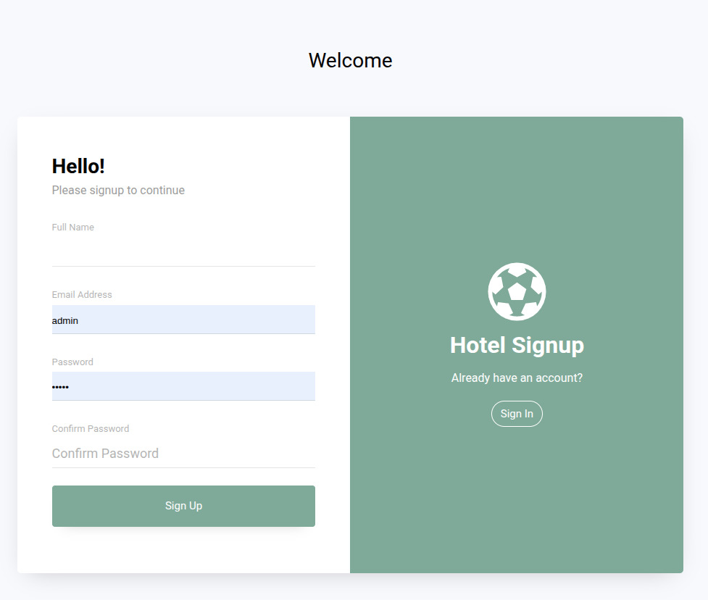

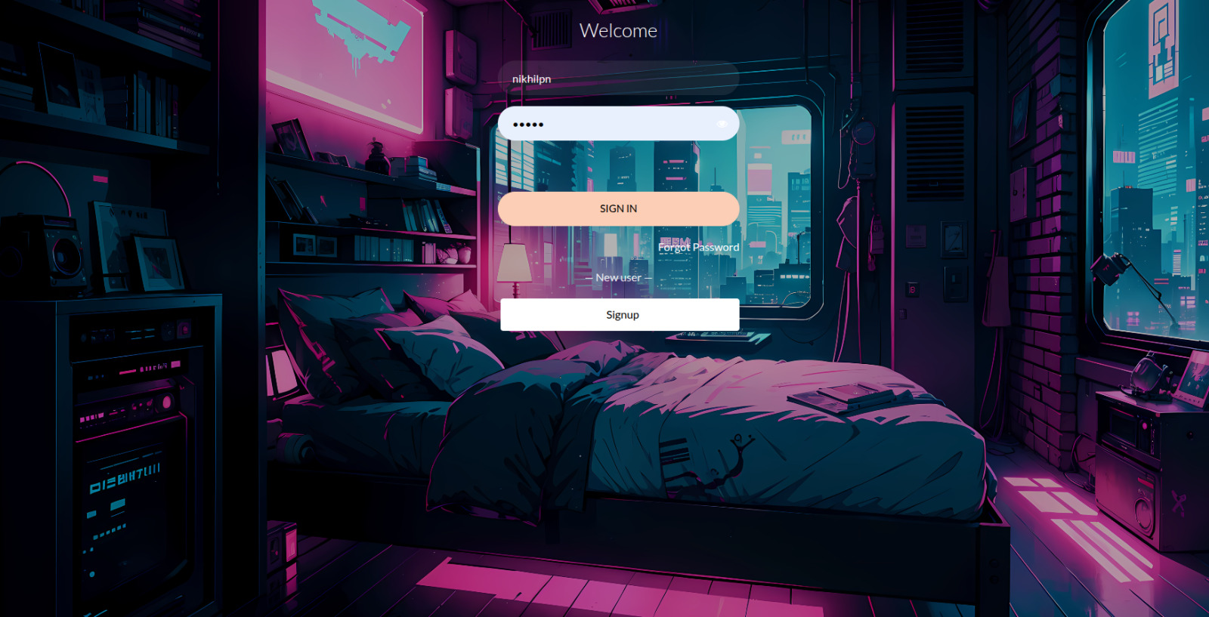

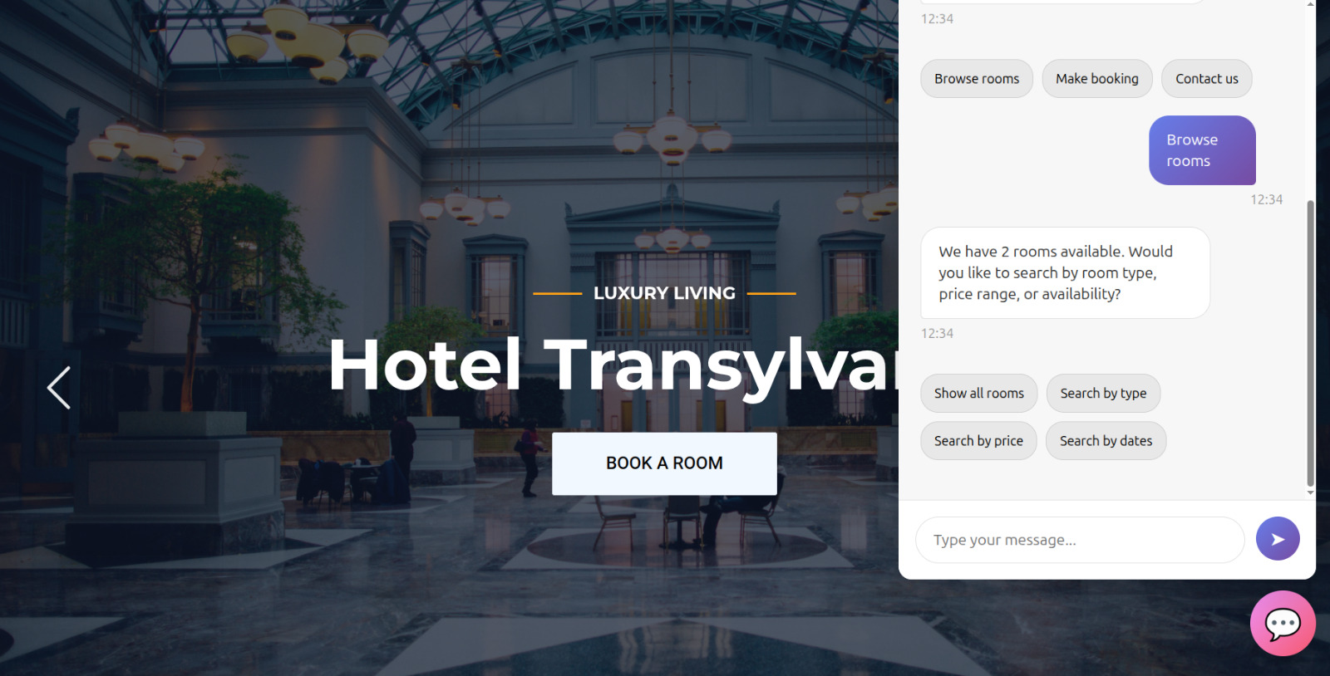

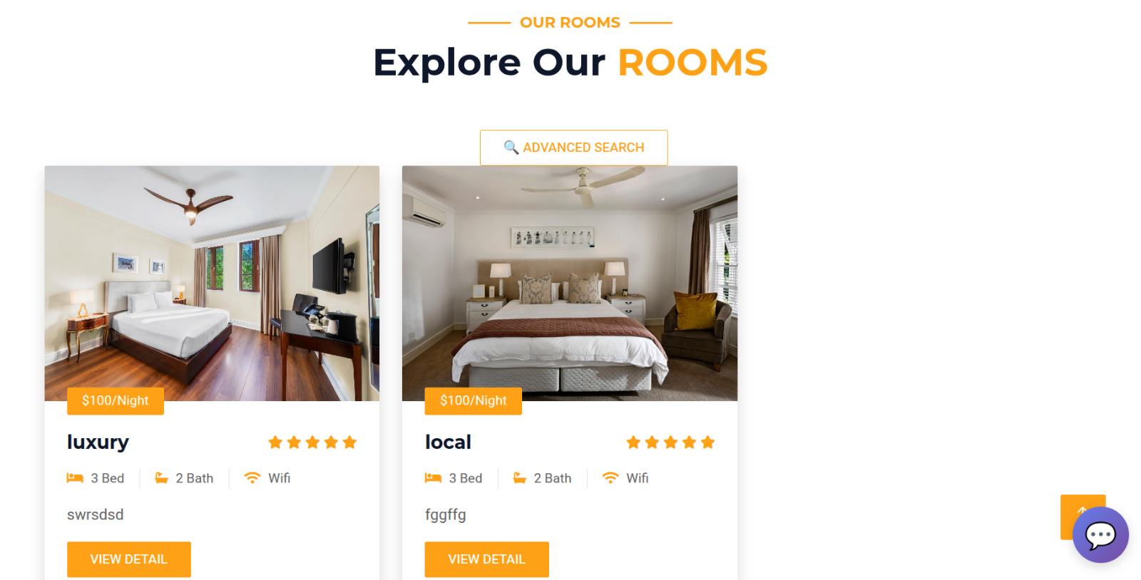

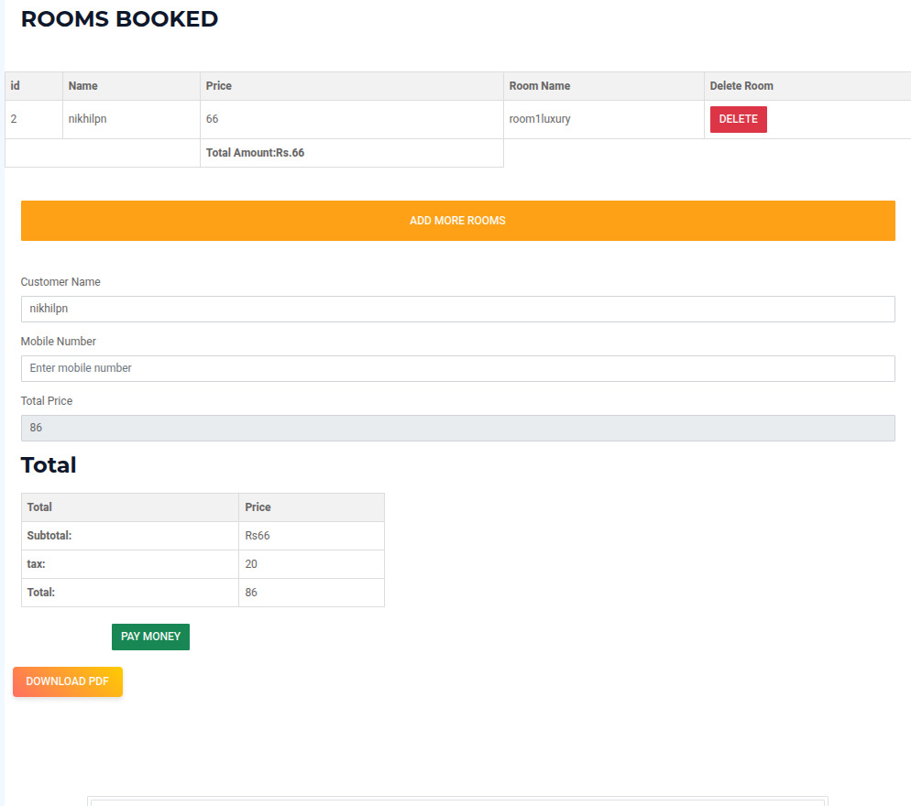

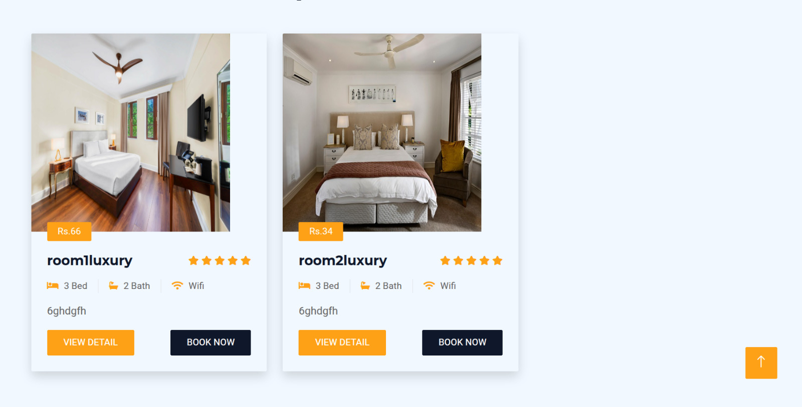

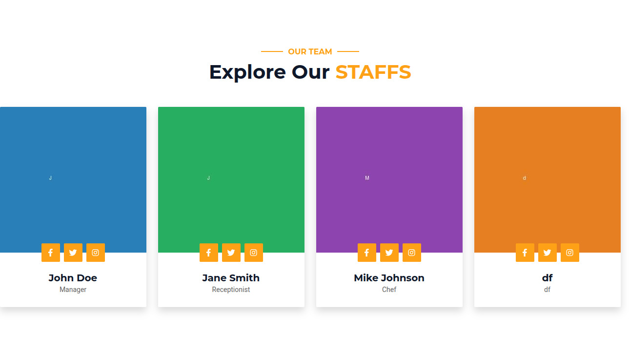

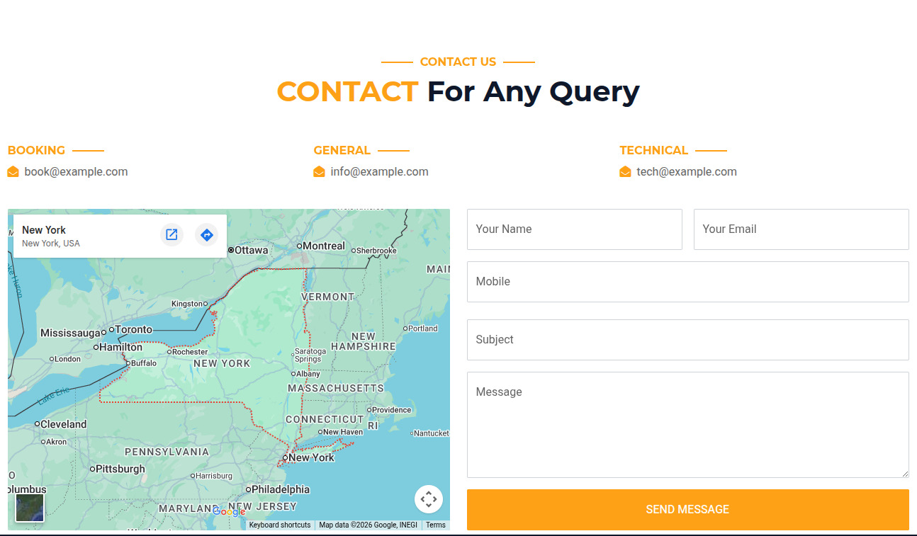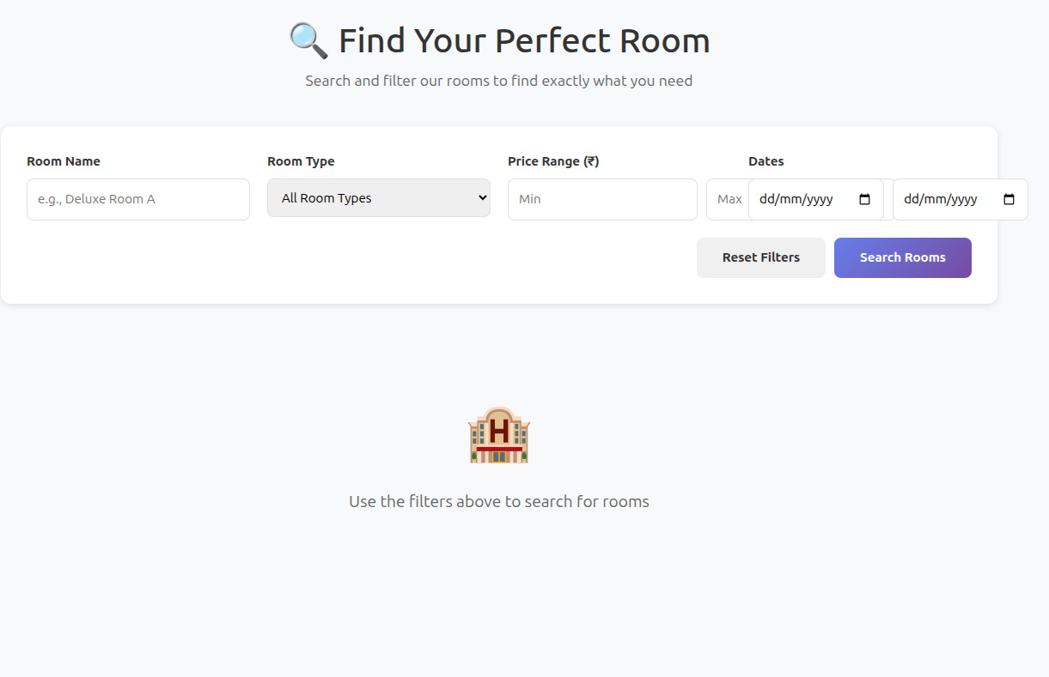

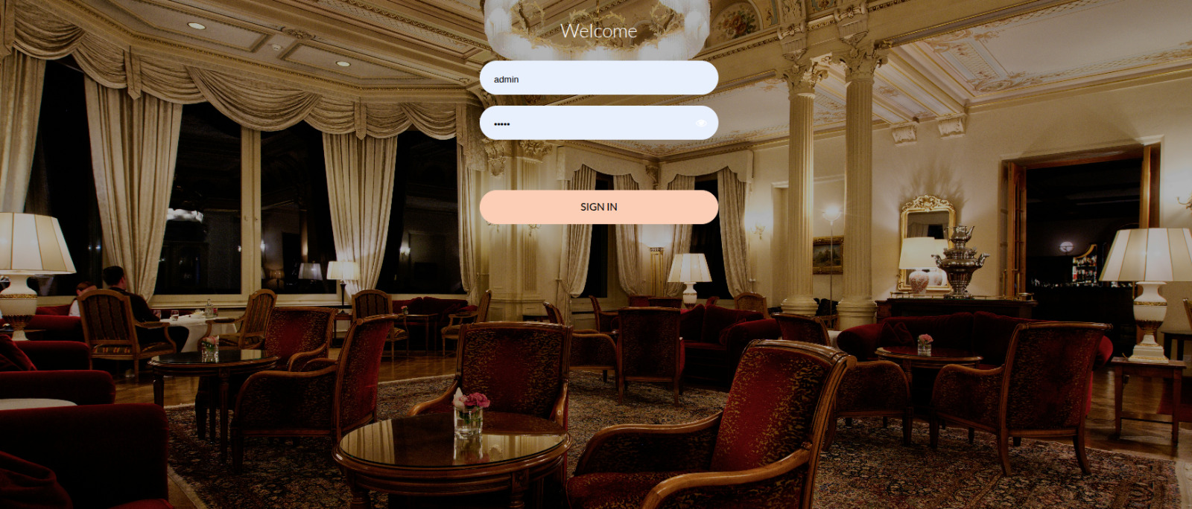

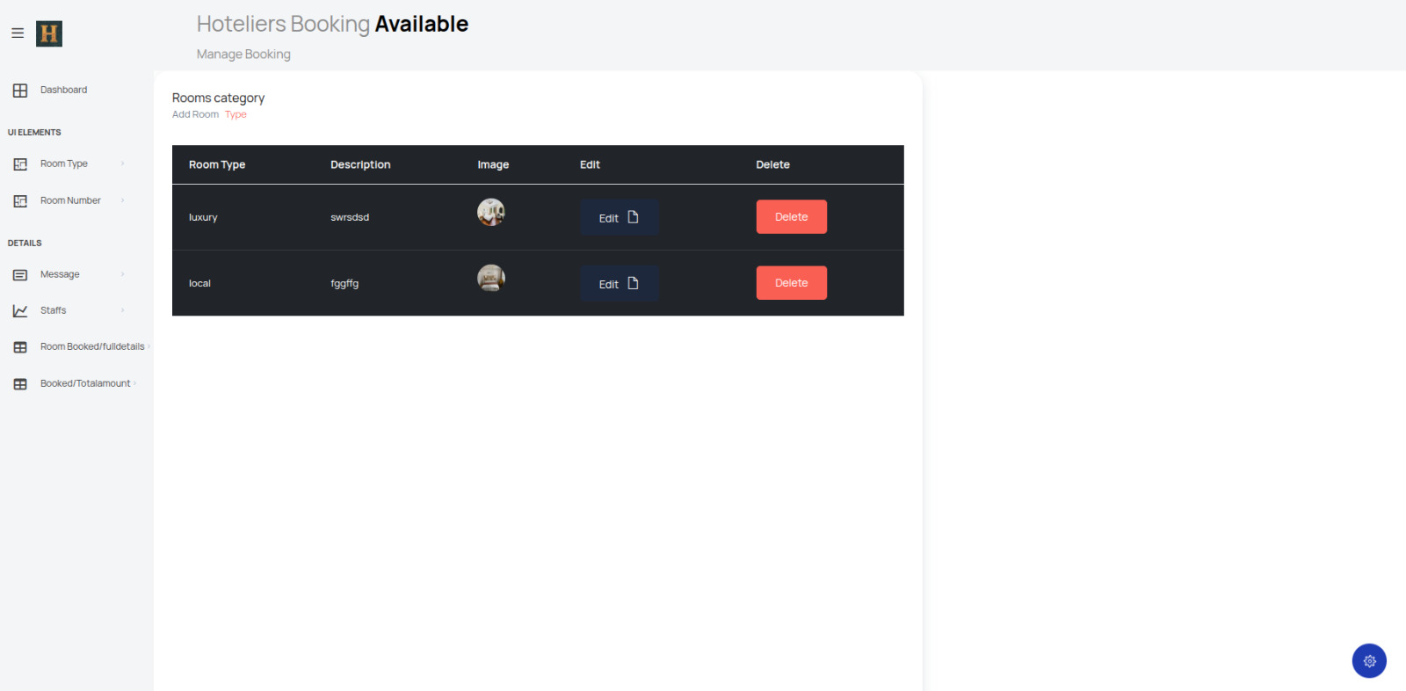

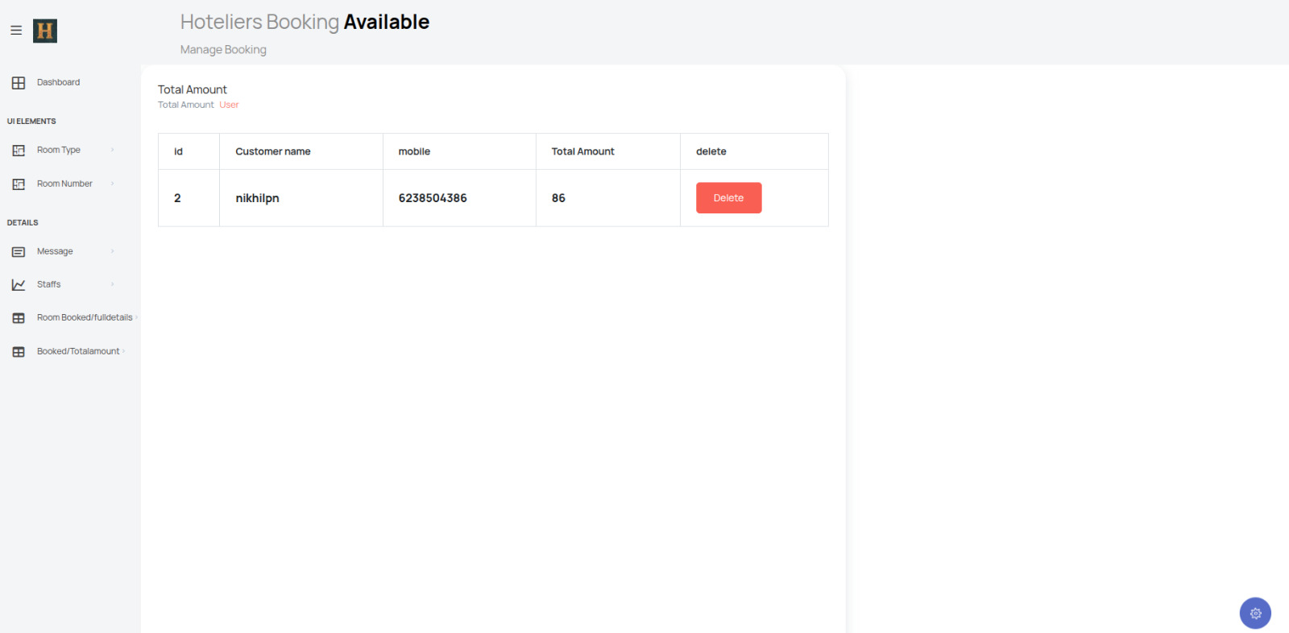

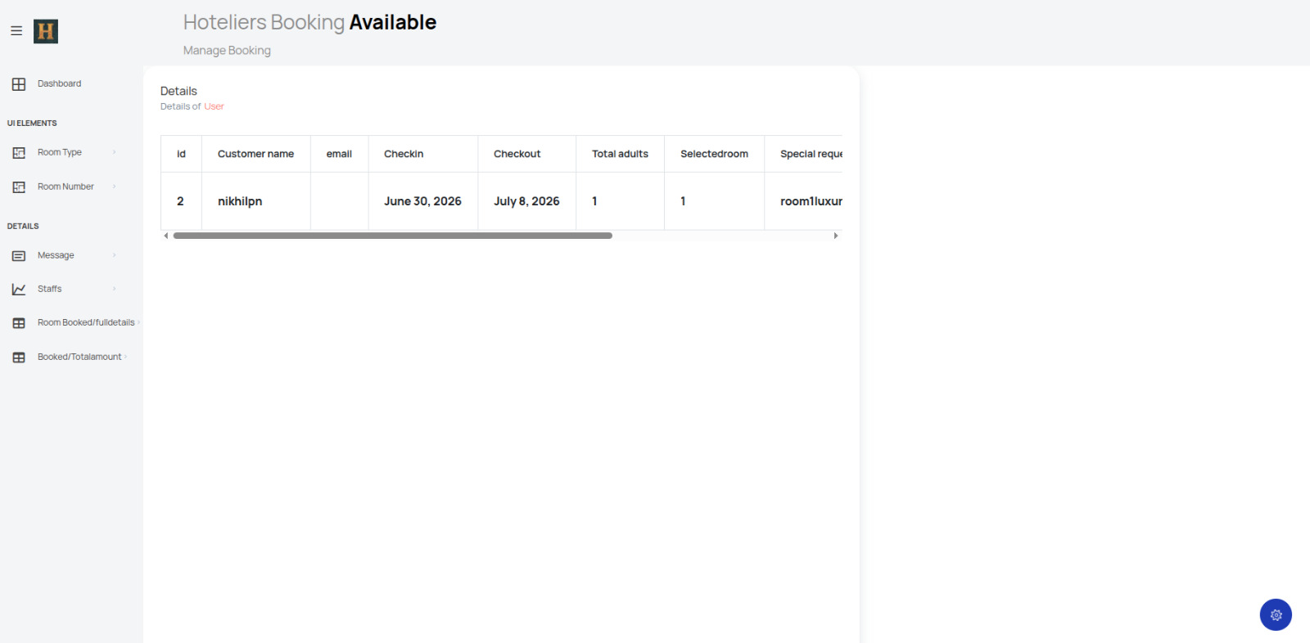

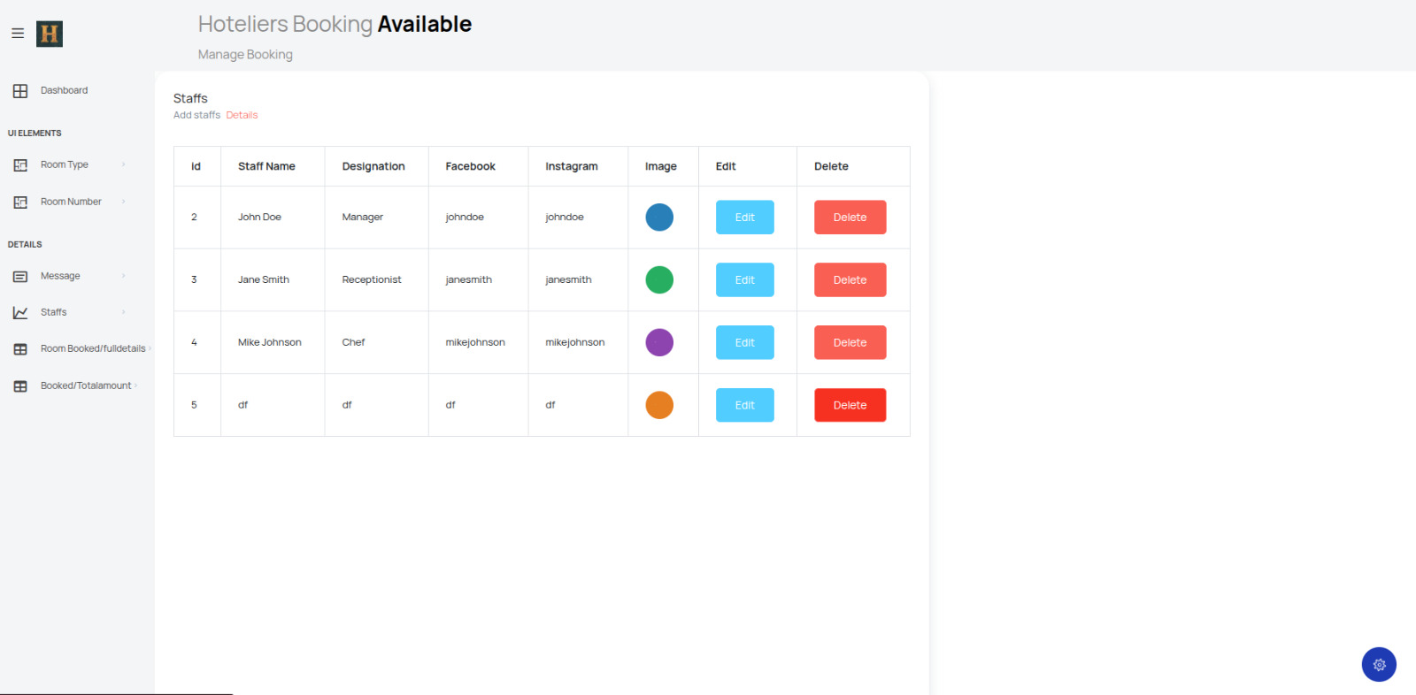
8. Implementation Plan
Phases: (1) Weeks 1-3: Requirements & feasibility. (2) Weeks 4-7: Design & DB schema. (3) Weeks 8-12: Core features (models, admin, auth, search, booking). (4) Weeks 13-16: Advanced (payment, chatbot, email, PDF). (5) Weeks 17-19: Testing. (6) Weeks 20-22: Documentation.
Phase 1 - Requirements Analysis (2 weeks): Studied BCSP-064 guidelines, analysed existing hotel booking systems, identified functional/non-functional requirements, finalised technology stack (Python, Django, PostgreSQL, Bootstrap). Deliverable: SRS document.
Phase 2 - System Design (2 weeks): Designed database schema with 10 normalized tables, created UI wireframes, planned modular app structure, designed chatbot engine. Deliverable: System Design Document.
Phase 3 - Database Setup (1 week): Installed PostgreSQL, created database, implemented Django models, ran migrations. Deliverable: Working database.
Phase 4 - Backend Development (4 weeks): Implemented views, URL routing, admin CRUD, booking engine with overlap detection, Razorpay integration, email notifications, chatbot API, AJAX search. Deliverable: Complete backend.
Phase 5 - Frontend Development (3 weeks): Created responsive Bootstrap templates, admin dashboard, AJAX search UI, chatbot widget, form validation. Deliverable: Complete frontend.
Phase 6 - Testing (2 weeks): Unit testing (25 cases), integration testing (4 scenarios), system testing, user acceptance testing. Fixed 8 bugs. Deliverable: Tested application.
Phase 7 - Documentation (2 weeks): Prepared project report, captured screenshots, compiled source code. Deliverable: Complete report with all deliverables.
Phase 8 - Project Submission (Week 23): Final review of all deliverables, verification of BCSP-064 guideline compliance, preparation of submission bundle, and final project submission through prescribed channels.
The phased approach ensured steady progress throughout the development cycle with clear milestones and deliverables at each stage. Regular reviews at the end of each phase helped identify and address any issues early in the development process, preventing major rework later in the project.
9. Limitations of the Project
- OS Requirement: Requires modern OS (Windows 10+, Linux, macOS) with Python 3.10+ support.
- Software Dependencies: Requires Python, Django, PostgreSQL, and supporting libraries installed.
- Hardware: Dual-core processor, 4-8 GB RAM recommended for multiple concurrent users.
- Rule-Based Chatbot: Uses keyword matching, not NLU. Complex queries may not be understood.
- Plain-Text Passwords: Customer passwords stored as plain text (PBKDF2/Argon2 hashing recommended).
- Single-Hotel: Designed for single hotel use; no multi-branch support.
- No Dynamic Pricing: Prices are fixed; no demand-based adjustment.
- No Refunds: Automated refunds not implemented; manual processing required.
- No Mobile App: Web-only; no native Android/iOS app available.
- No Multi-Currency Support: All prices are in INR only. International guests must manually convert currencies.
- Limited Analytics: Basic payment totals only. No occupancy trends, revenue forecasting, or customer insights.
- Manual Tax Configuration: Tax rates hardcoded as 10% and 20%. No configurable GST engine.
- No Automated Backups: Database backup and recovery requires manual DBA intervention.
- Single-Language Interface: The user interface is available only in English. Multi-language support through Django internationalisation (i18n) would be needed to serve non-English speaking guests in different regions of India.
- No Social Login Integration: Users must register with a username and password. There is no option for social login through Google, Facebook, or other OAuth providers, which would improve user onboarding and reduce registration friction.
- Limited Payment Methods: While Razorpay supports major Indian payment methods, international payment gateways and digital currencies are not supported. International guests may face difficulty making payments.
- Absence of Audit Trail: The system does not maintain detailed audit logs of administrative actions such as who deleted a room or modified a booking, which is important for accountability in a production environment.
10. Future Application of the Project
- Dynamic Pricing: Auto-adjust prices based on demand, season, and occupancy.
- Loyalty Program: Rewards system and discount coupon codes.
- Multi-Hotel: Central dashboard for multiple branches.
- NLP Chatbot: ML-based understanding using OpenAI/Hugging Face.
- OTA Integration: Sync with Booking.com, MakeMyTrip, Goibibo.
- Advanced Payments: Refunds, GST invoices, EMI, wallet support.
- Review System: Customer ratings and reviews with aggregate scores.
- SMS Notifications: Twilio/MSG91 integration for booking alerts.
- Cloud Deployment: AWS, Google Cloud, or DigitalOcean hosting.
- Mobile App: React Native/Flutter for Android and iOS.
- Multi-Language: Django i18n for global customers.
- Room Amenity Tagging: Filter by Wi-Fi, AC, TV, Mini bar.
- Housekeeping Integration: Automated cleaning schedules linked to check-out times for optimal room turnaround.
- Analytics Dashboard: Revenue trends, occupancy forecasts, and customer demographics using Chart.js.
- Channel Manager: Sync room inventory with Booking.com, MakeMyTrip, Goibibo in real-time.
- Voice Assistant: Google Assistant and Alexa integration for voice-based room booking.
- Food and Beverage Ordering: In-room dining and restaurant booking integrated with the main booking module.
- GST Invoice Generation: Automated GST-compliant invoice generation with proper tax breakdown (CGST, SGST, IGST) and invoice numbering for business travellers.
- Digital Guest Profile: Maintain guest preferences, history, and special occasion dates for personalised service and targeted marketing campaigns.
- Automated Review Collection: Post-stay email/SMS campaign requesting guest reviews with integration to Google Business Profile and TripAdvisor.
- Dynamic Room Upgrade: Offer discounted room upgrades during check-in based on current occupancy levels and guest booking history.
- Frequent Guest Dashboard: Self-service portal for returning guests to view booking history, manage preferences, and access exclusive offers.
11. Conclusion
The Hotel Room Booking Website with Assistant Chatbot represents a comprehensive effort to address the real-world challenges faced by small and medium-sized hotels in managing their room inventory, bookings, payments, and guest communications. By leveraging modern web technologies including Python, Django 6.0, PostgreSQL 16, and Bootstrap 5.3, the system delivers a robust, scalable, and user-friendly platform that significantly improves upon the manual and semi-automated methods prevalent in the industry.
The Hotel Room Booking Website with Assistant Chatbot project was successfully designed, developed, and tested as part of the BCSP-064 course requirement. The system addresses the real-world need for an affordable, web-based hotel booking solution that automates room management, customer booking, payment processing, and guest communication.
All ten objectives were met: a full-stack Django application, responsive Bootstrap interface, date-overlap booking prevention, Razorpay payment integration, rule-based chatbot, AJAX search, email notifications, PDF reports, secure access control, and SDLC-aligned development with thorough testing.
The system successfully integrates multiple technologies including Django 6.0, PostgreSQL 16, Razorpay payment gateway, Bootstrap 5.3, and xhtml2pdf into a cohesive, functional web application. Each technology was chosen for its specific strengths and the integration between components follows established best practices for the respective platforms.
The project provides valuable practical experience in full-stack web development covering all layers of a modern web application from database design and server-side business logic to responsive frontend interfaces and third-party API integration. The systematic SDLC approach ensured that the project was completed on schedule with clear documentation at each phase.
In summary, the Hotel Room Booking Website with Assistant Chatbot successfully meets all its stated objectives and delivers a functional, reliable, and user-friendly system suitable for small to medium-sized hotels seeking to establish an online presence with automated booking capabilities.
The system handles the complete booking lifecycle including room browsing, availability checking, payment processing via Razorpay, and automated email confirmations. The modular architecture allows individual components to be updated independently. The chatbot, though rule-based, effectively handles common guest queries and can be enhanced with NLP in the future.
The project demonstrates competence in Python programming, database management, web development, software engineering, and AI-assisted user interaction. The system is fully functional and ready for deployment, providing a solid foundation for a commercial-grade hotel management solution.
The integration of the Razorpay payment gateway provides customers with a seamless and secure online payment experience supporting multiple payment modes, while the automated email notification system ensures timely communication for booking confirmations and password recovery. The AJAX-powered advanced search functionality demonstrates modern web development practices by delivering real-time filtering capabilities without page reloads, enhancing the user experience significantly.
The admin backend interface, built on the Star Admin2 template, provides hotel staff with comprehensive tools for managing room types, individual rooms, staff profiles, bookings, payments, and customer enquiries. The separation of concerns between the customer-facing webapp module and the Backend admin module follows Django best practices and ensures clean code organisation with well-defined responsibilities.
The development of this project has provided invaluable practical experience in full-stack web development, database design and normalization, payment gateway integration, REST API development, AJAX-based asynchronous communication, and professional software engineering methodologies. The systematic approach following the Software Development Life Cycle, from requirements analysis through design, implementation, testing, and documentation, has instilled professional development practices that extend beyond this project into future professional endeavours.
The system was tested at unit (25 tests), integration (4 scenarios), system, and user acceptance levels with all tests passing. Eight bugs were identified and resolved during testing. The database follows 3NF with 10 interconnected tables. The modular architecture allows easy addition of new features.
W3Schools HTML/CSS Tutorial - https://www.w3schools.com/
jQuery API Documentation - https://api.jquery.com/
Git Documentation - https://git-scm.com/doc/
R. Nageswara Rao - Core Python Programming, 2nd Ed., Dreamtech Press.
Mark Lutz - Learning Python, 5th Ed., O'Reilly.
John Watson - Django 5 By Example, 5th Ed., Packt Publishing.
David Beazley, Brian K. Jones - Python Cookbook, 3rd Ed., O'Reilly.
12. Bibliography
Online Documentation
- Django Official Documentation - https://docs.djangoproject.com/
- Python Official Documentation - https://www.python.org/doc/
- PostgreSQL Documentation - https://www.postgresql.org/docs/
- Razorpay Django Integration - https://razorpay.com/docs/
- Bootstrap 5 Documentation - https://getbootstrap.com/docs/
- MDN Web Docs - https://developer.mozilla.org/
- xhtml2pdf Documentation - https://xhtml2pdf.readthedocs.io/
Reference Books
- Adrian Holovaty, Jacob Kaplan-Moss - The Definitive Guide to Django, 2nd Ed., Apress.
- William S. Vincent - Django for Beginners, WelcomeToCode.
- Eric Matthes - Python Crash Course, 3rd Ed., No Starch Press.
- Abraham Silberschatz et al. - Database System Concepts, 7th Ed., McGraw-Hill.
- Regina O. Obe, Leo S. Hsu - PostgreSQL: Up and Running, 3rd Ed., O'Reilly.
IGNOU Study Materials
- BCS-051: Introduction to Software Engineering

