Systematic benchmarking of bulk transcriptomic harmonization tools across a multi-platform germinal centre B-cell lymphoma cohort identifies MNN and SVA as top-performing methods

Authors: Daniil Nikitin^{1*}, Arsen Arakelyan, Nicolas Borisoff, Maria Savchenko, Anatoly Bobe, Alexandr Bagaev?

Affiliation:
Institute of Molecular Biology, National Academy of Science of the Republic of Armenia

*Correspondence: danya.nikitin.orel@gmail.com
Переделать под NAR, свести вместе Результаты и Обсуждение.

ABSTRACT
Cross-platform harmonization of bulk transcriptomic datasets remains a fundamental challenge for the development of reproducible cancer biomarkers, as unresolved batch effects introduce systematic technical noise that dwarf biologically meaningful variation. Most existing harmonization tools are benchmarked on datasets with large inter-group biological differences (e.g., TCGA tumour types), whereas actionable cancer biomarkers mining demands preservation of subtle transcriptional distinctions between closely related diagnoses.

Here we present ComboBatch, a systematic benchmarking pipeline that evaluates the full cross-product of 14 batch removal strategies, 3 imputation methods, 31 harmonization algorithms, and 2 post-removal conditions across 7,174 samples from 88 germinal centre B-cell lymphoma cohorts spanning four transcriptomic platforms.

Scoring 87 quality metrics across 2,234 harmonization attempts, we show that method choice (eta-squared = 0.36) and batch removal strategy (eta-squared = 0.26) are the principal determinants of harmonization quality, while imputation (eta-squared = 0.016) and post-removal (eta-squared < 0.01) play secondary roles. Mutual Nearest Neighbours (MNN) and Surrogate Variable Analysis (SVA) with softimpute and KNN were the top-performing methods, jointly resolving follicular lymphoma (FL), diffuse large B-cell lymphoma (DLBCL), and normal germinal centre B-cell transcriptional differences in the multiplatform and RNA-seq only dataset compositions, respectively. We provide a data-driven four-scenario decision tree for harmonization method selection, applicable to any retrospective multi-platform transcriptomic study.

INTRODUCTION

Отметить что несмотря на модные методы типа spatial транскриптомики, single cell – bulk самый объемный по биологии. В Обсуждении написать, что планируем сделать аналогичную интеграцию датасетов с single cell. И написать в Обсуждении какой объем выборки есть по пациентам – найти сколько есть сингл селл датасетов по GC B cell lymphomas, сравнить с моими датасетами с их числом. И сделать вывод что bulk неизбежен. Отметить, что у single cell будут другие проблемы.

Объединить результаты и обсуждение – потому что у меня блочная структура обсуждения.
Despite considerable progress in transcriptomic batch correction, technical variation introduced by differences in sequencing platform, RNA extraction protocol, and sample preservation method remains a principal obstacle to the development of reproducible cancer biomarkers — particularly for AI-driven classifiers trained on heterogeneous multi-cohort datasets. When batch effects are inadequately removed, models learn to exploit technical artefacts rather than true biological signal, a phenomenon that has been termed algorithmic hallucination (Yu et al., 2024). Batch-confounded AI models can undergo performance collapse upon deployment, as exemplified by an AUC decrease from 0.79 to 0.50 reported for a digital pathology prognostic classifier (Dawood et al., 2024).[1]

The two principal sources of batch variation in multi-platform transcriptomic studies are the technology axis — microarray versus RNA-seq — and the biomaterial axis — fresh-frozen (FF) versus formalin-fixed paraffin-embedded (FFPE) tissue — which introduce systematic differences in gene coverage, dynamic range, and signal-to-noise ratio.

Most harmonization tools have been developed and benchmarked on datasets characterized by large inter-group biological differences, such as TCGA pan-cancer collections, in which the biological signal substantially exceeds technical noise. However, the vast majority of cancer studies analyze related subtypes — such as FL and DLBCL, which share a common germinal centre B-cell origin and exhibit partially overlapping transcriptional programs. These studies operate in a fundamentally different signal-to-noise regime, in which technical batch effects can exceed the biology of interest by an order of magnitude.

RESULTS

Application of batch removal strategies, harmonization methods, imputation methods and post-removal to the FL dataset

We assembled a multi-platform dataset of 7,174 bulk transcriptomic profiles from 88 cohorts spanning RNA-seq, Affymetrix, Illumina, and Agilent microarray platforms (Figure 1A). With a focus on germinal centre (GC) B-cell malignancies, the dataset comprised 4,466 DLBCL, 1,697 FL, and 875 normal B-cell samples (Figure 1B), together with 88 Burkitt lymphoma and 34 high-grade B-cell lymphoma samples from overlapping cohorts serving as additional reference biology groups. Complete sample annotation is provided in Supplementary Table 1.

To benchmark publicly available harmonization tools in an unbiased manner and identify the optimal approach for a dataset with subtle biological and pronounced technical differences, we designed a nine-step computational pipeline named ComboBatch (Figure 1C). Starting from the full multi-platform dataset, ComboBatch applied one of 14 prior batch removal strategies — retaining sample subsets defined by platform or biomaterial type, or excluding outlier batches identified by annotation or unsupervised screening — followed by imputation of missing expression values using KNN or softimpute (or strict exclusion of genes with any NA), log2-transformation per cohort, and one of 31 harmonization methods. Of the 38 methods identified through literature search, 7 failed implementation and are documented with reasons in Supplementary Table N. Optionally, the pipeline excluded a single PCA-outlier batch after harmonization as a fine-tuning step. The pipeline then computed 87 polarity-defined scoring metrics and assembled an integrated clustermap across all harmonization attempts — each defined as a unique combination of prior batch removal strategy, imputation method, harmonization algorithm, and post-removal status. The full cross-product of these four factors yielded 2,234 successfully completed harmonization attempts. 27???

The dataset was markedly imbalanced with respect to both batch and biology group composition. Among the five largest RNA batches by sample count, the fifth-largest (GPL14951_FFPE, 810 samples) and sixth-largest (GPL570_FFPE) contained DLBCL exclusively, while the second-largest (GPL570_Unknown, 1,007 samples) comprised only four biological groups: FL, DLBCL, Burkitt lymphoma, and normal B cells (Figure 1D). The distribution of biological groups across batches was more uniform (Figure 1E): DLBCL and FL were represented in 12 and 15 batches, respectively, whereas rare groups showed extreme batch skew — high-grade B-cell lymphoma was confined to a single batch (RNASeq_FFPE_Exome_capture), and plasmablasts and Burkitt lymphoma were each represented by two batches. Analogous composition skew was observed at the cohort level (Supplementary Figure 1): the five largest cohorts by sample count were exclusively DLBCL (Supplementary Figure 1A), with the exception of the SOM cohort (ref). Normal B cells were profiled predominantly in smaller cohorts. With two exceptions (Kassandra and PUB_FL_NCISTAUDT), each cohort contributed samples to a single RNA batch (Supplementary Figure 1B).

Figure 1. Dataset composition and computational pipeline. (A) Dataset composition by batches. (B) Dataset composition by biology groups, each point represents one sample here and in the panel A. (C) Scheme of the ComboBatch computational pipeline. (D) Bar plot of sample counts by batches and biology, ordered by batches. Biology groups are color coded according to the B panel color legend. (E) Bar plot of sample counts by biology and batches, ordered by biology groups. Batches are color coded according to the A panel color legend.
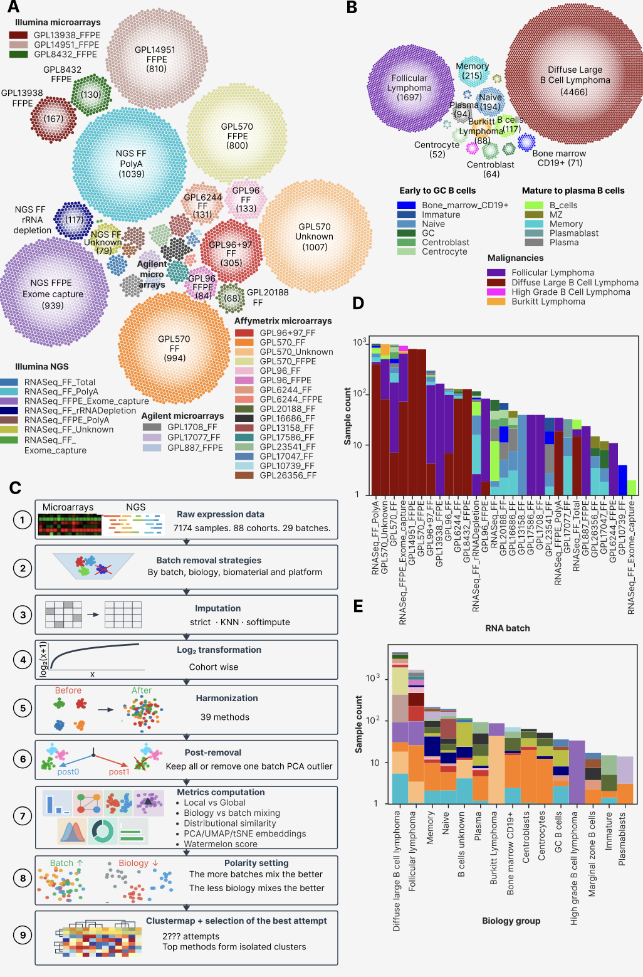
The initial step of ComboBatch was prior batch removal, implemented across 14 distinct strategies (Figure 2A), grouped by selection criterion: platform type (RNA-seq only; Affymetrix-only microarrays, all microarrays), biomaterial (FF-only; FFPE-only), tumor biology (malignant only), and outlier batch exclusion (rare batches and those performing poorly in initial FSQN and quantile normalization screening; Supplementary Table N, Supplementary Figure N). Imputation substantially increased the number of genes available for downstream analysis (Figure 2B): strict NA exclusion yielded between 3,447 genes (S0 and D strategies) and 6,797 genes (C strategy), whereas KNN and softimpute imputation extended this range to 6,797 (J strategy) -15,885 (C strategy) genes. KNN and softimpute produced identical gene sets because both were applied exclusively to genes with fewer than 20% NA values per strategy subset. Strict NA exclusion produced predominantly unimodal expression distributions in microarray cohorts (16 of 88) and bimodal distributions in RNA-seq cohorts (72 of 88; Supplementary Figure 2), whereas KNN and softimpute yielded more homogeneous per-cohort distributions, reducing the number of cohorts with unimodal distributions to 5 (KNN, Supplementary Figure 3) and 3 (softimpute, Supplementary Figure 4), respectively. Notably, softimpute also introduced spurious trimodal expression distributions in 14 cohorts (Supplementary Figure 4), an imputation artifact consistent with the low-rank approximation underlying the algorithm and its sensitivity to heterogeneous missingness patterns (ref). https://docs.google.com/presentation/d/1G5UKZZrDl2wkUc5Z_ipnPASIwSJEpqA9/edit?slide=id.g3d627fdd336_2_120#slide=id.g3d627fdd336_2_120

The initial dataset exhibited substantial heterogeneity in gene coverage before any NA handling (Figure 2C): RNA-seq, GPL570, and GPL14951 batches provided expression values for more than 15,000 genes, whereas rare platform batches (GPL20188_FF, GPL13158_FF, and GPL16686_FF) contained only 6,000-7,000 genes with defined expression. This inter-platform heterogeneity was the primary driver of the restricted gene numbers obtained under strict NA exclusion (3,447-6,797 genes), a limitation largely overcome by imputation (6,797-15,885 genes).

We visualized gene set overlaps across imputation and strict NA-exclusion approaches using a Circos-Sankey plot (Figure 2D). Iterative batch removal — in PCA space (strategies A to E1 to E2 to E3) or restricted to microarrays (strategies F to H to G) — did not substantially increase post-imputation gene counts, although strict gene numbers rose from 3,447 (strategy F) to 6,133 (strategy H), and from 3,520 (A) to 5,658 (B) and 5,175 (E1). By contrast, imputation yielded a 3.4-fold gene count increase for the unrestricted S0 strategy (3,447 to 11,768 genes). The strategies with the highest post-imputation gene numbers (A, E1-E3, B, D, K, C) shared near-identical gene sets, with pairwise Jaccard indices of 95-100% (Supplementary Figure 5), indicating that imputation is most effective when the contributing platforms and biomaterials have broadly overlapping transcriptome coverage.

Figure 2. Batch removal strategies, NA genes and imputation. (A) Circos-Sankey plot showing batch removal strategies and number of samples remaining after each strategy being applied. The strategies extend from the central blue circle symbolizing the S0 strategy, and logically they are divided into the four groups (arcs in the blue circle): by platform, by biology, by biomaterial, bad batches removal. (B) Bar plots showing gene number under the strict approach (bottom plot, all genes with at least one NA in a dataset removed) and after the imputation procedures (top plot, KNN or Softimpute). Gene number counted as number of genes having non-NA expressions in at least one sample in the dataset. (C) Heat map of NA/defined expression by genes and samples in the dataset. Samples and genes are ordered by ascending NA count from left to right and from top to bottom. Palettes for color annotation in the top of the heat map can be found in Figure 1A, 1B. (D) Circos-Sankey plot showing gene numbers and overlapping of gene sets for batch removal strategies under the strict NA handling and gene imputation. Batch removal strategies are structured by the same four groups as in the panel A.
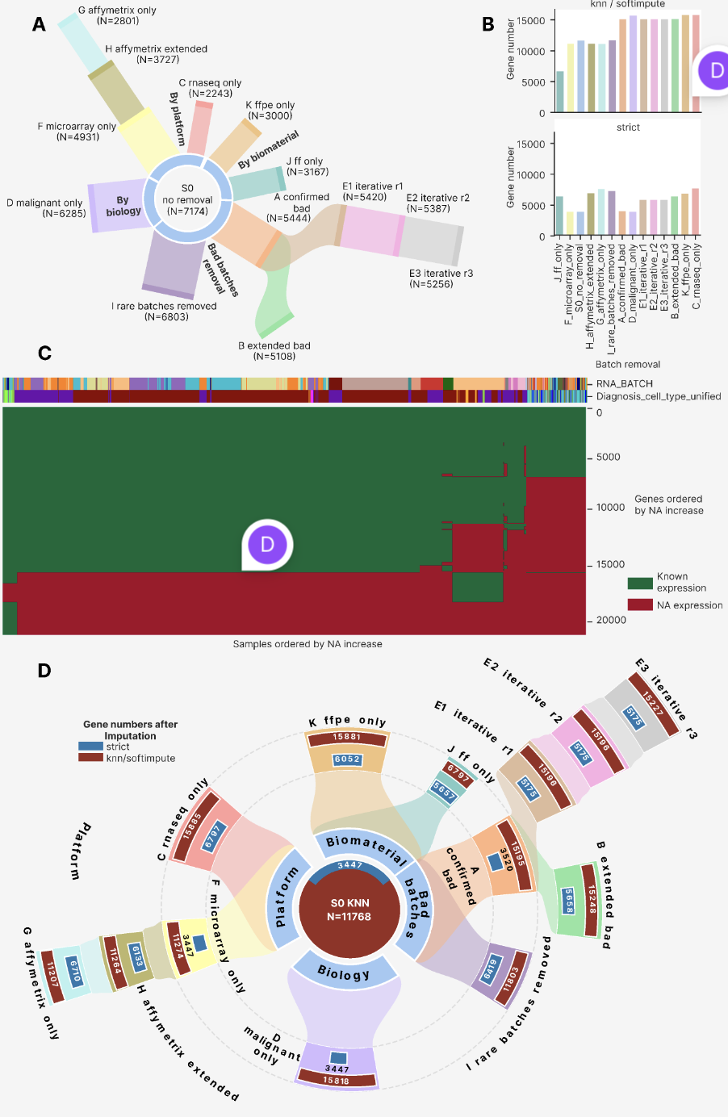

Best approaches selection
For each combination of batch removal strategy and imputation method, we applied 31 harmonization algorithms followed by an optional post-removal step, yielding 2,407 harmonization attempts in total, of which 2,234 completed with fewer than 5% of samples having exclusively NA expression values. We computed up to 230 harmonization metrics per attempt, selected from the published literature to span all dimensions of cross-platform harmonization quality (Supplementary File N; Table N in Methods). For strategies restricting samples to a single platform or biomaterial (strategies C, G, J, and K), a subset of annotation-dependent metrics was undefined: for example, in strategy J (FF only), the column RNASEQ_SOURCE was invariant, rendering all metrics conditioned on that column inapplicable. Additionally, some attempts were terminated by a 3-hour CPU timeout (add more about it).

For 87 of the 230 computed metrics, we manually assigned polarity values of +1 (higher is better) or -1 (lower is better), based on the principle that high-quality harmonization should maximize batch mixing and preserve biological group structure: metrics quantifying the homogeneity of batch-class distribution in expression space were assigned positive polarity, whereas metrics quantifying biological group mixing were assigned negative polarity. Polarity assignments for all 87 metrics are listed in Supplementary File X.

Using the 87 polarity-defined metrics and 2,234 qualifying harmonization attempts, we constructed a clustermap to characterize the overall quality landscape of the harmonization attempt space (Figure 3). At the level of metric structure, the 87 metrics resolved into six co-clustering groups: three comprising global metrics, and three comprising distributional similarity, NA-percentage, and local mixing metrics, respectively. To characterize the relationship between local and global metric performance, we constructed a separate Spearman cross-correlation clustermap among all 87 metric vectors computed across the 2,234 attempts (Supplementary Figure 6). This analysis revealed an isolated cluster of 33 metrics — 22 of which were local mixing metrics — that negatively correlated with a second cluster of global metrics (10 global, 6 distributional, and 1 other). A third cluster showed no dominant correlation direction with the other two, it consisted of global, other and distributional metrics. Within the larger metric-type clusters, smaller sub-clusters formed around shared annotation columns (primarily PLATFORM_RNA and RNASEQ_SOURCE, describe these metrics in Supplementary), with no systematic grouping by metric group. PCA, UMAP, and tSNE embeddings of metric vectors (Supplementary Figure 7) confirmed large-scale co-localization by metric type and finer-scale grouping by annotation column, with no pattern by metric group.

At the level of harmonization attempts, the clustermap revealed four major clusters (Figure 3). Based on relative metric performance and the co-clustering patterns of batch removal strategies, we designated these clusters: 'good cross-platform', 'bad cross-platform', 'same sample type', and 'same platform'. The 'same sample type' and 'same platform' clusters each contained a good and a bad sub-cluster, separated primarily by local mixing metrics — specifically LISI values and UMAP/tSNE entropy. The 'good cross-platform' cluster correspondingly showed higher local metric values than its 'bad' counterpart. Across all harmonization attempts, kBET acceptance rate was the only local mixing metric that remained near-zero universally, with the sole exception of RNA-seq-only configurations with post-removal applied.

Metrics in the 'NA percentage' cluster showed uniformly high performance across all attempts; the sole exception was pct_genes_noNA, which recorded poor performance exclusively for the Angel harmonizer. Metrics conditioned on the RNASEQ_SOURCE and PLATFORM_RNA annotation columns were undefined for strategies restricted to a single sample type (J, K) or a single platform (H, C), respectively, because these columns were invariant within those strategy subsets. Global cluster B metrics (primarily tSNE/UMAP centroid-based measures) showed highest performance within the 'good cross-platform' cluster and the good sub-clusters of 'same platform' and 'same biomaterial'. Distributional similarity metrics showed an analogous pattern, while global cluster C metrics showed intermediate performance across the full attempt set.

We calculated Spearman cross-correlations between all harmonization attempts in the 87-metric scoring space and constructed a clustermap of these correlations (Supplementary Figure 9). The four clusters identified in the primary clustermap — 'same platform', 'same sample type', 'good cross-platform', and 'bad cross-platform' — were reproduced, confirming cluster identity was not an artefact of the primary metric-space embedding. As in the primary clustermap, clustering was driven primarily by batch removal strategy and secondarily by harmonization method. Unlike the metric cross-correlation clustermap (Supplementary Figure 7), no negatively correlating attempt clusters were observed. The 'same sample type' cluster showed the strongest deviation from all others, with Spearman correlations of only 0.1-0.25 relative to 'same platform' and 'good cross-platform' clusters. PCA, UMAP, and tSNE embeddings of harmonization attempts in the 87-metric space (Supplementary Figure 10) confirmed the dominant influence of batch removal strategy and harmonization method, and revealed no co-clustering by method harshness.
Figure 3. Cluster map of 2234 harmonization attempts (columns) in a space of 87 quality metrics (rows). Black cells represent NA metrics. The best attempts by clustermap are outlined below it via arrows and a rectangle for the MNN group.
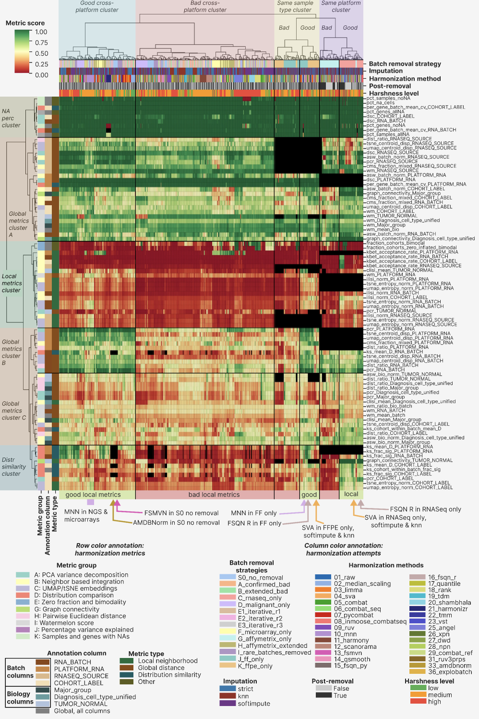

Best approaches
Based on clustermap visual inspection combined with quantitative composite scoring, we identified eight best-performing harmonization approach groups (Table 1), spanning multi-platform and single-platform strategies as well as FF-only and FFPE-only compositions. MNN and SVA emerged as the most versatile harmonization methods: MNN achieved top performance across multi-platform and FF-only strategies, while SVA showed highest performance in RNA-seq-only and FFPE-only contexts.

Table 1. Best harmonization approaches groups identified via the integrative clustermap assessment in Figure 3.
Group name | Batch removal strategies | Harmonization methods | Imputation | Reason to include
MNN multiplatform | All multiplatform strategies: S0, A, B, D, E1, E2, E3, I | MNN | Any | Superior local metrics performance compared to the rest attempts in the ‘good multiplatform cluster’
FSMVN in S0 | S0 | FSMVN | Any | High quality mixing of NGS and Illumina microarrays on UMAP and tSNE
AMDBNorm in S0 | S0 | AMDBNorm | Any | High quality mixing of NGS and Illumina microarrays on UMAP and tSNE
MNN FF only | J | MNN | Any | Best performance by local metrics in the FF part of the good “Same sample type” cluster
FSQN R FF only | J | FSQN R | Any | Hugh quality mixing of NGS and microarrays on UMAP and tSNE
SVA FFPE only | K | SVA | KNN, Softimpute | Best performance by local metrics in the FFPE part of the good “Same sample type” cluster
SVA RNASeq only | C | SVA | KNN, Softimpute | Best performance by local metrics in the RNASeq part of the good “Same platform” cluster
FSQN R RNASeq only | C | FSQN R | Any | High quality mixing of RNASeq FF and FFPE batches on UMAP and tSNE

Without harmonization, the FL dataset exhibited a pronounced batch effect structure in both PCA and tSNE space (Figure 4A). In PCA, RNA-seq samples formed a compact central cluster, while Affymetrix GPL570 batches arranged in a linear upper-right trajectory, and the remaining microarray batches (Affymetrix, Illumina, and Agilent) formed a lower-right trajectory. In tSNE, RNA batches dispersed into discrete compact clusters across the full embedding, confirming the validity of the RNA_BATCH annotation, with no discernible biological grouping. After MNN harmonization under strict NA handling, a single cohort outlier remained apparent in PCA space — the SOM cohort, which had undergone prior quantile normalization — while the remaining cohorts clustered together (Figure 4B). tSNE revealed only three batch outliers: a subset of RNASeq_FFPE_Exome_capture, a subset of GPL570_Unknown (the same SOM cohort), and the majority of the GPL570_FFPE batch. All remaining samples organised into biologically coherent groups, with FL, DLBCL, and normal B cells forming discrete clusters with batches mixing within each group, although Illumina microarray samples formed a distinct sub-cluster. Strategy D (malignant-only, Figure 4C) produced further improvement in the concurrence of biological clustering and batch mixing. Hierarchical clustering in the first-ten-PC space before and after MNN harmonization — with the SOM cohort removed — confirmed increased batch intermixing after harmonization: FL and normal B cells resolved into single isolated clusters, though DLBCL samples retained a partially batch-structured dendrogram topology (Figure 4D). Strategy H (Affymetrix extended) under MNN similarly highlighted the pre-normalised SOM cohort as a PCA outlier (Supplementary Figure 11A), and all three MNN-harmonized strategies showed 2-3 consistent batch outliers in both UMAP and PCA space (Supplementary Figure 11B, C).

We next examined the second top-performing approach: SVA applied to the RNA-seq-only strategy (Figure 4E). Both PCA and tSNE revealed near-complete batch mixing — including the previously outlying RNASeq_FFPE_Exome_capture batch — with concurrent preservation of biological group separation. This level of performance was achieved exclusively with KNN and softimpute imputation; strict NA handling failed to mix the major FF and FFPE batches in PCA, UMAP, or tSNE space (Supplementary Figure 12A-C), and the strict SVA result was visually indistinguishable from the unharmonized data. Hierarchical clustering in the first-ten-PC space before and after SVA harmonization (Figure 4F) demonstrated a near-complete transition from a batch-structured to a biology-structured dendrogram: FL samples resolved into a single discrete cluster, and normal B cells formed a sub-cluster nested within the broader DLBCL clade.

Figure 4. SVA in RNA-seq only and MNN in multiplatform strategy, the best harmonization attempts. (A) Raw dataset without batch removal (S0 strategy) dimensional reduction visualization in a 2 X 2 square grid. The upper row is visualization by batch, the lower one shows biological groups. The left column contains PCA plots, the right column shows tSNE plots. (B) PCA and tSNE visualization of batches and biology in the MNN harmonized S0 dataset, the structure is the same as in the panel A. (C) tSNE visualizations of MNN harmonized D dataset (malignant only), the lower one is by batch, and the upper one is by biology. (D) Comparison of first 10 PCs dendrograms in the raw (top) and MNN-harmonized S0 dataset (bottom), with color annotation by batch and biology. (E) Square grid with PCA/tSNE visualizations of SVA-harmonized KNN-imputed C dataset (RNA-seq only), the structure is the same as in the panel A. (F) Comparison of first 10 PCs dendrograms in the raw (top) and SVA-harmonized, KNN imputed S0 dataset (bottom), with color annotation by batch and biology. Color palettes of batch and biology groups are applicable to all the panels of this figure and are shown below the E and F panels.
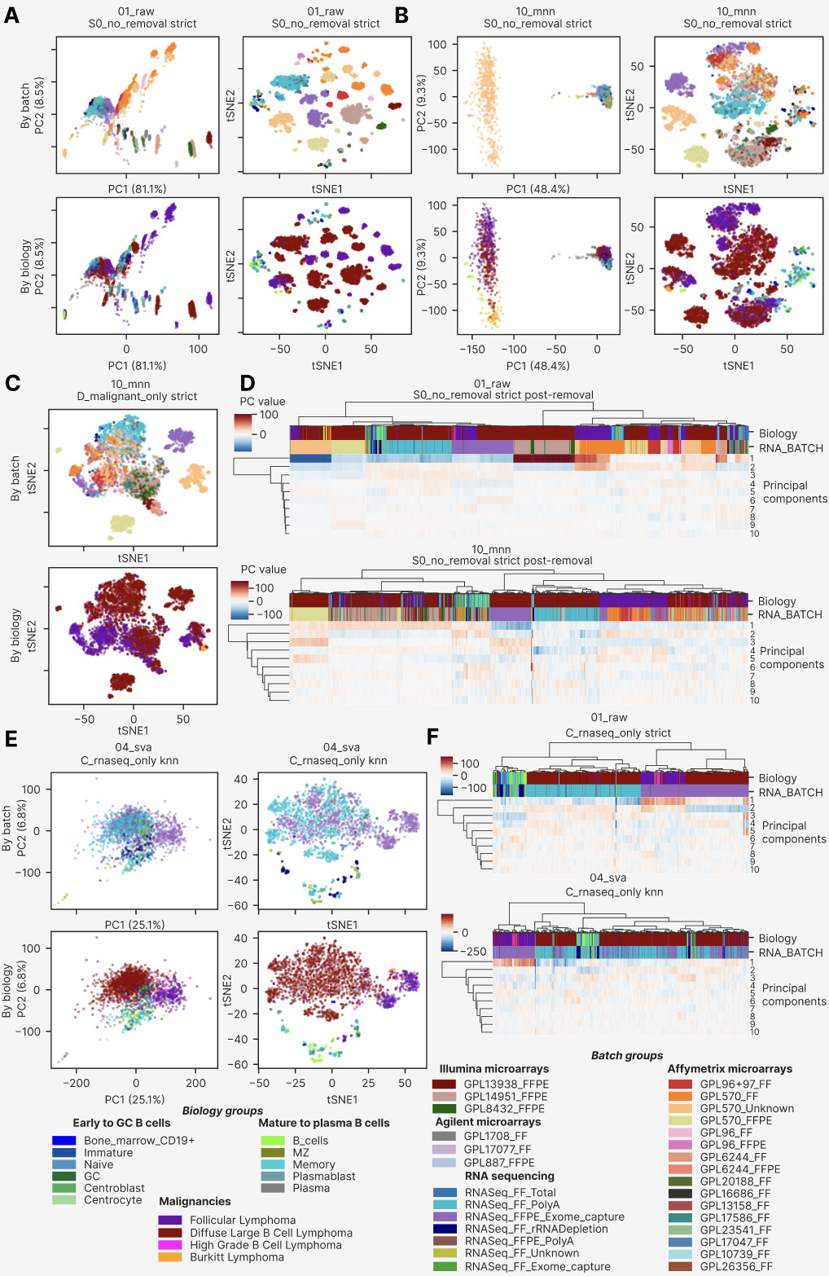

The second-best approach for the RNA-seq-only strategy (C) was FSQN R — the method implemented using the original R package, as distinct from the custom Python re-implementation (method 15_fsqn_py). On PCA, samples clustered by biological group (Supplementary Figure 13A), while non-linear dimensionality reduction revealed additional substructure within biological groups with improved batch mixing relative to the unharmonized data (Supplementary Figure 13B, C): there were 3 batch-derived subclusters in the DLBCL cluster and two ones in the FL one.

We next visualized and assessed the remaining top-performing approaches across all benchmark strategies (Figure 5). In the FF-only MNN-harmonized dataset, PCA revealed incomplete batch mix but biologically relevant batches ordering: FL between normal cells and DLBCL (Figure 5A). tSNE confirmed this supremacy of biology over batch, but there was high degree of same batch connectivity: most NGS and Affymetrics platforms formed isolated clusters (Figure 5A). Yet, clustering in the first 10 PCs revealed and improvement of batch mixing primarily for microarrays (Figure 5B). FSQN R harmonization was selected as the second-best approach for FF only, because it resulted in the less pronounced biological clustering supremacy on both PCA, UMAP and tSNE (Supplementary Figure 14A, B, C, respectively). FL batch-level subclusters surrounded the DLBCL cluster instead of being between it and normal cells (Supplementary Figure 14A).

For the FFPE only batch removal strategy, the top approach of SVA harmonization and softimpute imputation resulted in a larger success: DLBCL samples of NGS, Affymetrix and Illumina microarrays mixed perfectly on both PCA and tSNE (Figure 5C), whereas FL batch-dependent subclusters formed a large cluster without intersection with DLBCL. First 10 PCs clustering (Figure 5D) resulted two high level branches, each consisting of FL and DLBCL and having homogeneous mixing of batches in DLBCL and heterogeneous in FL. Before harmonization we observed a complete dominance of batch over biology on the dendrogram (Figure 5D). Softimpute imputation mixed batches in FFPE only better than the KNN and strict approach, leading to the minor Illumina microarray GPL8432_FFPE mixing with other batches in softimpute. This effect was not clear on PCA (Supplementary Figure 15A) but was observable on UMAP and tSNE (Supplementary Figure 15B, C, respectively).

Finally, FSMVN and AMDBNorm methods showed promising results for the cross-platform harmonization of Illumina microarrays and NGS. FSMVN in S0 lead to co-clustering of the large batch RNASeq_FF_PolyA and Illumina microarrays on tSNE (Figure 5E). As previously, the effect was not observed on PCA plots for any imputation (Supplementary Figure 16A) but was observable on UMAP and tSNE for all imputations (Supplementary Figure 16B, C, respectively). AMDBNorm mixed the RNASeq_FF_ PolyA and Illumina microarrays batches on PCA, UMAP and tSNE (Supplementary Figure 17A, B, C, respectively). The effect was expressed to the highest extent in the S0 strategy, whereas FF and FFPE only strategies lead to moderate success (Supplementary Figure 17).

Figure 5. The second part of the best harmonization attempts: MNN for FF only (J), SVA, softimpute for FFPE only (K), FSMVN for S0 with Illumina microarrays and NGS. (A) FF only batch removal harmonized with MNN dimensional reduction visualization in a 2 X 2 square grid. The upper row is visualization by batch, the lower one shows biological groups. The left column contains PCA plots, the right column shows tSNE plots. (B) Comparison of first 10 PCs dendrograms in the raw (top) and MNN-harmonized FF only dataset (bottom), with color annotation by batch and biology. (C) PCA and tSNE visualization of batches and biology in the SVA harmonized softimpute FFPE only dataset, the structure is the same as in the panel A. (D) Comparison of first 10 PCs dendrograms in the raw (top) and SVA-harmonized, softimpute FFPE only dataset (bottom), with color annotation by batch and biology. (E) PCA and tSNE visualization of batches and biology in the FSMVN harmonized S0 dataset, the structure is the same as in the panel A.
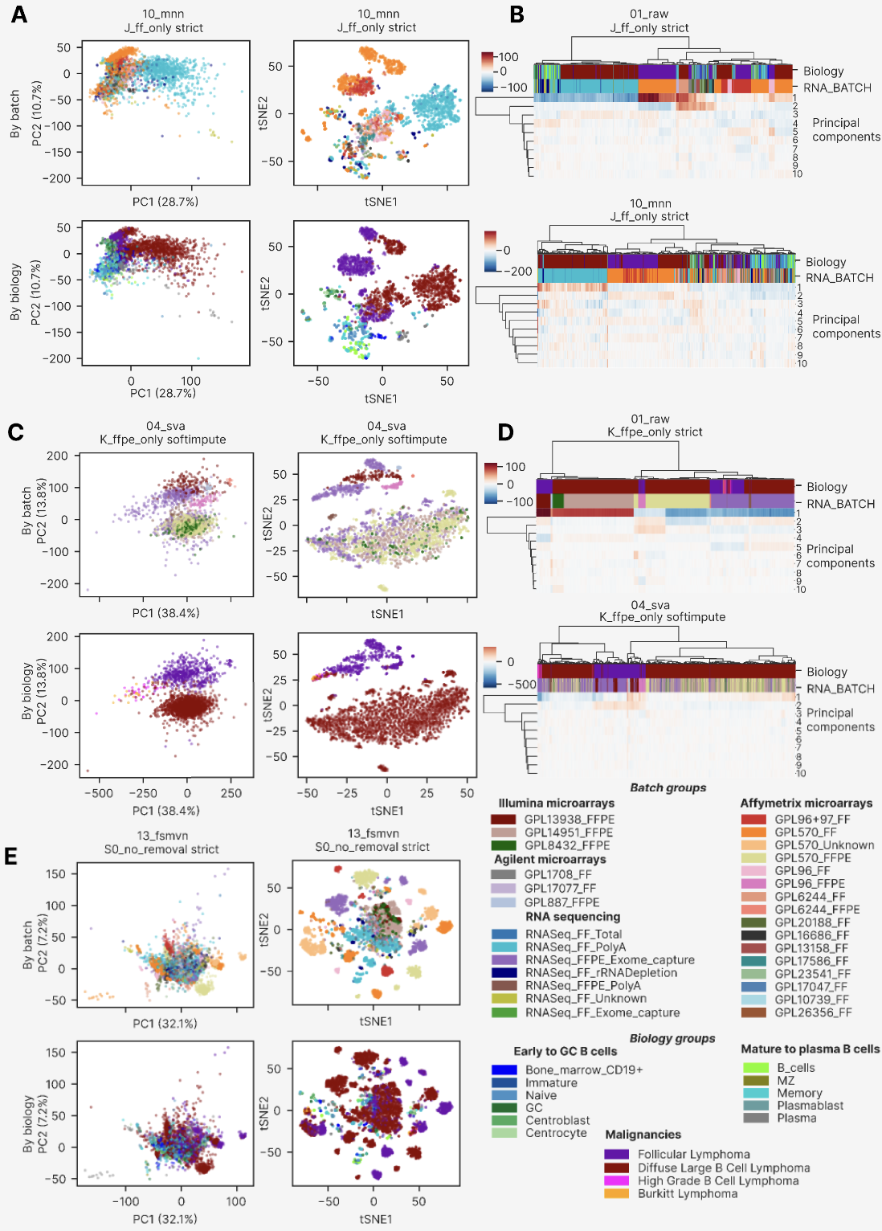

Harmonization metrics behavior by approaches
On the clustermaps in Figure 3 and Supplementary Figure 7 we observed a trade-off between local mixing and global batch correction metrics. To deeply investigate the root cause of this trend, we analyzed harmonization metrics by group, harmonization method and batch removal strategy. We separately highlighted metrics for the best approaches selected using the clustermap in Figure 3. The results are summarized in the three main figures (Figure 6-8), and the extended comparison of harmonization quality metrics in this study was uploaded to GitHub and can be accessed via the link …..

For the global PCA-based metrics we selected Principal Component Regression (PCR) as the most unbiased one and visualized its distribution for the main batch column RNA_BATCH in comparison with the same metric for the biology column Diagnosis_cell_type_unified. We annotated the resulting scatter plots by harmonization method (Figure 6A) and by batch removal strategy (Figure 6B). The clustermap-selected best approaches located in the upper-right quadrant of the plot, displaying high overlapping of both batches and biology. Combat and combat-ref harmonization showed better separation of biology (Figure 6A), but they were rejected by clustermap (Figure 3) and by manual inspection of PCA/UMAP/tSNE plots (new supplementary figure). Smooth quantile harmonization (14_qsmooth) showed the lowest batch correction performance by PCR (Figure 6A). At the level of batch removal strategies, malignant only, FFPE only and S0 showed the worst performance by biology and formed quasi-horizontal lines, whereas RNA-seq only had highest average ability to correct batch variation (Figure 6B). Notably, the malignant only and FFPE only strategies did not have normal B cells, so their number of unique classes by Diagnosis_cell_type_unified was only 4. FF only had relatively lower batch and biology groups overlapping in the PCA space. Interestingly, harmonization methods formed diagonal lines moving from the left-top to right-bottom corners of the plot, with those close to the PCR RNA_BATCH = 1 vertical line being vertical too (Figure 6A).

To deeply investigate the PC-level variation, we calculated percentage of variance explained by each of the first 10 PCs, as well as R² explained by RNA_BATCH for each of them. The resulting heatmaps (Figure 6C) showed that 5 methods (20_shambhala, 18_rank, 17_quantile, 15_fsqn_py, 25_angel) had a slow decay of variance percentage explained by PC, starting with 10-15% for the first PC, 5-7% for the second PC etc. Additional 8 methods (33_amdbnorm, 28_npn, 26_xpn, 22_tmm, 23_vst, 10_mnn, 09_ruv, 12_scanorama) and the group of clustermap best approaches had more variance explained by the first component (20-30%) and the same slow decay over PCs. The rest 18 methods resulted in a large proportion of variance explained by first PC (up to 80% in 11_harmony, 79% in 27_dwd – check the numbers).

PCA variance explained by batch (R² by RNA_BATCH) showed a more complicated pattern. For the top 5 methods by average PCR RNA_BATCH (33_amdbnorm, 13_fsmvn, 03_limma, 07_pycombat, 28_npn) R² were zero for all PCs, implying that the batches completely overlapped each other on the PCA space. Yet local mixing for these approaches was of poor quality (Figure 3) with except for 33_amdbnorm applied to the NGS and Illumina microarrays (Supplementary Figure 17). 14 methods out of 31 showed RNA_BATCH R² for the first PC lower than the next PCs ones. For the 5 methods that demonstrated smooth decay of percentage variance explained by PCs, 4 ones (with except for 20_shambhala) maximum RNA_BATCH R² was for the non-first PC. Such pattern could indicate that these methods do not abolish batch-level variance but rather hide it in lower rank PCs, which manifest itself in poor local mixing performance. The group of clustermap best approaches showed average 15 and 7% total variance explained and 22 and 17% R² RNA_BATCH by first and second PC, respectively (check the numbers). 14_qsmooth method as the worst one by PCA-based performance showed average 15 and 7% total variance explained and 22 and 17% R² RNA_BATCH by first and second PC, respectively (check the numbers).

Figure 6. Global PCA-based metrics performance by harmonization methods and batch removal strategies. (A) Scatterplot of PCR Diagnosis_cell_type_unified versus PCR RNA_BATCH, color annotated by harmonization method. The clustermap-based best approaches are shown with black asterisks. (B) Scatterplot of PCR Diagnosis_cell_type_unified versus PCR RNA_BATCH, color annotated by batch removal strategy, with the same highlighting of the clustermap-based best approaches. (C) Heatmaps showing percentage of total variance explained (left heatmap) and percentage of the RNA_BATCH-explained variance for the first 10 PCs, grouped by harmonization method and sorted by PCR RNA_BATCH. The composite group of the best approaches is shown by the black cell with an exclamation sign on the harshness level color annotation.
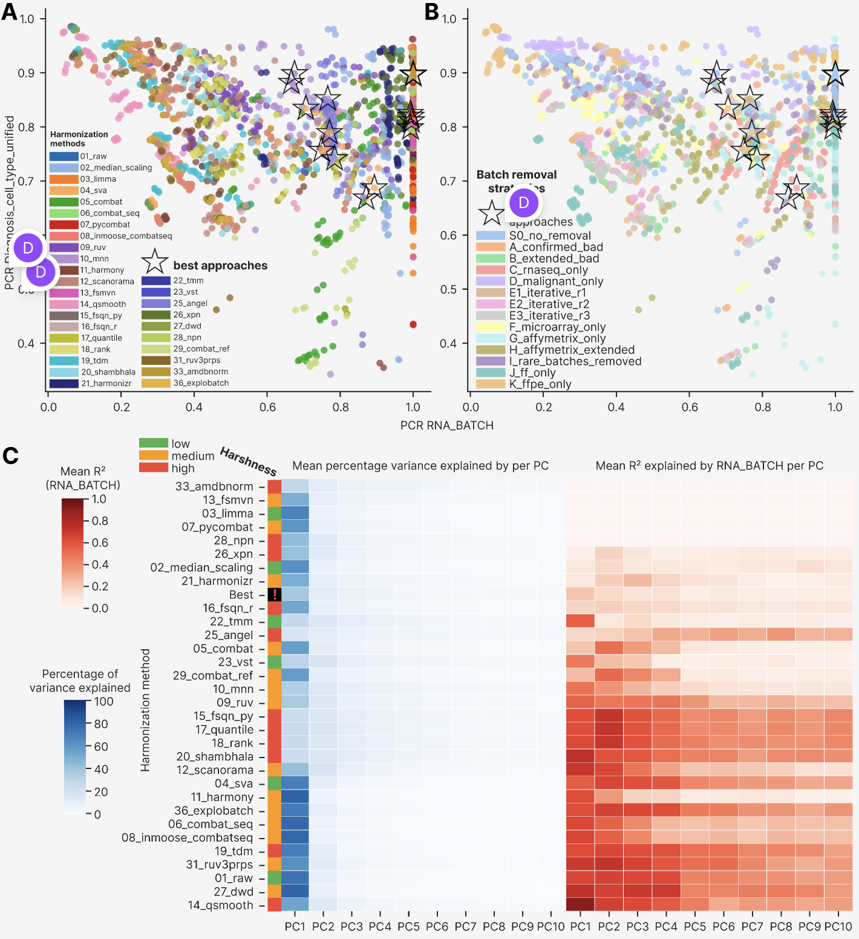

We then investigated performance of the local mixing (local neighborhood) metrics (Figure 7). As a representative metric we selected Local inverse Simpson's index (LISI) as it was scattered along the entire local metrics cluster in Supplementary Figure 6 and visualized it for the same biology and batch column by harmonization method (Figure 7A) and batch removal strategy (Figure 7B). The clustermap best approaches located in the right half of each scatterplot, demonstrating higher than average batch local mixing but visually no trend by local preservation of biological groups. MNN harmonization conferred the highest degree of local batch mixing, as was previously showed on Figure 3. Batch removal strategies formed isolated curved structures located in layers in order resembling the PCR by biology order in Figure 6B: FFPE only and malignant only had lowest local mixing of biology groups, and FF only had the highest local biology mixing, followed by RNA-seq only and Affymetrix extended. We also observed positive correlation of biology mixing by the batch one for all the strategies (add statistic), which implies a fundamental trade-off: better local mixing of different batches leads also to the lower integrity of biology-derived local clusters.

As an additional local mixing metric, we visualized tSNE entropy calculated by RNA batch (Figure 7C) – the one that by definition closely correlates with different batches mixing at tSNE plot. As in the case of LISI, MNN was the best approach, 14_qsmooth was the worst one. Among the batch removal strategies, FF only and S0 were the best ones, whereas the two Affymetrix strategies (G and H) were the worst approaches. RNA-seq only formed a deviating group with lower MNN performance compared to the rest strategies. The clustermap-selected best approaches occupied local peaks in the heatmap, indicating that tSNE entropy reliably represents local mixing performance. To contrast the local tSNE mixing, we also visualized a global tSNE metric, namely tSNE centroid dispersion, in the analogous heatmap (Figure 7D). Harmonization methods and batch removal strategies clearly separated into the high and low dispersion areas, with the clustermap best approaches tending to locate at the border between these areas. Such a non-trivial pattern could indicate that tSNE centroids are poor harmonization quality measures, and global metrics should be calculated in PCA space, whereas the local ones are inherently linked to the non-linear dimensional reduction approaches such as tSNE and UMAP.

Figure 7. Local mixing-based metrics performance by harmonization methods and batch removal strategies. (A) Scatterplot of cLISI Diagnosis_cell_type_unified versus iLISI RNA_BATCH, color annotated by harmonization method. (B) Scatterplot of cLISI Diagnosis_cell_type_unified versus iLISI RNA_BATCH, color annotated by batch removal strategy. (C) Heatmap of tSNE entropy calculated by RNA_BATCH, ordered by harmonization methods and batch removal strategies. (D) The analogous heatmap of tSNE centroid dispersion calculated by RNA_BATCH. For all panels, the clustermap-based best approaches are shown with black asterisks.
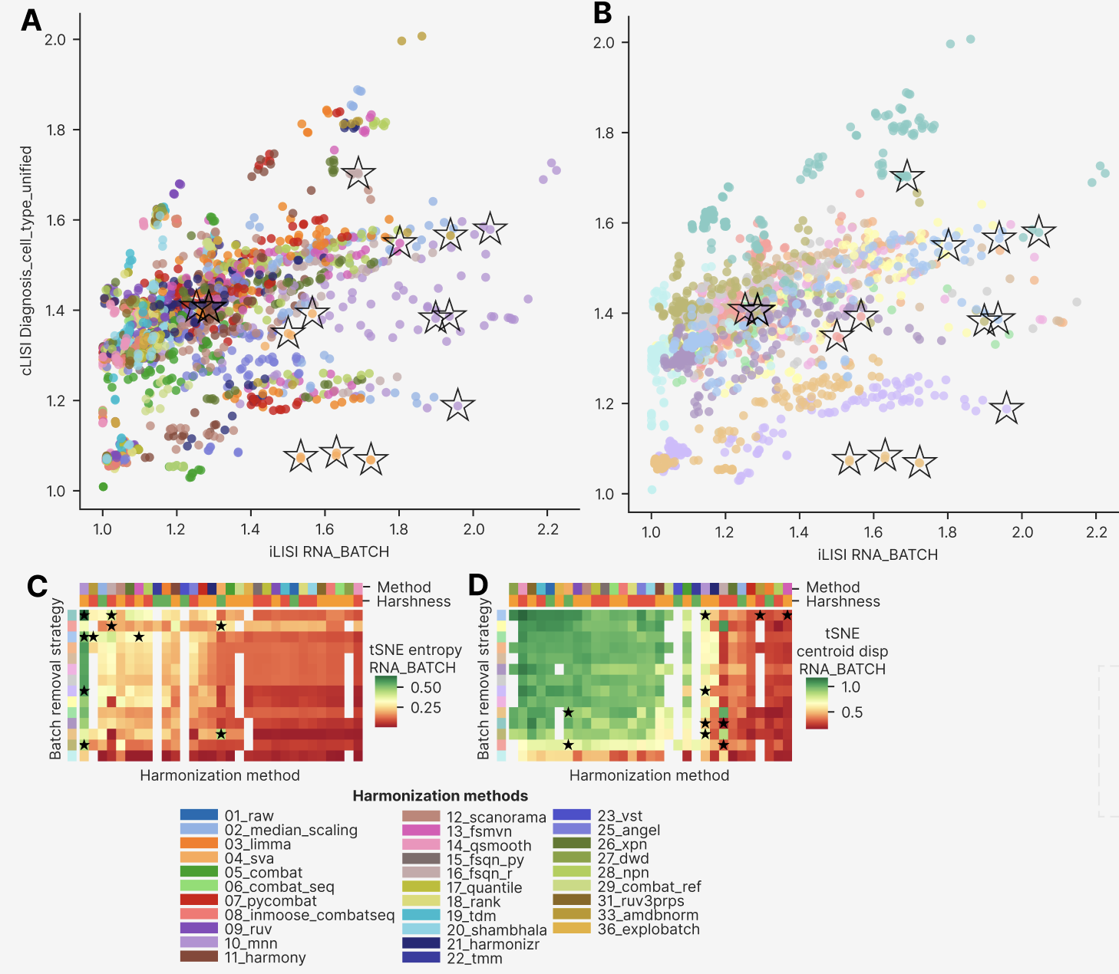

As a final part of the harmonization quality metrics comparison among the approaches, we visualized the selected metrics that fall outside the main global/local axis, as well as the selected quantiles from the gene expression distributions (Figure 8). To systematically test whether harmonization leads to convergence in gene expression distribution, we plotted mean D statistic of Kolmogorov-Smirnov test between all sample pairs within batches versus mean between-batches (by RNA_BATCH) D statistics (Figure 8A). The clustermap best approaches were in the lower half of the plot showing high similarity of gene expression distributions for these best approaches within each batch group. Interestingly, different harmonization methods showed vertical lines of data points, implying that harmonization tools differ by their ability to transform different batch distributions to the same shape. At the level of batch removal strategies (Figure 8B), on the other hand, horizontal layers were formed with fixed within-batch mean D statistic, with the RNA-seq only strategy occupying the lower left corner of the plot.

We then compared percentage of samples and genes without NA (Figure 8C, D, respectively) by harmonization approaches. All samples had all genes with defined expression values for 19 out of 31 harmonization methods, regardless of the batch removal strategy used, 8 more methods had a minor percentage of 5-10% samples with at least one NA and 4 methods (20_shambhala, 26_xpn, 15_fsqn_py, 17_quantile) had 45-50% samples with at least one NA. At the level of genes with NA (Figure 8D), the same 10 harmonizations methods returned no NA at all, 11 more methods had 5-30% genes with at least one sample with NA and 21_harmonizr had all genes with NAs in 8 out of 14 batch removal strategies.

The harmonization methods drastically differ by expression range of their outputs (Figure 8E). 08_inmoose_combatseq and 06_combat_seq had outliers with expression value above 1million, whereas their 99th percentiles were only 18.5 and 17.9, respectively. 20_shambhala had generally high expression outputs, with 555004.7 maximum expression and 1359.6 median. 19_tdm had 75.1 median and 568.9 maximum value. All the rest methods were comparable with the standard RNA-seq log2(TPM) value range, having median expression at the level of 4-5. 18_rank and 25_angel collapsed entire distribution to range between 0 and 1, and 28_npn had expression median below zero. Generally, 20 out of 31 harmonization methods had minimum gene expression value below zero. Compared to all harmonization approaches, the best ones showed higher uniformity in the expression profiles (Figure 8F): SVA, FSQN R, FSMVN and AMDBNorm started with zero or negative values, MNN started with positive ones, and median expression was in the interval of 3-10 (check the numbers).

Figure 8. Additional quality metrics and gene expression snapshots by harmonization methods and batch removal strategies. (A) Scatterplot of mean D statistic of Kolmogorov-Smirnov test between all sample pairs within batches versus mean between-batches (by RNA_BATCH) D statistics, colored by harmonization methods. (B) The same scatterplot colored by batch removal strategies. (C) Heatmap of percentage samples without NA gene expression values, ordered by harmonization methods and batch removal strategies. (D) The analogous heatmap of percentage genes without NA gene expression values. For the panels A-D, the clustermap-based best approaches are shown with black asterisks. (E) Heatmap showing gene expression minimum, maximum, the 1st, 5th, 25th, 50th (median), 95th and 99th percentile as well as gene standard deviation, averaged and visualized for harmonization methods. The methods are ordered by ascending PCR RNA_BATCH. (F) The analogous heatmap for the 15 clustermap-selected best approaches.

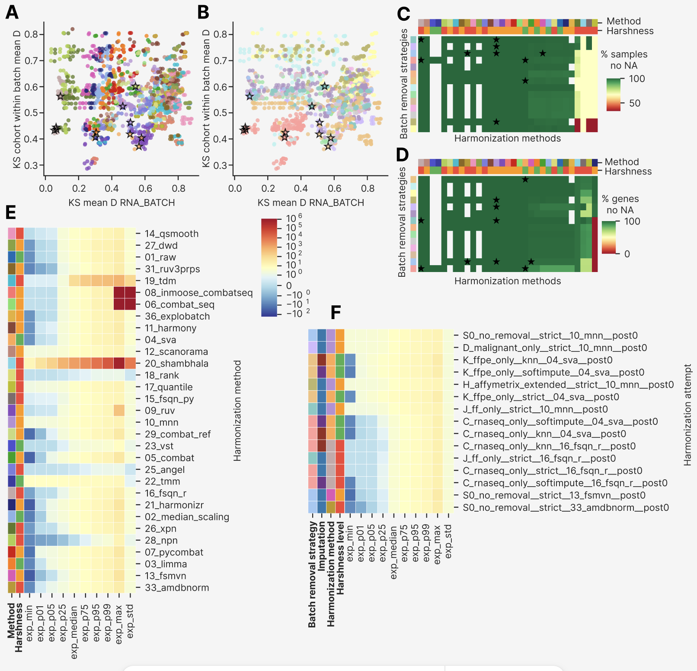

Relative impact of batch removal strategies, harmonization methods, imputation methods and post-removal.
To integrate the multi-dimensional metric signals, we computed a composite harmonization score as the mean of polarity-normalized values across all the 87 scoring metrics, weighted by their polarity (Figure 9). We compared the composite score between harmonization methods by their harshness: the high harshness methods had higher maximum values (0.69 compared to 0.66 for low harshness methods) but have the comparable medians (add statistics). The clustermap best methods occupied the upper 1/3 of the distributions, having the composite score 0.55 and higher.

To quantify the relative contribution of each experimental factor to overall harmonization quality, we performed a variance decomposition analysis using eta-squared (η²) effect sizes across the full 87-metric composite scoring space (Figure 9B). Harmonization method emerged as the dominant factor, explaining 36.3% of variance in composite harmonization quality, followed by batch removal strategy (η² = 0.256). Imputation method contributed only 1.6% of variance, and post-removal contributed less than 1%, confirming the four-factor hierarchy: method > strategy > imputation > post-removal. It should be noted that earlier in the main clustermap (Figure 3) we visually observed the priority of batch removal strategy, followed by harmonization method, but post-removal and imputation comprised a negligibly minor impact in the clustermap too.

This ordering has direct practical implications for experimental planning: one third of the good harmonization is the method itself, and one quarter more is the batch pre-selection. Importantly, this analysis refutes the common assumption that imputation strategy is a critical hyperparameter: the ~10 percentage-point advantage of softimpute over KNN emerged consistently within each strategy tier but were dwarfed by method-level differences (Extended Metrics Comparison).

We then visualized the clustermap best approaches along the six axes of local and global performance by batches and biology (Figure 9C, D). The approaches performed best in global batch overlapping (0.65 – 1.0), followed by local biology preservation (0.07-0.7). Global biology preservation and local batch mixing were the worst performing axes (Figure 9C). The SVA best approaches behaved better in terms of local batch mixing, whereas FSQN R had better biology performance. By batch removal strategies we had the C one with the highest batch mixing by kBET and the best biology separation (Figure 9D). Local biology separation was the best in the J strategy, and the S0 best approaches were the worst ones by all metrics except for global batch mixing and local biology separation.

We then assessed an impact of metric types into the composite score. The stacked metric-type composition (Figure 9E) revealed that the top-ranking methods derived their advantage primarily from local neighbourhood metrics and distributional similarity metrics, while most methods showed comparable performance on global distance metrics. The two top methods after the clustermap best group (it was the best by the composite score) were 22_tmm and 23_vst – apparently because they were applied to C strategy only. Methods 33_amdbnorm, 28_npn and 10_mnn were the 3rd – 5th, respectively, with gradual decrease of local composite impact from 0.1 to 0.7 (in 28_npn) and then raising to 0.11 in 10_mnn, accompanied with the decrease of global and distributional performance. The high relative contribution of local and distributional metrics explains the poor discriminative power of PCR-only or DSC-only rankings — which dominated early-generation harmonization benchmarks (REF) — because the most biologically consequential improvements are captured only by the expanded 87-metric framework.

Figure 9. Composite performance score, clustermap best approaches behavior and the final decision tree. (A) Violin plot showing the composite score by harmonozation method harshness level, with the clustermap best approaches shown in black stars. (B) Horizontal barplot showing eta-squared (η²) effect sizes of the composite score for four experimental factors: harmonization method, batch removal strategy, imputation method, and post-removal. (C) Radar plot showing performance of the clustermap best approaches by six axes: local batch mixing by kBET, local batch mixing by LISI, local biology preservation, global biology preservation, global batch overlapping and the total composite score. The approaches are colored by their harmonization methods. (D) Stacked bar chart of cumulative normalized score per harmonization method, decomposed by metric type (local neighbourhood, global distance, distributional similarity, other). Y-axis represents cumulative summed normalized score across all metrics of each type. (E) Enlarged radar plot showing the same best approaches with the same axes as in panel C but colored by batch removal strategy. (F) Data-driven decision tree showing the workflow and the best harmonization approaches depending on the dataset composition. At the biomaterial/platform type (step 1) we consider only the cross-platform and/or cross-biomaterial datasets. At the imputation step (step 3), ‘Any’ means both imputation methods (KNN and Softimpute) and no imputation (the Strict approach).
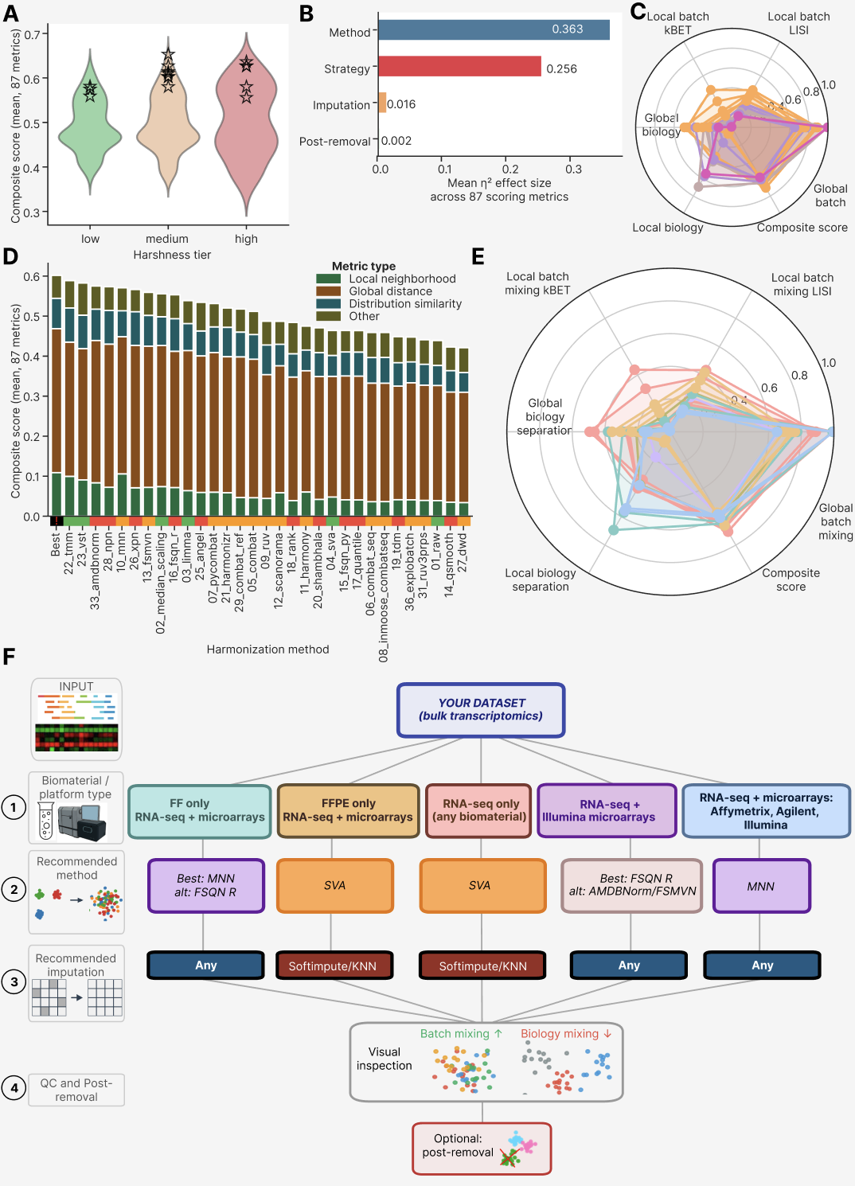

Final decision tree for bulk transcriptomic datasets harmonization
Based on the comprehensive benchmarking analysis, we formulated a data-driven hierarchical decision tree for harmonization method selection, conditioning recommendations on dataset biomaterial type and platform composition (Figure 9F). The decision tree formalizes five primary scenarios derived from the final decision analysis: 1) fresh-frozen only (FF) with RNA-seq and microarrays, 2) FFPE only with RNA-seq and microarrays, 3) RNA-seq only (any biomaterial including FF and FFPE), 4) RNA-seq combined with Illumina microarrays (any biomaterial), and 5) the full dataset: RNA-seq combined with microarrays with any biomaterial. We did not included the trivial combination of single platform and biomaterial type (such as FFPE only RNA-seq only, FF only Affymetrix only, etc), because the cohorts of these batches already co-clustered in PCA and tSNE spaces (Figure 4A), therefore the extensive and tricky harmonization was not needed. We considered only the cross-platform and/or cross-biomaterial datasets as the most challenging ones.

For fresh-frozen only datasets — comprising Affymetrix, Illumina, and Agilent microarray platforms mixed with RNA-seq — MNN achieved the best overall performance across all metric families and is recommended as the primary method, with FSQN R as an alternative where global PCR minimization is prioritized. For FFPE-only datasets, SVA with softimpute or KNN imputation represents the rarely demonstrated successful mixing of FFPE Affymetrix, FFPE Illumina microarray, and FFPE RNA-seq platforms in a single harmonized B-cell lymphoma dataset; this combination achieved a 56% relative reduction in PC1 variance (from 87.6% raw to 38.4% post-harmonization) while preserving FL and DLBCL cluster separation. For RNA-seq only datasets, SVA with softimpute or KNN again emerged as the top-performing approach, uniquely revealing two FL transcriptional subgroups — invisible in all other harmonization configurations — that may correspond to the previously unknown molecular subtypes.

For mixed RNA-seq and Illumina microarray datasets, FSQN R achieved the best balance between global correction and biology preservation, with AMDBNorm or FSMVN combined with post-removal as alternatives for scenarios where global PCR is prioritized. For the most compositionally complex scenario — RNA-seq combined with Affymetrix and Illumina microarrays spanning multiple biomaterial types — MNN achieved superior global batch correction and consistent local mixing across all metric families. A common finding across the RNA-seq only and FFPE only scenarios was the superiority of imputation-augmented approaches over strict gene-set restriction combined with SVA harmonization (Figures 4, 5).

Notably, post-removal — the exclusion of one PCA-outlier batch after harmonization — provided marginal metric improvement (η² < 0.01 in the global variance decomposition), confirming that it is a fine-tuning step rather than a fundamentally distinct correction stage. We recommend post-removal for all strategies as an optional step after visual inspection (Figure 9F), where a strong outlier batch was systematically identified across multiple imputation conditions.

DISCUSSION

Subtle biological differences under batch effect

The dataset assembled for this study was markedly imbalanced with respect to both batch and biology group composition (Figure 1D, 1E), reflecting the typical structure of publicly available retrospective transcriptomic data aggregated from independent clinical studies. This real-world heterogeneity — with dominant DLBCL-only batches, rare subtypes confined to one or two cohorts, and mixed FF/FFPE biomaterial composition — renders FL-containing datasets inherently more challenging harmonization targets than purpose-built benchmark datasets. Such composition complexity is, however, representative of the data landscape encountered in multi-cohort transcriptomic signature mining, justifying the design of a strategy-inclusive evaluation framework that explicitly models the effect of dataset composition on harmonization performance.

The follicular lymphoma transcriptome represents one of the most technically demanding targets for cross-platform harmonization precisely because the biological signal of interest — the distinction between FL and DLBCL, or between FL molecular subtypes — is subtle relative to the technical noise introduced by inter-platform and inter-biomaterial differences. Our dataset, spanning 7,174 samples across 29 RNA batches and four sequencing platforms, encapsulates this challenge at a scale not previously assembled for GC B-cell lymphoma research. The observation that 95% of PCA variance in the raw dataset is attributable to RNA_BATCH — with virtually no biology-driven structure visible before harmonization — quantifies the magnitude of this challenge and underscores why standard benchmarking frameworks using TCGA or GTEx-scale datasets, where biology effects typically dominate batch effects, are insufficient for subtle-biology applications.

The FL-specific biological discovery — two transcriptional subgroups revealed by SVA with softimpute in the RNA-seq-only strategy — constitutes an unexpected and biologically significant finding emerging from the harmonization process itself. These subgroups were invisible in all other harmonization configurations, including other methods in the same strategy and SVA with strict imputation. This dependency on imputation suggests that the subgroup signal resides in genes recovered by softimpute beyond the strict 3,447-gene set, genes that may carry platform-specific regulatory signatures detectable only at higher coverage depth. Whether these subgroups correspond to the established GCB/non-GCB molecular subtypes of FL (ref), or represent a novel transcriptional axis orthogonal to known classifiers, requires downstream survival analysis and gene set enrichment that is beyond the scope of this benchmarking study. Crucially, the finding underscores that harmonization method selection is not merely a technical pre-processing decision but can determine which biological discoveries are accessible from a given dataset.

Novel computational pipeline for harmonization tools adjustment and selection

The ComboBatch pipeline is conceptually distinct from previous harmonization benchmarks (ref, ref, ref) in three fundamental respects. First, it exhaustively evaluates the full cross-product of four hyperparameter dimensions — 14 batch removal strategies × 3 imputation methods × 31 harmonization methods × 2 post-removal conditions = 2,604 theoretical configurations (2,234 successfully completed) — rather than selecting a representative subset of configurations for pairwise comparison. This exhaustive coverage allows the pipeline to detect interactions between factors (such as the imputation-dependency of SVA's FL subgroup discovery) that would be missed by incomplete designs. Second, it applies 87 polarity-defined scoring metrics spanning local neighbourhood, global, distributional, and structural aspects of harmonization quality, providing a multi-dimensional evaluation surface rather than relying on a single metric or a small panel. Third, it operates under the constraint of realistic biological subtlety: the FL/DLBCL distinction is approximately 5–10-fold smaller in transcriptional effect size than the batch effects in this dataset, requiring methods to identify approaches that simultaneously correct for large technical noise while preserving small biology signals.

The computational scale of ComboBatch — 2,234 completed attempts on 16 vCPU / 240 GiB RAM infrastructure with parallelized job dispatch across S3-backed intermediate storage — required systematic engineering of timeout handling, memory-limited execution, and error recovery. All harmonization methods that exceeded 3 hours of CPU time were recorded as failures and excluded from the main analysis (see Methods). The pipeline architecture is containerized and reproducible, with all intermediate expression matrices and metric tables available via the S3 storage paths described in the Data Availability statement.

We note important technical limitations of the current pipeline. The kBET metric is known to be sensitive to small batch sizes and failed to produce valid outputs for strategies with very small batch representations (e.g., I_rare_batches_removed with batches below 5 samples). The variancePartition-based PCR calculation timed out for the largest strategy × imputation combinations (S0_no_removal × softimpute), reducing the number of valid metric values for those configurations. These failures are handled by the pipeline's 5% missing-metric exclusion filter, which is the basis for restricting the main analysis to the 2,234 qualifying attempts.

Clustermap on a full metrics space as the best approach for harmonization selection
The 87-metric × 2,234-attempt clustermap (Figure 3) represents, to our knowledge, the largest systematic harmonization evaluation matrix reported to date in bulk transcriptomics. The clustermap revealed a robust four-cluster structure at the attempt level — good cross-platform, bad cross-platform, same sample type, and same platform — that was reproduced across independent Spearman correlation analysis (Supplementary Figure 9) and metric-space embeddings (Supplementary Figure 10). Critically, this structure was dominated by batch removal strategy rather than by harmonization method, confirming the theoretical expectation that sample composition determines the accessible range of correction rather than the algorithm applied.

The practical value of the clustermap-based selection approach is that it provides a bias-free, data-driven ranking that does not require prior assumptions about which metrics are most relevant for a given dataset. For datasets with different biological contexts — rare cell types, subtle molecular subtypes, or extreme platform imbalance — the same pipeline can be run with the same 87 metrics, and the clustermap will identify the dominant sources of quality variation specific to that context. The ability to visually identify anomalous metric-level patterns — such as the Angel harmonizer's catastrophic gene retention failure (manifesting as a distinct column in the NA-percentage metric cluster) or the CMS metric's uniformly low discriminative power across all attempts — provides a level of interpretability that single-score rankings fundamentally cannot achieve.

The metric cross-correlation structure (Supplementary Figure 7) further reveals that the local and global metric clusters are nearly orthogonal (Spearman ρ ≈ 0 between clusters), validating the two-axis (batch mixing × biology preservation) evaluation framework used throughout the benchmark. This empirical orthogonality is the key statistical justification for requiring both metric families in harmonization benchmarks, and it explains why methods that score highly on PCR can simultaneously fail spectacularly on kBET and iLISI.

AI-driven brute force and human-based approaches: AI enhancement leads to ~2 time more actionable approaches

The ComboBatch benchmark was designed as an exhaustive computational search, not a hypothesis-driven selection. This brute-force approach proved critical: of the three top-performing methods (MNN, SVA, FSQN R), MNN and SVA were initially identified through literature search and AI-assisted method curation (Claude, Anthropic), while FSQN R was discovered independently through manual literature exploration of the quantile normalization family. This mixed discovery process — AI-assisted broad enumeration combined with human domain expertise for method-specific parameter tuning — identified a combination that outperformed any single-strategy search.

Interestingly, rank normalization and standard quantile normalization — both harsh and computationally simple approaches — performed substantially below their more architecturally advanced FSQN R counterpart. This performance gap cannot be explained by harshness alone: FSQN R shares the quantile normalization principle but conditions on a biology-matched reference distribution, preserving expression shape while eliminating scale differences. This finding illustrates a general principle: algorithmic sophistication in method design (biology-conditioned normalization, mutual nearest-neighbour graph construction, surrogate variable modelling) consistently outperforms generic location-and-scale corrections, even when the simpler methods appear algorithmically equivalent at first inspection.

Notably, rank normalization and standard quantile normalization — algorithmically simple yet harsh approaches — both performed at an inferior level compared to their biologically conditioned counterpart FSQN R. This performance gap, observed consistently across strategies, underscores a general principle: algorithmic sophistication in method design — specifically, the conditioning of normalization on a biology-matched reference distribution — consistently outperforms generic location-and-scale correction when the biological signal of interest is small relative to technical noise.

Comparison with other batch effect mitigation approaches
Among the 31 methods benchmarked, MNN, SVA, and FSQN R were the only algorithms that simultaneously resolved FL, DLBCL, and Normal GC B-cell transcriptional differences after cross-platform integration. This finding is consistent with the known mechanistic properties of these methods: MNN models the local geometry of expression space to identify mutual nearest neighbours across batches, inherently preserving within-biology neighbourhood structure (Haghverdi et al., 2018); SVA uses surrogate variable analysis to model latent technical factors while conditioning on the provided biological covariates (Leek & Storey, 2007); FSQN R applies feature-specific quantile normalization against an RNA-seq reference distribution, preserving the global expression topology of the reference biology (Franks et al., 2018). All three methods share a common architectural principle: they model or condition on biological structure during the correction process, preventing the collapse of biology-associated variance that characterizes unconstrained normalization methods.

Methods that dominated earlier harmonization benchmarks designed on TCGA or GTEx data — pyCombat, limma removeBatchEffect, median scaling, and standard quantile normalization — achieved strong global batch correction (PCR reduction) in our dataset but uniformly failed to preserve local biology structure, as evidenced by near-zero kBET acceptance rates and compressed cLISI values below 1.1. This failure is directly attributable to the scale mismatch between training context and our dataset: in TCGA or GTEx, batch effects are typically 2–5-fold smaller in variance explained than in our multi-platform lymphoma dataset, allowing unconstrained methods to correct batch effects without inadvertently erasing biology. When the technical noise is 10-fold larger than the biology signal — as in our raw FL dataset (95% vs. ~3–5% variance explained, respectively) — unconstrained methods cannot distinguish the two and remove both.

The Quartet reference material framework (ref), while conceptually elegant for prospective experimental designs, is inapplicable to retrospective harmonization of pre-existing clinical transcriptomic cohorts such as ours, where concurrent profiling of a reference material was not performed and cannot be retroactively added. Our results suggest that for retrospective multi-platform integration under realistic clinical-cohort conditions — heterogeneous batch sizes, multiple platforms, mixed biomaterials, confounded batch–biology composition — algorithm selection conditioned on biomaterial type and platform composition, as formalized in the ComboBatch decision tree, provides a robust and reproducible alternative to reference-material-based normalization frameworks. The decision tree further provides actionable guidance for prospective study design by identifying which sample composition scenarios are most tractable and which harmonization approaches are most robust to deviations from those scenarios.

To address these confounding variables, the Quartet framework proposes a reference-material-based normalization strategy: absolute feature values for each study sample are scaled relative to those of a concurrently profiled common reference material. Under this paradigm, each batch of clinical samples is co-processed with a physical aliquot of the Quartet reference material; the analytical pipeline then computes expression ratios between each clinical sample and the reference, converting highly variable absolute quantities into stable relative fold-changes that are inherently normalized for batch-specific technical noise.
The efficacy of this ratio-based scaling approach has been extensively validated. The Quartet consortium profiled 252 RNA-seq libraries across 21 batches in eight independent laboratories using divergent library construction protocols (poly(A) selection and RiboZero) and sequencing platforms (Illumina NovaSeq and MGI DNBSEQ-T7). Using the signal-to-noise ratio (SNR) — quantifying the ratio of inter-group biological variance to intra-group technical variance — as an evaluation metric, ratio-based scaling consistently outperformed established batch correction algorithms, particularly in severely confounded experimental designs in which biological and technical factors co-varied.
https://pubmed.ncbi.nlm.nih.gov/37679543/
https://pmc.ncbi.nlm.nih.gov/articles/PMC11251996/
https://pmc.ncbi.nlm.nih.gov/articles/PMC10483871/
https://pubmed.ncbi.nlm.nih.gov/37884999/

MATERIALS AND METHODS

Dataset assembly
We assembled the largest possible set of publicly available cohorts containing FL samples, supplemented with DLBCL cohorts as the most closely related GC B-cell malignancy and normal B-cell cohorts as a biological reference for future FL transcriptomic signature studies. The final dataset comprised 88 cohorts, 7,174 samples, and four platform types: RNA-seq (NGS), Affymetrix, Illumina, and Agilent microarrays (Supplementary Table 1).

Batch annotation and classification
We devised a systematic batch naming convention in which each batch is labelled <Platform_name>_<Biomaterial_name>_<Target_enrichment_name>. Platform_name is the GEO platform identifier for microarray batches, or 'RNASeq' for NGS batches. Biomaterial_name is coded as 'FFPE' for cohorts with unambiguous FFPE annotation, 'FF' for all fresh biomaterials (fresh-frozen tissue, sorted cells, PBMCs, etc.), and 'Unknown' for samples lacking unambiguous biomaterial classification in the source article or GEO record. For NGS batches, Target_enrichment_name records the enrichment strategy (poly-A selection, exome capture, rRNA depletion, total RNA, or unknown); for microarray batches this field is set to 'unknown', as target specificity is inherent to the probe design of the array platform (ref). Additional granular batch attributes — RNA extraction kit, library preparation protocol, NGS platform model, and detailed biomaterial subtype — are available in Supplementary Table X but were excluded from the batch classification scheme to avoid over-parameterizing the batch correction logic.

Gene expression profiling

Computational hardware
The full cross-product of prior batch removal, imputation, log2-transformation, harmonization, and post-removal was executed on a virtual server with 32-48 CPU cores and 240 GB RAM. Downstream data analysis and visualization were performed on a JupyterHub server with 16 CPU cores and 64 GB RAM.

Batch removal strategies
Because most harmonization algorithms process samples jointly and their performance depends critically on the initial batch composition of the input dataset (ref), we designed 14 prior batch removal strategies to be applied before imputation and log2-transformation. These strategies were developed iteratively across three rounds of pipeline refinement (Table N).

The column 'Iteration when added' in Table N records the pipeline development round in which each strategy was introduced. The initial ten strategies were evaluated in the first round; following results review, two additional strategies were added (Iteration 2). Analysis of the first two rounds established that the FF/FFPE biomaterial dichotomy was the most consequential factor in batch composition, motivating the addition of FF-only and FFPE-only strategies (Iteration 3).

Table N. Prior batch removal strategies for the GC lymphoma dataset utilized in this study.
Strategy name | Strategy type | Strategy description | Sample number | Iteration when added
S0 no removal | Default | No sample removal | 7174 | 1
F microarray only | By platform | All microarrays taken | 4931 | 1
G Affymetrix only | By platform | GPL570 only | 2801 | 1
C RNASeq only | By platform | NGS only | 2243 | 1
D malignant only | By biomaterial | Normal B cells excluded | 6285 | 1
A confirmed bad | By batch | Outlier batches by an initial FSQN manual screening removed: GPL14951_FFPE_Unknown, GPL8432_FFPE_Unknown and GPL13938_FFPE_Unknown. | 5444 | 1
B extended bad | By batch | Additional outlier batches by an additional QN manual screening removed from strategy A confirmed bad. The batches removed: GPL6244_FFPE_Unknown, GPL17586_FF_Unknown, GPL20188_FF_Unknown, GPL23541_FF_Unknown, GPL887_FFPE_Unknown, GPL26356_FF_Unknown, GPL17047_FF_Unknown, GPL6244_FF_Unknown | 5108 | 1
E1 iterative r1 | By batch | One more batch with highest PC distance from the global centroid removed from the strategy A | 5420 | 1
E2 iterative r2 | By batch | One more batch with highest PC distance from the global centroid removed from the strategy E1 | 5387 | 1
E3 iterative r3 | By batch | One more batch with highest PC distance from the global centroid removed from the strategy E2 | 5256 | 1
H Affymetrix extended | By platform | All Affymetrix batches included | 3727 | 2
I rare batches removal | By batch | Batches with less than 50 samples excluded | 6803 | 2
K FFPE only | By biomaterial | FFPE batches included | 3000??? | 3
J FF only | By biomaterial | All batches classified as FF included | 3167 | 3

Missing expression values imputation
Multi-platform batch correction introduced extensive missing expression values because different microarray platforms interrogate different gene sets (Supplementary Figure X). We initially evaluated four imputation approaches: strict NA exclusion, KNN, softimpute, and missForest. The strict approach excluded all genes with at least one NA value across any sample in a given strategy subset. MissForest was excluded from the benchmark after exceeding 48 hours of computation time on an 8-core, 64 GB RAM server without convergence, and was therefore deemed impractical for pipeline-scale application.
We ran KNN imputation using the parameters … according to … and softimpute using the parameters according to …, average computation time was … .

Both KNN and softimpute imputation were applied exclusively to genes for which fewer than 20% of samples had NA expression values, to ensure sufficient observed data for reliable imputation.

Harmonization methods

Through systematic literature search, we identified 38 harmonization methods potentially applicable to the GC lymphoma dataset. We implemented 31 of these methods in a Python 3.11 virtual environment, preferring native R package wrappers via rpy2 where R-specific implementations existed, and implementing standard methods (median scaling, quantile normalization) as custom Python functions. Seven methods failed implementation and are documented with reasons in Table N. Each implemented method was assigned a qualitative harshness score (low, medium, or high) reflecting the degree of data transformation imposed: low-harshness methods apply linear transformations (e.g., median scaling); high-harshness methods alter data distributions or dimensionality (e.g., quantile normalization, rank transformation); medium-harshness methods transform data to an intermediate degree. Harmonization methods were incorporated across three development iterations; each successive iteration had a higher implementation failure rate owing to increasing algorithmic complexity.

Table N. Harmonization methods utilized in this study.
Method name | Method harshness | Method full name | Implementation done | Implementation failure reason | Reference
01_raw |  |  | Yes
02_median_scaling |  |  | Yes
03_limma |  |  | Yes
04_sva |  |  | Yes
05_combat |  |  | Yes
06_combat_seq |  |  | Yes
07_pycombat |  |  | Yes
08_inmoose_combatseq |  |  | Yes
09_ruv |  |  | Yes
10_mnn |  |  | Yes
11_harmony |  |  | Yes
12_scanorama |  |  | Yes
13_fsmvn |  |  | Yes
14_qsmooth |  |  | Yes
15_fsqn_py |  |  | Yes
16_fsqn_r |  |  | Yes
17_quantile |  |  | Yes
18_rank |  |  | Yes
19_tdm |  |  | Yes
20_shambhala (put here the standard Shambhala) |  |  | Yes
21_harmonizr |  |  | Yes
22_tmm |  |  | Yes
23_vst |  |  | Yes
24_ ? |  |  | No
25_angel |  |  | Yes
26_xpn |  |  | Yes
27_dwd |  |  | Yes
28_npn |  |  | Yes
29_combat_ref |  |  | Yes
30_ ? |  |  | No
31_ruv3prps |  |  | Yes
32_? |  |  | No
33_amdbnorm |  |  | Yes
34_arsyn |  |  | Yes
35_? |  |  | No
36_explobatch |  |  | Yes
37_? |  |  | No
38_harman |  |  | Yes

Post-removal

Harmonization pipeline architecture

Harmonization quality metrics
For harmonization quality assessment, we assembled a set of 87 polarity-defined scoring metrics together with approximately 100 additional metrics computed but not included in the composite scoring (Table N). The 87 scoring metrics spanned four major groups: (i) global intersection metrics, quantifying the overlap of batch or biology classes in global PCA space; (ii) local mixing metrics, assessing the homogeneity of class intermixing in the neighbourhood of each individual sample; (iii) distributional similarity metrics, evaluating the degree of convergence of per-cohort gene expression distributions after harmonization; and (iv) other metrics, including gene retention rate and entropy-based measures.

Table N. Metric groups for harmonization quality control. A “column” here refers to any batch or biology column in the annotation table. (Maybe move to supplementary)

Metric name | Metric type | Metric group | Method definition | Source
PCA R² | Global | A | Fraction of variance in principal components (PCs) that is attributable to a column, by one-way ANOVA R². Calculated per PC and for top 10 PCs average. | [2]
Percentage variance | Global | J | Percentage of variance explained by each PC.
Principal component regression (PCR) | Global | A | Fraction of total PCA variance attributable to a column labels, where each PC is weighted by its proportion of explained variance. | Luecken MD et al. *Nature Methods* 19(1):41–50. 2022. DOI: 10.1038/s41592-021-01336-8. Also:
Dispersion separability criterion (DSC) | Global | A | Ratio of between-group scatter to within-group scatter in the first two PCA dimensions. Scatter is trace of a scatter matrix derived from the top 2 PC coordinates according to … . | PCA-Plus paper. *PLOS ONE* (2024). DOI: 10.1371/journal.pone.0295473.
kBET acceptance rate | Local | B | Tests whether the local (25-nearest-neighbor) composition of batch labels around each sample matches the global batch label distribution. | Büttner M et al. *Nature Methods* 16(1):43–49. 2019. DOI: 10.1038/s41592-018-0254-1.
Local inverse Simpson's index (LISI) | Local | B | For each sample, how diverse are the batch labels in its 30 nearest neighbor vicinity, measured by effective number of equally present batches. | Korsunsky I et al. *Nature Methods* 16(12):1289–1296. 2019. DOI: 10.1038/s41592-019-0619-0.
Average silhouette width (ASW) | Global | B | How much more similar each sample is to its own class versus the nearest other class. Computed on the first 50 PCs in Euclidean space. | Rousseeuw PJ. *Journal of Computational and Applied Mathematics* 20:53–65. 1987. Applied to batch assessment in Luecken et al. 2022.
Cell-specific mixing score (CMS) | Global | B | Anderson-Darling test on per-batch 30 nearest neighbor’s distance distributions. Tests whether distances from a sample to each group are drawn from the same distribution. | Lüttgenau S et al. *Life Science Alliance* 4(6):e202001004. 2021. DOI: 10.26508/lsa.202001004
Centroid dispersion in UMAP and tSNE | Global | C | After computing a UMAP/tSNE 2D embedding, for each group compute its centroid. The centroid dispersion is the standard deviation of centroid positions divided by the overall standard deviation of all sample positions. | ?
Local neighborhood entropy in UMAP and tSNE | Local | C | For each sample, Shannon entropy of the group label distribution in its 30-nearest-neighbor neighborhood in the embedding space. Averaged over all samples. | ?
KS test mean gene-level D-statistic | Distributional similarity | D | For each gene of a randomly selected 1000 genes, Kolmogorov-Smirnov two-sample test comparing expression distributions between all pairs of batches. The D statistic is maximum absolute difference between empirical distributions. | [2]
Within-batch cohort-level D-statistic | Distributional similarity | D | Same as the previous metric but measures within-batch cohort effects. Its specifically isolates residual cohort effects within the same technology batch by comparing each cohort only against the pooled samples from its own batch. This detects lab-specific effects that platform-level normalization cannot remove. | [2]
Per-gene batch mean CV | Distributional similarity | D | For each gene, CV of the per-batch mean expression values, averaged across all genes. | [2]
Zero expression fraction | Other | E | Fraction of genes with zero expression.
Fraction cohorts bimodal | Other | E | For each cohort, fit the marginal expression distribution (across all genes × samples in that cohort) and test for bimodality by Sarle’s coefficient. | [3]
Graph connectivity | Local | G | For each group, checks whether all samples in that group are connected in the kNN graph regardless of batch. Captures whether groups are connected in kNN topology. K is set as minimum between 15 and sample number in each group.
Average pairwise Euclidean distance | Global | H | In the full harmonized expression space (all genes), the average intra-group and inter-group pairwise Euclidean distances for each annotation column.
Watermelon score | Global | I | The metric measures how strongly a hierarchical clustering top 50 PCs dendrogram separates class labels, relative to a random permutation baseline. It is an entropy-based normalized AUC metric computed over all dendrogram fork levels. | Zolotovskaya et al., 2020, PMC7084891

Harmonization quality metrics were computed using the scipy (v1.12.0), scikit-learn (v1.3.2), statsmodels (v0.14.1), and umap-learn (v0.5.5) Python packages.

Figures preparation

Clustering, dimensional reduction, basic plotting

AI usage

DATA AVAILABILITY
The data supporting this article are available in the article and its online supplementary materials. Intermediate analysis files, Python scripts, YAML configuration files for the computational pipeline, Jupyter notebooks, and exploratory plots not included in the article or supplementary materials have been deposited in a public GitHub repository (https://github.com/[REPOSITORY]/ComboBatch/). Note: the current link in the draft points to an unrelated repository (T2T_transposons_evolution) and must be updated before submission.
Containerized and parallelized Shambhala that was developed and tested in this article has been published in a separate GitHub repository and is accessible via the link:
… Shambhala2-fast.

FUNDING

ACKNOWLEDGEMENTS

SUPPLEMENTARY MATERIALS

New supplementary figures (from metric and summary analysis)

Supplementary Figure A. Non-NA gene count per RNA batch in the initial S0_no_removal dataset. Top panel: horizontal bar chart of the number of genes with defined (non-NA) expression per RNA batch, sorted by gene count and coloured by RNA batch identity. The vertical red dashed line marks the maximum gene coverage of the strict imputation gene set (3,520 genes). Most batches achieve near-complete gene coverage; rare platform batches (GPL20188_FF, GPL13158_FF, GPL16686_FF) are restricted to 6,000–7,000 non-NA genes, motivating the use of imputation-based gene recovery. Bottom panel: sample count per batch in the same ordering, showing the 3-fold range in batch size (N = 68–1,039 samples).

Supplementary Figure B. Imputation gene set overlap and per-strategy gene counts. Left: Sankey diagram illustrating gene set flows from KNN, Strict, and Softimpute imputation methods into the combined gene universe for the S0_no_removal strategy; gene counts per imputation method are annotated at the source nodes. Right: bar chart of gene counts per imputation method (Strict = 3,520; KNN = Softimpute = 3,447 genes in the shared analysis gene set after filtering), showing that KNN and Softimpute recover an identical set of 73 additional genes beyond strict.

Supplementary Figure C. Gene retention heatmap across harmonization methods and imputation strategies. Heatmap of the percentage of non-NA gene retention per harmonization method (rows) × imputation strategy (columns) combination for the S0_no_removal strategy. Colour encodes percentage retention (dark green = 100%; lighter = lower retention). Most harmonization methods achieve >99% gene retention under all three imputation strategies. Two anomalous methods show severely reduced retention (~42–43%): harmonizr (21_harmonizr) and the Python FSQN implementation (15_fsqn_py), indicative of method-specific gene-level failures unrelated to imputation strategy.

Supplementary Figure D. Group B local neighbourhood metrics — full detail panel. Grid of 22 boxplot panels showing the complete set of Group B scoring metrics (kBET acceptance rate for RNA_BATCH, COHORT_LABEL, PLATFORM_RNA, and RNASEQ_SOURCE; iLISI for the same covariates; cLISI for Diagnosis_cell_type_unified, Major_group, and TUMOR_NORMAL; ASW_batch and ASW_bio; CMS fraction mixed) per harmonization method across all relevant annotation covariates. Best-15 approaches (★) are overlaid as red stars in each panel. Minimum font size of 7pt is enforced for all axis labels to preserve readability.

Supplementary Figure E. Group C centroid dispersion and embedding entropy — full detail panel. Grid of 13 strip plot panels showing tSNE and UMAP centroid dispersion metrics (per covariate: RNA_BATCH, COHORT_LABEL, PLATFORM_RNA, RNASEQ_SOURCE) and UMAP/tSNE mixing entropy metrics per harmonization method. Methods are sorted by mean dispersion (lowest = best batch compaction). Best-15 approaches (★) achieve consistently lower centroid dispersion in most panels.

Supplementary Figure F. Group H Euclidean distance ratios — full detail panel. Grid of 7 boxplot panels showing per-covariate Euclidean distance ratios (biology inter-centroid distance / batch inter-centroid distance) per harmonization method (RNA_BATCH, PLATFORM_RNA, RNASEQ_SOURCE, COHORT_LABEL, Diagnosis_cell_type_unified, Major_group, TUMOR_NORMAL). A ratio > 1.0 indicates that biology-associated inter-centroid distances exceed batch-associated ones — the ideal harmonization outcome. Best-15 approaches (★) are overlaid.

Supplementary Figure G. Group G graph connectivity — full detail panel. Grid of 3 barplot panels showing graph connectivity (fraction of samples reachable within a kNN graph by the same biology group) per harmonization method for three annotation covariates: Diagnosis_cell_type_unified, Major_group, and TUMOR_NORMAL. Best-15 approaches (★) achieve consistently high connectivity (>0.85) for the Diagnosis covariate, with wider variance for TUMOR_NORMAL, indicating that tumour/normal structure is the most challenging biological grouping to preserve after cross-platform batch correction.

Supplementary Figure 7S. UMAP mixing entropy per harmonization method. Boxplot of UMAP mixing entropy (normalized) per harmonization method, sorted by median entropy (highest = best local mixing). MNN (10_mnn) achieves the highest UMAP entropy, consistent with its leading kBET and iLISI performance. Methods with near-zero entropy — including dwd (27_dwd), combat_seq (06_combat_seq), and inmoose_combatseq (08_inmoose_combatseq) — achieve minimal local mixing in UMAP space despite strong global correction metrics, confirming the local–global metric dichotomy observed throughout the benchmark.

REFERENCES

