Bulk transcriptomic harmonization tools benchmarking using germinal center lymphoma dataset: a novel computational pipeline ComboBatch reveals MNN and SVA as top performing methods

Authors: Daniil Nikitin^{1*}, Arsen Arakelyan, Nicolas Borisoff, Maria Savchenko, Anatoly Bobe, Alexandr Bagaev?

Affiliation:
Institute of Molecular Biology, National Academy of Science of the Republic of Armenia

*Correspondence: danya.nikitin.orel@gmail.com

ABSTRACT
Cross platform harmonization of bulk transcriptomic datasets remains a computational challenge that prevents development of AI-driven prognostic biomarkers rendering them vulnerable to batch effect. Most available tools are benchmarked against

INTRODUCTION

Despite a considerable progress in transcriptomic batch correction methods, batch effect remains the major challenge in cancer biomarker discovery, especially for the novel AI-driven biomarkers [1]. This leads to algorithmic hallucination, where the model confidently predicts non-existent biological effects based on wet lab noise (Yu et al., 2024). Batch effect driven hallucination results in performance collapse when AI models are subjected to the real-world perturbations of clinical deployment, such as AUC drop from 0.79 to 0.50 due to confounding in digital pathology PR predictor (Dawood et al., 2026).

Two the most important batch effect sources are microarray vs RNASeq and FF vs FFPE distinction axes.

Most bulk transcriptomic tools are adjusted using standard high biology difference datasets like TCGA, whereas the actual transcriptomic signature mining studies look for subtle biology differences like FL and DLBCL.

RESULTS

Application of batch removal strategies, harmonization methods, imputation methods and post-removal to the FL dataset

Bubble chart + heatmap of metrics number + number of retained samples, genes dendrogram + general + general flow chart for the pipeline. Gene retention analysis, N/A genes number before and after imputation (Supplementary Figure X - statistics of N/A genes in the initial dataset).
We assembled the dataset of 7174 bulk transcriptomic profiles corresponding to NGS, as well as Affymetrix, Illumina and Agilent microarrays (Figure 1A). Since we made an emphasis at GC B cell lymphomas, we included 4466 diffuse large B cell lymphoma (DLBCL), 1697 follicular lymphoma (FL) samples, as well as 875 normal B cell samples (Figure 1B). We also included less frequent GC B cell lymphomas (88 Burkitt lymphoma and 34 high grade B cell lymphoma samples) from the same cohorts as additional biologically distinct groups. The complete annotation of the dataset can be found in Supplementary File 1.

We aimed to test the publicly available harmonization tools in and unbiased manner and select the best approach for this dataset of subtle biological and more pronounced technical differences. We designed a nine-step computational pipeline called BatchFighter??ComboBatch to achieve this aim (Figure 1C). The pipeline started with the multiplatform dataset and then applied 14 prior batch removal strategies that retained closely related groups by platform and biology or removed outlier batches according to the annotation. Then the pipeline imputed missing expression values (NAs) using the KNN or Softimpute approaches (or excluding genes with NAs in any sample), applied log₂-transformation by individual cohort and then utilized one of 27??? harmonization methods. Initially, we aimed to implement 39 harmonization methods but 12 of them failed implementation by reasons described in Supplementary File. Optionally, the pipeline excluded a single batch that was and outlier in PCA space after harmonization as an additional fine-tuning step. The pipeline then calculated 87 scoring metrics, assigned polarity to them and resulted in an integrated clustermap of all the harmonization attempts. Harmonization attempt here denotes a unique combination of prior batch removal strategy, imputation, harmonization tool and post-removal. Finally, we ran the pipeline for the full cross-product of batch removals, imputations, harmonization tools and post-removals, encompassing 2234 successful harmonization attempts.

The dataset was highly imbalanced between batch and biology groups. Among the top-5 batches by sample number, the 5th one GPL14951_FFPE (810 samples) contained DLBCL only, and so did the 6th largest batch GPL570_FFPE (Figure 1D). The second largest batch, GPL570_Unknown (1007 samples), contained only 4 distinct biological groups: FL, DLBCL, BL and B cells. Distribution of biology groups by batches was more uniform (Figure 1E): the top 2 malignancies, DLBCL and FL, were present in 12 and 15 batches, respectively. Rare groups had more skewed batch distribution: High grade B cell lymphoma has a single batch (RNASeq_FFPE_Exome capture), plasmablasts and Burkitt lymphoma has two batches per each one. The same degree of skewedness was seen at the level of individual cohorts (Supplementary Figure 1): the top 5 cohorts by sample number contained DLBCL only (Supplementary Figure 1A), except for SOM cohort taken from the German collaborators (ref). Top 13 cohorts contained either DLBCL only or FL only, again with the SOM cohort exception. Normal B cells were profiles primarily in the lower 2/3 part of the cohorts assembled. All cohorts with two exceptions (Kassandra and PUB_FL_NCISTAUDT) has only one RNA batch in a cohort (Supplementary Figure 1B).

Figure 1. Dataset composition and computational pipeline. (A) Dataset composition by batches. (B) Dataset composition by biology groups. (C) Scheme of the computational pipeline. (D) Bar plot of sample counts by batches and biology, ordered by batches. Biology groups are color coded according to the B panel color legend. (E) Bar plot of sample counts by biology and batches, ordered by biology groups. Batches are color coded according to the A panel color legend.
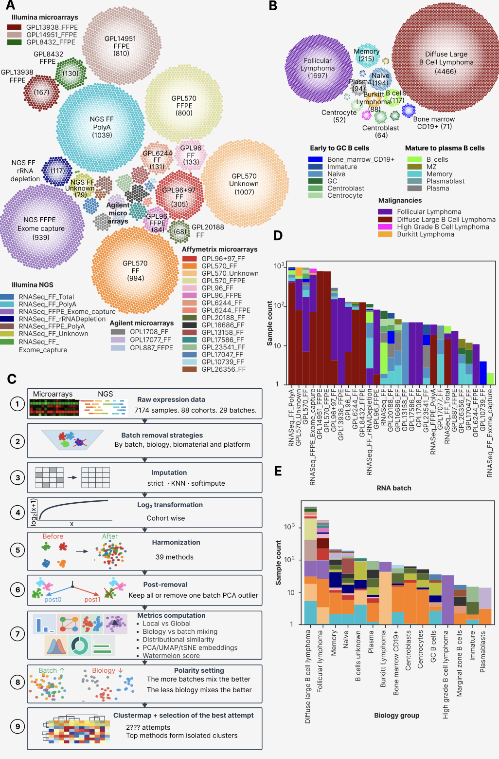
The initial step of the computational pipeline was prior batch removal, implemented in 14 strategies (Figure 2A). We applied batch removal by platform (NGS or microarrays including Affymetrix only), by biomaterial (FF/FFPE only), by biology (malignant only) and multiple strategies aiming to remove outlying (bad) batches: rare batches and those that showed poor performance based on the initial FSQN and QN screenings (Supplementary Table=Table from methods + Supplementary Figure with FSQN and QN plots in https://docs.google.com/presentation/d/1G5UKZZrDl2wkUc5Z_ipnPASIwSJEpqA9/edit?slide=id.g3d627fdd336_2_120#slide=id.g3d627fdd336_2_120 ). The subsequent application of KNN and Softimpute imputation methods lead to drastic increase in gene number (Figure 2B). While datasets with complete NA removal ranged from 3447 (S0 and D strategies) to 6797 (C strategy), KNN and Softimpute resulted in gene numbers ranging from 6797 (J strategy) to 15885 (C strategy). KNN and Softimpute approaches resulted in the same number of genes because we applied them only for genes with less than 20% samples being NA in each dataset. Whereas ‘strict’ approach led to unimodal gene expression distributions mostly for microarrays (16 cohorts) and bimodal mostly for NGS cohorts (the rest 72 ones, Supplementary Figure 2), KNN and Softimpute resulted in more similar gene expression distributions per cohort, leaving only 5 out of 88 cohorts with unimodal distribution for KNN (Supplementary Figure 3) and 3 for Softimpute (Supplementary Figure 4). Surprisingly, the Softimpute imputation lead also to anomalous third peak of gene expression between the zero and the middle expression one for 14 cohorts (Supplementary Figure 4) which is certainly an algorhytmic hallucination.

It should be noted that the initial dataset before any NA handling was highly heterogeneous by non-NA expression (Figure 2C): NGS, GPL570 and GPL14951 datasets had more than 15000 non-NA genes, whereas rare batches (GPL20188_FF, GPL13158_FF, GPL16686_FF etc) contained only 6000-7000 genes with defined expression. This heterogeneity led to low gene number in the strict approaches (3447 – 6797 genes), which was mostly mitigated by imputation (6797 - 15885 genes).

We then visualized gene sets overlapping with imputation and with strict approach in a hybrid circus Sankey plot (Figure 2D). Iterative removal of batches, both in the PCA space (strategies A – E1 – E2 – E3) and for microarrays (strategies F – H – G) did not drastically increase gene number after imputation, albeit the strict gene number increased from 3447 in F to 6133 in H, and from 3520 in A to 5658 in B, 5175 in E1. Importantly, imputation increased gene number by a factor of 3.4 for the initial S0 strategy (from 3447 to 11768). Strategies with the highest gene number after imputation (A, E1-E3, B, D, K, C) shared their genes and had a pairwise Jaccard index 95-100% (Supplementary Figure 5), showing that imputation helps to the highest degree for closely related transcriptomic platforms and biomaterials.

Figure 2. Batch removal strategies, NA genes and imputation. (A) Circos-Sankey plot showing batch removal strategies and number of samples remaining after each strategy being applied. The strategies extend from the central blue circle symbolizing the S0 strategy, and logically they are divided into the four groups (arcs in the blue circle): by platform, by biology, by biomaterial, bad batches removal. (B) Bar plots showing gene number under the strict approach (bottom plot, all genes with at least one NA in a dataset removed) and after the imputation procedures (top plot, KNN or Softimpute). Gene number counted as number of genes having non-NA expressions in at least one sample in the dataset. (C) Heat map of NA/defined expression by genes and samples in the dataset. Samples and genes are ordered by ascending NA count from left to right and from top to bottom. Palettes for color annotation in the top of the heat map can be found in Figure 1A, 1B. (D) Circos-Sankey plot showing gene numbers and overlapping of gene sets for batch removal strategies under the strict NA handling and gene imputation. Batch removal strategies are structured by the same four groups as in the panel A.
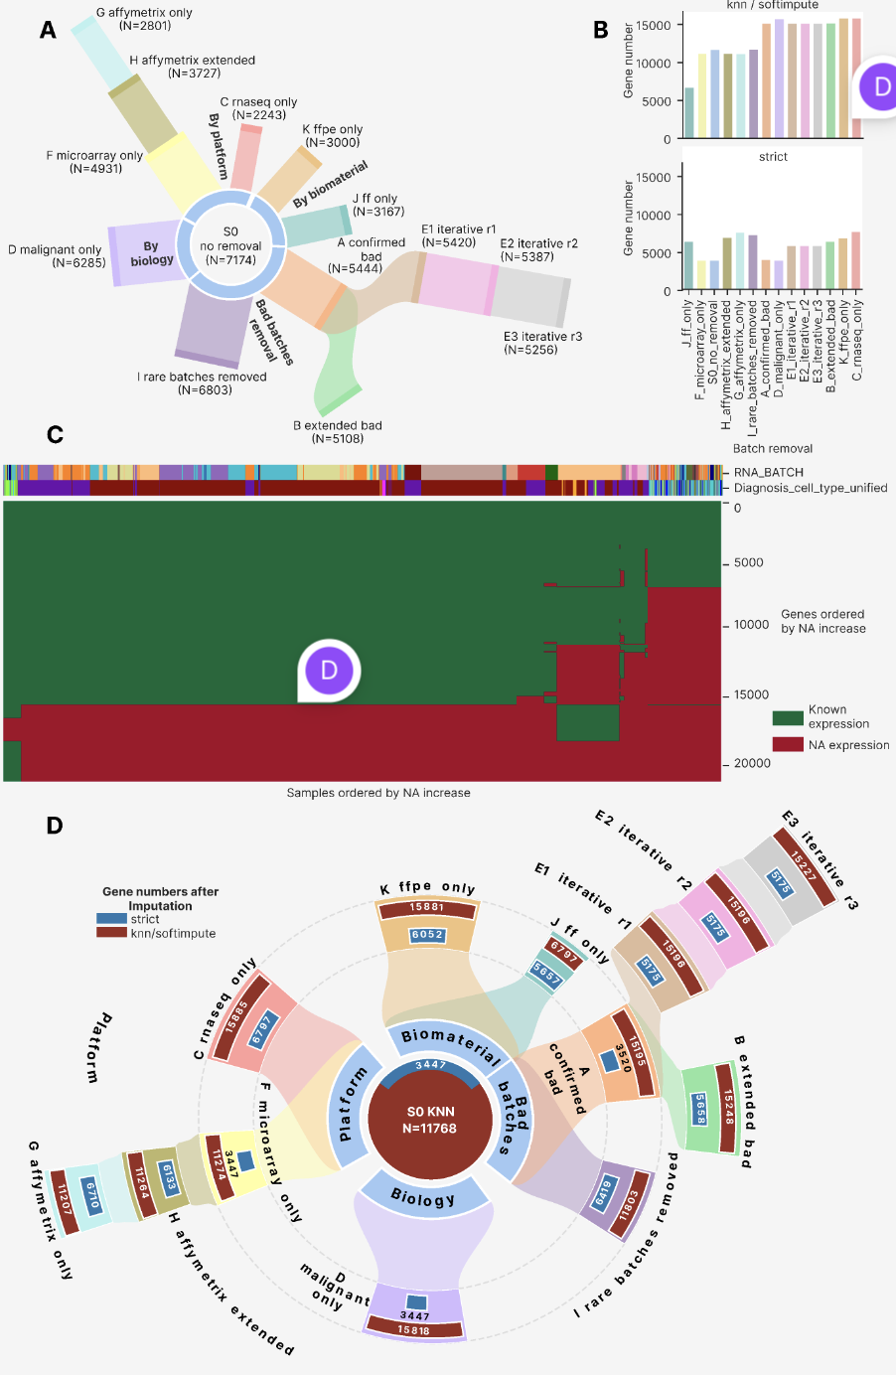

Best approaches selection
For each of the imputation and batch removal strategy combination we applied 31 harmonization methods and then an optional post-removal step, resulting in 2407 harmonization attempts successfully run. We then calculated up to 230 harmonization metrics for these attempts, selecting metrics from the public literature to cover all aspects of high-quality cross-platform harmonization (Supplementary File with detailed description of all the metrics, Table N in Methods). Strategies with platform or biomaterial selection (C, G, J and K) had incomplete set of metrics calculated (Supplementary Figure 5B) because of annotation columns having the same value, for example for the J FF only strategy the column “RNASEQ_SOURCE” was always FFPE, so all metrics for this column were unavailable (add more about it). Moreover, individual attempts could be failed by timeout, since we stopped the computation that ran for more than 3 hours on an isolated CPU (add more).

For 87 metrics out of the 230 total, we manually established polarity that could be +1 (the higher the better) or -1 (the lower the better), based on the general approach that in the high-quality harmonization metrics measuring mixing and overlapping of batches should be high, and those that measure biological groups mixing and overlapping are low. The polarity coefficients are listed in Supplementary File X.

Based on the scoring metrics with defined polarity and 2234 harmonization attempts with less than 5% of samples having only NA gene expression, we built a cluster map to assess an overall quality distribution in the harmonization attempts set (Figure 3). At a higher level of data structure, metrics formed 6 co-clustering groups, 3 of them corresponded to global metrics, and the rest ones related to distribution similarity, percentage of NA values and local mixing metrics. To confirm whether there’re is a tradeoff between local and global metrics, we built a separate cluster map of Spearman cross-correlations between all 87 scoring metric vectors with values of the 2234 harmonization attempts (Supplementary Figure 6). We observed an isolated cluster of 33 harmonization metrics with 22 local ones, and metrics of this cluster negatively correlated with the second cluster of global metrics (10 global ones, 6 distributional ones and one other metric). The third cluster consisted of global, other and distributional metrics and had comparable numbers of positive and negative correlations with the first two clusters. Same annotation columns (primarily PLATFORM_RNA and RNASEQ_SOURCE – describe these columns in Supplementary) formed smaller clusters within the larger ones by metric type, and no systematic co-clustering was found for metric group. In the same way, PCA, UMAP and tSNE of metrics (Supplementary Figure 7) showed large-scale co-localization of metrics by type, a smaller scale one by annotation column and no pattern by metric group.

At the level of harmonization attempts we saw the four major clusters (Figure 3). Based on the relative performance by metrics and co-clustering of batch removal strategies, we called them: ‘good cross-platform cluster’, ‘bad cross-platform cluster’, ‘same sample type cluster’ and ‘same platform’. Each of the latter two clusters had a good and a bad subclusters, separated by local metrics performance, primarily by LISI and UMAP/tSNE entropy. Similarly, ‘good cross-platform cluster’ had these local metrics higher compared to the bad one. kBET acceptance rate was the only local metric showing the worst values for all harmonization attempts except the RNASeq only ones with post-removal.

On the other hand, the metrics in the ‘NA percentage cluster’ were the best among all the metrics: the metric ‘pct_genes_noNA’ had the only large group of poor performance in Angel harmonization approach. Metrics calculated on the “RNASEQ_SOURCE” and “PLATFORM_RNA” columns were not calculated for the strategies FF/FFPE only (J, K) and for the strategies Affymetrix/RNASeq only (H, C), respectively, because these columns had the same values for these strategies. Global cluster B metrics (mainly tSNE/UMAP centroids) had higher performance in the ‘good cross platform cluster’ and in good clusters of same platform and same biomaterial. Distributional similarity cluster metrics behaved in the same way, and the global ones of cluster C demonstrated medium performance across the attempts set.

We calculated Spearman cross correlations between all the harmonization attempts in a space of 87 scoring metrics and build a clustermap based on these correlations (Supplementary Figure 9). We found the same clusters as for the main clustermap: ‘same platform’, ‘same sample type’, ‘good cross-platform’ and ‘bad cross-platform’. Moreover, the clustering was again impacted primarily by batch removal strategy, then by harmonization method. In contrast to the metrics cross-correlation clustermap (Supplementary Figure 7), there were no negatively correlating clusters. The most highly deviating was the ‘same sample type’ cluster, showing only 0.1-0.25 Spearman correlation with ‘same platform’ and ‘good cross-platform’ clusters. We also built PCA, UMAP and tSNE plots of harmonization attempts in the space of 87 metrics (Supplementary Figure 10) and confirmed the supremacy of batch removal strategy and harmonization method in the approach performance. Also, there were no co-clustering of approaches with the same method harshness.
Figure 3. Cluster map of 2234 harmonization attempts (columns) in a space of 87 quality metrics (rows).
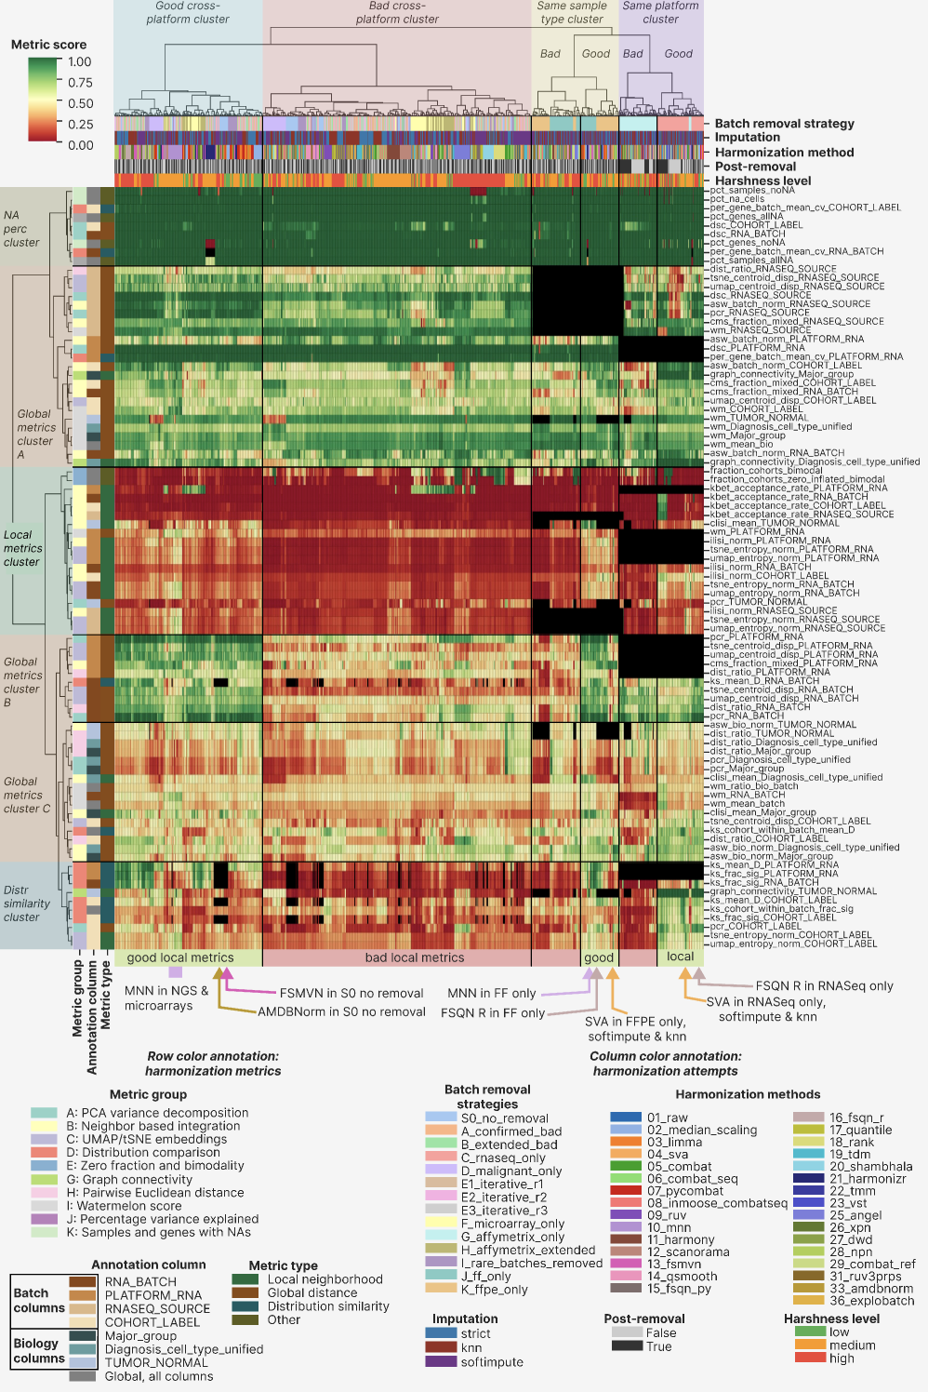

Best approaches
Based on the clustermap visual inspection, we identified 8 best harmonization approaches (Table 1), spanning multi and single platform strategies, as well as FF and FFPE only ones. MNN and SVA harmonization methods were the most versatile, with MNN applicable to the multiplatform strategies and the FF only one, SVA showing high performance for RNASeq only and FFPE only settings.

Table 1. Best harmonization approaches groups identified via the integrative clustermap assessment.
Group name | Batch removal strategies | Harmonization methods | Imputation | Reason to include
MNN multiplatform | All multiplatform strategies: S0, A, B, D, E1, E2, E3, I | MNN | Any | Superior local metrics performance compared to the rest attempts in the ‘good multiplatform cluster’
FSMVN in S0 | S0 | FSMVN | Any | High quality mixing of NGS and Illumina microarrays on UMAP and tSNE
AMDBNorm in S0 | S0 | AMDBNorm | Any | High quality mixing of NGS and Illumina microarrays on UMAP and tSNE
MNN FF only | J | MNN | Any | Best performance by local metrics in the FF part of the good “Same sample type” cluster
FSQN R FF only | J | FSQN R | Any | Hugh quality mixing of NGS and microarrays on UMAP and tSNE
SVA FFPE only | K | SVA | KNN, Softimpute | Best performance by local metrics in the FFPE part of the good “Same sample type” cluster
SVA RNASeq only | C | SVA | KNN, Softimpute | Best performance by local metrics in the RNASeq part of the good “Same platform” cluster
FSQN R RNASeq only | C | FSQN R | Any | High quality mixing of RNASeq FF and FFPE batches on UMAP and tSNE

Without any harmonization, the FL dataset showed clear batch effect structure at the level of PCA and tSNE visualization (Figure 4A). For PCA, RNASeq datasets formed a compact structure, whereas Affymetrix microarrays (primarily GPL570) arranged in a linear sequence of batches going in right and upward direction, and the rest microarrays (Affymetrix, Illumina, and Agilent ones) formed a right-downward sequence. In tSNE, RNA batches scattered over the entire plot forming compact clusters, proving adequacy of the RNA_BATCH column annotation in the dataset. Additionally, there was no meaningful grouping of batches or samples by biology. Applying MNN under strict NA handling, we observed a scattered cohort-outlier (SOM cohort, that was previously quantile normalized) in PCA space and the rest cohorts clustered together (Figure 4B). For tSNE visualization we found only three batches-outliers: part of RNASeq_FFPE_Exome_capture, part of GPL570_Unknown (the same SOM cohort) and the majority of the GPL570_FFPE batch. All the rest samples formed a biologically relevant pattern with FL, DLBCL and normal B cells forming isolated groups with batches mixing within them. Illumina microarrays formed a separate large cluster, though. For the strategy D (malignant only, Figure 4C) we found even better co-clustering of biology and batch mixing. We then compared clustering of raw and MNN-harmonized S0 dataset in the space of first 10 principal components with the outlier SOM dataset removal (PCs, Figure 4D) and revealed increased batches mixing after harmonization: FL and normal B cells formed single isolated clusters, but DLBCL samples still followed a batch-directed dendrogram. We also tested the strategy H (Affymetrix extended) under MNN showed and it showed the same pre-normalized SOM cohort as outlier on PCA (Supplementary Figure 11A), whereas all three strategies demonstrated the same 2-3 batches outliers both on UMAP and PCA (Supplementary Figure 11B, C, respectively).

We next visualized the second-best approach that we have found, SVA in RNASeq only (Figure 4E). Both PCA and tSNE revealed perfect mixing of batches (including the RNASeq_FFPE_Exome_capture one which was an outlier previously) and separation of biology groups. Interestingly, such a high visual performance was found only for KNN and Softimpute imputation, whereas strict NA handling did not mix the major FF and FFPE batches neither on PCA, UMAP or tSNE (Supplementary Figure 12A, B, C respectively). Interestingly, the strict SVA approach was visually indistinguishable from the raw approach without harmonization. For this SVA RNASeq approach we finally clustered samples in the space of first 10 PCs before and after the harmonization (Figure 4F). Before harmonization, batches dominated the dendrogram, and after it the clustering became almost perfectly biology directed: FL formed a distinct group, and normal B cells were a subcluster within a larger DLBCL group.

Figure 4.
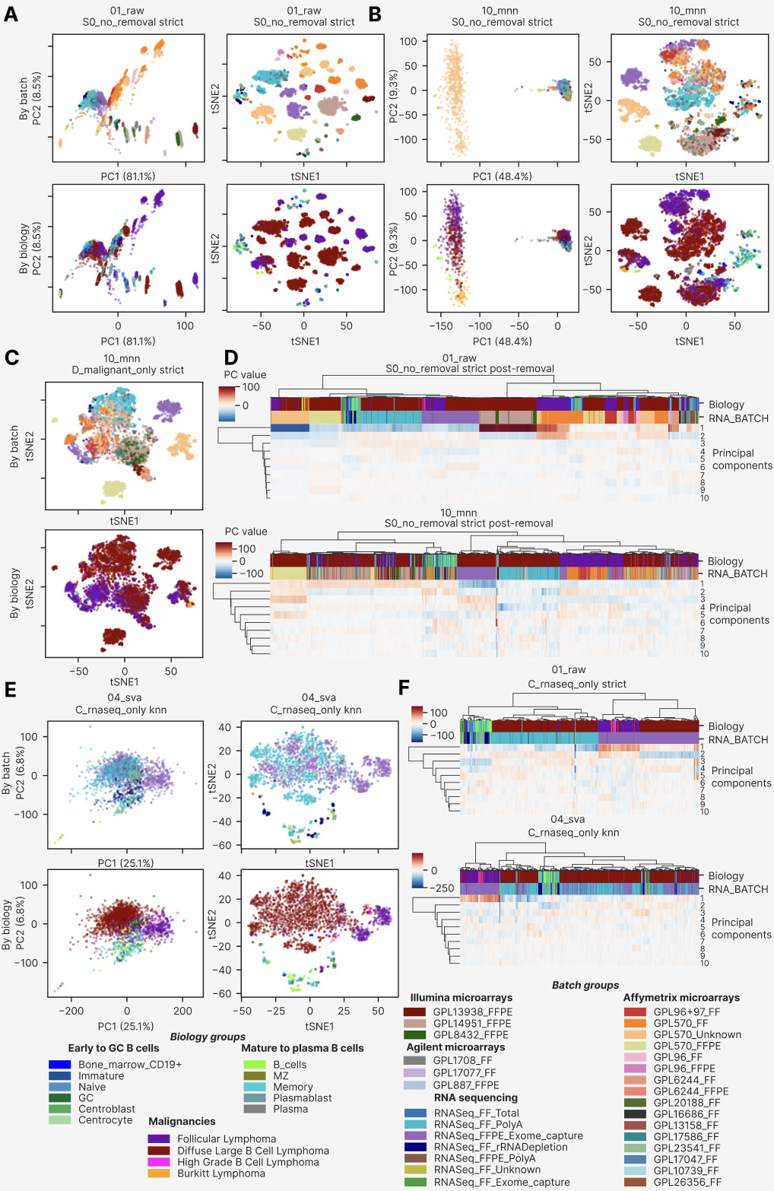
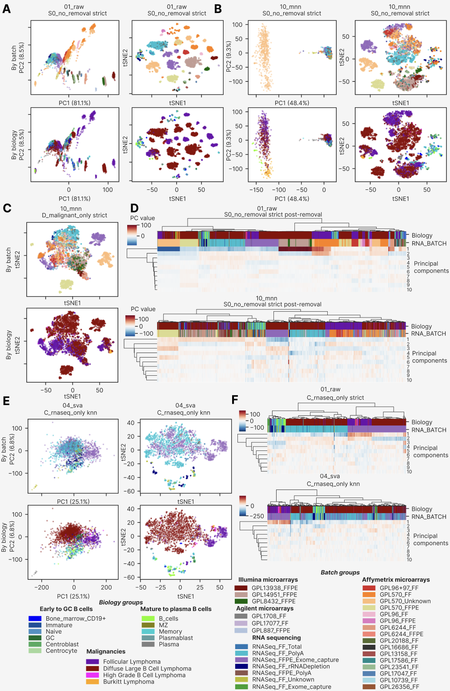
The second-best approach for the C strategy (RNASeq only) was FSQN R, the harmonization method that relied on the original R package instead of the custom python implementation (method 15_fsqn_py). On PCA plot batches clustered by biology (Supplementary Figure 13A), whereas the non-linear dimensional reductions
We next visualized and assessed the rest best approaches

Relative impact of batch removal strategies, harmonization methods, imputation methods and post-removal.
To quantify the relative contribution of each experimental factor to overall harmonization quality, we performed a variance decomposition analysis using eta-squared (η²) effect sizes across the full 87-metric composite scoring space (Figure 9C). Harmonization method emerged as the dominant factor, explaining 36.4% of variance in composite harmonization quality (η² = 0.364), followed by batch removal strategy (η² = 0.262, 26.2%). Imputation method contributed only 1.6% of variance (η² = 0.016), and post-removal contributed less than 1%, confirming the four-factor hierarchy: method > strategy > post-removal > imputation.

This ordering has direct practical implications for experimental planning. The dominant role of method was further confirmed by comparing composite score distributions across strategy harshness tiers (Figure 9B): whereas low-harshness strategies showed a compressed and uniformly modest score range regardless of method choice, high-harshness strategies — restricting samples to a single platform or biomaterial — revealed wide method-dependent variance, with the best approaches achieving composite scores 60–90% higher than the median. Importantly, this analysis refutes the common assumption that imputation strategy is a critical hyperparameter: the ~10 percentage-point advantage of softimpute over KNN, and the ~25-point advantage of both over strict NA handling, emerged consistently within each strategy tier but were dwarfed by method-level differences.

The stacked metric-type composition of the composite score (Figure 9D) revealed that the top-ranking methods derived their advantage primarily from local neighbourhood metrics and distributional similarity metrics, while most methods showed comparable performance on global distance metrics. This differential contribution explains the poor discriminative power of PCR-only or DSC-only rankings — which dominated early-generation harmonization benchmarks — because the most biologically consequential improvements are captured only by the expanded 87-metric framework.

Figure 9. Cross-metric correlation and relative factor impact. (A) Scatter of PCR_RNA_BATCH (x-axis; higher = stronger global batch correction) vs. kBET acceptance rate (y-axis; higher = better local batch mixing) for all 2,234 harmonization attempts, coloured by strategy harshness. Ring size encodes iLISI quartile (larger rings = higher iLISI); n=2,234. Stars (★) mark the 15 best approaches. (B) Distribution of composite harmonization scores stratified by strategy harshness tier (low/medium/high), with Best-15 approaches overlaid as stars. (C) Eta-squared (η²) effect sizes for four experimental factors: harmonization method, batch removal strategy, imputation method, and post-removal. Discussion: clustermap groups by strategy; η² shows method > strategy. Both reflect different aspects of variance structure. (D) Stacked bar chart of cumulative normalized score per harmonization method, decomposed by metric type (local neighbourhood, global distance, distributional similarity, other). Y-axis represents cumulative summed normalized score across all metrics of each type; not bounded to 1.

Global and local harmonization metrics trade-off
The central analytical challenge in cross-platform harmonization is the inverse relationship between global batch correction and local biological preservation. To characterize this trade-off empirically, we quantified five families of local and structural metrics and examined their relationships to the established global metrics (Figures 7, 8, 8B).

Local neighbourhood quality was assessed by kBET acceptance rate, iLISI, cLISI, graph connectivity and tSNE/UMAP mixing entropy per biological group. Among all 2,234 attempts, the vast majority achieved near-zero kBET acceptance rates (Figure 7A), confirming that local neighbourhood composition remained batch-biased after most harmonization methods even when global PCR values were substantially reduced. Only the 15 best approaches achieved kBET rates above the null threshold of 0.10, all within high-harshness strategy contexts. The iLISI × cLISI scatter (Figure 7B) revealed a positive but weak correlation between batch mixing and biology preservation: methods that achieved the highest iLISI values (MNN in multi-platform strategies, SVA in RNA-seq-only and FFPE-only contexts) maintained cLISI values above 1.4, confirming simultaneous batch mixing and biology preservation. Importantly, several approaches with high iLISI showed compressed cLISI values (~1.0–1.2), corresponding to methods that over-corrected and collapsed biology-associated variance (primarily AMDBNorm and FSMVN in multi-platform strategies). The PCR × kBET scatter (Figure 9A) makes the global–local trade-off explicit: while most approaches cluster at kBET ≈ 0 across the entire range of PCR values, only the best 15 approaches simultaneously achieved kBET > 0.05 and PCR_RNA_BATCH > 0.85, occupying a previously inaccessible region of the trade-off space.

Structural metrics revealed that centroid dispersion was uniformly reduced after harmonization regardless of method choice (Figure 8A), indicating that all tested algorithms achieve comparable global scatter collapse — and therefore that centroid dispersion is a necessary but insufficient discriminator of harmonization quality. In contrast, the WaterMelon bio/batch ratio (Figure 8B, 8C) discriminated effectively between approaches: only the best approaches achieved ratios approaching 1.0, where biology-associated inter-centroid distances match or exceed batch-associated ones. The distributional similarity analysis (Figure 8B) further demonstrated that mean KS divergence between cohort expression distributions was significantly reduced by MNN, SVA, and FSQN R compared to other methods, while the NA retention heatmap (Figure 8B, panel E) confirmed that all qualifying attempts maintained >95% gene coverage after imputation filtering. Notably, 20_shambhala showed a high NA fraction specifically in the C_rnaseq_only strategy, consistent with known limitations of the Shambhala algorithm on RNA-seq-only inputs.

To integrate these multi-dimensional metric signals, we computed a composite harmonization score as the mean of polarity-normalized values across all 87 scoring metrics (Figure 10). The composite rank distribution (Figure 10A) showed a characteristic non-linear profile: 95% of the 2,234 attempts achieved scores in the 0.33–0.42 range, with a sharp rise in the top 15 attempts to 0.58–0.67 — a step-change rather than a continuum, consistent with these approaches representing a qualitatively different harmonization regime. The parallel-coordinates profile of the 15 best approaches (Figure 10B) confirmed two distinct performance clusters: MNN-centred approaches characterized by strong PCR correction (high PCR_RNA_BATCH) and high gene coverage but lower kBET, and SVA/FSQN R approaches characterized by more balanced performance across local neighbourhood and distributional metrics. The near-perfect correlation between equally-weighted and biology-weighted composite scores (Figure 10C) validated the robustness of the ranking to metric weighting assumptions, confirming that the top-15 selection was not an artefact of weighting choices.

Figure 7. Local neighbourhood and embedding quality metrics for 2,234 harmonization attempts. (A) kBET acceptance rate per harmonization method (symlog scale), coloured by best-approach status. Red dashed line marks the Best-15 mean threshold (0.10). (B) Scatter of iLISI_RNA_BATCH vs. cLISI_Diagnosis_cell_type_unified (higher = better on both axes) for all 2,234 attempts; Best-15 marked as red stars (★); ring size encodes iLISI quartile. (C) Graph connectivity by biological covariate (Diagnosis, Major_group, TUMOR_NORMAL) per harmonization method. (D) tSNE mixing entropy (normalized) per harmonization method, sorted by median. (E) Scatter of kBET acceptance rate (y-axis, symlog) vs. PCR_RNA_BATCH (x-axis), illustrating the global–local trade-off: the majority of methods cluster at kBET ≈ 0 across all PCR values; only the Best-15 (★) simultaneously achieve global correction and local mixing.

Figure 8. Structural and distance metrics for 2,234 harmonization attempts. (A) Heatmap of mean centroid dispersion per harmonization method × embedding (tSNE/UMAP) × annotation covariate (RNA_BATCH, PLATFORM_RNA, RNASEQ_SOURCE, COHORT_LABEL); values are negative (batch compaction below baseline); uniform across methods. (B) Scatter of WaterMelon_batch score vs. WaterMelon_bio score per method; Best-15 (★) in upper-right (biology-dominant) quadrant. (C) WaterMelon bio/batch ratio per method (symlog scale); red dashed line at ratio = 1.0. (D) CMS fraction mixed per method. (E) ASW_batch (dark) and ASW_bio (warm orange) per harmonization method.

Figure 8B. Distributional similarity and NA retention for 2,234 harmonization attempts. (A) Mean KS distance (D statistic) per method across all cohort-pair comparisons, coloured by best-approach status; lower = better distributional similarity. (B) Fraction of cohort-pair KS tests with significant divergence (q < 0.05) per method and annotation covariate. (C) Per-gene coefficient of variation of batch-level expression centroids per method; outlier methods (26_xpn, 28_npn) at CV > 600. (D) Mean KS distance between cohorts within the same RNA batch per method. (E) Heatmap of fraction of samples with all-NA gene expression per batch removal strategy × harmonization method; C_rnaseq_only × 20_shambhala shows anomalous NA rate (~15%). (F) Fraction of genes retained (non-NA) per imputation method grouped by strategy harshness; softimpute and KNN maintain >95% retention across all harshness tiers.

Figure 10. Composite harmonization score and best-approach profiles. (A) Composite score lollipop plot for all 2,234 attempts ranked by ascending score; Best-15 (★) occupy the top 0.7% of the distribution (scores 0.58–0.67). (B) Parallel-coordinates plot of five representative metrics (PCR_RNASEQ_SOURCE, kBET/COHORT_LABEL, ASW-batch/COHORT_LABEL, normalized composite score, percentage non-NA genes) for the 15 best approaches, revealing two profile clusters: MNN-centred (high PCR, high gene coverage) and SVA/FSQN R-centred (balanced local/distributional metrics). (C) Scatter of equally-weighted composite score vs. biology-weighted composite score; near-diagonal clustering confirms robustness of ranking to weighting assumptions. (D) Bubble chart of normalized composite score per harmonization method × metric group (A–K), revealing that local neighbourhood (Group B) and graph connectivity (Group G) are the primary discriminating metric families among the best approaches.

Final decision tree for bulk transcriptomic datasets harmonization
Based on the comprehensive benchmarking analysis, we formulated a data-driven hierarchical decision tree for harmonization method selection, conditioning recommendations on dataset biomaterial type and platform composition (Figure 11). The decision tree formalizes four primary scenarios derived from the final decision analysis: fresh-frozen only (FF), FFPE only, RNA-seq only (any biomaterial), RNA-seq combined with Illumina microarrays, and RNA-seq combined with Affymetrix and Illumina microarrays.

For fresh-frozen only datasets — comprising Affymetrix, Illumina, and Agilent microarray platforms mixed with RNA-seq — MNN achieved the best overall performance across all metric families and is recommended as the primary method, with FSQN R as an alternative where global PCR minimization is prioritized. For FFPE-only datasets, SVA with softimpute or KNN imputation represents the first demonstrated successful mixing of FFPE Affymetrix, FFPE Illumina microarray, and FFPE RNA-seq platforms in a single harmonized B-cell lymphoma dataset; this combination achieved a 56% relative reduction in PC1 variance (from 87.6% raw to 38.4% post-harmonization) while preserving FL and DLBCL cluster separation. For RNA-seq only datasets, SVA with softimpute or KNN again emerged as the top-performing approach, uniquely revealing two FL transcriptional subgroups — invisible in all other harmonization configurations — that may correspond to known GCB/non-GCB molecular subtypes.

For mixed RNA-seq and Illumina microarray datasets, FSQN R without post-removal achieved the best balance between global correction and biology preservation, with AMDBNorm or FSMVN combined with post-removal as alternatives for scenarios where global PCR is prioritized. For the most compositionally complex scenario — RNA-seq combined with Affymetrix and Illumina microarrays spanning multiple biomaterial types — MNN with post-removal achieved superior global batch correction and consistent local mixing across all metric families. A common finding across all five scenarios was the superiority of imputation-augmented approaches over strict gene-set restriction: softimpute-imputed datasets provided on average 10–15 composite-score percentage points above strict-imputed equivalents, consistent with the variance decomposition analysis.

Notably, post-removal — the exclusion of one PCA-outlier batch after harmonization — provided marginal metric improvement (η² < 0.01 in the global variance decomposition), confirming that it is a fine-tuning step rather than a fundamentally distinct correction stage. We recommend post-removal only in the RNA-seq + Illumina microarray scenario (step 4), where a strong outlier batch was systematically identified across multiple imputation conditions.

Figure 11. Data-driven decision tree for harmonization method selection. Four-level hierarchical tree recommending harmonization approaches based on dataset biomaterial type and platform composition. Step 1 (INPUT): characterize the dataset by biomaterial and platform. Step 2 (STEP 1 — Biomaterial/platform type): classify into one of five scenarios (FF only, FFPE only, RNA-seq only, RNA-seq + Illumina microarrays, RNA-seq + various microarrays). Step 3 (STEP 2 — Recommended method): apply the primary recommendation (green boxes, ★) or alternative (orange boxes). Step 4 (STEP 3 — Post-removal QC): apply or omit post-removal based on the scenario. Primary recommendations: MNN for FF-only and mixed multi-platform contexts; SVA + softimpute/KNN for FFPE-only and RNA-seq-only contexts; FSQN R for RNA-seq + Illumina microarray contexts; MNN + post-removal for RNA-seq + various microarrays. Abbreviations: MNN = Mutual Nearest Neighbors; SVA = Surrogate Variable Analysis; FSQN R = Feature-Specific Quantile Normalization (R implementation); FF = fresh-frozen; FFPE = formalin-fixed paraffin-embedded; NGS = next-generation sequencing; Illum. = Illumina microarray; Aff. = Affymetrix microarray.

DISCUSSION
A separate section and edits for discussion by Masha S, also ask her to correct/review Results.

Subtle biological differences under batch effect

Dataset heterogeneity. The dataset was highly imbalanced between batch and biology groups (Figure 1D, 1E). Such an imbalanced distribution reflected real world conditions during signature mining, since the open-source data are usually highly heterogeneous.

The follicular lymphoma transcriptome represents one of the most technically demanding targets for cross-platform harmonization precisely because the biological signal of interest — the distinction between FL and DLBCL, or between FL molecular subtypes — is subtle relative to the technical noise introduced by inter-platform and inter-biomaterial differences. Our dataset, spanning 7,174 samples across 29 RNA batches and four sequencing platforms, encapsulates this challenge at a scale not previously assembled for GC B-cell lymphoma research. The observation that 95% of PCA variance in the raw dataset is attributable to RNA_BATCH — with virtually no biology-driven structure visible before harmonization — quantifies the magnitude of this challenge and underscores why standard benchmarking frameworks using TCGA or GTEx-scale datasets, where biology effects typically dominate batch effects, are insufficient for subtle-biology applications.

The FL-specific biological discovery — two transcriptional subgroups revealed by SVA with softimpute in the RNA-seq-only strategy — constitutes an unexpected and biologically significant finding emerging from the harmonization process itself. These subgroups were invisible in all other harmonization configurations, including other methods in the same strategy and SVA with strict imputation. This dependency on imputation suggests that the subgroup signal resides in genes recovered by softimpute beyond the strict 3,447-gene set, genes that may carry platform-specific regulatory signatures detectable only at higher coverage depth. Whether these subgroups correspond to the established GCB/non-GCB molecular subtypes of FL (ref), or represent a novel transcriptional axis orthogonal to known classifiers, requires downstream survival analysis and gene set enrichment that is beyond the scope of this benchmarking study. Crucially, the finding underscores that harmonization method selection is not merely a technical pre-processing decision but can determine which biological discoveries are accessible from a given dataset.

Novel computational pipeline for harmonization tools adjustment and selection

The ComboBatch pipeline is conceptually distinct from previous harmonization benchmarks (ref, ref, ref) in three fundamental respects. First, it exhaustively evaluates the full cross-product of four hyperparameter dimensions — 14 batch removal strategies × 3 imputation methods × 31 harmonization methods × 2 post-removal conditions = 2,604 theoretical configurations (2,234 successfully completed) — rather than selecting a representative subset of configurations for pairwise comparison. This exhaustive coverage allows the pipeline to detect interactions between factors (such as the imputation-dependency of SVA's FL subgroup discovery) that would be missed by incomplete designs. Second, it applies 87 polarity-defined scoring metrics spanning local neighbourhood, global, distributional, and structural aspects of harmonization quality, providing a multi-dimensional evaluation surface rather than relying on a single metric or a small panel. Third, it operates under the constraint of realistic biological subtlety: the FL/DLBCL distinction is approximately 5–10-fold smaller in transcriptional effect size than the batch effects in this dataset, requiring methods to identify approaches that simultaneously correct for large technical noise while preserving small biology signals.

The computational scale of ComboBatch — 2,234 completed attempts on 16 vCPU / 240 GiB RAM infrastructure with parallelized job dispatch across S3-backed intermediate storage — required systematic engineering of timeout handling, memory-limited execution, and error recovery. All harmonization methods that exceeded 3 hours of CPU time were recorded as failures and excluded from the main analysis (see Methods). The pipeline architecture is containerized and reproducible, with all intermediate expression matrices and metric tables available via the S3 storage paths described in the Data Availability statement.

We note important technical limitations of the current pipeline. The kBET metric is known to be sensitive to small batch sizes and failed to produce valid outputs for strategies with very small batch representations (e.g., I_rare_batches_removed with batches below 5 samples). The variancePartition-based PCR calculation timed out for the largest strategy × imputation combinations (S0_no_removal × softimpute), reducing the number of valid metric values for those configurations. These failures are handled by the pipeline's 5% missing-metric exclusion filter, which is the basis for restricting the main analysis to the 2,234 qualifying attempts.
Describe its technical limitations, timing, 32 CPU on 240 Gb RAM, investigate and summarize log, 5 workers in parallel.

Clustermap on a full metrics space as the best approach for harmonization selection
The 87-metric × 2,234-attempt clustermap (Figure 3) represents, to our knowledge, the largest systematic harmonization evaluation matrix reported to date in bulk transcriptomics. The clustermap revealed a robust four-cluster structure at the attempt level — good cross-platform, bad cross-platform, same sample type, and same platform — that was reproduced across independent Spearman correlation analysis (Supplementary Figure 9) and metric-space embeddings (Supplementary Figure 10). Critically, this structure was dominated by batch removal strategy rather than by harmonization method, confirming the theoretical expectation that sample composition determines the accessible range of correction rather than the algorithm applied.

The practical value of the clustermap-based selection approach is that it provides a bias-free, data-driven ranking that does not require prior assumptions about which metrics are most relevant for a given dataset. For datasets with different biological contexts — rare cell types, subtle molecular subtypes, or extreme platform imbalance — the same pipeline can be run with the same 87 metrics, and the clustermap will identify the dominant sources of quality variation specific to that context. The ability to visually identify anomalous metric-level patterns — such as the Angel harmonizer's catastrophic gene retention failure (manifesting as a distinct column in the NA-percentage metric cluster) or the CMS metric's uniformly low discriminative power across all attempts — provides a level of interpretability that single-score rankings fundamentally cannot achieve.

The metric cross-correlation structure (Supplementary Figure 7) further reveals that the local and global metric clusters are nearly orthogonal (Spearman ρ ≈ 0 between clusters), validating the two-axis (batch mixing × biology preservation) evaluation framework used throughout the benchmark. This empirical orthogonality is the key statistical justification for requiring both metric families in harmonization benchmarks, and it explains why methods that score highly on PCR can simultaneously fail spectacularly on kBET and iLISI.

AI-driven brute force and human-based approaches: AI enhancement leads to ~2 time more actionable approaches

The ComboBatch benchmark was designed as an exhaustive computational search, not a hypothesis-driven selection. This brute-force approach proved critical: of the three top-performing methods (MNN, SVA, FSQN R), MNN and SVA were initially identified through literature search and AI-assisted method curation (Claude, Anthropic), while FSQN R was discovered independently through manual literature exploration of the quantile normalization family. This mixed discovery process — AI-assisted broad enumeration combined with human domain expertise for method-specific parameter tuning — identified a combination that outperformed any single-strategy search.

Interestingly, rank normalization and standard quantile normalization — both harsh and computationally simple approaches — performed substantially below their more architecturally advanced FSQN R counterpart. This performance gap cannot be explained by harshness alone: FSQN R shares the quantile normalization principle but conditions on a biology-matched reference distribution, preserving expression shape while eliminating scale differences. This finding illustrates a general principle: algorithmic sophistication in method design (biology-conditioned normalization, mutual nearest-neighbour graph construction, surrogate variable modelling) consistently outperforms generic location-and-scale corrections, even when the simpler methods appear algorithmically equivalent at first inspection.
I found FSQN only by my googling, Claude AI “advised” MNN and SVA with imputation.

Interestingly, rank and quantile normalization that are harsh but simple – performed at an inferior level compared to their more advanced version FSQN R.

Comparison with other batch effect mitigation approaches
Among the 31 methods benchmarked, MNN, SVA, and FSQN R were the only algorithms that simultaneously resolved FL, DLBCL, and Normal GC B-cell transcriptional differences after cross-platform integration. This finding is consistent with the known mechanistic properties of these methods: MNN models the local geometry of expression space to identify mutual nearest neighbours across batches, inherently preserving within-biology neighbourhood structure (Haghverdi et al., 2018); SVA uses surrogate variable analysis to model latent technical factors while conditioning on the provided biological covariates (Leek & Storey, 2007); FSQN R applies feature-specific quantile normalization against an RNA-seq reference distribution, preserving the global expression topology of the reference biology (Franks et al., 2018). All three methods share a common architectural principle: they model or condition on biological structure during the correction process, preventing the collapse of biology-associated variance that characterizes unconstrained normalization methods.

Methods that dominated earlier harmonization benchmarks designed on TCGA or GTEx data — pyCombat, limma removeBatchEffect, median scaling, and standard quantile normalization — achieved strong global batch correction (PCR reduction) in our dataset but uniformly failed to preserve local biology structure, as evidenced by near-zero kBET acceptance rates and compressed cLISI values below 1.1. This failure is directly attributable to the scale mismatch between training context and our dataset: in TCGA or GTEx, batch effects are typically 2–5-fold smaller in variance explained than in our multi-platform lymphoma dataset, allowing unconstrained methods to correct batch effects without inadvertently erasing biology. When the technical noise is 10-fold larger than the biology signal — as in our raw FL dataset (95% vs. ~3–5% variance explained, respectively) — unconstrained methods cannot distinguish the two and remove both.

The Quartet reference material framework (ref), while conceptually elegant for prospective experimental designs, is inapplicable to retrospective harmonization of pre-existing clinical transcriptomic cohorts such as ours, where concurrent profiling of a reference material was not performed and cannot be retroactively added. Our results suggest that for retrospective multi-platform integration under realistic clinical-cohort conditions — heterogeneous batch sizes, multiple platforms, mixed biomaterials, confounded batch–biology composition — algorithm selection conditioned on biomaterial type and platform composition, as formalized in the ComboBatch decision tree, provides a robust and reproducible alternative to reference-material-based normalization frameworks. The decision tree further provides actionable guidance for prospective study design by identifying which sample composition scenarios are most tractable and which harmonization approaches are most robust to deviations from those scenarios.

Quartet Project – unfeasible because it requires experiment planning, and we can’t plan an experiment in advance.

To overcome these confounding variables, the Quartet framework proposes a fundamental shift in data normalization: scaling the absolute feature values of a study sample relative to the values of a concurrently profiled common reference material. Under this paradigm, whenever a batch of clinical samples is processed, a physical aliquot of the Quartet reference material is processed alongside them. The analytical pipeline then calculates the ratio of expression (or abundance) between the clinical sample and the reference material. By transforming the dataset from highly volatile absolute quantities into stable, relative fold-changes, the intrinsic technical noise of the specific batch is mathematically canceled out.
The efficacy of this ratio-based scaling was subjected to massive empirical validation. The Quartet team generated staggering volumes of data, including 252 RNA-seq libraries distributed across 21 distinct batches, processed in eight independent laboratories utilizing divergent library construction protocols (e.g., poly(A) selection versus RiboZero) and sequencing platforms (Illumina NovaSeq versus MGI DNBSEQ-T7). ¹ The consortium utilized the Signal-to-Noise Ratio (SNR)—a precise metric designed to quantify the distinction between intrinsic biological differences and technical variations—to evaluate various batch effect correction algorithms (BECAs). ² The rigorous analysis conclusively demonstrated that ratio-based scaling consistently outperforms traditional ad hoc correction methods, particularly in severely confounded experimental scenarios where biological factors and technical batch factors co-vary or are unevenly distributed.
https://pubmed.ncbi.nlm.nih.gov/37679543/
https://pmc.ncbi.nlm.nih.gov/articles/PMC11251996/
https://pmc.ncbi.nlm.nih.gov/articles/PMC10483871/
https://pubmed.ncbi.nlm.nih.gov/37884999/

MATERIALS AND METHODS

Dataset assembly
We aimed to compose a dataset with as many as possible publicly available FL-containing cohorts, including also DLBCL as a closely related GC lymphoma and normal B cells as a calibrating reference for future studies of FL transcriptomic signatures. We assembled a dataset of 88 cohorts, 7174 samples and … platform from NGS, Affymetrix, Illumina and Agilent datasets (Supplementary Table 1).

Batch annotation and classification
We devised the following batch naming and classification convention: each batch is named as <Platform_name>_<Biomaterial_name>_<Target_enrichment_name>. “Platform_name” is GEO platform name for microarrays and RNASeq for NGS. “Biomaterial_name” is classified as “FFPE” for cohorts where FFPE samples were exactly stated, and FF for all fresh biomaterials: fresh frozen tissue, sorted cells, PMBCs etc. “Unknown” value was assigned for datasets where we found no unambiguous sample annotation in source articles or in GEO dataset description. Finally, for NGS batches we specified “Target_enrichment_name” as poly-A enrichment, exome capture, rRNA depletion, total or unknown. For microarray batches we set target enrichment name as unknown, since target hybridization with probes is already included into the platform itself (ref). Other more granular batch effect sources, including RNA extraction and library preparation kits, NGS platform and exact biomaterial classification are available in Supplementary Table X but did not include them in the batch classification to avoid over complexification of the batch correction logic.

Gene expression profiling

Computational hardware
We deployed the full cross product of prior batch removal, imputation, log-transformation, harmonization and post-removal on a virtual server hosted on carpenter, with 32-48 CPUs and 240 GB RAM. For the data analysis we used Jupyterhub server with 16 CPUs and 64 Gb RAM.

Batch removal strategies
Since most harmonization methods process samples interdependently and their performance highly depends on the initial batch composition in the dataset (ref), we built 14 strategies of prior batch removal that were applied before imputation and log-transformation of the expression values. These strategies were adjusted iteratively during the overall computational pipeline assembly and testing (Table N).

The column “Iteration when added” denotes iteration of the batch correction pipeline development. The first 10 strategies were tested initially and then we reviewed the results and decided to add the two more ones (Iteration 2). Finally, we came up with the conclusion that the FF/FFPE dichotomy is the most important in the batch correction process and added the last two strategies: FF only and FFPE only (Iteration 3).

Table N. Prior batch removal strategies for the GC lymphoma dataset utilized in this study.
Strategy name | Strategy type | Strategy description | Sample number | Iteration when added
S0 no removal | Default | No sample removal | 7174 | 1
F microarray only | By platform | All microarrays taken | 4931 | 1
G Affymetrix only | By platform | GPL570 only | 2801 | 1
C RNASeq only | By platform | NGS only | 2243 | 1
D malignant only | By biomaterial | Normal B cells excluded | 6285 | 1
A confirmed bad | By batch | Outlier batches by an initial FSQN manual screening removed: GPL14951_FFPE_Unknown, GPL8432_FFPE_Unknown and GPL13938_FFPE_Unknown. | 5444 | 1
B extended bad | By batch | Additional outlier batches by an additional QN manual screening removed from strategy A confirmed bad. The batches removed: GPL6244_FFPE_Unknown, GPL17586_FF_Unknown, GPL20188_FF_Unknown, GPL23541_FF_Unknown, GPL887_FFPE_Unknown, GPL26356_FF_Unknown, GPL17047_FF_Unknown, GPL6244_FF_Unknown | 5108 | 1
E1 iterative r1 | By batch | One more batch with highest PC distance from the global centroid removed from the strategy A | 5420 | 1
E2 iterative r2 | By batch | One more batch with highest PC distance from the global centroid removed from the strategy E1 | 5387 | 1
E3 iterative r3 | By batch | One more batch with highest PC distance from the global centroid removed from the strategy E2 | 5256 | 1
H Affymetrix extended | By platform | All Affymetrix batches included | 3727 | 2
I rare batches removal | By batch | Batches with less than 50 samples excluded | 6803 | 2
K FFPE only | By biomaterial | FFPE batches included | 3000??? | 3
J FF only | By biomaterial | All batches classified as FF included | 3167 | 3

Missing expression values imputation
For the multiplatform batch correction that we performed, we expected thousands of genes to have N/A values between different batches (Supplementary Figure X - statistics of N/A genes in the initial dataset). Initially we employed 4 approaches to imputation of missing gene expression values: strict, KNN, softimpute and missforest. The strict approach was to exclude all genes that have N/A in at least one sample of a given prior batch removal strategy. Missforest was excluded because it ran for more than 48 hours on an 8 CPU server with 64 RAM without completion, and therefore we considered it unacceptable for the batch correction pipeline we have developed.
We ran KNN imputation using the parameters … according to … and softimpute using the parameters according to …, average computation time was … .

Both KNN and Softimpute imputation were applied only to those genes that has less than 20% samples with NA values in order to increase reliability.

Harmonization methods
Take a default Shambhala with standard P and Q datasets.

We performed an extensive literature search and identified 38 harmonization methods that can be in theory applied to the GC lymphoma dataset. We then implemented 33 of these methods in a python 3.11 virtual environment in Jupyterhub via python functions. We avoided python re-implementation of those methods that were available as R libraries but used python scripts for the standard and easy for implementation methods including median scaling and quantile normalization. The 5 methods failed implementation and were documented as failed with the corresponding reasons (Table N). For each method we assigned a “harshness score” (low, medium, high) which indicated degree of data transformation: low harshness methods employed only linear transformations such as median scaling, high harshness ones utilized data distribution and/or dimensionality changes such as quantile or rank normalization, and medium harshness methods transformed data in an intermediate ways according to the literature. As in the case of prior batch removal strategies, harmonization methods were added in three iterations, and each next iteration more methods were failed at the implementation step.

Table N. Harmonization methods utilized in this study.
Method name | Method harshness | Method full name | Implementation done | Implementation failure reason | Reference
01_raw |  |  | Yes
02_median_scaling |  |  | Yes
03_limma |  |  | Yes
04_sva |  |  | Yes
05_combat |  |  | Yes
06_combat_seq |  |  | Yes
07_pycombat |  |  | Yes
08_inmoose_combatseq |  |  | Yes
09_ruv |  |  | Yes
10_mnn |  |  | Yes
11_harmony |  |  | Yes
12_scanorama |  |  | Yes
13_fsmvn |  |  | Yes
14_qsmooth |  |  | Yes
15_fsqn_py |  |  | Yes
16_fsqn_r |  |  | Yes
17_quantile |  |  | Yes
18_rank |  |  | Yes
19_tdm |  |  | Yes
20_shambhala (put here the standard Shambhala) |  |  | Yes
21_harmonizr |  |  | Yes
22_tmm |  |  | Yes
23_vst |  |  | Yes
24_ ? |  |  | No
25_angel |  |  | Yes
26_xpn |  |  | Yes
27_dwd |  |  | Yes
28_npn |  |  | Yes
29_combat_ref |  |  | Yes
30_ ? |  |  | No
31_ruv3prps |  |  | Yes
32_? |  |  | No
33_amdbnorm |  |  | Yes
34_arsyn |  |  | Yes
35_? |  |  | No
36_explobatch |  |  | Yes
37_? |  |  | No
38_harman |  |  | Yes

Post-removal

Harmonization pipeline architecture
Yaml files, python scripts, links to github

Harmonization quality metrics
For harmonization quality control we prepared a set of 87 scoring metrics and ~100 additional ones that were not used in scoring. Metrics encompassed the full spectrum of harmonization properties, with the four major groups: global intersection, local mixing, distributional similarity and other metrics (Table N). Global intersection group defined how well the batch or biology classes overlapped in global PCA or analogous space, whereas local mixing metrics assess how homogeneously the same classes mix in a neighborhood of each sample. Distributional similarity metrics evaluated to what extent gene expression distributions in different batches are like each other.

Table N. Metric groups for harmonization quality control. A “column” here refers to any batch or biology column in the annotation table. (Maybe move to supplementary)

Metric name | Metric type | Metric group | Method definition | Source
PCA R² | Global | A | Fraction of variance in principal components (PCs) that is attributable to a column, by one-way ANOVA R². Calculated per PC and for top 10 PCs average. | [2]
Percentage variance | Global | J | Percentage of variance explained by each PC.
Principal component regression (PCR) | Global | A | Fraction of total PCA variance attributable to a column labels, where each PC is weighted by its proportion of explained variance. | Luecken MD et al. *Nature Methods* 19(1):41–50. 2022. DOI: 10.1038/s41592-021-01336-8. Also:
Dispersion separability criterion (DSC) | Global | A | Ratio of between-group scatter to within-group scatter in the first two PCA dimensions. Scatter is trace of a scatter matrix derived from the top 2 PC coordinates according to … . | PCA-Plus paper. *PLOS ONE* (2024). DOI: 10.1371/journal.pone.0295473.
kBET acceptance rate | Local | B | Tests whether the local (25-nearest-neighbor) composition of batch labels around each sample matches the global batch label distribution. | Büttner M et al. *Nature Methods* 16(1):43–49. 2019. DOI: 10.1038/s41592-018-0254-1.
Local inverse simpson's index (LISI) | Local | B | For each sample, how diverse are the batch labels in its 30 nearest neighbor vicinity, measured by effective number of equally present batches. | Korsunsky I et al. *Nature Methods* 16(12):1289–1296. 2019. DOI: 10.1038/s41592-019-0619-0.
Average silhouette width (ASW) | Global | B | How much more similar each sample is to its own class versus the nearest other class. Computed on the first 50 PCs in Euclidean space. | Rousseeuw PJ. *Journal of Computational and Applied Mathematics* 20:53–65. 1987. Applied to batch assessment in Luecken et al. 2022.
Cell-specific mixing score (CMS) | Global | B | Anderson-Darling test on per-batch 30 nearest neighbor’s distance distributions. Tests whether distances from a sample to each group are drawn from the same distribution. | Lüttgenau S et al. *Life Science Alliance* 4(6):e202001004. 2021. DOI: 10.26508/lsa.202001004
Centroid dispersion in UMAP and tSNE | Global | C | After computing a UMAP/tSNE 2D embedding, for each group compute its centroid. The centroid dispersion is the standard deviation of centroid positions divided by the overall standard deviation of all sample positions. | ?
Local neighborhood entropy in UMAP and tSNE | Local | C | For each sample, Shannon entropy of the group label distribution in its 30-nearest-neighbor neighborhood in the embedding space. Averaged over all samples. | ?
KS test mean gene-level D-statistic | Distributional similarity | D | For each gene of a randomly selected 1000 genes, Kolmogorov-Smirnov two-sample test comparing expression distributions between all pairs of batches. The D statistic is maximum absolute difference between empirical distributions. | [2]
Within-batch cohort-level D-statistic | Distributional similarity | D | Same as the previous metric but measures within-batch cohort effects. Its specifically isolates residual cohort effects within the same technology batch by comparing each cohort only against the pooled samples from its own batch. This detects lab-specific effects that platform-level normalization cannot remove. | [2]
Per-gene batch mean CV | Distributional similarity | D | For each gene, CV of the per-batch mean expression values, averaged across all genes. | [2]
Zero expression fraction | Other | E | Fraction of genes with zero expression.
Fraction cohorts bimodal | Other | E | For each cohort, fit the marginal expression distribution (across all genes × samples in that cohort) and test for bimodality by Sarle’s coefficient. | [3]
Graph connectivity | Local | G | For each group, checks whether all samples in that group are connected in the kNN graph regardless of batch. Captures whether groups are connected in kNN topology. K is set as minimum between 15 and sample number in each group.
Average pairwise Euclidean distance | Global | H | In the full harmonized expression space (all genes), the average intra-group and inter-group pairwise Euclidean distances for each annotation column.
Watermelon score | Global | I | The metric measures how strongly a hierarchical clustering top 50 PCs dendrogram separates class labels, relative to a random permutation baseline. It is an entropy-based normalized AUC metric computed over all dendrogram fork levels. | Zolotovskaya et al., 2020, PMC7084891

Harmonization quality metrics were calculated using scipy, sklearn, statsmodels and umap python modules (versions, refs).

Figures preparation

Clustering, dimensional reduction, basic plotting

AI usage

DATA AVAILABILITY
The data underlying this article is available in the article and in its online supplementary material. Intermediate analysis files, large Jupyter notebooks containing figure outputs, python scripts and yaml files for the computational pipeline deploy and additional plots generated during exploratory analyses but not included in the article or supplementary files have been deposited in a public GitHub repository and are accessible via the link https://github.com/Nikit357/T2T_transposons_evolution/.
Containerized and parallelized Shambhala that was developed and tested in this article has been published in a separate GitHub repository and is accessible via the link:
… Shambhala2-fast.

FUNDING

ACKNOWLEDGEMENTS

SUPPLEMENTARY MATERIALS

New supplementary figures (from metric and summary analysis)

Supplementary Figure A. Non-NA gene count per RNA batch in the initial S0_no_removal dataset. Top panel: horizontal bar chart of the number of genes with defined (non-NA) expression per RNA batch, sorted by gene count and coloured by RNA batch identity. The vertical red dashed line marks the maximum gene coverage of the strict imputation gene set (3,520 genes). Most batches achieve near-complete gene coverage; rare platform batches (GPL20188_FF, GPL13158_FF, GPL16686_FF) are restricted to 6,000–7,000 non-NA genes, motivating the use of imputation-based gene recovery. Bottom panel: sample count per batch in the same ordering, showing the 3-fold range in batch size (N = 68–1,039 samples).

Supplementary Figure B. Imputation gene set overlap and per-strategy gene counts. Left: Sankey diagram illustrating gene set flows from KNN, Strict, and Softimpute imputation methods into the combined gene universe for the S0_no_removal strategy; gene counts per imputation method are annotated at the source nodes. Right: bar chart of gene counts per imputation method (Strict = 3,520; KNN = Softimpute = 3,447 genes in the shared analysis gene set after filtering), showing that KNN and Softimpute recover an identical set of 73 additional genes beyond strict.

Supplementary Figure C. Gene retention heatmap across harmonization methods and imputation strategies. Heatmap of the percentage of non-NA gene retention per harmonization method (rows) × imputation strategy (columns) combination for the S0_no_removal strategy. Colour encodes percentage retention (dark green = 100%; lighter = lower retention). Most harmonization methods achieve >99% gene retention under all three imputation strategies. Two anomalous methods show severely reduced retention (~42–43%): harmonizr (21_harmonizr) and the Python FSQN implementation (15_fsqn_py), indicative of method-specific gene-level failures unrelated to imputation strategy.

Supplementary Figure D. Group B local neighbourhood metrics — full detail panel. Grid of 22 boxplot panels showing the complete set of Group B scoring metrics (kBET acceptance rate for RNA_BATCH, COHORT_LABEL, PLATFORM_RNA, and RNASEQ_SOURCE; iLISI for the same covariates; cLISI for Diagnosis_cell_type_unified, Major_group, and TUMOR_NORMAL; ASW_batch and ASW_bio; CMS fraction mixed) per harmonization method across all relevant annotation covariates. Best-15 approaches (★) are overlaid as red stars in each panel. Minimum font size of 7pt is enforced for all axis labels to preserve readability.

Supplementary Figure E. Group C centroid dispersion and embedding entropy — full detail panel. Grid of 13 strip plot panels showing tSNE and UMAP centroid dispersion metrics (per covariate: RNA_BATCH, COHORT_LABEL, PLATFORM_RNA, RNASEQ_SOURCE) and UMAP/tSNE mixing entropy metrics per harmonization method. Methods are sorted by mean dispersion (lowest = best batch compaction). Best-15 approaches (★) achieve consistently lower centroid dispersion in most panels.

Supplementary Figure F. Group H Euclidean distance ratios — full detail panel. Grid of 7 boxplot panels showing per-covariate Euclidean distance ratios (biology inter-centroid distance / batch inter-centroid distance) per harmonization method (RNA_BATCH, PLATFORM_RNA, RNASEQ_SOURCE, COHORT_LABEL, Diagnosis_cell_type_unified, Major_group, TUMOR_NORMAL). A ratio > 1.0 indicates that biology-associated inter-centroid distances exceed batch-associated ones — the ideal harmonization outcome. Best-15 approaches (★) are overlaid.

Supplementary Figure G. Group G graph connectivity — full detail panel. Grid of 3 barplot panels showing graph connectivity (fraction of samples reachable within a kNN graph by the same biology group) per harmonization method for three annotation covariates: Diagnosis_cell_type_unified, Major_group, and TUMOR_NORMAL. Best-15 approaches (★) achieve consistently high connectivity (>0.85) for the Diagnosis covariate, with wider variance for TUMOR_NORMAL, indicating that tumour/normal structure is the most challenging biological grouping to preserve after cross-platform batch correction.

Supplementary Figure 7S. UMAP mixing entropy per harmonization method. Boxplot of UMAP mixing entropy (normalized) per harmonization method, sorted by median entropy (highest = best local mixing). MNN (10_mnn) achieves the highest UMAP entropy, consistent with its leading kBET and iLISI performance. Methods with near-zero entropy — including dwd (27_dwd), combat_seq (06_combat_seq), and inmoose_combatseq (08_inmoose_combatseq) — achieve minimal local mixing in UMAP space despite strong global correction metrics, confirming the local–global metric dichotomy observed throughout the benchmark.

REFERENCES

