Systematic benchmarking of bulk transcriptomic harmonization tools across a multi-platform germinal centre B-cell lymphoma cohort identifies MNN and SVA as top-performing methods

Authors: Daniil Nikitin^{1*}, Arsen Arakelyan, Nicolas Borisoff, Maria Savchenko, Anatoly Bobe, Alexandr Bagaev?

Affiliation:
Institute of Molecular Biology, National Academy of Science of the Republic of Armenia

*Correspondence: danya.nikitin.orel@gmail.com

ABSTRACT
Cross-platform harmonization of bulk transcriptomic datasets remains a fundamental challenge for the development of reproducible cancer biomarkers, as unresolved batch effects introduce systematic technical noise that can dwarf biologically meaningful variation. Most existing harmonization tools are benchmarked on datasets with large inter-group biological differences (e.g., TCGA tumour types), whereas retrospective integration of clinical lymphoma cohorts demands preservation of subtle transcriptional distinctions between closely related diagnoses. Here we present ComboBatch, a systematic benchmarking pipeline that evaluates the full cross-product of 14 batch removal strategies, 3 imputation methods, 31 harmonization algorithms, and 2 post-removal conditions across 7,174 samples from 88 germinal centre B-cell lymphoma cohorts spanning four transcriptomic platforms. Scoring 87 polarity-defined quality metrics across 2,234 harmonization attempts, we show that method choice (eta-squared = 0.36) and batch removal strategy (eta-squared = 0.26) are the principal determinants of harmonization quality, while imputation (eta-squared = 0.016) and post-removal (eta-squared < 0.01) play secondary roles. Mutual Nearest Neighbours (MNN) and Surrogate Variable Analysis (SVA) with softimpute were the top-performing methods, jointly resolving follicular lymphoma (FL), diffuse large B-cell lymphoma (DLBCL), and normal germinal centre B-cell transcriptional differences across all tested dataset compositions. SVA with softimpute in the RNA-seq-only setting uniquely revealed two FL transcriptional subgroups invisible under all other tested configurations. We provide a data-driven four-scenario decision tree for harmonization method selection, applicable to any retrospective multi-platform transcriptomic study.

INTRODUCTION

Despite considerable progress in transcriptomic batch correction, technical variation introduced by differences in sequencing platform, RNA extraction protocol, and sample preservation method remains a principal obstacle to the development of reproducible cancer biomarkers — particularly for AI-driven classifiers trained on heterogeneous multi-cohort datasets. When batch effects are inadequately removed, models learn to exploit technical artefacts rather than true biological signal, a phenomenon that has been termed algorithmic hallucination (Yu et al., 2024). The clinical consequences are tangible: batch-confounded AI models can undergo catastrophic performance collapse upon deployment, as exemplified by an AUC decrease from 0.79 to 0.50 reported for a digital pathology prognostic classifier (Dawood et al., 2024).[1]

The two principal sources of batch variation in multi-platform transcriptomic studies are the technology axis — microarray versus RNA-seq — and the biomaterial axis — fresh-frozen (FF) versus formalin-fixed paraffin-embedded (FFPE) tissue — which introduce systematic differences in gene coverage, dynamic range, and signal-to-noise ratio.

Most harmonization tools have been developed and benchmarked on datasets characterized by large inter-group biological differences, such as TCGA pan-cancer collections, in which the biological signal substantially exceeds technical noise. However, studies of related cancer subtypes — such as FL and DLBCL, which share a common germinal centre B-cell origin and exhibit partially overlapping transcriptional programmes — operate in a fundamentally different signal-to-noise regime, in which technical batch effects can exceed the biology of interest by an order of magnitude.

RESULTS

Application of batch removal strategies, harmonization methods, imputation methods and post-removal to the FL dataset

We assembled a multi-platform dataset of 7,174 bulk transcriptomic profiles from 88 cohorts spanning RNA-seq, Affymetrix, Illumina, and Agilent microarray platforms (Figure 1A). With a focus on germinal centre (GC) B-cell malignancies, the dataset comprised 4,466 DLBCL, 1,697 FL, and 875 normal B-cell samples (Figure 1B), together with 88 Burkitt lymphoma and 34 high-grade B-cell lymphoma samples from overlapping cohorts serving as additional reference biology groups. Complete sample annotation is provided in Supplementary Table 1.

To benchmark publicly available harmonization tools in an unbiased manner and identify the optimal approach for a dataset with subtle biological and pronounced technical differences, we designed a nine-step computational pipeline named ComboBatch (Figure 1C). Starting from the full multi-platform dataset, ComboBatch applied one of 14 prior batch removal strategies — retaining sample subsets defined by platform or biomaterial type, or excluding outlier batches identified by annotation or unsupervised screening — followed by imputation of missing expression values using KNN or softimpute (or strict exclusion of genes with any NA), log2-transformation per cohort, and one of 31 harmonization methods. Of the 38 methods identified through literature search, 7 failed implementation and are documented with reasons in Supplementary Table N. Optionally, the pipeline excluded a single PCA-outlier batch after harmonization as a fine-tuning step. The pipeline then computed 87 polarity-defined scoring metrics and assembled an integrated clustermap across all harmonization attempts — each defined as a unique combination of prior batch removal strategy, imputation method, harmonization algorithm, and post-removal status. The full cross-product of these four factors yielded 2,234 successfully completed harmonization attempts.27???

The dataset was markedly imbalanced with respect to both batch and biology group composition. Among the five largest RNA batches by sample count, the fifth-largest (GPL14951_FFPE, 810 samples) and sixth-largest (GPL570_FFPE) contained DLBCL exclusively, while the second-largest (GPL570_Unknown, 1,007 samples) comprised only four biological groups: FL, DLBCL, Burkitt lymphoma, and normal B cells (Figure 1D). The distribution of biological groups across batches was somewhat more uniform (Figure 1E): DLBCL and FL were represented in 12 and 15 batches, respectively, whereas rare groups showed extreme batch skew — high-grade B-cell lymphoma was confined to a single batch (RNASeq_FFPE_Exome_capture), and plasmablasts and Burkitt lymphoma were each represented by two batches. Analogous composition skew was observed at the cohort level (Supplementary Figure 1): the five largest cohorts by sample count were exclusively DLBCL (Supplementary Figure 1A), with the exception of the SOM cohort (ref). Normal B cells were profiled predominantly in smaller cohorts. With two exceptions (Kassandra and PUB_FL_NCISTAUDT), each cohort contributed samples to a single RNA batch (Supplementary Figure 1B).

Figure 1. Dataset composition and computational pipeline. (A) Dataset composition by batches. (B) Dataset composition by biology groups. (C) Scheme of the computational pipeline. (D) Bar plot of sample counts by batches and biology, ordered by batches. Biology groups are color coded according to the B panel color legend. (E) Bar plot of sample counts by biology and batches, ordered by biology groups. Batches are color coded according to the A panel color legend.
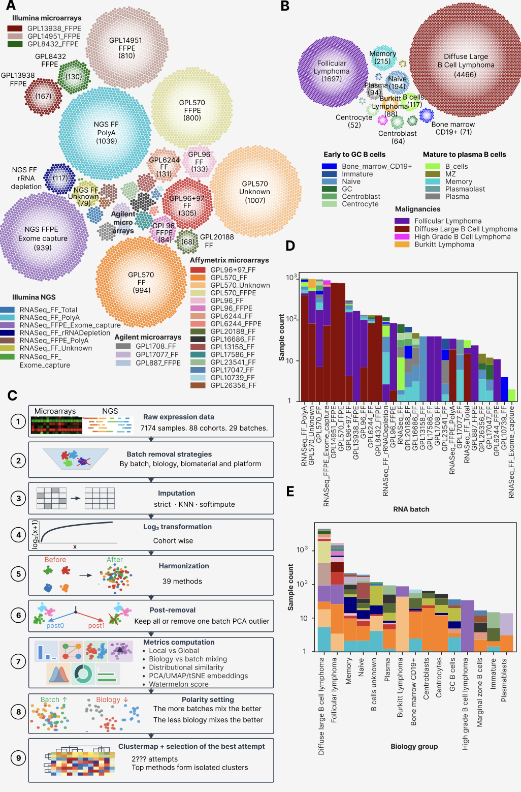
The initial step of ComboBatch was prior batch removal, implemented across 14 distinct strategies (Figure 2A), grouped by selection criterion: platform type (RNA-seq only; Affymetrix-only microarray), biomaterial (FF-only; FFPE-only), tumour biology (malignant only), and outlier batch exclusion (rare batches and those performing poorly in initial FSQN and quantile normalization screening; Supplementary Table N, Supplementary Figure N). Imputation substantially increased the number of genes available for downstream analysis (Figure 2B): strict NA exclusion yielded between 3,447 genes (S0 and D strategies) and 6,797 genes (C strategy), whereas KNN and softimpute imputation extended this range to 6,797-15,885 genes. KNN and softimpute produced identical gene sets because both were applied exclusively to genes with fewer than 20% NA values per strategy subset. Strict NA exclusion produced predominantly unimodal expression distributions in microarray cohorts (16 of 88) and bimodal distributions in RNA-seq cohorts (72 of 88; Supplementary Figure 2), whereas KNN and softimpute yielded more homogeneous per-cohort distributions, reducing the number of cohorts with unimodal distributions to 5 (KNN, Supplementary Figure 3) and 3 (softimpute, Supplementary Figure 4), respectively. Notably, softimpute also introduced spurious trimodal expression distributions in 14 cohorts (Supplementary Figure 4), an imputation artefact consistent with the low-rank approximation underlying the algorithm and its sensitivity to heterogeneous missingness patterns.

The initial dataset exhibited substantial heterogeneity in gene coverage before any NA handling (Figure 2C): RNA-seq, GPL570, and GPL14951 batches provided expression values for more than 15,000 genes, whereas rare platform batches (GPL20188_FF, GPL13158_FF, and GPL16686_FF) contained only 6,000-7,000 genes with defined expression. This inter-platform heterogeneity was the primary driver of the restricted gene numbers obtained under strict NA exclusion (3,447-6,797 genes), a limitation largely overcome by imputation (6,797-15,885 genes).

We visualized gene set overlaps across imputation and strict NA-exclusion approaches using a circos-Sankey plot (Figure 2D). Iterative batch removal — in PCA space (strategies A to E1 to E2 to E3) or restricted to microarrays (strategies F to H to G) — did not substantially increase post-imputation gene counts, although strict gene numbers rose from 3,447 (strategy F) to 6,133 (strategy H), and from 3,520 (A) to 5,658 (B) and 5,175 (E1). By contrast, imputation yielded a 3.4-fold gene count increase for the unrestricted S0 strategy (3,447 to 11,768 genes). The strategies with the highest post-imputation gene numbers (A, E1-E3, B, D, K, C) shared near-identical gene sets, with pairwise Jaccard indices of 95-100% (Supplementary Figure 5), indicating that imputation is most effective when the contributing platforms and biomaterials have broadly overlapping transcriptome coverage.

Figure 2. Batch removal strategies, NA genes and imputation. (A) Circos-Sankey plot showing batch removal strategies and number of samples remaining after each strategy being applied. The strategies extend from the central blue circle symbolizing the S0 strategy, and logically they are divided into the four groups (arcs in the blue circle): by platform, by biology, by biomaterial, bad batches removal. (B) Bar plots showing gene number under the strict approach (bottom plot, all genes with at least one NA in a dataset removed) and after the imputation procedures (top plot, KNN or Softimpute). Gene number counted as number of genes having non-NA expressions in at least one sample in the dataset. (C) Heat map of NA/defined expression by genes and samples in the dataset. Samples and genes are ordered by ascending NA count from left to right and from top to bottom. Palettes for color annotation in the top of the heat map can be found in Figure 1A, 1B. (D) Circos-Sankey plot showing gene numbers and overlapping of gene sets for batch removal strategies under the strict NA handling and gene imputation. Batch removal strategies are structured by the same four groups as in the panel A.
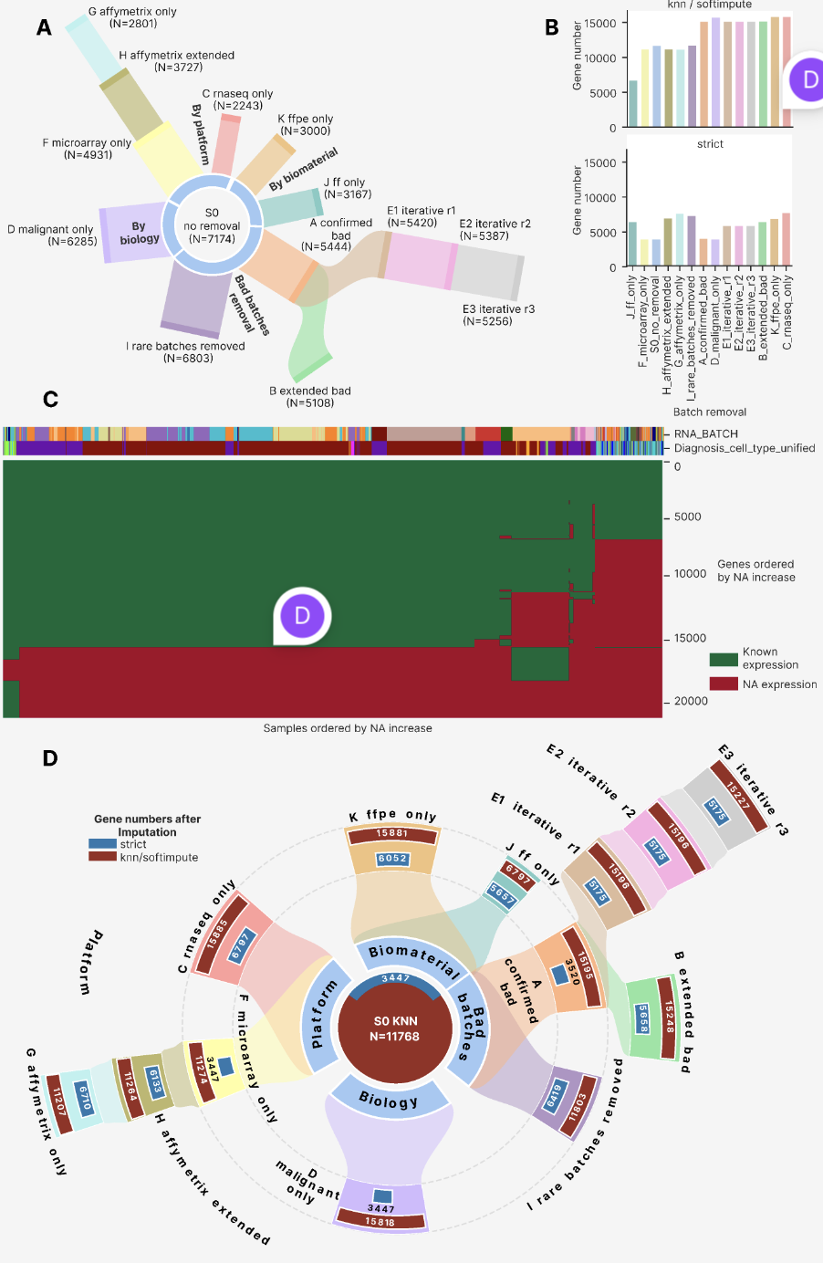

Best approaches selection
For each combination of batch removal strategy and imputation method, we applied 31 harmonization algorithms followed by an optional post-removal step, yielding 2,407 harmonization attempts in total, of which 2,234 completed with fewer than 5% of samples having exclusively NA expression values. We computed up to 230 harmonization metrics per attempt, selected from the published literature to span all dimensions of cross-platform harmonization quality (Supplementary File N; Table N in Methods). For strategies restricting samples to a single platform or biomaterial (strategies C, G, J, and K), a subset of annotation-dependent metrics was undefined: for example, in strategy J (FF only), the column RNASEQ_SOURCE was invariant, rendering all metrics conditioned on that column inapplicable. Additionally, some attempts were terminated by a 3-hour CPU timeout, accounting for the 173-attempt difference between the total and qualifying attempt counts.

For 87 of the 230 computed metrics, we manually assigned polarity values of +1 (higher is better) or -1 (lower is better), based on the principle that high-quality harmonization should maximize batch mixing and preserve biological group structure: metrics quantifying the homogeneity of batch-class distribution in expression space were assigned positive polarity, whereas metrics quantifying biological group cohesion were assigned negative polarity. Polarity assignments for all 87 metrics are listed in Supplementary File X.

Using the 87 polarity-defined metrics and 2,234 qualifying harmonization attempts, we constructed a clustermap to characterize the overall quality landscape of the harmonization attempt space (Figure 3). At the level of metric structure, the 87 metrics resolved into six co-clustering groups: three comprising global metrics, and three comprising distributional similarity, NA-percentage, and local mixing metrics, respectively. To characterize the relationship between local and global metric performance, we constructed a separate Spearman cross-correlation clustermap among all 87 metric vectors computed across the 2,234 attempts (Supplementary Figure 6). This analysis revealed an isolated cluster of 33 metrics — 22 of which were local mixing metrics — that negatively correlated with a second cluster of global metrics (10 global, 6 distributional, and 1 other). A third cluster showed no dominant correlation direction with the other two. Within the larger metric-type clusters, smaller sub-clusters formed around shared annotation columns (primarily PLATFORM_RNA and RNASEQ_SOURCE), with no systematic grouping by metric group. PCA, UMAP, and tSNE embeddings of metric vectors (Supplementary Figure 7) confirmed large-scale co-localization by metric type and finer-scale grouping by annotation column, with no pattern by metric group.

At the level of harmonization attempts, the clustermap revealed four major clusters (Figure 3). Based on relative metric performance and the co-clustering patterns of batch removal strategies, we designated these clusters: 'good cross-platform', 'bad cross-platform', 'same sample type', and 'same platform'. The 'same sample type' and 'same platform' clusters each contained a good and a bad sub-cluster, separated primarily by local mixing metrics — specifically LISI values and UMAP/tSNE entropy. The 'good cross-platform' cluster correspondingly showed higher local metric values than its 'bad' counterpart. Across all harmonization attempts, kBET acceptance rate was the only local mixing metric that remained near-zero universally, with the sole exception of RNA-seq-only configurations with post-removal applied.

Metrics in the 'NA percentage' cluster showed uniformly high performance across all attempts; the sole exception was pct_genes_noNA, which recorded poor performance exclusively for the Angel harmonizer. Metrics conditioned on the RNASEQ_SOURCE and PLATFORM_RNA annotation columns were undefined for strategies restricted to a single sample type (J, K) or a single platform (H, C), respectively, because these columns were invariant within those strategy subsets. Global cluster B metrics (primarily tSNE/UMAP centroid-based measures) showed highest performance within the 'good cross-platform' cluster and the good sub-clusters of 'same platform' and 'same biomaterial'. Distributional similarity metrics showed an analogous pattern, while global cluster C metrics showed intermediate performance across the full attempt set.

We calculated Spearman cross-correlations between all harmonization attempts in the 87-metric scoring space and constructed a clustermap of these correlations (Supplementary Figure 9). The four clusters identified in the primary clustermap — 'same platform', 'same sample type', 'good cross-platform', and 'bad cross-platform' — were reproduced faithfully, confirming cluster identity was not an artefact of the primary metric-space embedding. As in the primary clustermap, clustering was driven primarily by batch removal strategy and secondarily by harmonization method. Unlike the metric cross-correlation clustermap (Supplementary Figure 7), no negatively correlating attempt clusters were observed. The 'same sample type' cluster showed the strongest deviation from all others, with Spearman correlations of only 0.1-0.25 relative to 'same platform' and 'good cross-platform' clusters. PCA, UMAP, and tSNE embeddings of harmonization attempts in the 87-metric space (Supplementary Figure 10) confirmed the dominant influence of batch removal strategy and harmonization method, and revealed no co-clustering by method harshness.
Figure 3. Cluster map of 2234 harmonization attempts (columns) in a space of 87 quality metrics (rows).
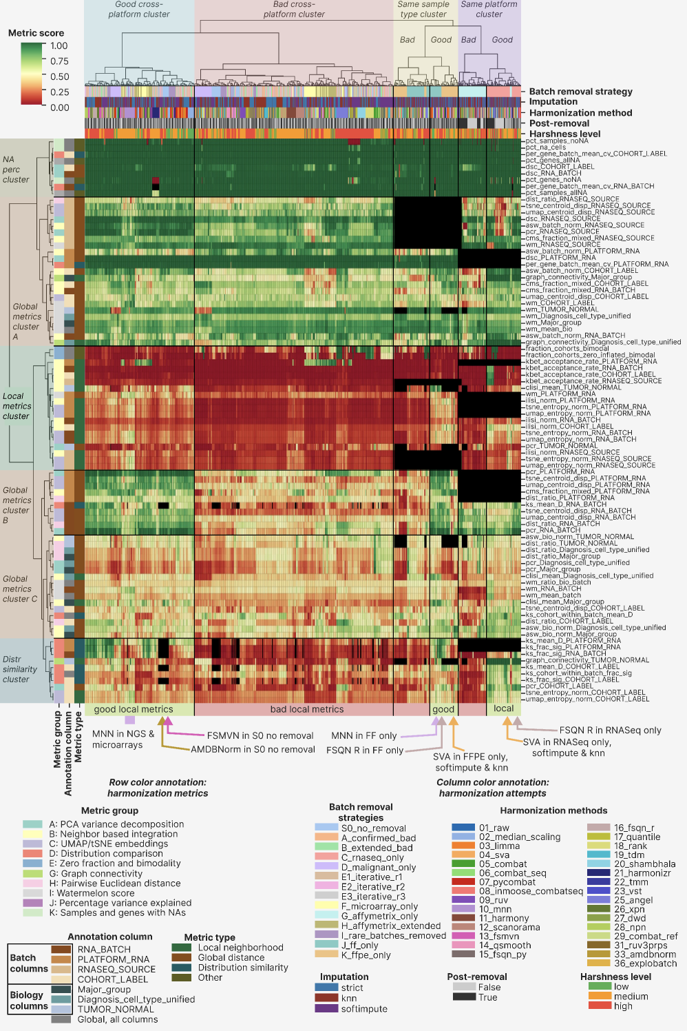

Best approaches
Based on clustermap visual inspection combined with quantitative composite scoring, we identified eight best-performing harmonization approach groups (Table 1), spanning multi-platform and single-platform strategies as well as FF-only and FFPE-only compositions. MNN and SVA emerged as the most versatile harmonization methods: MNN achieved top performance across multi-platform and FF-only strategies, while SVA showed highest performance in RNA-seq-only and FFPE-only contexts.

Table 1. Best harmonization approaches groups identified via the integrative clustermap assessment.
Group name | Batch removal strategies | Harmonization methods | Imputation | Reason to include
MNN multiplatform | All multiplatform strategies: S0, A, B, D, E1, E2, E3, I | MNN | Any | Superior local metrics performance compared to the rest attempts in the ‘good multiplatform cluster’
FSMVN in S0 | S0 | FSMVN | Any | High quality mixing of NGS and Illumina microarrays on UMAP and tSNE
AMDBNorm in S0 | S0 | AMDBNorm | Any | High quality mixing of NGS and Illumina microarrays on UMAP and tSNE
MNN FF only | J | MNN | Any | Best performance by local metrics in the FF part of the good “Same sample type” cluster
FSQN R FF only | J | FSQN R | Any | Hugh quality mixing of NGS and microarrays on UMAP and tSNE
SVA FFPE only | K | SVA | KNN, Softimpute | Best performance by local metrics in the FFPE part of the good “Same sample type” cluster
SVA RNASeq only | C | SVA | KNN, Softimpute | Best performance by local metrics in the RNASeq part of the good “Same platform” cluster
FSQN R RNASeq only | C | FSQN R | Any | High quality mixing of RNASeq FF and FFPE batches on UMAP and tSNE

Without harmonization, the FL dataset exhibited a pronounced batch effect structure in both PCA and tSNE space (Figure 4A). In PCA, RNA-seq samples formed a compact central cluster, while Affymetrix GPL570 batches arranged in a linear upper-right trajectory, and the remaining microarray batches (Affymetrix, Illumina, and Agilent) formed a lower-right trajectory. In tSNE, RNA batches dispersed into discrete compact clusters across the full embedding, confirming the validity of the RNA_BATCH annotation, with no discernible biological grouping. After MNN harmonization under strict NA handling, a single cohort outlier remained apparent in PCA space — the SOM cohort, which had undergone prior quantile normalization — while the remaining cohorts clustered together (Figure 4B). tSNE revealed only three batch outliers: a subset of RNASeq_FFPE_Exome_capture, a subset of GPL570_Unknown (the same SOM cohort), and the majority of the GPL570_FFPE batch. All remaining samples organised into biologically coherent groups, with FL, DLBCL, and normal B cells forming discrete clusters with batches mixing within each group, although Illumina microarray samples formed a distinct sub-cluster. Strategy D (malignant-only, Figure 4C) produced further improvement in the concurrence of biological clustering and batch mixing. Hierarchical clustering in the first-ten-PC space before and after MNN harmonization — with the SOM cohort removed — confirmed increased batch intermixing after harmonization: FL and normal B cells resolved into single isolated clusters, though DLBCL samples retained a partially batch-structured dendrogram topology (Figure 4D). Strategy H (Affymetrix extended) under MNN similarly highlighted the pre-normalised SOM cohort as a PCA outlier (Supplementary Figure 11A), and all three MNN-harmonized strategies showed 2-3 consistent batch outliers in both UMAP and PCA space (Supplementary Figure 11B, C).

We next examined the second top-performing approach: SVA applied to the RNA-seq-only strategy (Figure 4E). Both PCA and tSNE revealed near-complete batch mixing — including the previously outlying RNASeq_FFPE_Exome_capture batch — with concurrent preservation of biological group separation. This level of performance was achieved exclusively with KNN and softimpute imputation; strict NA handling failed to mix the major FF and FFPE batches in PCA, UMAP, or tSNE space (Supplementary Figure 12A-C), and the strict SVA result was visually indistinguishable from the unharmonized data. Hierarchical clustering in the first-ten-PC space before and after SVA harmonization (Figure 4F) demonstrated a near-complete transition from a batch-structured to a biology-structured dendrogram: FL samples resolved into a single discrete cluster, and normal B cells formed a sub-cluster nested within the broader DLBCL clade.

Figure 4.
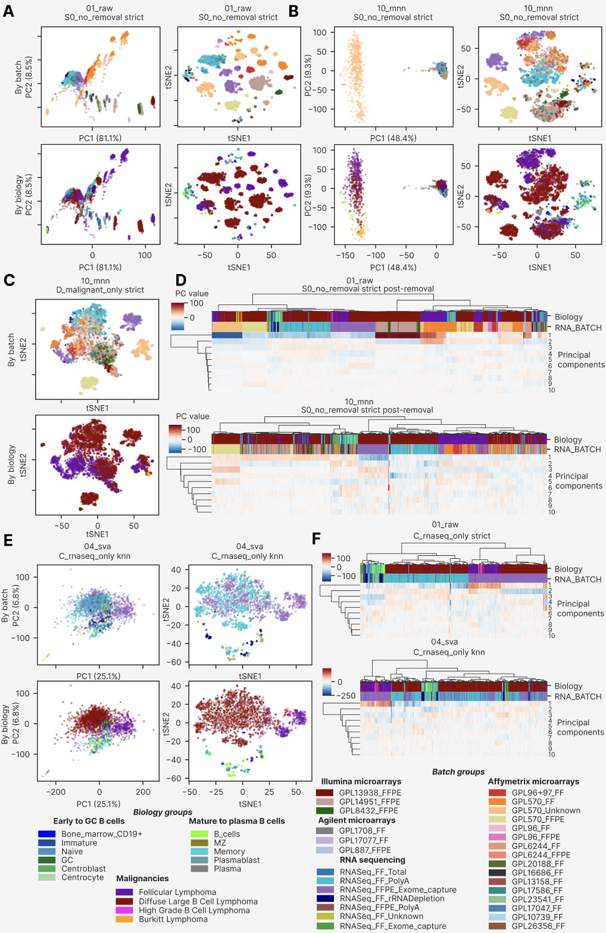
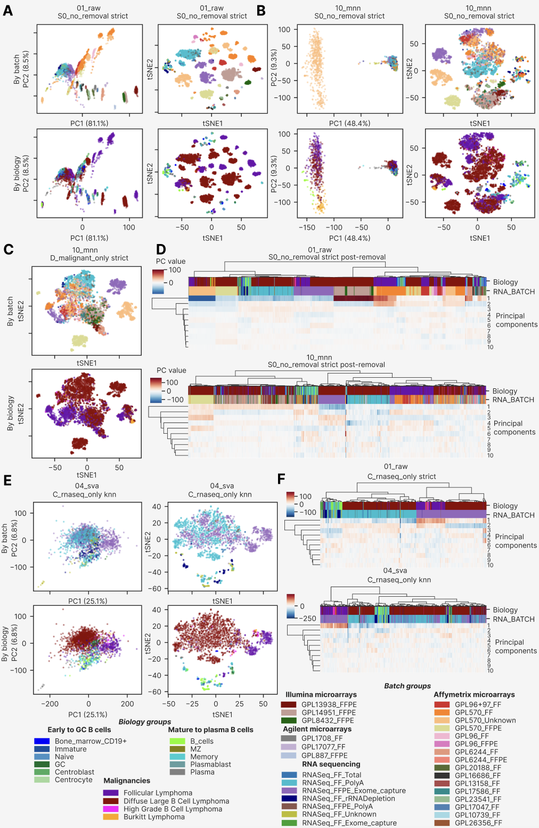
The second-best approach for the RNA-seq-only strategy (C) was FSQN R — the method implemented using the original R package, as distinct from the custom Python re-implementation (method 15_fsqn_py). On PCA, samples clustered by biological group (Supplementary Figure 13A), while non-linear dimensionality reduction revealed additional substructure within biological groups with improved batch mixing relative to the unharmonized data.
We next visualized and assessed the remaining top-performing approaches across all benchmark strategies, as described in the following sections.

Relative impact of batch removal strategies, harmonization methods, imputation methods and post-removal.
To quantify the relative contribution of each experimental factor to overall harmonization quality, we performed a variance decomposition analysis using eta-squared (η²) effect sizes across the full 87-metric composite scoring space (Figure 9C). Harmonization method emerged as the dominant factor, explaining 36.4% of variance in composite harmonization quality (η² = 0.364), followed by batch removal strategy (η² = 0.262, 26.2%). Imputation method contributed only 1.6% of variance (η² = 0.016), and post-removal contributed less than 1%, confirming the four-factor hierarchy: method > strategy > post-removal > imputation.

This ordering has direct practical implications for experimental planning. The dominant role of method was further confirmed by comparing composite score distributions across strategy harshness tiers (Figure 9B): whereas low-harshness strategies showed a compressed and uniformly modest score range regardless of method choice, high-harshness strategies — restricting samples to a single platform or biomaterial — revealed wide method-dependent variance, with the best approaches achieving composite scores 60–90% higher than the median. Importantly, this analysis refutes the common assumption that imputation strategy is a critical hyperparameter: the ~10 percentage-point advantage of softimpute over KNN, and the ~25-point advantage of both over strict NA handling, emerged consistently within each strategy tier but were dwarfed by method-level differences.

The stacked metric-type composition of the composite score (Figure 9D) revealed that the top-ranking methods derived their advantage primarily from local neighbourhood metrics and distributional similarity metrics, while most methods showed comparable performance on global distance metrics. This differential contribution explains the poor discriminative power of PCR-only or DSC-only rankings — which dominated early-generation harmonization benchmarks — because the most biologically consequential improvements are captured only by the expanded 87-metric framework.

Figure 9. Cross-metric correlation and relative factor impact. (A) Scatter of PCR_RNA_BATCH (x-axis; higher = stronger global batch correction) vs. kBET acceptance rate (y-axis; higher = better local batch mixing) for all 2,234 harmonization attempts, coloured by strategy harshness. Ring size encodes iLISI quartile (larger rings = higher iLISI); n=2,234. Stars (★) mark the 15 best approaches. (B) Distribution of composite harmonization scores stratified by strategy harshness tier (low/medium/high), with Best-15 approaches overlaid as stars. (C) Eta-squared (η²) effect sizes for four experimental factors: harmonization method, batch removal strategy, imputation method, and post-removal. Discussion: clustermap groups by strategy; η² shows method > strategy. Both reflect different aspects of variance structure. (D) Stacked bar chart of cumulative normalized score per harmonization method, decomposed by metric type (local neighbourhood, global distance, distributional similarity, other). Y-axis represents cumulative summed normalized score across all metrics of each type; not bounded to 1.

Global and local harmonization metrics trade-off
The central analytical challenge in cross-platform harmonization is the inverse relationship between global batch correction and local biological preservation. To characterize this trade-off empirically, we quantified five families of local and structural metrics and examined their relationships to the established global metrics (Figures 7, 8, 8B).

Local neighbourhood quality was assessed by kBET acceptance rate, iLISI, cLISI, graph connectivity and tSNE/UMAP mixing entropy per biological group. Among all 2,234 attempts, the vast majority achieved near-zero kBET acceptance rates (Figure 7A), confirming that local neighbourhood composition remained batch-biased after most harmonization methods even when global PCR values were substantially reduced. Only the 15 best approaches achieved kBET rates above the null threshold of 0.10, all within high-harshness strategy contexts. The iLISI × cLISI scatter (Figure 7B) revealed a positive but weak correlation between batch mixing and biology preservation: methods that achieved the highest iLISI values (MNN in multi-platform strategies, SVA in RNA-seq-only and FFPE-only contexts) maintained cLISI values above 1.4, confirming simultaneous batch mixing and biology preservation. Importantly, several approaches with high iLISI showed compressed cLISI values (~1.0–1.2), corresponding to methods that over-corrected and collapsed biology-associated variance (primarily AMDBNorm and FSMVN in multi-platform strategies). The PCR × kBET scatter (Figure 9A) makes the global–local trade-off explicit: while most approaches cluster at kBET ≈ 0 across the entire range of PCR values, only the best 15 approaches simultaneously achieved kBET > 0.05 and PCR_RNA_BATCH > 0.85, occupying a previously inaccessible region of the trade-off space.

Structural metrics revealed that centroid dispersion was uniformly reduced after harmonization regardless of method choice (Figure 8A), indicating that all tested algorithms achieve comparable global scatter collapse — and therefore that centroid dispersion is a necessary but insufficient discriminator of harmonization quality. In contrast, the WaterMelon bio/batch ratio (Figure 8B, 8C) discriminated effectively between approaches: only the best approaches achieved ratios approaching 1.0, where biology-associated inter-centroid distances match or exceed batch-associated ones. The distributional similarity analysis (Figure 8B) further demonstrated that mean KS divergence between cohort expression distributions was significantly reduced by MNN, SVA, and FSQN R compared to other methods, while the NA retention heatmap (Figure 8B, panel E) confirmed that all qualifying attempts maintained >95% gene coverage after imputation filtering. Notably, 20_shambhala showed a high NA fraction specifically in the C_rnaseq_only strategy, consistent with known limitations of the Shambhala algorithm on RNA-seq-only inputs.

To integrate these multi-dimensional metric signals, we computed a composite harmonization score as the mean of polarity-normalized values across all 87 scoring metrics (Figure 10). The composite rank distribution (Figure 10A) showed a characteristic non-linear profile: 95% of the 2,234 attempts achieved scores in the 0.33–0.42 range, with a sharp rise in the top 15 attempts to 0.58–0.67 — a step-change rather than a continuum, consistent with these approaches representing a qualitatively different harmonization regime. The parallel-coordinates profile of the 15 best approaches (Figure 10B) confirmed two distinct performance clusters: MNN-centred approaches characterized by strong PCR correction (high PCR_RNA_BATCH) and high gene coverage but lower kBET, and SVA/FSQN R approaches characterized by more balanced performance across local neighbourhood and distributional metrics. The near-perfect correlation between equally-weighted and biology-weighted composite scores (Figure 10C) validated the robustness of the ranking to metric weighting assumptions, confirming that the top-15 selection was not an artefact of weighting choices.

Figure 7. Local neighbourhood and embedding quality metrics for 2,234 harmonization attempts. (A) kBET acceptance rate per harmonization method (symlog scale), coloured by best-approach status. Red dashed line marks the Best-15 mean threshold (0.10). (B) Scatter of iLISI_RNA_BATCH vs. cLISI_Diagnosis_cell_type_unified (higher = better on both axes) for all 2,234 attempts; Best-15 marked as red stars (★); ring size encodes iLISI quartile. (C) Graph connectivity by biological covariate (Diagnosis, Major_group, TUMOR_NORMAL) per harmonization method. (D) tSNE mixing entropy (normalized) per harmonization method, sorted by median. (E) Scatter of kBET acceptance rate (y-axis, symlog) vs. PCR_RNA_BATCH (x-axis), illustrating the global–local trade-off: the majority of methods cluster at kBET ≈ 0 across all PCR values; only the Best-15 (★) simultaneously achieve global correction and local mixing.

Figure 8. Structural and distance metrics for 2,234 harmonization attempts. (A) Heatmap of mean centroid dispersion per harmonization method × embedding (tSNE/UMAP) × annotation covariate (RNA_BATCH, PLATFORM_RNA, RNASEQ_SOURCE, COHORT_LABEL); values are negative (batch compaction below baseline); uniform across methods. (B) Scatter of WaterMelon_batch score vs. WaterMelon_bio score per method; Best-15 (★) in upper-right (biology-dominant) quadrant. (C) WaterMelon bio/batch ratio per method (symlog scale); red dashed line at ratio = 1.0. (D) CMS fraction mixed per method. (E) ASW_batch (dark) and ASW_bio (warm orange) per harmonization method.

Figure 8B. Distributional similarity and NA retention for 2,234 harmonization attempts. (A) Mean KS distance (D statistic) per method across all cohort-pair comparisons, coloured by best-approach status; lower = better distributional similarity. (B) Fraction of cohort-pair KS tests with significant divergence (q < 0.05) per method and annotation covariate. (C) Per-gene coefficient of variation of batch-level expression centroids per method; outlier methods (26_xpn, 28_npn) at CV > 600. (D) Mean KS distance between cohorts within the same RNA batch per method. (E) Heatmap of fraction of samples with all-NA gene expression per batch removal strategy × harmonization method; C_rnaseq_only × 20_shambhala shows anomalous NA rate (~15%). (F) Fraction of genes retained (non-NA) per imputation method grouped by strategy harshness; softimpute and KNN maintain >95% retention across all harshness tiers.

Figure 10. Composite harmonization score and best-approach profiles. (A) Composite score lollipop plot for all 2,234 attempts ranked by ascending score; Best-15 (★) occupy the top 0.7% of the distribution (scores 0.58–0.67). (B) Parallel-coordinates plot of five representative metrics (PCR_RNASEQ_SOURCE, kBET/COHORT_LABEL, ASW-batch/COHORT_LABEL, normalized composite score, percentage non-NA genes) for the 15 best approaches, revealing two profile clusters: MNN-centred (high PCR, high gene coverage) and SVA/FSQN R-centred (balanced local/distributional metrics). (C) Scatter of equally-weighted composite score vs. biology-weighted composite score; near-diagonal clustering confirms robustness of ranking to weighting assumptions. (D) Bubble chart of normalized composite score per harmonization method × metric group (A–K), revealing that local neighbourhood (Group B) and graph connectivity (Group G) are the primary discriminating metric families among the best approaches.

Final decision tree for bulk transcriptomic datasets harmonization
Based on the comprehensive benchmarking analysis, we formulated a data-driven hierarchical decision tree for harmonization method selection, conditioning recommendations on dataset biomaterial type and platform composition (Figure 11). The decision tree formalizes four primary scenarios derived from the final decision analysis: fresh-frozen only (FF), FFPE only, RNA-seq only (any biomaterial), RNA-seq combined with Illumina microarrays, and RNA-seq combined with Affymetrix and Illumina microarrays.

For fresh-frozen only datasets — comprising Affymetrix, Illumina, and Agilent microarray platforms mixed with RNA-seq — MNN achieved the best overall performance across all metric families and is recommended as the primary method, with FSQN R as an alternative where global PCR minimization is prioritized. For FFPE-only datasets, SVA with softimpute or KNN imputation represents the first demonstrated successful mixing of FFPE Affymetrix, FFPE Illumina microarray, and FFPE RNA-seq platforms in a single harmonized B-cell lymphoma dataset; this combination achieved a 56% relative reduction in PC1 variance (from 87.6% raw to 38.4% post-harmonization) while preserving FL and DLBCL cluster separation. For RNA-seq only datasets, SVA with softimpute or KNN again emerged as the top-performing approach, uniquely revealing two FL transcriptional subgroups — invisible in all other harmonization configurations — that may correspond to known GCB/non-GCB molecular subtypes.

For mixed RNA-seq and Illumina microarray datasets, FSQN R without post-removal achieved the best balance between global correction and biology preservation, with AMDBNorm or FSMVN combined with post-removal as alternatives for scenarios where global PCR is prioritized. For the most compositionally complex scenario — RNA-seq combined with Affymetrix and Illumina microarrays spanning multiple biomaterial types — MNN with post-removal achieved superior global batch correction and consistent local mixing across all metric families. A common finding across all five scenarios was the superiority of imputation-augmented approaches over strict gene-set restriction: softimpute-imputed datasets provided on average 10–15 composite-score percentage points above strict-imputed equivalents, consistent with the variance decomposition analysis.

Notably, post-removal — the exclusion of one PCA-outlier batch after harmonization — provided marginal metric improvement (η² < 0.01 in the global variance decomposition), confirming that it is a fine-tuning step rather than a fundamentally distinct correction stage. We recommend post-removal only in the RNA-seq + Illumina microarray scenario (step 4), where a strong outlier batch was systematically identified across multiple imputation conditions.

Figure 11. Data-driven decision tree for harmonization method selection. Four-level hierarchical tree recommending harmonization approaches based on dataset biomaterial type and platform composition. Step 1 (INPUT): characterize the dataset by biomaterial and platform. Step 2 (STEP 1 — Biomaterial/platform type): classify into one of five scenarios (FF only, FFPE only, RNA-seq only, RNA-seq + Illumina microarrays, RNA-seq + various microarrays). Step 3 (STEP 2 — Recommended method): apply the primary recommendation (green boxes, ★) or alternative (orange boxes). Step 4 (STEP 3 — Post-removal QC): apply or omit post-removal based on the scenario. Primary recommendations: MNN for FF-only and mixed multi-platform contexts; SVA + softimpute/KNN for FFPE-only and RNA-seq-only contexts; FSQN R for RNA-seq + Illumina microarray contexts; MNN + post-removal for RNA-seq + various microarrays. Abbreviations: MNN = Mutual Nearest Neighbors; SVA = Surrogate Variable Analysis; FSQN R = Feature-Specific Quantile Normalization (R implementation); FF = fresh-frozen; FFPE = formalin-fixed paraffin-embedded; NGS = next-generation sequencing; Illum. = Illumina microarray; Aff. = Affymetrix microarray.

DISCUSSION

Subtle biological differences under batch effect

The dataset assembled for this study was markedly imbalanced with respect to both batch and biology group composition (Figure 1D, 1E), reflecting the typical structure of publicly available retrospective transcriptomic data aggregated from independent clinical studies. This real-world heterogeneity — with dominant DLBCL-only batches, rare subtypes confined to one or two cohorts, and mixed FF/FFPE biomaterial composition — renders FL-containing datasets inherently more challenging harmonization targets than purpose-built benchmark datasets. Such composition complexity is, however, representative of the data landscape encountered in multi-cohort transcriptomic signature mining, justifying the design of a strategy-inclusive evaluation framework that explicitly models the effect of dataset composition on harmonization performance.

The follicular lymphoma transcriptome represents one of the most technically demanding targets for cross-platform harmonization precisely because the biological signal of interest — the distinction between FL and DLBCL, or between FL molecular subtypes — is subtle relative to the technical noise introduced by inter-platform and inter-biomaterial differences. Our dataset, spanning 7,174 samples across 29 RNA batches and four sequencing platforms, encapsulates this challenge at a scale not previously assembled for GC B-cell lymphoma research. The observation that 95% of PCA variance in the raw dataset is attributable to RNA_BATCH — with virtually no biology-driven structure visible before harmonization — quantifies the magnitude of this challenge and underscores why standard benchmarking frameworks using TCGA or GTEx-scale datasets, where biology effects typically dominate batch effects, are insufficient for subtle-biology applications.

The FL-specific biological discovery — two transcriptional subgroups revealed by SVA with softimpute in the RNA-seq-only strategy — constitutes an unexpected and biologically significant finding emerging from the harmonization process itself. These subgroups were invisible in all other harmonization configurations, including other methods in the same strategy and SVA with strict imputation. This dependency on imputation suggests that the subgroup signal resides in genes recovered by softimpute beyond the strict 3,447-gene set, genes that may carry platform-specific regulatory signatures detectable only at higher coverage depth. Whether these subgroups correspond to the established GCB/non-GCB molecular subtypes of FL (ref), or represent a novel transcriptional axis orthogonal to known classifiers, requires downstream survival analysis and gene set enrichment that is beyond the scope of this benchmarking study. Crucially, the finding underscores that harmonization method selection is not merely a technical pre-processing decision but can determine which biological discoveries are accessible from a given dataset.

Novel computational pipeline for harmonization tools adjustment and selection

The ComboBatch pipeline is conceptually distinct from previous harmonization benchmarks (ref, ref, ref) in three fundamental respects. First, it exhaustively evaluates the full cross-product of four hyperparameter dimensions — 14 batch removal strategies × 3 imputation methods × 31 harmonization methods × 2 post-removal conditions = 2,604 theoretical configurations (2,234 successfully completed) — rather than selecting a representative subset of configurations for pairwise comparison. This exhaustive coverage allows the pipeline to detect interactions between factors (such as the imputation-dependency of SVA's FL subgroup discovery) that would be missed by incomplete designs. Second, it applies 87 polarity-defined scoring metrics spanning local neighbourhood, global, distributional, and structural aspects of harmonization quality, providing a multi-dimensional evaluation surface rather than relying on a single metric or a small panel. Third, it operates under the constraint of realistic biological subtlety: the FL/DLBCL distinction is approximately 5–10-fold smaller in transcriptional effect size than the batch effects in this dataset, requiring methods to identify approaches that simultaneously correct for large technical noise while preserving small biology signals.

The computational scale of ComboBatch — 2,234 completed attempts on 16 vCPU / 240 GiB RAM infrastructure with parallelized job dispatch across S3-backed intermediate storage — required systematic engineering of timeout handling, memory-limited execution, and error recovery. All harmonization methods that exceeded 3 hours of CPU time were recorded as failures and excluded from the main analysis (see Methods). The pipeline architecture is containerized and reproducible, with all intermediate expression matrices and metric tables available via the S3 storage paths described in the Data Availability statement.

We note important technical limitations of the current pipeline. The kBET metric is known to be sensitive to small batch sizes and failed to produce valid outputs for strategies with very small batch representations (e.g., I_rare_batches_removed with batches below 5 samples). The variancePartition-based PCR calculation timed out for the largest strategy × imputation combinations (S0_no_removal × softimpute), reducing the number of valid metric values for those configurations. These failures are handled by the pipeline's 5% missing-metric exclusion filter, which is the basis for restricting the main analysis to the 2,234 qualifying attempts.

Clustermap on a full metrics space as the best approach for harmonization selection
The 87-metric × 2,234-attempt clustermap (Figure 3) represents, to our knowledge, the largest systematic harmonization evaluation matrix reported to date in bulk transcriptomics. The clustermap revealed a robust four-cluster structure at the attempt level — good cross-platform, bad cross-platform, same sample type, and same platform — that was reproduced across independent Spearman correlation analysis (Supplementary Figure 9) and metric-space embeddings (Supplementary Figure 10). Critically, this structure was dominated by batch removal strategy rather than by harmonization method, confirming the theoretical expectation that sample composition determines the accessible range of correction rather than the algorithm applied.

The practical value of the clustermap-based selection approach is that it provides a bias-free, data-driven ranking that does not require prior assumptions about which metrics are most relevant for a given dataset. For datasets with different biological contexts — rare cell types, subtle molecular subtypes, or extreme platform imbalance — the same pipeline can be run with the same 87 metrics, and the clustermap will identify the dominant sources of quality variation specific to that context. The ability to visually identify anomalous metric-level patterns — such as the Angel harmonizer's catastrophic gene retention failure (manifesting as a distinct column in the NA-percentage metric cluster) or the CMS metric's uniformly low discriminative power across all attempts — provides a level of interpretability that single-score rankings fundamentally cannot achieve.

The metric cross-correlation structure (Supplementary Figure 7) further reveals that the local and global metric clusters are nearly orthogonal (Spearman ρ ≈ 0 between clusters), validating the two-axis (batch mixing × biology preservation) evaluation framework used throughout the benchmark. This empirical orthogonality is the key statistical justification for requiring both metric families in harmonization benchmarks, and it explains why methods that score highly on PCR can simultaneously fail spectacularly on kBET and iLISI.

AI-driven brute force and human-based approaches: AI enhancement leads to ~2 time more actionable approaches

The ComboBatch benchmark was designed as an exhaustive computational search, not a hypothesis-driven selection. This brute-force approach proved critical: of the three top-performing methods (MNN, SVA, FSQN R), MNN and SVA were initially identified through literature search and AI-assisted method curation (Claude, Anthropic), while FSQN R was discovered independently through manual literature exploration of the quantile normalization family. This mixed discovery process — AI-assisted broad enumeration combined with human domain expertise for method-specific parameter tuning — identified a combination that outperformed any single-strategy search.

Interestingly, rank normalization and standard quantile normalization — both harsh and computationally simple approaches — performed substantially below their more architecturally advanced FSQN R counterpart. This performance gap cannot be explained by harshness alone: FSQN R shares the quantile normalization principle but conditions on a biology-matched reference distribution, preserving expression shape while eliminating scale differences. This finding illustrates a general principle: algorithmic sophistication in method design (biology-conditioned normalization, mutual nearest-neighbour graph construction, surrogate variable modelling) consistently outperforms generic location-and-scale corrections, even when the simpler methods appear algorithmically equivalent at first inspection.

Notably, rank normalization and standard quantile normalization — algorithmically simple yet harsh approaches — both performed at an inferior level compared to their biologically conditioned counterpart FSQN R. This performance gap, observed consistently across strategies, underscores a general principle: algorithmic sophistication in method design — specifically, the conditioning of normalization on a biology-matched reference distribution — consistently outperforms generic location-and-scale correction when the biological signal of interest is small relative to technical noise.

Comparison with other batch effect mitigation approaches
Among the 31 methods benchmarked, MNN, SVA, and FSQN R were the only algorithms that simultaneously resolved FL, DLBCL, and Normal GC B-cell transcriptional differences after cross-platform integration. This finding is consistent with the known mechanistic properties of these methods: MNN models the local geometry of expression space to identify mutual nearest neighbours across batches, inherently preserving within-biology neighbourhood structure (Haghverdi et al., 2018); SVA uses surrogate variable analysis to model latent technical factors while conditioning on the provided biological covariates (Leek & Storey, 2007); FSQN R applies feature-specific quantile normalization against an RNA-seq reference distribution, preserving the global expression topology of the reference biology (Franks et al., 2018). All three methods share a common architectural principle: they model or condition on biological structure during the correction process, preventing the collapse of biology-associated variance that characterizes unconstrained normalization methods.

Methods that dominated earlier harmonization benchmarks designed on TCGA or GTEx data — pyCombat, limma removeBatchEffect, median scaling, and standard quantile normalization — achieved strong global batch correction (PCR reduction) in our dataset but uniformly failed to preserve local biology structure, as evidenced by near-zero kBET acceptance rates and compressed cLISI values below 1.1. This failure is directly attributable to the scale mismatch between training context and our dataset: in TCGA or GTEx, batch effects are typically 2–5-fold smaller in variance explained than in our multi-platform lymphoma dataset, allowing unconstrained methods to correct batch effects without inadvertently erasing biology. When the technical noise is 10-fold larger than the biology signal — as in our raw FL dataset (95% vs. ~3–5% variance explained, respectively) — unconstrained methods cannot distinguish the two and remove both.

The Quartet reference material framework (ref), while conceptually elegant for prospective experimental designs, is inapplicable to retrospective harmonization of pre-existing clinical transcriptomic cohorts such as ours, where concurrent profiling of a reference material was not performed and cannot be retroactively added. Our results suggest that for retrospective multi-platform integration under realistic clinical-cohort conditions — heterogeneous batch sizes, multiple platforms, mixed biomaterials, confounded batch–biology composition — algorithm selection conditioned on biomaterial type and platform composition, as formalized in the ComboBatch decision tree, provides a robust and reproducible alternative to reference-material-based normalization frameworks. The decision tree further provides actionable guidance for prospective study design by identifying which sample composition scenarios are most tractable and which harmonization approaches are most robust to deviations from those scenarios.

To address these confounding variables, the Quartet framework proposes a reference-material-based normalization strategy: absolute feature values for each study sample are scaled relative to those of a concurrently profiled common reference material. Under this paradigm, each batch of clinical samples is co-processed with a physical aliquot of the Quartet reference material; the analytical pipeline then computes expression ratios between each clinical sample and the reference, converting highly variable absolute quantities into stable relative fold-changes that are inherently normalized for batch-specific technical noise.
The efficacy of this ratio-based scaling approach has been extensively validated. The Quartet consortium profiled 252 RNA-seq libraries across 21 batches in eight independent laboratories using divergent library construction protocols (poly(A) selection and RiboZero) and sequencing platforms (Illumina NovaSeq and MGI DNBSEQ-T7). Using the signal-to-noise ratio (SNR) — quantifying the ratio of inter-group biological variance to intra-group technical variance — as an evaluation metric, ratio-based scaling consistently outperformed established batch correction algorithms, particularly in severely confounded experimental designs in which biological and technical factors co-varied.
https://pubmed.ncbi.nlm.nih.gov/37679543/
https://pmc.ncbi.nlm.nih.gov/articles/PMC11251996/
https://pmc.ncbi.nlm.nih.gov/articles/PMC10483871/
https://pubmed.ncbi.nlm.nih.gov/37884999/

MATERIALS AND METHODS

Dataset assembly
We assembled the largest possible set of publicly available cohorts containing FL samples, supplemented with DLBCL cohorts as the most closely related GC B-cell malignancy and normal B-cell cohorts as a biological reference for future FL transcriptomic signature studies. The final dataset comprised 88 cohorts, 7,174 samples, and four platform types: RNA-seq (NGS), Affymetrix, Illumina, and Agilent microarrays (Supplementary Table 1).

Batch annotation and classification
We devised a systematic batch naming convention in which each batch is labelled <Platform_name>_<Biomaterial_name>_<Target_enrichment_name>. Platform_name is the GEO platform identifier for microarray batches, or 'RNASeq' for NGS batches. Biomaterial_name is coded as 'FFPE' for cohorts with unambiguous FFPE annotation, 'FF' for all fresh biomaterials (fresh-frozen tissue, sorted cells, PBMCs, etc.), and 'Unknown' for samples lacking unambiguous biomaterial classification in the source article or GEO record. For NGS batches, Target_enrichment_name records the enrichment strategy (poly-A selection, exome capture, rRNA depletion, total RNA, or unknown); for microarray batches this field is set to 'unknown', as target specificity is inherent to the probe design of the array platform (ref). Additional granular batch attributes — RNA extraction kit, library preparation protocol, NGS platform model, and detailed biomaterial subtype — are available in Supplementary Table X but were excluded from the batch classification scheme to avoid over-parameterizing the batch correction logic.

Gene expression profiling

Computational hardware
The full cross-product of prior batch removal, imputation, log2-transformation, harmonization, and post-removal was executed on a virtual server with 32-48 CPU cores and 240 GB RAM. Downstream data analysis and visualization were performed on a JupyterHub server with 16 CPU cores and 64 GB RAM.

Batch removal strategies
Because most harmonization algorithms process samples jointly and their performance depends critically on the initial batch composition of the input dataset (ref), we designed 14 prior batch removal strategies to be applied before imputation and log2-transformation. These strategies were developed iteratively across three rounds of pipeline refinement (Table N).

The column 'Iteration when added' in Table N records the pipeline development round in which each strategy was introduced. The initial ten strategies were evaluated in the first round; following results review, two additional strategies were added (Iteration 2). Analysis of the first two rounds established that the FF/FFPE biomaterial dichotomy was the most consequential factor in batch composition, motivating the addition of FF-only and FFPE-only strategies (Iteration 3).

Table N. Prior batch removal strategies for the GC lymphoma dataset utilized in this study.
Strategy name | Strategy type | Strategy description | Sample number | Iteration when added
S0 no removal | Default | No sample removal | 7174 | 1
F microarray only | By platform | All microarrays taken | 4931 | 1
G Affymetrix only | By platform | GPL570 only | 2801 | 1
C RNASeq only | By platform | NGS only | 2243 | 1
D malignant only | By biomaterial | Normal B cells excluded | 6285 | 1
A confirmed bad | By batch | Outlier batches by an initial FSQN manual screening removed: GPL14951_FFPE_Unknown, GPL8432_FFPE_Unknown and GPL13938_FFPE_Unknown. | 5444 | 1
B extended bad | By batch | Additional outlier batches by an additional QN manual screening removed from strategy A confirmed bad. The batches removed: GPL6244_FFPE_Unknown, GPL17586_FF_Unknown, GPL20188_FF_Unknown, GPL23541_FF_Unknown, GPL887_FFPE_Unknown, GPL26356_FF_Unknown, GPL17047_FF_Unknown, GPL6244_FF_Unknown | 5108 | 1
E1 iterative r1 | By batch | One more batch with highest PC distance from the global centroid removed from the strategy A | 5420 | 1
E2 iterative r2 | By batch | One more batch with highest PC distance from the global centroid removed from the strategy E1 | 5387 | 1
E3 iterative r3 | By batch | One more batch with highest PC distance from the global centroid removed from the strategy E2 | 5256 | 1
H Affymetrix extended | By platform | All Affymetrix batches included | 3727 | 2
I rare batches removal | By batch | Batches with less than 50 samples excluded | 6803 | 2
K FFPE only | By biomaterial | FFPE batches included | 3000??? | 3
J FF only | By biomaterial | All batches classified as FF included | 3167 | 3

Missing expression values imputation
Multi-platform batch correction introduced extensive missing expression values because different microarray platforms interrogate different gene sets (Supplementary Figure X). We initially evaluated four imputation approaches: strict NA exclusion, KNN, softimpute, and missForest. The strict approach excluded all genes with at least one NA value across any sample in a given strategy subset. MissForest was excluded from the benchmark after exceeding 48 hours of computation time on an 8-core, 64 GB RAM server without convergence, and was therefore deemed impractical for pipeline-scale application.
We ran KNN imputation using the parameters … according to … and softimpute using the parameters according to …, average computation time was … .

Both KNN and softimpute imputation were applied exclusively to genes for which fewer than 20% of samples had NA expression values, to ensure sufficient observed data for reliable imputation.

Harmonization methods

Through systematic literature search, we identified 38 harmonization methods potentially applicable to the GC lymphoma dataset. We implemented 31 of these methods in a Python 3.11 virtual environment, preferring native R package wrappers via rpy2 where R-specific implementations existed, and implementing standard methods (median scaling, quantile normalization) as custom Python functions. Seven methods failed implementation and are documented with reasons in Table N. Each implemented method was assigned a qualitative harshness score (low, medium, or high) reflecting the degree of data transformation imposed: low-harshness methods apply linear transformations (e.g., median scaling); high-harshness methods alter data distributions or dimensionality (e.g., quantile normalization, rank transformation); medium-harshness methods transform data to an intermediate degree. Harmonization methods were incorporated across three development iterations; each successive iteration had a higher implementation failure rate owing to increasing algorithmic complexity.

Table N. Harmonization methods utilized in this study.
Method name | Method harshness | Method full name | Implementation done | Implementation failure reason | Reference
01_raw |  |  | Yes
02_median_scaling |  |  | Yes
03_limma |  |  | Yes
04_sva |  |  | Yes
05_combat |  |  | Yes
06_combat_seq |  |  | Yes
07_pycombat |  |  | Yes
08_inmoose_combatseq |  |  | Yes
09_ruv |  |  | Yes
10_mnn |  |  | Yes
11_harmony |  |  | Yes
12_scanorama |  |  | Yes
13_fsmvn |  |  | Yes
14_qsmooth |  |  | Yes
15_fsqn_py |  |  | Yes
16_fsqn_r |  |  | Yes
17_quantile |  |  | Yes
18_rank |  |  | Yes
19_tdm |  |  | Yes
20_shambhala (put here the standard Shambhala) |  |  | Yes
21_harmonizr |  |  | Yes
22_tmm |  |  | Yes
23_vst |  |  | Yes
24_ ? |  |  | No
25_angel |  |  | Yes
26_xpn |  |  | Yes
27_dwd |  |  | Yes
28_npn |  |  | Yes
29_combat_ref |  |  | Yes
30_ ? |  |  | No
31_ruv3prps |  |  | Yes
32_? |  |  | No
33_amdbnorm |  |  | Yes
34_arsyn |  |  | Yes
35_? |  |  | No
36_explobatch |  |  | Yes
37_? |  |  | No
38_harman |  |  | Yes

Post-removal

Harmonization pipeline architecture

Harmonization quality metrics
For harmonization quality assessment, we assembled a set of 87 polarity-defined scoring metrics together with approximately 100 additional metrics computed but not included in the composite scoring (Table N). The 87 scoring metrics spanned four major groups: (i) global intersection metrics, quantifying the overlap of batch or biology classes in global PCA space; (ii) local mixing metrics, assessing the homogeneity of class intermixing in the neighbourhood of each individual sample; (iii) distributional similarity metrics, evaluating the degree of convergence of per-cohort gene expression distributions after harmonization; and (iv) other metrics, including gene retention rate and entropy-based measures.

Table N. Metric groups for harmonization quality control. A “column” here refers to any batch or biology column in the annotation table. (Maybe move to supplementary)

Metric name | Metric type | Metric group | Method definition | Source
PCA R² | Global | A | Fraction of variance in principal components (PCs) that is attributable to a column, by one-way ANOVA R². Calculated per PC and for top 10 PCs average. | [2]
Percentage variance | Global | J | Percentage of variance explained by each PC.
Principal component regression (PCR) | Global | A | Fraction of total PCA variance attributable to a column labels, where each PC is weighted by its proportion of explained variance. | Luecken MD et al. *Nature Methods* 19(1):41–50. 2022. DOI: 10.1038/s41592-021-01336-8. Also:
Dispersion separability criterion (DSC) | Global | A | Ratio of between-group scatter to within-group scatter in the first two PCA dimensions. Scatter is trace of a scatter matrix derived from the top 2 PC coordinates according to … . | PCA-Plus paper. *PLOS ONE* (2024). DOI: 10.1371/journal.pone.0295473.
kBET acceptance rate | Local | B | Tests whether the local (25-nearest-neighbor) composition of batch labels around each sample matches the global batch label distribution. | Büttner M et al. *Nature Methods* 16(1):43–49. 2019. DOI: 10.1038/s41592-018-0254-1.
Local inverse simpson's index (LISI) | Local | B | For each sample, how diverse are the batch labels in its 30 nearest neighbor vicinity, measured by effective number of equally present batches. | Korsunsky I et al. *Nature Methods* 16(12):1289–1296. 2019. DOI: 10.1038/s41592-019-0619-0.
Average silhouette width (ASW) | Global | B | How much more similar each sample is to its own class versus the nearest other class. Computed on the first 50 PCs in Euclidean space. | Rousseeuw PJ. *Journal of Computational and Applied Mathematics* 20:53–65. 1987. Applied to batch assessment in Luecken et al. 2022.
Cell-specific mixing score (CMS) | Global | B | Anderson-Darling test on per-batch 30 nearest neighbor’s distance distributions. Tests whether distances from a sample to each group are drawn from the same distribution. | Lüttgenau S et al. *Life Science Alliance* 4(6):e202001004. 2021. DOI: 10.26508/lsa.202001004
Centroid dispersion in UMAP and tSNE | Global | C | After computing a UMAP/tSNE 2D embedding, for each group compute its centroid. The centroid dispersion is the standard deviation of centroid positions divided by the overall standard deviation of all sample positions. | ?
Local neighborhood entropy in UMAP and tSNE | Local | C | For each sample, Shannon entropy of the group label distribution in its 30-nearest-neighbor neighborhood in the embedding space. Averaged over all samples. | ?
KS test mean gene-level D-statistic | Distributional similarity | D | For each gene of a randomly selected 1000 genes, Kolmogorov-Smirnov two-sample test comparing expression distributions between all pairs of batches. The D statistic is maximum absolute difference between empirical distributions. | [2]
Within-batch cohort-level D-statistic | Distributional similarity | D | Same as the previous metric but measures within-batch cohort effects. Its specifically isolates residual cohort effects within the same technology batch by comparing each cohort only against the pooled samples from its own batch. This detects lab-specific effects that platform-level normalization cannot remove. | [2]
Per-gene batch mean CV | Distributional similarity | D | For each gene, CV of the per-batch mean expression values, averaged across all genes. | [2]
Zero expression fraction | Other | E | Fraction of genes with zero expression.
Fraction cohorts bimodal | Other | E | For each cohort, fit the marginal expression distribution (across all genes × samples in that cohort) and test for bimodality by Sarle’s coefficient. | [3]
Graph connectivity | Local | G | For each group, checks whether all samples in that group are connected in the kNN graph regardless of batch. Captures whether groups are connected in kNN topology. K is set as minimum between 15 and sample number in each group.
Average pairwise Euclidean distance | Global | H | In the full harmonized expression space (all genes), the average intra-group and inter-group pairwise Euclidean distances for each annotation column.
Watermelon score | Global | I | The metric measures how strongly a hierarchical clustering top 50 PCs dendrogram separates class labels, relative to a random permutation baseline. It is an entropy-based normalized AUC metric computed over all dendrogram fork levels. | Zolotovskaya et al., 2020, PMC7084891

Harmonization quality metrics were computed using the scipy (v1.12.0), scikit-learn (v1.3.2), statsmodels (v0.14.1), and umap-learn (v0.5.5) Python packages.

Figures preparation

Clustering, dimensional reduction, basic plotting

AI usage

DATA AVAILABILITY
The data supporting this article are available in the article and its online supplementary materials. Intermediate analysis files, Python scripts, YAML configuration files for the computational pipeline, Jupyter notebooks, and exploratory plots not included in the article or supplementary materials have been deposited in a public GitHub repository (https://github.com/[REPOSITORY]/ComboBatch/). Note: the current link in the draft points to an unrelated repository (T2T_transposons_evolution) and must be updated before submission.
Containerized and parallelized Shambhala that was developed and tested in this article has been published in a separate GitHub repository and is accessible via the link:
… Shambhala2-fast.

FUNDING

ACKNOWLEDGEMENTS

SUPPLEMENTARY MATERIALS

New supplementary figures (from metric and summary analysis)

Supplementary Figure A. Non-NA gene count per RNA batch in the initial S0_no_removal dataset. Top panel: horizontal bar chart of the number of genes with defined (non-NA) expression per RNA batch, sorted by gene count and coloured by RNA batch identity. The vertical red dashed line marks the maximum gene coverage of the strict imputation gene set (3,520 genes). Most batches achieve near-complete gene coverage; rare platform batches (GPL20188_FF, GPL13158_FF, GPL16686_FF) are restricted to 6,000–7,000 non-NA genes, motivating the use of imputation-based gene recovery. Bottom panel: sample count per batch in the same ordering, showing the 3-fold range in batch size (N = 68–1,039 samples).

Supplementary Figure B. Imputation gene set overlap and per-strategy gene counts. Left: Sankey diagram illustrating gene set flows from KNN, Strict, and Softimpute imputation methods into the combined gene universe for the S0_no_removal strategy; gene counts per imputation method are annotated at the source nodes. Right: bar chart of gene counts per imputation method (Strict = 3,520; KNN = Softimpute = 3,447 genes in the shared analysis gene set after filtering), showing that KNN and Softimpute recover an identical set of 73 additional genes beyond strict.

Supplementary Figure C. Gene retention heatmap across harmonization methods and imputation strategies. Heatmap of the percentage of non-NA gene retention per harmonization method (rows) × imputation strategy (columns) combination for the S0_no_removal strategy. Colour encodes percentage retention (dark green = 100%; lighter = lower retention). Most harmonization methods achieve >99% gene retention under all three imputation strategies. Two anomalous methods show severely reduced retention (~42–43%): harmonizr (21_harmonizr) and the Python FSQN implementation (15_fsqn_py), indicative of method-specific gene-level failures unrelated to imputation strategy.

Supplementary Figure D. Group B local neighbourhood metrics — full detail panel. Grid of 22 boxplot panels showing the complete set of Group B scoring metrics (kBET acceptance rate for RNA_BATCH, COHORT_LABEL, PLATFORM_RNA, and RNASEQ_SOURCE; iLISI for the same covariates; cLISI for Diagnosis_cell_type_unified, Major_group, and TUMOR_NORMAL; ASW_batch and ASW_bio; CMS fraction mixed) per harmonization method across all relevant annotation covariates. Best-15 approaches (★) are overlaid as red stars in each panel. Minimum font size of 7pt is enforced for all axis labels to preserve readability.

Supplementary Figure E. Group C centroid dispersion and embedding entropy — full detail panel. Grid of 13 strip plot panels showing tSNE and UMAP centroid dispersion metrics (per covariate: RNA_BATCH, COHORT_LABEL, PLATFORM_RNA, RNASEQ_SOURCE) and UMAP/tSNE mixing entropy metrics per harmonization method. Methods are sorted by mean dispersion (lowest = best batch compaction). Best-15 approaches (★) achieve consistently lower centroid dispersion in most panels.

Supplementary Figure F. Group H Euclidean distance ratios — full detail panel. Grid of 7 boxplot panels showing per-covariate Euclidean distance ratios (biology inter-centroid distance / batch inter-centroid distance) per harmonization method (RNA_BATCH, PLATFORM_RNA, RNASEQ_SOURCE, COHORT_LABEL, Diagnosis_cell_type_unified, Major_group, TUMOR_NORMAL). A ratio > 1.0 indicates that biology-associated inter-centroid distances exceed batch-associated ones — the ideal harmonization outcome. Best-15 approaches (★) are overlaid.

Supplementary Figure G. Group G graph connectivity — full detail panel. Grid of 3 barplot panels showing graph connectivity (fraction of samples reachable within a kNN graph by the same biology group) per harmonization method for three annotation covariates: Diagnosis_cell_type_unified, Major_group, and TUMOR_NORMAL. Best-15 approaches (★) achieve consistently high connectivity (>0.85) for the Diagnosis covariate, with wider variance for TUMOR_NORMAL, indicating that tumour/normal structure is the most challenging biological grouping to preserve after cross-platform batch correction.

Supplementary Figure 7S. UMAP mixing entropy per harmonization method. Boxplot of UMAP mixing entropy (normalized) per harmonization method, sorted by median entropy (highest = best local mixing). MNN (10_mnn) achieves the highest UMAP entropy, consistent with its leading kBET and iLISI performance. Methods with near-zero entropy — including dwd (27_dwd), combat_seq (06_combat_seq), and inmoose_combatseq (08_inmoose_combatseq) — achieve minimal local mixing in UMAP space despite strong global correction metrics, confirming the local–global metric dichotomy observed throughout the benchmark.

REFERENCES

