Metrics extended trends by approaches

Metrics performance overview

On the clustermaps in Figure 3 and Supplementary Figure 7 we observed a trade-off between local mixing and global batch correction metrics. To deeply investigate the root cause of this trend, we analyzed harmonization metrics by group, harmonization method and batch removal strategy. In our analysis, we treated metrics for clustermap best approaches (Figure 3) as a separate group. The results are summarized in the three figures of the current section (Extended Figures 1-3).

For the global PCA-based metrics we selected Principal Component Regression (PCReg) as the most unbiased one. PCReg is reported here in polarity-adjusted form, so that a value of 0 indicates that the annotation column explains all of the PCA variation and a value of 1 indicates that it explains none of it. We visualized its distribution for the main batch column RNA_BATCH in comparison with the same metric for the biology column Diagnosis_cell_type_unified. We annotated the resulting scatter plots by harmonization method (Extended Figure 1A) and by batch removal strategy (Extended Figure 1B), obtaining a weak negative correlation (Spearman r = -0.159, p = 3.7 * 10⁻¹⁴, 95% CI -0.21, -0.12). The clustermap-selected best approaches located in the upper-right quadrant of the plot, displaying high overlapping of both batches and biology (median 0.871 and MAD 0.122 by batch, median 0.820 and MAD 0.063 by biology), albeit only the batch difference between the best and the rest approaches was significant (two-sided Mann-Whitney p = 0.0063).

05_combat and 29_combat_ref harmonization showed better separation of biology for A, B, I, J and E1-E3 strategies (Extended Figure 1A, PCReg 0.357 – 0.465), but they were not selected in the clustermap-based assessment (Figure 3). 33_amdbnorm has PCReg RNA_BATCH of exactly 1.0000 in all 14 of its runs and 13_fsmvn reaches 0.9967-1.0000 (median 1.0000) — a global metric pinned at its theoretical optimum, but they were again not selected as the best approaches in the clustermap because of poor performance of other metrics (except for S0 strategy, Figure 3). It should also be noted that 33_amdbnorm completed only 14 of 84 possible runs being terminated by 3 hours timeout (Supplementary Extended Figure 1). Smooth quantile harmonization (14_qsmooth) showed the lowest batch correction performance by PCReg (Extended Figure 1A, median 0.208, MAD 0.098). At the level of batch removal strategies, malignant only, FFPE only and S0 showed the worst performance by biology and formed quasi-horizontal lines (medians 0.939, 0.925 and 0.883, respectively), whereas RNA-seq only had highest average ability to correct batch variation (Extended Figure 1B, median 0.872). Notably, the malignant only and FFPE only strategies did not have normal B cells, so their number of unique classes by Diagnosis_cell_type_unified was only 4. FF only had relatively lower batch and biology groups overlapping in the PCA space (median 0.529 and 0.745, respectively). Interestingly, harmonization methods formed diagonal lines moving from the left-top to right-bottom corners of the plot, with those close to the PCReg RNA_BATCH = 1 vertical line being vertical too, such as 21_harmonizr and 02_median_scaling (Figure 6A).

It should be noted that S0 01_raw dataset (strict NA handling, no post-removal), i.e. the full dataset of 7174 samples without harmonization, had PCReg RNA_BATCH 0.226. This corresponds to 77.4% of the total PCA variance in all PCs being explained by batch — a baseline that successful harmonization is expected to reduce, thereby raising the polarity-adjusted PCReg value.

To deeply investigate the PC-level variation, we calculated percentage of variance explained by each of the first 10 PCs, as well as R² explained by RNA_BATCH for each of them. The resulting heatmaps (Extended Figure 1C) showed that 5 methods (20_shambhala, 18_rank, 17_quantile, 15_fsqn_py, 25_angel) had a slow decay of variance percentage explained by PC, starting with 17.3-25.3% for the first PC, 11.3-15.3% for the second PC etc. Additional 8 methods (33_amdbnorm, 28_npn, 26_xpn, 22_tmm, 23_vst, 10_mnn, 09_ruv, 12_scanorama) and the group of clustermap best approaches had more variance explained by the first component (26.2-43.3%) and the same slow decay over PCs. The remaining 18 methods resulted in a large proportion of variance explained by first PC (up to 79.9% in 11_harmony, 79.5% in 27_dwd).

PCA variance explained by batch (R² by RNA_BATCH) showed a more complicated pattern. For the top 5 methods by average PCReg RNA_BATCH (33_amdbnorm, 13_fsmvn, 03_limma, 07_pycombat, 28_npn) R² values were below 1% for all PCs (0.0013 at maximum for 28_npn PC1), implying that the batches almost completely overlapped each other on the PCA space. Yet local mixing for these approaches was of poor quality (Figure 3) with the exception of 33_amdbnorm applied to the NGS and Illumina microarrays (Supplementary Figure 17) as we showed earlier in this study. 14 methods out of 31 showed a lower RNA_BATCH R2 for the first PC than for the subsequent PCs. For the 5 methods that demonstrated smooth decay of percentage variance explained by PCs, four (with the exception of 20_shambhala) maximum RNA_BATCH R² was for the non-first PC. Such a pattern could indicate that these methods do not abolish batch-level variance but rather hide it in lower rank PCs, which manifests itself as poor local mixing performance. The group of clustermap best approaches showed average 37.9 and 11.6% total variance explained and 22.9 and 15.2% R² RNA_BATCH by first and second PC, respectively. 14_qsmooth method as the worst one by PCA-based performance showed average 53.7 and 13.5% total variance explained and 90.8 and 67.1% R² RNA_BATCH by first and second PC, respectively. No harmonization (01_raw) resulted in 64.8 and 65.9% R² RNA_BATCH and 73.5 and 9.8% of total variance explained by first and second PC. The 73.5 differs from 81.1% in Figure 4A because the former was averaged among all the batch removal strategies and imputations, and the latter was calculated for precisely one approach: S0 strategy, 01_raw harmonization, strict NA handling and no post-removal.

Extended Figure 1. Global PCA-based metrics performance by harmonization methods and batch removal strategies. (A) Scatterplot of PCReg Diagnosis_cell_type_unified versus PCReg RNA_BATCH, color annotated by harmonization method. The clustermap best approaches are shown with black asterisks. (B) Scatterplot of PCReg Diagnosis_cell_type_unified versus PCReg RNA_BATCH, color annotated by batch removal strategy, with the same highlighting of the clustermap best approaches. (C) Heatmaps showing percentage of total variance explained (left heatmap) and percentage of the RNA_BATCH-explained variance for the first 10 PCs, grouped by harmonization method and sorted by PCReg RNA_BATCH. The composite group of the best approaches is shown by the black cell with an exclamation sign on the harshness level color annotation.
Alt text: Global PCA-based metric panels: scatter plots of biology versus batch principal-component regression colored by method and by strategy, and heat maps of variance and batch-explained variance across the first ten principal components.
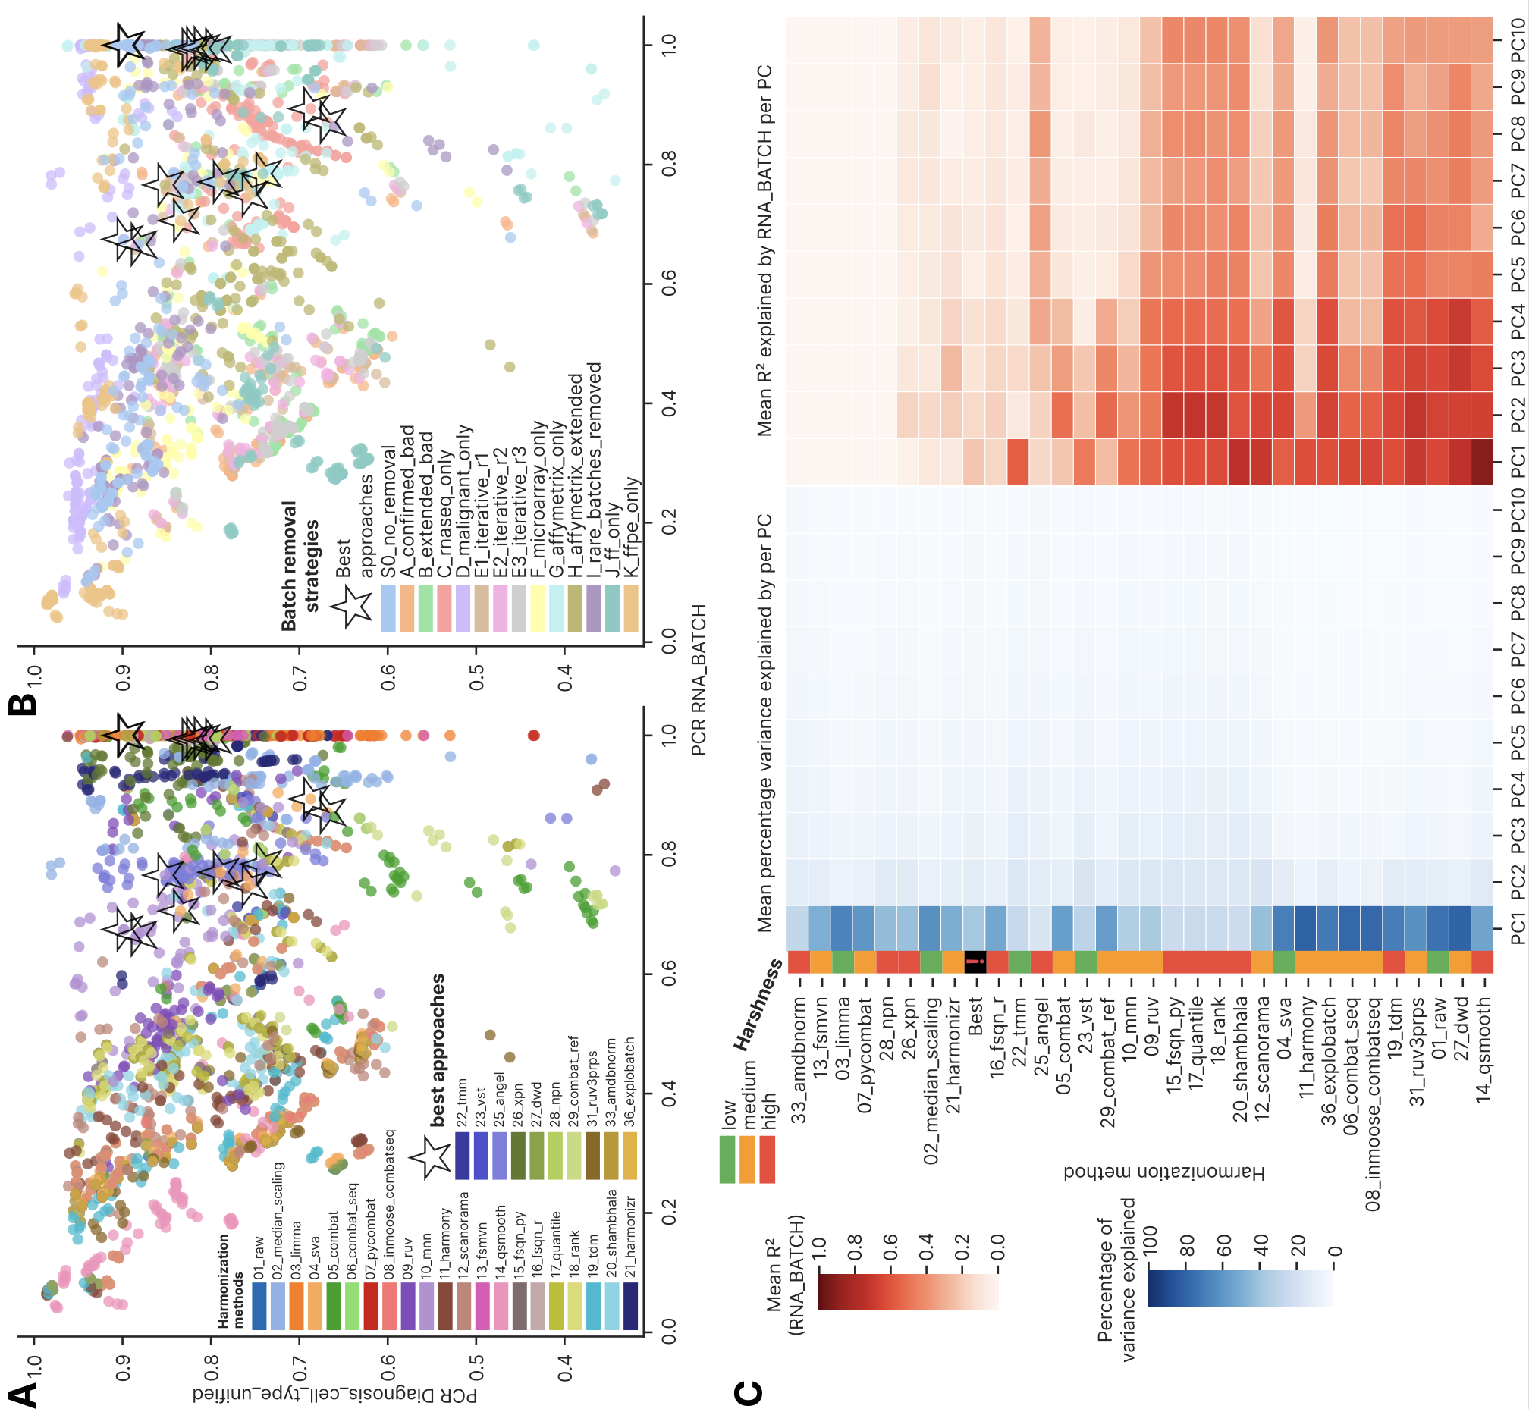

We then investigated performance of the local mixing (local neighborhood) metrics (Extended Figure 2). As a representative metric we selected Local Inverse Simpson's index (LISI) as it was scattered along the entire local metrics cluster in Supplementary Extended Figure 2 and visualized it for the same biology and batch column by harmonization method (Extended Figure 2A) and batch removal strategy (Figure 7B). The clustermap best approaches located in the right half of the scatterplots, demonstrating higher than average batch local mixing but visually no trend by local preservation of biological groups (two-sided Mann-Whitney p = 8.5*10-9 for batch and 0.80 for biology). 10_mnn harmonization conferred the highest degree of local batch mixing (median 1.72, MAD 0.209, median for all approaches 1.17 and MAD 0.109), as was previously showed on Figure 3. 14_qsmooth was the worst one by batch mixing as in the case of PCReg by RNA_BATCH, showing median 1.07 and MAD 0.032. Batch removal strategies formed isolated curved structures located in layers in order resembling the PCReg by biology order in Extended Figure 1B: FFPE only and malignant only had lowest local mixing of biology groups (median 1.07 and 1.10, respectively), and FF only had the highest local biology mixing, followed by RNA-seq only and Affymetrix extended (median 1.62, 1.39 and 1.41, respectively). We also observed positive correlation of biology mixing with the batch one (Spearman r = 0.523, p = 1.8*10-151 for the entire dataset, n = 2,150 approaches for which un-normalized LISI values were available), which implies a trade-off: better local mixing of batches is accompanied by lower integrity of biology-defined local neighborhoods. The significant positive correlation (FDR p < 0.05, Spearman r varied from 0.355 to 0.820 with median 0.650) was observed for all batch removal strategies except the G one.

As an additional local mixing metric, we visualized tSNE entropy calculated by RNA batch (Extended Figure 2C) – the one that by definition closely correlates with different batches mixing at tSNE plot. As in the case of LISI, 10_mnn was the best method (median 0.179, MAD 0.025), 14_qsmooth was the worst one (median 0.0178, MAD 0.0086). Among the batch removal strategies, FF only and RNA-seq only were the best ones (median 0.062 and 0.089, respectively), whereas the FFPE only and Affymetrix only were the worst approaches (median 0.011 and 0.015, respectively). The clustermap best approaches occupied local peaks in the heatmap, indicating that tSNE entropy reliably represents local mixing performance. To contrast the local tSNE mixing, we also visualized a global tSNE metric, namely tSNE centroid dispersion, in the analogous heatmap (Extended Figure 2D). Harmonization methods and batch removal strategies clearly separated into the low and high dispersion areas (peak values of 0.26 and 1.01, respectively), with the clustermap best approaches tending to locate at the border between these areas. Such a non-trivial pattern could indicate that tSNE centroids are poor harmonization quality measures as tSNE does not preserve global distance, and global metrics should be calculated in PCA space, whereas the local ones are inherently linked to the non-linear dimensional reduction approaches such as tSNE and UMAP.

Extended Figure 2. Local mixing-based metrics performance by harmonization methods and batch removal strategies. (A) Scatterplot of cell-type LISI (cLISI) Diagnosis_cell_type_unified versus integration LISI (iLISI) RNA_BATCH, color annotated by harmonization method. Both metrics are non-normalized, and the normalized ones were used in the Figure 3 clustermap. (B) Scatterplot of cLISI Diagnosis_cell_type_unified versus iLISI RNA_BATCH, color annotated by batch removal strategy. (C) Heatmap of tSNE entropy calculated by RNA_BATCH, ordered by harmonization methods and batch removal strategies. (D) The analogous heatmap of tSNE centroid dispersion calculated by RNA_BATCH. For all panels, the clustermap-based best approaches are shown with black asterisks.
Alt text: Local-mixing metric panels: scatter plots of biology versus batch LISI colored by method and by strategy, and heat maps of tSNE entropy and tSNE centroid dispersion by RNA batch.

As a final part of the harmonization quality metrics comparison among the approaches, we visualized the selected metrics that fall outside the main global/local axis, as well as the selected quantiles from the gene expression distributions (Extended Figure 3). To systematically test whether harmonization leads to convergence in gene expression distribution, we plotted mean D statistic of Kolmogorov-Smirnov test between randomly selected 1000 genes within batches versus mean between-batches (by RNA_BATCH) D statistics by the same 1000 genes (Extended Figure 3A).

The clustermap best approaches were in the lower half of the plot (median 0.445, MAD 0.041) showing high similarity of gene expression distributions for these best approaches within each batch group. Interestingly, different harmonization methods showed vertical lines of data points, implying that harmonization tools differ in their ability to transform different batch distributions to the same shape. At the level of batch removal strategies (Extended Figure 3B), on the other hand, horizontal layers were formed with fixed within-batch mean D statistic, with the RNA-seq only strategy occupying the lower left corner of the plot (KS cohort within batch mean D median 0.439 and MAD 0.015, KS mean D RNA_BATCH median 0.332, MAD 0.052).

We then compared percentage of samples and genes without NA (Extended Figure 3C, D, respectively) by harmonization approaches. All samples had all genes with defined expression values for 18 of the 30 harmonization methods for which the metric snapshot holds expression statistics, regardless of the batch removal strategy used; 9 more methods had a minor percentage of 0.003 - 1.4% samples with at least one NA, and 3 methods (26_xpn, 15_fsqn_py, 17_quantile) had 30.2 - 38.1% samples with at least one NA. At the level of genes with NA (Extended Figure 3D), the same 18 harmonization methods returned no NA at all, 9 more methods had 0.003-2.4% genes, two methods (15_fsqn_py and 17_quantile) had 13.0 and 16.2% genes with at least one sample with NA and the last one method 21_harmonizr had all genes with NAs in 8 out of 14 batch removal strategies.

The harmonization methods differed markedly in the expression range of their outputs (Extended Figure 3E). 08_inmoose_combatseq and 06_combat_seq had outliers with mean maximum expression of 1.46*1011 and 2.76*108 respectively, whereas their 99th percentiles were only 17.9 and 18.5. 20_shambhala had generally high expression outputs, with 555004.7 maximum expression and 1359.6 median (these two values could not be re-derived from the deposited metric table, in which 20_shambhala is absent). 19_tdm had 75.1 median and 568.9 maximum value. 18_rank and 25_angel collapsed entire distribution to range between 0 and 1, and 28_npn had expression median below zero (-0.01). All the rest methods were comparable with the standard RNA-seq log2 (transcripts per million, TPM) value range, having median expression at the level of 1.90-7.08. Generally, 19 of the 30 harmonization methods with available expression statistics had a mean minimum gene expression value below zero (the lowest one -40.6 for 13_fsmvn). Compared to all harmonization approaches, the best ones showed higher uniformity in the expression profiles (Extended Figure 3F). SVA, FSQN R, FSMVN and AMDBNorm started with zero or negative values: -10.8 to -4.98 for SVA, -8.07 to 0 for FSQN R, -19.4 for FSMVN and -6.25 for AMDBNorm. MNN started with positive ones (1.61 to 2.44), and median expression was in the interval of 2.89 to 6.70, maximum one being in the interval 12.6 to 28.6. This higher uniformity of best approaches is close to the typical log2(TPM) normalization distribution, whereas methods returning atypical expression profiles (20_shambhala, 08_inmoose_combatseq and 06_combat_seq) performed poorly.

Extended Figure 3. Additional quality metrics and gene expression snapshots by harmonization methods and batch removal strategies. (A) Scatterplot of mean D statistic of Kolmogorov-Smirnov test between all sample pairs within batches versus mean between-batches (by RNA_BATCH) D statistics, colored by harmonization methods. (B) The same scatterplot colored by batch removal strategies. (C) Heatmap of percentage samples without NA gene expression values, ordered by harmonization methods and batch removal strategies. (D) The analogous heatmap of percentage genes without NA gene expression values. For the panels A-D, the clustermap-based best approaches are shown with black asterisks. (E) Heatmap showing gene expression minimum, maximum, the 1st, 5th, 25th, 50th (median), 95th and 99th percentile as well as gene standard deviation, averaged and visualized for harmonization methods. The methods are ordered by ascending PCReg RNA_BATCH. (F) The analogous heatmap for the 15 clustermap-selected best approaches.
Alt text: Additional-metric panels: Kolmogorov–Smirnov within- versus between-batch distribution scatter plots, heat maps of the percentage of samples and genes without missing values, and heat maps of expression-value distribution statistics by method and for the best approaches.

Global metrics
Among global metrics, we firstly analyzed Principal Component Regression (PCReg) by batch and biology columns (Extended Figure 4), comparing different harmonization methods (Extended Figure 4A), batch removal strategies (Extended Figure 4B) and the clustermap best approaches. 10 out of 31 harmonization methods showed better PCA overlap of batches than biology and were considered as of ‘good’ quality, and the clustermap best approaches were deemed ‘good’ too. 5 of the methods (33_amdbnorm, 13_fsmvn, 03_limma, 07_pycombat, 28_npn) showed maximum possible PCReg values of 1, indicating complete overlap of batches in PCA space. At the level of batch removal strategies, only two of them (C and G) demonstrated higher overlap by batch compared to biology, that could indicate that harmonization method impacts more the PCA resolution of batches compared to biology compared to prior batch removal strategies.

Extended Figure 4. Principal component regression metrics comparison. (A) Barplot showing PCReg metrics by 3 columns visualized by harmonization methods, sorted by PCReg RNA_BATCH. Color annotations below the bars show method harshness score and overall quality. Best group means a composed group of the clustermap best approaches. (B) The analogous barplot for 4 PCReg metrics by batch removal strategies. Higher values indicate better overlap of classes by a given column in the PCA space. Error bars indicate 95% confidence interval (CI) estimation.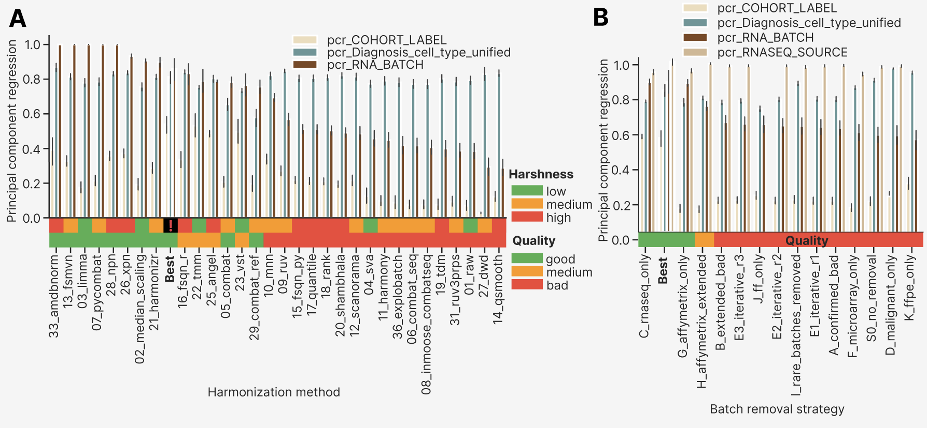

As a next step of global metrics analysis, we compared PCReg RNA_BATCH by imputations, looking at individual harmonization methods (Extended Figure 5A). KNN and strict approach were indistinguishable, whereas Softimpute had 7-10% better performance for the 11 lowest PCReg methods: 12_scanorama, 04_sva, 11_harmony, 36_explobatch, 06_combat_seq, 08_inmoose_combatseq, 19_tdm, 31_ruv3prps, 01_raw (no harmonization), 27_dwd and 14_qsmooth (the worst method by PCReg RNA_BATCH. We then compared PCReg RNA_BATCH by batch removal strategies, again investigating individual harmonization methods (Extended Figure 5B). Multiplatform strategies (S0, A, B, D, E1-E3, I) and FF only (J) had the methods performance as in the total plots by imputations (Extended Figure 5A), whereas RNA-seq only (C), FFPE only (K) and Affymetrix strategies (G, H) deviated from the general methods order by PCReg RNA_BATCH. In the C strategy, all methods lead to PCReg RNA_BATCH above 0.62. G had lower limit of 0.55, and H had this limit at the level of 0.4. Moreover, the 16_fsqn_r method had poorer performance than on average: 0.77 in G, 0.6 in H, compared to 0.84 averaged (Extended Figure 4A). In the K strategy it had 0.11 PCReg RNA_BATCH, indicating that FSQN is not applicable for FFPE datasets. Earlier in the main results we have shown that post-removal is the least important step in the computational pipeline. For additional check we visualized PCReg RNA_BATCH by harmonization methods and compared the values by post-removal (Extended Figure 5C). The only visible difference was 22_tmm and 25_angel inverse order: the former had higher PCReg RNA_BATCH with post-removal (0.83), the latter had better performance without post-removal (0.77).

We defined PCReg metric in such a way that 1 is the best possible overlapping in PCA space by a given column: the variance is not explained by this column at all. Conversely, 0 PCReg means that the entire variance is explained by the column, and this is the worst scenario for batch columns (RNA_BATCH, PLATFORM_RNA, COHORT_LABEL, RNASEQ_SOURCE) and the best one for the biology one (Major_Group, Diagnosis_cell_type_unified, TUMOR_NORMAL). Keeping in mind the fact that variance in unevenly distributed along the PCs, we compared PCReg RNA_BATCH against R² of RNA_BATCH in the first PCs by harmonization methods and batch removal strategies (Extended Figure 5D, 2E, respectively). As expected, we observed a strong negative relationship, with the clustermap best approaches occupying the lower right corner of the plot. 10_mnn, 20_shambhala and 16_fsqn_r were shifted above the main diagonal, suggesting that their batch-explained variance is moved towards lower rank PCs. The same was true for the C strategy (Extended Figure 5E).

For all the batch removal strategies we also investigated batch-explained variance for the first 10 PCs (Extended Figure 5F), looking at percentage variance explained and R² RNA_BATCH for each PC. The joint group of the clustermap best approaches was the second one after the C strategy (shown earlier in Extended Figure 4B). At the heatmap both the strategy C and the clustermap best approaches group showed lowest average percentage of variance explained by the first PC (20 and 22%, respectively), and the smoothest decay of the percentage by PC’s number. G strategy showed highest average percentage at the level of 50%, presumably because the already quantile-normalized SOM cohort comprised the highest percentage of samples in this strategy compared to the rest ones. The decay trajectory of R² RNA_BATCH for the strategy C and the best approaches started with 0.27 and 0.22, respectively, whereas the rest strategies (except for G and H) had higher first PC values. 8 out of 14 batch removal strategies had lower R² RNA_BATCH for first PCs than the one for the second PC.

Extended Figure 5. Global metrics comparison by imputation, harmonization methods and batch removal strategies. (A) Boxplots of PCReg RNA_BATCH by harmonization methods stratified by imputation. Methods are ordered by mean PCReg RNA_BATCH across all batch removal strategies, imputations and post-removals. The clustermap best approaches are highlighted in bold. (B) Boxplots of PCReg RNA_BATCH by harmonization methods stratified by batch removal strategies. Harmonization methods order is the same as in panel A, but with the group of clustermap best approaches is empty for strategies where no best approaches were selected. (C) Boxplots of PCReg RNA_BATCH by harmonization methods stratified by post-removal. The group of clustermap best approaches is empty in the post-removal boxplot because only the approaches without post-removal were selected. (D) Scatterplot showing correlation of PCReg RNA_BATCH and RNA_BATCH R² by first PC, color annotated by harmonization methods with black stars indicating the clustermap best approaches. (E) The same scatterplot color annotated by batch removal strategies. (F) Heatmaps showing percentage of total variance explained (left heatmap) and percentage of the RNA_BATCH-explained variance for the first 10 PCs, grouped by batch removal strategy and sorted by PCReg RNA_BATCH. The composite group of the best approaches is shown by bold font.
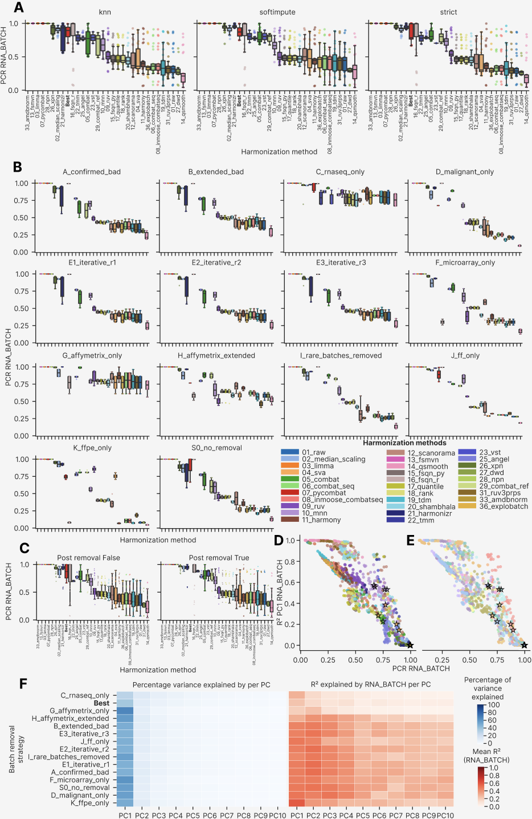
As the last step of global metrics analysis, we compared PCReg by various columns and non-PCReg metrics with the pre-established standard of PCReg RNA_BATCH (Extended Figure 6). PLATFORM_RNA was a larger scale column compared to RNA_BATCH: one class of PLATFORM_RNA could correspond to 2-3 classes for RNA_BATCH. Therefore, PCReg by PLATFORM_RNA and PCReg by RNA_BATCH followed a strictly linear relationship (Extended Figure 6A), with strategies the FFPE only and FF only strategies being closest to the 1:1 diagonal line. This can be explained by the fact that selecting FFPE only or FF only batches reduced the batch and platform classes to the 1:1 ratio: for each platform only its FFPE or FF batch was selected. Multi-batch PLATFORM_RNA column in the rest strategies explained less variance in PCA space compared to RNA_BATCH, hence these strategies are above the main 1:1 diagonal. For COHORT_LABEL (Extended Figure 6B) we observed the inverse pattern: the approaches generally had higher COHORT_LABEL related variance (lower PCReg COHORT_LABEL) than the RNA_BATCH derived one. The clustermap best approaches were consistently found in the best 1/3 part of the plots.

Dispersion separability criterion (DSC) was selected as an orthogonal PCA-based global metric, but it showed monotonous sigmoidal dependency on PCReg for the RNA_BATCH column (Extended Figure 6C). DSC by PLATFORM_RNA over RNA_BATCH dependency was again monotonous and linear in a log-scale (Extended Figure 6D) without any non-trivial effects as in the PCReg case (Extended Figure 6A). In a contrast, DSC COHORT_LABEL showed two clouds of points not explained by batch removal strategies (Extended Figure 6E), that could be presumably explained by harmonization methods. Interestingly, only 2 out of 15 clustermap best approaches were found in the lower half of the DSC RNA_BATCH log scale. Such outliers can be explained by the fact that DSC is calculated as ratio of between group scatter to within group scatter, and ratio is vulnerable to outliers even under log-transformation.

Among the non-linear global metrics, we visualized and studied tSNE centroid dispersion (Extended Figure 6F, G, H) and Average Silhouette Width (ASW, Extended Figure 6I and J) – all by the RNA_BATCH column. As expected, tSNE centroid dispersion negatively correlated with PCReg following a non-linear arc-like pattern. Interestingly, a subgroup of 11_harmony approaches in J and K strategies deviated below the general trend, showing an improved tSNE centroid dispersion: 0.55-0.75 compared to the expected 1.1 for K and 0.65 compared to the expected 1.0 for J (Extended Figure 6F, G). For the dependency of tSNE centroid dispersion and PCReg we also investigated whether post-removal affects the approaches moving them towards better or poorer performance (Extended Figure 6H): we found no systematic shift except for the G strategy points that had 0.7-0.9 PCReg RNA_BATCH before post-removal and 0.9-1 PCReg after it. This fact can be again attributed to the fact that the SOM cohort comprised approximately 800 out of 2801 samples processed with the GPL570 cohort in this strategy. This also means that post-removal of only one cohort does not significantly improve the harmonization performance for the majority of cases. ASW depended on PCReg in a noisier manner, with the K strategy showing the worst performance (Extended Figure 6I). Again, the G strategy was an upward outlier, located in the zone of -0.05 – 0.3 ASW but with the same high PCReg as the clustermap best approaches (PCReg 0.68 - 1). 02_median_scaling and 11_harmony were the top performing harmonization methods by ASW (Extended Figure 6J).

Extended Figure 6. Additional global metrics analysis. (A) Scatterplot showing correlation of PCReg PLATFORM_RNA with PCReg RNA_BATCH. (B) Scatterplot of PCReg COHORT_LABEL versus PCReg RNA_BATCH. (C) Scatterplot of DSC RNA_BATCH versus PCReg RNA_BATCH. (D) Scatterplot of DSC PLATFORM_RNA versus DSC RNA_BATCH. (E) Scatterplot of COHORT_LABEL versus DSC RNA_BATCH. Scatterplots in the panel A-E are color annotated by batch removal strategy. (F) Scatterplot of tSNE centroid disp RNA_BATCH versus PCReg RNA_BATCH, color annotated by batch removal strategy. (E) The same scatterplot of tSNE centroid disp RNA_BATCH versus PCReg RNA_BATCH, color annotated by harmonization method. (H) The same scatterplot with color annotation by post-removal and connection lines that show transition between approaches with and without post-removal. (I) Scatterplot of ASW RNA_BATCH versus PCReg RNA_BATCH, color annotated by batch removal strategy. (E) The same scatterplot of ASW RNA_BATCH versus PCReg RNA_BATCH, color annotated by harmonization method.
Black empty stars on all the panels of this figure show the clustermap best approaches.
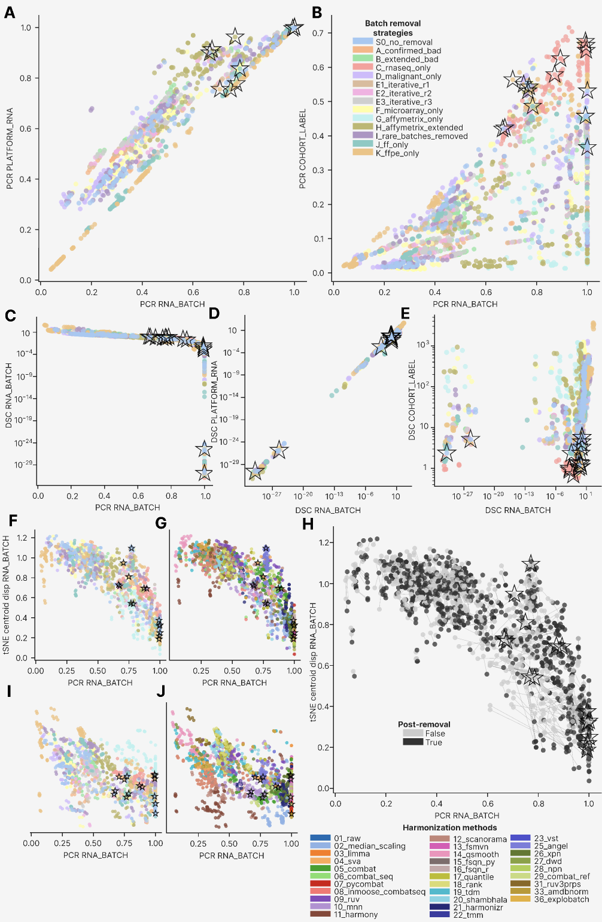
At a general scale, global metrics behaved to the high degree like the PCReg metrics family. R² by first principal component, dispersion separability criterion, tSNE centroid dispersion, average silhouette width – they monotonously correlated with PCReg, either linearly or non-linearly. Outliers that arose in the perpendicular direction of the main dependency and that performed better than average – were not validated by the clustermap best methods and, therefore, had a poorer performance by other metrics, especially the local ones.

Local metrics

Local neighborhood quality was assessed by kBET acceptance rate, iLISI, cLISI, graph connectivity and tSNE/UMAP mixing entropy per biological and batch group. We expected that the best approaches should mix batch labels in the local neighborhood of each sample while preserving local integrity of biological groups.

LISI metrics (Local inverse Simpson's index) revealed 10_mnn the top performing harmonization method by RNA_BATCH labels mixing, and the clustermap best approaches formed the second group (Extended Figure 7A). The best approaches performed so well by LISI because they were selected in the relatively high local mixing clusters of the main clustermap, and visually confirmed by tSNE/UMAP plots to have good batch mixing while preserving the biology groups. Among 31 methods in total, only 6 ones (10_mnn, 33_amdbnorm, 02_median_scaling, 28_npn, 16_fsqn_r, 25_angel) were considered as ‘good’ since their LISI by biology (Diagnosis_cell_type_unified) was lower than the one by RNA_BATCH – indicating better batch than biology local mixing. 4 more methods (13_fsmvn, 26_xpn, 03_limma, 12_scanorama) were of ‘medium’ quality since their biology LISI was higher than the batch one, but the 95% CI overlapped between batch and biology.

LISI metrics stratification by batch removal strategy revealed the highest values for the clustermap best approaches (Extended Figure 7B): they had highest LISI by RNA_BATCH. J and S0 strategies followed it by LISI RNA_BATCH, but their biology local mixing (LISI Diagnosis_cell_type_unified) was higher than the batch ones. Two strategies, D and K, had better local mixing by batch than the one by biology and were deemed ‘good’ by this criterion. We also visualized the batch and biology LISI metrics on heatmaps by harmonization method and batch removal strategy (Extended Figure 7C, D, respectively). We found that the best approaches occupied local peaks by batch but did not so with local valleys the biology, which reflects the subtle biological differences and the sharper technical ones in the current FL dataset.

Extended Figure 7. LISI metrics of local neighborhood. (A) Barplot of the LISI metrics by 3 columns (Diagnosis_cell_type_unified, COHORT_LABEL, RNA_BATCH) visualized by harmonization methods, sorted by iLISI RNA_BATCH. Color annotations below the bars show method harshness score and overall quality. Best group means a composed group of the clustermap best approaches. (B) The analogous barplot for 4 LISI metrics by batch removal strategies (added the metric for the RNASEQ_SOURCE column). Higher values indicate better overlap of classes by a given column in a local nearest neighbors’ environment. Error bars indicate 95% confidence interval (CI) estimation. (C) Heatmap of LISI by RNA_BATCH, clustered by harmonization methods (columns) and batch removal strategies (rows). Each cell shows the metric value averaged by imputations and post-removals. (D) The similar heatmap for LISI by Diagnosis_cell_type_unified. Best approaches are marked as black asterisks in the panels C and D.
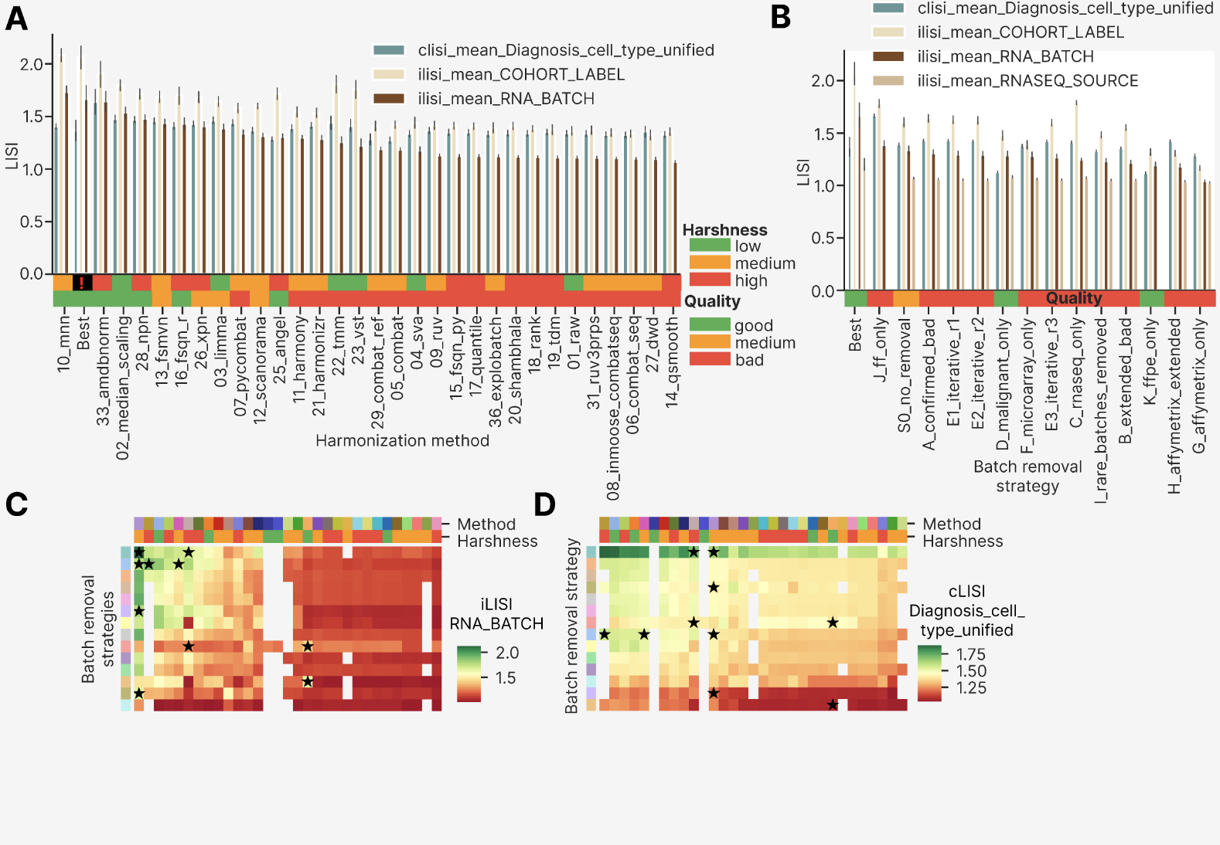

We then compared LISI with other local metrics (Extended Figure 8). There was a weak positive relationship between LISI and kBET acceptance rate for the same RNA_BATCH column (Extended Figure 8A, B). Among all 2,234 attempts, the vast majority achieved near-zero kBET acceptance rates, confirming that local neighborhood composition remained batch-biased after most harmonization methods even when global PCReg values were substantially reduced. Only 5 of the 15 clustermap best approaches achieved kBET rates above the threshold of 0.10, all being SVA ones (for RNA-seq and FFPE only strategies). The MNN best approaches (for the cross-platform harmonization) had the highest LISI values between 1.9 and 2.1 but relatively lower kBET values (Extended Figure 8A). Interestingly, other harmonization methods were also unevenly distributed along the kBET-LISI axis: 02_median_scaling had disproportionally high LISI and 25_angel was shifted towards the kBET direction, probably pointing at different modes of local batches mixing by harmonization method. The fact that the clustermap best approaches occupied area above the y = -x diagonal (with two exceptions of 16_fsqn_r) suggests that both modes really improve the batch correction performance. At the level of batch removal strategies (Extended Figure 8B), the C strategy was the highest one by kBET with a compact group of methods located between 0.6 and 1 kBET. But they had LISI below 1.4 and were not selected by the integrative clustermap. S0 and D strategies tended to have near-zero kBET, whereas both Affymetrix strategies (G and H) and the I strategy (rare batches removed) were close to the minimum LISI values floor.
Looking at kBET acceptance rate by different columns (Extended Figure 8C, D), we revealed that only three harmonization methods (22_tmm, 23_vst, 10_mnn) showed kBET acceptance rate RNA_BATCH better than in 01_raw and could be considered as ‘good’, and 14 methods were poorer by this metric than 01_raw and can be therefore deemed ‘bad’ (Extended Figure 8C). kBET by PLATFORM_RNA was above 0.1 for all methods except 36_explobatch, indicating that good local mixing by platforms is abolished by the FF/FFPE distinction in 28 out of 31 methods in total. The clustermap best approaches were the third best method by kBET RNA_BATCH, whereas 22_tmm and 23_vst performed better because they were applied to the C strategy only, where all methods perform better because of RNA-seq platforms higher comparability. At the level of batch removal strategies (Extended Figure 8D), the strategies C, H, J and G were considered as ‘good’ by the same criterion compared with the S0 strategy, and the clustermap best approaches were the second top by kBET RNA_BATCH. The strategies B, D and I had poor performance, indicating that minor batch removal or selecting malignant-only samples does not improve local mixing by batches.

We then investigated behavior of other local mixing metrics that highly impacted harmonization quality: tSNE and UMAP entropy. tSNE entropy strongly correlated with LISI by RNA_BATCH, with 10_mnn and the three clustermap 04_sva approaches forming a distinct linear trend with higher tSNE entropy to LISI ratio (Extended Figure 8E). By batch removal strategies we saw less differences, with the S0, I, H and F strategies located in the lower side of the trend line (Extended Figure 8F). UMAP and tSNE entropies correlated even more strongly, without any new and nontrivial differences by harmonization methods (Extended Figure 8I) or batch removal strategies (Extended Figure 8J).

Generally, for local metrics we observed less harmonization methods performing at a ‘good’ level (Extended Figure 7A) compared to the global ones (Extended Figure 4A), reflecting the fact that local mixing by batches is more challenging than their global overlapping at the PCA space.

Extended Figure 8. Analysis of a more diverse set of local mixing metrics: LISI, kBET acceptance rate, tSNE and UMAP entropy. (A) Scatterplot showing LISI and kBET acceptance rate by RNA_BATCH, color annotated by harmonization methods. (B) The same scatterplot color annotated by harmonization strategies. (C) Barplot of the kBET metrics by 3 columns (PLATFORM_RNA, COHORT_LABEL, RNA_BATCH) visualized by harmonization methods, sorted by kBET acceptance rate RNA_BATCH. Color annotations below the bars show method harshness score and overall quality. Best group means a composed group of the clustermap best approaches. (D) The analogous barplot for the same 3 kBET metrics by batch removal strategies. Higher values indicate better overlap of classes by a given column in a local nearest neighbors’ environment. Error bars indicate 95% confidence interval (CI) estimation. (E) Scatterplot of tSNE entropy vs LISI by RNA_BATCH, color annotated by harmonization methods. (F) The same scatterplot color annotated by batch removal strategies. (G) Scatterplot of tSNE entropy vs tSNE centroid dispersion by RNA_BATCH, color annotated by harmonization methods. (H) The same scatterplot color annotated by batch removal strategies. (I) Scatterplot of UMAP entropy vs tSNE entropy by RNA_BATCH, color annotated by harmonization methods. (J) The same scatterplot color annotated by batch removal strategies. (K) Scatterplot of UMAP centroid dispersion vs tSNE centroid dispersion by RNA_BATCH, color annotated by harmonization methods. (L) The same scatterplot color annotated by batch removal strategies. The clustermap best approaches are shown as empty black stars on the panels A, B and E – L.
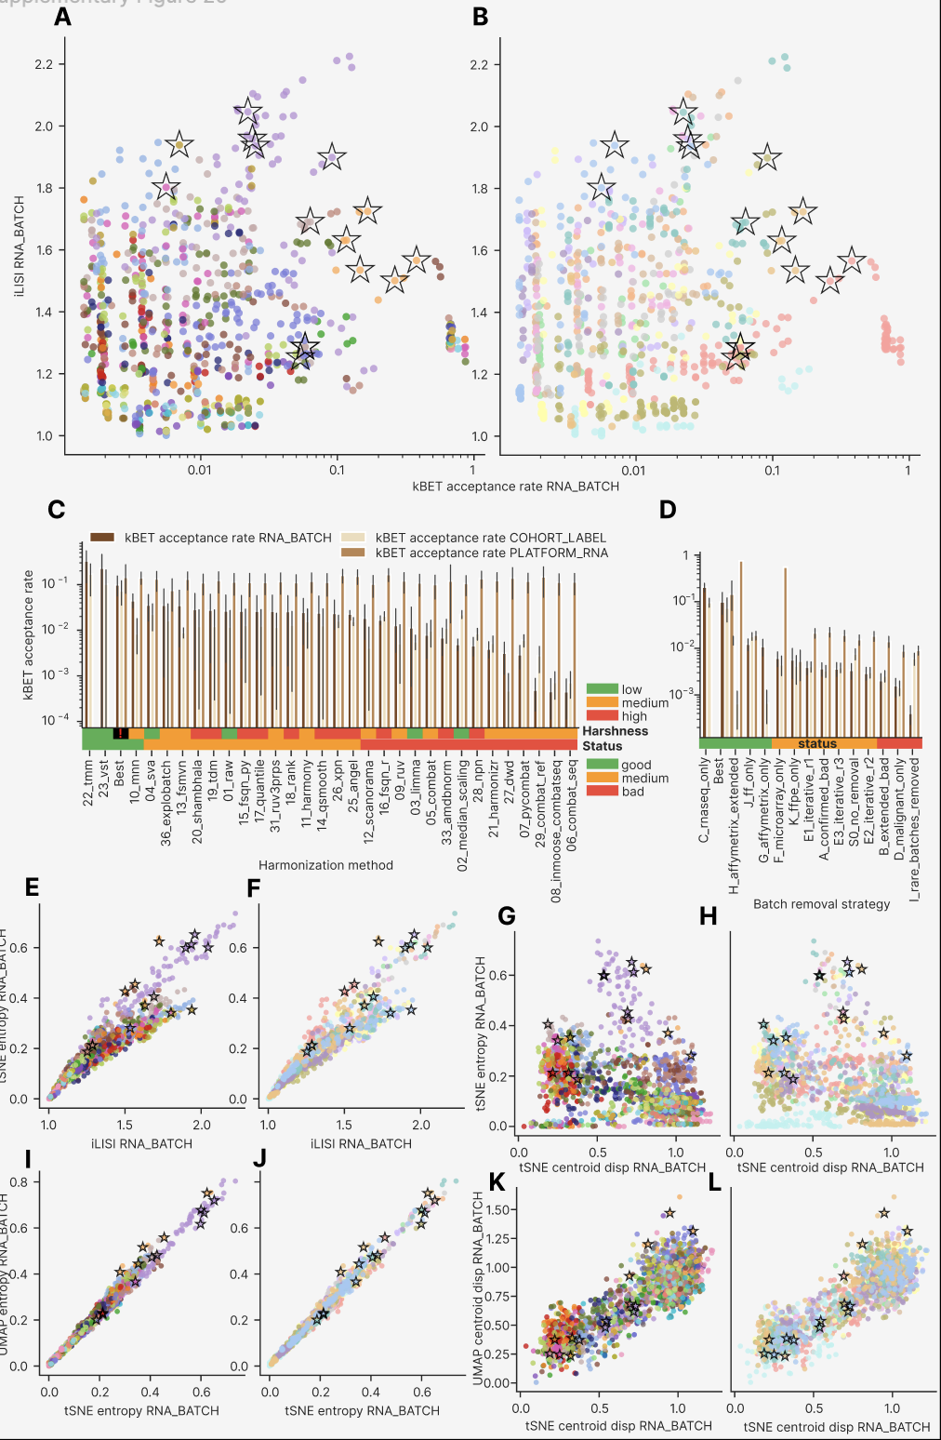

Local and global metrics relationship

The central analytical challenge in cross-platform harmonization is the inverse relationship between global batch correction and local biological preservation. To characterize this trade-off empirically, we visualized local versus global metrics behavior on scatterplots (Extended Figure 8G, 8H, 8K, 8L and Extended Figure 9).

tSNE centroid dispersion is a natural complementary pair to tSNE entropy: it quantifies separation of groups in the same embedding space as their local mixing by entropy. We observed a negative relationship between these metrics: 10_mnn with minority of 04_sva, 11_harmony, 12_scanorama and 16_fsqn_r approaches formed a diagonally shaped cloud with high tSNE entropy values (0.3 – 0.75), whereas the rest harmonization methods separated into two dense clouds with approximately round shape (Extended Figure 8G). Batch removal strategies, on the other hand, formed layers of negatively correlating metrics, each layer located in both clouds on top of each other and being randomly mixed in the 10_mnn cloud (Extended Figure 8H). At a higher level, this pattern indicates that a given harmonization method can lead to good or bad batches overlapping in tSNE embeddings, but the precise composition of batches will govern how well they mix locally. Only MNN mixes batches well for most of the batch removal strategies. In other words, harmonization method cannot impact local mixing of batches except for these three methods.

As an additional check, we compared tSNE and UMAP centroid dispersion on scatterplots: we saw strong positive relationship and the same separation of harmonization methods in two clouds (Extended Figure 8K) and batch removal strategies were scattered each in both clouds (Extended Figure 8L). The clustermap best approaches were randomly distributed along the trend line, indicating that local mixing was of higher priority compared to the global separation even in the case of non-linear embeddings (tSNE and UMAP).

We then compared LISI and kBET against PCReg as the main global metric established earlier (Extended Figure 9). LISI by RNA_BATCH showed weakly positive relationship with PCReg, having 10_mnn, 04_sva, 11_harmony, 12_scanorama and 16_fsqn_r above the general trend (Extended Figure 9A). Batch removal strategies demonstrated a layered structure (Extended Figure 9B) resembling the pattern of tSNE centroid dispersion and tSNE entropy albeit noisier (Extended Figure 8H). As previously in Extended Figure 7 and 8, the clustermap best approaches occupied the top-right corner of the scatterplots.

The analogous comparison of LISI and PCReg by the main biology column Diagnosis_cell_type_unified revealed more noise but general weak negative relationship (Extended Figure 9C, D). The clustermap best approaches were distributed uniformly in the space of these two metrics, indicating that biology preservation was secondary criterion compared to the batch mixing. While the distribution of harmonization methods by LISI and PCReg by Diagnosis_cell_type_unified was apparently random (Extended Figure 9C), batch removal strategies formed horizontal layers with variable PCReg and fixed LISI (Extended Figure 9D), probably connected with different effective number of biological groups in each strategy. Indeed, the D and K strategies contained a few malignant only groups (FL, DLBCL, Burkitt Lymphoma and High-Grade B Cell Lymphoma) and they had lowest LISI. Simultaneously the J strategy contained all the diverse normal B cell types and less cancers than other strategies, and it had highest LISI. This finding implies that local metrics could be highly impacted by the effective number of classes, whereas the global ones like PCReg are more robust to such changes in the dataset.

Finally, we compared PCReg and kBET acceptance rate by RNA_BATCH (Extended Figure 9E, F). The comparison revealed a weakly positive dependency, where only 04_sva and 10_mnn methods had kBET above 0.1 for enough approaches (5 and more, Extended Figure 9E). Interestingly, approaches that had PCReg 1.0 (07_pycombat, 03_limma, 13_fsmvn, 14_qsmooth, 16_fsqn_r, 06_combat_seq) demonstrated kBET below 0.1. Among batch removal strategies, C showed the highest kBET unlike in the case of LISI by biology (Extended Figure 9D). There was a compact group of RNA-seq only approaches having kBET between 0.6 and 0.9 and PCReg between 0.8 and 1.0 – but neither of them was selected as the clustermap best approaches. This example highlights the general trend: absolute maximum by any metric (even the local mixing one) does not guarantee an approach to be the best by clustermap and confirmed by visual inspection. Only the entire set of metrics reveals the truly best approaches via clustermap.

Extended Figure 9. Comparison of kBET and LISI against PCReg. (A) Scatterplot of LISI vs PCReg by RNA_BATCH, color annotated by harmonization methods. (B) The same scatterplot color annotated by batch removal strategies. (C) Scatterplot of LISI vs PCReg by Diagnosis_cell_type_unified, color annotated by harmonization methods. (D) The same scatterplot color annotated by batch removal strategies. (E) Scatterplot of kBET acceptance rate vs PCReg by RNA_BATCH, color annotated by harmonization methods. (F) The same scatterplot color annotated by batch removal strategies. The clustermap best approaches are shown as empty black stars on all the panels of this figure.
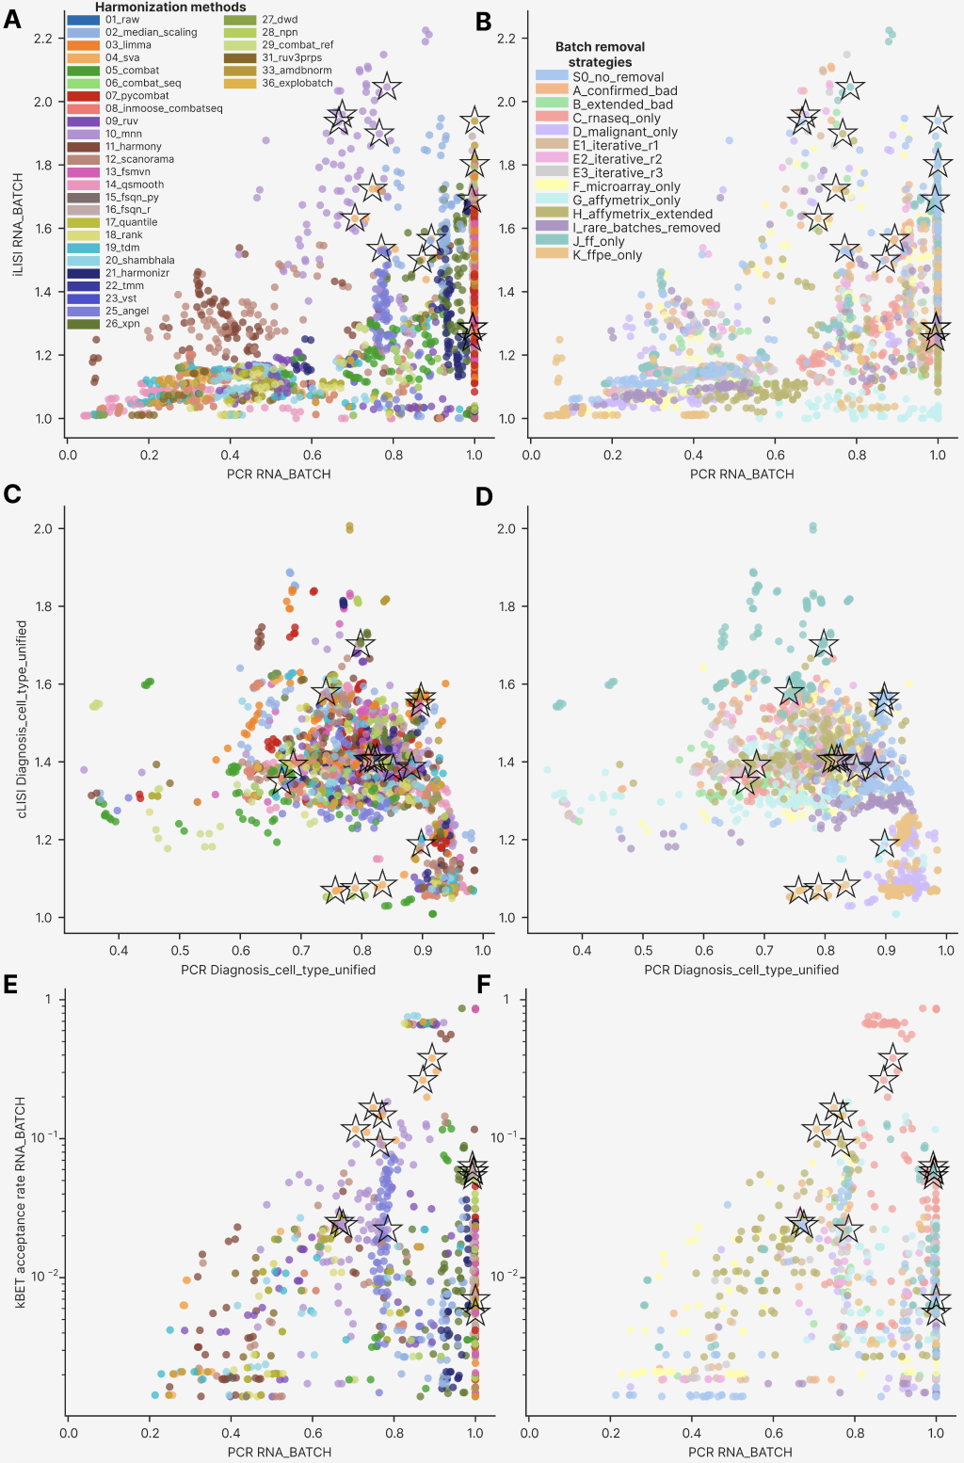

Structural and other metrics performance

As the next section of harmonization quality metrics analysis, we visualized and compared distributional similarity, graph connectivity, Watermelon score, distance ratio and expression properties (Extended Figure 10). For distributional similarity we selected the metric KS fraction significant, quantifying fraction of pairs by a certain column that have significant differences by gene expression distribution according to Kolmogorov-Smirnov test. We visualized KS fraction significant by columns PLATFORM_RNA, COHORT_LABEL, RNA_BATCH by harmonization method (Extended Figure 10A) and batch removal strategy (Extended Figure 10B). 15 out of 31 harmonization methods showed KS fraction significant for RNA_BATCH lower than this metric for 01_raw and were considered ‘good’ by this metric, as in the case for the clustermap best approaches. Interestingly, KS fraction significant was above 0.7 for all methods except 22_tmm and 23_vst, since they were applied to RNA-seq only cohorts with lower between-cohort differences. This fact indicates that even for the best harmonization by RNA_BATCH there are still 70-80% cohorts that have significant differences in gene expression profiles between them. For batch removal strategies (Extended Figure 10B) we saw the lowest KS fraction significant in the S0 strategy, and the comparable one in the clustermap best approaches and in the C strategy, so they all had medium quality, and all the rest ones were considered as ‘bad’.

We then investigated the behavior of graph connectivity as an orthogonal measure of local mixing. Comparing graph connectivity between Diagnosis_cell_type_unified and PLATFORM_RNA (Extended Figure 10C, D) revealed no dependency, but the clustermap derived best approaches had connectivity by both columns relatively high: above 0.8 for PLATFORM_RNA and above 0.65 for Diagnosis_cell_type_unified. Harmonization methods were non-randomly distributed too (Extended Figure 10C): 10_mnn, 25_angel, 09_ruv and 16_fsqn_r were located in the upper right corner close to the clustermap best approaches, whereas 02_median_scaling, 07_pycombat, 03_limma, 04_sva (surprisingly) and 11_harmony were situated in the lower left corner of the plot, having lower biology preservation and simultaneously more interrupted platform-level distribution. At the level of batch removal strategies (Extended Figure 10D), only D and K ones significantly deviated from the rest strategies: they formed two compact clouds below the main peak, having 0.53 – 0.65 graph connectivity by Diagnosis_cell_type_unified. Notably, they each have only 4 biological groups and their connectivity should be higher all else being equal, but the fact that they were composed mainly from heterogeneous FFPE batches (and malignant FF ones in D which further increases heterogeneity) could explain lower connectivity by biology.

As an additional metric of global distance separation, we calculated ratio of within group Euclidean distance to the between group one and compared it by RNA_BATCH and Diagnosis_cell_type_unified (Extended Figure 10E, F). As expected, the clustermap best approaches located at the right side of the plot having dist ratio RNA_BATCH above 0.8 and no shift by dist ratio Diagnosis_cell_type_unified, emphasizing higher priority of batch overlapping than biological differences preservation in these best approaches. Surprizingly, 07_pycombat, 03_limma and minority of 02_median_scaling were located even further to the right in the plot (Extended Figure 10E). This fact could be interpreted as a manifestation of the same principle: neither metric alone can be used to select the best harmonization approaches, but the clustermap of all of them can. 14_qsmooth, 11_harmony and 19_tdm had the poorest performance by RNA_BATCH distance ratio. Batch removal strategies had more random distribution along the distance ratio axes (Extended Figure 10F), with S0 and K having higher distance ratio by biology (less biology preservation, ratio 0.8 – 1.1) and J having it lower (0.5 – 0.8), which could be explained by lower biological group size in the J (FF only) strategy.

The next step of other metrics comparison was the Watermelon (WM) score analysis, which measures how well a given harmonization approach separates classes on a clustermap in a space of gene expression. The clustermap best approaches were slightly shifted to the low values of WM by RNA_BATCH (Extended Figure 10G, H), whereas there was not any directed change by the WM Diagnosis_cell_type_unified metric. By harmonization methods 10_mnn and three RNA-seq only instances of 11_harmony had the lowest WM by RNA_BATCH (Extended Figure 10G). Batch removal strategies revealed the poorest performance by RNA_BATCH for the G strategy (GPL570 only) and the best performance by biology for D and K strategies that have only four malignant classes each (Extended Figure 10H). S0 and I strategies had relative decrease in WM by Diagnosis_cell_type_unified (more biology classes). We then calculated and averaged WM score by all batch columns and all biology columns and built a standard scatterplot (Extended Figure 10I, J). Even further compared to the previous WM score metrics, the clustermap best approaches did not form any compact or shifted group in the plot. As previously, we had a compact group of 10_mnn approaches with low WM score by batch columns (Extended Figure 10I). Batch removal strategies had even higher degree of separation into compact groups (Extended Figure 10J): the malignant only (D) approaches had the lowest WM by biology (poorest performance) and high WM by batch (poor performance), whereas the FFPE only strategies were highest by WM biology, which is particularly interesting since their number of biology classes is the same (4 malignancies). The C strategy had lowest WM by batch (0.12-0.25), and G strategy had again the highest batch WM (0.4-0.5).

The last of the ‘other’ metrics in our analysis was gene expression quantiles and standard deviation by batch removal strategy (Extended Figure 10K). Compared to the analysis by harmonization method (described in the main article), average gene expression properties by batch removal strategy were indistinguishable except the G strategy with the highest maximum gene expression and its standard deviation.

Taken together, the distributional similarity and distance ratio metrics differentiated the clustermap best approaches, but Watermelon score did not. Potentially WM score measures another mode of harmonization quality that is not captured by the clustermap. The future best harmonization pipelines should take WM score as an independent group of metrics equally important as the PCA-based global and tSNE/UMAP based local ones.

Extended Figure 10. Structural and other metrics performance. (A) Barplot of the KS fraction significant metrics by 3 columns (PLATFORM_RNA, COHORT_LABEL, RNA_BATCH) visualized by harmonization methods, sorted by KS fraction significant RNA_BATCH. Color annotations below the bars show method harshness score and overall quality. Best group means a composed group of the clustermap best approaches. (B) The analogous barplot for the same 3 KS metrics by batch removal strategies. Higher values indicate higher proportion of pairwise comparisons with significant differences in gene expression distributions by Kolmogorov-Smirnov test. Error bars indicate 95% confidence interval (CI) estimation. (C) Scatterplot of graph connectivity by Diagnosis_cell_type_unified versus PLATFORM_RNA, color annotated by harmonization methods. (D) The same scatterplot color annotated by batch removal strategies. (E) Scatterplot of distance ratio (intragroup to intergroup) by Diagnosis_cell_type_unified versus RNA_BATCH, color annotated by harmonization methods. (F) The same scatterplot color annotated by batch removal strategies. (G) Scatterplot of Watermelon score by Diagnosis_cell_type_unified versus RNA_BATCH, color annotated by harmonization methods. (H) The same scatterplot color annotated by batch removal strategies. (I) Scatterplot of mean Watermelon score by biology columns versus the same score by batch columns, color annotated by harmonization methods. (J) The same scatterplot color annotated by batch removal strategies. The clustermap best approaches are shown as empty black stars on the panels C – J. (K) Heatmap showing gene expression quantiles and standard deviation by harmonization strategies.
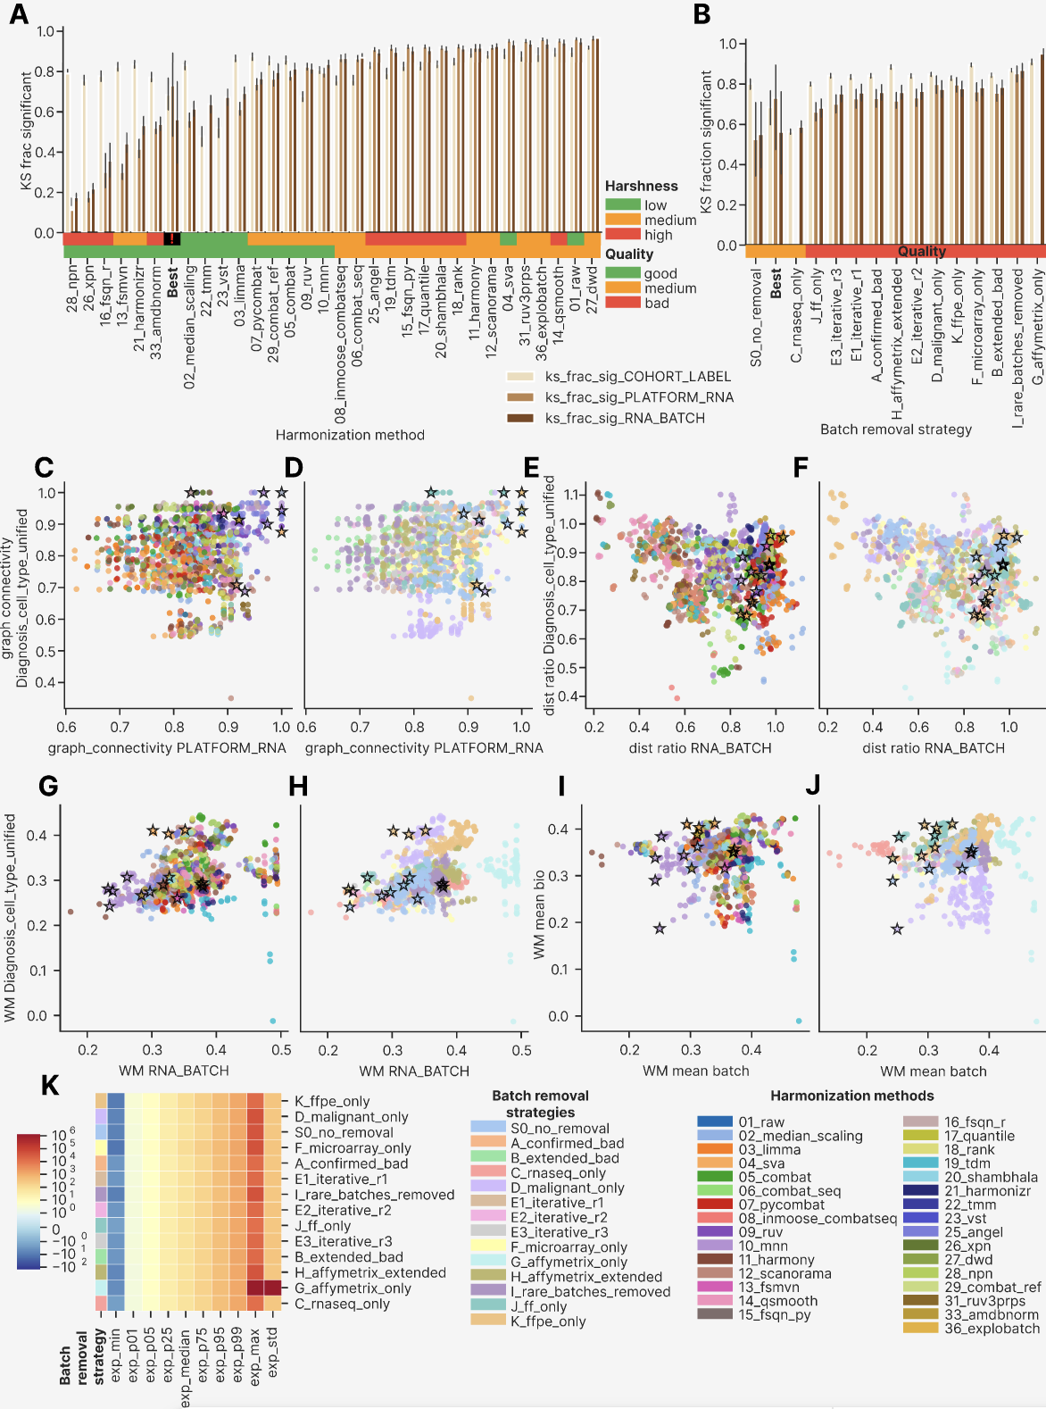

Impact of harmonization method harshness on harmonization quality

As an additional study of harmonization methods, we compared major metric types by harmonization method harshness (Extended Figure 11). We started with the widely accepted premise that in order to obtain perfect batch mixing and biology separation, one should apply as sophisticated methods that extensively reshape the gene expression distribution as possible. We aimed to test whether this is true in the case of our FL multiplatform dataset.

In the case of PCReg RNA_BATCH (Extended Figure 11A) 11 out of 14 batch removal strategies had methods with low harshness showing the highest metric, the exceptions were C, G and J strategies. In an opposite way, for PCReg Diagnosis_cell_type_unified (Extended Figure 11B) in 8 strategies low harshness showed the lowest metric (best performance), and 9 strategies had high harshness methods with the highest metric.

Local metrics showed a similar pattern of low harshness methods having the best performance. tSNE entropy by RNA batch (Extended Figure 11C) had 6 strategies with low harshness being the best and 8 more with medium harshness having the highest performance. By LISI RNA_BATCH the behavior was even more favorable towards low harshness (Extended Figure 11D): it was the best in 10 strategies and medium harshness was the best in the rest 4 ones. By LISI Diagnosis_cell_type_unified, unfortunately, low harshness methods performed the worst (highest LISI by biology) in 12 strategies (Extended Figure 11E). Unlike PCReg, where low harshness methods had both highest batch PCReg and the lowest biology one, here in the case of LISI we observed the local mixing trade-off as in the main article: stronger local mixing by batch inevitably causes less local preservation (higher local mixing) of biology.

As a final part of the methods harshness comparison, we visualized KS fraction significant RNA_BATCH by harshness and strategies (Extended Figure 11F). Here we observed the best performance of high harshness methods (lowest metric) in 13 strategies out of the 14 total ones, and 5 strategies had the worst performance in low harshness methods, and in 9 cases the worst behavior was observed for medium harshness methods.

Taken together, the harshness comparisons confer an intricate picture: low harshness methods tend to outperform the high harshness ones in terms of PCReg by batch and biology, whereas by local mixing they both better mix batches and worse preserve biology. Finally, high harshness methods better converge gene expression distributions to the same shape for different batches. In other words, it is better for harmonization to take less harsh interventions into data (like rank or quantile normalization), and harsh data transformations lead only to apparent success (similar expression distributions), not a real one.

Extended Figure 11. Barplots comparing metrics of different harshness harmonization methods by batch removal strategies. (A) PCReg RNA_BATCH. (B) PCReg Diagnosis_cell_type_unified. (C) tSNE entropy RNA_BATCH. (D) LISI RNA_BATCH. (E) LISI Diagnosis_cell_type_unified. (F) KS fraction significant RNA_BATCH. In each barplot, the harmonization strategies are sorted by the metric shown, and the clustermap best methods are shown as a surrogate batch removal strategy.
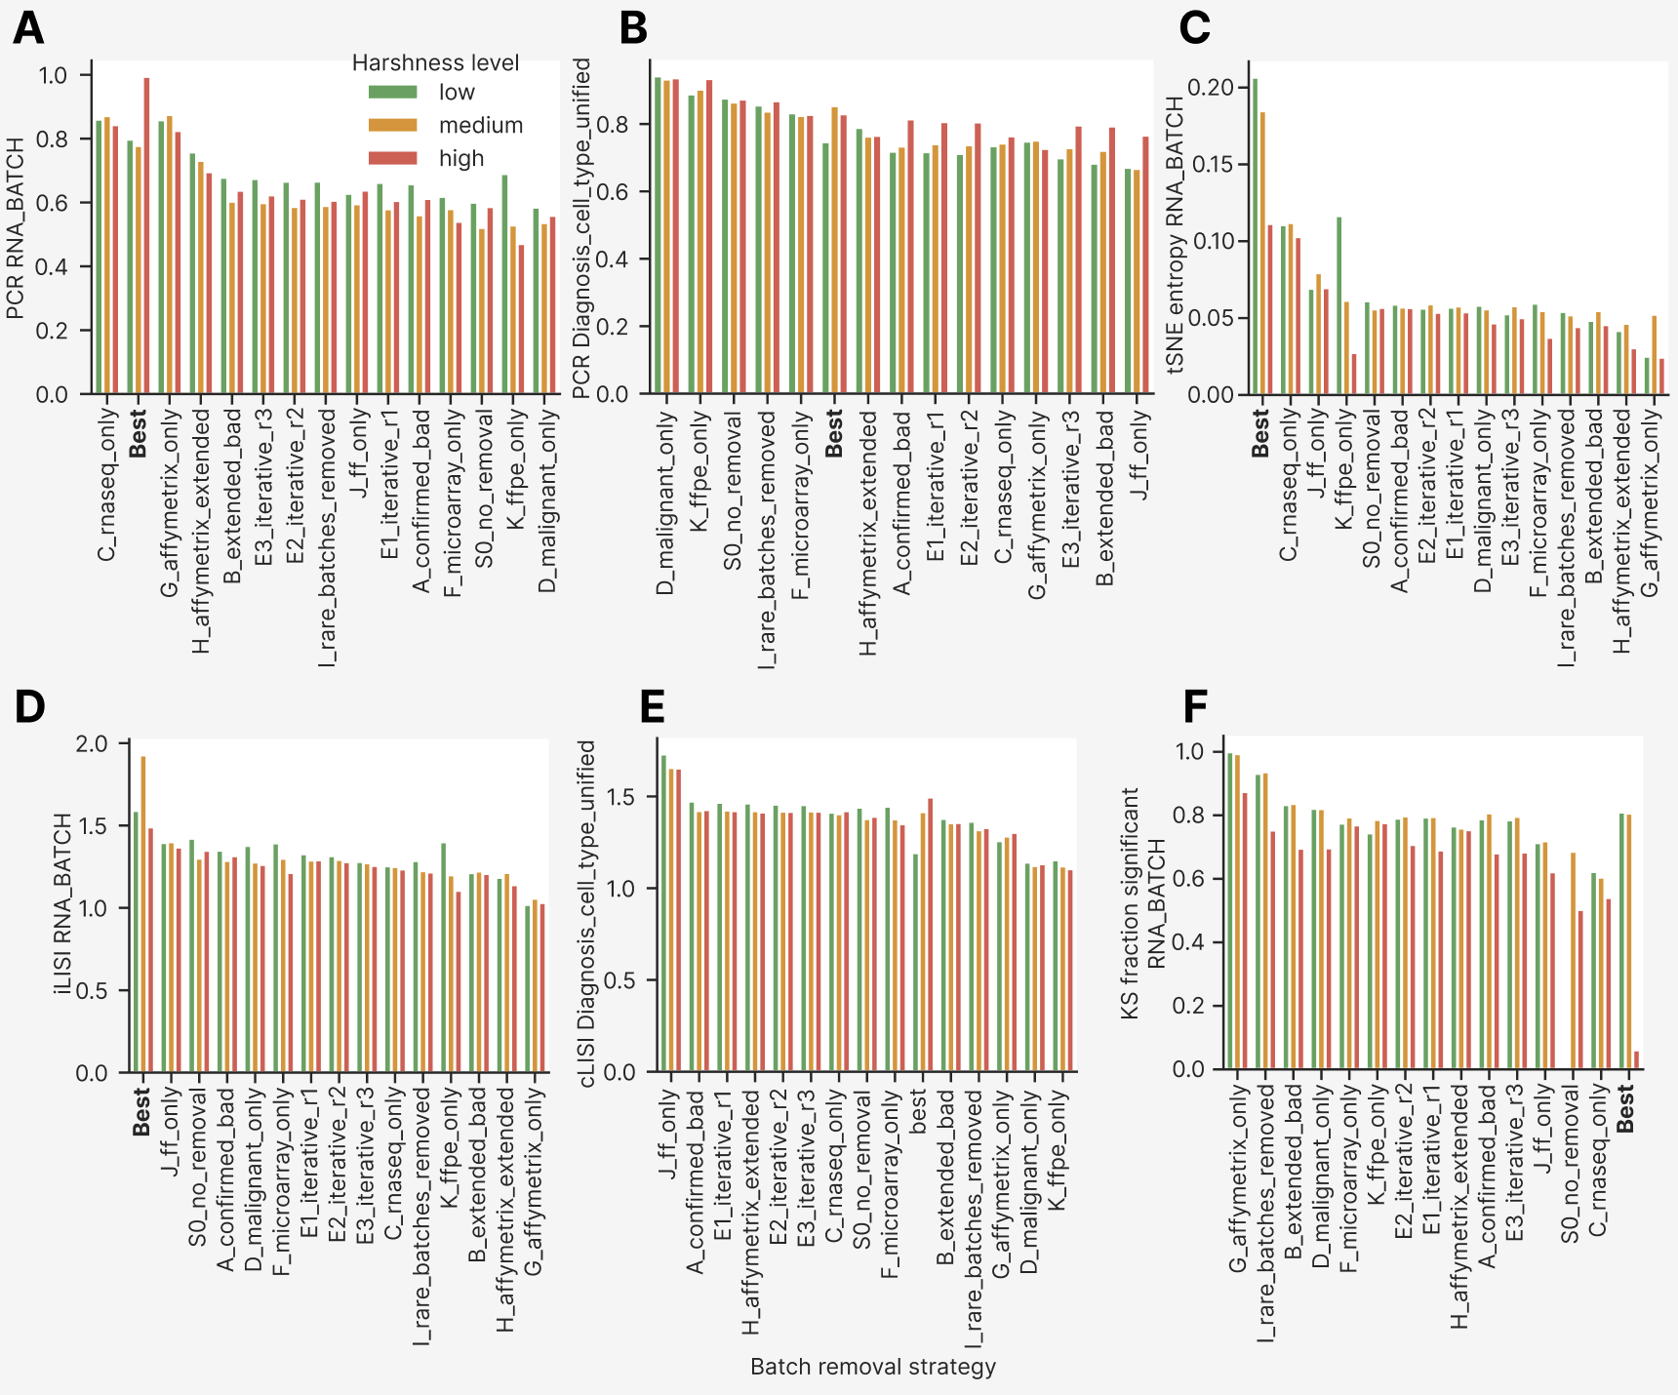

Composite performance score of harmonization methods and batch removal strategies
As the last part of the harmonization metrics extended analysis, we built the composite performance score as average of all the 87 polarity-multiplied scoring metrics and visualized it by harmonization methods and batch removal strategies (Extended Figure 12).

The group of clustermap best approaches was indeed the best by composite score, having it at the level of 0.6 (Extended Figure 12A), whereas the next strategy C had the composite score 0.57. Global distance metrics were the most numerous and therefore contributed 0.35 of the total score of the best group, but they were homogeneous among the batch removal strategies. In contrast, the local neighborhood contributed only 0.12 total score in the best group but they heavily differentiated the strategies: C had it 0.9, the next one J had it 0.6 and the rest 11 strategies showed it at the level of 0.4-0.5 without significant differences, with the worst one G having the local score 0.3. The distributional similarity and other groups conferred no visible differences at the level of batch removal strategies.
The pattern of metric type impact by harmonization methods was more complicated (Extended Figure 12B). The two top methods after the clustermap best group (it was again the best by the composite score) were 22_tmm and 23_vst – apparently because they were applied to C strategy only. Methods 33_amdbnorm, 28_npn and 10_mnn were the 3rd – 5th, respectively, with gradual decrease of local composite impact from 0.10 to 0.07 (in 28_npn) and then rising to 0.11 in 10_mnn, accompanied with the decrease of global and distributional performance.

Comparison of the metrics computational groups revealed that PCA-based variance decomposition metrics (PCReg, DSC etc) did not confer difference by batch removal strategies (Extended Figure 12C) and introduced a minor impact of 0.02 total score between the first 15 and the rest methods (Extended Figure 12D). Neighbor based integration and tSNE/UMAP embeddings were the two major groups for local metrics, and they differentiated significantly the C strategy against the rest ones (by 0.04 total score) and the top 12 methods (except 25_angel) versus the rest ones (by 0.03 total score). Watermelon score and samples/genes with NA conferred no differences, and the rest three groups (graph connectivity, distributional similarity, pairwise Euclidean distance) added 0.04 of the total score between the top 1/3 and the bottom 1/3 of the harmonization methods and batch removal strategies.

Finally, we investigated the impact of metrics calculated by different annotation columns, again by batch removal strategies and harmonization methods (Extended Figure 12E, F, respectively). Biology columns (Major_group, Diagnosis_cell_type_unified, TUMOR_NORMAL) added no significant difference into the composite score, and in total they comprised a quarter of the metrics equally weighted average. Among the batch columns COHORT_LABEL and RNA_BATCH brought the most variability between the top and the bottom strategies and harmonization methods.

Taken together, the metrics of local type were the most important in the total composite score even though they comprised only 10-15% of the total score. Batch related metrics comprised ¾ of it and the biology ones did not differ between the good and the bad harmonization methods or batch removal strategy.

Extended Figure 12. Stacked barplots showing impact of metric type, group and column into the equally weighted composite score. (A) Metric type by batch removal strategy. (B) Metric type by harmonization method. (C) Metric group by batch removal strategy. (D) Metric group by harmonization method. (E) Metric column by batch removal strategy. (F) Metric column by harmonization method. In all barplots bars are sorted by average value descending.
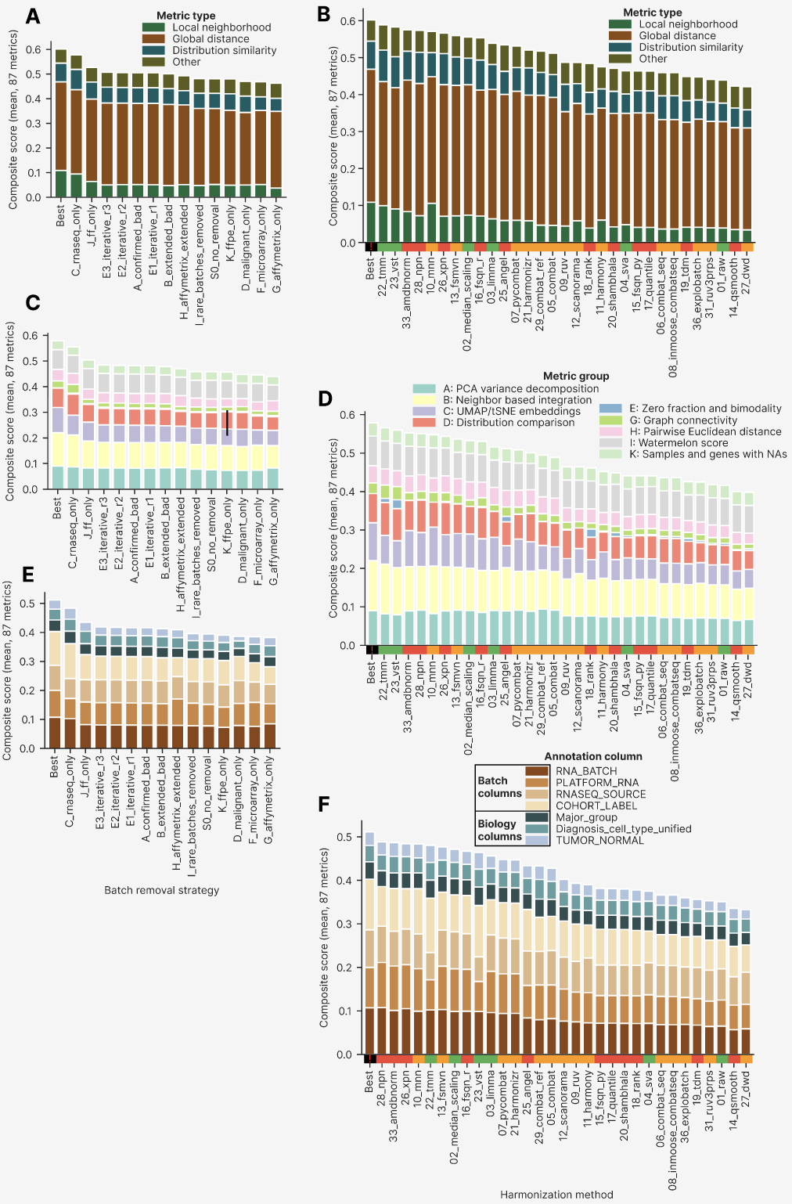
We sorted and visualized all the approaches by their composite score (Extended Figure 13). The resulting curve had an upper tail of outliers by high composite score (above 0.6), with 10/15 clustermap best approaches residing in it. Such a pattern confirms the general strategy dataset harmonization with high technical and subtle biological differences: a tiny minority of harmonization approaches (1-5%) are promising from the point of view of the actual PCA/UMAP/tSNE plots and quality metrics. To find these approaches, one should build a clustermap of quality metrics or do another integrative analysis of them, then visually confirming the findings on the dimensional reduction plots. There is no shortcut in cross-platform transcriptomic harmonization.

Extended Figure 13. Individual approaches sorted by the composite score, color annotated by batch removal strategy, imputation, harmonization method, post-removal and harshness level. The clustermap best approaches are shown with black stars.
